**MANUAL GUIDELINE**

**“OPTIMAL ESTIMATION FOR STANDARD CLOUD RETRIEVAL”**

Author : Trismono Candra Krisna

Institution : SRON Netherlands Institute for Space Research

Version : V2.1

Release date : 02 June 2020

Email : [t.c.krisna@sron.nl](mailto:t.c.krisna@sron.nl)

**CHANGE LOG**

|  |  |  |  |
| --- | --- | --- | --- |
| **Version** | **Date** | **Author** | **Reason for changes** |
| 1.0 | 11 May 2020 | Trismono C. Krisna | Initial document |
| 2.0 | 29 May 2020 | Trismono C. Krisna | Implement multi-processing module in SIM_FWD, remove typos, change retrieval equation and gamma parameter in the codes, update manual guideline |
| 2.1 | 02 June 2020 | Trismono C. Krisna | Update perturbation coefficient and cost function threshold, add execution time for SIM_FWD and SIM_RET, update manual guideline |

**INTRODUCTION**

This document is written as a brief guideline to the end-to-end (E2E) cloud retrieval software. A modified optimal estimation (OE) approach is applied to derive bulk cloud properties, namely optical thickness *tau* and effective radius *reff*. For simplification, a homogeneous cloud vertical profile is assumed in the simulation.

**CONTENT**

The software is delivered as a full package consisting of several modules. Each is represented by a folder as follows,

1. CREATE CASE

To generate the configuration of measurement condition.

1. SIM_FWD

To simulate line-by-line spectra (forward model) given the output of [1] as the input.

1. L1B

To generate synthetic measurement given the output of [2] as the input. This module generates spectra at instrument wavelengths by a convolution with noise applied on top of it.

1. SIM_RET

To retrieve bulk cloud properties *tau* and *reff*. The measurement input is taken from the output of [3]. An OE with Levenberg-Marquardt (LM) algorithm is implemented in the retrieval. Forward model and spectra convolution are also carried out within the retrieval module.

1. ERROR_ANALYSIS

To calculate error using outputs of [4] as the input. The analysis is carried out by taking Jacobian matrix and error covariance from the last iteration assuming a linear problem.

Additionally, DATA dir is aimed to store auxiliary data such as the spectral albedo (sea water) and the wavelength grid. Those folders must **be placed in parallel** because a relative path is commonly used by each module to determine the location of others. Currently, the modules work consecutively (end-to-end), that makes convenient for sensitivity studies. It is possible to pull out an individual module, such as [4] and [5] if the user wants to work on the retrieval of real measurement data.

**HARDWARE AND SOFTWARE REQUIREMENTS**

The codes were built and tested in a LINUX environment with 4 cores (CPU) and 8 GB RAM. This is the standard requirement. The number of core is important for running modules with multi process. Before running the module, *libRadtran* should have been installed. The software is built and tested using *libRadtran* version 2.0.2. Older or newer versions might be applicable. Please refer to *libRadtran* website <http://www.libradtran.org/doc/libRadtran.pdf> for more details.

The software is coded in Python3.7 with standard libraries. Please check the availability of the required libraries in your local machine prior running. A Python3 compiler is necessary. All versions of Python3 compiler should be relevant, but using version 3.7 is recommended. The codes should also work on Python2 with some adjustments but it is **not recommended** considering its remaining lifetime.

**HOW TO RUN MODULES**

Brief steps to run each module is explained here. For more detailed information, please check in the codes. Descriptions have been made to explain each task, so the user can follow the workflow easily. Each module has corresponding MODULES dir, which is essential to store the routines. To make changes, please make a copy so it won’t risk the master.

1. CREATE_CASE

Please go to dir MODULES. The main code is called main_create.py*.* For this standard example, only *tau* and *reff* are varied. The other parameters, e.g., surface albedo, measurement geometry, cloud height, etc, remain constant but it’s possible to be adjusted depending on the purpose. The code can be executed from the terminal,

>> python3 main_create.py

where python3 is the alias of Python3 compiler in your machine. Once the code has been executed, the outputs are stored in the dir OUTPUT. Please make sure this folder exists prior execution (recommended), although the code is capable to create. If it is already exist and (or) has outputs from previous executions, it will not be overwritten.

1. SIM_FWD

The main code is located in the MODULES dir, namely main_fwd_sp.py for serial-processing or main_fwd_mp.py for multi-processing. The use of multi-processing module is recommended. The number of process employed, namely n_proc, must be adjusted in main_fwd_mp.py. In this example n_proc is set to 3, that can be extended as long as it does not exceed the number of core (CPU). Otherwise, the maximum performance won’t be gained. Prior execution, change the path of *libRadtran* in fwd_wrapper.py (variable lib_dir) based on the condition in your local machine and use an absolute path. The code can be executed from the terminal,

>> python3 main_fwd_<sp/mp>.py

The outputs, such as input-output of forward simulation and transformed radiative quantities, will be stored in the dir INOUT. The dir CLOUD is dedicated to store the cloud profiles. The main code may generate those dirs, but it is recommended to create them before execution.

1. L1B

The main code is in the MODULES dir, namely main_l1b.py. The noise realization is adapted from the Moderate Resolution Imaging Spectroradiometer (MODIS) Signal-to-Noise Ratio (SNR). This is a simple assumption, thus it is possible to be modified by the user. Please read the description given in the code for more detail. The code can be executed from the terminal,

>> python3 main_l1b.py

The outputs are stored in the dir OUTPUT. For each measurement, the spectra information is split into the visible to near-infrared range (VNIR) and the short wavelength infrared (SWIR). To define the spectra at a particular wavelength, a convolution is applied. The instrument spectral response function (ISRF) is assumed as a Gaussian function with Full Width at Half Maximum (FWHM) of 3 nm and 201 sampling grid.

1. SIM_RET

The main code is placed in the MODULES dir and it is called main_l2m_sp.py for serial-processing or main_l2m_mp.py for multi-processing (recommended). The number of process employed, namely n_proc, must be adjusted in main_fwd_mp.py. In this example n_proc is set to 3, that can be extended as long as it does not exceed the number of core (CPU). Otherwise, the maximum performance won’t be gained. Please change the *libRadtran* path to your local machine. This can be done by changing variable lib_dir in l2m_wrapper.py in MODULES.

Before running retrievals, you must create the retrieval setting. A python code retrieval_setting.py is available in the dir INPUT for this purpose. Do not change or remove this dir. Albeit, a standard setting has been defined, users have the freedom to change the setting. It must be reasonable, otherwise deprecated retrieval performance may occur. When the setting has been defined, it can be executed as follows,

>> python3 retrieval_setting.py

which generates the retrieval_setting.ini (retrieval setting) in the respective dir. The a priori is set to 8 for *tau* and 10 µm for *reff* according to climatology data. The prior error is intentionally set to a relatively large number (twice as a priori) to minimize possible constrains in the retrieval. The maximum number of iteration is currently set to 15. However, retrievals will most likely converge before 8 iterations (4-6 in average). The noise flag = 1 is for retrieval with noise and 0 for without noise applied on the measurement. The retrieval is performed using wavelengths between 630 and 670 nm in the visible to near infrared (VNIR) range that is sensitive for *tau* and between 1500 and 1660 nm in the short wavelength infrared (SWIR) range which is sensitive for *reff*. Using this configuration, the number of measurements used in the retrieval would be 79 (over-constrained problem). Finally, the retrieval code can be executed from terminal as follows,

>> python3 main_l2m_<sp/mp>.py

The dir DUMMY is aimed to store input-output of forward simulation, such as cloud profile and line-by-line spectra, as well as convolved spectra. Retrieval outputs are stored in the dir OUTPUT. Those two dirs can be created by the code, but it is recommended to create them before execution.

The retrieval module generates three main outputs: Jacobian matrix, Gain matrix, and retrieval statistic which summarizes results (e.g., optimum solution and cost function) and retrieval diagnostics. conv_id 1 = converged, 2 = not converged (exceed maximum number of iteration) , and 3 = not converged (boundary condition hit). Only retrievals with index 1 provide meaningful information. Jacobian matrix kmat_<pixel_id>_<iter_id>.dat is comprised of six columns: wavelength, measured radiance, measurement covariance (error), modeled radiance, Jacobian *tau*, and Jacobian *reff*. The Gain gain_<pixel_id>.dat has three columns: wavelength, Gain *tau*, and Gain *reff*. Those two matrices are meaningful to analyze retrieval errors.

1. ERROR_ANALYSIS

The main code is located in the MODULES dir and it is called main_l2m_error.py. Note that variable weighting (prior error) must be consistent with those defined in the retrieval setting [4]. Jacobian matrix from the last iteration [4] is used in this analysis. The code can be executed from the terminal as follows,

>> python3 main_l2m_error.py

Retrieval errors are stored in the dir OUTPUT. Four different errors are provided: prior_error = error estimate before measurement is made, noise_error = error due to instrument noise, smoothing_error = error due to the lack of prior information, and total_error = error due to noise and smoothing error.

**KNOWN LIMITATION**

The code is dedicated for liquid water clouds. For cirrus, adjustments are required. The computation of Jacobian matrix is considerably expensive. To calculate Jacobian *tau* and *reff*, the forward model need to be run three (3) times. The forward model uses an option “tau550 set”, therefore the entire spectra including lambda = 550 nm must be calculated. Those factors makes one iteration needs 2.5 minutes more or less, depending on the machine. Assuming one retrieval needs 6 iterations, ca. 15 minutes is required for one pixel retrieval (maximum). A multi-processing module is implemented to tackle this high computational time. In the future, alternative methods to derive Jacobian matrix should be implemented.

**SOURCE CODE AVAILABILITY**

Codes are available on the version control <https://github.com/trismono/CLOUD-RETRIEVAL.git>

**REFERENCE**

Rodgers, C. D., 2000: Inverse Methods for Atmospheric Sounding: Theory and Practice. World Scientific Publishing Company, 240 pp.

**APPENDIX**

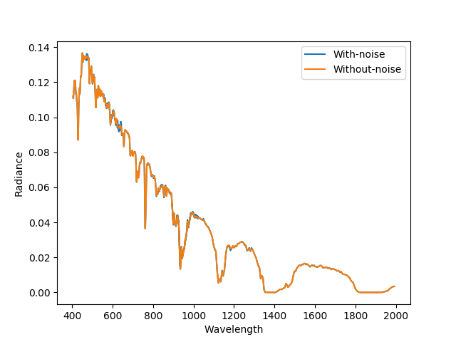

Figure 1. Spectral radiance with and without noise for cloudy condition with *tau* = 4 and *reff* = 8 µm, surface albedo = sea water, sza = 30°, and phi0 = 100°.

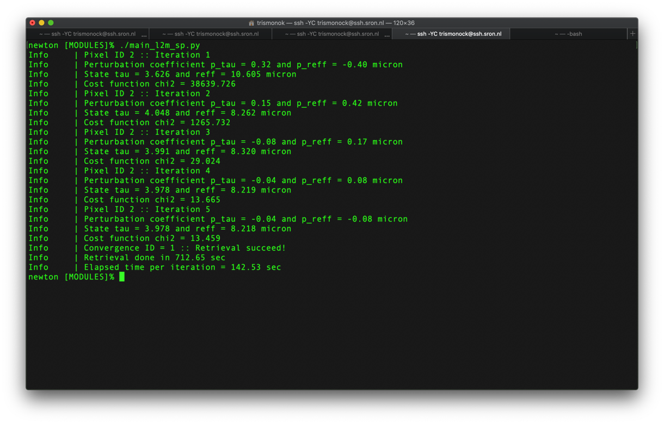

Figure 2. Screen output of retrieval module. Converged after 5th iteration with *tau* = 3.98, *reff* = 8.21 µm, chi2 = 13.46 for n_measurement = 79.

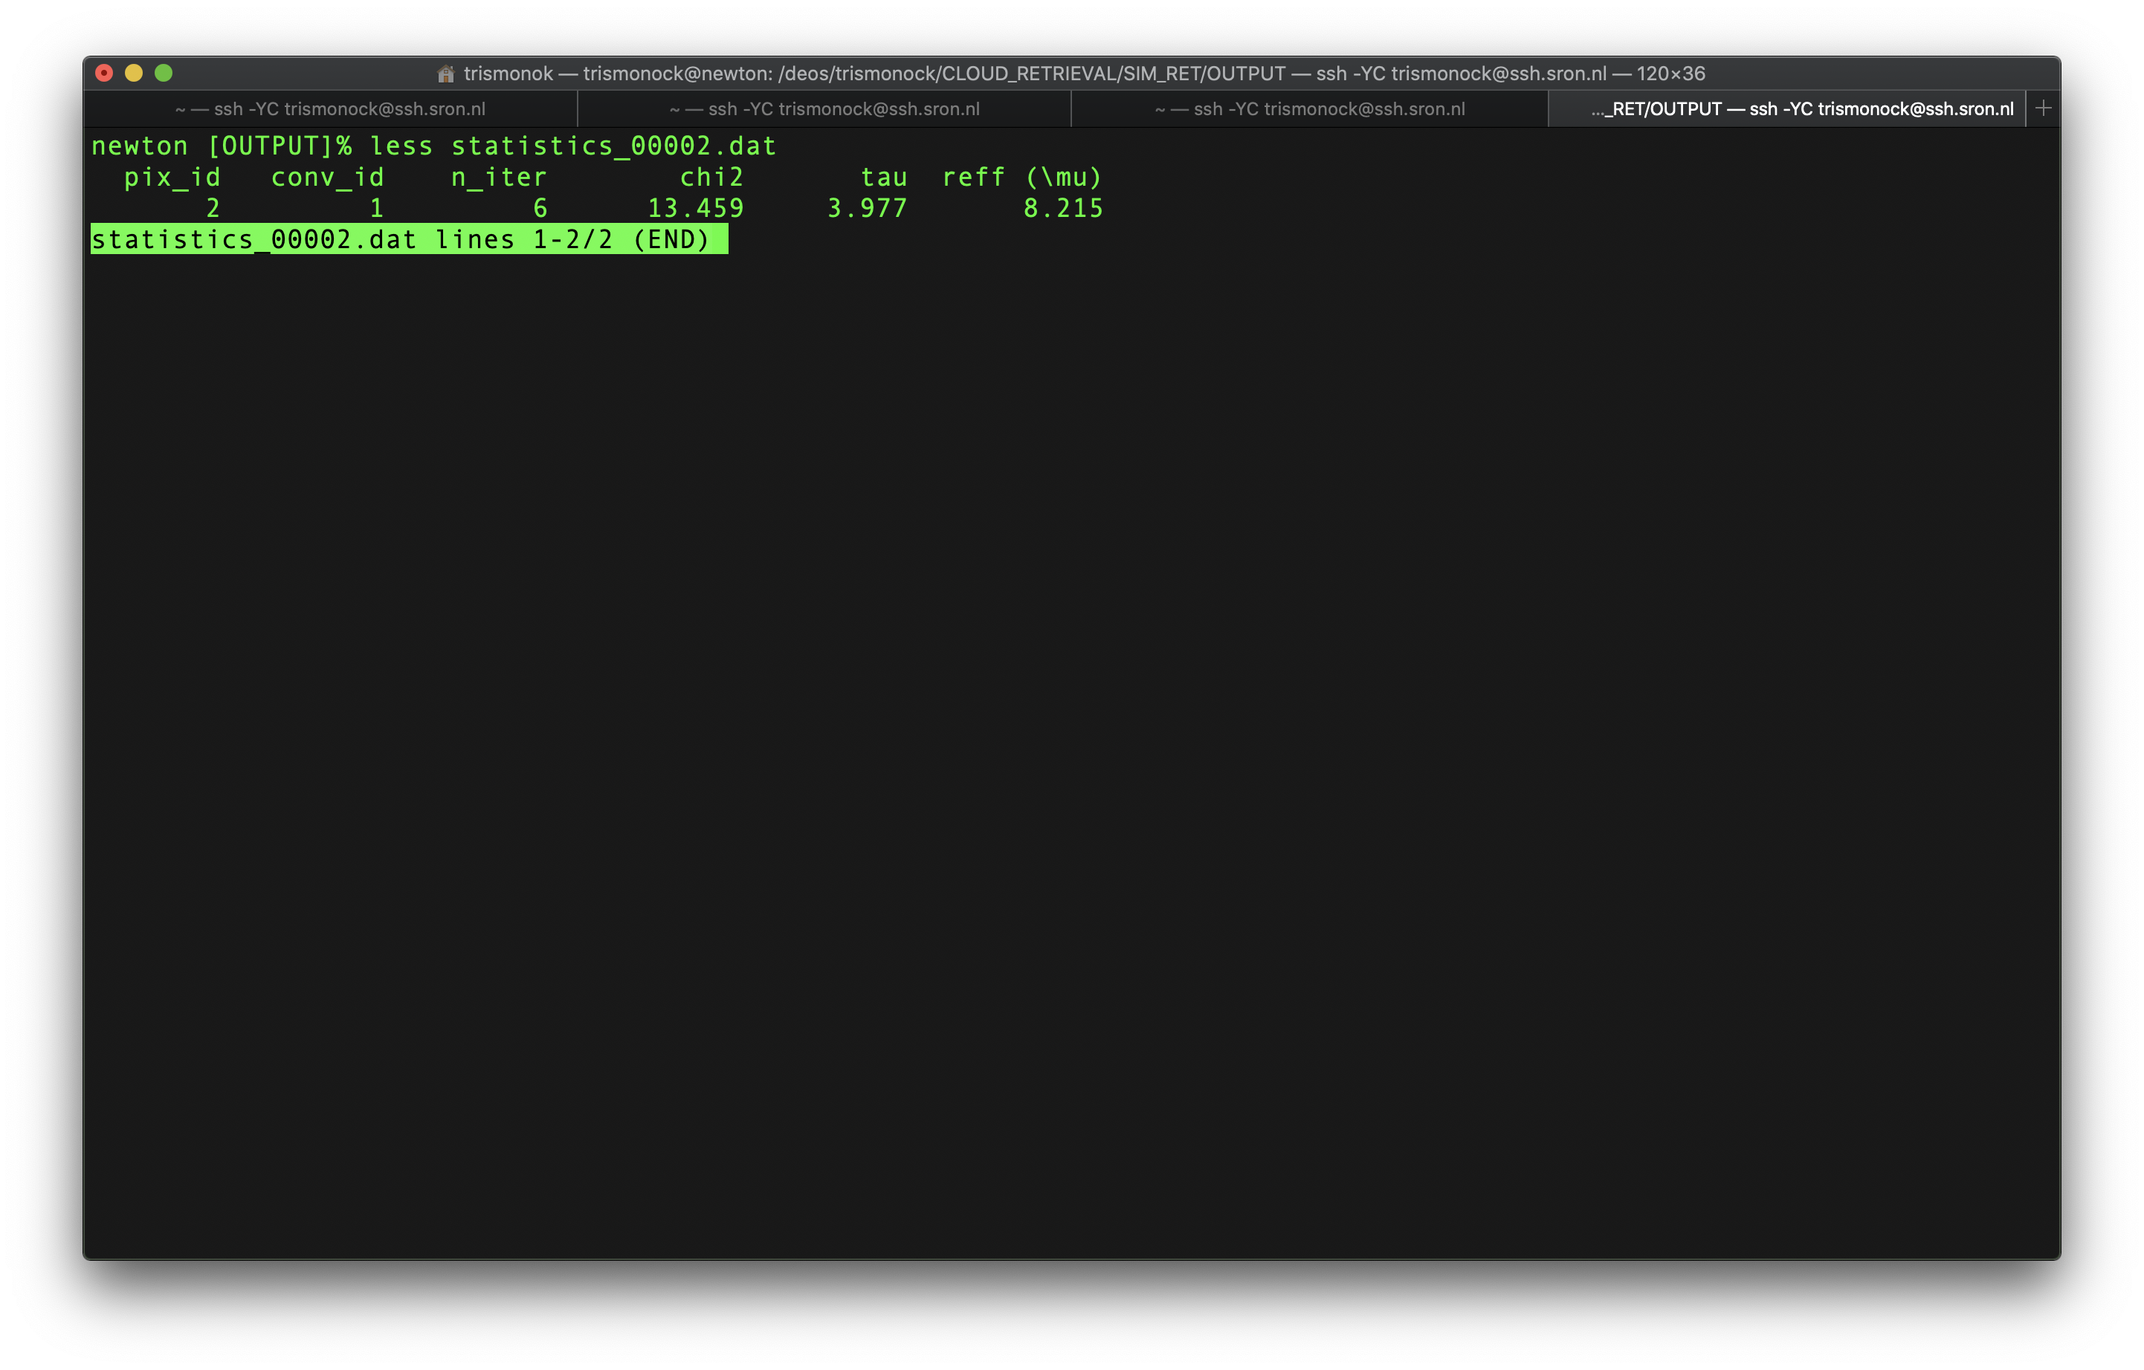

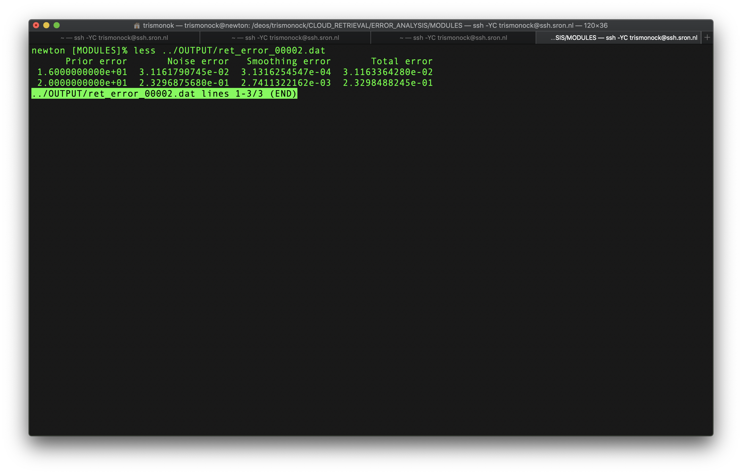

Figure 3. Retrieval statistic (top) and error (bottom). The order of retrieval error (from top): *tau* and *reff*.

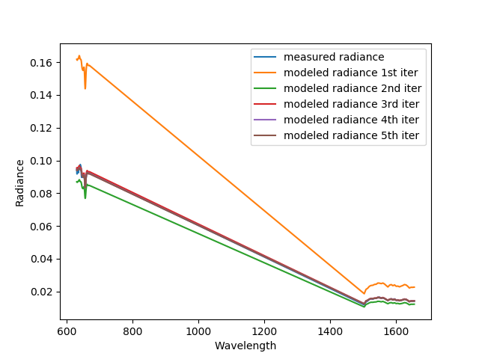

Figure 4. Comparison of measured and modeled radiance for each iteration. An optimum solution is reached at 5th iteration.

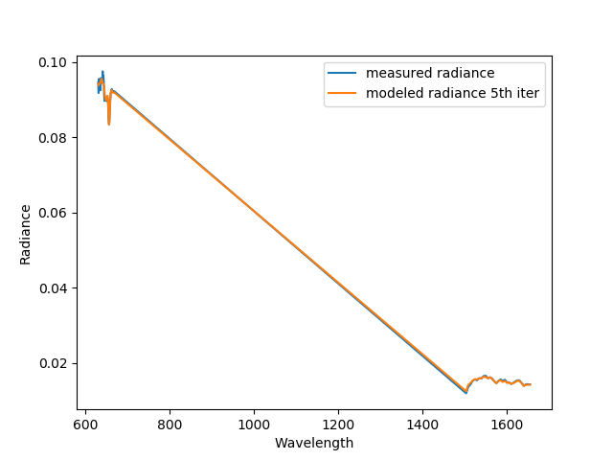

Figure 5. Comparison of measured and modeled (optimum solution – 5th iteration ) radiance.