Resin used: Siraya Tech Sculpt High-temperature resistant resin in clear color.
Printer used: Elegoo Mars 3 Pro with a magnetic removable build plate.
Print settings:
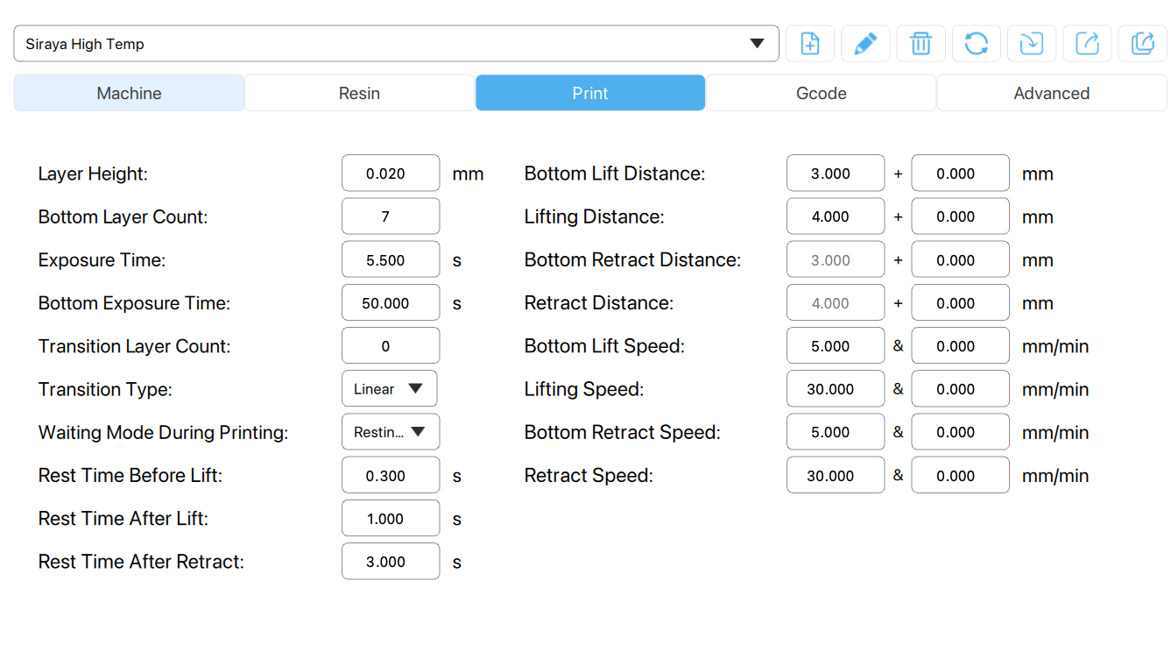
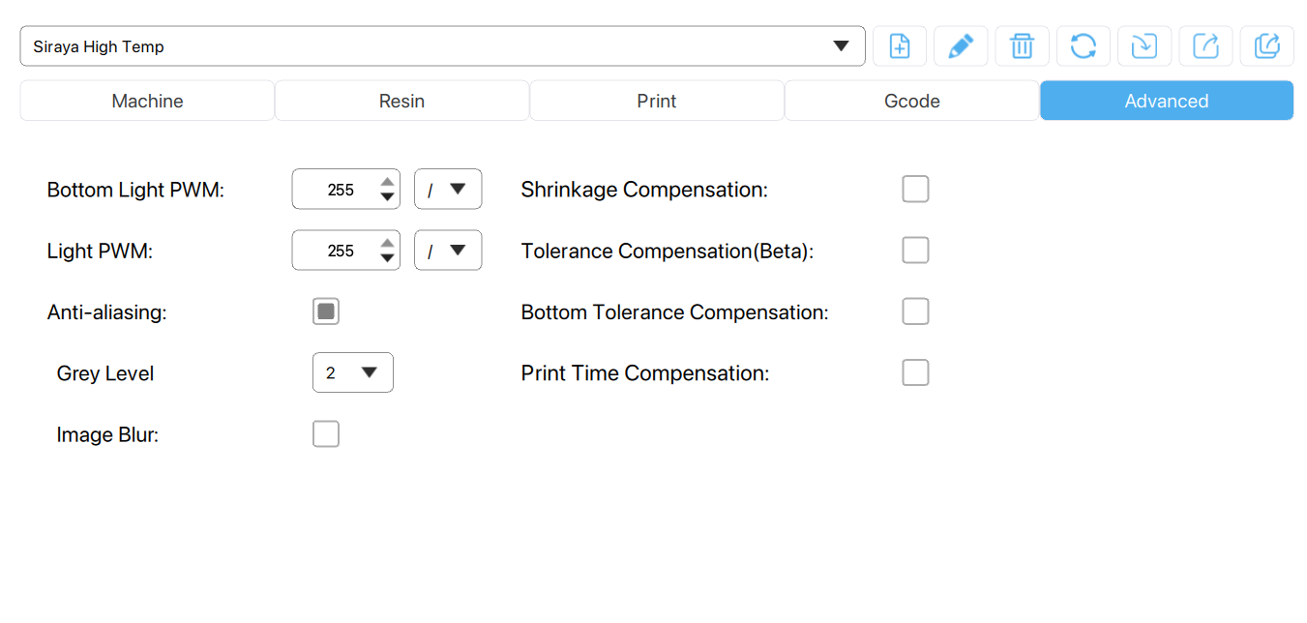
Post processing steps:
- Spray with acetone
- Blow dry with compressed high pressure nitrogen
- Repeat steps 1-2 until pins are completely clean of residual resin (6-8 cycles)
- Remove flexible metal plate from printer build plate.
- Place inside Elegoo Mercury X rotating UV cure station.
- UV cure for 15 minutes.

