Plate-format PDMS microfluidic culture devices from hybrid SU-8/3D-printed resin wafer molds

Tristan Simas^{1,#,} Yonatan Morocz², Jathav Puvirajan¹, David Juncker², and Alyson Fournier¹

¹Department of Neurology and Neurosurgery, Montréal Neurological Institute, McGill University, Montréal, Québec, Canada
²Victor Phillip Dahdaleh Institute of Genomic Medicine, McGill University, Montréal, QC, Canada.
#Corresponding author

Abstract
Microfluidic cell-culture platforms combine fine channels with pipette-accessible wells, but producing these features at different scales can require labor-intensive fabrication and assembly. This challenge is particularly relevant to neuronal assays, which use fine channels to connect spatially separated culture compartments. Here, we present an open-source, hybrid microfabrication strategy for producing reusable silicon-wafer molds that integrate photolithographically defined microchannels with structures produced by three-dimensional (3D) printing for simultaneous formation of culture wells. A parametric design framework, OpenMFD, generates coordinated photomasks and three-dimensional insert arrays, enabling array-scale alignment and simultaneous bonding of millimeter-scale structures to wafers patterned with SU-8 and SUEX photoresists. As an example application, we fabricated polydimethylsiloxane (PDMS) culture plates containing 48 compartmentalized devices arranged on a standard microplate grid, eliminating individual well punching during device production. Devices supported multichannel liquid handling, automated high-content imaging, directional tracer movement, primary cortical neuron culture and retrograde axonal labeling. OpenMFD also generated matching fabrication files for alternative compartment layouts.
Introduction
Compartmentalized neuronal cultures enable independent access to cell bodies, axons and their local extracellular environments. Microchannel-connected culture chambers permit spatially restricted treatments, isolation of axonal material and analysis of axonal injury, regeneration and transport (PMID: 16094385). Subsequent designs have enabled controlled axon-guidance gradients (PMID: 26000554), localized neuron–glia interactions (PMID: 22828584) and modular neuronal culture models (PMID: 35466333). The geometry of connecting microchannels also influences device performance and the study of communication between neuronal populations (PMID: 36111641).
Extending these experimental capabilities to parallel assays requires platforms that accommodate multiple treatment conditions, biological replicates and established liquid-handling and imaging workflows. A high-capacity microfluidic plate containing up to 96 independently addressable, three-compartment culture units has been used with primary rodent and human induced pluripotent stem cell-derived neurons, demonstrating compatibility with morphological and functional measurements (PMID: 38150531). Other approaches prioritizing experimental flexibility include modular microfluidic units that can be combined into customizable neuronal culture configurations (PMID: 35466333), whereas fluid-walled chambers support human neuronal microcircuits and moderate-throughput axotomy assays (PMID: 38841815).
A persistent fabrication challenge in microfluidic cell culture is the integration of micrometer-scale channels, which control access and local fluid movement between compartments, with millimeter-scale reservoirs that permit straightforward cell seeding and pipetting. Conventional PDMS soft lithography can reproduce photolithographically defined microfeatures, but culture reservoirs are often opened individually after casting. Fine channel-forming features, such as the 10 µm widths designed here, can fall below the practical resolution of desktop resin printers. Photolithography provides these fine features, while printed structures form the larger wells (PMID: 40190179). Fabrication approaches differ in the equipment and operations required to combine these scales (Supplementary Table S2). This mismatch has previously been addressed with hybrid micro–macro molding combining milled and hot-embossed structures to replicate microscopic channels and macroscopic reservoirs without manual punching (PMID: 20049640). The approach was subsequently applied to multi-compartment neuron–glia cultures supporting localized treatments (PMID: 22828584). Other strategies use additive manufacturing to create compartmentalized neuronal devices without extensive manual post-processing (PMID: 32832365).
For academic laboratories, access to a shared cleanroom for reusable mold fabrication can be more practical than acquiring dedicated precision molding or machining equipment (Supplementary Table S2). Photopolymer-based 3D printing offers accessible fabrication of larger structures and complex geometries, although printed resins can inhibit PDMS curing and may require additional treatments before use as casting molds (PMID: 40190179). Hybrid assemblies combining soft lithography with printed polymer components provide another route to customizable biological microfluidic systems (PMID: 40667579). Parylene C coatings have also been shown to limit material degradation and cytotoxic leaching from printed resins in primary-cell applications (PMID: 37534979). Particularly relevant to neuronal compartmentalization, Ristola and colleagues combined SU-8 microfeatures with individually positioned 3D-printed metal inserts to fabricate neuron–oligodendrocyte culture devices (Ristola et al., 2019; DOI: 10.1088/1361-6439/ab16a7).
Here, we introduce OpenMFD, an open-source parametric design and hybrid fabrication workflow for producing reusable wafer-scale molds for medium-throughput microfluidic culture devices. Shared design coordinates generate matched photomasks, resin-insert arrays and plate components, enabling the simultaneous alignment and bonding of well-forming inserts to SU-8/SUEX-patterned silicon wafers. Photolithography defines the fine microchannels, while the retained printed inserts form the culture wells directly during each PDMS cast, removing the need for individual well punching in successive production runs. We demonstrate this combination of fine channels and pipette-accessible wells in an example neuronal application: an array of 48 two-compartment devices containing 96 wells on a standard 9 mm plate grid. We evaluate repeated casting, compatibility with multichannel pipetting and automated imaging, directional tracer movement, and primary cortical neuron culture with retrograde axonal labeling. OpenMFD also arranges alternative compartment geometries into plate-format arrays and generates their matching fabrication files. Once a mold is made, further plates can be cast and assembled on the bench without repeating cleanroom processing.

Materials and Methods
Supplementary Protocol S2 describes one-time hybrid mold fabrication; Supplementary Protocol S1 describes routine casting, assembly and assays.
Parametric design and fabrication-file generation - OpenMFD (https://github.com/trissim/OpenMFD) generated photomasks, insert arrays, wafer outlines, cutting guides, and plate frames from shared well, chamber, channel, and array dimensions (Figure 1). Device shapes were defined in OpenSCAD design software using the SolidPython library and exported as two-dimensional Drawing Exchange Format (DXF) mask drawings for each layer and three-dimensional stereolithography (STL) models of the inserts and frames. Matching solid and hollow marks were used to align the photolithographic layers. The pin positions in the insert STL and the hole positions in the SUEX photomask came from the same coordinates, allowing the printed array to be aligned with the patterned wafer as a unit.
The tested design contained a 6 × 8 array of two-well units spaced 18 × 9 mm apart, giving 48 devices and 96 wells on a 9 mm grid. Each device had 62 microchannels with a design width of 10 µm and an interchannel gap of 30 µm. Matching masks and inserts received a horizontal scale factor of 1.0226 (2.26% enlargement) for the 100°C PDMS cure. Supplementary Table S3 gives the nominal device, channel, pin, taper, and frame dimensions used to generate the fabrication files.
OpenMFD also generated matched photomasks, inserts, wafer outlines, and frames for three literature-inspired layouts: oligodendrocyte myelination (PMID: 26015546), axon guidance with gradients at right angles to each other (PMID: 26000554), and a three-compartment assay (PMID: 24662423). These devices were not fabricated or biologically tested (Supplementary Table S3).
Fabrication of hybrid SU-8/SUEX and 3D-printed wafer molds - The mold comprised two 5 µm layers of SU-8 2005 liquid photoresist (Kayaku Advanced Materials), a 200 µm layer of SUEX K200 dry-film photoresist (DJ MicroLaminates), and a printed resin-insert array on a 6-inch silicon wafer (UniversityWafer ID857). These photoresists are light-sensitive resins used to pattern the mold features. SU-8 was spread by spinning the wafer (spin-coating) using a Laurell WS-650-8B, SUEX was laminated using an SK 335R6, and photolithographic layers were aligned and exposed using an EVG620. Unless otherwise noted, materials were processed according to the manufacturers’ instructions; the SU-8 2005 procedure targeted a 5 µm layer. Changes to the manufacturers’ procedures are described below and in Supplementary Protocol S2. No dehydration bake or hexamethyldisilazane (HMDS) adhesion-promoter treatment was used. Facility-supplied propylene glycol monomethyl ether acetate (PGMEA) was the developer solvent used to remove unexposed material from both photoresists.
Layer 1 (base): SU-8 2005 was spin-coated to a 5 µm target thickness, flood-exposed without a mask, and left undeveloped beneath the patterned microchannel layer (Supplementary Note S2).
Layer 2 (microchannels): A second 5 µm SU-8 2005 layer was exposed through the microchannel photomask and developed. Before SUEX lamination, the wafer bearing the approximately 10 µm SU-8 stack was placed directly in an oven at 150°C for 10 min, then removed without controlled heating or cooling.
Layer 3 (wells): SUEX K200 dry film (200 µm) defined the well features and insert-alignment holes. The SUEX was exposed at 2800 mJ/cm² through an LP360 long-pass optical filter to block shorter-wavelength ultraviolet (UV) light. After exposure, the oven was heated from room temperature to 50°C at 1°C/min, held at 50°C for at least 12 h overnight, then switched off and allowed to cool. The wafer was submerged in developer and mixed for 20 min; the developer was replaced at 15 min. For the hard bake, the oven was heated to 120°C at 3°C/min, held for 30 min, then switched off and allowed to cool.
Well inserts were printed at their final relative positions using an Elegoo Mars 3 Pro and Siraya Tech Sculpt Clear resin. The profile used 20 µm layers, 5.5 s normal exposure, 50 s bottom exposure, 7 bottom layers, edge smoothing (anti-aliasing) at grey level 2, and no shrinkage or tolerance compensation in the print-preparation software. Supplementary Table S4 provides the remaining motion, timing, washing, and UV post-cure settings. Each insert had a 1.85 × 1.85 mm alignment pin corresponding to a 2.0 × 2.0 mm SUEX hole, giving 150 µm total clearance (75 µm per side).
The inserts were kept on a detachable flexible metal build plate so the whole array could be transferred at once. EPO-TEK 301-2 epoxy adhesive was applied around each pin, and the mold was positioned until the pins seated in their SUEX holes. An ethylene propylene diene monomer (EPDM) rubber sheet (0.03125 inch thick; Shore A hardness 60) between the fixed magnet and removable build plate provided a compressible backing; a second flat plate and clamps distributed pressure across the assembly (Figure 2). The clamped assembly was washed in two successive 1 min acetone baths, thoroughly blow-dried, and cured at room temperature for 48 h. After curing, the assembly was cleaned in an ultrasonic acetone bath for 10 min to remove residual material. The flexible metal build plate was flexed to release the bonded array (Supplementary Protocol S2).
After bonding, the hybrid mold received a 1 µm coating of the polymer parylene C to separate the printed resin and adhesive from the cast PDMS and aid release during demolding (PMID: 37534979; DOI: 10.1016/j.sna.2012.09.024). Parylene was deposited using a Specialty Coating Systems SCS 200 coater at the McGill Nanotools Microfab facility. The specified channel dimensions are the design dimensions before parylene coating.
PDMS casting and plate assembly - Frames were generated with the other fabrication files and printed in high-impact polystyrene (HIPS), a rubber-modified plastic, on an enclosed Creality K1C using a 0.4 mm nozzle, 0.20 mm layers, a 220°C nozzle, and a 100°C build plate. The remaining printing settings are listed in Supplementary Table S6 and included in the supplied Creality Print 6.0.4 G-code printer-instruction file.
PDMS (Sylgard 184) was mixed at a 10:1 base:curing-agent ratio and poured over the full wafer within an aluminum-foil reservoir. The fill level remained below the insert tops to leave the wells open. Filled molds were supported in a six-shelf metal wafer rack, degassed until visible bubbles were removed (typically 10–30 min; approximately −15 inHg in our setup), and cured for 1 h at 100°C. Multiple molds could be degassed and cured in parallel.
The large mold features had tapered sidewalls to aid demolding, following the same design principle used in earlier multiscale PDMS molds (PMID: 20049640; DOI: 10.1088/1361-6439/ab16a7). The wafer was supported on a flat surface, and peeling proceeded from the corners toward the center while the PDMS was pulled backward to reduce local stress on the wafer.
A rectangular guide molded around the array was aligned to an industrial paper guillotine to trim each cast to 108 × 72 mm. The trimmed PDMS and a 110 × 74 × 0.17 mm coverslip-glass sheet were activated with dry-air plasma for 1 min at 200–600 mTorr in a Harrick PDC-001, brought into contact, and heated at 100°C for at least 1 min under uniform pressure (Supplementary Protocol S1).
The bonded PDMS-on-glass assembly was autoclaved in a sterilization pouch at 121°C for 15 min before frame assembly. The frame was decontaminated with 70% ethanol and inverted so that its adhesive groove faced upward. Henkel LOCTITE SI 5140 (3 oz tube, IDH 135264), a one-part silicone sealant that cures at room temperature, was dispensed into the groove (typically 0.5–1 mL per frame) (manufacturer technical data sheet). The bonded device was inverted with the glass facing upward and seated into the frame. After a 3-day room-temperature cure, the assembly was turned upright and excess adhesive was trimmed with a razor blade.
After adhesive curing, the assembled device received a second dry-air plasma treatment (Harrick PDC-001; high power, 30 W, 10 min, 400 mTorr) before aqueous coating and culture. This surface-treatment step was distinct from the earlier 1-min PDMS-glass bonding treatment.
Mold and device characterization - Each pin height was measured individually with a micrometer at all 96 positions of one 8 × 12 printed array before bonding. Supplementary Table S1 reports the individual values, mean, standard deviation, and difference between the tallest and shortest pins. Molds and casts were inspected to check that the SU-8/SUEX features remained attached, the inserts were seated and bonded, and the cast wells and microchannels were open and intact. Microscopy was used to inspect the channels after coating and casting. Apparent channel widths were measured in original brightfield fields from device R02C02 on each of three plates, using three transverse rulers per device. Rulers joined the centres of opposing dark wall bands at the acquisition scale of 1.18675253 µm/pixel. Supplementary Table S8 records the nine measurements; Supplementary Fig. S3 shows their positions. Supplementary Table S5 reports mold numbers and usable-cast yield separately and defines a usable cast.
Printed frames and assembled joints were inspected visually while selecting frame materials. Frame adhesives were screened by whether primary cortical-neuron cultures survived to the end of the experiment. Cell toxicity was not quantified.
To test whether cells could grow at the outer positions without the frame, one PDMS device was bonded to glass without a frame or frame adhesive and placed in a 14.5 cm-diameter polystyrene culture dish. This control removed both the frame assembly and the sealing effect of the frame adhesive.
Eight tips were fitted to a 12-channel pipette and aligned with one plate column to fill eight wells in parallel. Compatibility with plate-format imaging was tested by focusing and collecting images on Opera Phenix Plus and ImageXpress Micro Confocal microscopes at the Early Drug Discovery Unit (EDDU), The Neuro, McGill University, without custom plate handling or instrument modification.
Assessment of directional fluorescent tracer transport - Tracer distributions were compared immediately after loading and after 72 h in 24 two-compartment devices. Alexa Fluor 568-conjugated secondary antibody diluted 1:1000 in phosphate-buffered saline (PBS) was loaded at 25 µL into the left compartment, and Alexa Fluor 488-conjugated secondary antibody diluted 1:1000 in PBS was loaded at 50 µL into the right compartment. The volume difference was established once, and the devices were kept in a cell-culture incubator for 72 h without replenishment or volume adjustment. Images were acquired in widefield mode using a 10× objective with a numerical aperture (NA) of 0.30, 2 × 2 camera binning, a 100 ms exposure, and red and green channels suited to the two fluorophores. Tracer movement was assessed visually by comparing green fluorescence appearing in the initially lower-volume compartment with red fluorescence appearing in the opposite compartment. Flow rate and the duration of the pressure difference were not measured.
Primary cortical neuron culture and retrograde axonal tracing - Primary cortical neurons were isolated from one embryonic day 18 (E18) Sprague Dawley rat embryo following Harris et al. (2007; PMID: 18989412), then distributed across three separately assembled plates. Routine culture maintenance followed the cited protocol, with the device-specific conditions described below. The three plates were technical replicates of a single neuronal preparation. Dendritic polyglycerol amine (dPGA; DendroTEK Biosciences) was selected as the cell-attachment coating based on Clément et al. (2022; PMID: 35023760). Wells were coated with 30 µL of 10 µg/mL dPGA for 10 min and washed once with water. Neurons were seeded into the cell-body (soma) compartment in 50 µL Dulbecco’s modified Eagle medium (DMEM) containing 10% fetal bovine serum (FBS) at 5,000–10,000 cells per well, allowed to attach for at least 30 min, and then switched to supplemented Neurobasal Plus medium (1% N2, 2% B27, 1% glutamine). Volumes of 50 µL in the soma compartment and 25 µL in the axon compartment created a small pressure difference that directed fluid from the soma compartment toward the axon compartment during culture.

Cultures were maintained for 11 days in vitro (DIV). At DIV10, cholera toxin subunit B (CTβ) conjugated to Alexa Fluor 647 (CTβ-647) was applied to the lower-volume axon compartment at 1 µg/mL. CTβ-positive neuronal cell bodies were counted 24 h later, with one count per analyzed device. Analysis was restricted to the 24 interior devices on each plate because culture performance was poorer at the plate edges. Devices flagged for cell-counting artifacts in the saved DMSO analysis were excluded from the plate summaries and retained as red crosses in Fig. 4C. High or low counts alone were not grounds for exclusion. Supplementary Table S7 lists every device count and identifies the exclusions. Supplementary Protocol S1 provides the complete procedure.
High-content imaging and cell counting - CTβ images were collected at DIV11 in widefield mode on a PerkinElmer Opera Phenix Plus at EDDU using a 10×/0.30 NA objective, 2 × 2 camera binning, and laser autofocus. The effective pixel size was 1.187 µm. Brightfield images used a 10 ms exposure; Alexa 647 images used 640 nm excitation, 706 nm emission, and a 100 ms exposure.
For each device, images were collected at 35 positions (7 × 5 grid) on Plates 1 and 2 and 42 positions (7 × 6 grid) on Plate 3, with approximately 10% overlap. These images were stitched into one image per device. The PDMS array on Plate 3 was shifted slightly rightward during gluing, so a larger area was imaged to capture more microchannel exits. Each stitched image was aligned to a reference brightfield image and cropped to the same area for cell counting, regardless of the number of imaging positions. One cell count was recorded per analyzed device. These were baseline images collected before axotomy; Supplementary Protocol S1 describes the dataset. The supplementary files include the microscope’s saved settings and image positions for Plate 1 in Extensible Markup Language (XML) format.
Statistical analysis - Supplementary Table S5 lists the numbers of molds and usable casts. All three culture plates contained neurons isolated from the same E18 rat embryo. The plates and the devices within them are therefore technical replicates. Figure 4C shows individual device counts and each plate's mean and standard deviation after exclusion of the flagged counting artifacts. These summaries describe variation within this experiment.

Results
Parametric design enables coordinated fabrication of medium-throughput microfluidic arrays - We developed OpenMFD, a parametric design framework that integrates the generation of photolithographic masks, three-dimensional resin inserts, and supporting plate components within a common coordinate system (Fig. 1). The framework enables microchannel geometries, culture compartment dimensions, well positions, and device arrangements to be modified while maintaining the spatial relationships required for mold fabrication. In particular, the positions of the alignment pins on the printed resin inserts are matched to corresponding openings patterned in the SUEX layer, allowing complete insert arrays to be aligned with the photolithographically patterned silicon wafer.
To demonstrate this approach, we designed a medium-throughput platform comprising 48 independent, two-compartment microfluidic devices arranged in a 6 × 8 array (Fig. 1). Each device contained two culture wells connected by 62 parallel microchannels with nominal widths of 10 µm and interchannel gaps of 30 µm. The resulting array contained 96 wells positioned on a standard 9 mm microplate grid, providing a format compatible with multichannel liquid handling and automated plate-based microscopy. The coordinated design framework also incorporated a common dimensional scaling correction to account for PDMS shrinkage during curing.
To examine the adaptability of OpenMFD, we generated matching photomasks and resin-insert arrays for three additional microfluidic configurations: an oligodendrocyte myelination platform, an orthogonal-gradient axon-guidance platform, and a three-compartment neuronal culture platform (Fig. 5). Modifications to compartment number, well arrangement, and microchannel geometry were incorporated into the corresponding fabrication files while maintaining the alignment relationships between photolithographic and printed components. These examples establish the capacity of the design framework to generate coordinated fabrication files for distinct experimental configurations, although the additional designs were not physically fabricated or biologically evaluated.
Development and optimization of reusable hybrid wafer molds - The hybrid mold fabrication strategy combined photolithographically defined SU-8 microchannels and SUEX compartment structures with 3D-printed resin inserts that form the culture wells during PDMS casting (Fig. 2). A central requirement was the integration of micrometer-scale features with millimeter-scale structures while maintaining the integrity of the patterned wafer and enabling simultaneous positioning of the well-forming inserts.
Several fabrication challenges were identified and addressed during process development. Initial SUEX processing without an LP360 long-pass optical filter produced raised edges around patterned structures that interfered with contact between the resin inserts and their bonding surfaces. Incorporation of the long-pass filter reduced these surface irregularities and improved the apparent flatness of the SUEX structures, providing more suitable surfaces for insert attachment (Supplementary Fig. S1; Supplementary Note S1).
Adhesion of the photolithographically patterned microchannels presented a second challenge. SU-8 microchannel structures patterned directly onto bare silicon detached during subsequent processing. Introducing an underlying, uniformly exposed SU-8 layer prevented this observed detachment. Additional optimization was required to maintain layer integrity during SUEX lamination and thermal processing. In an initial development batch of eight wafers fabricated without a high-temperature SU-8 bake, some wafers exhibited warping and separation of patterned layers during cooling after SUEX processing. In contrast, both wafers fabricated in a subsequent batch incorporating a 150 °C bake for 10 min remained intact (Supplementary Fig. S2; Supplementary Note S2).
Simultaneous bonding of the resin inserts required accommodation of dimensional variation across the printed array. Measurements of 96 printed alignment pins revealed a mean height of 5.551 mm, a standard deviation of 26.7 µm, and a maximum height difference of 116 µm (Supplementary Table S1). Rigid clamping did not provide uniform contact across the insert array. Incorporating a compressible EPDM backing distributed the applied pressure and accommodated differences in insert height, enabling the pins to engage their corresponding SUEX alignment openings during a single bonding operation (Fig. 2).
The optimized process produced hybrid molds in which the photolithographic structures remained attached to the silicon substrate and the printed inserts were bonded in their designated positions. Following parylene C coating, cured PDMS could be released from the molds without additional silane-based release treatment. Microscopic inspection of the resulting PDMS casts confirmed the presence of open microchannels. Nine brightfield ruler estimates from three devices spanned 9–11 pixels, equivalent to apparent widths of 10.7–13.1 µm (Supplementary Table S8; Supplementary Fig. S3).
Repeated casting and assembly of plate-format microfluidic devices - The completed hybrid molds enabled the fabrication of PDMS devices containing all 48 compartmentalized culture units and 96 wells in a single casting operation (Fig. 3). Because the well-forming inserts remained attached to the mold, culture wells were generated directly during PDMS curing, eliminating the need for individual reservoir punching in subsequent production cycles. Multiple molds could be filled, degassed, and cured simultaneously, allowing parallel production of complete device arrays.
Five wafer-scale hybrid molds were assembled using the optimized fabrication procedure. Three molds entered routine use and collectively produced more than 50 usable PDMS casts (Supplementary Table S5). Of the remaining molds, one wafer fractured during demolding, while another was lost following PDMS leakage beneath the wafer and subsequent curing within the casting rack. The most recently fabricated molds remained in active use for more than eight months without visible deterioration of their structures.
PDMS casts were trimmed, plasma-bonded to glass, and incorporated into 3D-printed supporting frames to generate complete plate-format devices (Fig. 3). During development, both HIPS and polypropylene were evaluated as frame materials. HIPS exhibited less visible warping under the printing conditions tested and was selected for subsequent device assembly.
The adhesive used to attach the glass-backed PDMS devices to the supporting frames was also found to influence biological compatibility. Among the adhesives evaluated, LOCTITE SI 5140 was the only formulation that supported primary cortical neuronal cultures through the experimental endpoint. The resulting adhesive joint remained visibly intact and leak-tight during routine handling and repeated incubator transfers. Culture survival was assessed qualitatively; adhesive cytotoxicity was not quantified.
Compatibility with multichannel liquid handling and automated imaging - The arrangement of the 96 culture wells on a standard 9 mm microplate grid enabled liquid handling using conventional multichannel pipettes (Fig. 1). Eight wells within a plate column could be filled simultaneously using a multichannel pipette, providing an alternative to the individual loading procedures commonly required for conventional compartmentalized microfluidic devices.
The assembled plates were compatible with two automated high-content imaging platforms, the Opera Phenix Plus and ImageXpress Micro Confocal. Both instruments successfully focused on and acquired images of the microfluidic arrays without modification to their plate-handling or imaging hardware. The Opera Phenix Plus was subsequently used for fluorescent tracer imaging and quantitative neuronal assays because it was faster for these experiments.
Directional fluid transport in compartmentalized devices - To assess fluid movement between the two culture compartments, we examined the redistribution of fluorescent tracers following the establishment of an initial volume difference between wells (Fig. 4A). Alexa Fluor 568-conjugated antibody was introduced into the lower-volume compartment (25 µL), while Alexa Fluor 488-conjugated antibody was introduced into the opposite compartment (50 µL). Tracer distributions were examined in 24 devices immediately after loading and following 72 h of incubation without further volume adjustment.
At the initial imaging time point, the two fluorophores were predominantly localized to their respective loading compartments. After 72 h, green fluorescence was observed in the initially lower-volume compartment, whereas comparatively little red fluorescence was visible in the opposite compartment (Fig. 4A). This redistribution was consistent with net tracer movement in the direction established by the initial hydrostatic volume difference.
These observations demonstrate that the connecting microchannels permit tracer transport between compartments and that an initial difference in fluid volume can produce directional redistribution. However, the experimental design did not determine the magnitude or duration of fluid flow, and compartmental isolation throughout the 72 h interval was not established.
Validation of primary neuronal culture and retrograde axonal labeling - We next evaluated the suitability of the fabricated microfluidic devices for compartmentalized primary neuronal culture. Embryonic rat cortical neurons were seeded into the somatic compartments of three independently assembled plates and maintained for 11 DIV. The three plates contained neurons derived from a single embryonic preparation and therefore represented technical replicates.
At DIV10, CTβ-647 was applied selectively to the axonal compartments. Following 24 h of incubation, fluorescently labeled neuronal cell bodies were detected within the somatic compartments (Fig. 4B). The appearance of CTβ-positive cell bodies following tracer application to the axonal compartment was consistent with uptake by axons extending through the microchannels and subsequent retrograde transport to neuronal somata.
Neuronal culture performance varied with position within the assembled plates, with poorer growth observed in peripheral devices. Quantitative analysis was therefore restricted to the 24 interior devices on each plate. The saved DMSO-only analysis flagged 5 of the 72 interior devices for cell-counting artifacts, leaving 22, 21, 24 devices on Plates 1–3, respectively (67 total; Supplementary Table S7).
CTβ-positive neuronal cell bodies were quantified from standardized image regions acquired by automated high-content microscopy. Counts per device were Plate 1, 177.7 ± 43.7; Plate 2, 269.3 ± 62.3; Plate 3, 203.6 ± 32.4 (mean ± SD; Fig. 4C). These measurements demonstrate the feasibility of collecting quantitative retrograde labeling data across multiple compartmentalized neuronal cultures using an automated imaging workflow.
To investigate the reduced neuronal growth at peripheral positions, an additional PDMS device was bonded directly to glass and maintained in a conventional culture dish without the supporting frame or frame adhesive. In this configuration, neuronal growth at peripheral positions appeared comparable to that in more central regions. Although this observation suggests that peripheral devices can support neuronal culture, the relative contributions of frame geometry, adhesive exposure, sealing, and culture environment to the reduced growth observed in assembled plates remain unresolved.
Discussion
Ristola and colleagues incorporated individually aligned 3D-printed metal inserts into SU-8 molds to fabricate compartmentalized neuron–oligodendrocyte culture devices (DOI: 10.1088/1361-6439/ab16a7). Our method extends this principle through a common parametric design framework that generates matching photomasks, alignment features, and resin-insert arrays, permitting all 96 inserts to be positioned in a single alignment operation. The use of corresponding square alignment pins and SUEX openings constrains lateral displacement during assembly, while a compressible backing accommodates variations in insert height. In the present design, the nominal lateral clearance was 75 µm per side, substantially smaller than the 1.275 mm margin between the microchannel array and surrounding chamber boundaries. The chamber margin is 17 times the nominal per-side clearance (Supplementary Table S3). Final alignment also depends on photolithographic registration and resin-printing precision. Importantly, the same array-transfer procedure can be applied to different numbers and arrangements of inserts, provided the complete array remains compatible with the wafer and printer dimensions.
In our approach, the printed resin inserts remain permanently attached to the silicon-wafer mold rather than becoming components of the finished culture device. A conformal parylene C coating separates the printed resin and adhesive from the cast PDMS and facilitates repeated demolding. The suitability of parylene C as a protective coating for resin-printed components has also been demonstrated in biological applications (PMID: 37534979). Consequently, the finished culture surfaces comprise PDMS bonded to glass, while the printed components are confined to the reusable manufacturing tool.
The fabrication results demonstrate the feasibility of repeated production using the hybrid molds. Three molds collectively produced more than 50 usable PDMS casts, and the most recently fabricated molds remained in active use for more than eight months without visible deterioration. Several processing modifications were important for achieving this performance, including the use of a continuous SU-8 base layer, optimized thermal processing, filtered SUEX exposure, compressible clamping, and a flexible build plate for releasing the bonded insert array. These modifications addressed distinct challenges involving photoresist adhesion, bonding-surface uniformity, printed insert-height variation, and mechanical stress during assembly. Once a mold was completed, subsequent production required only PDMS casting, demolding, glass bonding, and plate assembly, without repeating photolithography or individually punching culture wells. This separation of mold fabrication from repeated device production may improve accessibility for laboratories that can obtain molds through a shared microfabrication facility but do not have routine access to cleanroom equipment.
The 48-device array provides 96 culture wells on a standard 9 mm microplate grid, enabling multichannel pipetting and automated high-content imaging without instrument modification. Our approach extends existing compartmentalized device designs by carrying different layouts into multiwell plate arrays with matching fabrication files. The demonstration of directional fluorescent tracer redistribution and retrograde CTβ labeling confirms that the fabricated devices support fluid movement through the connecting microchannels and compartment-specific neuronal manipulations. However, the tracer experiment did not establish the duration of hydrostatic flow or quantitatively measure fluidic isolation. Similarly, neuronal experiments using 67 interior devices across three plates demonstrate assay feasibility but were performed using a single embryonic neuronal preparation.
Several design considerations remain important when adapting the platform to other experimental configurations. The current mold incorporates a 2.26% dimensional scaling correction to compensate for PDMS shrinkage, and the examined finished channels had apparent brightfield widths of 10.7–13.1 µm. In addition, the 1 µm parylene coating is expected to increase the width of a channel-forming ridge by approximately 2 µm, assuming uniform deposition, while leaving its height relative to the surrounding coated surface approximately unchanged. These geometrical effects may be significant for microchannels with nominal widths of 10 µm. The brightfield estimates depend on wall-band placement: shifting each endpoint by one pixel changes a span by up to 2.37 µm. Channel depth remains unmeasured. The geometry of the well-forming inserts also introduces practical constraints. Tapered sidewalls facilitate demolding but reduce the available reservoir dimensions at fixed well spacing, limiting the present design to a maximum working volume of approximately 50 µL per well. Increasing reservoir capacity would require balancing well dimensions, wall thickness, demolding performance, and the dimensions and cost of the supporting glass substrate.
The supporting plate frame represents another opportunity for optimization. Although assembled devices supported routine handling, automated imaging, and neuronal culture, neuronal growth was reduced at peripheral positions. In an unframed PDMS-on-glass device maintained in a conventional culture dish, peripheral cultures appeared comparable to those at interior positions, suggesting that this limitation is not necessarily intrinsic to the compartmentalized PDMS geometry. However, this observation does not distinguish the potential contributions of frame geometry, adhesive exposure, sealing, or the surrounding culture environment. Modifying the frame and its assembly procedure independently of the reusable mold should allow these factors to be investigated without redesigning the microfluidic structures. Resolving this limitation will be important for achieving reliable biological performance across the complete 48-device array.
OpenMFD generated matching fabrication files for oligodendrocyte myelination, axon-guidance and three-compartment neuronal layouts. Changing the compartment geometry and array layout updates the matching photomasks, inserts and plate components. These additional designs have not been fabricated or biologically tested.

Conclusions

We developed OpenMFD to arrange compartmentalized device layouts into plate-format arrays and generate matching photomasks, well-forming inserts and plate components. The inserts are transferred and bonded together onto a photolithographically patterned wafer, forming a reusable mold that casts the complete array without individual well punching. The demonstrated 48-device plate supported multichannel pipetting, automated imaging, compartmentalized neuronal culture and retrograde axonal labeling. Peripheral culture performance remains a target for improvement.

Data availability

The OpenMFD software and associated fabrication files, including photomasks, 3D-printable resin inserts, and plate-frame designs, are available at https://github.com/trissim/OpenMFD. A versioned archive of the software and fabrication files will be deposited in a public repository before publication. The Supplementary Information contains the resin-insert measurements, mold fabrication and casting outcomes, per-device neuronal counts and channel-width measurements. The count and width tables are also supplied as CSV files. The source images used for quantitative analyses will be deposited with the submission. Detailed fabrication protocols, printing parameters, and imaging configurations are also provided to facilitate reproduction of the devices and experimental procedures.
Conflict of Interest Statement
There are no conflicts to declare.
Acknowledgements - We acknowledge the McGill Makerspace for access to fused deposition modeling (FDM) 3D printers used to develop the device frame. We also acknowledge the McGill Nanotools Microfab facility for access to microfabrication equipment and parylene coating, and for technical collaboration during process development. Alyson Fournier is funded by grants from the Canadian Institutes of Health Research and MSCanada.
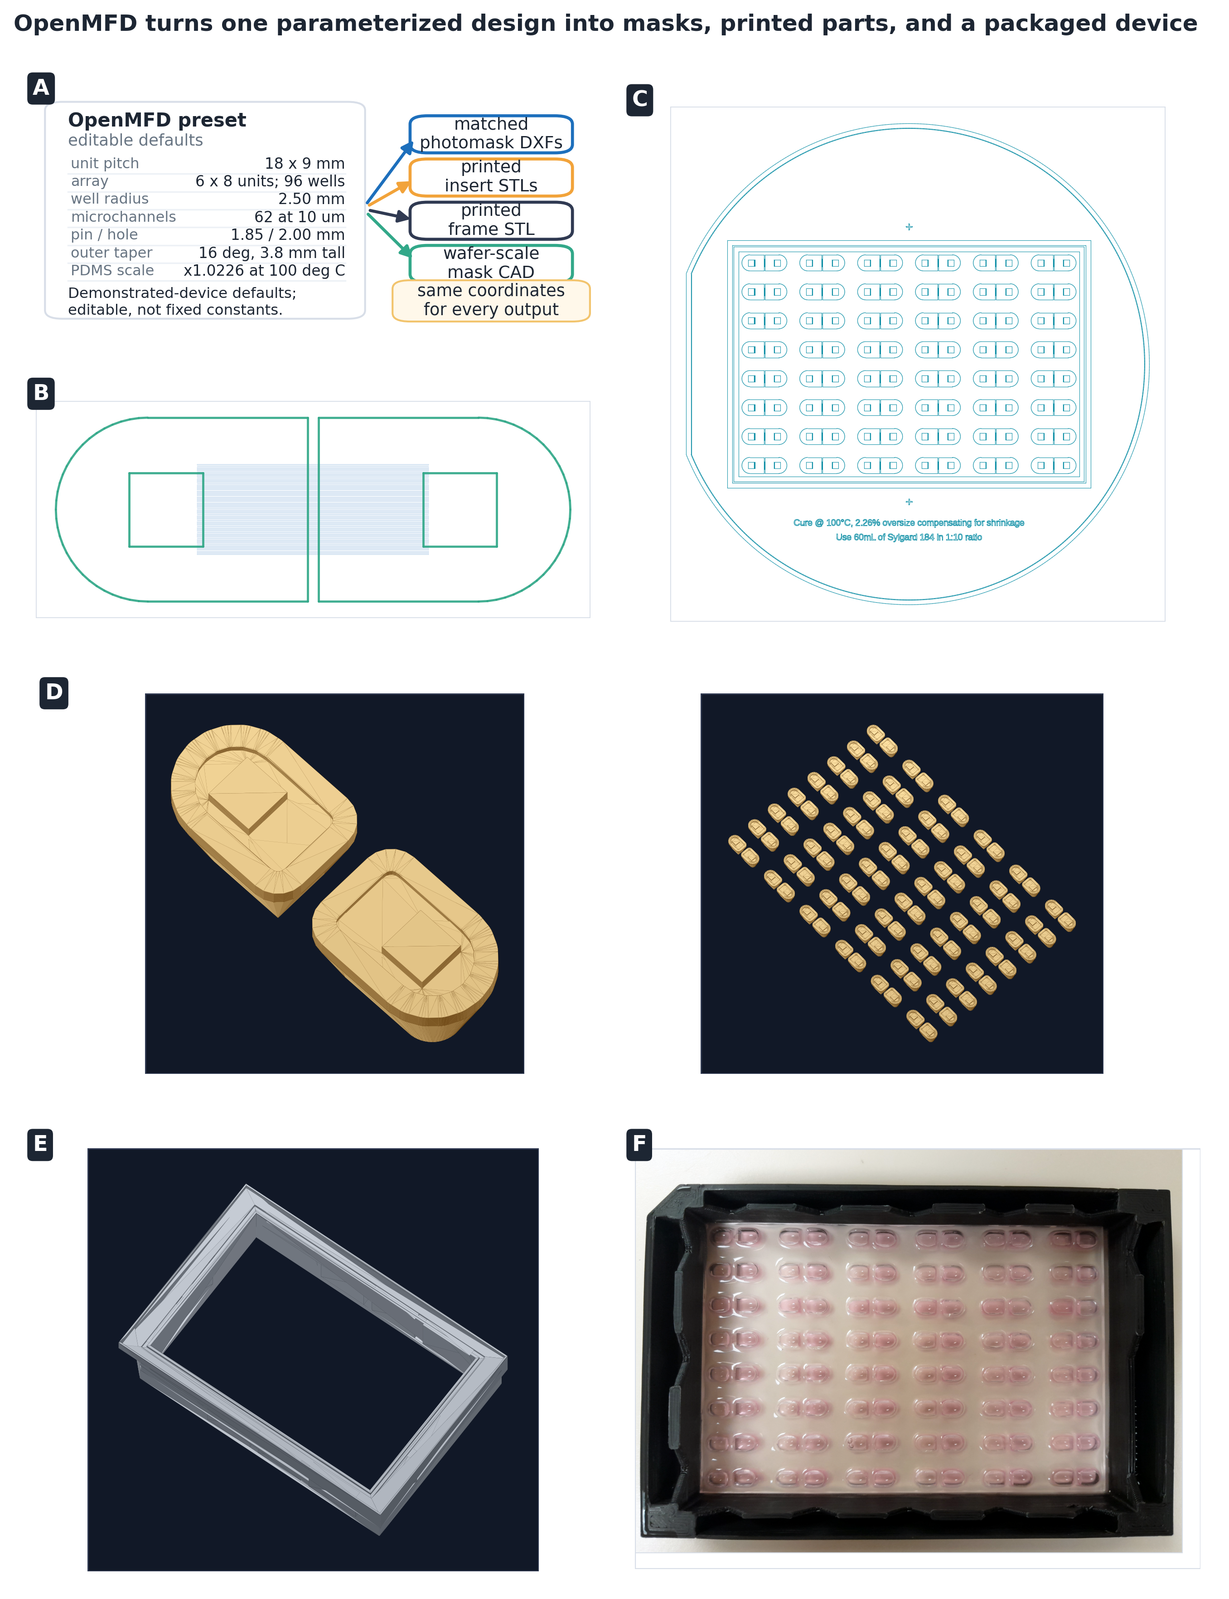
Figure 1: Shared device dimensions connect photomask and insert design to plate assembly. (A) Editable preset containing the shared device dimensions. (B, C) Single-device and wafer-scale photomask DXFs. (D) Single and arrayed 3D-printable resin-insert models. (E) Plate-frame model. (F) Assembled plate-format device.
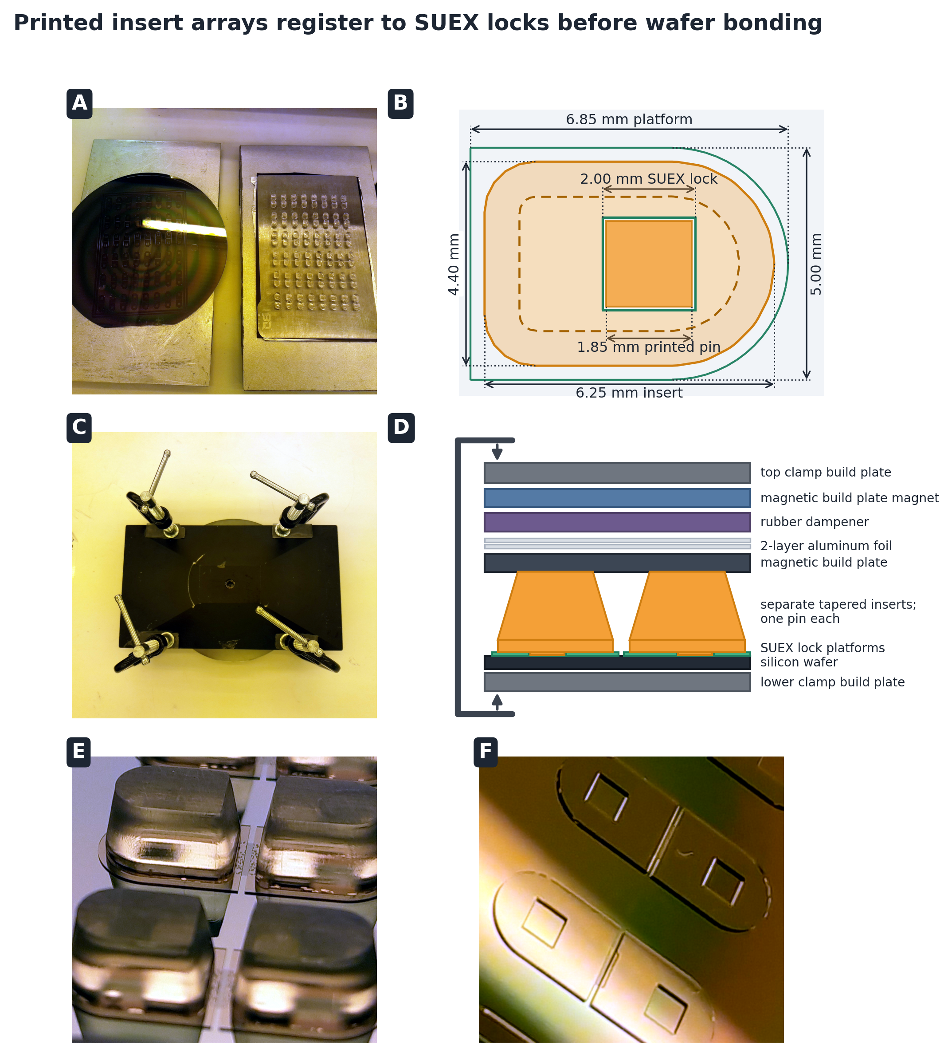
Figure 2: Insert transfer and wafer bonding for the hybrid mold. (A) Wafer and 3D-printed resin insert array before clamping. (B) Top view showing the relative positions of the printed insert, SUEX alignment hole, adhesive contact area, and gap around the alignment pin. (C) Clamped assembly used for acetone washing and room-temperature cure. (D) Side view of the clamping layers, including the compressible EPDM rubber sheet. (E) Bond between a resin insert and the wafer. (F) SUEX alignment-hole micrograph.
Figure 3: Repeated PDMS device casting and plate assembly. PDMS is poured over the full hybrid mold within an aluminum-foil reservoir, degassed in a cylindrical vacuum chamber, and cured in a six-shelf wafer rack. The circular cast is demolded, placed with the molded channels facing upward, taped to paper along the cutting guides, and trimmed with a paper guillotine. The trimmed device is plasma-bonded to glass and autoclaved at 121°C for 15 min before frame assembly. The frame is inverted with its adhesive groove facing upward, and the device is seated with the glass facing upward. After a 3-day room-temperature cure, the assembled plate is turned upright and plasma-treated before coating and culture. One-time mold fabrication is detailed in Supplementary Protocol S2.
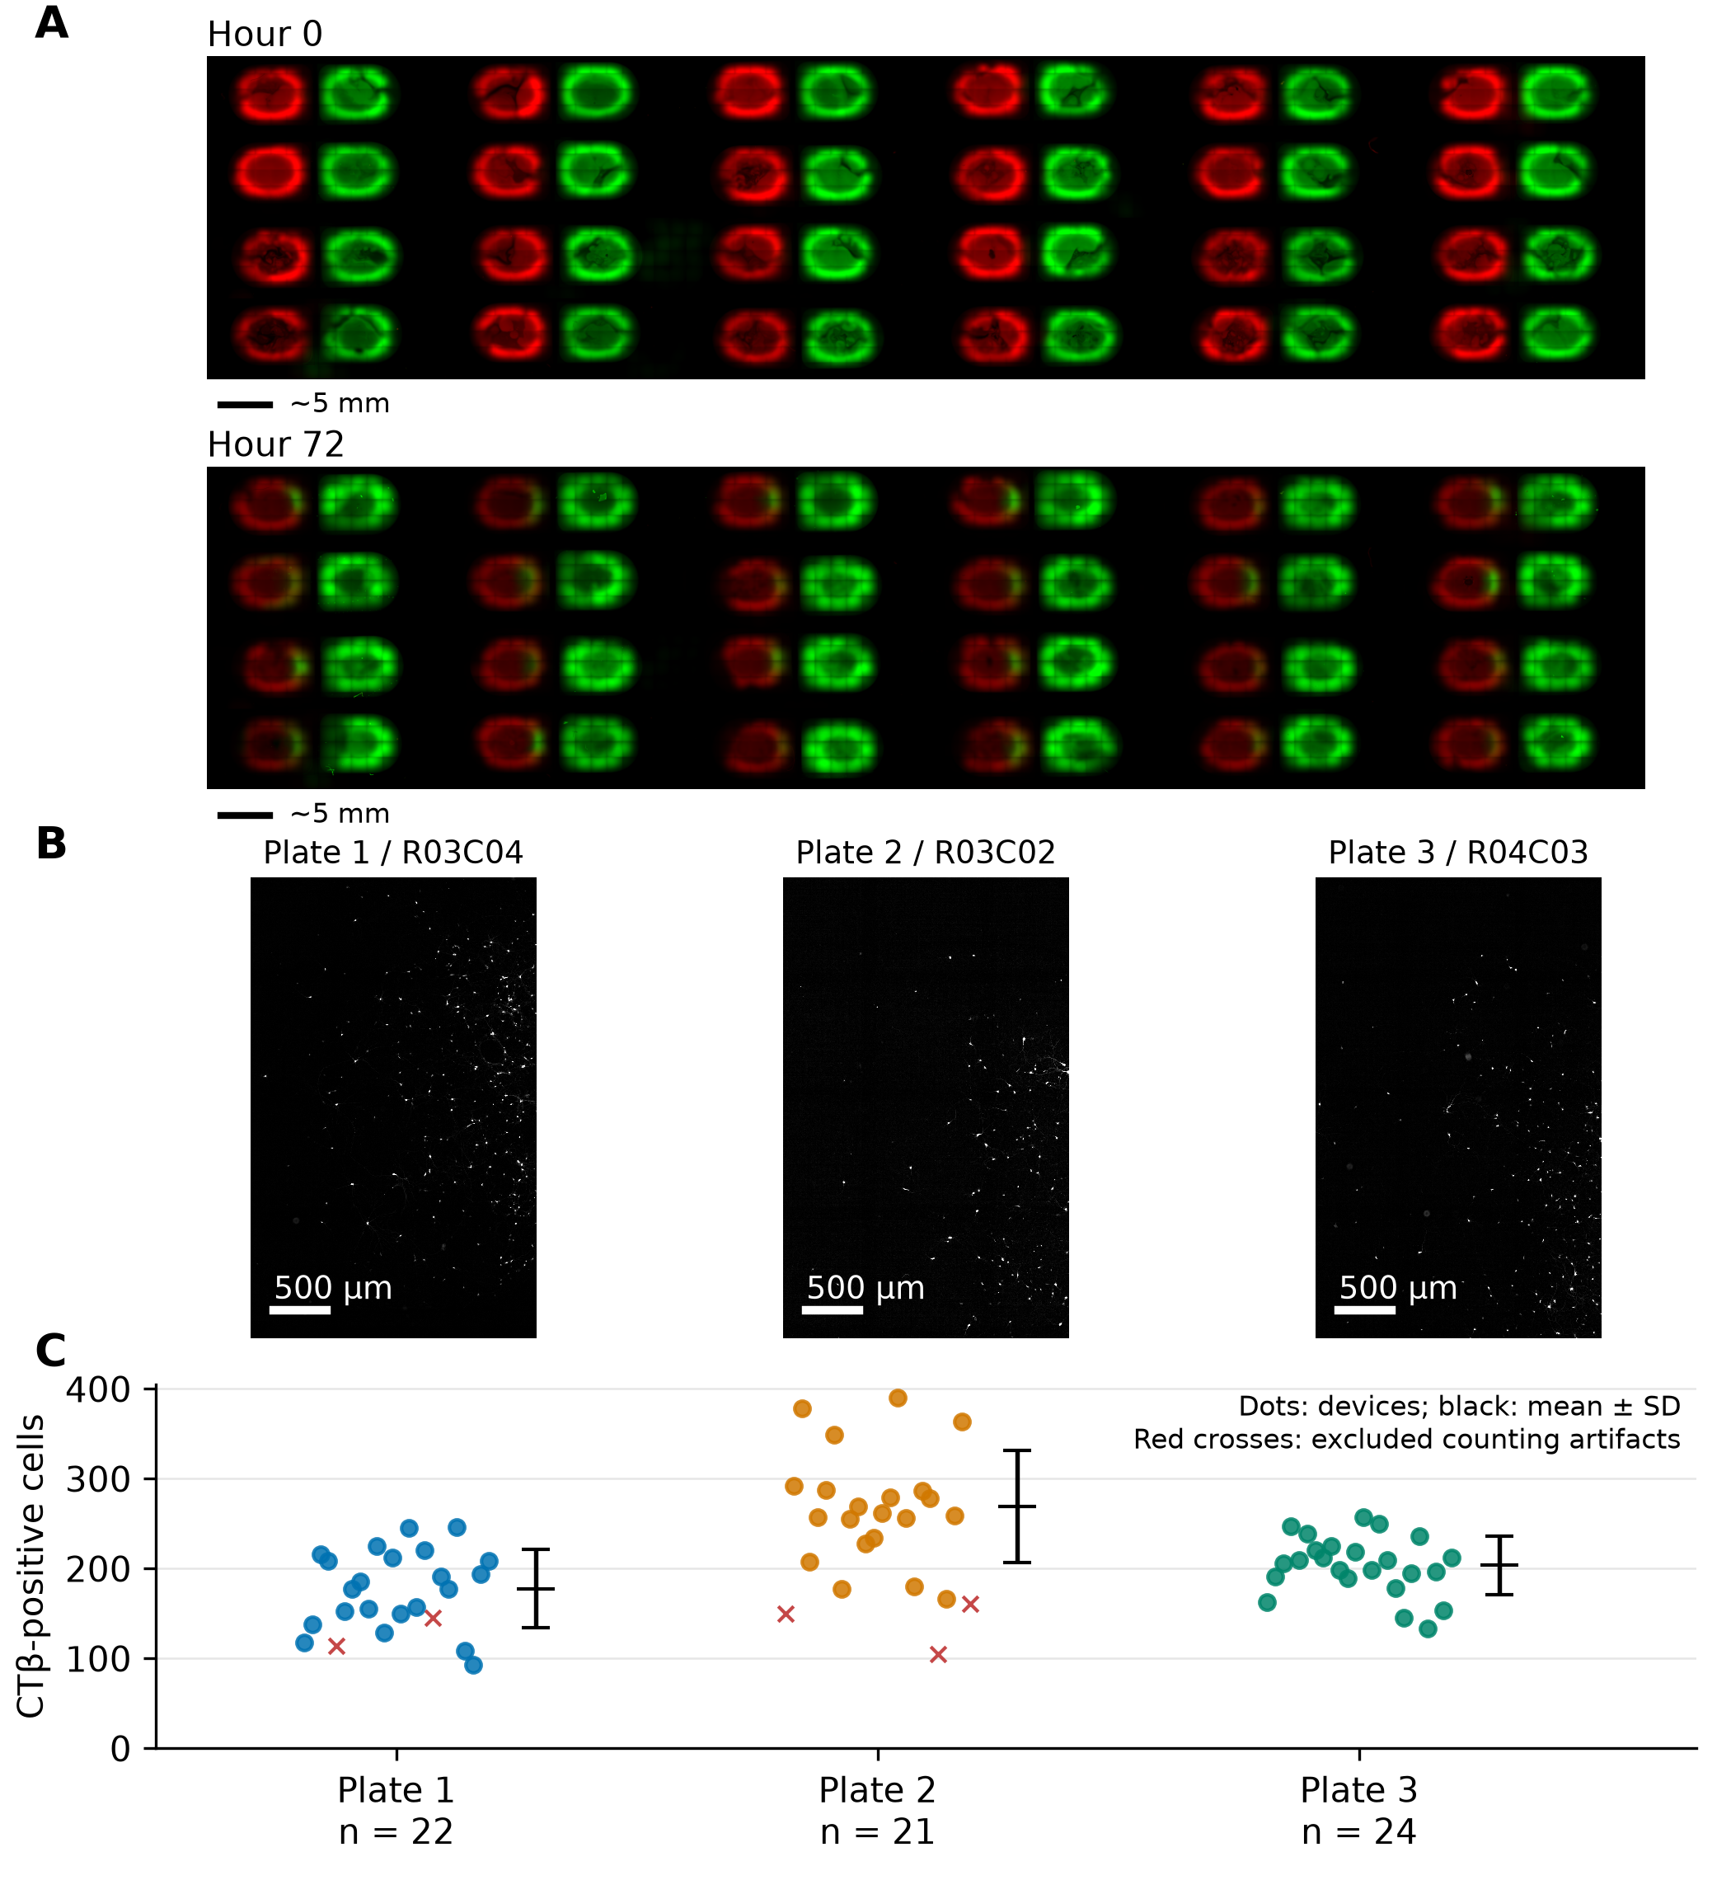
Figure 4: Directional fluid movement and neuronal compatibility. (A) Twenty-four devices at loading and after 72 h without volume adjustment. Alexa Fluor 568-conjugated secondary antibody (red; 25 µL) was loaded into the left compartment and Alexa Fluor 488-conjugated secondary antibody (green; 50 µL) into the right, each at 1:1000 in PBS. Devices were incubated between images. Bars: approximately 5 mm, estimated from the known 9 mm well-centre spacing within one device. (B) Representative CTβ-647 images at DIV11, one device per plate. Bars: 500 µm, calibrated using acquisition metadata. Background subtraction and contrast normalization are for display. (C) Individual CTβ-positive cell-body counts from three technical-replicate plates derived from one E18 rat embryo. Black marks: mean ± SD across 22, 21, 24 included devices on Plates 1–3 (67 total). Red crosses: five flagged counting artifacts, excluded from the summaries. Supplementary Table S7 gives all 72 counts.
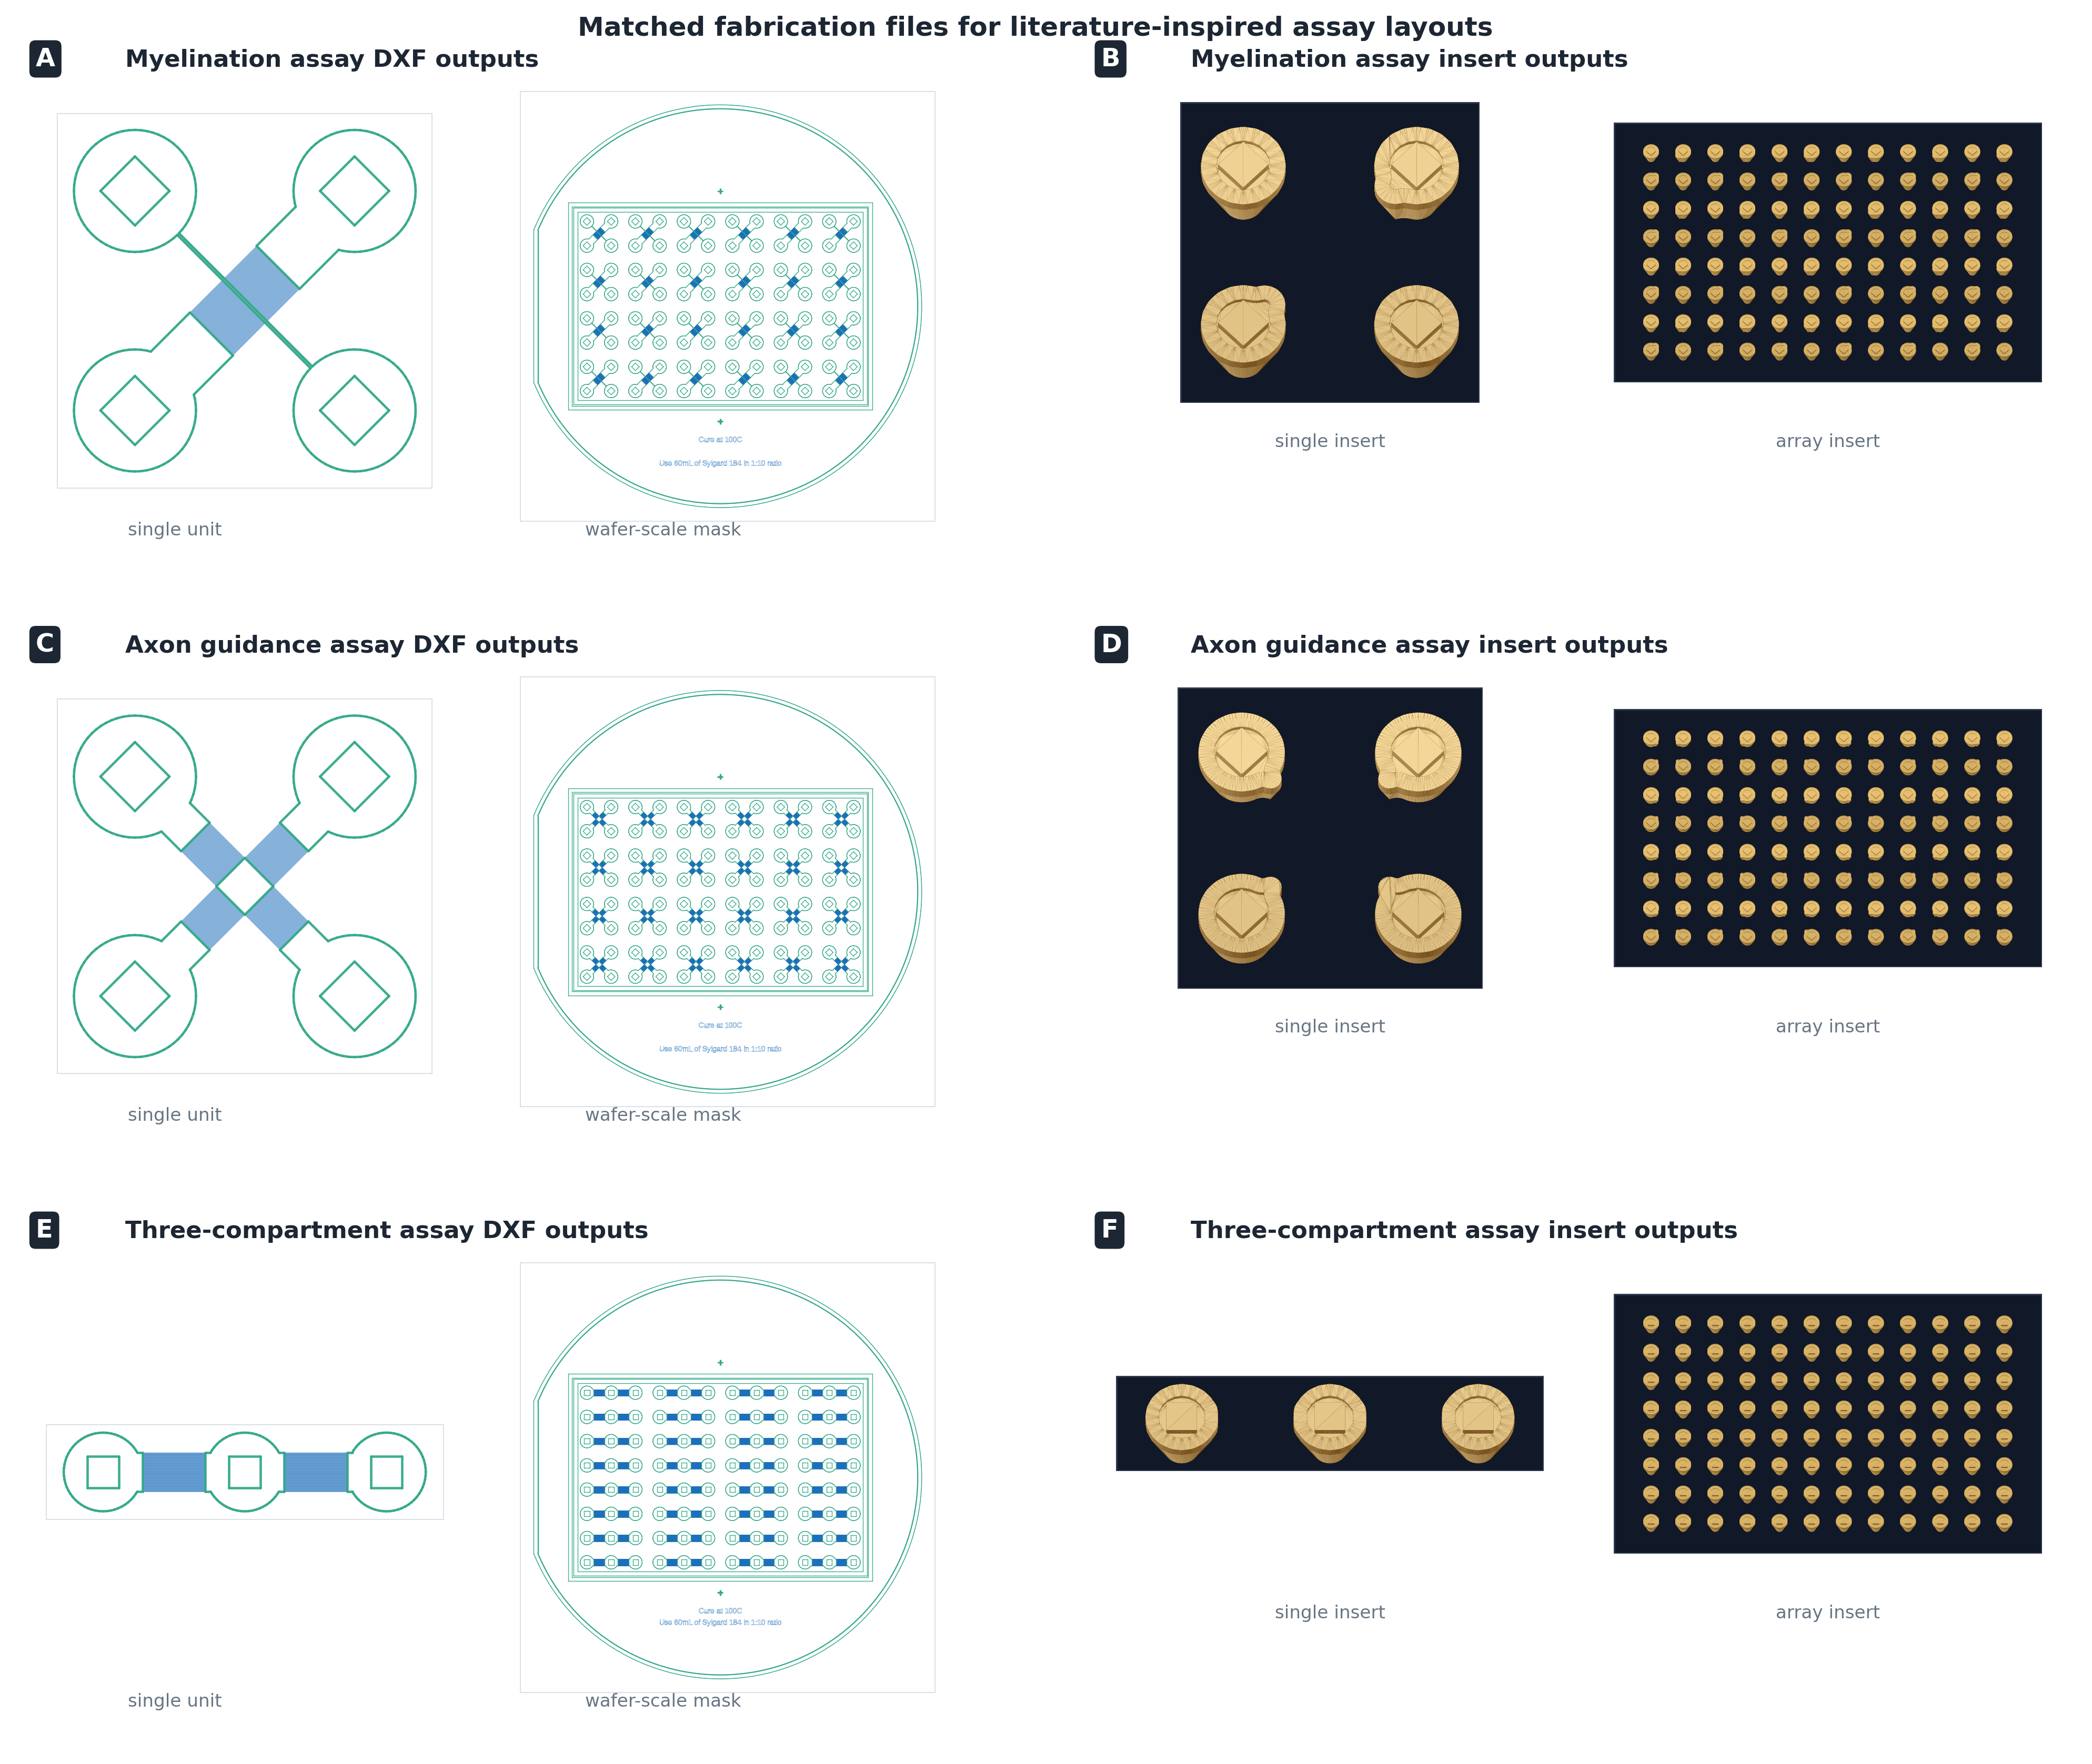
Figure 5: Matching photomasks and insert arrays generated from shared dimensions for three literature-inspired layouts. (A, C, E) Single-device and wafer-scale photomask DXFs; (B, D, F) single and arrayed resin-insert renderings. The examples are an oligodendrocyte myelination layout inspired by Kerman et al. (2015) (A, B), an axon-guidance layout with gradients at right angles to each other inspired by Taylor et al. (2015) (C, D), and a three-compartment layout inspired by Coquinco et al. (2014) (E, F). Plate-frame outputs are omitted for clarity. Physical fabrication and assay testing of these generated designs remain future work.

Supplementary Information

Supplementary Table S1. Resin-insert pin-height variation across a 96-position array
Each pin height was measured individually with a micrometer across one 8 × 12 resin-insert array (rows A-H, columns 1-12; n = 96). Values are reported in millimeters (mm) and as deviations from the mean in micrometers (µm).
- Mean height: 5.551 mm
- Standard deviation: 26.7 µm
- Minimum / maximum height: 5.483 mm (H12) / 5.599 mm (A3, A4, and A6)
- Difference between tallest and shortest pins: 116 µm

S1A. Measured pin heights (mm)
Row | 1 | 2 | 3 | 4 | 5 | 6 | 7 | 8 | 9 | 10 | 11 | 12
A | 5.567 | 5.588 | 5.599 | 5.599 | 5.591 | 5.599 | 5.598 | 5.598 | 5.597 | 5.596 | 5.581 | 5.562
B | 5.557 | 5.588 | 5.591 | 5.591 | 5.592 | 5.588 | 5.593 | 5.592 | 5.592 | 5.591 | 5.587 | 5.562
C | 5.555 | 5.556 | 5.555 | 5.563 | 5.563 | 5.556 | 5.560 | 5.557 | 5.560 | 5.560 | 5.558 | 5.555
D | 5.549 | 5.552 | 5.552 | 5.555 | 5.552 | 5.552 | 5.549 | 5.552 | 5.549 | 5.552 | 5.550 | 5.545
E | 5.543 | 5.546 | 5.549 | 5.550 | 5.547 | 5.547 | 5.548 | 5.544 | 5.544 | 5.543 | 5.536 | 5.532
F | 5.522 | 5.531 | 5.548 | 5.544 | 5.540 | 5.540 | 5.543 | 5.542 | 5.536 | 5.531 | 5.528 | 5.522
G | 5.519 | 5.528 | 5.542 | 5.543 | 5.536 | 5.535 | 5.538 | 5.538 | 5.532 | 5.529 | 5.521 | 5.501
H | 5.499 | 5.516 | 5.525 | 5.525 | 5.521 | 5.520 | 5.529 | 5.517 | 5.517 | 5.503 | 5.495 | 5.483

S1B. Deviation from mean (µm)
Row | 1 | 2 | 3 | 4 | 5 | 6 | 7 | 8 | 9 | 10 | 11 | 12
A | +16.2 | +37.2 | +48.2 | +48.2 | +40.2 | +48.2 | +47.2 | +47.2 | +46.2 | +45.2 | +30.2 | +11.2
B | +6.2 | +37.2 | +40.2 | +40.2 | +41.2 | +37.2 | +42.2 | +41.2 | +41.2 | +40.2 | +36.2 | +11.2
C | +4.2 | +5.2 | +4.2 | +12.2 | +12.2 | +5.2 | +9.2 | +6.2 | +9.2 | +9.2 | +7.2 | +4.2
D | -1.8 | +1.2 | +1.2 | +4.2 | +1.2 | +1.2 | -1.8 | +1.2 | -1.8 | +1.2 | -0.8 | -5.8
E | -7.8 | -4.8 | -1.8 | -0.8 | -3.8 | -3.8 | -2.8 | -6.8 | -6.8 | -7.8 | -14.8 | -18.8
F | -28.8 | -19.8 | -2.8 | -6.8 | -10.8 | -10.8 | -7.8 | -8.8 | -14.8 | -19.8 | -22.8 | -28.8
G | -31.8 | -22.8 | -8.8 | -7.8 | -14.8 | -15.8 | -12.8 | -12.8 | -18.8 | -21.8 | -29.8 | -49.8
H | -51.8 | -34.8 | -25.8 | -25.8 | -29.8 | -30.8 | -21.8 | -33.8 | -33.8 | -47.8 | -55.8 | -67.8

Supplementary Table S2. Multiscale microfluidic fabrication strategies
Representative strategies for combining micrometer-scale features with millimeter-scale wells or other tall structures are summarized below. The comparison emphasizes the operations and equipment each strategy adds to conventional PDMS soft lithography. Abbreviations: poly(methyl methacrylate) (PMMA); cyclic olefin copolymer (COC); computer numerical control (CNC); American National Standards Institute (ANSI); Society for Laboratory Automation and Screening (SLAS).
Approach | Micrometer-scale features | Millimeter-scale wells or tall structures | Plate-format and automation compatibility | Added workflow and equipment | Representative references
Conventional PDMS soft lithography with manual punching | SU-8 photolithography for micrometer-scale channels | Openings made with a biopsy punch after casting | Each opening is made separately after casting | Biopsy punching and manual debris removal during every device-production cycle | Baseline approach; see Taylor et al., 2005
Carbon dioxide (CO2) laser micromachining of PDMS | Maskless laser-ablated trenches whose profile depends on power, pulse density, and traverse speed | Laser-ablated PDMS channels rather than cast well features | Computer-controlled but serial processing of PDMS sheets | CO2 laser processing during each device-production cycle | Holle et al., 2007
Hybrid micro- and millimeter-scale mold via milling and hot embossing | Hot embossing for microfeatures | PMMA-milled large structures | Batch device production from a reusable PDMS mold | Milling, hot embossing, and a workflow involving several molds | Park et al., 2010
Thick SU-8 molding and photolithography | Photolithography on a molded SU-8 surface | Millimeter structures molded from a 3D-printed pattern through an intermediate PDMS mold | Continuous micro- and millimeter-scale structures | Printed-pattern preparation, intermediate molding, and multi-step SU-8 handling | Tamura and Suzuki, 2019
Direct 3D printing of PDMS onto a photolithographic mold | Photolithographic mold for microchannels | Printed PDMS walls or compartments | Automated deposition of selected large structures | PDMS-printing hardware, material formulation, and print control during production | Kajtez et al., 2020
Resin-printed molds and parts retained in the finished device | Printed molds form the PDMS microstructures | A separate printed cap defines and closes the culture chambers | Eight parallel chambers aligned to a 96-well plate grid for robotic and microscope compatibility | Printer and resin selection, post-treatment, mixed-material assembly, and perfusion hardware | Meynard et al., 2025
Aligned resin printing onto patterned chips | SU-8 lithography on diced chips | Resin-printed micro- and millimeter-scale 3D features | Aligned structures on individual chips | Chip dicing, resin-printing equipment, and chip-level alignment fixtures | Pan et al., 2022
3D-printed inserts bonded to SU-8 | SU-8 photolithography for micrometer-scale features | Tall 3D-printed metal inserts bonded with epoxy | Open cell compartments at individual-device scale | Metal 3D printing and individual alignment and bonding of three inserts on each mold | Ristola et al., 2019
Hard-plastic microtiter microfluidic plates | Hot-embossed microchannels in COC | CNC-milled wells or compartments with fusion bonding | ANSI/SLAS-compatible automated plate format | CNC milling, hot embossing, layer alignment, and fusion bonding | Moll et al., 2024
Commercial microfluidic titer plates | Proprietary phaseguide-based microfluidics | Proprietary | 384-well plate footprint containing 40 tissue-culture chips | Commercial procurement and vendor-defined geometries | Spijkers et al., 2021
This work: wafer-bonded resin well inserts with SU-8/SUEX features | SU-8/SUEX photolithography for micrometer-scale features | An aligned resin insert array is bonded once to the reusable mold; all wells form during casting | Standard plate dimensions and 9 mm well grid; demonstrated with high-content imaging and autofocus | Resin-array printing, one-time alignment and bonding, and parylene coating of the reusable mold; repeated device production uses PDMS casting and glass bonding | This work

Supplementary Table S3. Design parameters and validation checks
The tested design used two-well device units spaced 18 × 9 mm apart and a 200 µm SUEX well layer. These values provide starting points for new layouts. Changes to gaps, margins, taper allowances, and adhesive contact areas require testing to determine which values work reliably.
These dimensions connect the printed and photolithographic parts of the mold. Shared coordinates place the pins over their matching holes, while their sizes set the alignment clearance. The insert skirt provides space for adhesive, and taper affects both demolding and well capacity. The same shrinkage correction is applied to the masks and inserts to preserve their relative positions and sizes.
Design feature | Value used here | Allowance included in the design | Changes that require testing
Device and well spacing | 6 × 8 two-well units (48 devices, 96 wells); device units spaced 18 × 9 mm apart; wells at ±4.5 mm from the unit center | Well centers remain on a 9 mm grid, so each two-well unit occupies two plate columns by one plate row | Any non-9 mm well spacing, nonstandard device spacing, or layout intended for a different liquid handler or imager
Device and frame dimensions | 108 × 72 mm device array on a 110 × 74 mm glass outline; 150 mm wafer with a 57.5 mm flat | The glass provides a 1 mm designed margin on each side of the device array; wafer, cutting, and frame outlines are generated from the same dimensions | Smaller glass margins, larger arrays, a different wafer diameter, or manually edited cutting or frame outlines
Alignment of wells, chambers, and channels | 2.5 mm well radius; 5.0 mm chamber width; 62 channels with 10 µm width and 30 µm spacing | The channel array is 2.45 mm wide, leaving a 1.275 mm chamber margin on each side; chamber and insert dimensions are derived from the same channel measurements | Narrower channel gaps, wider channel arrays, smaller chambers, or channels placed closer to insert or adhesive-contact regions
Separation of fabrication layers | 5 µm SU-8 microchannel layer plus 200 µm SUEX well and alignment-hole layer | The microchannels and taller well features are fabricated as separate aligned layers using matching solid and hollow alignment marks | Combining layers, changing SUEX thickness, or moving alignment holes into the microchannel layer
Insert alignment | 1.85 × 1.85 mm printed pins seated in 2.0 × 2.0 mm SUEX holes | 150 µm total side-to-side clearance, or 75 µm per side, between the printed pins and wafer holes | Smaller gaps between pins and holes, different resin or printer settings, or smaller alignment features
Insert seating across the array | Measured pin-height variation of 116 µm between the lowest and highest pins; compressible EPDM rubber sheet used during clamping | The clamping layers must accommodate at least the measured height variation so all pins can seat before the epoxy cures | Larger height variation across a print, stiffer clamping layers, or omission or replacement of the compressible layer
Insert taper and demolding | 3.8 mm insert height; 16° outer taper; 0.300 mm extra taper allowance | The taper reduces each side by 1.39 mm from bottom to top; this preserves wall thickness while avoiding vertical outer walls | Steeper walls, smaller wells or chambers after applying the taper, or less taper
Well size, depth, and working volume | Safe maximum working volume of 50 µL per well in the present plate | At the fixed 9 mm spacing, taper and interwell wall thickness constrain well width and depth. The array fits the selected 110 × 74 mm glass sheet; enlarging the wells would require larger, substantially more expensive custom-cut glass | Applications requiring more than 50 µL per well: revise well geometry and check demolding, array and glass dimensions, handling, and cost
Skirt and adhesive contact area | Two-step skirt: 0.75 × 0.66 mm plus 0.80 × 0.04 mm | Provides an approximately 0.75–0.80 mm-wide recessed contact and sealing area around the insert while keeping adhesive away from microchannels | Smaller contact areas, different epoxy viscosity, or layouts with channels closer to the insert edge
PDMS shrinkage compensation | 1.0226 horizontal scale factor for the 100°C cure used here | The same 2.26% enlargement is applied to matching masks and inserts, keeping them aligned after thermal curing | A different cure temperature, PDMS formulation, or independent scaling of only one output file
Parylene coating and channel dimensions | 1 µm parylene C; nominal channel width of 10 µm before coating | A uniform coating adds approximately 2 µm to ridge width. Relative ridge height remains approximately unchanged because the ridge top and surrounding base both receive coating. Final cast dimensions also depend on PDMS shrinkage | Measure coated ridge and cast dimensions to establish a coating-thickness correction; this correction is not yet included in the generator

S3B. Fabrication checks for the Figure 5 layouts
For each literature-inspired layout in Figure 5, OpenMFD generated corresponding mask, insert, wafer, and frame files using the same method as for the neuronal device. These layouts have not been fabricated or experimentally validated. Their dimensions determine the first-fabrication checks listed below.
Layout | Device spacing and array | Well radius | Microchannel summary | What was tested | Checks when first fabricating the design
Demonstrated compartmentalized-neuron device | 18 × 9 mm; 6 × 8 two-well units | 2.5 mm | 62 channels with 10 µm width and 30 µm spacing | Fabricated, cast, assembled, imaged, and used for neuronal culture in analyzed interior devices | Baseline demonstrated workflow
Myelination-inspired layout | 18 × 18 mm; 6 × 4 units | 2.5 mm | 125 channels at 10 µm plus an oligodendrocyte branch | Complete matched fabrication files generated | Confirm the different device spacing, crossing layout, higher channel count, and assay-specific operation
Axon-guidance layout | 18 × 18 mm; 6 × 4 units | 2.5 mm | 83 channels at 10 µm per arm | Complete matched fabrication files generated | Confirm the different device spacing, orthogonal-gradient layout, and assay-specific operation
Three-compartment layout | 27 × 9 mm; 4 × 8 units | 2.5 mm | Two successive channel arrays with 125 channels at 10 µm per array | Complete matched fabrication files generated | Confirm the three-well unit, different device spacing, successive channel arrays, and assay-specific operation

Supplementary Table S4. Resin insert 3D-printing and post-processing settings
These settings were used to print the wafer-bonded resin inserts. Validate alternative printers, resins, and slicer profiles for local print quality and fit.

Printer and resin
Parameter | Setting
Resin | Siraya Tech Sculpt Clear high-temperature resin
Printer | Elegoo Mars 3 Pro
Build plate / transfer fixture | Magnetic removable build plate
Slicer profile name | Siraya High Temp

Print profile
Parameter | Setting
Layer height | 0.020 mm
Bottom layer count | 7
Exposure time | 5.500 s
Bottom exposure time | 50.000 s
Transition layer count | 0
Transition type | Linear
Waiting mode during printing | Resting time
Rest time before lift | 0.300 s
Rest time after lift | 1.000 s
Rest time after retract | 3.000 s
Bottom lift distance | 3.000 + 0.000 mm
Lifting distance | 4.000 + 0.000 mm
Bottom retract distance | 3.000 + 0.000 mm
Retract distance | 4.000 + 0.000 mm
Bottom lift speed | 5.000 + 0.000 mm/min
Lifting speed | 30.000 + 0.000 mm/min
Bottom retract speed | 5.000 + 0.000 mm/min
Retract speed | 30.000 + 0.000 mm/min

Advanced slicer settings
Parameter | Setting
Bottom light pulse-width modulation (PWM) | 255
Light PWM | 255
Anti-aliasing | Enabled
Grey level | 2
Image blur | Disabled
Shrinkage compensation | Disabled
Tolerance compensation (beta) | Disabled
Bottom tolerance compensation | Disabled
Print time compensation | Disabled

Post-processing
- Spray the printed inserts with acetone.
- Blow dry with compressed high-pressure nitrogen.
- Repeat the acetone spray and nitrogen drying cycle until the pin features are completely clean of residual resin. In this work, cleaning required 6–8 cycles.
- Remove the flexible metal plate from the printer build plate.
- Place the print inside an Elegoo Mercury X rotating UV cure station.
- UV cure for 15 min.

Supplementary Table S5. Hybrid-mold use and PDMS-cast outcomes
This table summarizes mold use with the finalized protocol. Process-development observations are reported in the Results and Supplementary Notes S1-S2.
Stage or outcome | Observed count | Interpretation
Molds assembled using the final protocol | 5 | Five wafer-scale molds completed insert bonding and final assembly.
Molds entering routine use | 3 | These molds produced usable PDMS casts with open microchannels and retained well features.
Wafer assemblies lost during casting or handling | 2 | One wafer broke during demolding. Leaked PDMS cured beneath a second wafer in the casting rack.
Usable PDMS casts from the three routinely used molds | More than 50 | PDMS casts demolded intact with open wells and preserved microchannel regions; inserts remained bonded and SU-8/SUEX features remained attached to the reusable mold. Casts were classified by inspection, not by measuring their dimensions.
Mold use duration | More than 8 months | The most recent molds remained active for more than 8 months and retained their visible condition at the time of manuscript preparation.

Supplementary Table S6. HIPS frame-printing settings
These settings were used to print the frame generated by OpenMFD. The complete Creality Print 6.0.4 configuration is embedded in the distributed G-code file UPGRADE_96_well_plate_reservoirs_print_hips_2_chamfered_v2_HIPS_3h36m.gcode. When using other printers, slicers, or materials, check for warping, correct fit, an unbroken adhesive groove, and a leak-tight seal around the device.
Parameter | Setting
Printer | Creality K1C, enclosed
Slicer | Creality Print 6.0.4.1795
Filament | Generic HIPS, 1.75 mm diameter
Nozzle | 0.4 mm brass
Layer height | 0.20 mm
First-layer height | 0.20 mm
Nozzle temperature | 220°C, first and subsequent layers
Build-plate temperature | 100°C, first and subsequent layers
Part cooling | Disabled
Wall loops | 2
Top layers | 5 (0.8 mm)
Bottom layers | 3
Sparse infill | 15% grid
Supports | Disabled
Build-plate adhesion | 5 mm outer brim, 0 mm object gap
Outer-wall speed | 200 mm/s
Inner-wall speed | 300 mm/s
Sparse-infill speed | 270 mm/s
Top-surface speed | 200 mm/s
Initial-layer speed | 60 mm/s
Travel speed | 500 mm/s
Maximum filament volumetric speed | 5 mm³/s
Printed height / layer count | 17.0 mm / 85 layers

Supplementary Table S7. DMSO-only CTβ-positive cell-body counts
Baseline counts from the February 2026 experiment. * marks the five counting-artifact exclusions; their values remain listed. Means and SDs use unflagged devices. All three plates came from one E18 rat embryo.
Device | Plate 1 | Plate 2 | Plate 3
R02C02 | 118 | 150* | 163
R02C03 | 186 | 177 | 212
R02C04 | 157 | 390 | 250
R02C05 | 93 | 259 | 197
R03C02 | 114* | 257 | 210
R03C03 | 212 | 234 | 219
R03C04 | 177 | 278 | 195
R03C05 | 138 | 292 | 191
R04C02 | 155 | 255 | 225
R04C03 | 221 | 256 | 210
R04C04 | 194 | 364 | 154
R04C05 | 153 | 288 | 239
R05C02 | 150 | 262 | 257
R05C03 | 246 | 105* | 236
R05C04 | 216 | 378 | 206
R05C05 | 225 | 269 | 199
R06C02 | 145* | 180 | 178
R06C03 | 209 | 161* | 212
R06C04 | 177 | 349 | 221
R06C05 | 245 | 279 | 199
R07C02 | 109 | 166 | 133
R07C03 | 209 | 208 | 247
R07C04 | 129 | 228 | 189
R07C05 | 191 | 287 | 145
Included n | 22 | 21 | 24
Mean ± SD | 177.7 ± 43.7 | 269.3 ± 62.3 | 203.6 ± 32.4

Supplementary Table S8. Apparent connecting-microchannel widths
Three rulers per device in original field 1, brightfield channel 1. Widths span opposing dark wall-band centres at 1.18675253 µm/pixel from each acquisition's Index.xml. Moving both endpoints by one pixel changes the span by up to 2.37 µm; blur also affects boundary placement. No channel depth was measured.
Ruler | Plate / device | Endpoints (x, y), pixels | Pixels | Width (µm)
M01 | P1 / R02C02 | (80, 194)–(80, 204) | 10 | 11.9
M02 | P1 / R02C02 | (80, 228)–(80, 237) | 9 | 10.7
M03 | P1 / R02C02 | (80, 260)–(80, 271) | 11 | 13.1
M04 | P2 / R02C02 | (600, 183)–(600, 192) | 9 | 10.7
M05 | P2 / R02C02 | (600, 216)–(600, 225) | 9 | 10.7
M06 | P2 / R02C02 | (600, 249)–(600, 258) | 9 | 10.7
M07 | P3 / R02C02 | (500, 183)–(500, 192) | 9 | 10.7
M08 | P3 / R02C02 | (500, 216)–(500, 225) | 9 | 10.7
M09 | P3 / R02C02 | (500, 249)–(500, 259) | 10 | 11.9
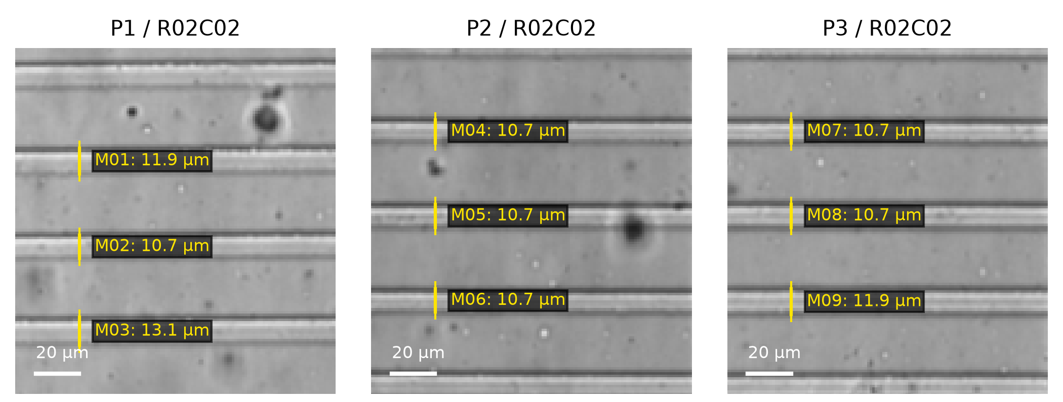
Supplementary Figure S3. Brightfield channel-width measurements. Yellow rulers M01–M09 join opposing dark wall-band centres in the three original field-1 crops listed in Table S8. Images are contrast-stretched for display; measurements use original pixel coordinates. White bars: 20 µm.

Supplementary Note S1. LP360 long-pass filter improves SUEX K200 top-surface flatness
During development of the 200 µm SUEX K200 layer, unfiltered exposure produced ridge-like artifacts around patterned features. These ridges interrupted the seal between the printed inserts and the mold, allowing epoxy to reach nearby SU-8 features and weakening the insert bond.
Exposure through an LP360 long-pass filter substantially reduced the ridges and produced a flatter bonding surface.
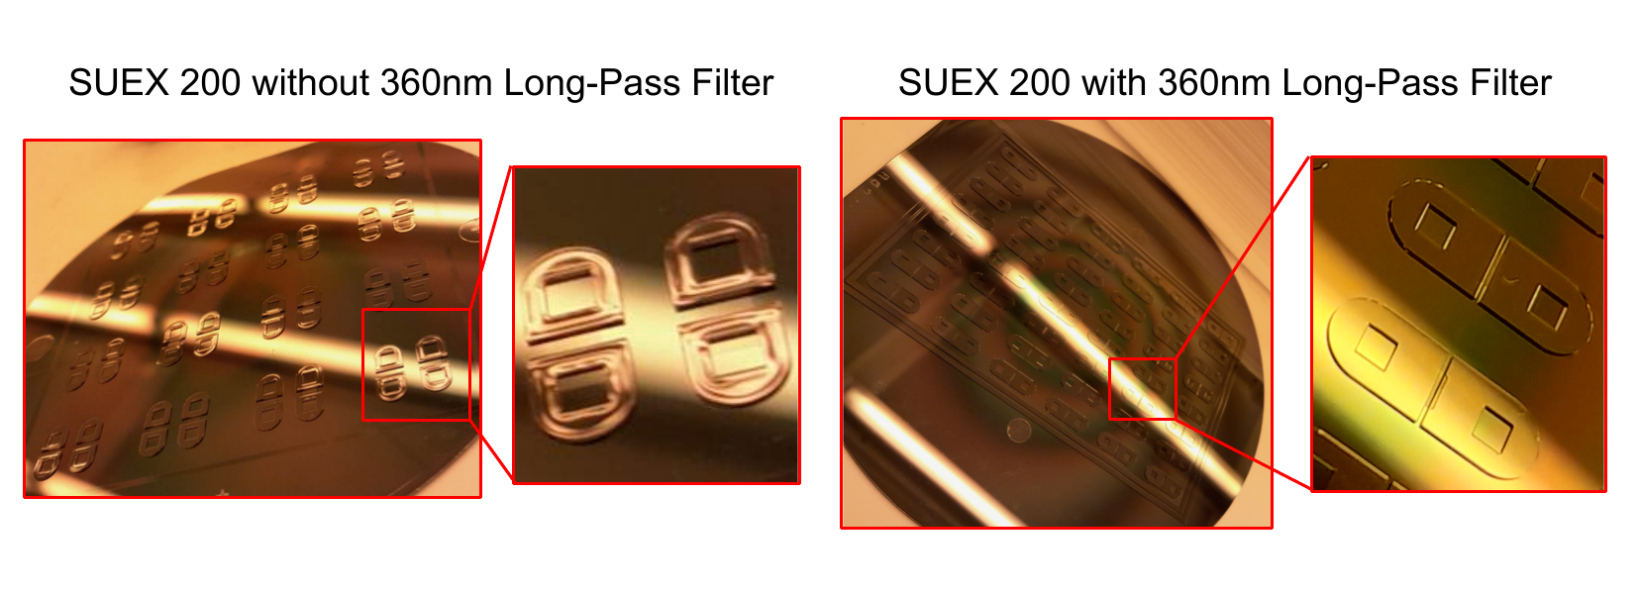
Supplementary Figure S1. SUEX K200 features after unfiltered exposure (left) and LP360-filtered exposure (right). Ridge-like edge artifacts are visible after unfiltered exposure and substantially reduced with the filter. The images provide a qualitative process-development comparison.

Supplementary Note S2. SU-8 base-layer adhesion and pre-SUEX hard bake
SU-8 microchannels patterned directly on bare silicon at a target thickness of 5 µm delaminated during development or subsequent processing.
A 5 µm flood-exposed SU-8 2005 base layer was therefore added before the patterned microchannel layer. The base layer is exposed without a mask and is not developed. It provides sufficient adhesion without a dehydration bake or HMDS treatment.
The developed two-layer SU-8 stack also requires a 10 min hard bake at 150°C before SUEX lamination. No controlled ramp up or cooldown is used because the combined SU-8 stack is approximately 10 µm thick. Eight wafers were processed in parallel during one process-development batch in which this hard bake was inadvertently omitted. Stress during cooling after subsequent SUEX processing caused the SU-8 stack to warp and delaminate around well features on part of the batch, although some wafers remained intact. A subsequent two-wafer batch included the 150°C hard bake, and both wafers remained intact. These observations distinguish adhesion to bare silicon, addressed by the flood-exposed base layer, from stabilization of the completed SU-8 stack before SUEX processing.
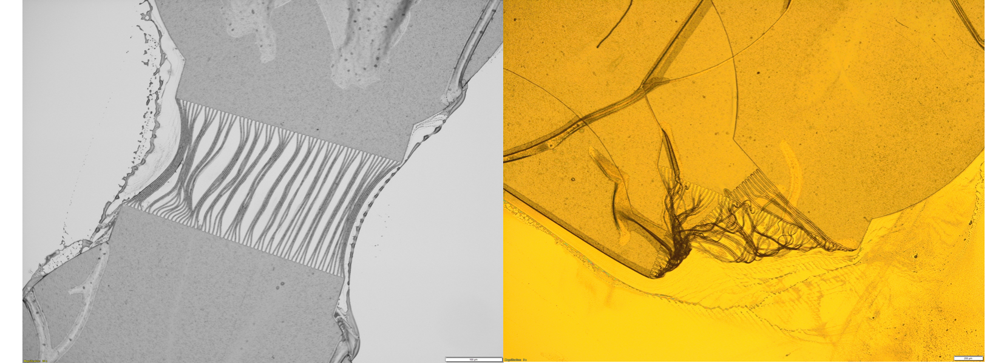
Supplementary Figure S2. Representative optical micrographs of SU-8 microchannel delamination when features were patterned directly on bare silicon without the flood-exposed base layer. Scale bars: 100 µm (left) and 200 µm (right).

Supplementary Protocol S1. Post-mold device assembly, primary cortical neuron culture, and CTβ retrograde axon tracing

Scope
This protocol covers PDMS casting from the parylene-coated hybrid mold, plate assembly, neuronal culture, and imaging. The assays measure tracer movement between compartments and count CTβ-positive neuronal cell bodies in each device.
The plate contains 48 two-compartment devices and 96 pipette-accessible wells on a 9 mm well grid. The two-well device units are spaced 18 × 9 mm apart. CTβ-positive cell bodies were counted in the 24 interior devices on each plate because culture performance was poorer at the plate edges during long-term culture. Each plate also contains 24 perimeter devices. The safe maximum working volume for this plate is 50 µL per well.

Materials and equipment
- Completed parylene-coated hybrid mold (Supplementary Protocol S2).
- Sylgard 184 PDMS base and curing agent.
- Vacuum desiccator and 100°C oven.
- Industrial paper guillotine and clean razor blades.
- Coverslip glass, 110 × 74 × 0.17 mm.
- Harrick PDC-001 plasma cleaner or equivalent.
- Dry-air supply for plasma treatment.
- Sterilization pouches and autoclave operated at 121°C for 15 min.
- OpenMFD-generated HIPS frame printed on an enclosed FDM printer.
- 12-channel pipette fitted with eight tips.
- 70% ethanol.
- Henkel LOCTITE SI 5140 one-part alkoxy-cure room-temperature-vulcanizing silicone sealant (3 oz tube, IDH 135264), 3 mL Luer-lock syringe, and 18 gauge dispensing needle.
- dPGA (DendroTEK Biosciences) surface-coating reagent.
- DMEM with 10% fetal bovine serum.
- Neurobasal Plus medium supplemented with 1% N2, 2% B27, and 1% glutamine.
- Primary E18 Sprague Dawley rat cortical neurons.
- CTβ-647.
- Alexa Fluor 488- and Alexa Fluor 568-conjugated secondary antibodies.
- PerkinElmer Opera Phenix Plus high-content imaging system with a 10×/0.30 NA objective.

Adhesive selection and substitution
Use LOCTITE SI 5140 for the frame assembly described here. Adhesives were screened according to whether primary cortical-neuron cultures survived to the end of the experiment; only SI 5140 passed. Cell toxicity was not quantified. Test alternative adhesives for cell survival, joint strength, and leaks in the complete framed device.

Control without a frame or frame adhesive
One PDMS device was bonded to glass without adding a HIPS frame or frame adhesive and was placed in a 14.5 cm-diameter polystyrene culture dish. This control removed both the frame and adhesive seal and changed the surrounding culture environment. Growth was assessed visually. The control does not identify the separate effects of the frame, adhesive seal, or dish; observations are reported in the main Results.

A. Cast and demold the PDMS device
- Form a leak-tight aluminum-foil reservoir around the parylene-coated wafer mold.
- Mix Sylgard 184 at a 10:1 base:curing-agent ratio. Approximately 35 mL total mixture is sufficient for one wafer mold.
- Pour approximately 30 mL PDMS over the mold.
- Load the filled molds into the six-shelf metal wafer rack and place the rack in the cylindrical vacuum chamber. Degas until visible bubbles are removed (typically 10–30 min; approximately −15 inHg in this setup).
- Transfer the loaded rack to the oven. Cure for 1 h at 100°C and allow the mold to return to room temperature.
- Remove the aluminum foil and release the PDMS around the mold perimeter.
- Support the wafer on a flat surface. Start peeling at the corners and progress toward the center while pulling the PDMS upward and backward to reduce stress on the wafer.
- Inspect the demolded cast. Wells must be open, microchannel regions must be intact, and no insert or SU-8/SUEX feature may have detached from the mold.

B. Trim and bond the device to glass
- Place the demolded PDMS feature-side up on a clean sheet of paper on the industrial paper-guillotine bed.
- Apply clean low-residue tape along the inner edge of each molded cutting wall. Overlap the wall and extend each strip beyond the circular cast onto the paper so that the cast is held flat. Align the molded cutting guide with the guillotine blade.
- Trim the device to the generated 108 × 72 mm outline and cut a small 45° chamfer at each corner for frame alignment.
- Remove particles from the bonding surface with repeated application of clean tape. Keep the final protective layer in place until plasma treatment.
- Place the PDMS and a clean 110 × 74 × 0.17 mm coverslip-glass sheet in the plasma cleaner with the bonding surfaces exposed.
- Treat with dry-air plasma for 1 min at 200–600 mTorr in a Harrick PDC-001, or use locally validated equivalent conditions, to activate both surfaces for PDMS-glass bonding.
- Bring the activated surfaces into contact while maintaining a uniform glass margin around the PDMS. Apply gentle pressure from the center outward.
- Heat the bonded assembly at 100°C for at least 1 min while applying uniform pressure.
- Autoclave the bonded PDMS-on-glass assembly in a sterilization pouch at 121°C for 15 min.

C. Assemble the framed plate
- Decontaminate the HIPS frame with 70% ethanol, allow it to dry, and invert it so that the adhesive groove surrounding the device opening faces upward.
- Dispense 0.5–1 mL LOCTITE SI 5140 into the upward-facing frame groove using an 18 gauge dispensing needle.
- Invert the bonded PDMS-on-glass assembly so that the glass faces upward. Align the PDMS with the frame recess and lower the assembly into the frame.
- Inspect the adhesive joint for visible gaps.
- Cure at room temperature for 3 days, turn the framed device upright, and trim excess cured adhesive with a clean razor blade.
- Before coating or culture, plasma-treat the assembled device with dry air at high power (30 W) for 10 min at approximately 400 mTorr to decontaminate the surface and make it hydrophilic. Begin aqueous coating within 15 min of plasma treatment.

D. Perform the fluorescent tracer assay
- Reserve 24 assembled two-compartment devices for the fluorescent tracer assay.
- Prepare Alexa Fluor 488- and Alexa Fluor 568-conjugated secondary antibodies, each at a 1:1000 dilution in PBS.
- Add 25 µL Alexa Fluor 568 solution to the left compartment of each device.
- Add 50 µL Alexa Fluor 488 solution to the right compartment.
- Image the complete device set immediately after loading (Hour 0).
- Keep the devices in a cell-culture incubator for 72 h without replenishing either compartment or adjusting the volumes, then image the same devices.
- Acquire images in widefield mode using the same 10×/0.30 NA objective, 2 × 2 camera binning, and 100 ms fluorescence exposure used for the CTβ imaging, with green and red channels suited to the two fluorophores.
- Compare green fluorescence in the initially lower-volume left compartment between Hour 0 and 72 h. The readout is qualitative tracer redistribution from the higher-volume right compartment.

E. Coat and seed primary cortical neurons
- Isolate cortical neurons from one embryonic day 18 (E18) Sprague Dawley rat embryo following the procedure described by Harris et al. (2007), under the laboratory’s approved animal-use procedure.
- Distribute neurons from that embryo across three separately assembled plates. Because the neurons all come from the same embryo, the plates are technical replicates, not independent biological samples.
- Add 30 µL of 10 µg/mL dPGA to each culture well, incubate for 10 min, and wash once with sterile water. dPGA was selected as the neuronal culture substrate based on Clément et al. (2022; PMID: 35023760).
- Add 50 µL supplemented Neurobasal Plus medium to the axon compartment.
- Seed 5,000–10,000 neurons in 50 µL DMEM with 10% fetal bovine serum in the cell-body (soma) compartment.
- Allow cells to attach for at least 30 min, then replace the soma-compartment medium with 50 µL supplemented Neurobasal Plus medium.
- Remove 25 µL from the axon compartment. Maintain 50 µL in the soma compartment and 25 µL in the axon compartment to create a small pressure difference that directs fluid from the soma compartment toward the axon compartment.
- Maintain cultures for 11 DIV following the procedure of Harris et al. (2007; PMID: 18989412), with the medium formulation and compartment volumes specified above applied across all three plates.

F. Perform CTβ retrograde axon tracing and imaging
- At DIV10, add CTβ-647 to the 25 µL axon compartment at a final concentration of 1 µg/mL.
- After adding CTβ, keep 50 µL in the soma compartment and 25 µL in the axon compartment.
- Incubate for 24 h.
- At DIV11, collect images in widefield mode on a PerkinElmer Opera Phenix Plus using a 10×/0.30 NA objective, 2 × 2 camera binning, and the built-in laser autofocus. Acquire brightfield images with a 10 ms exposure and Alexa 647 fluorescence with 640 nm excitation, 706 nm emission, and a 100 ms exposure. The effective pixel size is 1.187 µm. Use the same exposure and optical settings for all plates.
- Collect overlapping images and stitch them into one image per device. In this experiment, Plates 1 and 2 used 35 imaging positions per device (7 × 5 grid), and Plate 3 used 42 positions (7 × 6 grid), with approximately 10% overlap. Plate 3’s PDMS array was shifted slightly rightward during gluing, so a larger area was imaged to capture more microchannel exits. The area covered by 35 imaging positions was sufficient for cell counting.
- Align each stitched brightfield image to the reference brightfield image and crop all plates to the same area for cell counting, regardless of whether images were collected at 35 or 42 positions. Imaging a larger area does not enlarge the area used for counting.
- Identify and count CTβ-positive neuronal cell bodies using the same cell segmentation settings and criteria for CTβ labeling in every cropped image. Record one CTβ-positive cell-body count for each cropped device.

G. Analysis set and descriptive statistics
- CTβ-positive cells were counted before axotomy in the February 2026 three-plate DMSO-only experiment.
- Analysis was restricted to the 24 interior devices per plate because culture conditions differed at the plate perimeter. Images from 72 interior devices across three plates were checked for contamination and technical failures.
- The saved DMSO analysis flags five device counts as counting artifacts. Retain all values in the count table, but omit flagged values from the plate means and SDs. High or low counts alone are not exclusion criteria.
- All neurons came from one embryo. The three separately assembled plates and the devices within each plate are technical replicates, not samples from different embryos.
- The saved DMSO-only analysis retained 67 of 72 interior devices for the plate summaries: 22, 21, 24 on Plates 1–3. The flagged devices were P1 R03C02, P1 R06C02, P2 R02C02, P2 R05C03, P2 R06C03. Supplementary Table S7 retains all 72 values and marks these five exclusions.
- CTβ-positive counts are summarized descriptively as the mean and standard deviation across analyzed interior devices within each plate, representing variation among devices containing neurons from the same embryo.

Supplementary Protocol S2. One-time hybrid SU-8/SUEX/resin mold fabrication
This protocol describes how to make the reusable mold for the neuronal device in a shared microfabrication facility, starting from OpenMFD-generated masks and insert models. The finished parylene-coated mold is used repeatedly for PDMS casting and plate assembly as described in Supplementary Protocol S1.
Follow the manufacturers’ instructions for routine material processing; changes used in this work are specified below. Supplementary Table S3 provides validation checks for adapting the array, device spacing, well radius, pin clearance, SUEX thickness, channel layout, resin, printer, or parylene thickness.

Required design files
- OpenMFD-generated channel-layer photomask.
- OpenMFD-generated SUEX well-layer and insert-alignment photomask.
- OpenMFD-generated resin insert STL array.
- OpenMFD-generated wafer, cutting, and plate-frame outlines.

Materials and equipment
- 6-inch silicon wafer (UniversityWafer ID857 was used here).
- SU-8 2005 negative photoresist (Kayaku Advanced Materials).
- SUEX K200 dry film.
- PGMEA developer.
- LP360 long-pass filter for SUEX exposure.
- Laurell WS-650-8B spin coater or equivalent.
- SK 335R6 laminator or equivalent dry-film laminator.
- EVG620 mask aligner or equivalent photolithography aligner.
- Elegoo Mars 3 Pro resin printer or locally validated equivalent.
- Siraya Tech Sculpt Clear high-temperature resin or locally validated equivalent.
- Detachable magnetic resin-printer build plate or equivalent transfer fixture.
- Larger bonding plate compatible with the full wafer.
- EPDM rubber sheet, 0.03125 inch thickness, 60A durometer.
- EPO-TEK 301-2 epoxy.
- Acetone baths and dry air gun.
- Specialty Coating Systems SCS 200 parylene coater or equivalent parylene C coating service.

A. Generate and review fabrication files
- Generate matched photomask, insert, wafer, and frame files from the same OpenMFD preset.
- Confirm that the channel layer, SUEX well and alignment-hole layer, insert pins, insert skirts, taper allowances, and cutting/frame outlines share the same coordinate system.
- Apply the demonstrated horizontal PDMS shrinkage compensation factor of 1.0226 (2.26% enlargement) for the 100°C cure consistently to matching mask and insert outputs (Supplementary Table S3). Do not add an independent slicer scale correction.
- Before fabrication, inspect the single-device and wafer-scale DXF outputs and the single and arrayed insert STL outputs.

B. Pattern the SU-8/SUEX wafer
- Start with a clean 6-inch silicon wafer.
- Spin coat SU-8 2005 for a 5 µm target thickness.
- Flood expose the first SU-8 2005 layer without a mask. Do not develop this layer. This layer functions as an adhesion base for the microchannel layer.
- Spin coat a second SU-8 2005 layer for a 5 µm target thickness.
- Align and expose the second SU-8 layer through the microchannel photomask.
- Bake and develop the patterned SU-8 layer according to the manufacturer’s SU-8 2005 process for a 5 µm target thickness.
- Hard bake the developed two-layer SU-8 stack for 10 min at 150°C before SUEX lamination. Place the approximately 10 µm stack directly in the heated oven and remove it after 10 min; no controlled heating ramp or cooldown is required.
- Laminate SUEX K200 dry film onto the wafer.
- Expose the SUEX layer through the well and insert-alignment photomask using an LP360 long-pass filter at 2800 mJ/cm².
- Post-exposure bake by ramping from room temperature to 50°C at 1°C/min, holding at 50°C for at least 12 h overnight, then shutting off the oven and allowing it to cool.
- Develop the SUEX layer in PGMEA for 20 min with mixing, exchanging developer at 15 min.
- Hard bake by ramping from room temperature to 120°C at 3°C/min, holding for 30 min, and ramping down by powering off the oven.
Routine inspection after photolithography:
- Confirm that the 5 µm SU-8 microchannel features remain attached.
- Confirm that the SUEX well features and insert-alignment holes are visibly intact.
- Confirm that the SUEX top surfaces are sufficiently flat for a continuous insert-wafer epoxy seal.

C. Print and prepare resin inserts
- Print the OpenMFD-generated insert array. This work used Siraya Tech Sculpt Clear resin on an Elegoo Mars 3 Pro printer with the settings in Supplementary Table S4. Test settings for other printers and resins before printing the full array.
- Record resin, layer height, exposure, lift/retract, washing, and post-cure settings with the local printer profile. These settings apply to the local printer and resin, independently of the device dimensions in OpenMFD.
- Clean the printed inserts by spraying with acetone and blow drying with compressed nitrogen. Repeat until pin features are free of residual resin; this work used 6–8 acetone/nitrogen cycles.
- Remove the flexible metal build plate from the printer platform and post-cure the print in an Elegoo Mercury X rotating UV cure station for 15 min.
- Keep the inserts in their printed relative positions on the detachable flexible metal build plate or equivalent transfer fixture.
- Measure each printed pin individually with a micrometer before bonding. In one 8 × 12 array of 96 pins, the tallest and shortest pins differed by 116 µm (Supplementary Table S1).
Routine inspection before bonding:
- Confirm that inserts remain in their intended array positions.
- Confirm that pins are intact and free of resin debris.
- Confirm that the compressible clamping layers allow all pins to seat despite the measured differences in height.

D. Bond inserts to the SU-8/SUEX wafer
- Transfer the insert array from the resin-printer build plate to a bonding plate suitable for clamping against the full wafer.
- Place a 0.03125-inch-thick, 60A EPDM rubber sheet between the fixed magnet on the clamping build plate and the flexible metal build plate carrying the inserts.
- Apply EPO-TEK 301-2 epoxy in excess to the underside cavity on the pin side of each insert.
- Place the wafer with SU-8/SUEX features facing the insert pins.
- Align the wafer until all insert pins seat into their corresponding SUEX alignment holes.
- Place a second flat plate above the wafer and clamp the stack to spread epoxy at the insert-wafer interface.
- Submerge the clamped assembly in acetone for 1 min.
- Transfer to a fresh acetone bath for a second 1 min wash.
- Blow-dry the assembly thoroughly with dry air until the joints and nearby mold features are as dry and visibly clear as possible.
- Cure the clamped assembly at room temperature for 48 h.
- After cure, sonicate the bonded insert-wafer assembly in acetone for 10 min to remove residual material.
- Release the bonded insert array from the transfer fixture by flexing the flexible metal build plate while preserving the insert-wafer bond.
Routine inspection after bonding:
- Confirm that all inserts remain bonded.
- Confirm that all pins are visibly seated in their alignment holes across the array.
- Confirm that the wafer remains intact after release from the bonding stack.

E. Parylene coat the hybrid mold
- Coat the bonded hybrid mold with 1 µm parylene C.
- Use a local parylene coater or send the completed hybrid mold to an external university core or commercial coating service.
- After coating, store and handle the mold as a reusable wafer-scale mold for PDMS casting.
Routine inspection during the first casting cycle:
- Confirm that the parylene-coated mold releases PDMS.
- Confirm that the cast wells are open after demolding.
- Confirm that the cast retains the intended well features.
Microscopy confirmed open channels after coating and casting. Apparent brightfield widths are reported in Supplementary Table S8 and Fig. S3. Specified microchannel dimensions in the manuscript and design tables refer to the design dimensions before parylene coating.

