

Artists on Artists: Joe Fyfe on Andrzej Zieliński

September 2007
By Joe Fyfe

Andrzej Zieliński’s portraits of ATMs, paper shredders, and laptops are rendered as dumbly as possible. Zieliński is in league with a number of young painters – Jackie Gendel comes immediately to mind – who unite painterly abstraction with the language of caricature. Perhaps this is where the legacies of John Currin and Lisa Yuskavage become apparent, not in the continuance of their style but through a more formal analysis.
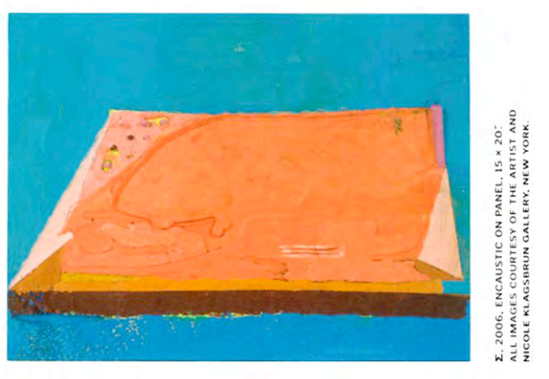
The historical elements of Zielińksi’s works are from the Paris division of the modernist canon: Manet’s deadpan, relatively shadowless backgrounds, Cubism’s tabletop proscenium, the paint-as-sticky-shit approach of the Tachists and Nicolas de Staël. Another appealing trait is Zieliński’s preoccupied facture. His static yet exuberant surfaces seem tucked and tut-tutted, confident but cautious. When painterly improvisations do take place, they seem closer to a kind of wrangling than say, the exhilarant spatter of Sam Francis.

This may be because Zieliński has not chosen these objects as motifs for painterly investigation so much as oil paint, crayons, panels, graphite, and paper are mediums utilized to help him define his attitude toward these singular objects. There is nothing simple in the psychological interface that takes place when we use a machine that gives us money from our bank accounts – or lends us money on credit – or one that destroys personal documents. The intensely prosthetic relationship many of us have developed with our laptops is reflected in Zieliński’s discovery that it is impossible for him to create a stable image of one of them.

Looking at Purple ATM, for example, one can detect that hard plastic curves of the original object, but the folds in the unit seem to have pulled apart and spread out over the surface of the painting, like entrails on a table. One is reminded of a Richard Artschwager’s Flayed Table sculptures, with their painted, exaggerated wood grain, splayed legs, and broken knees, and then one might think of Ovid’s Flaying of Marsyas. The satyr provoked Apollo by challenging him to a musical contest. Marsyas’s pipe still has Athena’s music in it, so he easily matched Apollo’s lyre, but when Apollo suggested singing while they played, Marsyas lost. Apollo has him flayed alive.
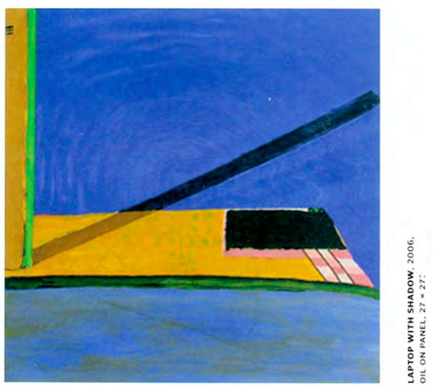
Beneath the candy colors of Zieliński’s work, he has discovered a universal insecurity. We are affronted by these machines that seem to know so much about us, that pretend to be our equals when they are simply temporarily filled with our money, our information, like the traces of the goddess’s music in Marsyas’s flute. We are as gods, but we are fiercely competitive and have no faith in our own power. The music of our age is money and information. Whatever challenges our predominance shall be eviscerated. Zieliński’s work is, as it turns out, surprisingly sardonic.

