

Correct Culture: Naughty Needlepoint, Apocalyptic Hats

July 9, 2009
By Walt Cessna

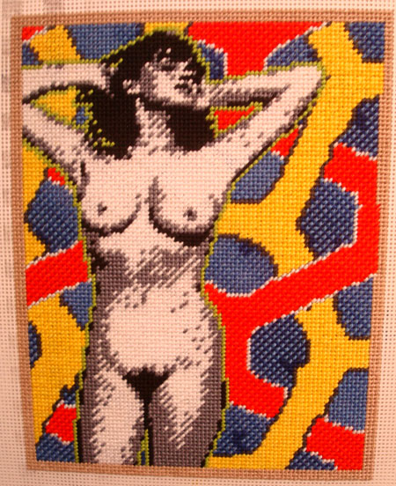
Fiercely Correct Art

Maria E. Pineres showing at DCKT. I’ve known Maria since she was a brilliantly before-her-time teen rocking Sprouse & Alaia at the 80s Palladium in the Mike Todd room. She’d done many things over the years: model, muse, OCD graphic-obsessed repetitive artist, best friend to too many count, interior decorator, proud aunt to Master Schellenbach, for the past 10 years creating the most insanely yet abstractly detailed needlepoints depicting vintage 60s & 70s porn imagery mostly, but also venturing into the arenas of fashion and celebrity portraiture (her Eminem is classically correct). Her new show was a chilled-out affair of old 80s pals reconnecting and getting a chance to catch an artist so obviously at the top of her form and selling out to boot. Go girl. Plus it was a blast sneaking cigs with fellow artist painter Erika Keck, whom I’ll be featuring soon. TRUST.

