
San Francisco
castaneda/reiman:
“places we have never been”
at Stephen Wirtz Gallery

By Kristen Evangelista
September 2009

What happens when you mix drywall mud and pigment? In the hands of collaborative artists Charlie Castaneda and Brody Reiman, ordinary construction materials offer extensive creative potential. Their solo exhibition, “places we have never been,” transforms the gallery into a makeshift quasi-domestic space inhabited by landscape vistas, units of stacked drywall, and cast porcelain rocks. This array of seemingly disparate objects forms a cohesive installation that offers a clever and insightful commentary on our relationship to nature.
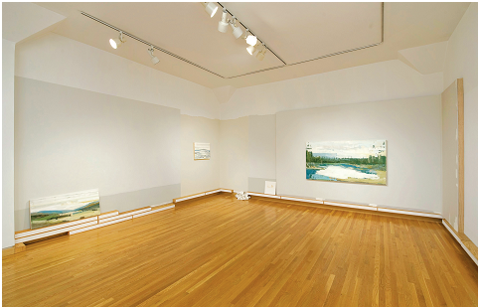
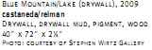

Although drywall may seem like an unlikely art making material, castaneda/reiman formerly worked in the construction business and share similar experiences of growing up in half-built homes. The duo embraces a strict economy of means – in particular drywall, drywall mud, pigment, wood, and a trowel – to craft paintings such as Blue Mountain/Lake (2009). The latter portrays trees, water, and sky in a composition that verges on abstraction. This work and others on view are inspired by amateur landscape paintings collected by castaneda/reiman over the past twenty years. Furthermore, this exhibition includes photographs of the duo’s painting collection, juxtaposing different approaches to representing the natural world. As revealed by the exhibition’s title, “places we have never been,” the panoramas are largely imagined and yet uncannily familiar.

castaneda/reiman’s paintings and photos are displayed in an intentionally unfinished environment—some works hang on partially painted walls and others lean on low units of stacked drywall. These units recall minimalist sculpture in their use of commercial materials and modular forms, but also resemble baseboards common to domestic settings. Amidst these low sculptures, castaneda/reiman have strewn rocks cast from porcelain, a medium typically associated with decorative objects. Taken together, the elements in this installation investigate how the outdoors can be conjured in an interior space.

“places we have never been” builds upon the duo’s previous projects, including Floorplan, which featured towers of plywood and drywall that evoked a forest of evergreen trees. In this new work, castaneda/reiman continue to offer a unique perspective on nature—grounded in their experiences of fabricating homes from natural resources. In a sense, the artists are constructing their own version of nature, and inviting us to view it as a work in progress.

