

Not Spaced Out Enough

November 26, 2008
By Hiya Swanhuyser

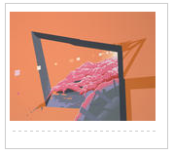
If 2001: A Space Odyssey had a mod color scheme and had been animated by M.C. Escher ... wait, no. If Wall-E's matte painters took psychedelic mushrooms while in a very bitter mood ... no, no. The truth about William Swanson's work at "The Impact Curve" is that it is its own self, like all good painting. But the canvases do conjure comparisons, and Swanson himself admits to being a borrower: "Vintage biology textbooks and books from the early ecology movement often provide material that translates well into an abstract language," he writes. Other inspirations (or what's the word for the thing you despise that drives you to create?) include poor land use, ugly overdevelopment, and though we can't corroborate it specifically, cruise ships. Massive, calm, highly abstracted natural shapes lurk behind the diseased, dilapidated corporate structures, as if to say, "We can wait." Oh, and now we're back to Wall-E.

