

Cordy Ryman
October 19, 2010
by Jill Conner
Affecting formal inconsistency while taking hard-edge abstraction to task, Cordy Ryman's small-scale non-serial abstract paintings made of acrylic, enamel, spray paint, staples, foam, Velcro, Floam, glue and Styrofoam are layered, non-referential, brittle and bent with provocative juxtapositions that use a selection of mundane, everyday materials that first appear as a series of naïve constructions. But these unpretentious, three-dimensional representations relentlessly debate geometry, order and unity, freeing up painting as a performative object that shifts between color, flat surface, as well as high and low relief. In a gesture to Frank Stella, Ryman vigorously distorts the surface of each painting, while in a nod to Donald Judd, he stays true to the square. Throughout this show, Ryman breaks down the surface of painting into a series of modular wood components that twist and struggle against each other.
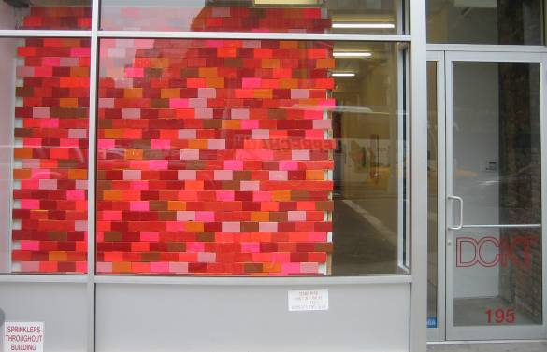 Red Brick, 2008-2010, dimensions variable: 113 x 108 x 1 ½” as installed
This exhibition begins with Red Brick (2008–2010), a massive nine-foot-tall square full of small rectangular wood blocks that simulate a brick wall, bearing different shades of red. Set within the gallery's Bowery storefront this piece displays prominently to the street outside and references the immediate built environment, which is populated with historic brick buildings. But the elements within the piece itself contain no literal referents beyond the pigments that they represent. Another equally sized work, Scrap Wall (2009-2010), features myriad unpainted and painted wood scraps, which jut into the room and foreshorten the gallery's front space, creating a sculptural presence. By miniaturizing the modular cube, Ryman expands the possibilities of geometric abstraction.
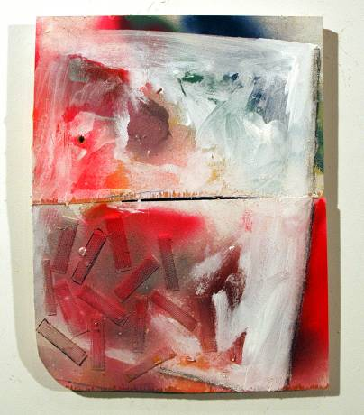 Pepermint Ice Cream, 2010, 13 ¼ x 10 ½ x ¾”

Peppermint Ice Cream (2010) features a mix of red, blue and black spray-paint covered with a thin layer of white that looks as if it is oozing across the composition's wood surface. Thin strips of Velcro in the lower left corner lend a tactile finish to this work, while suggesting a puddle of melted ice cream. The literality of the painting's title clashes with the visual, referencing its saccharine effect, while in the end this piece offers nothing but an abstract representation. The densely packed surface of Gator Ghost (2010) consists of varied green edges set horizontally and vertically that project off the painting's surface. Different shades render subtle shadows that create the illusion of cross-hatching lines over a yellow surface when seen from a distance. 536 Days (2010) features similarly tight groups of brown, white, black and gray blocks aligned together on a single surface. In each case, however, the visual content consists of a selective palette with built-up texture, provoking literal associations to each title. The representations are otherwise non-specific, and non-referential. Ryman's work skirts the decorative by virtue of its visceral nature. In Shaved Ice (2010), a white painted surface gives way to the bubbly texture of Gorilla Glue, weighted down by dozens of copper-plated steel bits that make the surface appear even more constrained, referencing Piero Manzoni. The artist then echoes Dan Flavin in Waiting for Christopher, (2010) a seven-foot-high wall installation of small pastel colored fragments that emit an orange glow from the back, illuminating the wall. Like Stella and Judd, Ryman is not limited to the stretched canvas over wood but instead uses wood itself as the painting's surface. Free from order but committed to geometry, Ryman works within the scheme of a square in order to keep each idea distinct and unified.

