depARTure

The Horizon and the Interstate Sublime

By Georgina Kobler
November, 2008
A couple of weeks ago I attended the opening reception of Fine Line, a group exhibition of three artists at the Museo De Las Americas in Denver. For this exhibit, the artists were asked to respond, in their material and media of choice, to a horizon line that had been drawn in pen across the walls of the Museo. Each artist's interaction with the line was unique in style, material and form, mirroring the huge variety of emotional and intellectual responses 'the horizon' stirs in each of us.
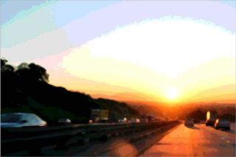
Image Courtesy of DCKT Contemporary
Timothy Tompkins, Sunrise, 2005, Interstate Sublime Series
Yet the three individual interpretations of the artists together yielded one continuous installation across the walls of the Museo- a landscape whose peaks, valleys, rivers and plains were comprised of industrial screws, sewing pins and crumpled paper currency--objects not ordinarily associated with the horizon or any other aspect of the natural world.
Fine Line was one of the most intriguing exhibits I've seen in quite some time in Denver and deserves further discussion and analysis. But as soon as I left the Museo, I couldn't help but think about the significance of the horizon line throughout art history--how it has been considered and rendered by different artists as an actual line and also as an allusion to an emotion or desire. Specifically, the contemporary artist Timothy Tompkins was brought to my mind--and I will return to his Interstate Sublime series as the culmination of this discussion about the horizon line in American art.
On a technical level, the ubiquitous horizon line is the foundation of linear perspective which originated in Florence, Italy in the 1400s and continues to be the method of graphically depicting three-dimensional objects and spatial relationships on a two-dimensional plane. In every two-dimensional picture, the horizon line runs across the composition somewhere near the eye level of the viewer and depicts where sky and ground meet, thus serving as the point of orientation.
But most interesting to me is that on an art historical level, the treatment of the horizon and the landscape surrounding it--the vast frontier, mountain-pass and dazzling sunset--is reflective of American social, religious and political trends. The horizon and its surrounding landscape have been employed in the visual arts to communicate or symbolize shared ideals and sentiments of the American populace and its government. In these cases, there is no need to include human beings in the work: instead, the artwork's orientation towards the horizon effectively substitutes.
The wilderness has always played an essential role in fashioning America's national identity. Specifically in the 19th Century, as explorers and settlers expanded west, the concept of Manifest Destiny, or the theory that God gave white Americans the sole responsibility and authority to make use of the land, became central to building the American narrative.
Enter the Hudson River School artists. Considered the first coherent school of American art, the Hudson River School painters successfully constructed a sentimental lexicon of idyllic imagery that helped popularize the mythos of the boundless American landscape in the 19th Century.
Rooted in European Romanticism, the Hudson River School was characterized by dramatic landscape paintings that revealed both the tranquility and the turmoil settlers might confront if they were to brave new territory. Located in the Hudson Valley of New York, they were plein-air (outdoor) painters who spent much of their time observing nature, similar to their contemporaries, the Transcendentalist writers.
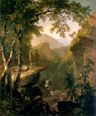 | 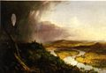 | 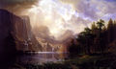
Asher Durand, Kindred Spirits,1849 | Thomas Cole, Oxbow,1836 | Albert Bierstadt, Among the Sierra Nevada

Majestic and large scale canvases like Asher Durand's Kindred Spirits sought to inspire Americans to get into nature, converse with God and explore new frontiers. I think it fair to say that the horizon line, always looming far in the distance, set a tone of intrigue, thrill and yearning for the unknown. Ideally these canvases prompted viewers to feel compelled to explore and settle the American wilderness. Obviously, such an agenda would have served both the individual and the nation: the more people who were inspired to expand west, the more territory America would eventually acquire.
Thomas Cole's Oxbow of 1836 is a classic of this school-- the scene feels sublime overall, yet nature's unruliness is also suggested. The founder of the Hudson River School, Cole purposefully juxtaposes a seemingly hospitable, warm, sun-lit river valley and a brewing, potentially relentless storm. Ultimately, Cole reveals the tension between nature and civilization, a conflict that American explorers and settlers constantly negotiated. Nonetheless, the mood is sanguine and the painting intends to be inspirational. From this elevated vantage point on a hill, painter and viewer are to gaze outward and imagine what possibilities exist beyond the infinitely distant horizon.
Similarly, Albert Bierstadt's Among the Sierra Nevada, California of 1868 seeks to evoke patriotism and reverence. The painting's supernatural lighting suggests that if one can reach this place where the sun cascades out of the clouds and on to the river, one may find God. Similar to Cole, Bierstadt portrays the wilderness as divine but not fully tangible or conquerable; one must trudge through water and dense forests to get there. Once again, it is the horizon in the distance that delineates the very place where God resides and where unfamiliar opportunities await.
The Hudson River School endured for two generations of painters. Their legacy of revering the American wilderness and instilling it with divine sensuality set a precedent for many American artists that continues into the present day. Writers and artists like the Hudson River School painters propagated the notion that the American landscape was wild, awesome and a vital feature of America's unique character. Importantly, these artists successfully popularized for generations to come, the concept of Manifest Destiny.
The contemporary artist Timothy Tompkins posits that although the term 'Manifest Destiny' was officially phased out in the 20th Century, the expansionist tendencies it outlined have never gone out of style. Tompkins' Interstate Sublime series revisits Manifest Destiny in the context of contemporary 21st Century America.
Whereas the Hudson River school painters emphasized the awesome and untamed character of the American wilderness of the 19th Century, Tompkins paints the landscape of the 21st Century, one that has become a multi-textured fabric of man-made and natural elements. Whereas the Hudson River School artists sat as observers, recording the wilderness beyond them, Tompkins places himself behind the wheel of a car, journeying along the Interstate and photographing what he sees as he penetrates the landscape, all the while driving toward the horizon.
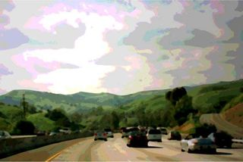 | 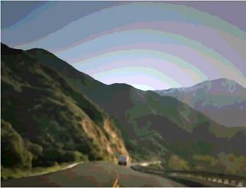
Image courtesy of DCKT Contemporary  Timothy Tompkins, Green Hills, 2005, Interstate Sublime series | Image Courtesy of DCKT Contemporary  Timothy Tompkins, Morning Sun, 2005, Interstate Sublime series
Difficult to appreciate in the jpegs here, Tompkins' Interstate Sublime series is strikingly gorgeous. His technique is distinct in that he starts with a photograph, reducing it to its basic 12 to 16 colors in order to blur and thus abstract the forms; then he prints the photograph onto an aluminum sheet. Next, he layers high-gloss commercial enamel paint onto the aluminum surface, giving it an intense luster. He builds the paint onto the photograph, and because the enamel paint is so quick drying, the contours of one form bleed into the next, giving the paintings an expressive and improvisational feel. The paintings look wet, as though they were still forming.
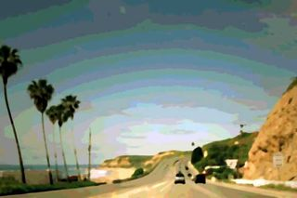 | 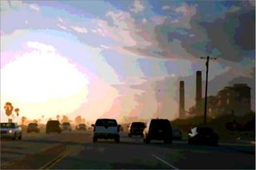
Image courtesy of DCKT Contemporary  Timothy Tompkins, Palms, 2005, Interstate Sublime series | Image courtesy of DCKT Contemporary  Timothy Tompkins, Powerplant, 2005, Interstate Sublime series

With the exception of Powerplant, Tompkins titles all of the works in this series after a natural element in the scene: Tree, Palm, Green Hills. Yet the tree, palm and green hills after which these paintings are named, appear to serve as backdrops or corridors against and through which vehicles travel from one place to another. The cars, trucks and factory silos are as much a part of these compositions as are the trees. Tompkins illustrates that the natural world has been pushed aside and trimmed back to make room for the Interstate, yielding an entirely new American landscape suited for industry and continual modernization.
Similar to the Hudson River School canvases, the mood of these works is sublime yet slightly menacing. In each work, the sky's mesmerizing patterns, unusual, iridescent color scheme and fantastic emanations of light, draw the viewer in deep. Yet these hyper-real colors and surrealistically rendered forms feel ominous, suggesting that the Interstate Sublime series is rooted in tension or uncertainty. To further heighten this ambiguity, the artist has partially or fully obstructed the horizon line by traffic, factories or the Interstate itself.
I like to look at Tompkins' works as sequels to the Hudson River school paintings: where once lay open prairie leading towards an impassable mountain range, now sits I-70 and the Eisenhower Tunnel (in Colorado, of course) which have cut through mountains to create access to Keystone and Copper ski areas, among others. Undeniably, the Interstate provides us today with the ability to reach and explore those places that in the 19th Century were inaccessible. But our access to the mountains and oceans comes at a cost to the pristine integrity of the American wilderness. Similarly, America's status as a superpower of industry and productivity is made possible only by compromising the natural world. Tompkins' Interstate Sublime series illustrates that the American landscape is today one in which nature and built environments have been inextricably melded, both for better and for worse; at once our horizons broaden and disappear.

