

Possessed

Curated by Miriam Kienle
February 4 – April 17, 2007

“If referring to what you eat you were to say, “I possess this,” then I would understand you. Because you obviously incorporate what you eat into yourself, you transform it into your substance, you feel it enter you and belong to you. But it’s not with regard to what you eat that you speak of possession. What do you call possessing?”
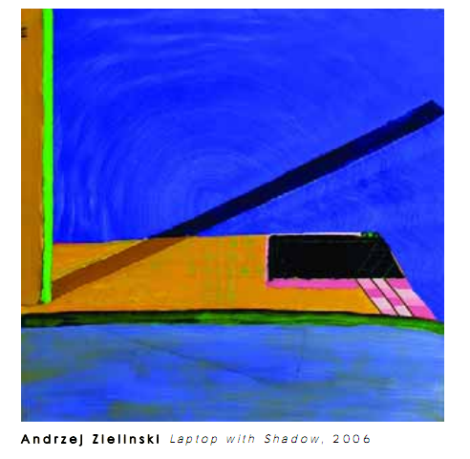
- Fernando Pessoa, The Book of Disquiet

How does art about objects facilitate an understanding of the process of possession? How does a simple object very quickly become complex when it enters into subject/object, object/thing, and artist/art/viewer relationships within the work of art? By rendering single objects that hold a particular resonance, the artists in this exhibition address these questions. Their works engage us with personal, everyday objects—objects that protect and assist us in rationalizing both the built and natural world, as well as aid us in communicating what we have come to understand about these worlds. Although these objects may feel immediately recognizable and familiar, deeper inspection yields psychological and aesthetic dislocation. Through the artist’s rendering, the object becomes strange—clunky, witty, wordy, worn, full of longing and loss. These artists question spatial realms by representing the object as beyond a singular function or symbolic value. In asking how we possess objects—and how objects possess us—they animate our intimate, inanimate world.
Andrzej Zieliński’s paintings are of laptops and cell phones, objects that could be said to possess us not only because of the amount of time that we spend with them, but because they retain traces of our histories: pictures, contacts, conversations, memories and ideas. Furthermore, through these objects we can access a seemingly infinite number of things, some intentionally created/found and others stumbled upon. It is our window into cyberspace, where simulated environments offer strange products that signal our fears and desires. In this way, the laptop becomes like a virtual version of the arcades found in Surrealist’s novels (a place Breton and Aragon found anachronistic objects—things that spoke to displaced desire). But Zieliński’s object is not the laptop itself, but a strange representation that is more akin to the Surrealist “found object” of indeterminable function. These humorous items float alone, brightly colored. Zieliński’s electronics are seductive and recall the strategies of advertising. But clearly these are neither representations of “real” laptops, nor advertisements for them. They are not iconic or well “branded.” They are oddly shaped, clunky, and ridiculously dysfunctional in the over- the-top quality of their painted surface. One might imagine them as a future or obsolete model of a laptop that reveals the absurdity of the desire for that which is “state-of-the-art.”

