Bomb Magazine
Cordy Ryman
Summer 2010
By Stephen Westfall
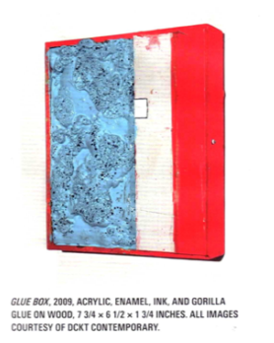
A typical Cordy Ryman lies in a hybridized zone between sculpture and painting; pieces of wood or perhaps canvas may be isolated like small geometric paintings or even extended into the full expanse of the rooms in which they are installed, following a kind of modular accumulation strategy. His sense of geometry and architecture is imbued with itchy tactility and open-endedness. I should mention color too, since his range of hues is commented on a lot, mostly as a playful/loving rejection of his father Robert Ryman’s epic material discourse on the color white. But the younger Ryman’s colors are used sparingly and nearly as specifically as his father’s. It’s only when you see an installation of several different pieces that you realize how his color can drift into an inclusive index of primaries, secondaries , and adjuncated muddy “non-colors”. In the early ‘90s he intuited his way into processes that are now taught as formal strategies: the use of cheap or discarded construction elements like wood slats to extend a work so that it takes over a corner or an entire wall. His paint can be sticky as tar or fluid as a think milkshake. A tough, tiny urchin of a painting might be fastened to the wall with nuts and bolts as though it possesses the will and strength to pull itself free and escape out the door.
Every shift in material, color and scale is considered in Ryman’s art, even as the “found” nature of some of the support materials imposes a lively raggedness where a more polished finish might kill a piece. What exactly would die? I think it would be his sense of spontaneity, wherein viewers can imagine that they are somehow inside Ryman’s thinking process and that they too could make art like this if they could work up the nerve (most won’t). What is retained is a certain material independence crucial to the work’s animism. A show of Ryman’s conjures the spectral presence of the artist arranging things just so, but it also feels like the pieces have rather strangely made themselves, propagating like planets or crystals. So I see the artist sometimes struggling and arguing with his materials as often as he confidently unrolls or stacks them. The works retain their individual will, including the right to be rather ugly. But the homeliness or one piece is inevitably a response to the whole population of his work, an extension of form-giving into less predictable realms.
Ryman’s art is less elegant than that of Richard Tuttle, Polly Apfelbaum, or Siobhan Liddell, artists to whom he’s earning the right to be compared. It’s a thicker, somewhat more dangerous world he’s negotiating. Gedi Sibony is a closer peer comparison, but Ryman is still rougher around the edges and makes greater use of color. Paul Thek comes to mind as a possible avatar and prophet not Ryman specifically, but for an expanded sense of formalism that allows for a range of unanticipated temperaments, sometimes prickly and sometimes uncertain.
Like Thek, Ryman’s is a post-Minimalism that pushes the unifying verities of Minimalism into the deep background. In the foreground is an artist figuring things out with materials that talk back. It’s a comic performance of the fragile, articulated gesture that can take over or energize a room.
- Stephen Westfall is a painter and writer who is currently a fellow of the American Academy in Rome. His work is represented by Lennon Weinberg Gallery in New York.
