

Sort of Nature

By Montgomery Rene
June 13, 2009

In places we have never been, castaneda/reiman touch on the much more tangible side of the question for me, as they share with us their joint love of landscape paintings and, seemingly, drywall.
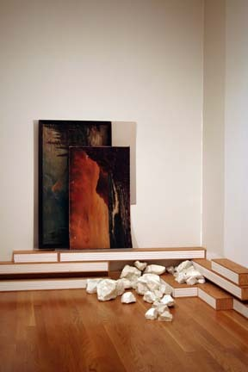
When entering places we have never been, first thought was that this was a replica of their work space, maybe. Moving around the room, I noticed that the landscape "paintings" leaned against Wirtz's white walls, were not paintings. I had to press my toes a little closer and squint my eyes in on Painting Stack with Rocks, noticing that the brush strokes just didn't seem right. On closer inspection, I was sure that the pixilation of my eyesight had finally taken place, and I was seeing computer screen everywhere now. Thankfully, I had information with me to see that this was no painting, this was a pigment print. Phew.
On inspection of the baseboard, diligently holding up these paintings, I find that
these are not the Wirtz baseboards, but exhibition creations. Constructed from oak hardwood and drywall, the effect throughout the room is now that of "stand-ins". The paintings aren't paintings, the baseboard is not the baseboard and these big hunks of chalk rock? No, they're porcelain casts of rocks. Not even chalk rocks- just rocks. The constant of replicas, and the backdrop of drywall over the finely finished walls of the Wirtz Gallery, delivers a feeling of ongoing construction; ongoing fabrication in the surroundings, as we continually try our darndest at bringing nature to the guts of our lives.

