

Claire Sherman Slow Pan

By Alan Artner
March 2, 2007

The first solo exhibition in the United States for Illinois painter Claire Sherman takes place through March 17 at the Kavi Gupta Gallery, and an impressive debut it is. The artist, in her mid 20s , handles oils with deftness in landscape canvases that excite through their surfaces more than their representation of rural subject matter.

Sherman calls her show “Slow Pan,” suggesting a kinship with film that is furthered through close-ups and cinematic perspectives. But the way she builds the pictures through daubs and strokes of a loaded brush emphasizes just how much she is really a painter, for the visceral impact of these pieces could not be communicated as strongly in any other medium – and that is how it should be.
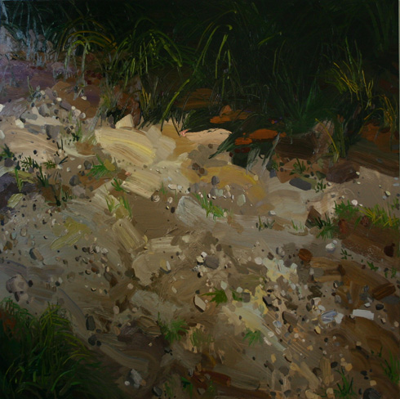
Claire Sherman, Gravel, 2007

The most successful large painting is “Gravel,” where an apparent view of stones on sand at the edge of grasses teeters most persuasively on the edge of abstraction.

The artist apparently also wants her strokes to carry the day in “Rapids,” “Forest III” and “Grass”.

But “Gravel” surpasses the others in energy and variety of handling while arriving at a place where the gestures and splatter just edge into abstraction without appearing either labored or facile.

Several pieces in a group of mixed-media works bring Sherman’s tactility within a smaller compass. Some could have been studies for larger works on view, but others communicate so strongly that they seem to be complete works of art on their own.

