

February 5–11, 2009
by Nuit Banai

Art
Cordy Ryman at DCKT Contemporary, through Feb 14
When you’re the son of monochrome master Robert Ryman, striking out on your own may be a challenge, but Cordy Ryman proves he’s his own man. While evidently nurtured in painterly reductivism and minimalism, Ryman’s playful taunting of these idioms is somewhat oedipal; he aims to trump them by exposing the gap that separates contemporary art from its precedents.
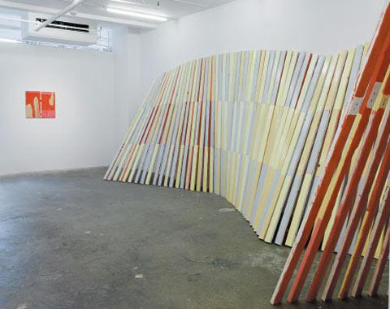
Installation view
Photograph: Courtesy DCKT Contemporary
Most obvious is young Ryman’s manipulation of his father’s signature use of a single color on a canvas, by retaining the premise while disrupting it.
In Grey Fold, for example, a piece of crimped sheet-metal covered in the titular color is attached to a support and then summarily pierced with screws. Raw Chips is constructed from separate pieces of untreated wooden squares, joined together unceremoniously with Gorilla Glue to create a light-brown tonal field.
Ryman likewise resurrects and modifies Donald Judd’s notion of the “specific object,” a term coined in the mid-’60s for a hybrid of painting and sculpture. In V5, Ryman hangs a duo-toned surface covered with small rectangular swatches of white Velcro (shades of Dad again), at an angle from the wall. The deep shadow created suggests that what happens behind an object is as important as any activity on its surface. Driving this point home, the artist has coated the work’s wall support in hot pink and azure.
What makes Ryman’s formal patricide so enjoyable is his irreverent, though loving, use of materials. This patently effusive affection takes his work beyond mere Conceptual posturing to the realm of pleasure.

