

Josh Azzarella: Taking the Thrill out of Thriller

By Paul Laster
October 8, 2009
Known for his video and photography manipulations of monumental news imagery, including the 9/11 terrorist attack on the World Trade Center, prisoner abuse at Abu Ghraib, and the Tiananmen Square protests, Josh Azzarella is a whiz at altering and erasing history. The artist’s latest project, which was two years in the making, takes on something nearly as significant in pop culture, Michael Jackson’s “Thriller” video. Stripping it of its song and all signs of life — bar the ticket booth attendant at the cinema — Azzarella’s interpretation of the classic offers a landscape that ripe for new fantasies.
There are no zombies, no lovers, no screams, and no dance numbers in Azzarella’s Untitled #100 (Fantasia). The artist has, however, left the fog, which rolls through the haunting scenes like a ghostly curse. Viewable online at the humorously titled www.thefunkof40000years.com, which references Vincent Price’s “Thriller” rap, Azzarella’s video retains the spooky visual atmosphere of John Landis’ film scenery. Those woods, cemetery, vacant industrial streets, and abandoned old house are set to a new ambient music soundtrack that poetically heightens the tension of looking at an emptied icon. Azzarella may have taken the thrill out of “Thriller,” but he leaves us with a new playground for the mind.
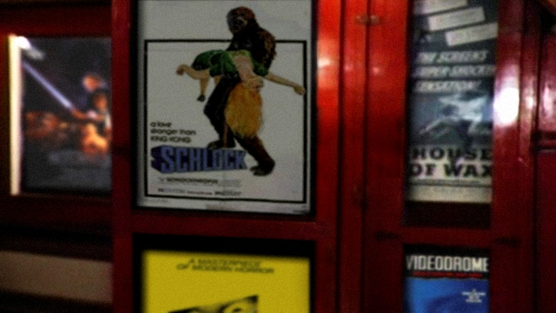
Josh Azzarella, Untitled #100 (Fantasia), 2007-2009,
Courtesy DCKT Contemporary, New York
Catch the video before the copyright police seize it or collectors grab up all of the available copies; rumors have it that David Lachapelle has already purchased one of the five editions and that Kanye West is considering one, as well.

