

Art Candy
August 22, 2008

Photographer Lia Halloran Captures Skaters Hitting Warp Speed

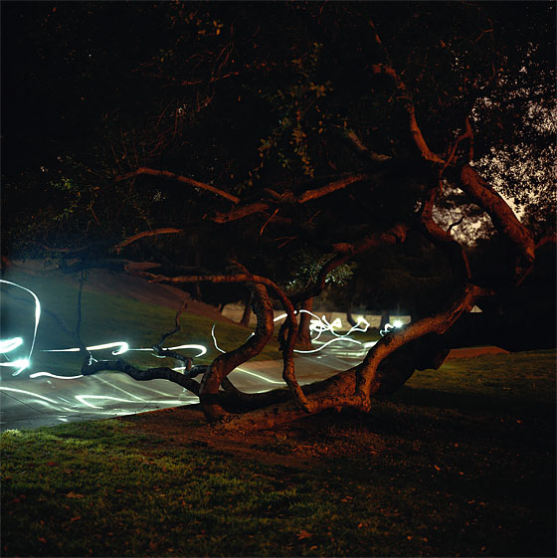
Lia Halloran’s Griffith Park (2008)
Courtesy of DCKT Contemporary

J.J. Abrams would do well to take a look at Lia Halloran’s spooky photographs of late-night skate parks, all of them seemingly possessed of skaters past. Those among us who have (sexist presumptions ahead!) spent hours sitting on the sidelines watching the boys skate up and down and up and whoosh, there they go, down again, can be glad Halloran's made something lovely out of the experience.

