ART LIES,
Issue 54, Summer 2007

Paperwork
Unit B Gallery
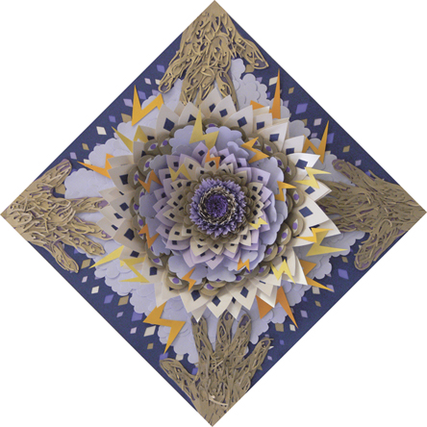
- Lawrence Jennings –

…Two other works by Kuhlman depict images of perched birds, as does the triptych Movement in Winter by Michael Velliquette. Both Kuhlman and Velliquette employ a more colorful and painterly aesthetic than the other artists in Paperwork. Velliquette cuts and layers colored card stock until the images have actual depth, which is then contained behind glass in white, shadow-box frames. The texture of simulated tree bark in his triptych is nicely achieved by tearing a rough textured paper. Velliquette gets maximum use from employing paper as metaphorical material; paper
Michael Velliquette, Truth Blooms Electric, detail, 2007
becomes bark, flower petals, flesh, feathers, an iridescent sky and lightning. In Truth Blooms Electric, a diamond-shaped work, he constructs a flower in relief, its paper petals spaced closer and closer together towards the center indicating a bloom in pause. Open eyelids, lightning, rain and clouds reside in the flat space around the flower. In the corners are four hands made of paper veins. This visionary work has the low-tech quality of a pop-up book, conjuring memories of using construction paper and Elmer’s glue in elementary school…

