

Just Rewards, A Beautiful Investment

October 2008
By R. Scott Macintosh

…For emerging artists making a splash nationally, look local. A number of Kansas City (my own backyard) artists – both those currently living here and those with ties to Kansas City, typically by virtue of the Kansas City Art Institute – are breaking out on the national scene.

They are attracting big-time collectors and showing in prestigious galleries. As a result, the value of their work is growing. CEO asked a dozen Kansas City art experts to pinpoint a few art stars sure to add some shine to any blossoming collection.

The triumvirate of Eric Sall, Andrzej Zieliński, and Brian Fahlstrom share the strange coincidence of having gone to the same Kansas City High School at roughly the same time. And they‘re all making names for themselves in the art world. Zieliński shows in New York and Los Angeles but paints from the Kansas City suburb of Gladstone, Missouri…

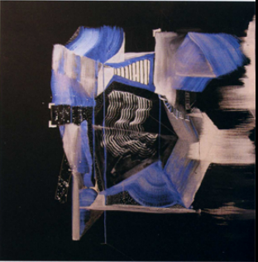
Andrzej Zieliński’s “Blue Paper Shredder” is a great example of art that should prove to be a good investment both now and in the future.

