
December 30, 2005 – January 6, 2006
A Considerable Town
Rooms With a View
by STEFFIE NELSON
There are 31 hotels and motels surrounding LAX, and artist Zoe Crosher has stayed in all of them — except one, the Royal Comfort Hotel, and that’s where we’re headed in her silver 1980 Mercedes at 10:30 on a Wednesday night. Since 2001, Crosher has been photographing airplanes coming in to land, through the windows of rooms where people stay only on their way to somewhere else.
With a few exceptions, she says, “the views are all shit.” Some of the expensive hotels closest to the terminals face squarely onto the glittering lights of the runway, but most are directly under the flight path. Crosher shoots in the morning, and the images (which often feature the plastic linings of cheap curtains) are in a sense second to the narrative thread of the series: transience, anonymity and the fleeting promise of Los Angeles. This spring, the collection will be published as a book, Out the Window (LAX),by L.A. Forum (images can be viewed at www.zoecrosher.com/lax). But first she has to take the final picture.
The Royal Comfort is on a bleak stretch of Century Boulevard, on the wrong side of La Cienega. Driving east from Sepulveda, we pass streets called Avion, Aviation and Airport, hospitality chains like Best Western and the Hampton Inn, and weird one-offs like Marletta’s and the Topper, where, Crosher tells me, the mattresses are covered in plastic. Predictably, there are a number of liquor stores and sex shops. One sign, displayed in temporary marquee letters as though it may actually change someday, reads “ADULTBOOK.”
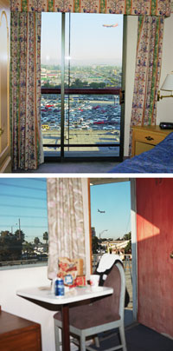
(top): LAX Embassy Suites
(bottom): LAX Topper Motel

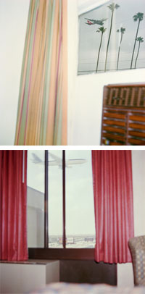
(top): LAX Adventurer
(bottom): LAX Hampton Inn
According to Crosher, the prostitutes hang out on a corner by the Microtel, and the Motel 6 is a happening party scene on Friday nights. “I guess that’s something to do in Inglewood,” she shrugs. She proclaims the Travelodge “the best place to stay at LAX,” revealing that behind the generic lobby and the connecting Denny’s is an intact motel from the ’50s. “By the way, you can see the beautiful planes coming in to land.” She gestures skyward in an arc across the windshield, like a proper tour guide — or maybe like a kid in a candy store.
Crosher’s parents met on an airplane in 1964. Her mother was a TWA stewardess and her diplomat father was returning to New York from Frankfurt. Their first date was at the New York World’s Fair, and the life they gave their two kids was filled with travel and faraway places. Crosher could have rebelled against her rootless upbringing, she says, but has in fact always loved the “liberation” of hotels.
“There are people who don’t unpack anything, and those who unpack everything. I’m the person who unpacks everything.” Unfortunately there’s only one hanger in the closet at the Royal Comfort, so neither of us does much unpacking. It’s just before midnight, and though Crosher rarely interacts with anyone besides the night clerk and the person accompanying her — usually a friend; it’s “too stressful” with lovers — we go for a nightcap at the lounge of the Adventurer Hotel next door, where the shuttle buses parked outside advertise “free champagne and cookies.”
We order whiskey, and a man seated at the bar tells the bartender to make them doubles. “Welcome to paradise in the ’hood,” he says, introducing himself as the Adventurer’s general manager, Chris Christianson. “This is my wife.” He points to the blond bartender. “Right, his wife,” she says in an Eastern European accent, taking his glass off the bar for a refill. She holds up a bottle of Jim Beam. “You’ve been through a whole thing today.”
Christianson, the only person wearing a shirt and tie, is curious to know what we’re doing in his establishment. The other patrons include a pair of Rastafarians, a group of Korean workers, some college students in sweatshirts, an older couple, and a younger Eastern European girl who keeps putting Alanis Morissette on the jukebox. Crosher reluctantly tells Christianson about her project. She’s clearly conflicted about sharing these personal experiences with a stranger, but soon the two of them are rapping about “the hotel biz.” They agree that the people at the Sheraton Gateway are “assholes,” and that there are “too many hookers” at another hotel. A third, says Christianson, is simply “drug alley.”
“I’m tired of staying at bad hotels,” Crosher says finally, her voice rising with a faint plea as though she needs permission to stop.
“Some of these places are nothin’ nice,” Christianson agrees. After 24 years in the business, he’s seen it all — and evidently too much. “When you put that Do Not Disturb sign on the door. . . . You ever see a guy put a shotgun in his mouth?” When we leave, Christianson has the large Samoan security guard escort us safely back to our room. “It’s about 300 feet,” he says, “but you’d be surprised what happens.”
I sleep fitfully and wake to the orange burst of a flash. It’s a little after 7, and the photo shoot has begun. Sometimes Crosher’s companions scout for planes, but this morning she’s already got her shot all worked out: A satellite dish blooms from the jungly growth behind the motel, and there’s one small, perfect corner just waiting for a plane. Now the right one has to fly by, and the big, international jets don’t start coming in until 10:30. “I hate the fucking commuter ones,” she says, almost to herself.
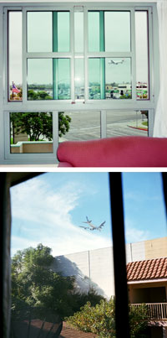
(top): LAX Rennaissance
(bottom): LAX Royal Comfort
By 8 a.m., planes arrive every five minutes. Crosher sits in a chair by the window, occasionally walking over and staring at the TV. I tune in to Little House on the Prairie. We decide that Pa Ingalls is totally hot, but we’re kind of alarmed by the Christian vibe. The Rockford Files, which I used to watch with my grandparents, is on next, and we agree that Jim Rockford, with his gold Firebird and impeccably tailored sport jackets, is also hot. And the 1970s Los Angeles locations are mesmerizing. Actually, many of the seedier stretches of Century Boulevard still do look like 1978.
“Photography has a complicated relationship to truth,” Crosher says, noting an L.A.-specific tradition of documentary series, like Ed Ruscha’s Sunset Boulevard or Cathy Opie’s strip malls that “purport to be the truth through image.” But, like Out the Window (LAX),these photographs are enhanced by the viewer’s associations and projections. Crosher admits that her work is fetishistic; she draws us in to the intimacy of the room and allows the tension of possibility to quiver in the air. It’s almost a tease. Does it tell “the truth”? It’s pretty unlikely that anyone would look at Out the Window and imagine two tired girls drinking coffee, watching The Rockford Files. Does it matter?
Checkout is 11 a.m., and in an uncanny stroke of timing, the flash Crosher’s been using for 10 years, which is now jerry-rigged together with an elastic band, decides to call it quits for good. She takes her last pictures sans flash, and chucks the useless piece of equipment into the garbage as we leave. “See ya!” she calls, and the door locks behind us.
“Hopefully I’ll never go back to LAX,” says Crosher happily as we head home in the diamond lane. Fleetwood Mac is on the radio, and the San Gabriel mountains rise clearly in the distance. “This day has the same feel as when I first moved to L.A., the same kind of promise,” Crosher enthuses. “Oh, look at that!” She points to the blue sky. “I think my next project’s gonna be helicopters.”
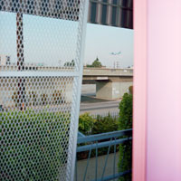
LAX Travelodge

