

Kansas City
Andrzej Zieliński

June/July 2009
By Alice Thorson

Andrzej Zieliński paints the devices that populate our lives: cell phones, laptops, ATM machines and, most recently, paper shredders. Cheery confectionary colors gave a friendly air to Zieliński’s earlier abstractions of machines. The iconic paper shredders in his recent show (all works 2007 or '08) offered a darker view of technology's role in our lives. Black gesso backgrounds enhance the sinister cast of the shredders, which are rendered primarily in black and white and a single shade of interference paint (a shimmering mica-infused polymer that changes with the angle of viewing). The chosen color varies from one canvas to the next.
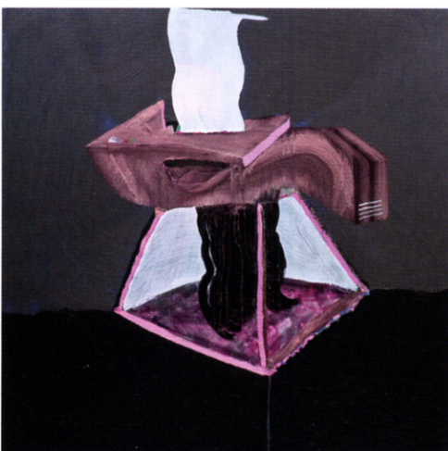
Andrzej Zielinski, Rosso Paper Shredder, 2008, mixed mediums on linen, 48 x 48”

Zieliński does battle with these objects as he brings them into being. Many emerge as flayed, sometimes ghostly, presences, engaged in a flurry of destruction that threatens to engulf the machines themselves. He begins by loading a wide brush with interference paint and making several long, angling strokes. He adds painted shapes, drippy diaphanous passages of thinned acrylic, and drawn and painted outlines made with chalk, crayon and more paint. The exhibition featured two drawings on black paper and eight paintings on linen. The three largest paintings, measuring 5 ¾ x 5 ¾ feet, employ a diamond format, inspired in part by Mondrian.
In Blue Paper Shredder, Zieliński fractures the machine into patches of broad colliding strokes around a wavy emission of thin white stripes. Veils of translucent white and purple describe a dematerialized Violet Paper Shredder, which rises from a trapezoidal black and white "base" defined by a moiré pattern. It is one of several effects Zieliński achieves by incompletely applying the black gesso. Gestural and casually drawn elements give these paintings a spontaneous feel, yet their construction, which incorporates built-up areas of modeling paste, glossy shapes made with a mixture of paint and matte medium, and wiggly striated lines connoting ribbons of shredded paper, is very deliberate.
The source of Zieliński's fascination with machines is what he sees as a "mythological thing going on with technology." "It's everywhere, it's omnipresent," he said in a recent interview. "It's like fire -- people worship it." He compares the paper shredder -- "always stuck in a corner or underneath a desk" -- to the weird, shining creatures hidden in caves, or jellyfish in deep water, an impression he enhances via the see-through iridescence of the interference paint.
Zieliński endows each shredder with a personality or presence. Green Paper Shredder is a phantom, caught in a spasm of juddering motion. Presented as the diamond shape, Red Paper Shredder exhibits the devouring maw of a science-fiction creature. Rosso Paper Shredder, secure atop a pyramidal base edged with bright pink modeling paste, is the best behaved. The painting is one of several in which the object maintains its integrity. Zieliński’s destructive impulse toward these machines is tempered by a view of their beneficent possibilities. The ocean depths may hold scary unknowns, he observes, "yet new medicines can be found in these places."

