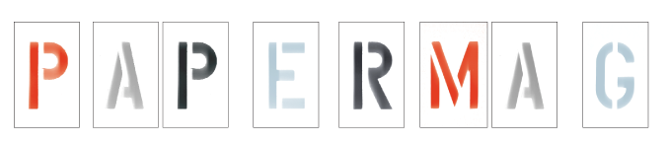
Portrait of a Crazy Artist as a Young Woman
R. Crumb’s daughter Sophie is coming into her own with a new book and solo exhibit
November 4, 2010
By Carlo McCormick
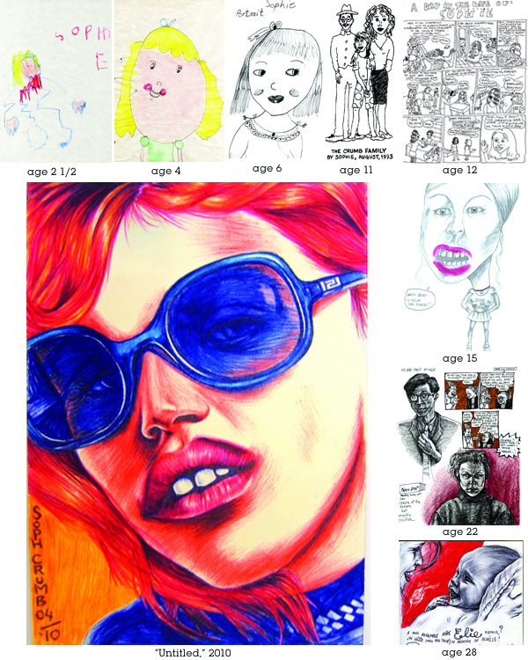
The best and most surprising thing about Sophie Crumb, the daughter of underground comic-book legends Robert Crumb and Aline Kominsky-Crumb, is that she is so very much her own person. Now, at the grand old age of 29, the little girl we saw in Crumb (that hellishly hilarious documentary about her dysfunctional family) is not only all grown up (and a new mom herself), she's more than ready to step out a bit from her family's large and bewildering shadow with a solo exhibition of her works at DCKT Contemporary and a hefty volume of her marvelously quirky pictures (published by W.W. Norton).
First off, because some might be wondering why such a young and relatively unknown artist would already have a 271-page hardcover of her work put out by so prestigious a publisher, of course a bit of nepotism and fame helps -- it is edited by her parents. But not simply a scattering of juvenilia, Sophie Crumb: Evolution of a Crazy Artist is a full-on collection of her drawings, done from as early as two years old. As such, it is as much a psychological study of her own personal development as a most worthy tribute to how far a life of constantly making pictures and her innate talent has taken her art. But of course being a Crumb, it's all a little wackier than that, embodying both Sophie's deeply personal and intimate voice and her parents' obsessive archive of her old childhood drawings. That they saved everything she ever did is weird enough, but when most of us would cringe as our parents reach for the pictures of us as a naked toddler eating mud pies, Sophie is excited, she says, to present all the "random stuff I've done all my life but never published or shown anyone." Then again, her last collaboration with her parents was called Dirty Laundry Comics.
"To me the book is supposed to be funny, above all," Crumb explains from her home in the South of France. "And that includes self-loathing of course, which has always been part of my inspirations and the humor I grew up with, my mom being a hilarious New York Jew and my dad a nerd goofball. It's about making fun of yourself and being painfully honest." And indeed, one of the real treats delivered by Crumb's lifelong reflexive gaze is that we see every stage of her arduous trek to selfdiscovery. (It's a must-have textbook for anyone studying developmental psychology.) So what did she learn about herself from poring over and sorting through two-plus decades' worth of scribbles and doodles? "That I'm a wingnut!" She is quick to add, "I'm only 29. It's a growing- up book, not a whole life's work. I am hardly an accomplished artist."
Humble though she might be, anyone who visits her November show at DCKT in New York will object to her overly modest appraisal of her own skills. In her personal journey we witness the young Crumb grapple with the comics medium: "My whole adolescence I struggled with my desire to do comics, a love-hate thing -- I'd get all neurotic, self-critical and perfectionist, so I had a hard time finishing a comic or being satisfied with my work." She also contends with her dual nationality and bilingualism -- "It's a little confusing sometimes because when I'm about to make a drawing I think, 'Is a French person going see this or an American?' I definitely have a schizo double-nationality thing." -- and with forging her identity within a daunting family legacy. She signed some early work simply "Sophie" and others "Sophie Miette," which she explains by saying "I didn't want to sign 'Crumb' because 'Crumb' is R. Crumb. 'Miette' means 'crumb' in French, like 'breadcrumb,' and I thought that was really clever. Then I stopped caring about that stuff."
Most of the works on paper that Sophie has included in her gallery show are neither about her nor these nagging internal issues, but rather offer a mature look at adult issues in the world around us -- in particular, our skewered view of feminine beauty and glamour -- that is as deft and acerbically spot-on as it is deliriously quirky.
Though she has temporarily given up being a comic book artist after two very promising issues of her own Belly Button Comics, Sophie has managed to bring an underground comic's critical and subversive eye to her fine art. "I do believe an artist's job can sometimes be to puke back at the world, in his own shapes and forms, all the violence that is thrown at him every day," she offers. "I try to draw these images realistically, without purposely deforming them, but no matter how close to reality I try to render them, there is always an involuntary transformation of the image. Something creepy always comes out."

