

Artist, Full Circle

March 15, 2009
By Elisabeth Kirsch

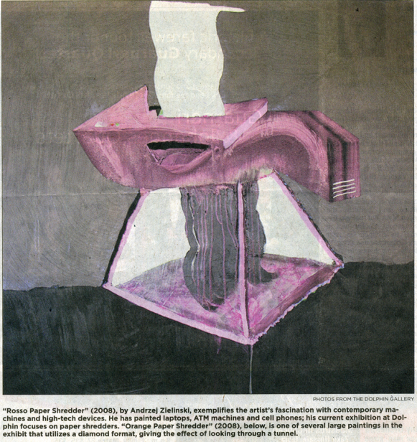
Andrzej Zieliński gains International fame and rediscovers KC scene.

It’s been a long road back to the Kansas City area for artist Andrzej (pronounced “ahndjay”) Zieliński.

In the last 10 years, the 33-year-old artist from Parkville has lived in Chicago, New York, Connecticut, Rome and Berlin.

During this time his work has received national acclaim, along with multiple gallery showings throughout the U.S. His colorful, absurdist depictions of ATMs, laptops and phones have struck a hot nerve in both the art world and an increasing virtual planet.

At first not everyone knew what to think of Zieliński’s painterly renditions of contemporary machines. His “portraits” looked more like goofy-looking pieces of candy or melting Popsicles.

Zieliński’s peculiar brand of organic geometry struck some as either not realistic or not abstract enough. His art is a genuine refutation of Precisionism, the American art movement from the 1920s practiced by Charles Sheeler, Charles Demuth and others, that emphasized geometric structure and clarity of form, particularly in the representation of modernist structures.

But the accolades, often reverential, accumulated. As his former professor, noted artist Peter Halley of “Neo-Geo” fame, wrote about Zieliński’s work: “(I’ve) witnessed the transformation of this brainy young kid from Kansas City into a strange and brilliant painter.”

With a career this promising, Zielińksi might have chosen to remain in either New York or Los Angeles, where his work is regularly exhibited. But his lives in Gladstone and teaches at Johnson County Community College.

“The arts seemed provincial when I first left here, “Zieliński said. “I was shocked when I came back. There is a face on the art scene now. Artists are taken seriously here, curators make studio visits, and there are conversations about art in the local media and among arts professionals… this is now a viable place to live and make art.”

Since his return, Zieliński has received a $10,000 Charlotte Street Foundation visual artist award and has a one-person exhibit at the Dolphin gallery. He may have come full circle, but on a much different path than he anticipated.

Zieliński attended schools in the Park Hill district from kindergarten through high school. Although he remembers drawings pictures of helicopters at the time, he did not grow up with art and had no thoughts of being an artist. After graduating two years of manual labor, he re-evaluated his goals.

He knew he didn’t want to trim trees anymore.

“Also, I discovered that I really liked art,” he said.

He enrolled at Johnson County Community College and focused on studio art and art history. Then he attended the University of Kansas for one semester. After that, he moved to Illinois and studied at the Art Institute of Chicago, where he received his bachelor’s in 2002.

With the encouragement of his professors, he applied for and was accepted at Yale’s prestigious master’s program, where he survived on scholarships and student loans while being promoted by such art notables as Klaus Kertess.

The next logical step would have been to move to New York. Zieliński’s work was being shown at the Nicole Klagsbrun Gallery and had been selected for the highly competitive “Greater New York” show at P.S. 1 Contemporary Art Center, an affiliate of the Museum of Modern Art.

“New York is the default for artist after graduate school,” Zieliński said. “But the gallery scene also has fangs. I needed a bigger worldview, and I wanted to find myself as a young adult.”

Fluent in German and Italian, Zieliński traveled throughout Europe and looked at a lot of “old art.” “It wasn’t exactly a bowl of cherries,” he admitted “but I learned a lot.

Perhaps as a result, Zieliński’s current paintings of paper shredders reflect a more world-weary attitude than his earlier, more upbeat depictions of office machines. His shredders, barely discernible as such, are little more than phosphorescent, gossamer images shimmering on inky black backgrounds.

There are still the irresistible tensions between realism and abstraction and the witness of using paint and gesture to define machinery. But for the first time Zieliński lavishly uses gel medium (a material with the consistency of glue) along with an interference paint (a shiny acrylic that changes color as one walks through it) to achieve disorienting, hallucinogenic effects.

Some canvases are square, while others are diamond shaped. The latter particularly underscore the effect of looking through a tunnel, which is deliberate. “It’s a little bit like shining a light in a cave and seeing strange creatures, like jellyfish,” Zieliński explained. “Paper shredders are like that…they mostly sit in a corner, unnoticed. But when you turn them on, they light up.”

These are Zieliński’s least assuring machines. “Blau Paper Shredder” resembles a mouth with fangs. “Green Paper Shredder” looks like a maze from hell, while “Blue Paper Shredder” appears to be blowing away in a wind tunnel.

His works on paper are black and white, sometimes layered and cut, and emphasize drawing. They also are less menacing.

“Some people joke that with the paintings I’ve gone over to the dark side,” Zieliński said with a laugh. “It’s true that the world’s troubles have had an impact on me. These paintings have an attitude. When they start to twitch, I know they’re done.”

Zieliński will speak and show work April 8 as apart of “Slideshow at the Kemper Museum.”

In May he will be in the group exhibit “Skin Jobs” at the Marc Selwyn Fine Art Gallery in Los Angeles. Later this year his work will be part of the exhibit “Our Love of Machines” at the Nerman Museum of Contemporary Art at Johnson County Community College.

