**GEOS3009: Coastal Environment & Processes**

Tristan Salles

Lab Overview

|  |  |  |  |  |
| --- | --- | --- | --- | --- |
|  | **Exercises** | **Weight** | **Due Date** | **Submission** |
| Lab 1 (Week 9) | Ocean Data | 25% | Tuesday May 16 @ 9am | Madsen Dropbox |
| Lab 2  (Week 10) | Storm induced beach profile erosion | 25% | Tuesday May 23 @ 9am | Madsen Dropbox |
| Lab 3 (Week 11) | Coastal evolution across scales | 25% | Tuesday May 30 @ 9am | Madsen Dropbox |
| Lab 4 (Week 12) |  | 25% | Tuesday June 6 @ 9am | Madsen Dropbox |

Each week a paper copy of the exercise will be provided for you. Please write neatly and clearly, messy and illegible reports will not be marked. You are also welcome to complete the exercise in the pdf available online. Remember to attach relevant maps and data.

Exercises are shown in grey boxes, answer in the space provided or attach your answer to the lab sheet.

**Your assignment is due Tuesday the following week at 9am! 10% will be deducted per day late.**

Please note: You do not need to include your script for iPython practicals unless a question states “**Include your script”** in which case you only need to include the relevant portion of your script (please do not waste paper and print the entire script).

Lab 1: Ocean Data

General Instructions

The goals of this first lab are:

* To help you get comfortable with IPython notebooks. (We will use it throughout our modelling pracs for this UoS).
* To show you some examples of dataset coming from different systems: buoys & models.
* To familiarize you with the different open data services and the most common data formats.

Through the notes and the notebooks you will see questions. You will need to provide solution for each of them.

Here we will introduce several **IPython** libraries such as **Matplotlib**, **Basemap** or **pandas** as well as common data format libraires (like **netcdf**). These libraries can be used to create maps, plot marine datasets but also to analyse them.

If you follow along the associated ipython notebooks, you'll build the basic knowledge of scientific data analyze that will be useful in your future job as engineer, consultant or researcher.  The goal is not to press button here but to make sense of what you are doing!

If at any point you don’t understand something, don’t be shy and ask for help.

The IPython Notebooks for this lab are called:

* **Waverider.ipynb**
* **Oceanforecast.ipynb**

Lab 1: Exercises

NAME: _________________________________ SID: ________________________________

In the first part of this exercise, we will first use wave data collected by the NSW Public Works' Manly Hydraulics Laboratory (MHL) for the Office of Environment and Heritage. These data provide essential input to design, construction and performance monitoring of coastal zone projects undertaken by the NSW Government.

The NSW Wave Climate Program utilises a network of seven **Waverider** stations along the NSW coast. The buoys are located off Byron Bay, Coffs Harbour, Crowdy Head, Sydney, Port Kembla, Batemans Bay and Eden. To provide deepwater wave data, the buoys are typically moored in water depths between 60 and 100 metres, between 6 and 12 kilometres from the shoreline.

**We will first load the historical records for the buoy located Offshore Sydney using the** Waverider.ipynb **notebook.**

**Overview of the Waverider dataset**

Q1. Run the notebook and give the names of the variable defining the wave height root mean square and wave crest period and the shape (size) of these variables.

______________________________________________________________________________________________________________________________________________________________________________________________________________________________________________________

Q2. Once you have extracted the temporal extent of the recorded dataset and the number of record per day what should be the size (shape) of the dataset?

Q3. Can you provide a reason for this mismatch?

Q4. What is the shape of the LONGITUDE & LATITUDE variables?

__________________________________________________________________________________________________________________________________________________________________________________________________________________________________________________________________________________________________________________________________________________________________________________________________________________________

Q5. Provide for the entire 2015 record the wave height root mean square and the wave crest period. (Attached the 2 figures to your report).

**Analysing one of the biggest storms hitting Sydney in a century**

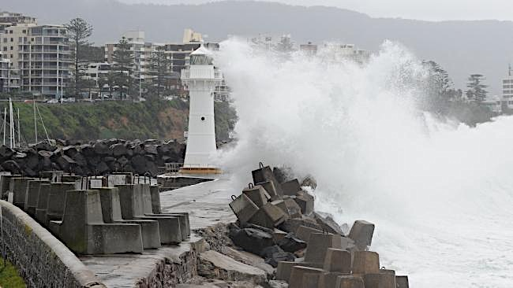

Figure 1 Wollongong harbour lighthouse gets a pounding by the large seas in the Illawarra. *Picture: Simon Bullard*

As you can see from the 2015 buoy record, there is a huge storm in April 2015. During that storm the Sydney’s WaveRider buoy recorded a 14.9m wave — one of the largest since measurements began in the early 1970s.

Throughout the storms the Manly Hydraulics Laboratory was able to provide local councils and other State emergency agencies with reliable and site specific nearshore wave conditions and expected coastal hazards along the entire NSW coast exacerbated by coinciding king tides and heavy rainfall.

This was achieved through the new State Wide Nearshore Wave Transformation Toolkit that has become a popular daily resource for surfers, divers, mariners and fishermen, as well as for community and commercial purposes including marine and transport operations, tourism and lifesaving.

**April 2015 storm in the media:**

* [The Conversation](http://theconversation.com/explainer-the-wild-storms-that-lash-australias-east-coast-40564)
* [The Australian](http://www.theaustralian.com.au/news/nation/sydney-storms-wild-winds-rain-hit-nsw-for-third-day/news-story/8f697d284e37b2c51eba8a8294c003ca)

Q6. Run the second part of the notebook and provide the wave height root mean square and the wave crest period for 96-hours centred on the wave height root mean square maximum for the storm. (Attached the 2 figures to your report).

**Wave power**

In general, larger waves are more powerful but wave power is also determined by wave speed, wavelength, and water density. How powerful a wave is determined by the ‘Wave Power Formula’. In this case, the ‘power’ does not refer to the power that would be produced by a wave power machine, rather it means the ‘wave energy flux’, or the transport rate of wave energy. In deep water where the water depth is larger than half the wavelength, the wave power is found using the following equation:



Where P is the wave energy flux per unit of wave-crest length, Hm0 the significant wave height, T the wave period, ρ the water density and g the acceleration by gravity. The above formula also says that wave power is proportional to the wave period and to the square of the wave height. If the significant wave height is given in meters, and the wave period in seconds wave power has units of kilowatts (kW) per meter of wave front length.

**Wave energy**

In average ocean conditions, the average energy density per unit area of sea surface waves is proportional to the wave height squared, shown in the following equation:



where E is the mean wave energy density per unit horizontal area (J/m2), the sum of kinetic and potential energy density per unit horizontal area. The potential energy density is equal to the kinetic energy, both contributing half to the wave energy density E.

Q7. Familiarise yourself with the wave power and energy equations. Define them as functions in iPython and calculate them for the storm duration using the wave significant height ‘WHTH’ and the period ‘WPTH’. **Include your script** and attached the 2 figures to your report.

Reading: [wave power link](http://theconversation.com/ocean-power-making-waves-in-australias-clean-energy-future-9689)

**Analysing data from forecast models**

In this 2nd part, we will build upon what you have learned in the previous notebook.

We have seen how to use real observations to assess wave conditions. Now we will work with a forecast model called **FVCOM** (Finite-Volume, primitive equation Community Ocean Model) developed by the University of Massachusetts-Dartmouth in collaboration with the Woods Hole Oceanographic Institution. The model is well suited for simulating the circulation and ecosystem dynamics from global to estuarine scales, particularly for regions characterized by irregular complex coastlines, islands, inlets, creeks, and inter-tidal zones.

The model strengths not only rely on the physical processes that are simulated but also in its capacity to be coupled to other codes (meteorological, sediment transport, inundation models...).

The data that we are going to work with come from the Northeast Coastal Ocean Forecast System (NECOFS) which is a US integrated atmosphere-ocean model forecast system designed for the northeast US coastal region covering a computational domain from the south of Long-Island Sound to the north of the Nova Scotian Shelf.

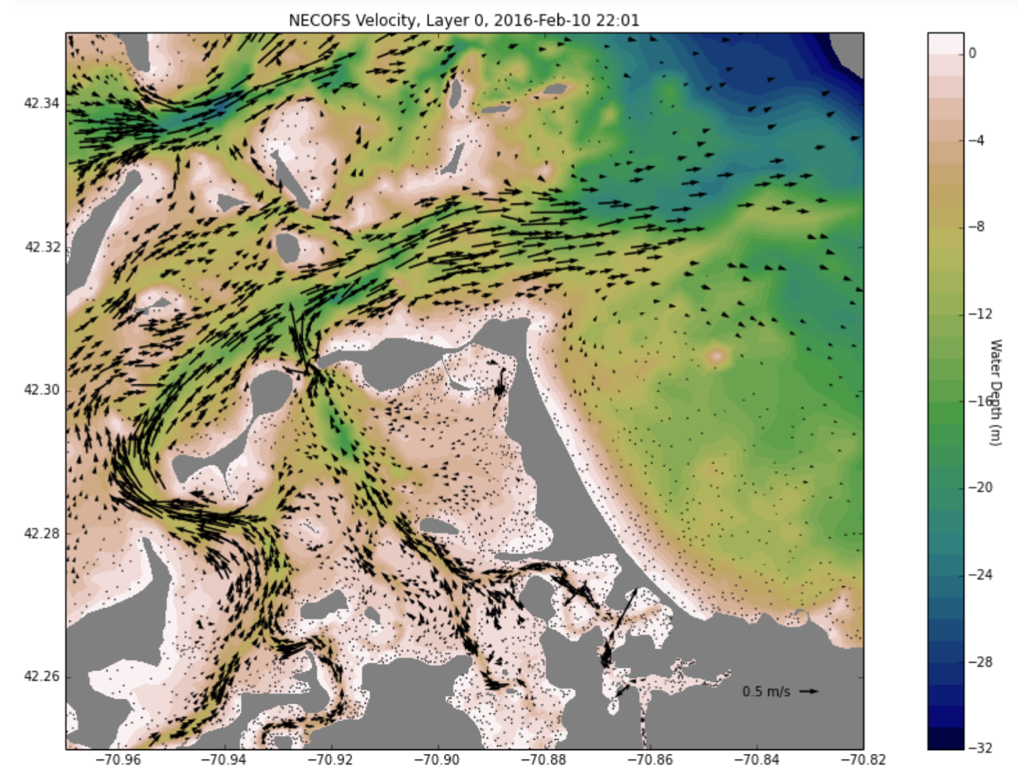

Figure 2 FVCOM ocean forecast model for northeast US coastal region.

The system includes:

1. a mesoscale meteorological model WRF (Weather Research and Forecasting model);
2. an unstructured grid Finite-Volume Community Ocean Model and Surface WAVE model with configuration for the Gulf of Maine/Georges Bank /New England Shelf (FVCOM- GOM and FVCOM-SWAVE);
3. the Massachusetts Coastal Waters domain FVCOM (Mass- Coastal FVCOM) and
4. a fully wave-current coupled coastal inundation model systems for Scituate Harbor and Boston Harbor, MA, and Hamption-Seabrook Estuary, NH.

NECOFS has been validated by hindcast experiments from 1978 to present. This model is capable of reproducing accurately both tidal and subtidal motions in the Gulf of Maine/ Georges Bank/New England Shelf regions.

**You will load the model predictions from the** Oceanforecast.ipynb **notebook.**

Using this notebook, you will use hourly products from the NECOFS Web Map Server (WMS). NECOFS provides three days of forecast fields of surface winds, air pressure, air temperature, air humidity, sea surface heat flux, evaporation minus precipitation, sea level, water temperature, salinity, currents, wave heights, wave directions and wave frequencies as well as wintertime icing rates and storm-induced inundation areas. Just that.... ☺

Using the loaded dataset you will first have a look at the distribution of water depth and currents in the bay for the current time (US time actually).

Q8. Based on the low and high tide time for today’s prediction in the region, plot two maps showing the current distribution forecasts and discuss the results below. (Attached the 2 figures to your report).

____________________________________________________________________________________________________________________________________________________________________________________________________________________________________________________________________________________________________________________________________________________________________________________________________________________________________________________________________________________________________________

We will now look at the water levels forecasted for several stations in the Massachusetts Bay. The idea is that it is possible to refine the model prediction by looking at buoy data from specific observations recorded on these stations.

Q9. Below, you have a list of stations. The first four are the only one provided in the notebook file. Make a plot showing the information for water level forecast for the entire set of stations. (Attached the figure to your report).

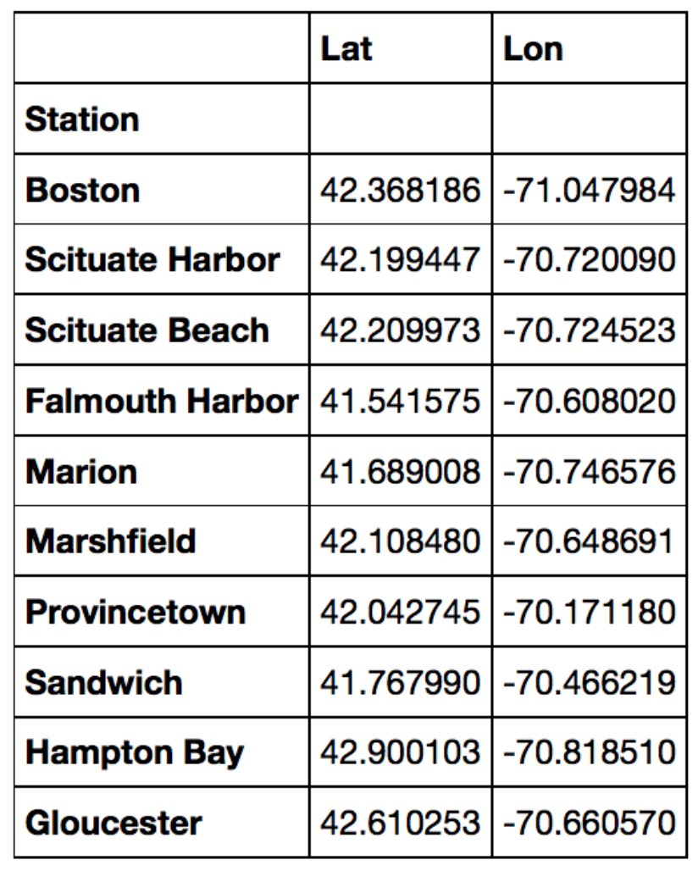

Table 1 List of stations locations.