**Practical: Lithospheric extension**

## Introduction

The mode of continental lithospheric extension, and subsequent basin formation along continental margins and in the interior of continents, depends on the rheological stratification of the lithosphere, which strongly depends of the temperature distribution with depth. We will use the particle-in-cell finite element code *Ellipsis* to create a two-dimensional model of the continental lithosphere under extension, and we will explore what impacts various strength changes and initial weaknesses have on lithospheric deformation.

***The continental lithosphere***

The lithosphere is the stronger outer shell of the Earth. In contrast to the asthenosphere which flows under small deviatoric stress (a few MPa), the lithosphere can sustain a few 10’s to a few 100’s MPa without deformation. The base of the lithosphere is characterised by an abrupt decrease in shear-wave velocities at depths of around 100 to 200 km (up to 300 km in the case of Archaean lithosphere), and is often described as the depth at which the isotherm reaches 1330ºC (give or take a few 10s ºC). In the asthenosphere, the temperature gradient is low (about 0.3ºC per km) due to convective mixing. The Mohorovicic discontinuity (in short Moho) marks the boundary between the crust and the mantle lithosphere. It is a seismically and compositionally well defined boundary.

***Rheology***

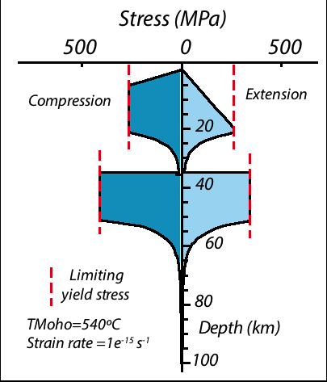The lithosphere shows a strong rheological layering, which is comprised a succession of strong plastic layers (where brittle deformation or strongly localizing shear zones dominates), and weaker more viscous layer (where ductile flow dominates). Plastic behavior implies that rocks can sustain an amount of stress before strain can accumulate. In constrast viscous behavior implies that strain accumulates as soon as a deviatoric stress is applied (though strain rate can be infinitesimally small). Depending on the geotherm and/or composition of the lower crust, and/or imposed strain rates, the crust can be either mechanically coupled (little rheological contrast between the crust and the mantle) or decoupled from the underlying mantle when the rheological contrast is important.

*Figure 1. Yield strength envelope for the continental lithosphere. There is a yield envelop for compression and another one for extension because reverse faults are stronger than normal faults.*

*Brittle deformation*

At low temperatures, and/or high strain rates, and/or high-pore pressures, rocks behave elastically until the yield stress is reached at which point they fail by fracturing. A frictional law (Mohr-Coulomb criteria or alternatively Byerlee law when C0=0) with a maximum shear stress τ yield approximates brittle behaviour:



(1)

where *c0* is the cohesion (yield stress at zero pressure), and *cp* is the pressure dependence of the yield stress (known as the coefficient of friction), and *p* is the pressure. The yield stress is reduced by a strain weakening factor (*f() <1)* which expresses the dependence between fault’s strength and the amount of strain*.* At a certain depth, the yield stress reaches a limiting yield stress value, and the yield stress no longer increases with pressure. Recent estimates of the limiting yield stress for the continental lithosphere suggests a value between 100 and 300 MPa.

## Strain Weakening

During frictional deformation (brittle) faults become weaker; this process is called strain weakening. Strain weakening is implemented in *Ellipsis* using the power-law function (Fig. 2):

(2)



where *ε* is the accumulated plastic (i.e. brittle) strain, *ε0* is the saturation strain beyond which no further weakening takes place (any values between >0, 0.5 is not bad), *εn* is an exponent which controls how weakening evolves with plastic strain (a value of 0.1 will trigger a drastic weakening very early in the strain history, a value of 10 will delay strain weakening until accumulated plastic strain is several 100%), and *a* is a maximum value of strain weakening factor (a value of 0.1 means that the coefficient of friction is reduced by a factor of 10).

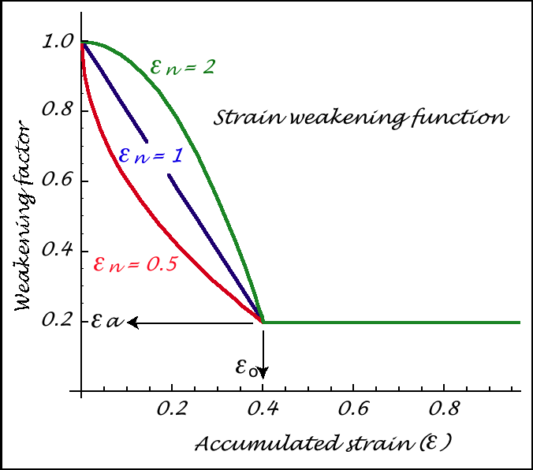 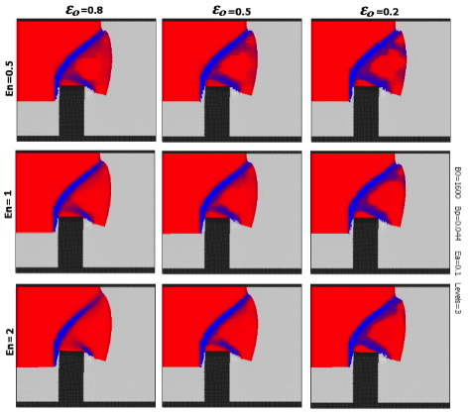

*Fig 2. On the left, definition of the strain weakening factor. On the right, map view of an experiment illustrating the role of εn* *and εo .*

*Ductile deformation*

When temperatures reach a significant fraction of the melting temperature (typically 0.3-0.4 solidus temperature) defects in crystal lattice (i.e. dislocations) become mobile enough resulting in stable creep over long time scales.

Newtonian flow is characterized by a simple linear relationship between stress and strain rate, the constant of proportionality being the viscosity, a measure of the resistance of material to flow. Viscosity is commonly strongly dependent on temperature and stress, the flow is no longer strictly Newtonian. This behaviour can be approximated by a so-called power-law rheology (see GEOS 3101).

Two different temperature dependent viscosity models can be used in *Ellipsis*: The complex Arrhenius viscosity model and the simpler Frank-Kamenetskii approximation to the Arrhenius viscosity. The Arrhenius viscosity (*ηarr*) is defined as,

(3)



where *A* is a scaling factor, *n* is the stress exponent, *Ea* is the activation energy, *R* is the universal gas constant (8.314 J/mol.K), *T* is the temperature (K) and is the strain rate.



In RStudio Arrhenius viscosity can be plotted using:

z<-seq(0, 60000, 1000)

n<-3  
A<-5*10^-6*(10^6)^-n  
R<-8.314  
TempGrad<-900/40000

edot<-1e-15  
plot(z, log(((A^-(1/n))/2*exp(190000/(n*R*TempGrad*z))*edot^((1-n)/n)), 10), xlim=c(1, 50000), ylim=c(18,25))

Here however, we will only use the Frank-Kamenetskii viscosity model, which is expressed as follows: (4)



where *η* is the viscosity, *T* is the temperature (K) and *η0* and *T1* are constants.

Deviatoric stress ** (force per unit area) is what drives deformation. Strain ** measures the change in length. In a viscous fluid, the rate of strain (*d/dt*) is related to the applied deviatoric stress ** and the viscosity *η* (a measure of the resistance of material to flow):



(4)



*In RStudio the Frank-Kamenetskii viscosity can be plotted using:*

*z<-seq(0, 60000, 1000)  
No<-2.5e27  
T1<-0.012  
TempGrad<-900/40000  
plot(z, log(No*exp(-T1*( TempGrad *z)), 10), xlim=c(0, 60000), ylim=c(18,25))*

NB: To plot both the Arrhenius and the Frank-Kamenetski viscosities on the same graph use the command *par(new=TRUE)* between both plots

.

***Lithospheric extension***

Because of its mechanical layering, extension of the lithosphere results in a strong vertical partitionning of the deformation. Weak ductile layers tend to stretch and thin in a more homogeneous manner under smaller deviatoric stresses, whereas the stronger plastic layers deform in a more heterogeneous manner through localisation of strain along brittle faults and ductile shear zones. This general behaviour is dependent on the strain rate at which extension unfolds. When the lithosphere is extended strain localizes in the brittle layers leading to necking between thicker boudins, whereas the hotter more ductile layers flow toward the base of the thinned brittle layers. Following an episode of extension, the lithosphere cools, contracts, and while the crust is thinned permanently, the upper mantle lithosphere thicken over time inducing a long and slow episode of subsidence called the thermal sag phase.

Physical properties to be considered when investigating the behavior of the lithosphere under tectonic deviatoric stresses include: rheology - rheological layering – and rheological anomalies, geotherm and thermal anomalies, extension velocity, erosion/sedimentation, and partial melting (because it affects the strength of partially molten rocks).

## Ellipsis background and download information

*Ellipsis* is a freely available open source program, which can be downloaded from the GeoFramework site at the California Institute of Technology

(http://www.geodynamics.org/).

Ellipsis has a long history of development, mainly driven by geodynamic modeller Louis Moresi, including not only Caltech, but also CSIRO and Monash University. Therefore, additional web pages with *Ellipsis* background information and examples can be found at:

[http://www.earthbyte.org/Resources/resources_*Ellipsis*.html](http://www.earthbyte.org/Resources/resources_ellipsis.html)

*Ellipsis* runs on all unix-based computer operating systems (e.g. Linux, Mac OSX, Sun Solaris, etc). To compile *Ellipsis* on your machine (on Mac or Linux) you need access to an appropriate compiler. To check if you have an appropriate compiler, in a Terminal window enter: *gcc --version*. If you do not have a gcc compiler installed then you need to install one. On Mac this means to install the *XCode* developer suite (available in the cd coming with your machine, or downloadable from the Internet). On Linux simply download from the Internet a *gcc* compiler for Linux. To compile, open a Terminal window, nagivate to the *Ellipsis* source directory using the *cd* command, then execute the following two lines:

On Mac OS 10.9 (Maverick 10.9) *gcc* compilers have been replaced by *clang*, which may fail. On Maverick we have successfully compiled Ellipsis using *gcc-4.8* that we installed using *Homebrew* package manager.  
  
Install *Homebrew* package manager (google *Homebrew* and follow instructions) then in a terminal window execute the following three commands:

brew tap homebrew/versions && brew install gcc48  
CFLAGS='-m32' ./configure CC=/usr/local/bin/gcc-4.8   
make

An executable called *Ellipsis3D* will be created in the source directory. You can copy this executable (its size is only a few 100s bytes) and paste it in a folder in which your input file will be located (good practice to paste a copy of the *Ellipsis* executable with each model so you can keep track of which version of *Ellipsis* you have been running).

To run the input file simply open a Terminal window, navigate to the folder holding *Ellipsis* and the input file at enter the following command:

*./Ellipsis* *mycoolmodel.input*

Where *mycoolmodel* is the name you have chosen for the *Ellipsis* input script file.

## Resolution of the computational grid

Calculation of models in *Ellipsis* is handled using a multigrid solver. This solver uses an iterative technique leading to a solution which converges rapidly (i.e. meeting rapidly a resolution criterion) by using a stack of increasingly fine computational grids. The rough solution obtained rapidly on a coarser grid is used as input to refine the solution on a finer grid. In *Ellipsis* input files, the number of **levels** refers to the number of grid in the multigrid stack (Fig. 3). The number of cells is multiplied by 4 when moving from a coarser grid to the next finer grid. The larger the levels the larger the resolution of the model, but the longer the running time.

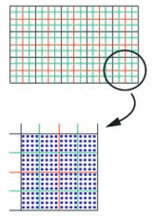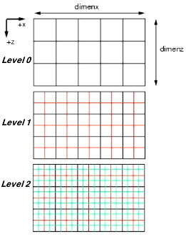

*Fig. 3. A grid stack (Levels=3: grid 0, grid 1 and grid 2) for the multigrid solver. The number of cell in the finest grid is determined by the Levels (here 3) and the parameters mgunitx (number of cell along the x direction in grid 0, here 5) and mgunitz (number of cell along the z direction in grid 0, here 3). On the right, tracer_density is defined on the finest level. In this example tracer_density=4, meaning there are four tracers/element both in the x and z direction (i.e. 4x4=16 tracers per element).*

Our finite element grid also contains tracers, which can move around through the computational grid. They carry information about the material properties. The more tracers there is in the model, the better defined are the density interfaces.

There is no fast rule for how many mesh levels and tracers you should use. The finer the mesh and the larger the number of tracers, the longer the model run will take. As consequence, a model run may take any time between just a few minutes to several weeks or months… In most cases, *levels=4* is a minimum when testing crustal to lithospheric-scale models. Once the model has been properly tested at *levels=4*, it is a good practice to let it run at levels=5.

## Exercise: Modelling Lithospheric Extension with Ellipsis

1. Evaluate the effect of changing the coupling between the crust and the mantle on the style of extension and basin formation during extension, based on *Ellipsis* script provided to you.
2. Run a model using a simple linear geotherm such that the surface of the crust is at 293 K and the Moho is at 693 K (400ºC).
3. Run the same model but with a Moho temperature of 893 K (600ºC)
4. Run the same model but with a Moho temperature of 1093 K (800ºC)

For this question you will have to set the thermal boundary conditions:

# Thermal conditions

toptbcval=68

bottbcval=1868

1. Evaluate the effect of changing the strain rate. Run model (b) (Moho at 600ºC) at a velocity of 2 mm / year (1 mm each side), and compared with a model model (b). What is the effect of the strain rate on extensional deformation?

For this question you will have to set the velocity of both vertical walls (nb: negative velocities means that the wall move to the left):

# Moving grid BC

BCmoveX0v=-3.171e-10

BCmoveX1v=3.171e-10

1. Run the model (b) by replacing the weak fault, by a small circle (1 km radius). What is the impact of this change on extension?
2. Decrease the viscosity of the lower crust by a factor of 10. What is the impact of this change on extension?

Write your answer into a report (PDF only) no longer than 5 pages. Your report must contain your name, an informative title, an introduction, a section presenting the objective of your modelling and the model setup to achieve it, a section presenting the results, a section on the interpretation of the results, a conclusion, and a reference list.

## Initial setup

The *Ellipsis* input file is a plain text file which defines all parameters we need to set up for an *Ellipsis* run, i.e. material geometries, rheologies, boundary conditions, mesh and tracer definitions, and output variables. The file contains an enormous number of things that the program needs to know, but most of which don't concern us. In the input file, all lines starting with a hash mark (#) represent comments which are ignored by *Ellipsis* but which provide very usefull information. In the following, we will be highlight the sections of the *Ellipsis* that you may need to alter for your model runs.

We won't have to change anything in the following sections: General, Advection-Diffusion Parameters, Solver Related Matters, Grid Points. They relate mostly to the resolution and accuracy of the simulation. The first setup we need to look at is:

# OUTPUT FILES

In *Ellipsis*, basic graphic outputs showing parameter fields (e.g. material, temperature, stress, strain etc) are stored in a ppm (portable pixel map) format. More sophisticated high-resolution graphics can be generated from the particles file, but require to translate a binary file into an ascii file which can then be imported into Paraview.

The number of basic graphic output is defined as follow:

PPM_files=2

We also need to extract some other data out of these models, as defined in:

# Specifications for graphical output files

## Running Ellipsis

To run *Ellipsis* extension models on your own laptop open a Terminal window, navigate into the folder holding your input script called *mycoolmodel.input* and the *Ellipsis* executable you have compiled (you may have rename the executable *myellipsis*) and type:

./myellipsis mycoolmodel.input

To stop the execution at any stage, simply do a *control-c*.

If you run *Ellipsis* remotely on another machine, navigate into the folder holding your input script called *mycoolmodel.input* and the *Ellipsis* executable and execute the following command:

**nohup nice -10 *Ellipsis*3d *inputfile &***

The “nohup” command means “no hangup”. This means if you accidentally close the command shell in which you have started this run, or even if you log out, *Ellipsis* will keep on running. This is important, as runs may take several hours. The “nice” command assigns an appropriate priority to your run, such that the computer does not get totally bogged down from your *Ellipsis* run.

When you run a program using the “nohup” command, all output that would normally be written to the screen will be written to a file called “nohup.out” in your working directory. In order to inspect the *Ellipsis* screen output as it is running, type:

**tail –f nohup.out**

This will reproduce the screen output that *Ellipsis* would normally produce.

A lot of weird stuff will scroll down the screen, but this is just normal diagnostics. Open up another terminal and navigate into the directory you left *Ellipsis* running in. You will eventually notice some files being created, and they look similar to the ones you looked at in the previous section. There are the *ppm* image files, also our stress profiles (out_ext.***.profiles), and .node_data (they give parameter such as temperature and pressure at the node of the grid). To do one simulation, it usually takes a few hours depending on the machine, and its work load. **Run** **each model in its own directory.**

***Compare two input scripts with the Unix command diff:***

As you run many scripts you may forget in what they are different. To get a listing of all differences between two input files: In a Terminal window enter: *diff name_of_file_1 name_of_file_2.*

## Recommended reading for extension modelling

http://www.geosci.usyd.edu.au/users/prey/Numerical/2-Lectures/day_one_1.html

Brune, S., 2014. Evolution of stress and fault patterns in oblique rift systems: 3-D numerical lithospheric-scale experiments from rift to breakup. ***Geochemistry Geophysics Geosystems***, doi:10.1002/2014GC005446

Gartrell, A.P., 2000, Rheological controls of extensional styles and the structural evolution of the Carnarvon Basin, Northwest Shelf, Australia, ***Australian Journal of Earth Sciences***, 47, 231-244.

Lavier and Manatschal, 2006, A mechanism to thin the continental lithosphere at magma-poor margins, ***Nature***, 440, 324-328.

Manatschal, 2004, New models for evolution of magma-poor rifted margins based on a review of data and concepts from West Iberia and the Alps*,* ***International Journal of Earth Sciences***, 93, 432-466.

Michon, L. and Merle, O., 2003, Mode of lithospheric extension: conceptual models from analogue modelling, ***Tectonics***, 22 (4).

Rey, P.F., Teyssier, C., and Whitney, D.L., 2008. Extension rates, crustal melting, and core complex dynamics. ***Geology***, 37, 391-394.