A CENTRALIZED SCHOLARSHIP MANAGEMENT AND TRACKING SYSTEM FOR BULACAN STATE UNIVERSITY – BUSTOS CAMPUS
Capstone Project Presented to

The Faculty of the Information Technology Department
Bulacan State University, Bustos Campus

In Partial Fulfillment of the Requirements for the Degree of
Bachelor of Science in Information Technology with Specialization in
Web and Mobile Application Development

By
Dela Cruz, Emerson DC.
Santos, Tristan Joseph M.
Valderama, Ian Harold DR.
Victorino, Veejay S.
Villarama, Johnvher S.

2026

TABLE OF CONTENTS
CHAPTER I: 1
Introduction 1
Background of the Study 3
Objectives of the Study 5
General Objective 5
Specific Objectives 5
Conceptual Framework 7
Scope and Limitations of the Study 9
Scope of the Study 9
Limitations of the Study 10
Significance of the Study 13
CHAPTER II: 15
REVIEW OF RELATED LITERATURE AND STUDIES 15
Technical Background 15
Review of Related Literature 23
Review of Related Studies and Systems 26
Synthesis of the Reviewed Literature and Studies 29
CHAPTER III: 31
Research Methods 31
Testing 33
Data Gathering Instrument 41
Sampling Technique 42
Data Privacy and Ethical Considerations 45
Requirements Documentation 56
Programming Languages 56
Back-End Technology 56
Frameworks 56
Databases 57
Front-End Technologies 57
System Architecture 58
Statistical Treatment of Data 60
Likert Scale Interpretation 61
Requirements Analysis 62
System Process 64
Development Environment 79
Implementation Plan 79
Planning and Designing Phase 80
Development and Prototyping 80
Testing and Feedback 81
Deployment 81
Post-Deployment Evaluation 82
CHAPTER IV: 83
I. Understanding the Challenges in Scholarship Management 83
II. Designing and Developing a Centralized Scholarship Management and Tracking System 85
Presentation and Description of the System 87
End-to-End System Workflow 87
Results and Discussion of the System's Evaluation 104
Users' Technology Acceptance Model (TAM) Evaluation Results 104
ISO/IEC 25010 Evaluation Results 108
CHAPTER V: 110
Summary of Findings 110
Conclusions 111
Recommendations 113
REFERENCES 116

CHAPTER I:
THE PROBLEM AND ITS BACKGROUND

Introduction
Scholarship programs play an important role in supporting students’ access to higher education by providing financial assistance to qualified and deserving learners. In universities, scholarship programs help reduce financial barriers and provide students with opportunities to continue their studies. However, as the number of applicants, scholarship programs, requirements, and grantors increases, managing scholarship records becomes more difficult when processes are handled manually or through fragmented systems.
Manual scholarship processing often results in delays, data errors, incomplete records, and communication problems between applicants and administrators. Jibrin et al. (2016) developed an e-scholarship system after identifying that paper-based scholarship application processing was time-consuming and prone to errors, especially during submission, screening, evaluation, and communication of application concerns. Similarly, Ablen et al. (2025) explained that manual scholarship administration may cause delayed processing, inaccurate record-keeping, and poor communication among stakeholders. These issues show the need for a centralized digital platform that can support scholarship application, validation, tracking, and communication.
At Bulacan State University – Bustos Campus, scholarship-related processes are handled by the Institutional Student Programs and Services (ISPS). Although scholarship programs are available to students, the current process still involves manual or fragmented procedures such as scholarship posting, application submission, document verification, approval monitoring, and student notification. These limitations make it difficult to track application status, monitor active scholarships, verify student records, and ensure that scholarship data are accurate and updated.
One major concern in scholarship management is the possibility of duplicate scholarship allocation. Widyastuti and Prasandha (2025) noted that lack of data integration in scholarship administration may result in delays, misallocation, and potential double funding. They also emphasized that centralized digital systems can improve efficiency, control, transparency, and audit trails. In relation to this, the developed system includes a pre-approval validation mechanism that checks whether a student already has an active scholarship before approval. This helps prevent duplicate scholarship allocation among scholarship records available to the system before a scholarship is granted, instead of relying only on detection after approval.
To address these concerns, this study developed a centralized web-based scholarship management and tracking system for Bulacan State University – Bustos Campus. The system supports scholarship posting, student application, document submission, scholarship recommendation, pre-approval validation, approval, monitoring, renewal, notification, and reporting. A web-based scholarship management system is appropriate because it can provide centralized access to scholarship information, support application submission, improve information dissemination, and promote transparency in the scholarship process (Al-Ayyubi & Maulana, 2023)

Background of the Study
Scholarship programs are designed to support students in pursuing higher education by providing financial assistance and academic opportunities. These programs are commonly managed by educational institutions, government agencies, private organizations, and other scholarship providers. Effective scholarship management requires accurate record-keeping, organized application processing, systematic evaluation, timely communication, and proper monitoring of scholars.
At Bulacan State University – Bustos Campus, scholarship-related processes are handled by the Institutional Student Programs and Services (ISPS). The office is responsible for managing scholarship applications, renewals, endorsements, and monitoring activities. Although scholarship programs are available to students, some processes still rely on manual or fragmented procedures, including application submission, document verification, record tracking, approval monitoring, and student notification. This setup may result in delays, data inconsistencies, and increased administrative workload.
Manual and fragmented scholarship processes can also affect the accuracy and transparency of scholarship records. Jibrin et al. (2016) explained that paper-based scholarship application processing is time-consuming and prone to errors, especially when applicants submit forms manually and administrators process applications through manual screening and evaluation. Similarly, Ablen et al. (2025) noted that manual scholarship administration may lead to delayed processing, inaccurate record-keeping, and poor communication among stakeholders.
One of the major concerns in scholarship management is ensuring that only one active scholarship is granted to a student at a given time. Without a centralized validation process, scholarship duplication may occur when records are stored separately or when scholarship information comes from different sources. Widyastuti and Prasandha (2025) stated that lack of data integration in scholarship administration may lead to delays, misallocation, and potential double funding. They also emphasized that digital and centralized systems can improve efficiency, transparency, data control, and accountability.
In response to these concerns, the study developed a centralized web-based scholarship management and tracking system for Bulacan State University – Bustos Campus. The system provides a unified platform where students can view scholarship opportunities, submit applications and required documents, and track their application status. Administrators and grantors can manage scholarship postings, evaluate applicants, process approvals, monitor scholars, and generate reports.
The developed system also includes pre-approval validation to help prevent multiple active scholarships, as well as scholarship recommendation, monitoring, renewal tracking, notifications, and reporting features. Through these functions, the system is designed to improve scholarship administration by reducing manual workload, improving data accuracy, supporting timely communication, and strengthening transparency and accountability in scholarship management.

Objectives of the Study

General Objective
To design, develop, and evaluate a centralized scholarship management and tracking system that streamlines application, approval, and monitoring processes while supporting the prevention of duplicate scholarship allocation.

Specific Objectives
Specifically, this study aims:
- To develop a centralized scholarship management system that enables students to apply and submit required documents, while allowing grantors and administrators to manage scholarship postings, evaluate applicants, and process approvals efficiently within a unified platform.
- To develop a system that validates student records, helps prevent multiple active scholarships, and supports duplication prevention using internal scholarship records and externally sourced scholarship records encoded into the system.
- To develop a system that provides scholarship recommendations, manages the scholarship lifecycle (application, approval, active status, renewal, and completion), and monitors student compliance and academic performance.
- To evaluate the acceptability of the system using the Technology Acceptance Model (TAM) in terms of:
  - Perceived Usefulness
  - Perceived Ease of Use
  - Behavioral Intention
- To evaluate the quality of the developed system based on the ISO/IEC 25010:2023 software quality model in terms of:
  - Functional Suitability
  - Performance Efficiency
  - Compatibility
  - Usability
  - Reliability
  - Security
  - Maintainability
  - Portability

Conceptual Framework
This study adopts the Input–Process–Output (IPO) framework as a research-supported structure for describing how scholarship-related information is transformed through the functions of the developed BulsuScholar system into usable outputs. The input component includes student and academic records, eligibility requirements, scholarship-program information, grantor details, and validated records available in the system. The process component comprises application processing, document verification, rule-based eligibility filtering, weighted scholarship ranking, identity and commitment validation, authorized decisions, monitoring, and reporting. The output component consists of recommended scholarship lists, application and award records, validation warnings, monitoring status, notifications, and administrative reports. The adoption of the Input–Process–Output framework is supported by research on the relationships among system inputs, operational processes, and resulting outcomes.
Ilgen et al. (2005) discussed the development of input–process–output models in organizational research, providing a theoretical basis for understanding how inputs and processes relate to outcomes. In the present study, the framework is adapted as a descriptive structure for organizing the components and functions of BulsuScholar rather than as a direct measure of the system's effectiveness.
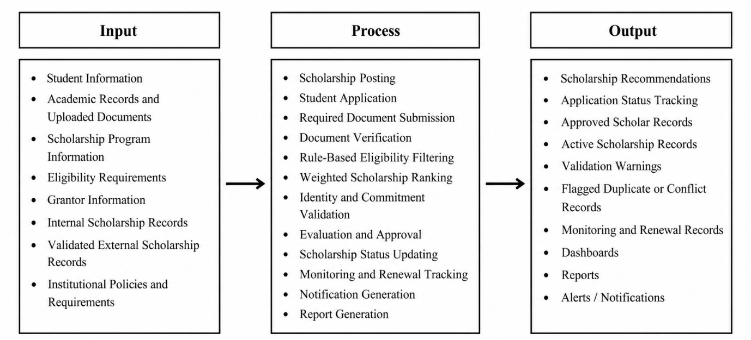
Figure 1.1. Conceptual Framework of the Study
Figure 1.1 presents the Research-Based Input–Process–Output (IPO) Conceptual Framework of the study, illustrating how the developed BulsuScholar system transforms scholarship-related information into organized and meaningful outputs. The framework consists of three interconnected components: Input, Process, and Output. These components represent the information required by the system, the procedures performed to manage scholarship activities, and the resulting information that supports students, scholarship grantors, and authorized university personnel.
The Input component represents the essential information and requirements necessary for the system to operate. These include student information, academic records, uploaded documents, scholarship program details, eligibility requirements, grantor information, internal scholarship records, validated external scholarship records, and institutional policies. Such information serves as the foundation for evaluating scholarship eligibility, managing applications, and maintaining centralized scholarship records. Externally sourced scholarship information is included only after it has been imported, encoded where supported, or validated within the system. This ensures that the framework reflects the system's reliance on available records rather than direct real-time access to external scholarship databases.
The Process component illustrates the major functions performed by the BulsuScholar system. These include scholarship posting, student application processing, required document submission and verification, scholarship recommendation, identity and scholarship commitment validation, evaluation and approval, scholarship status updating, monitoring and renewal tracking, notification generation, and report generation. The recommendation mechanism combines rule-based eligibility filtering with weighted scholarship ranking. The rule-based component evaluates student information against predefined scholarship requirements to identify eligible opportunities, while the weighted scoring component prioritizes eligible scholarships according to configured ranking factors. Additionally, identity and commitment validation helps identify possible duplicate records and conflicting scholarship assignments using available student and scholarship information. Application approval and conflict resolution remain subject to the decisions of authorized personnel.
The Output component represents the results generated after the system processes the provided information. These include scholarship recommendations, application status records, approved and active scholar records, validation warnings, flagged duplicate or conflicting records, monitoring and renewal records, dashboards, administrative reports, and alerts or notifications. These outputs allow students to identify potential scholarship opportunities and monitor their application progress. Meanwhile, scholarship grantors and authorized administrators can access organized information to evaluate applications, review potential conflicts, monitor scholarship recipients, and support scholarship-related administrative decisions.
Overall, the IPO Conceptual Framework demonstrates the relationship between the information entered into the system, the operations performed to process that information, and the results generated to support centralized scholarship management. The framework emphasizes how BulsuScholar integrates scholarship application processing, recommendation, validation, monitoring, and reporting into a unified system for Bulacan State University – Bustos Campus. Through this structured approach, the study illustrates how the developed system is designed to support more organized scholarship administration, improved record management, and informed decision-making.

Scope and Limitations of the Study

Scope of the Study
This study focuses on the design, development, and evaluation of a centralized scholarship management and tracking system for Bulacan State University – Bustos Campus. The system supports the scholarship process, including scholarship posting, student application, document submission, evaluation, approval, monitoring, renewal, and completion.
The system allows students to view available scholarship opportunities, apply for scholarships, submit required documents, and track the status of their applications. It also allows grantors and administrators to manage scholarship postings, review submitted applications, evaluate applicants, process approvals, monitor scholars, and generate reports.
The system centralizes student accounts, scholarship applications, uploaded document requirements, internal scholarship records, imported official scholarship rosters, scholarship commitments, monitoring information, and selected audit records within a unified database. The system supports student-record verification and scholarship validation to help prevent conflicting scholarship assignments.
External scholarship providers, including local government units and other organizations, may be represented by grantor accounts classified as External. Authorized users can upload official scholarship recipient lists through the existing spreadsheet roster-import process. External scholarship records become available for identity matching and scholarship-assignment validation only after they have been entered and validated within the centralized database. The system does not directly retrieve scholarship records from external providers without authorized data submission or encoding.
The system also provides scholarship recommendations based on student records and scholarship eligibility requirements. It supports scholarship lifecycle management by tracking application, approval, active status, renewal, and completion. It also monitors student compliance and academic performance as part of scholarship monitoring.
The system includes notification and reporting features to inform students, grantors, and administrators about scholarship postings, application status, document requirements, deadlines, renewal updates, and monitoring records. Notifications may be delivered through in-system alerts and email notifications.
The study involves students, scholarship grantors, and ISPS coordinators or administrators under the Institutional Student Programs and Services office of Bulacan State University – Bustos Campus.

Limitations of the Study
This study is limited to the scholarship management processes of Bulacan State University – Bustos Campus and does not cover other campuses of Bulacan State University. Only scholarship programs administered, recognized, or encoded within the campus system are included.
The system does not include financial disbursement, fund release, payroll, liquidation, or accounting-related processes. It focuses only on scholarship posting, application, document submission, validation, evaluation, approval, monitoring, renewal, completion, notification, and reporting.
The system does not provide full real-time system-to-system integration with DOST, UNIFAST, local government scholarship offices, or other external providers. Their records must first be uploaded through the official roster-import process, manually encoded where supported, and maintained by authorized users. Incomplete, outdated, or unrecorded awards may remain undetected. The proposed enhanced document-export workflow requires an authenticated user to complete six-digit MPIN authorization and then uses a separately generated random 24-character password to encrypt the official downloaded copy. Encryption does not prevent sharing passwords, screenshots, printing or copying authenticated previews; it does not establish universal field-level encryption, malware scanning, comprehensive retention or proven backup restoration.
The accuracy of the system depends on the correctness and completeness of the data provided by students, grantors, and administrators. Incomplete, outdated, or incorrectly encoded records may affect the accuracy of scholarship recommendations, validation results, monitoring records, and reports.
The system supports the monitoring of student compliance and academic performance, but final decisions regarding approval, renewal, cancellation, or termination of scholarships remain under the authority of the assigned grantors, or ISPS coordinator.
The system is developed as a web-based platform and does not include a native mobile application. However, it may be accessed through supported web browsers using compatible devices.
The system implements authentication, authorization, private document access, activity logging, and selected account-security mechanisms; however, the current implementation has operational security limitations. A dedicated malware or antivirus scanning mechanism for uploaded documents is not implemented, and a complete automated document-retention and deletion policy has not been established. The application also does not provide a separate field-level encryption layer for all sensitive student information. Although the project includes a manual Storage backup utility and deployment guidance related to database backups, a project-maintained automated backup schedule, verified Point-in-Time Recovery configuration, and a successfully tested complete database-and-document restoration procedure have not been demonstrated. Logging is implemented for selected authentication, administrative, document, and scholarship-related events, but the system does not maintain a complete before-and-after audit record for every database field or a uniform retention period for all logs.
The developed system incorporates existing security mechanisms intended to protect sensitive student information and scholarship-related records. These include user authentication, role-based access control, private document storage, and restricted document access based on authorized permissions, ownership, and relevant scholarship relationships.
The system may introduce an additional six-digit account Personal Identification Number (MPIN) verification requirement before preparing official document downloads. Following successful verification, a separate, randomly generated 24-character password would be used to encrypt the downloadable document copy. These proposed mechanisms are intended to provide additional protection for official document exports. Furthermore, encryption of downloaded files cannot prevent authorized users from sharing passwords, copying documents, capturing screenshots, or disclosing information after access has been granted.

Significance of the Study
Students
The developed system provides students with a centralized platform where they can view available scholarship opportunities, receive suitable scholarship recommendations, submit required documents, and track their application status. This can reduce confusion, missed deadlines, and delays in scholarship application processing. Web-based scholarship systems can improve access to scholarship information and support faster dissemination of updates to students (Al-Ayyubi & Maulana, 2023).
Scholarship Grantors
The system helps scholarship grantors manage scholarship postings, eligibility requirements, application records, evaluation results, and approved scholars. It also helps them monitor scholarship slots and generate reports. By using a centralized system, grantors can reduce manual workload and improve coordination with administrators and students.
ISPS Coordinators and Administrators
The developed system assists ISPS coordinators and administrators in managing scholarship records, validating applications, monitoring active scholars, preventing duplicate scholarship allocation, and generating reports. Centralized scholarship systems can improve accountability by strengthening transparency, data control, and audit trails (Widyastuti & Prasandha, 2025).
Bulacan State University – Bustos Campus
The system supports improved transparency, efficiency, and accountability in scholarship management. The system supports better decision-making through centralized reports, monitoring records, and organized scholarship data. It can also help the campus enforce scholarship policies, such as preventing multiple active scholarships from being granted to the same student.
System Developers and IT Personnel
The study may serve as a reference for system developers and IT personnel designing or improving scholarship management systems. It provides an example of how scholarship posting, application, recommendation, duplication prevention, monitoring, and reporting can be centralized into a single web-based platform.
Future Researchers
Future researchers may use this study as a reference for improving scholarship management systems, recommendation systems, duplication prevention mechanisms, and educational information systems. They may also extend the system by adding full external database integration, mobile application support, advanced analytics, or automated API-based verification with external scholarship providers.

CHAPTER II:

REVIEW OF RELATED LITERATURE AND STUDIES
This chapter presents the literature, technical concepts, related studies, and related systems that support the development of the centralized scholarship management and tracking system for Bulacan State University – Bustos Campus. It discusses scholarship management systems, web-based platforms, centralized data management, scholarship recommendation, duplication prevention, and system evaluation models. The reviewed materials serve as the foundation for understanding the need for a centralized system that can support scholarship application, validation, monitoring, and reporting.

Technical Background
Web-Based Information System
A web-based information system is an application that can be accessed through a web browser and used by different users through the internet or a local network. In scholarship management, a web-based system allows students, administrators, and grantors to access scholarship information, submit required documents, monitor applications, and receive updates without requiring installation on individual devices.
Al-Ayyubi and Maulana (2023) explained that web-based scholarship systems can improve access to scholarship information, facilitate the rapid dissemination of updates, and provide features such as centralized database management, application submission, document management, search functionality, security, and notifications. These features are relevant to the developed system because it aims to provide one platform for scholarship posting, application, monitoring, and reporting.
In the context of this study, the developed system uses a Rule-Based Decision Tree algorithm that evaluates predefined scholarship eligibility conditions. In contrast to trained machine-learning recommendation models described in previous studies, the BulsuScholar recommendation function applies predefined eligibility conditions to screen candidate scholarships and a deterministic weighted scoring process to rank the eligible options. The weighted score is a ranking indicator, not a predicted probability of award acceptance. The present implementation uses no labeled historical training dataset to learn a predictive classifier.
The recommendation process retrieves student information, compares the student’s attributes with scholarship eligibility criteria, and follows the corresponding decision branches to determine which scholarship programs match the student’s qualifications. The result assists students in identifying potentially suitable scholarship opportunities.
Centralized Scholarship Management
Centralized scholarship management uses a single system or database to manage scholarship-related data instead of storing records separately across offices, files, or disconnected platforms. A centralized system improves the organization of student records, scholarship postings, application data, monitoring records, and reports.
Widyastuti and Prasandha (2025) emphasized that lack of data integration in scholarship administration may result in delays, misallocation, and potential double funding. They also stated that centralized digital systems can improve efficiency, control, transparency, and audit trails. This supports the need for the developed system to centralize scholarship records and help prevent duplicate scholarship allocation.
For Bulacan State University – Bustos Campus, centralization is important because scholarship information may come from different sources, including internal scholarship programs and externally sourced scholarship records encoded into the system. By consolidating these records, the system can improve data accuracy, support better monitoring, and help administrators identify possible duplication before approval.
Role-Based Access Control
Role-Based Access Control, or RBAC, is a security approach in which system access is granted based on user roles. Authorization guidance emphasizes enforcing access restrictions according to the permissions assigned to users and verifying access to protected resources (OWASP Foundation, n.d.). In a scholarship management system, different users have different responsibilities. Students may apply for scholarships and track their application status, grantors may post scholarships and evaluate applicants, and administrators may manage users, validate records, monitor scholars, and generate reports.
Amer (2025) included role-based access, dashboards, reports, and scholarship management features in a smart scholarship management system to support transparency and accountability. In this study, RBAC is used to ensure that each user can only access the functions and records appropriate to their role. This helps protect student data and maintain accountability
Scholarship Recommendation
Scholarship recommendation refers to the process of identifying suitable scholarship opportunities based on student records and scholarship eligibility requirements. This feature is important because students may have difficulty determining which scholarships match their qualifications, academic standing, financial background, or other eligibility factors.
In the developed system, scholarship recommendations are based on student attributes such as general weighted average, family income, year level, course or program, achievements, residency, and other scholarship-related requirements. These data help the system identify scholarship programs that match the student’s profile and eligibility.
Rule Based Decision Tree algorithms may be used for scholarship recommendation because they classify data through clear decision rules. For example, a student with high academic performance and low family income may be recommended for an academic or financial assistance scholarship depending on the scholarship requirements. (Quinlan, 1993; Breiman et al., 1984).
Daluyon and Bilog (2025) developed a Scholarship Management Information System using machine learning models and found that the Decision Tree achieved the highest accuracy among the tested classifiers. Their study also used student profile data, data preprocessing, and classifier evaluation for scholarship recommendation, prescription, and prioritization. This study demonstrates how student attributes and eligibility-related data can support systematic scholarship recommendations. However, the developed system in the present study uses predefined rule-based eligibility conditions rather than a trained machine-learning Decision Tree model
The basic recommendation process involves collecting student data, preparing the dataset, comparing student attributes with scholarship eligibility criteria, and classifying students into appropriate scholarship categories. The study provides a relevant comparison for scholarship recommendation approaches; however, the developed system uses a rule-based Decision Tree algorithm based on predefined eligibility conditions rather than a Decision Tree model trained from historical data.
Duplication Prevention
Duplication prevention is an important feature of the developed system because scholarship records may contain repeated, inconsistent, or similar student information. The system supports the institutional policy of preventing conflicting scholarship assignments by validating student and scholarship records through exact identity checks, similarity-based record comparison, and scholarship commitment rules.
Record Linkage is a method used to determine whether records from different sources refer to the same person, object, or event. Fellegi and Sunter (1969) introduced a theoretical framework for identifying matching records across files. In the developed system, record-matching concepts are applied to compare student information from internally stored scholarship records and externally sourced scholarship records encoded into the system.
The system does not use one identical checking sequence for every process. Different workflows perform different validation procedures depending on the action being performed. For example, account creation checks the student’s identification number and verifies whether the corresponding student name is sufficiently similar, while scholar-list processing checks scholarship information, repeated records, student identity, existing scholar assignments, and scholarship commitments. The weighted duplicate checker separately compares the records provided to it using several student attributes.
Levenshtein Distance is used to measure the similarity of text values that may contain small spelling or formatting variations. It measures the number of insertions, deletions, or substitutions required to transform one string into another (Levenshtein, 1966). In the weighted duplicate checker, similarity checking may be performed even when the Student IDs are the same; therefore, Levenshtein-based comparison is not limited only to cases where the Student ID is missing or different.
The weighted duplicate checker compares available student information using the following fields: Student ID, full name, email address, contact number, course, year level, city or municipality, and province. The assigned weights are 32% for Student ID, 30% for full name, 10% for email address, 8% for contact number, 8% for course, 4% for year level, 4% for city or municipality, and 4% for province. Birthdate and school are not included in the weighted similarity score, and only city or municipality and province are used from the address information. When a value is unavailable, that comparison is excluded and the score is adjusted using the available weighted fields.
The duplicate checker applies different matching rules depending on the available information. An exact Student ID match may be considered sufficient to identify a duplicate. An exact email address or contact-number match combined with a name similarity of at least 72% may also identify matching records. For the general similarity rule, the student names must reach at least 82% similarity and the combined weighted similarity score must reach at least 84%. These thresholds are matching criteria used by specific validation rules and should not be interpreted as measures of system accuracy.
The use of Weighted Record Linkage with Levenshtein similarity provides an interpretable approach for identifying potentially duplicate student records that may contain minor spelling differences, typographical errors, or formatting inconsistencies. Data normalization reduces differences caused by capitalization, punctuation, and spacing, while Levenshtein similarity measures variations between text values based on character insertions, deletions, and substitutions. The application of attribute weights allows the comparison process to consider multiple student identifiers rather than relying solely on the student's name. This is important because different students may possess similar or identical names despite having different personal and academic records. However, a high similarity score does not automatically establish that two records belong to the same individual. Consequently, similarity-based results are treated as indicators of possible duplicate identities. Official scholarship assignment requires separate verification of student identity, the applicable academic cycle, recognized scholarship information, and existing scholarship commitments. This distinction reduces the risk of treating a possible duplicate match as sufficient authorization for a scholarship award.
Possible duplicates do not always produce the same system action. Depending on the workflow, a possible duplicate may be grouped or flagged for authorized review, may prevent a scholar record from being saved, may stop a conflicting scholar-list import, or may restrict a scholarship-related action when an existing scholarship commitment is present. Account activation and scholarship assignment are treated as separate processes; therefore, a flagged conflict does not necessarily prevent a pending account from being activated.
Input–Process–Output Framework
The Input–Process–Output (IPO) framework is a conceptual approach used to describe the relationship between available inputs, the processes that transform those inputs, and the resulting outputs. It provides an organized structure for understanding how resources, information, and operational activities contribute to the outcomes of a system or process. Ilgen et al. (2005) discussed input–process–output models in organizational research and their development toward more dynamic explanations of how inputs, interactions, and outcomes are related.
In the context of information systems, the IPO framework can be adapted to describe how collected information is processed through defined operations to produce useful results. Inputs represent the data and requirements necessary for the system to function, processes represent the activities performed on those inputs, and outputs represent the information or records generated from those activities.
In the present study, the IPO framework provides a descriptive basis for explaining the operation of the developed BulsuScholar system. The input component includes student profiles, academic records, scholarship eligibility requirements, grantor information, scholarship program details, and validated scholarship records available within the system. The process component involves scholarship application handling, document verification, rule-based eligibility filtering, weighted recommendation scoring, identity matching, scholarship commitment validation, approval processing, monitoring, and report generation.
The output component includes ranked scholarship recommendations, application results, verified scholarship records, validation warnings, monitoring information, notifications, and administrative reports. These outputs support students, scholarship grantors, and authorized administrators in managing scholarship-related activities.
The IPO framework is used in this study to explain the relationship among the developed system's information inputs, operational functions, and outputs. It does not independently establish the effectiveness, usability, or technical quality of BulScholar. These aspects are evaluated separately through functional testing, the Technology Acceptance Model (TAM), and the ISO/IEC 25010:2023 software quality model.

Technology Acceptance Model
The Technology Acceptance Model, or TAM, is used to evaluate whether users are likely to accept and use a system. It focuses on factors such as perceived usefulness and perceived ease of use. Davis (1989) explained that perceived usefulness and perceived ease of use are important determinants of user acceptance of information technology.
In this study, TAM was used to evaluate the acceptability of the developed system in terms of perceived usefulness, perceived ease of use, and behavioral intention. This helps determine whether students, grantors, and administrators find the system useful, easy to use, and likely to be adopted in scholarship management processes.
ISO/IEC 25010 Software Quality Model
ISO/IEC 25010 is a software quality model used to evaluate software systems. The standard provides quality characteristics that can be used to assess whether a system meets functional and operational requirements. In this study, ISO/IEC 25010:2023 was used to evaluate the developed system with respect to functional suitability, performance efficiency, compatibility, usability, reliability, security, maintainability, and portability (International Organization for Standardization & International Electrotechnical Commission, 2023).
Daluyon and Bilog (2025) evaluated their Scholarship Management Information System using ISO/IEC 25010 and obtained a “Highly Acceptable” rating. Yan (2024) also evaluated an online students’ scholarship evaluation system using ISO 25010 and found that the system met the assessed criteria to a very great extent in several software quality characteristics.

Review of Related Literature
Scholarship Management in Higher Education
Scholarship programs are important in higher education because they provide financial assistance to deserving students and help improve access to education. However, scholarship management requires the systematic handling of applications, scholarship requirements, eligibility assessments, approvals, monitoring, and reporting. Without an organized system, scholarship processes may become delayed, inconsistent, and difficult to monitor.
Jibrin et al. (2016) explained that manual processing of scholarship applications is time-consuming and error-prone because applicants must submit forms in person, while administrators manually screen, evaluate, and communicate application concerns. Their e-scholarship system allowed students to apply online and receive updates through SMS and email. This supports the need for online application and notification features in scholarship systems.
Ablen et al. (2025) also identified problems in manual scholarship administration, including delayed processing, inaccurate record-keeping, and poor communication among stakeholders. Their SMART-Scholar system used automation, real-time updates, web and mobile interfaces, and large-scale data management to improve scholarship administration. This shows that digital scholarship systems can improve efficiency, accuracy, and transparency.

Digital and Centralized Scholarship Administration
Digital scholarship administration helps reduce manual workload, organize records, and support faster access to information. Centralized systems are especially important when different offices or grantors handle scholarship data. Without integration, administrators may have difficulty identifying duplicate records, monitoring active scholars, and generating reliable reports.
Widyastuti and Prasandha (2025) stated that scholarship administration may face problems such as lack of data integration, delayed disbursement, misallocation, and potential double funding. Their study emphasized that digital systems can support centralized data management, reduce double funding errors, and improve transparency. This is directly related to the developed system, as one of its main goals is to prevent multiple active scholarships through centralized validation.
Al-Ayyubi and Maulana (2023) also highlighted the importance of web-based scholarship systems in improving access to information and rapid dissemination of updates. Their study included features such as a centralized database, search functionality, notifications, application submission, document management, security, and evaluation processes. These features are similar to the modules planned for the developed system.
Scholarship Recommendation Systems
Scholarship recommendation systems help students identify scholarship opportunities that match their qualifications, needs, and preferences. This is important because students may miss opportunities when scholarship information is scattered or when they are unsure which scholarships fit their profile.
Sulaiman and Ahmad (2023) developed ScholarsAid, a personalized scholarship web application that allows students to search and filter scholarships based on their preferences or needs. Their system used a matching algorithm to provide relevant scholarship options. This supports the developed system’s recommendation feature, which helps students identify suitable scholarships based on their academic, financial, and profile information.
Alfonso et al. (2025) developed Mediskolar, a web-based scholarship management system for Marikina City that incorporated the Analytical Hierarchy Process (AHP) and a Decision Tree algorithm for scholarship profile analysis. Their study provides a relevant comparison for scholarship decision-support functions, while the present system uses a rule-based Decision Tree based on predefined eligibility requirements.
Notification, Tracking, and Reporting
Scholarship systems should not only accept applications but also keep users informed about scholarship updates, application status, requirements, and deadlines. Notifications and reports improve communication between students, grantors, and administrators.
Al-Ayyubi and Maulana (2023) emphasized that web-based scholarship systems can provide real-time updates and notifications about application deadlines, eligibility criteria, and program changes. Jibrin et al. (2016) also included SMS and email notifications in their e-scholarship system to inform applicants about application progress. In the developed system, notifications were used to inform users about scholarship postings, requirements, application status, and monitoring updates.
Reporting is also necessary for transparency and decision-making. Centralized systems can support monitoring and accountability by keeping organized records and audit trails (Widyastuti & Prasandha, 2025). Therefore, the developed system includes dashboards and reports to help administrators and grantors monitor applications, approved scholars, available slots, and scholarship status.

Review of Related Studies and Systems
Development of E-Scholarship System
Jibrin et al. (2016) developed an e-scholarship system to address the limitations of manual scholarship application processing. Their study found that paper-based scholarship processing was time-consuming and error-prone. The system allowed students to apply online and provided notifications through SMS and email. Although the system improved application submission and communication, it primarily focused on online application processing and did not emphasize scholarship recommendation, duplication prevention, or full scholarship lifecycle monitoring.
Designing a Web-Based Information System for Scholarship Management
Al-Ayyubi and Maulana (2023) designed a web-based scholarship information system to improve access to scholarship information and rapid dissemination of updates. Their system included a centralized database, user-friendly interface, search functionality, notifications, application submission, document management, and security features. While the study supports the development of a web-based scholarship system, it did not focus on rule-based scholarship recommendation combined with duplication prevention.
Raya (2021) presented a web-based scholarship information system developed using the Waterfall model to facilitate scholarship registration and information management. Unlike the sequential development approach used in that study, the present research employed Agile methodology to accommodate iterative system development and stakeholder feedback.
Scholarship Management Information System Using Machine Learning Models
Daluyon and Bilog (2025) developed a Scholarship Management Information System using machine learning models. Their study used data preprocessing and compared classifiers such as Decision Tree, Random Forest, and Naïve Bayes for scholarship recommendation, prescription, and prioritization. The Decision Tree model achieved the highest accuracy, and the system was evaluated using ISO/IEC 25010. However, the study focused primarily on machine-learning-based scholarship management and did not fully address the prevention of duplicate scholarship records across internal and external records.
ScholarsAid: A Personalized Scholarship Web Application
Sulaiman and Ahmad (2023) developed ScholarsAid, a personalized scholarship web application based on web scraping and matching algorithms. The system helped students search, filter, and receive scholarship recommendations based on their needs and preferences. Although the system supported personalized scholarship discovery, it focused more on scholarship search and recommendation than on administrative approval, monitoring, duplication prevention, and lifecycle management.
SMART-Scholar: A Scholarship Management and Tracking System
Ablen et al. (2025) developed SMART-Scholar, an automated scholarship management and tracking system for Ormoc City. The system addressed delayed processing, inaccurate records, and poor communication by using automation, web and mobile interfaces, real-time updates, and data management. The study is relevant to the developed system because it supports scholarship tracking and transparency. However, it did not focus on the combination of scholarship recommendation and pre-approval duplication prevention.
A Smart Scholarship Management System: All-in-One Solution
Amer (2025) developed a smart scholarship management system featuring dashboards, donor management, reporting, role-based access, and automated administrative processes. The system emphasized transparency and accountability. This study supports the use of role-based access, dashboards, and reporting in the developed system. However, some features, such as donor matching, budget tracking, and receipt scanning, are outside the scope of the developed system, as financial disbursement and accounting are not included.

Synthesis of the Reviewed Literature and Studies
The reviewed literature and studies show that digital scholarship systems can improve application processing, record management, communication, recommendation, monitoring, and reporting. Jibrin et al. (2016) and Al-Ayyubi and Maulana (2023) demonstrated the usefulness of online applications, centralized records, document management, and notifications. Sulaiman and Ahmad (2023) and Daluyon and Bilog (2025) also showed how student information and scholarship criteria can support scholarship recommendation. However, unlike trained machine-learning approaches, the developed system uses a rule-based Decision Tree using predefined scholarship eligibility conditions.
The identified research gap is therefore not the absence of scholarship management, recommendation, or tracking systems individually. Rather, the reviewed studies provide limited coverage of a single platform that integrates scholarship posting and application, document submission, rule-based recommendation, pre-approval duplicate validation, applicant evaluation and approval, scholarship lifecycle monitoring, renewal and compliance tracking, notifications, and reporting. Related systems often emphasize only selected parts of this overall process.
The developed Centralized Scholarship Management and Tracking System for Bulacan State University – Bustos Campus addresses this gap by integrating these functions within one web-based platform. It also supports duplication prevention using available internal records and externally sourced scholarship records encoded into the system. The developed system was evaluated using the Technology Acceptance Model (TAM) for user acceptability and ISO/IEC 25010 for software quality.

CHAPTER III:
METHODOLOGY
This chapter presents the research methods and procedures used in developing the centralized scholarship management and tracking system for Bulacan State University – Bustos Campus. This covers the research design, data collection methods, system development process, tools and technologies utilized in the project, and techniques implemented to guarantee the correctness, usability, and reliability of the system.

Research Methods
This study employed a Developmental Research Design to design, develop, and evaluate a centralized scholarship management and tracking system for Bulacan State University – Bustos Campus. Developmental research is appropriate for this study because it focuses on the systematic design, development, implementation, and evaluation of an information system intended to address identified institutional problems.
The developed system was designed to improve the management of scholarship postings, applications, approvals, monitoring, notifications, and reporting processes through a centralized web-based platform. It also incorporates validation mechanisms to help prevent multiple active scholarship allocations and support compliance with institutional scholarship policies.
The research utilized a quantitative approach to evaluate the system’s acceptability and software quality. The quantitative approach involved structured survey questionnaires based on the Technology Acceptance Model (TAM) and the ISO/IEC 25010 Software Quality Model.
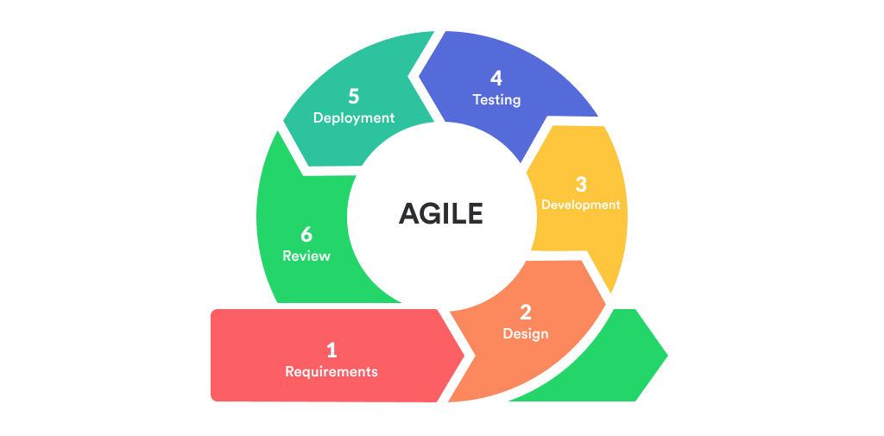
Furthermore, the system was developed using the Agile Software Development Methodology. Agile was selected because it supports iterative and flexible system development, allowing continuous improvement of system features throughout the development process. This methodology enabled the researchers to collaborate closely with stakeholders, including students, scholarship grantors, and ISPS coordinators, to gather feedback and refine system functionalities based on actual operational needs.
Figure 2.1. Agile Model
Agile was appropriate for this study because system requirements evolved as stakeholders provided feedback regarding scholarship posting, application, validation, approval, and monitoring processes. Through iterative development cycles, the researchers gradually implemented system modules and presented working prototypes for evaluation. This approach allowed necessary adjustments and enhancements to be incorporated during development rather than at the final stage. By adopting the Agile methodology, the researchers developed a system that is functional, reliable, and aligned with the operational requirements of scholarship administration at Bulacan State University – Bustos Campus. This ensures that the resulting system remains user-centered, adaptable, and capable of addressing the identified challenges in scholarship management.

Testing
In this phase, the developed system underwent testing procedures to ensure its functionality, reliability, performance, usability, and security. Various testing methods such as functional testing, usability testing, performance testing, and security checking were conducted to identify and resolve system errors before the final evaluation.
Functional testing verified whether major system modules performed their expected functions, including scholarship posting, student application, required document submission, validation, approval, monitoring, notification, and reporting. Automated backend tests were also conducted on selected authentication, account management, application, roster processing, monitoring, renewal, notification, and reporting functions. The complete scholarship recommendation ranking mechanism was not included as a dedicated passing test case in the current automated test summary and therefore is not claimed as fully verified by these results.
In addition to the selected core functional tests, targeted automated testing was conducted to verify student-record matching, official scholarship roster import, identity reconciliation, scholarship assignment, and prevention of conflicting current-cycle awards.
Backend regression tests examined exact identity matching, configured similarity thresholds, account activation and verified-login requirements, role-based authorization, and scholarship conflict handling.
These tests assessed roster assignment, repeated processing, current-cycle award conflicts, previous-cycle historical records, cancelled or terminated commitments, competing pending applications, reservation release, administrative restrictions, and transaction rollback behavior.
Each test was documented using an identifiable test-case number, a description of the function being evaluated, expected results, actual observed results, and the corresponding test status.
COR and ROG Functional Test Case Results

The researchers conducted automated backend testing and supplementary technical evaluation to assess the document-processing functions of the developed BulsuScholar system. The testing focused on the extraction, recognition, validation, and management of Certificates of Registration (COR) and Reports of Grades (ROG).
The automated tests examined selected document-processing conditions, including valid and invalid PDF submissions, academic-document recognition, Student ID verification, year-level extraction, academic-cycle validation, applicable ROG exemptions, document renewal requirements, document-access authorization, and protected-document processing.
The selected document-processing tests were identified as TC-16 through TC-35 in the consolidated backend and technical test-case summary. These references correspond to recorded automated regression tests and isolated technical scenarios.
A supplementary local evaluation was conducted on October 25, 2026, using two synthetic COR documents and one synthetic ROG document. The extracted information was compared with independently identified reference values to determine field-level extraction accuracy.
Field-level accuracy was calculated using the following formula:
$$F(\%) = (C/ T) × 100$$
Where :
- F = Field Accuracy
- C = Correctly Extracted Fields
- T = Total Evaluated Fields
The evaluation was performed in a controlled local environment using the existing document parser. Network connections were restricted, and database and storage interactions were mocked to avoid modifying production records.
The results of automated functional testing, isolated validation scenarios, and synthetic field-level extraction measurements were interpreted separately. Passing results represented successful behavior under the documented test conditions rather than proof of complete document-validation coverage or general extraction accuracy.
The developed system was also evaluated using standardized models, specifically the Technology Acceptance Model (TAM) and the ISO/IEC 25010 Software Quality Model. TAM assessed user acceptance in terms of Perceived Usefulness, Perceived Ease of Use, and Behavioral Intention, while ISO/IEC 25010 evaluated system quality in areas such as functional suitability, performance efficiency, compatibility, usability, reliability, security, maintainability, and portability.
The results of these evaluations determined whether the system meets the expected quality standards and user requirements.

Table 1
Summary of Core Automated Backend Test Cases
Test ID | Functionality | Expected Result | Actual Result | Status
TC-01 | User Login | Valid credentials return the correct account identity and reset failed login attempts. | Valid credentials authenticated successfully, returned the correct account identity, and reset failed login attempts. | Passed
TC-02 | Failed Login and Account Lockout | Invalid credentials record failed attempts; reaching the configured limit locks the account. | Invalid login attempts were recorded, and the account was locked after reaching the configured limit. | Passed
TC-03 | Role-Based Access | Unauthorized roles and users accessing another account’s records are rejected. | Unauthorized users and roles were prevented from accessing restricted or other users’ records. | Passed
TC-04 | Student Registration | Newly registered students remain pending until email confirmation. | Student registration created a pending account that remained inactive until email confirmation. | Passed
TC-05 | Email Confirmation | Confirmed authentication identity is used to process the student; unconfirmed or spoofed identity is rejected. | Confirmed identities were accepted, while unconfirmed or invalid identities were rejected. | Passed
TC-06 | Manual Account Approval | Unauthorized reviewers, unconfirmed students, and missing signup requirements prevent account approval. | Account approval was prevented when the reviewer was unauthorized, the student was unconfirmed, or required documents were incomplete. | Passed
TC-07 | Student Application Profile Validation | Required profile information is validated, and locked fields are taken from the stored student record. | Required profile information was validated and protected fields were retrieved from the student’s stored record. | Passed
TC-08 | Scholarship Application | Application identifiers are generated by the server, and unauthorized identities or document paths are rejected. | Scholarship applications received server-generated identifiers, while unauthorized identities and invalid document paths were rejected. | Passed
TC-09 | Official Roster Processing | Matching applications are identified for conversion; identity conflicts and unknown scholarships are flagged. | Matching applications were identified, while identity conflicts and unknown scholarship records were successfully flagged. | Passed
TC-10 | Applicant Filtering | Filters are applied before pagination, and reports follow the selected grouping and date order. | Applicant filters were correctly applied before pagination, and report results followed the selected grouping and date order. | Passed
TC-11 | Announcement Publishing | Creation requires an image, retries avoid duplicate announcements, and publishing uses the database workflow. | Announcements required the necessary image, duplicate creation was prevented during retries, and publishing followed the database workflow. | Passed
TC-12 | Inbox Required Action | A rejected document produces one required action, while an active waitlist offer takes priority. | Rejected documents generated the appropriate required action, while active waitlist offers were prioritized correctly. | Passed
TC-13 | Academic Cycle Management | Full administrators can access cycle controls; invalid cycles and stale concurrent updates are rejected. | Authorized administrators accessed academic-cycle controls, while invalid cycles and outdated concurrent updates were rejected. | Passed
TC-14 | Document Renewal Status | A cycle change identifies missing current-cycle documents, and the renewal banner clears when requirements are approved. | Missing current-cycle documents were identified after cycle changes, and the renewal notice cleared after the required documents were approved. | Passed
TC-15 | Report Generation | Reports respect filters, validate inputs, generate formatted PDFs, and protect CSV exports against spreadsheet formulas. | Reports followed selected filters, validated inputs, generated formatted PDF outputs, and protected CSV exports against spreadsheet-formula injection. | Passed

Table 1 presents 15 selected core automated backend test cases conducted to verify the functionality of the major modules of BulsuScholar. The table summarizes the tested operations, their expected outcomes, actual observed results, and corresponding test statuses.
Additional document-processing and technical test cases, identified as TC-16 through TC-35, are presented separately in Chapter IV. These supplementary cases cover selected COR and ROG processing, identity and academic-cycle validation, access restrictions, document renewal, and protected-document handling. The continuous test-case numbering is used for documentation consistency and does not indicate that all 35 cases were executed as part of a single test run.
These results represent different sets of technical verification activities and were not combined into a single algorithm accuracy percentage or treated as equivalent to real-user evaluation. The results are limited to the documented testing environments and datasets.
Data Gathering Instrument
This study utilized structured questionnaires as the primary data gathering instruments to evaluate the acceptability and software quality of the developed system. Two separate evaluation instruments were used based on the type of respondent and the aspect of the system being evaluated.
The Technology Acceptance Model (TAM) questionnaire was administered to 47 user respondents, consisting of 44 students, 2 scholarship grantors, and 1 ISPS Coordinator. It measured the acceptability of the system in terms of Perceived Usefulness, Perceived Ease of Use, and Behavioral Intention.
The ISO/IEC 25010 questionnaire was administered separately to 5 IT professionals who evaluated the technical quality of the developed system. The evaluation covered Functional Suitability, Performance Efficiency, Compatibility, Usability, Reliability, Security, Maintainability, and Portability.
In total, 52 respondents participated in the system evaluation, with each respondent group assigned to the evaluation instrument appropriate to their role and expertise.

Sampling Technique
The study employed purposive sampling in selecting the respondents for the evaluation of the Centralized Scholarship Management and Tracking System for Bulacan State University – Bustos Campus. Purposive sampling was used because the respondents were selected based on their direct involvement, experience, or relevant knowledge of the scholarship management process and the functions of the developed system.
The student respondents were selected because they represent the primary users of the system, particularly in viewing scholarship opportunities, submitting applications and documentary requirements, receiving scholarship recommendations, and monitoring application status. Scholarship grantors were selected because they are responsible for managing scholarship programs, evaluating applicants, and processing scholarship decisions. The ISPS Coordinator was included because of the role of the Institutional Student Programs and Services office in managing scholarship records, monitoring scholars, and overseeing scholarship-related processes. IT professionals were selected to evaluate the technical quality of the developed system based on the ISO/IEC 25010 software quality characteristics.
The inclusion criteria for the respondents were as follows: students must be enrolled at Bulacan State University – Bustos Campus and be capable of evaluating the student-related functions of the system; scholarship grantors must be involved in scholarship administration, applicant evaluation, or approval processes; the ISPS Coordinator must be directly involved in the management or monitoring of scholarship-related activities; and IT professionals must possess relevant knowledge or experience in information technology, software development, system evaluation, or related fields.
Through purposive sampling, the researchers ensured that the respondents selected for the study were appropriate to the specific functions and evaluation requirements of the developed system.
The questionnaires were distributed using online platforms such as Google Forms to the selected respondent groups. The TAM questionnaire was distributed to the students, scholarship grantors, and ISPS Coordinator, while the ISO/IEC 25010 questionnaire was distributed separately to the IT professionals.

Table 2: Distribution of Respondents
Respondents | No. of Respondents | Description
Students | 44 | Students of Bulacan State University – Bustos Campus scholarship applications and related requirements.
ISPS Coordinator | 1 | Personnel responsible for managing scholarship records and processing scholarship requirements and records
Scholarship Grantors | 2 | Users responsible for managing scholarship programs, evaluating applicants, and approving qualified students within the system.
IT Professionals | 5 | Experts who evaluate the technical quality and functionality of the system
Total | 52 | Participants involved in system evaluation

Table 2 presents the distribution of respondents involved in the evaluation of the developed Centralized Scholarship Management and Tracking System. A total of 52 respondents participated in the study. Of these, 47 were user respondents composed of 44 students, 2 scholarship grantors, and 1 ISPS Coordinator. These 47 respondents evaluated the system using the Technology Acceptance Model (TAM). The remaining 5 respondents were IT professionals who evaluated the technical quality of the system using the ISO/IEC 25010 Software Quality Model. This distribution allowed the researchers to obtain both user-based feedback on system acceptability and expert-based evaluation of software quality.

Data Privacy and Ethical Considerations
The developed system was designed with consideration for the principles of the Data Privacy Act of 2012 (Republic Act No. 10173). Personal, academic, scholarship, and documentary information collected by the system is used for scholarship processing, verification, monitoring, evaluation, and related administrative functions. Access to this information is restricted according to authenticated user identity, assigned role, permissions, record ownership, and the scholarship-related responsibilities of the user.
Digital identity guidelines provide guidance for managing authentication, credential security, and identity verification in information systems (Grassi et al., 2020).
User authentication is handled through Supabase Auth together with additional FastAPI application checks. Supabase verifies account credentials and issues authentication tokens, while the back-end verifies the corresponding account type, account status, lockout condition, user identity, and application-specific access requirements. Passwords used in the normal account flow are handled by Supabase Auth rather than being stored as readable password fields in student or grantor records. Student account activation also requires confirmed identity and email verification. The normal student, grantor, and administrator login process monitors unsuccessful login attempts and can lock an account when the configured failed-login limit is reached.
The system also implements additional account-verification and recovery controls. Students and grantors may be required to complete an email-code verification step after an extended period without recorded meaningful activity, while password recovery is handled through the provider's password-reset process together with application-level recovery verification. Authenticated sessions use Supabase access and refresh tokens, while protected back-end requests additionally validate account status, session information, roles, and permissions. These controls should not be interpreted as universal multi-factor authentication because authenticator applications, passkeys, and hardware security keys are not currently implemented.
Authorization is enforced through both application-level and database-level controls. The main technical account types are Student, Grantor/Provider, Administrator, and Root Admin. Administrator accounts may be assigned specialized permission groups according to their responsibilities. The ISPS Coordinator performs the appropriate administrative responsibilities through assigned administrator permissions rather than through a separate technical account type. Back-end services verify authenticated identity, role, permissions, ownership, and user-to-record relationships before protected operations are allowed. Students are restricted to their own protected profiles, applications, and documents, while grantor access is scoped to records related to the corresponding grantor. A read-only technical verification of the deployed database also found Row Level Security enabled on the public database tables inspected.
The system handles and processes various types of sensitive and personal information, including student identification details, student numbers, contact information, residential addresses, photographs, signatures, academic records, grades or General Weighted Average (GWA), Certificates of Registration (COR), Reports of Grades (ROG), scholarship applications, supporting documents, identity verification files, scholarship awards, monitoring records, scholarship-related review information, and selected audit events. Certain submitted documents may also contain additional confidential information, such as family background, household income, and financial declarations required for scholarship eligibility assessment and verification.
To protect these records against unauthorized access and disclosure, the system implements access controls based on authenticated user identity, assigned roles, record ownership, permissions, and relevant scholarship relationships, ensuring that information is accessible only to users with the appropriate authorization. In terms of data transmission security, testing of the publicly accessible website and Application Programming Interface (API) confirmed that HTTP requests were redirected to HTTPS, providing encrypted communication between users and the system. Furthermore, the Supabase platform provides provider-managed encryption for hosted customer data at rest and Transport Layer Security (TLS) protection for data transmitted between the application and its backend services.
However, these infrastructure-level security measures should be distinguished from application-specific protections, including authorization policies, document access restrictions, file-copy encryption, document preview controls, and audit logging. Although the system benefits from provider-managed authentication and encryption mechanisms, it does not implement an additional field-by-field encryption layer for all sensitive student information or independently encrypt every uploaded document at the application level.
Therefore, the system's security scope primarily relies on the combined implementation of application-level access controls, authenticated access, role-based permissions, and the underlying security mechanisms provided by its hosting and database infrastructure, while recognizing the limitations of its current encryption and document protection capabilities.
The system utilizes Supabase Storage for managing and storing uploaded student and scholarship-related documents, including Certificates of Registration (COR), Reports of Grades (ROG), identification documents, scholarship application forms, and other supporting requirements. To maintain the confidentiality and integrity of these files, the verified storage bucket is configured as private, preventing unrestricted public access to uploaded documents. Document preview and download operations are protected through authentication and authorization mechanisms that verify the requesting user's identity, assigned role, document ownership, or established relationship between the grantor and the corresponding scholarship application before access is granted.
Additionally, the system implements upload validation procedures to ensure that submitted files comply with supported file formats, maximum file size requirements, and appropriate ownership information, thereby reducing the risk of unauthorized or invalid file submissions. As an additional security enhancement, the proposed document download workflow introduces a two-stage verification and file protection process designed to strengthen the confidentiality of sensitive student records.
Under this proposed mechanism, an authenticated and authorized user must first provide a six-digit account Personal Identification Number (MPIN) before an official document download can be prepared. MPIN verification is performed on the server using securely stored verification material and a limited number of authentication attempts to reduce the risk of unauthorized access and repeated guessing. Following successful verification, the system generates a fresh, cryptographically secure, random 24-character password that is independent of the user's MPIN and account login credentials.
This generated password is then used to protect the downloadable copy of the requested document through an appropriate encryption method. For ordinary PDF documents, the system is proposed to apply an AES-256-capable PDF encryption format with suitable security settings, while documents requiring preservation of their original file formats may be packaged into password-protected ZIP archives using AES-256 encryption.
Before initiating the download, the generated file password is presented to the authorized user for secure storage and subsequent access to the protected file. Importantly, the original document stored in Supabase Storage, including the original bytes of digitally signed files, remains unchanged throughout this process, as encryption is applied only to the downloadable copy. Furthermore, the account MPIN serves exclusively as an additional verification factor and is not directly reused as the offline document encryption password, ensuring separation between account verification and file protection mechanisms.
Although these proposed enhancements aim to provide an additional layer of document security, the current implementation does not include a dedicated malware or antivirus scanning service for uploaded files, and a comprehensive time-based document retention and automatic deletion policy covering all student records has not yet been established.
These limitations identify areas for future system improvement, particularly in strengthening document security, managing the lifecycle of sensitive information, and supporting more comprehensive data protection practices.
The system maintains selected security and activity records, including login-security state, workflow and system events, privileged administrative actions, document review records, student-history events, and selected recovery or scholarship-related audit events. Supported records can identify the relevant actor and timestamp for activities such as account decisions and document reviews. However, the system does not provide a complete before-and-after audit history for every database field, and a uniform retention period for all security and workflow logs has not been established.
Authorized previews remain readable within the application and should not be described as fully protected against screenshots or copying. When an encrypted PDF upload requires a password, a supplied password may be used temporarily to create a processing copy for validation without replacing the authoritative original signed file. A download-preparation audit may record the actor, resource reference, file fingerprint, format, protection method, timestamp, and preparation result, but must exclude MPIN values, file passwords, and sensitive file contents. A prepared event demonstrates that the application generated a protected copy; it does not establish that the browser successfully saved or opened it
With regard to backup and recovery, the project includes a manual Storage backup utility and deployment guidance concerning database restore points and separate Storage copies. However, a project-maintained automated database-backup schedule, verified Point-in-Time Recovery configuration, and a successfully tested complete database-and-document restoration procedure were not demonstrated during the technical review. These items are therefore treated as operational limitations and areas for future improvement rather than completed security controls.
For the research evaluation, respondent participation was voluntary, and evaluation responses were treated confidentially. The collected evaluation data were used only for assessing the acceptability and software quality of the developed system. Personally identifiable, academic, scholarship, authentication, and documentary information was not intentionally disclosed to unauthorized individuals.
System Modules
The developed system is composed of several interconnected modules, each designed to perform specific functions that collectively support the complete scholarship management lifecycle. These modules ensure that the processes of posting, application, recommendation, validation, approval, monitoring, notification, and reporting are efficiently handled within a centralized platform. Each module is aligned with the system’s objectives and addresses specific challenges identified during the requirements gathering phase.
The system modules are described as follows:
1. Scholarship Posting Module
This module allows scholarship grantors and coordinators to create, update, and manage
scholarship opportunities within the system. It includes functionalities for defining eligibility criteria, application requirements, required documents, deadlines, available slots, scholarship duration, and scholarship descriptions. By centralizing scholarship postings, this module ensures that all available opportunities are organized, easily accessible, and consistently presented to students.
2. Application Module
The application module enabled students to apply for scholarships through an online interface. Students can submit required documents, fill out application forms, and track their application status. This module reduces manual submission processes and ensures that applicant data are securely stored and readily available for evaluation. Students can only be able to apply to scholarships that are currently posted and available within the system, ensuring that applications are aligned with active scholarship opportunities.
3. Scholarship Recommendation Module
The Scholarship Recommendation Module assists students in identifying scholarship opportunities through predefined recommendation-stage eligibility conditions and weighted scoring. The backend recommendation function evaluates application restrictions and minimum GWA requirements before calculating scores for qualifying scholarship opportunities. The scoring mechanism considers academic-grade suitability, scholarship-roster popularity, geographic relevance, and an announcement-related image-availability component.
The resulting recommendation scores are used to rank eligible scholarship opportunities. Other eligibility requirements, document verification, application restrictions, and official scholarship approval are handled through their respective system workflows. The recommendation module functions as a scholarship discovery and decision-support mechanism rather than an automatic scholarship approval system.
During the eligibility-filtering stage, the system compares the student's available information with the predefined requirements of scholarship programs. These conditions may include minimum academic-grade requirements, application availability, eligibility restrictions, and other mandatory program policies supported by the implementation. Scholarship opportunities that fail the applicable requirements are excluded from the eligible recommendation list.
After filtering, the remaining scholarship opportunities are evaluated through a deterministic weighted scoring mechanism. The scoring procedure considers supported factors such as academic-grade suitability, scholarship-roster popularity, geographic relevance, and available announcement information. The combined scores are used to arrange eligible scholarship opportunities according to their relative ranking.
The module does not independently approve scholarship applications or predict the probability of receiving a scholarship. Instead, it provides an organized list of potentially suitable scholarship programs based on predefined conditions and implemented scoring rules. Final evaluation, selection, and approval remain the responsibility of authorized scholarship grantors and administrators.
4. Rule-Based Eligibility Filtering and Weighted Recommendation Scoring Mechanism
The scholarship recommendation mechanism of the developed BulsuScholar system uses predefined eligibility conditions and deterministic weighted scoring to identify and rank scholarship opportunities. The algorithm is implemented in the recommend_scholarships function within the backend/scholarship_rules.py source file. It consists of three main stages: scholarship eligibility filtering, weighted recommendation-score calculation, and ranking of eligible scholarship opportunities.
Unlike machine-learning-based recommendation systems that learn patterns from historical training datasets, the developed mechanism evaluates scholarship information using predefined conditions and mathematical scoring rules. The resulting recommendations assist students in identifying potentially suitable scholarship programs based on their General Weighted Average (GWA), scholarship availability, provider-related records, geographic relevance, and available announcement information. The recommendations do not constitute official scholarship approval.
The following source-code excerpts demonstrate how the three stages are implemented in the developed system.
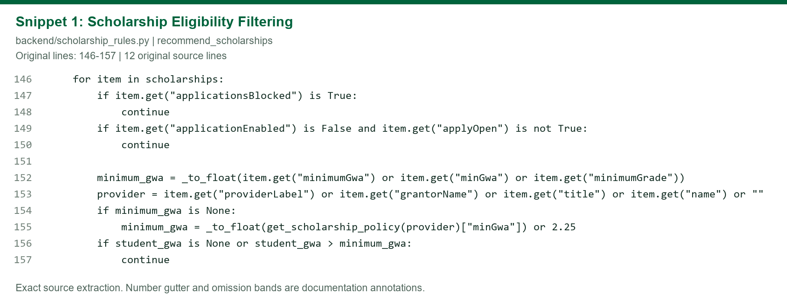
Figure x: Scholarship Recommendation Eligibility Filtering Source Code
The source code presented in this figure demonstrates the initial eligibility-filtering stage of the scholarship recommendation algorithm. The system iterates through the supplied scholarship opportunities and excludes those explicitly marked as blocked. It also excludes scholarship records when application submission is disabled and the application-open flag is not enabled.
The algorithm then identifies the minimum GWA requirement of each scholarship by checking the available scholarship-grade fields. If no valid minimum GWA is specified, the system retrieves the corresponding provider's predefined scholarship policy, with a final default value of 2.25 when an applicable value cannot be obtained.

The student's GWA is compared against the required threshold. Since lower numerical GWA values represent better academic performance under the grading scale used by the system, a student whose GWA exceeds the permitted threshold is excluded from the recommendation for that scholarship. A missing student GWA also causes the scholarship to be excluded.
This filtering stage reduces the candidate list to scholarship opportunities that satisfy the specific availability and GWA requirements implemented in the recommendation function.
Other application requirements, document checks, and official scholarship approval procedures are handled separately by the relevant system workflows.
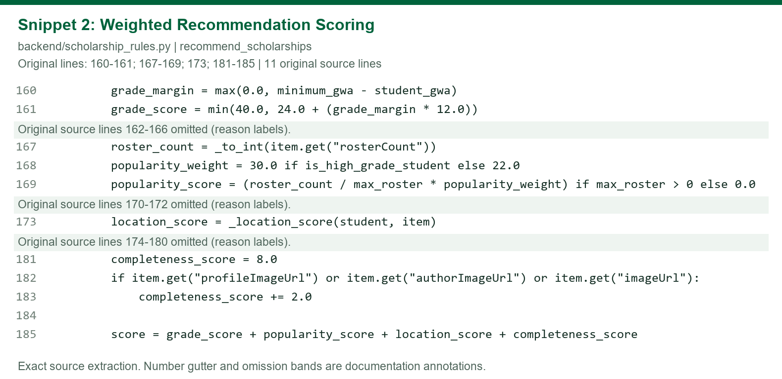
Figure x. Weighted Scholarship Recommendation Score Calculation Source Code
This figure illustrates the weighted scoring stage applied to scholarship opportunities that satisfy the initial eligibility conditions. The system calculates a recommendation score by combining four components: academic-grade suitability, scholarship-roster popularity, geographic relevance, and an announcement-related image-availability component.
The academic-grade score is calculated from the difference between the scholarship's minimum GWA requirement and the student's actual GWA. The algorithm begins with a base value of 24 points and adds 12 points for each unit of qualifying grade margin, subject to a maximum academic-grade score of 40 points.
Scholarship-roster popularity is calculated using the number of recorded scholars associated with the relevant grantor relative to the highest roster count among the supplied scholarship candidates. The popularity component has a configured weight of 22 points for ordinary qualifying students and 30 points for students classified as high-grade students, corresponding to a GWA of 1.75 or better.
Geographic relevance is evaluated through the separate _location_score function, which awards points according to matching or relevant province, city or municipality, and barangay information. This component can contribute up to 25 points.
The final component contributes a base value of 8 points, with an additional 2 points when a supported scholarship or grantor image field is available. This is an announcement-related image-presence score rather than a direct measure of student-profile completeness.
The four component scores are added to produce the scholarship's total recommendation score. This score is used to compare and order eligible scholarship opportunities. It is not a probability of scholarship acceptance or an independently measured accuracy percentage.
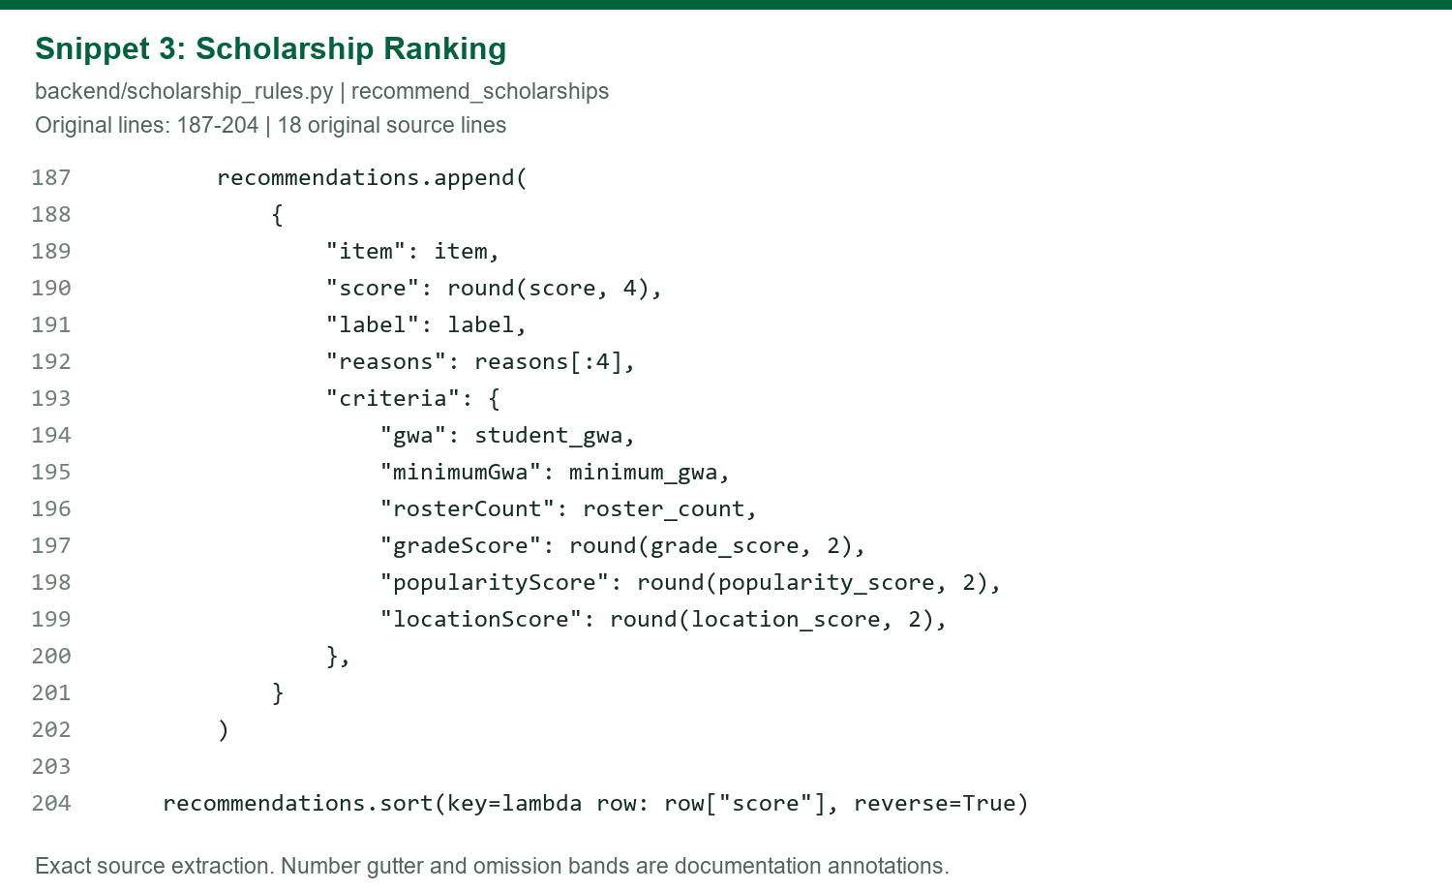
Figure x. Scholarship Recommendation Result Construction and Ranking Source Code
This figure presents the final ranking stage of the scholarship recommendation algorithm. After calculating the weighted recommendation score, the system constructs a recommendation record containing the scholarship information, computed score, recommendation label, selected explanatory reasons, and supporting criteria such as the student's GWA, minimum scholarship GWA, recorded roster count, grade score, popularity score, and location score.
The total recommendation score is rounded to four decimal places before being stored in the recommendation record. Once the eligible scholarship records have been processed, the algorithm sorts the recommendation list in descending order according to the computed score. Scholarships with higher scores are therefore positioned ahead of those with lower scores within the backend-generated ranking.
When two scholarships have equal stored scores, their relative order is preserved according to their incoming sequence because the sorting operation is stable. The resulting list provides a ranked set of eligible scholarship opportunities based on the configured scoring rules.
The backend-generated ranking is subsequently used within the broader student recommendation workflow. However, the final student interface may also consider separately prioritized invitations, administrator recommendations, reapplication opportunities, and application restrictions. Therefore, the order displayed to a student is not necessarily determined by the numerical recommendation score alone.
The recommendation results are intended to guide scholarship discovery and do not represent an automatic reservation, confirmed scholarship commitment, or final grantor approval.
Overall, the implemented scholarship recommendation mechanism follows a rule-based filtering and weighted scoring approach. The eligibility-filtering stage determines which scholarship opportunities satisfy the supported recommendation-stage requirements, while the weighted scoring stage evaluates the remaining options using predefined numerical factors. The ranking stage arranges those options according to their calculated recommendation scores.
The system does not use a trained machine-learning model, construct a learned Decision Tree, or predict the statistical probability of a student's scholarship acceptance. Its recommendations are determined by predefined rules, available scholarship records, and deterministic scoring calculations. Furthermore, the recommendation process is separate from document verification, application reservation, scholarship commitment validation, and final approval.
Consequently, the mechanism serves as a decision-support feature that assists students in identifying scholarship opportunities while preserving the responsibility of authorized grantors and administrators to evaluate applications and approve scholarship awards.
Sample Computation of Weighted Scholarship Recommendation Scores
To demonstrate how the implemented recommendation algorithm ranks eligible scholarship opportunities, a hypothetical scenario involving one student and two scholarship programs is presented. The example applies the same eligibility conditions and weighted scoring calculations found in the developed BulsuScholar system.
The sample student has a General Weighted Average (GWA) of 1.70 and is assumed to be eligible for both scholarship programs based on their minimum GWA requirements and applicable recommendation-stage availability conditions.
The calculation considers four implemented scoring components: academic-grade suitability, scholarship-roster popularity, geographic relevance, and the presence of a supported scholarship or grantor image. The resulting weighted scores determine the ranking order of the two scholarship opportunities.
The sample data are illustrative and do not represent actual student records, scholarship beneficiaries, or observed scholarship approval outcomes.

Assumptions that Both scholarships accept applications, neither is blocked, and the student and grantor locations produce the indicated location scores.
Attribute | Scholarship A | Scholarship B
Minimum GWA | 2.00 | 1.75
Scholar roster count | 40 | 80
Location match | Same Province, City | Same Province Only
Supported image present | Yes | No
Initial eligibility | Yes | Yes
Table x. Sample Student Records
The table presents the hypothetical scholarship information used to demonstrate the weighted recommendation scoring mechanism of BulsuScholar. Scholarship A has a minimum GWA requirement of 2.00 and a recorded scholar roster count of 40, while Scholarship B has a minimum GWA requirement of 1.75 and a roster count of 80. These values serve as sample inputs for calculating academic-grade suitability, roster popularity, geographic relevance, and image availability. The example uses synthetic information solely to illustrate how the recommendation mechanism compares eligible scholarships and does not represent actual student records or scholarship beneficiaries.

These are synthetic inputs, not actual scholarship records. The implementation uses:
$$[ S=G+P+L+C]$$
Where:
- (G) = Academic-grade score
- (P) = Roster-popularity score
- (L) = Location relevance score
- (C) = Image-availability component
G=min(40, 24 + ( Minimum GWA - Student GWA) x 12)
Scholarship | Scholarship A | Scholarship B
Formula | min(40, 24 + ( 2.00 – 1.70) x 12) | min(40, 24 + ( 1.75 – 1.70) x 12)
Score | 27.60 | 24.60
Table x. Academic-Grade Score
The table illustrates the academic-grade suitability calculation for the two sample scholarships using the student's hypothetical GWA of 1.70. Scholarship A receives a score of 27.60 because its minimum GWA requirement is 2.00, while Scholarship B receives 24.60 based on its requirement of 1.75. The calculation demonstrates how the difference between the student's academic performance and the scholarship's minimum grade requirement contributes to the weighted recommendation score. The resulting values are numerical scoring components used for ranking and should not be interpreted as scholarship acceptance probabilities.
$$P=\frac{\text{Roster Count}}{\text{Maximum Roster Count}}×30$$
Scholarship | Calculation | Score
A | (40 ÷ 80) × 30 | 15.00
B | (80 ÷ 80) × 30 | 30.00
Table x. Roster-Popularity Score
The table presents the roster-popularity component of the weighted recommendation mechanism. The calculation compares each scholarship's recorded scholar count with the highest roster count among the evaluated scholarships. Scholarship A, with 40 scholars, receives 15.00 points, while Scholarship B, with 80 scholars, receives 30.00 points. This component gives a higher score to scholarships with greater recorded roster representation under the illustrated scoring conditions. However, roster popularity is only one factor in the recommendation process and does not independently determine the final ranking.
Location match | Scholarship A | Scholarship B
Same province | 10 | 10
Same city/municipality | 10 | 0
Same barangay | 5 | 0
Location score | 25.00 | 10.00
Table x. Geographic Relevance
The table demonstrates how geographic relevance contributes to the recommendation score by comparing the student's location with the location associated with each scholarship. Scholarship A receives points for matching the province, city or municipality, and applicable barangay conditions, resulting in a higher geographic relevance score. Scholarship B receives fewer points because its recorded location satisfies fewer matching conditions. The scoring mechanism therefore gives additional consideration to scholarships that are geographically relevant to the student's recorded address, based on the available location information.

The algorithm assigns 8 base points and adds 2 points when a supported image field is present.
Scholarship | Calculation | Score
A | 8 + 2 | 10.00
B | 8 + 0 | 8.00
Table x. Image-Availability Component
The table presents the image-availability component used in the weighted scholarship recommendation calculation. Both scholarships receive a base score of eight points. Scholarship A receives an additional two points because a supported scholarship or grantor image is available, producing a total of 10.00 points. Scholarship B receives only the base score of 8.00 because the corresponding image condition is not satisfied. This component provides a relatively small contribution to the overall recommendation score and does not override the eligibility requirements established by the system.
Scoring component | Scholarship A | Scholarship B
Academic-grade suitability | 27.60 | 24.60
Roster popularity | 15.00 | 30.00
Geographic relevance | 25.00 | 10.00
Image availability | 10.00 | 8.00
Total recommendation score | 77.60 | 72.60
Backend ranking | 1st | 2nd
Table x. Sample Weighted Scholarship Recommendation Score Computation
The table summarizes the results obtained from the four scoring components used by the BulsuScholar recommendation mechanism. Scholarship A receives a total score of 77.60, while Scholarship B obtains 72.60. Although Scholarship B receives a higher roster-popularity score, Scholarship A achieves the higher overall result because of its stronger academic-grade suitability, geographic relevance, and image-availability contributions.
Based on the implemented descending sorting procedure, Scholarship A ranks first, followed by Scholarship B. The calculated scores are raw numerical indicators used for recommendation ranking and are not normalized percentages or predicted probabilities of scholarship acceptance.
The example demonstrates how the algorithm combines multiple predefined scoring factors rather than relying exclusively on the student's GWA or the number of scholars associated with a grantor. The result remains a recommendation intended to assist scholarship discovery and does not automatically authorize an application, reserve a scholarship slot, or approve an award.
The actual order displayed on the student recommendation page may also be affected by separately prioritized invitations, administrator recommendations, reapplication options, and applicable scholarship restrictions. Therefore, the ranking presented in this example illustrates the backend scoring algorithm rather than every possible ordering condition in the user interface.
5. Validation Module
The validation module supports duplication prevention and student-record verification throughout different system workflows. The system uses exact identity checking, Record Linkage, Levenshtein-based text similarity, weighted record comparison, scholar-list conflict checking, and scholarship commitment rules depending on the operation being performed.
The validation process does not follow one universal checking sequence. Account registration, scholar-list import, record editing, application processing, and administrative duplicate checking use validation procedures appropriate to their respective workflows. The system can identify exact identity matches, possible similarity-based matches, conflicting scholar assignments, and existing scholarship commitments.
Possible duplicate records may be flagged or grouped for authorized review, while confirmed identity or scholarship-assignment conflicts may restrict the corresponding scholarship-related operation. A duplicate-record flag does not automatically prevent account activation because student account approval and scholarship assignment are separate processes.
The validation mechanism covers internally stored scholarship information and externally sourced scholarship records encoded into the system. This supports data verification and assists authorized personnel in identifying conflicting scholarship records before another scholarship commitment is created.
Implementation of COR and ROG Document Extraction
The developed BulsuScholar system implements rule-based academic-document extraction to obtain relevant student information from uploaded Certificates of Registration (COR) and Reports of Grades (ROG). The extraction mechanism is implemented primarily through the parse_pdf_document function in the backend/document_scanner.py source file.
The function initially attempts to obtain embedded text from the uploaded PDF document and identify academic-year and year-level information through the available text and PDF layout. For ROG documents, the system applies multiple extraction procedures to obtain grade-related information. These include examining PDF table structures, identifying grade values through positioned text, and applying text-based extraction rules when the preceding methods do not produce suitable results.
The extracted information is processed into structured fields, including Student ID, student name, course, year level, academic year, semester, and applicable grade information. The parser also produces document-classification and academic-concern indicators that can be used by the corresponding validation workflow.
The extraction process uses predefined parsing rules and document-layout interpretation rather than a trained machine-learning classifier. Although an OCR fallback is implemented for PDFs without extractable text, successful OCR processing depends on the availability and correct configuration of the required local software dependencies.
The extracted information is subsequently evaluated according to the rules applicable to the relevant upload workflow. Document extraction and document validation are therefore treated as related but separate operations.

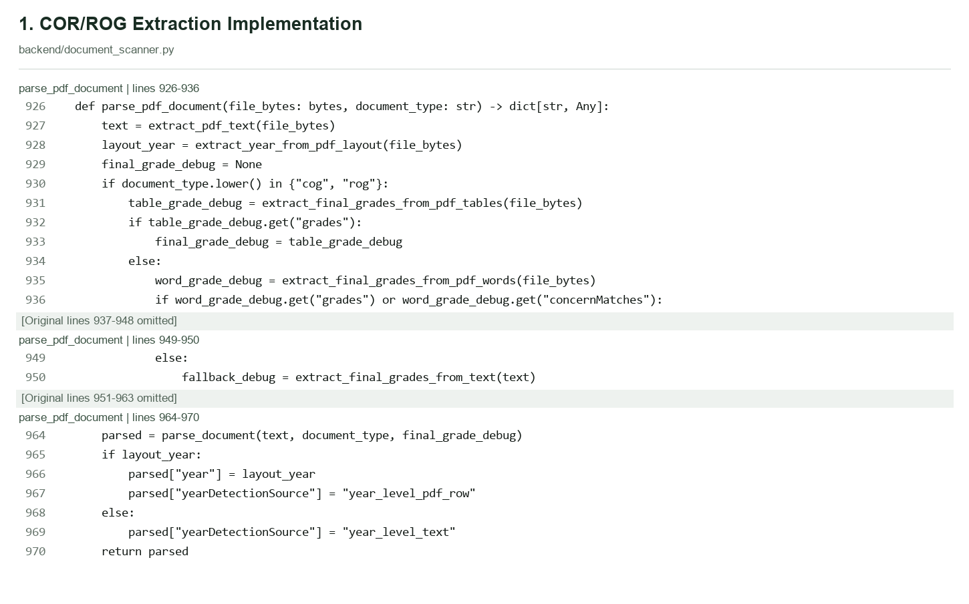
Figure x. Code Snippet for COR and ROG Document Extraction
The figure x illustrates the primary document-parsing procedure used by the developed system. The parse_pdf_document function retrieves available PDF text, attempts to identify academic-year or year-level information from the document layout, and processes grade information when the uploaded document is classified as a Report of Grades.
For grade-related documents, the algorithm first attempts to extract grade information from PDF tables. When suitable grade values are not obtained, the implementation proceeds through additional word-position and text-based extraction methods. The resulting information is passed to the document parser, which organizes the extracted academic fields into a structured result.
This process supports the automatic extraction of student and academic information from compatible text-based PDF documents. However, successful parsing does not independently establish document authenticity, completeness, or compliance with every applicable validation requirement.
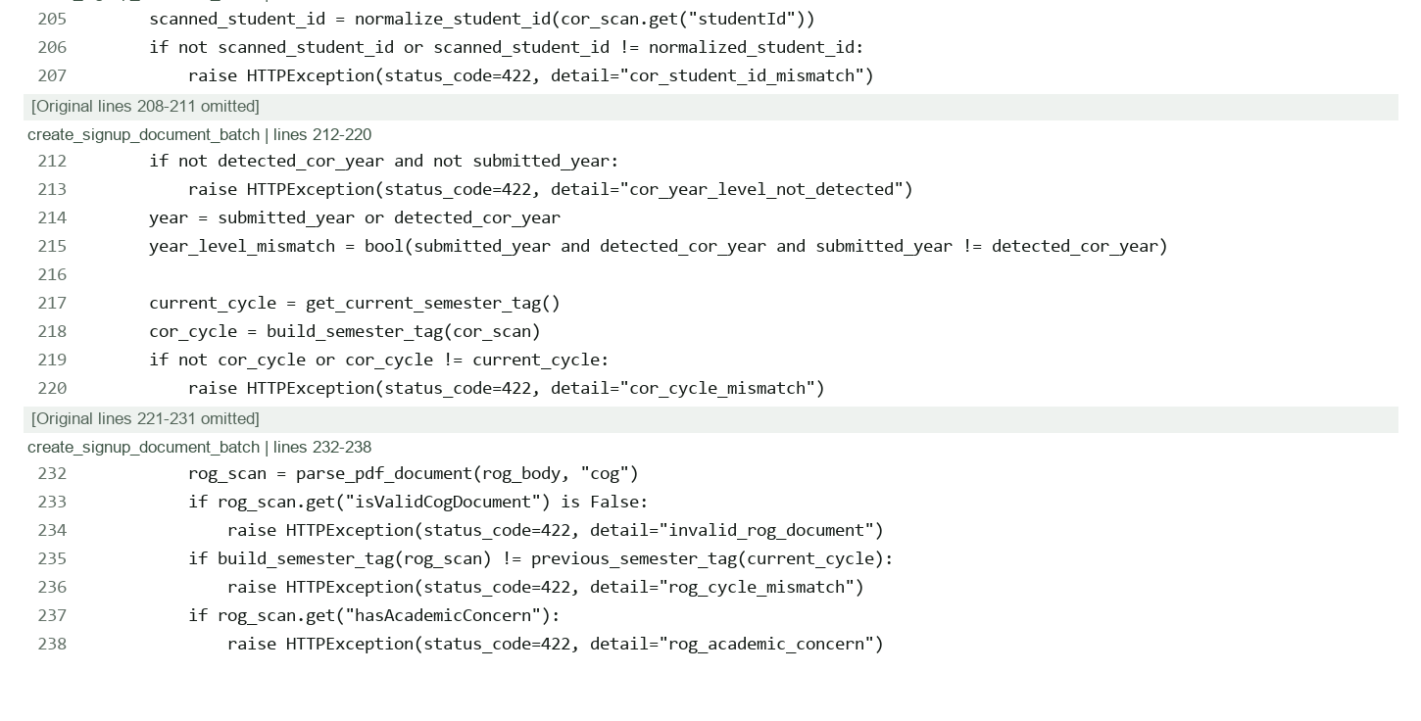
Figure x. Code Snippet for COR and ROG Academic-Document Validation
The figure presents selected validation conditions used during the student signup document-processing workflow. The implementation checks whether the Student ID extracted from the COR matches the submitted student identifier and whether the required academic-year and semester information satisfies the configured validation conditions.
For COR documents, the system verifies the presence of an applicable year-level value and compares the extracted academic cycle with the current cycle. The workflow rejects submissions that fail the corresponding required conditions.
For ROG documents, the system examines the recognized document type, required previous academic cycle, and detected academic concerns. When a selected condition is not satisfied, the workflow raises an appropriate validation error and prevents the corresponding signup-document batch from proceeding normally.
These checks are specific to the illustrated signup workflow and must not be interpreted as universal validation conditions automatically enforced by every academic-document upload operation. Other document submission and replacement workflows may apply different validation rules.

6. Duplication Prevention Algorithm
The duplication prevention mechanism combines exact identity matching, text-similarity checking, weighted record comparison, and scholarship commitment validation. Different system workflows apply different validation rules; therefore, the system does not use a single sequence in which calculations are performed before the combined decision.
For weighted record comparison, the system uses the following student attributes:
Student Attribute | Weight
Student ID | 32%
Full Name | 30%
Email Address | 10%
Contact Number | 8%
Course | 8%
Year Level | 4%
City or Municipality | 4%
Province | 4%
Total | 100%

Birthdate and school are not included in the weighted score. The address is represented only by city or municipality and province. When a comparison field is unavailable, the system excludes that field and adjusts the calculation based on the weights of the remaining available fields. The name comparison considers both the original word order and a token-sorted form and retains the higher similarity result.
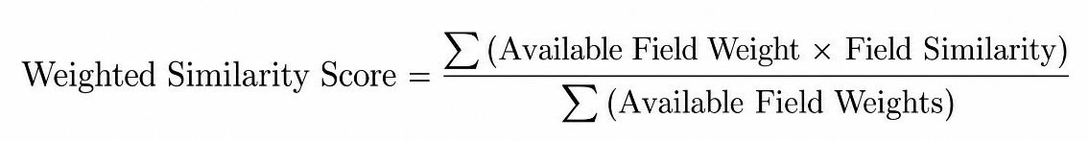
The duplicate-detection mechanism applies different matching conditions according to the purpose of the validation workflow. The general pairwise duplicate checker considers exact normalized identifiers and calculated record similarities to determine whether two available student records may correspond to the same individual. Potential duplicates are identified through predefined exact-match and fuzzy-matching conditions, while administrator duplicate-table grouping applies an additional configurable weighted-score threshold.
These matching conditions are distinct from official scholarship assignment requirements. Although general record matching can identify possible duplicates despite textual variations, official scholarship roster assignment requires stricter identity verification, recognition of the scholarship program, confirmation of the applicable academic cycle, and validation of existing scholarship commitments. Consequently, a potential duplicate-record match does not independently establish that a student has already received a scholarship or that an official assignment is authorized.
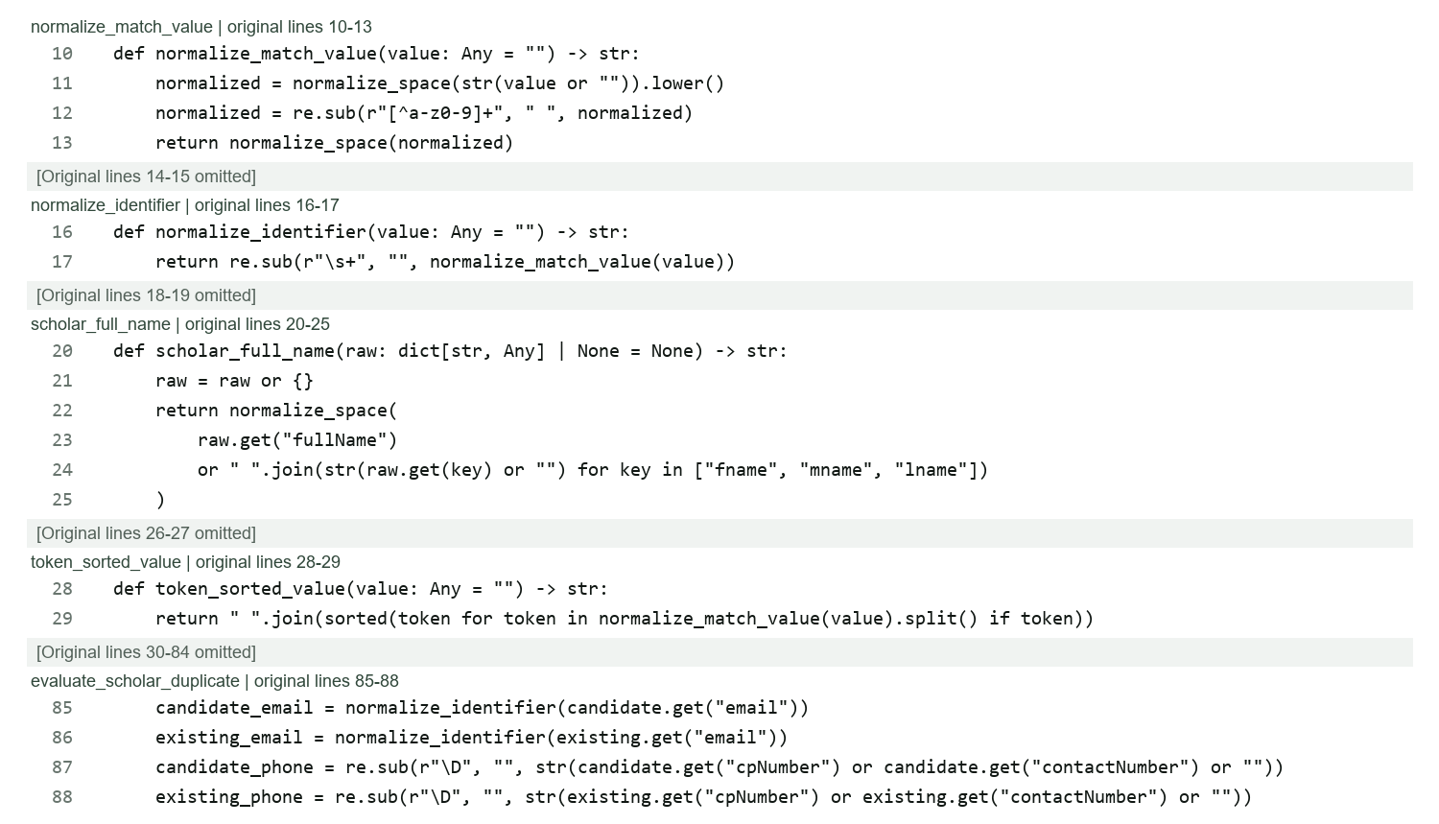
Figure x. Code Snippet for Student Record Normalization in Duplicate Detection
The figure presents the student-record normalization functions implemented in the developed BulsuScholar system. These functions prepare student identity information for comparison by applying consistent text formatting to the available records.
The normalize_match_value function converts input values into lowercase text, standardizes whitespace, and replaces unsupported characters with spaces. The normalize_identifier function further removes spaces from normalized identifier values. The scholar_full_name function obtains the student's complete name from the available full-name field or combines the separate first-name, middle-name, and last-name fields when necessary.
The token_sorted_value function arranges normalized name components alphabetically to support comparisons involving differences in word order. Email identifiers are normalized before comparison, while contact numbers are standardized by removing nonnumeric characters.
These procedures reduce inconsistencies caused by capitalization, spacing, punctuation, and name-component arrangement. However, normalization alone does not establish that two records belong to the same student. The resulting standardized values are subsequently evaluated through similarity calculations and duplicate-detection conditions.
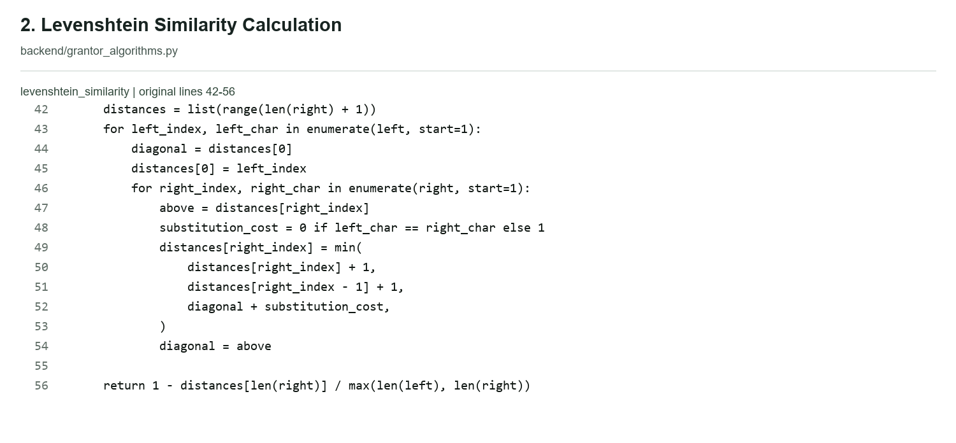
Figure x. Code Snippet for Levenshtein-Based Student Name Similarity Calculation
The figure illustrates the implementation of the Levenshtein-based similarity calculation used in the student-record comparison process. The algorithm measures differences between two normalized text values by determining the minimum number of single-character insertions, deletions, or substitutions required to transform one value into another.
The function uses a dynamic-programming approach to calculate the edit distance. Each character is compared against the corresponding characters of the second text value, and the minimum editing cost is maintained throughout the comparison. A substitution cost of zero is assigned when two characters match, while a cost of one is applied when they differ.
After computing the edit distance, the algorithm converts the result into a normalized similarity score by dividing the edit distance by the length of the longer compared value and subtracting the result from one. A similarity score approaching 1 indicates greater textual similarity, while a score approaching 0 indicates greater difference.
The duplicate-detection mechanism evaluates both direct name similarity and token-sorted name similarity, retaining the higher result for subsequent record comparison. This allows the system to consider minor spelling differences and variations in name-component ordering. Nevertheless, a high similarity score represents evidence of possible identity correspondence rather than definitive proof that the records belong to the same student.
$$S\left(A,B\right)=1-\frac{D\left(A,B\right)}{\max\left(A,B\right)}$$
Where (D(A,B)) is the Levenshtein edit distance between normalized strings, and (A) and (B) are their lengths.

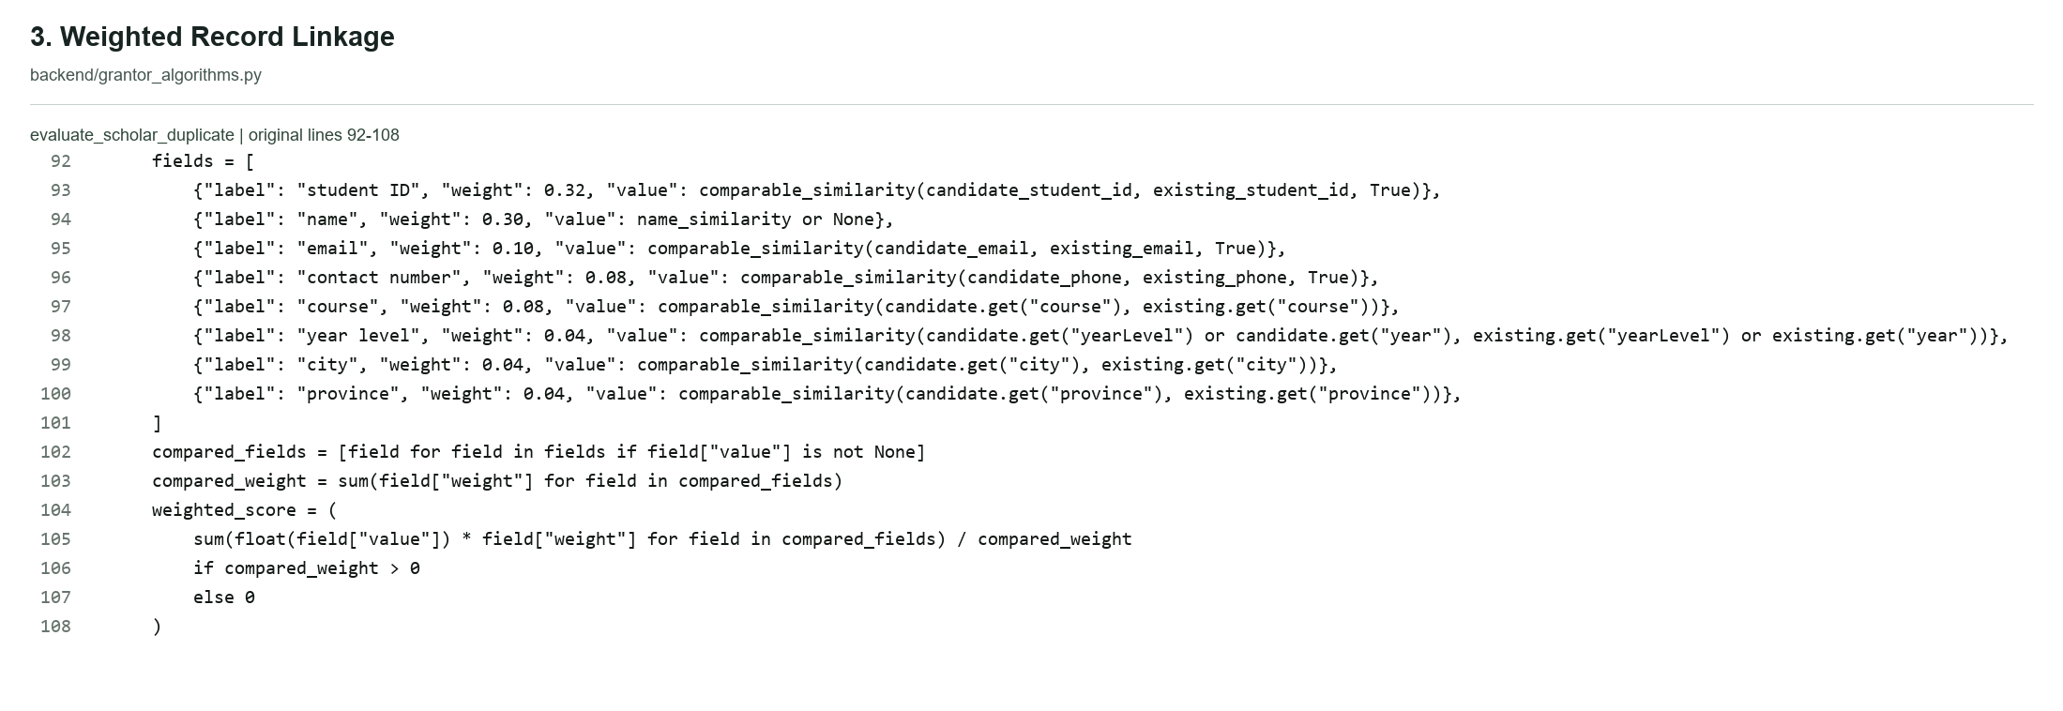
Figure x. Code Snippet for Weighted Student Record Linkage and Similarity Scoring
The figure presents the weighted record-linkage mechanism used to evaluate the similarity of available student records. The system compares eight attributes: Student ID, full name, email address, contact number, course, year level, city or municipality, and province. Each attribute is assigned a predefined weight representing its contribution to the combined similarity score.
Student ID receives the highest individual weight of 0.32, followed by full name with a weight of 0.30. Email address and contact number contribute weights of 0.10 and 0.08, respectively. Course contributes 0.08, while year level, city or municipality, and province each contribute 0.04.
The algorithm calculates the similarity value of each available attribute and multiplies it by the corresponding weight. Comparison fields without applicable values are excluded from the calculation, and the combined weighted similarity is divided by the total weight of the included fields.
This approach allows the system to evaluate the available identity evidence without automatically treating missing comparison fields as mismatches. The resulting weighted score is used together with exact-identifier and name-similarity conditions to identify potentially duplicated records.
The weighted similarity value is a deterministic matching indicator based on configured comparison rules. It does not represent a statistical probability that two records belong to the same individual and does not independently authorize scholarship assignment.
Attribute | Weight
Student ID | 0.32
Full Name | 0.30
Email | 0.10
Contact Number | 0.08
Course | 0.08
Year Level | 0.04
City/Municipality | 0.04
Province | 0.04
Total | 1.00

Table x. Existing Attribute Weight Table
The table presents the predefined attribute weights used in the weighted record-linkage mechanism of BulsuScholar. Student ID and full name receive the highest weights of 0.32 and 0.30, respectively, because they serve as primary identifying information during record comparison. Email address, contact number, and course contribute additional matching evidence, while year level, city or municipality, and province provide supplementary information.
The system calculates the combined similarity score using the available comparable attributes and their corresponding weights. Missing or inapplicable values are excluded from the weighted calculation instead of automatically being considered mismatches. The resulting score supports the identification of potentially duplicate student records and is evaluated alongside the configured exact-identifier and name-similarity conditions.
The weighted similarity score is a deterministic indicator based on predefined comparison rules and does not represent a statistical probability of identity.
$$W=\frac{\sum_{i=1}^{n}{w_{i}}s_{i}}{\sum_{i=1}^{n}{w_{i}}}$$
Where (w_i) is the weight of an included field and (s_i) is that field's similarity value. Only applicable comparisons are included. The source contains an important detail: a name similarity of exactly zero is excluded through name_similarity or None, whereas other applicable zero-valued comparisons may still contribute to the denominator.
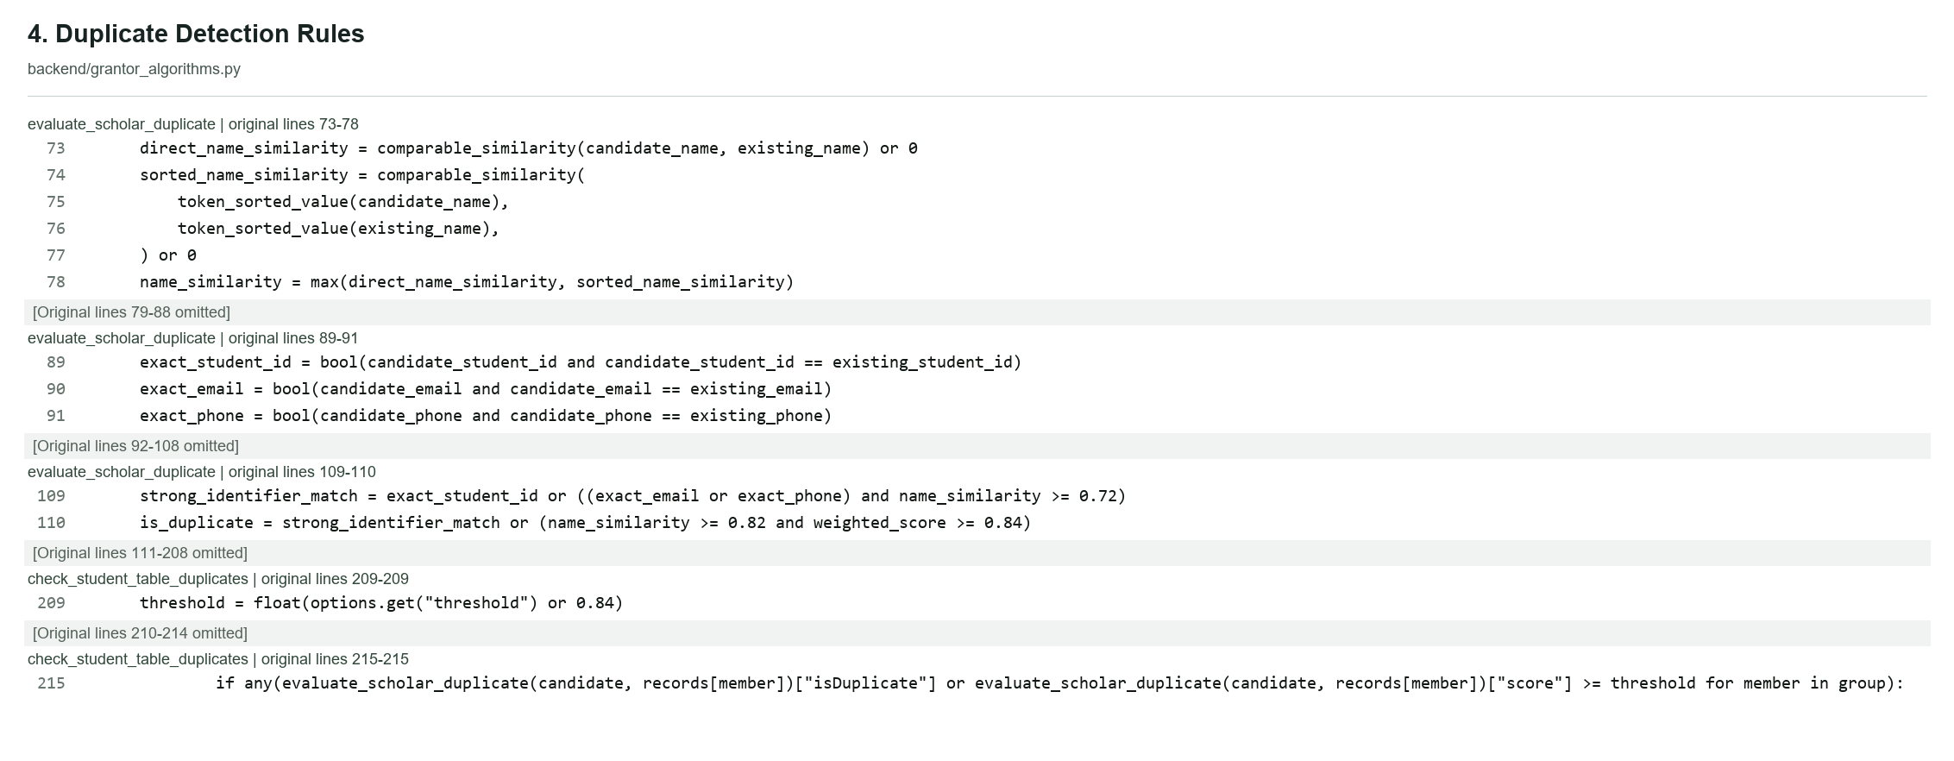
Figure x. Code Snipper for Exact and Similarity-Based Duplicate Detection Conditions
The figure presents the decision conditions used by the developed system to determine whether two student records should be identified as potential duplicates. The evaluate_scholar_duplicate function combines exact identifier comparisons, normalized name similarity, and weighted record-linkage results.
The system considers records potentially duplicated when their nonempty normalized Student IDs match exactly. A potential duplicate may also be identified when an exact normalized email address or contact number match is accompanied by a name-similarity score of at least 0.72.
For fuzzy matching without a qualifying strong-identifier condition, the algorithm requires a name-similarity score of at least 0.82 and a normalized weighted similarity score of at least 0.84. Both conditions must be satisfied before the record pair is classified as a potential duplicate under this rule.
The administrator duplicate-table checking function applies a related but distinct grouping condition. Records may be placed in a potential-duplicate group when the pairwise duplicate evaluator identifies a match or when their weighted similarity score reaches the configured grouping threshold, which defaults to 0.84.
These values are predefined decision thresholds, not experimentally established detection accuracy percentages. A record classified as a possible duplicate may require authorized review, and the duplicate-detection result does not automatically demonstrate that the student already holds an active scholarship award.

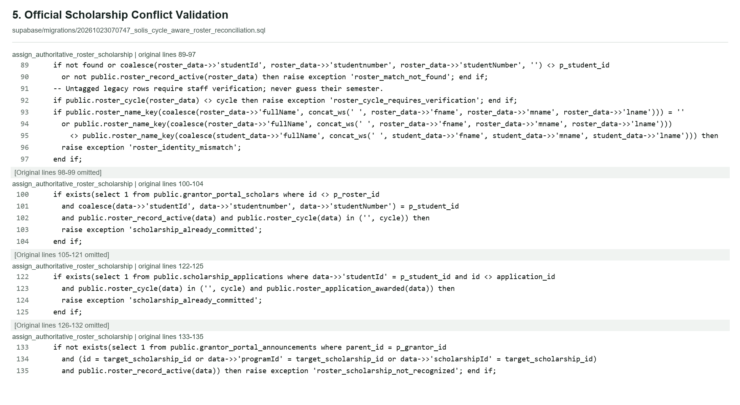
Figure x. Code Snippet for Official Scholarship Identity and Commitment Validation
The figure presents selected validation conditions implemented in the database function responsible for authoritative scholarship roster assignment. Unlike general duplicate detection, which identifies potentially corresponding student records through similarity calculations, this procedure applies strict identity, scholarship-recognition, academic-cycle, and existing-commitment checks before an official assignment can proceed.
The function first verifies that the selected scholarship roster record exists, is active, and contains a Student ID matching the target student's identifier. It also verifies that the roster's academic-cycle information corresponds to the applicable cycle and that the normalized full name recorded in the roster matches the student's registered identity.
The system then checks available scholarship records for existing commitments. If another active scholarship roster record or awarded scholarship application indicates an existing commitment within the current or unresolved academic cycle, the function raises a scholarship-conflict exception and prevents the conflicting assignment from proceeding.
The validation also verifies that the scholarship program associated with the requested assignment is recognized through an applicable active scholarship announcement. An unrecognized scholarship program results in rejection of the operation.
These validation conditions help preserve scholarship-record consistency by preventing official assignments that fail the required identity, academic-cycle, scholarship-recognition, or commitment checks. The procedure uses authoritative stored information and database-level restrictions rather than relying on fuzzy name similarity as sufficient evidence for approval.
The presented source-code excerpt documents selected validation guards within the broader assignment transaction. Other authorization, transaction-handling, and record-maintenance operations are implemented separately and are not fully shown in the figure.
The developed duplication prevention mechanism combines record normalization, Levenshtein-based similarity, weighted record linkage, and predefined matching conditions to identify potential duplicate student records. These procedures support the identification of inconsistent or corresponding records but do not independently confirm an existing scholarship commitment.
Official scholarship assignment applies a separate set of authoritative validation conditions involving exact student identity, recognized scholarship information, verified academic-cycle data, and existing scholarship commitments. The separation between potential duplicate detection and official assignment validation prevents similarity-based findings from being treated as sufficient grounds for granting or denying scholarship awards.
The effectiveness of these mechanisms depends on the completeness and accuracy of records available within the centralized system. Scholarship information maintained exclusively by external providers cannot be independently checked unless it has been entered into the database through an authorized process. Potentially ambiguous or conflicting records may require authorized administrative verification and resolution.
Consequently, the mechanism serves as a record-validation and scholarship-conflict prevention feature that assists administrative decision-making while preserving the responsibility of authorized personnel for resolving uncertain cases and approving official scholarship assignments.
7. Approval Module
The Approval Module supports the management of scholarship application decisions and official scholarship assignments while maintaining separate procedures for student account activation, academic-document validation, and Student Application Profile review.
During registration, student identity information and the applicable signup requirements are validated. When Manual Account Review is enabled, a Full Administrator reviews the required registration documents and approves the account after email confirmation and the necessary validation checks. When Manual Account Review is disabled, eligible accounts may activate automatically after satisfying the applicable requirements.
Certificates of Registration (COR) and applicable Reports of Grades (ROG) undergo automatic parsing. Valid submissions are accepted according to the implemented rules, while invalid submissions require correction. Student Application Profile submissions remain subject to administrator review. Student identification is verified during account creation, while optional Student ID replacements by active students may be processed according to the implemented automatic validation rules.
Scholarship grantors and ISPS Coordinator review applications and supporting information before performing authorized scholarship decisions. Once an official scholarship assignment or applicable commitment is confirmed, the system preserves the existing award, archives competing current-cycle pending applications where required, and releases their reserved slots without deleting historical records or submitted documents.
These procedures ensure that account activation, document acceptance, application approval, and scholarship assignment are not treated as one universal approval operation.
8. Monitoring Module
This module enabled continuous tracking of scholarship records, including scholar status, compliance requirements, academic performance, renewal conditions, and completion. Administrators and coordinators can monitor active scholars, verify compliance, and manage renewal processes efficiently.
Scholarship validation and monitoring are evaluated according to the applicable academic cycle and the authoritative application and scholarship commitment records. The academic cycle refers to the academic year and semester associated with a scholarship record.
A scholarship award that has been confirmed within the current academic cycle remains recognized as an existing commitment even when its processing workflow has been marked as Finished or Completed. Therefore, completion of the scholarship workflow does not automatically permit another conflicting scholarship assignment during the same academic cycle.
Completed awards from explicitly recorded previous academic cycles are maintained as historical records and do not independently prevent eligible applications for the current cycle. Cancelled, terminated, and inactive scholarship commitments are not treated as active-award blockers, although other scholarship eligibility requirements continue to apply.
Pending applications that have not resulted in a confirmed scholarship award or commitment are distinguished from active scholarship commitments. If an official scholarship assignment is confirmed, competing pending applications for the applicable academic cycle may be archived while retaining their associated records and uploaded documents.
Academic-Cycle and Scholarship Status Validation
The developed BulsuScholar system applies academic-cycle-aware validation to distinguish existing scholarship commitments from historical records, pending applications, and scholarship records requiring further verification. This mechanism supports the prevention of conflicting scholarship assignments by examining the status of available scholarship records and their relationship to the applicable academic cycle.
Scholarship records are not evaluated solely according to whether their processing workflow has been completed. Instead, the system considers the recognized academic cycle, recorded award status, and relevant commitment information before determining whether a new official scholarship assignment may proceed.
The following table summarizes the intended handling of scholarship records during academic-cycle and scholarship-commitment validation.

Scholarship record | Required system handling
Confirmed current-cycle award | Preserve the existing scholarship commitment and prevent a conflicting current-cycle assignment.
Current cycle Completed / Finished | Do not treat completion of a processing workflow as automatic termination of the scholarship commitment within the same cycle.
Explicit previous-cycle completed award | Retain historical information. It does not independently prevent a valid assignment in a subsequent academic cycle.
Cancelled / Terminated / Inactive | Do not automatically treat an inactive record as an active scholarship commitment; other validation conditions must still be satisfied.
Pending application without confirmed award | Distinguish the pending application from an awarded scholarship. Archive applicable competing pending applications and release associated reserved slots only after successful authorized assignment.
Legacy record without verified academic cycle | Hold or reject automatic assignment until authorized personnel verify the relevant academic-cycle information.

Table x. Academic-Cycle and Scholarship Commitment Validation Rules
Table x illustrates how BulsuScholar distinguishes scholarship records according to their academic-cycle information, recorded status, and existing commitment conditions. Confirmed scholarship awards belonging to the current academic cycle remain recognized commitments that may prevent conflicting assignments. Records marked Completed or Finished are not automatically treated as cancelled scholarships, because completion of a processing workflow does not necessarily remove an established award within the same cycle.
Scholarship records explicitly associated with previous academic cycles are preserved as historical information and do not independently prevent a new assignment in a later cycle. Similarly, records marked Cancelled, Terminated, or Inactive are excluded from the applicable active-roster checks, although other existing scholarship commitments may still restrict assignment.
Pending applications are distinguished from confirmed awards. An ordinary pending application does not independently establish an awarded scholarship. However, additional commitment indicators or unresolved roster conflicts may still affect application processing. When an authorized scholarship assignment succeeds, applicable competing pending applications may be closed or archived according to the relevant transaction rules.
Legacy scholarship records without verified academic-cycle information require additional attention. The system treats unresolved active records conservatively rather than automatically assuming that they belong to a previous cycle. Records containing unresolved identity, cycle, or scholarship-commitment conflicts remain subject to the applicable validation restrictions and authorized administrative review.
Through these rules, the system supports the preservation of historical scholarship information while reducing the possibility of conflicting scholarship commitments within the same academic cycle. The validation remains limited to scholarship information recorded in the centralized database.
9. Notification Module
The notification module provides updates to users regarding application status, missing requirements, deadlines, renewal reminders, monitoring concerns, and important announcements. Notifications are generated and delivered through the system, and email notifications may also be used when applicable. This supports timely communication between students, grantors, and administrators and reduces delays in scholarship processing.
10. Reporting Module
The reporting module generates organized reports and dashboards that summarize scholarship data. These may include statistics on applicants, approved scholars, active scholarships, renewal status, compliance status, and flagged records. The module supports data-driven decision-making by providing administrators and grantors with clear and accessible insights into scholarship operations.

Requirements Documentation

Programming Languages
The system uses JavaScript for the client-side interface and Python for the back-end processes. JavaScript supports interactive web features, while Python handles server-side logic, recommendation processing, validation processes, and communication between the front-end and the database.

Back-End Technology
The back-end of the system was developed using Python, a general-purpose programming language (Python Software Foundation, 2026). It manages core system operations such as authentication support, application processing, rule-based Decision Tree scholarship recommendation, Record Linkage and Levenshtein Distance-based validation, approval workflows, monitoring, notification handling, report generation, and communication with the database.

Frameworks
The development utilized React.js and FastAPI. React.js is a JavaScript library used to build dynamic and interactive user interfaces for web applications (React, n.d.). In the developed system, React.js supports the creation of role-based dashboards and interactive pages for students, scholarship grantors, ISPS coordinators, and administrators.
FastAPI is a Python-based web framework used for developing application programming interfaces (APIs) and handling server-side requests (FastAPI, n.d.). In the developed system, FastAPI was used to manage application logic, process user requests, implement scholarship recommendation and duplication-prevention functions, and facilitate communication between the front-end and the Supabase database.

Databases
The system uses Supabase as its database, authentication, and storage platform (Supabase, 2026).The centralized database stores student profiles, scholarship records, application data, notification information, monitoring records, security-state information, document metadata, review records, system logs, and references associated with authenticated users. Passwords used in the normal account flow are handled through Supabase Auth rather than being maintained as readable password fields within the application's student or grantor records.
Supabase Storage is used for uploaded student and scholarship documents. Access to protected records and files is controlled through application-level authentication and authorization checks together with database security mechanisms such as Row Level Security. These mechanisms restrict access according to authenticated identity, role, permissions, ownership, and the user's relationship to the corresponding scholarship record.

Front-End Technologies
The user interface was developed using the following front-end technologies:
- HTML
- CSS
- JavaScript
- React.js
These technologies allow the development of a responsive and interactive web interface that can be accessed through supported web browsers.

System Architecture
The developed system uses a web-based client-server architecture, which enables centralized data management, real-time access, and efficient communication between users and the system. This architecture is appropriate for the study because it allows multiple users, such as students, scholarship grantors, ISPS coordinators, and administrators, to access the system through standard web browsers without requiring installation on individual devices.
The system is composed of three primary components: the client side or front-end, the server side or back-end, and the centralized database. These components work together to ensure seamless operation, data processing, and secure information management.
1. Client Side (Front-End)
The client side serves as the user interface of the system, where users interact with the platform. It is designed to be accessible through web browsers, allowing users to conveniently access the system using desktops, laptops, or other web-enabled devices. This component provides role-based interfaces tailored for students, scholarship grantors, and administrators. Students can view available scholarships, submit applications, upload required documents, and track their status, while grantors and administrators can manage scholarship postings, review applications, validate records, monitor scholars, and generate reports. The front-end focuses on usability, accessibility, and responsiveness to ensure a user-friendly experience.
2. Server Side (Back-End)
The server side is responsible for handling the core functionality and logic of the system. It processes user requests, manages system operations, and ensures that transactions are executed accurately and securely. This component implements key functionalities such as application processing, recommendation processing, approval workflows, monitoring, notification handling, reporting, and the pre-approval validation mechanism, which supports the policy of allowing only one active scholarship per student. The back-end also manages communication between the front-end and the Supabase database, ensuring that user inputs are properly processed and that correct information is returned to users.
3. Database (Centralized Storage)
The database serves as the centralized repository of all system data, including student records, scholarship information, application details, required documents, approval history, monitoring records, externally sourced scholarship records, notification records, and transaction logs. It is designed to support updated and consistent information across users. By centralizing data storage, the system minimizes redundancy, reduces inconsistencies, and improves data integrity. The database also plays a critical role in supporting the validation mechanism by storing scholarship records that are checked before approval.
This architecture supports scalability, accessibility, security, and efficient data management for the developed centralized scholarship management and tracking system.

Statistical Treatment of Data
The following statistical formula were used:
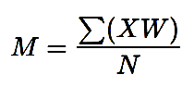
Weighted Mean Formula

Where:
M = Weighted Mean
X = Score
W = Weight
N = Total responses

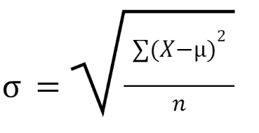
Standard Deviation Formula

Where:
s = Sample Standard Deviation
X = Individual Score
X̄ = Sample Mean
n = Number of Responses
Σ = Summation of all values
Table 3

Likert Scale Interpretation
Scale | Range | Descriptive Rating
5 | 4.21 – 5.00 | Very High Acceptability
4 | 3.41 – 4.20 | High Acceptability
3 | 2.61 – 3.40 | Moderate Acceptability
2 | 1.81 – 2.60 | Low Acceptability
1 | 1.00 – 1.80 | Very Low Acceptability
Table 3 presents the Likert scale interpretation used in evaluating the acceptability and quality of the developed system. A score ranging from 4.21 to 5.00 indicates Very High Acceptability, meaning that respondents strongly agree that the system meets the expected quality standards. Scores between 3.41 and 4.20 indicate High Acceptability, showing that the system performs well and satisfies user expectations. A rating of 2.61 to 3.40 represents Moderate Acceptability, suggesting that the system is acceptable but may still require improvements. Scores between 1.81 and 2.60 indicate Low Acceptability, while ratings from 1.00 to 1.80 represent Very Low Acceptability.
This scale was used together with the weighted mean formula to determine the overall acceptability and software quality of the system based on the responses of the participants.

Requirements Analysis
Requirements analysis involves identifying the existing problems in scholarship management at Bulacan State University – Bustos Campus. Through consultations with stakeholders, the study examines current procedures related to scholarship posting, application, validation, approval, monitoring, notification, and reporting.
The analysis reveals several issues, including manual record tracking, difficulty in verifying students with existing scholarships, lack of centralized monitoring, delays in communication between stakeholders, unclear tracking of scholarship status, and the need to define user roles and responsibilities. These findings guided the development of a centralized scholarship management system that manages scholarship records, recommends suitable scholarships, monitors eligibility, and supports the policy of allowing only one active scholarship per student through pre-approval validation.
- Data Collection and Requirement Analysis
Relevant scholarship-related data were gathered from the ISPS office, students, and scholarship grantors. These include student information, scholarship records, eligibility data, required documents, and existing monitoring procedures. The collected data guided the design of system functionalities, database structure, and reporting features.

- User Registration, Authentication, and Access Control
The system uses Supabase Auth together with FastAPI-based authentication and authorization checks. The main technical account types are Student, Grantor/Provider, Administrator, and Root Admin. Administrator accounts may be assigned specialized permission groups according to their responsibilities. The responsibilities of the ISPS Coordinator are supported through the appropriate administrator permissions rather than through a separate technical account type.
Access to protected system functions is controlled through authenticated identity, assigned role, permissions, account status, and record ownership. Students are restricted to their own protected records and documents, while grantors are limited to scholarship and applicant information associated with their authorized grantor account. Administrative and privileged operations require the corresponding permissions.
The system also implements account-security controls including email confirmation, failed-login monitoring and account lockout, authenticated session validation, account recovery, and conditional email-code verification for selected users.

- Scholarship Management and Monitoring
This includes scholarship posting, application processing, lifecycle management, approval status tracking, renewal monitoring, academic performance monitoring, and scholarship cancellation or termination rules.

- Scholarship Recommendation Mechanism
The system provides scholarship recommendations using a Rule Based Decision Tree algorithm based on predefined scholarship eligibility conditions. Student records are compared with scholarship requirements through a sequence of decision branches to identify suitable scholarship opportunities. The recommendation output serves as a guide for students and does not automatically determine final scholarship approval

- Validation and Approval Mechanism
The system implements validation procedures using exact identity checks, Record Linkage, Levenshtein-based similarity checking, weighted record comparison, scholar-list conflict detection, and scholarship commitment rules. These mechanisms help identify possible duplicate student records and conflicting scholarship assignments. Depending on the workflow, identified conflicts may be flagged for authorized review or may restrict the corresponding scholarship-related operation. Final scholarship approval and conflict resolution remain under authorized grantors, ISPS coordinators, or administrators.

- Notification and Reporting System
The system provides notifications and generates reports and dashboards to support monitoring, communication, and decision-making. Notifications inform users about application status, missing requirements, deadlines, renewal reminders, and monitoring updates.

System Process
The following flowcharts illustrate the major processes and user workflows of the developed Centralized Scholarship Management and Tracking System. These diagrams present the sequence of activities performed by students, scholarship grantors, and administrators, including account registration, document verification, scholarship posting and application, application review, scholar assignment, monitoring, and administrative management.
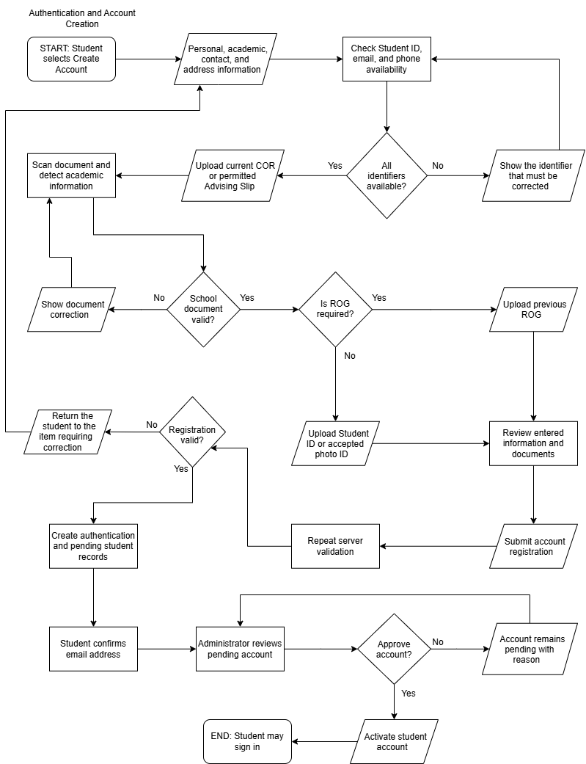

Figure 3.1: Student Account Registration and Authentication Flowchart

Figure 3.1 presents the student account registration and authentication process. Students provide the required registration information and identity documents, which undergo the applicable system validation checks. Following email confirmation, the system determines whether Manual Account Review is enabled.
When Manual Account Review is enabled, a Full Administrator reviews the applicable signup documents and approves the account after the required checks have been satisfied. Otherwise, the account may be activated automatically if all applicable requirements are met.
After activation, the system may reconcile eligible previously imported official scholarship rosters using verified student identity information. Any identity mismatch or conflicting scholarship assignment is referred to the authorized administrative resolution process rather than automatically granting another scholarship. Account activation and scholarship assignment remain separate system operations.
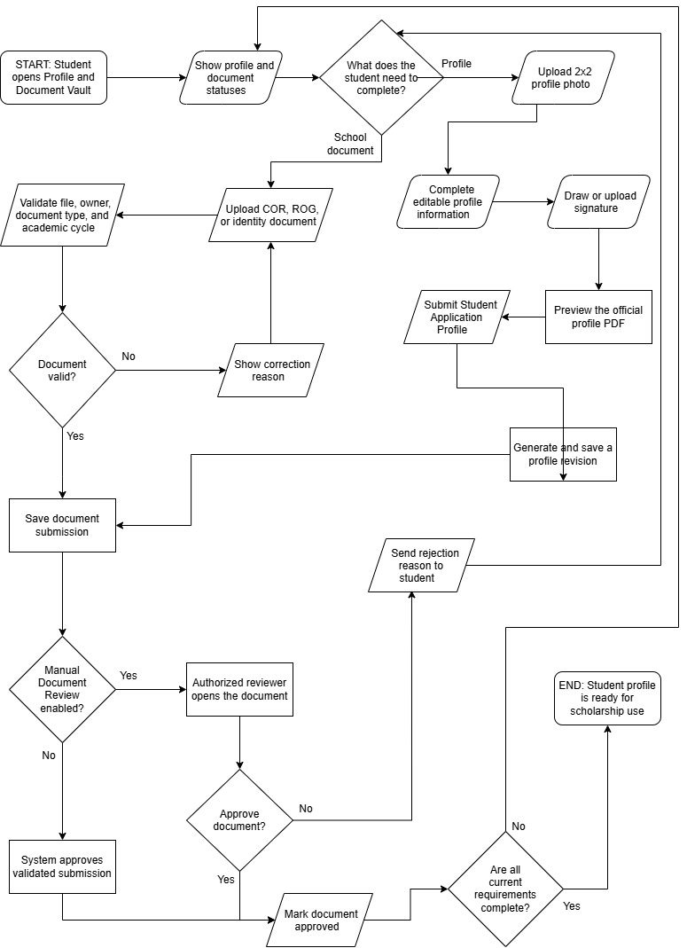

Figure 3.2: Student Profile and Document Verification Flowchart
Figure 3.2 illustrates the process of completing student profile information and validating documentary requirements. Certificates of Registration (COR) and applicable Reports of Grades (ROG) are processed through automatic document parsing and policy validation. When the submitted document satisfies the applicable requirements, the system accepts it. Otherwise, the student receives a correction message or the corresponding validation result.
Student Application Profile submissions follow a separate procedure and remain pending until reviewed by an authorized administrator. Student identification is required during registration but is not treated as a recurring semester-document requirement. Active students may replace their previously submitted identification documents where the system permits.
The Manual Account Review setting applies to new-account activation and does not convert routine COR and ROG validation into a universal manual document-review process.
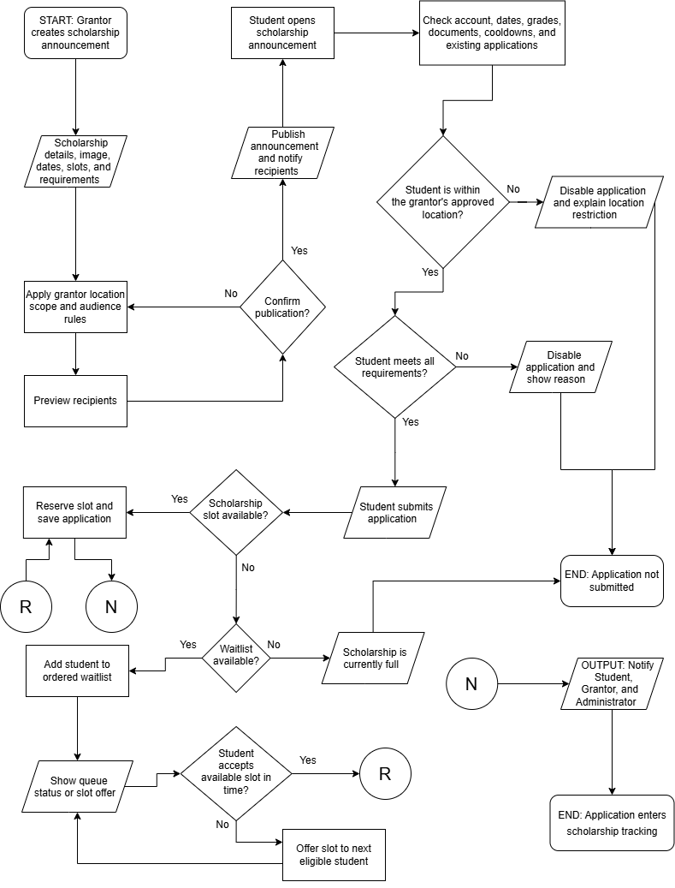
Figure 3.3: Scholarship Posting and Application Flowchart
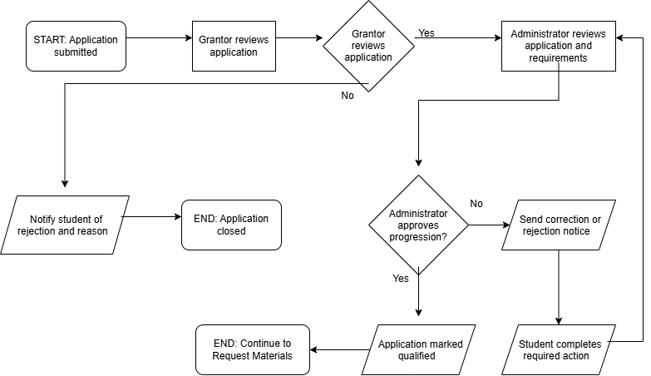
Figure 3.3 presents the process of creating scholarship announcements and receiving student applications. The process begins when a scholarship grantor enters the scholarship details, requirements, available slots, dates, and other eligibility conditions before publishing the announcement. Students who open the scholarship posting are checked against the configured eligibility requirements before they are allowed to submit an application. The system also verifies slot availability and may place eligible students on a waitlist when available slots have already been filled. Once an application is successfully submitted and reserved, the system records the application and notifies the student, grantor, and administrator before the application proceeds to scholarship tracking.

Figure 3.4: Scholarship Application Review and Tracking Flowchart
Figure 3.4 presents the standard scholarship application review and tracking process. After an application is submitted, the scholarship grantor reviews the applicant's information and determines whether the application should continue. Applications that do not meet the grantor's evaluation are closed and the student is informed of the reason. Applications that pass the grantor review are forwarded to the administrator for further evaluation of the submitted requirements. If corrections are required, the student is notified and given the opportunity to complete the necessary action. Once the required review stages are completed, the application is marked as qualified and proceeds to the next scholarship requirement or process.

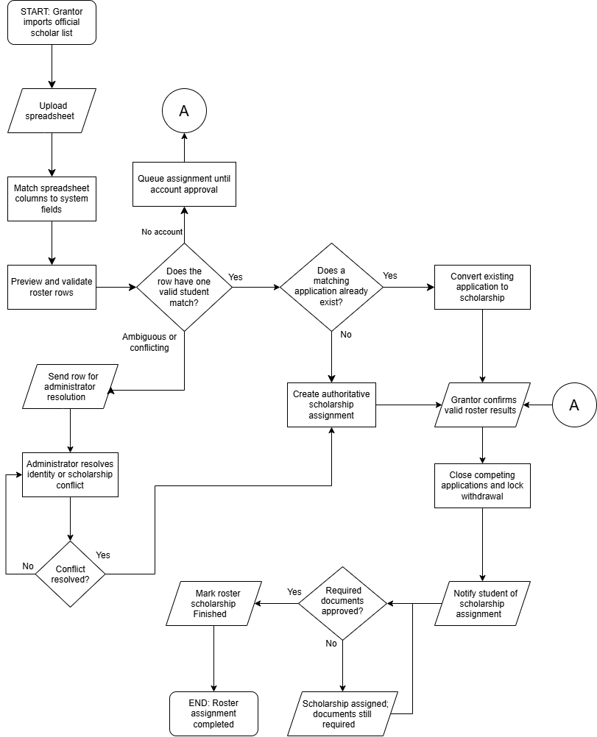
Figure 3.5: Scholarship Roster Import and Assignment Flowchart
Figure 3.5 illustrates the process of importing official scholarship rosters and validating scholarship assignments. Authorized users upload a spreadsheet containing official scholarship recipient information through the roster-import module. The process supports both Internal and External grantors, with External representing a provider classification rather than a separate administrative authorization role.
During the preview stage, the system checks required student identity information, repeated entries, recognized scholarship programs, academic-cycle information, and possible scholarship-assignment conflicts. Before the import is committed, the system repeats the applicable validation checks within a database transaction to prevent inconsistent assignments.
For an active student whose Student ID and full name match the official roster, the system may confirm a valid scholarship assignment for the applicable academic cycle. An existing matching pending application may be converted into the confirmed assignment without replacing its application identifier or deleting its submitted documents and progress records. Competing pending applications within the current cycle are archived, and their reserved slots are released.
If a matching student account is not yet active, the validated roster record is retained for reconciliation during account activation or subsequent verified login. Repeated roster processing does not create duplicate scholarship assignments or duplicate notifications.
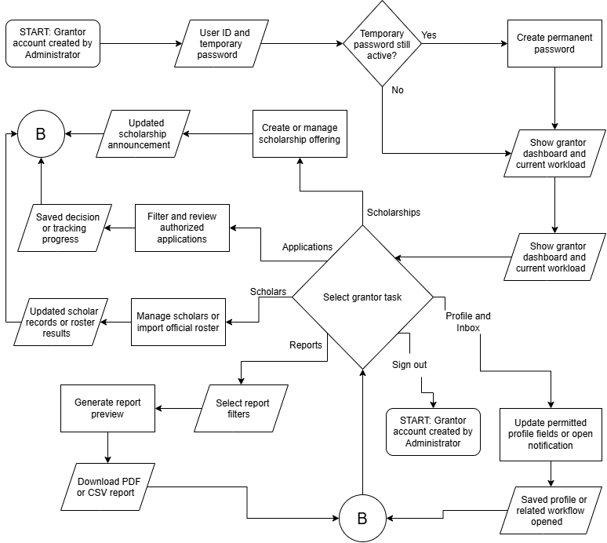
When the system detects a mismatched identity, an unverified academic cycle, multiple competing roster alternatives, or an existing conflicting scholarship award, automatic assignment is prevented. The conflict is displayed for authorized review through the corresponding warning interface. A Full Administrator verifies the supporting information and records the required reason before resolving the conflict. Existing awards and historical records are preserved..
Figure 3.6: Scholarship Grantor Portal Flowchart
Figure 3.6 presents the major functions available to scholarship grantors within the system. After receiving an account created by the administrator, the grantor accesses the system using a temporary password and creates a permanent password when required. From the grantor dashboard, authorized users may create or manage scholarship postings, review applications, manage scholar records, import official scholar rosters, generate reports, access notifications, and update permitted profile information. After completing a selected task, the grantor can return to the dashboard and continue managing other scholarship-related activities. This workflow demonstrates how different grantor responsibilities are centralized within a single platform.
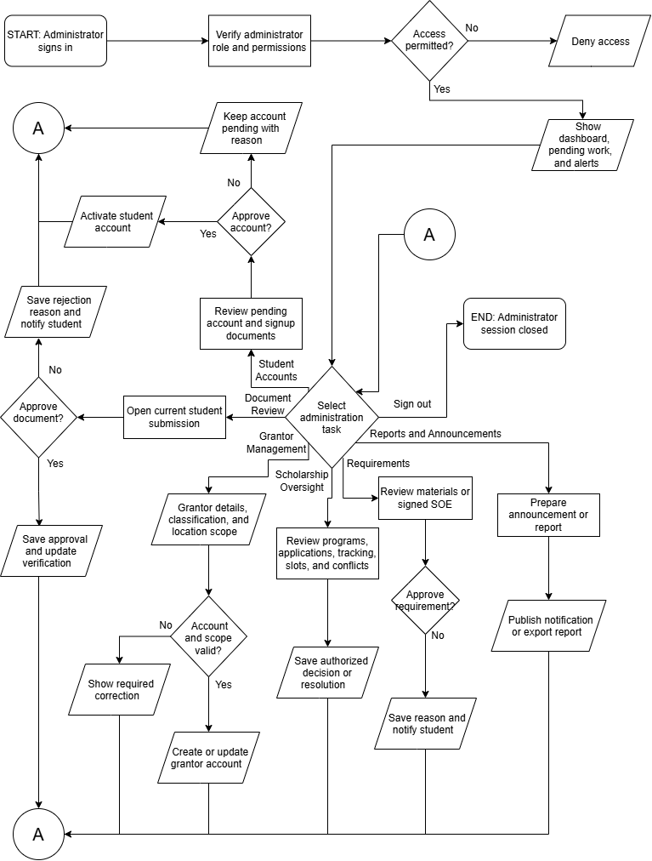
Figure 3.7: Administrator Portal Flowchart
Figure 3.7 presents the main administrative processes performed within the system. After signing in, the administrator's role and permissions are verified before access to administrative functions is granted. The administrator may review pending student accounts and documents, manage scholarship grantor accounts, oversee scholarship programs and applications, resolve scholarship conflicts, review requirements, and generate announcements or reports. Decisions such as account approval, document verification, and requirement approval are recorded in the system, while rejected or incomplete submissions are returned with the appropriate reason or corrective action. This workflow illustrates the administrator's role in maintaining system control, verification, and overall scholarship management oversight.
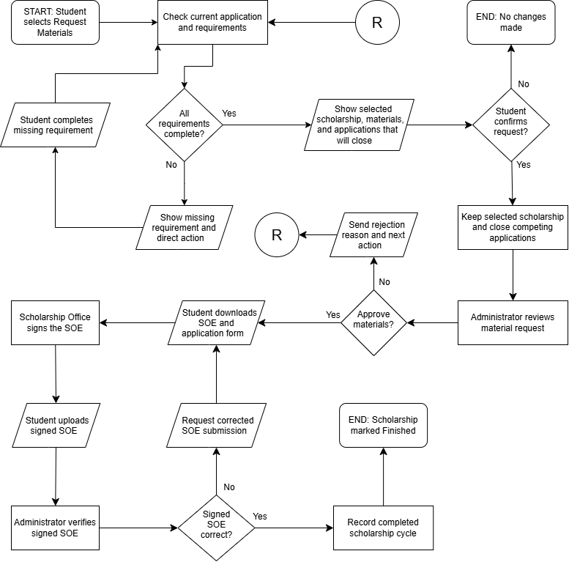
Figure 3.8: Scholarship Requirements and Completion Flowchart
Figure 3.8 presents the process for completing additional scholarship requirements after an application has qualified. Before a request can proceed, the system checks whether all required application stages have been completed. The administrator then reviews the request, and approved students are allowed to obtain the required scholarship documents, including the Statement of Expenses or SOE when applicable. The signed SOE is uploaded and verified before the scholarship cycle can be marked as completed. If an error or incomplete requirement is identified, the student is informed and required to submit the necessary correction before the process continues.

Development Environment
The system is deployed in a web hosting environment that provides centralized access to the developed platform. Publicly tested website and API routes use HTTPS, while authentication, authorization, database access controls, and private document-handling mechanisms are implemented through the application and its supporting services. Users can access the system through supported web browsers using compatible desktop, laptop, and other web-enabled devices.
The deployed environment uses Supabase Auth for authentication together with additional FastAPI access-control checks, while Supabase provides the centralized database and private object storage used by the system. These implemented safeguards support protected access to scholarship-related information. However, the technical review should not be interpreted as a penetration test, security certification, or guarantee that every system endpoint is free from security vulnerabilities.

Implementation Plan
The system was developed using the Agile Software Development Methodology, which supports iterative and flexible development. System features were continuously refined based on feedback from stakeholders, including students, scholarship grantors, and ISPS coordinators.
The implementation proceeded through development cycles focusing on core system modules such as scholarship posting, application processing, recommendation, validation, approval, monitoring, notification, and reporting. A centralized database and role-based access control were established to support secure and efficient system operation.
The developed system underwent testing and evaluation using the Technology Acceptance Model (TAM) and ISO/IEC 25010 Software Quality Model. The developed system is currently deployed and accessible through its web hosting environment. The system continues to support centralized scholarship management while evaluation results and user feedback provide a basis for future improvements, maintenance, and system sustainability.
Implementation Phases

Planning and Designing Phase
In this phase, the researchers finalized the system requirements, system architecture, database structure, user roles, and interface designs. Feedback from stakeholders was considered to ensure that the design reflected the actual scholarship process of Bulacan State University – Bustos Campus.

Development and Prototyping
In this phase, the researchers developed the core modules of the system, including scholarship posting, application, recommendation, validation, approval, monitoring, notification, and reporting. The rule-based Decision Tree recommendation algorithm and the Record Linkage with Levenshtein Distance validation process were implemented in the back-end. Initial prototypes were presented for review, and necessary improvements were applied based on feedback.

Testing and Feedback
After each development iteration, testing was performed to identify errors, bugs, missing features, or areas for improvement. Feedback from students, scholarship grantors, ISPS coordinators, administrators, and IT professionals was analyzed and used to improve the next development cycle.

Deployment
The developed Centralized Scholarship Management and Tracking System is deployed in a web hosting environment and is accessible to authenticated and authorized users through supported web browsers. The deployment uses HTTPS on the publicly tested website and API routes and applies the system's authentication, authorization, database-access, and document-access controls according to each user's assigned role and permissions.
The system interface was designed to support accessibility across desktop and laptop devices and can also be accessed through compatible web-enabled devices.
The current deployment serves as the operational environment of the developed system and provides the platform used for system access, testing, evaluation, and demonstration.

Post-Deployment Evaluation
The deployed system was evaluated using the Technology Acceptance Model (TAM) and the ISO/IEC 25010 Software Quality Model. The TAM evaluation was conducted among 47 user respondents, consisting of students, scholarship grantors, and the ISPS Coordinator, to measure system acceptability. The ISO/IEC 25010 evaluation was conducted separately among 5 IT professionals to assess the technical quality of the developed system. In total, 52 respondents participated in the evaluation. The evaluation results and user feedback served as the basis for identifying areas for improvement, future updates, maintenance, and continued development of the system.

CHAPTER IV:
PRESENTATION, ANALYSIS, AND INTERPRETATION OF DATA
This chapter presents, analyzes, and interprets the findings of the study based on the development and evaluation of the Centralized Scholarship Management and Tracking System for Bulacan State University – Bustos Campus. It discusses the concerns identified in the existing scholarship management process, presents the developed system and its major functionalities, and evaluates the acceptability and software quality of the system using the Technology Acceptance Model (TAM) and the ISO/IEC 25010 Software Quality Model.
The chapter is divided into three major sections. The first section presents the results of the preliminary study and the identified concerns that served as the basis for system development. The second section presents and describes the major interfaces and functions of the developed system. The third section presents and interprets the results of the system evaluation based on the responses gathered from the selected users and IT professionals.

I. Understanding the Challenges in Scholarship Management
The preliminary study examined the existing scholarship management procedures at Bulacan State University – Bustos Campus. The scholarship process involves activities such as posting scholarship opportunities, receiving student applications, submitting and verifying documentary requirements, evaluating applicants, monitoring approval status, maintaining scholarship records, monitoring scholars, and providing notifications.
The analysis identified that several scholarship-related activities relied on manual or fragmented procedures. This condition may make the processing and monitoring of scholarship records more difficult because information related to applications, requirements, approvals, and active scholarships may be maintained through different sources or processes. The study therefore identified a need for a centralized platform where scholarship-related records and activities could be managed in a more organized manner.
Another concern identified was the monitoring of students who already possess an active scholarship. Scholarship information may originate from internally administered programs as well as externally sourced scholarship records. Without centralized record checking, determining whether a student already has an active scholarship may become difficult and may result in possible duplicate scholarship allocation.
The study also identified the need for improved monitoring throughout the scholarship lifecycle. Aside from the initial application and approval processes, scholarship management includes monitoring academic performance, compliance requirements, renewal conditions, active scholarship status, completion, returning students, and possible cancellation or termination. These activities require updated and accessible records so that authorized personnel can properly monitor scholars.
The identified concerns became the basis for the development of the centralized scholarship management and tracking system. The developed system addresses these concerns through scholarship posting, application processing, scholarship recommendation, pre-approval validation, applicant evaluation and approval, scholar monitoring, renewal monitoring, notifications, and report generation. These functionalities are intended to provide organized scholarship records and support the different users involved in scholarship administration.

II. Designing and Developing a Centralized Scholarship Management and Tracking System
Based on the identified requirements, the researchers developed a centralized web-based platform that supports the major activities involved in scholarship management.
The Scholarship Posting Module enables authorized scholarship grantors and coordinators to create and manage scholarship opportunities. It contains information such as scholarship descriptions, eligibility criteria, documentary requirements, deadlines, available slots, and scholarship duration.
The Application Module enables students to apply for available scholarship programs and submit the required information and documents. Students are also provided with a mechanism for monitoring the status of their submitted applications.
The Scholarship Recommendation Module compares student information with the eligibility requirements of available scholarship programs. The system uses a rule-based Decision Tree algorithm based on predefined eligibility filtering and deterministic weighted recommendation scoring. The recommendation serves as a guide in identifying possible scholarship opportunities and does not replace the actual evaluation and approval process.
The Validation Module supports student-record verification and duplication prevention using exact identity checks, similarity-based comparison, and scholarship commitment rules. The system uses different validation procedures depending on the workflow. Possible duplicate records may be flagged or grouped for authorized review, while confirmed identity, scholar-list, or scholarship-assignment conflicts may restrict the corresponding operation. This mechanism assists authorized personnel in preventing conflicting scholarship assignments while maintaining review of records that require manual verification.
The Approval Module allows authorized scholarship grantors or coordinators to review applications, submitted requirements, eligibility information, and validation results before processing an application decision. Once an application is approved, the system updates the corresponding scholarship record and active scholarship status.
The Monitoring Module maintains information related to active scholars, compliance requirements, academic performance, renewal conditions, completion, returning student status, and scholarship cancellation or termination.
The Notification Module provides updates regarding application status, missing requirements, deadlines, renewal reminders, monitoring concerns, and other scholarship-related announcements.
The Reporting Module provides organized summaries and reports concerning applicants, approved scholars, active scholarships, renewal status, compliance records, and flagged scholarship records. These modules collectively support the scholarship management lifecycle within the centralized platform.
The developed system reflects the research gap identified from the reviewed literature and studies. While previous systems demonstrated individual capabilities such as online scholarship application, recommendation, tracking, notifications, centralized record management, dashboards, and reporting, the developed system integrates these functions with pre-approval duplication prevention and scholarship lifecycle monitoring within one platform. The implemented modules therefore provide the functional connection between the findings of the reviewed studies and the specific scholarship-management requirements identified at Bulacan State University – Bustos Campus. The succeeding system presentation and evaluation demonstrate how these integrated functions were implemented and assessed in the developed system.

Presentation and Description of the System
This section presents the major interfaces and functionalities of the developed Centralized Scholarship Management and Tracking System for Bulacan State University – Bustos Campus

End-to-End System Workflow

The system interfaces presented in this section collectively demonstrate the major scholarship-management workflow of the developed system. Using the appropriate Student, Grantor/Provider, and Administrator permissions, the process begins with the creation and publication of a scholarship opportunity. A student may then view available scholarships, receive scholarship recommendations based on predefined eligibility conditions, submit an application and documentary requirements, and monitor the application status. Authorized scholarship personnel subsequently review the application, perform pre-approval validation for possible duplicate or conflicting scholarship records, and process the appropriate application decision. Once approved, the student becomes part of the scholar-monitoring process, where academic performance, compliance requirements, scholarship status, and renewal conditions may be monitored. The system also provides notifications and consolidated reports throughout the scholarship lifecycle.
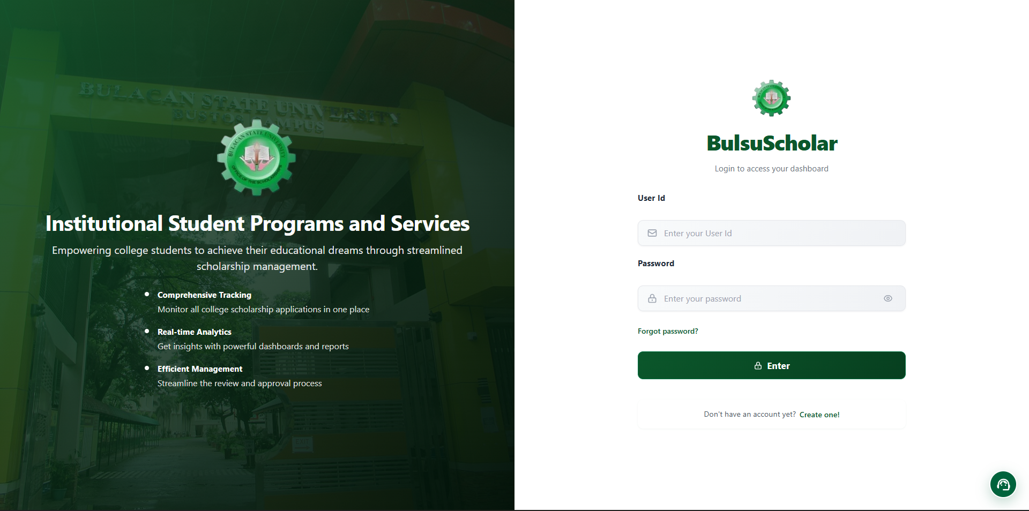Figure 4.1. Login Page
Figure 4.1 presents the login page of the system. The interface allows registered users to enter their authorized account credentials and access the system according to their assigned role. Students, scholarship grantors, and authorized administrators are directed to functions appropriate to their respective permissions and responsibilities. ISPS personnel perform their authorized functions through the applicable administrator permissions.
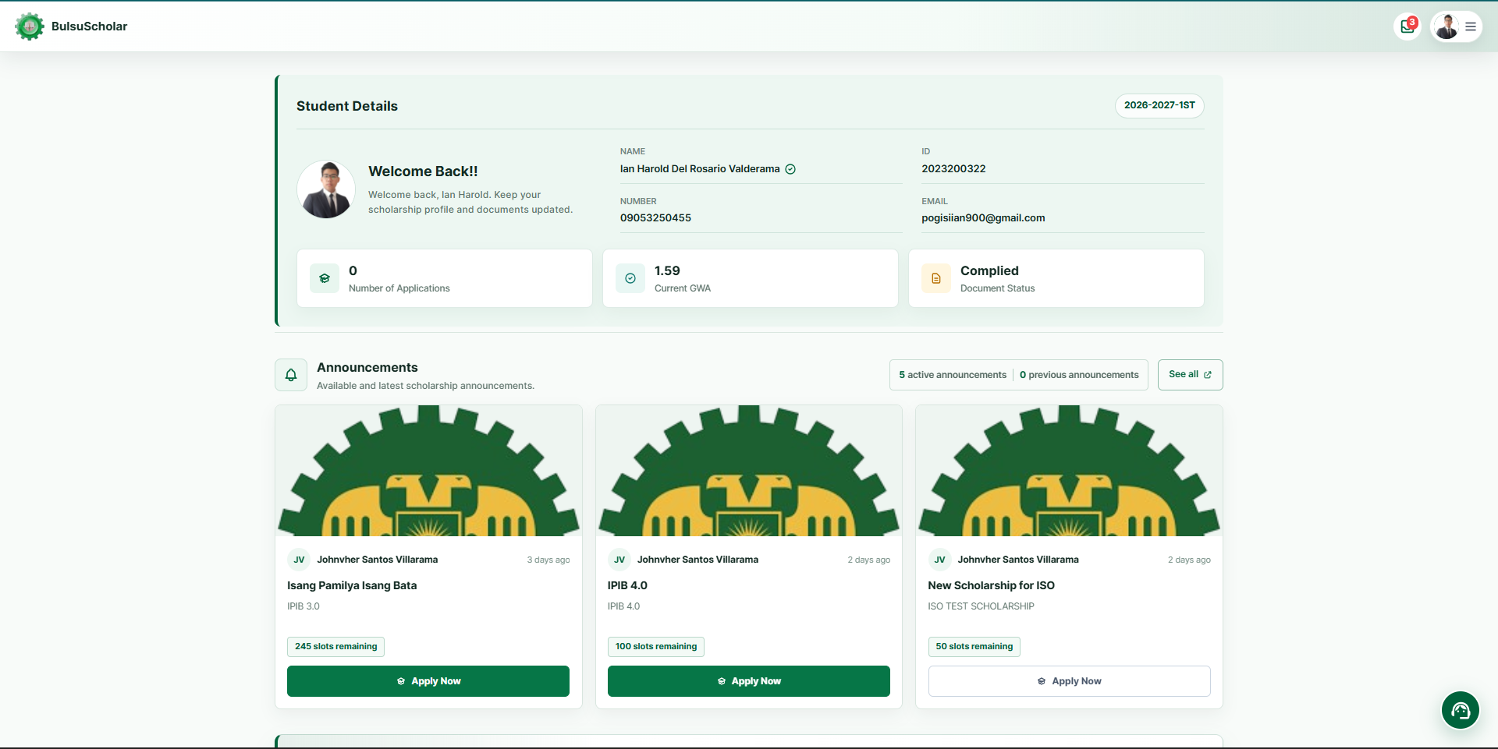Figure 4.2. Student Dashboard
Figure 4.2 presents the student dashboard. The dashboard serves as the main interface for students and provides an overview of scholarship-related information available to them. It gives students access to available scholarship opportunities, submitted applications, current scholarship status, system-generated recommendations, and notifications. By consolidating this information on a single interface, students are able to monitor scholarship activities without relying on separate sources.
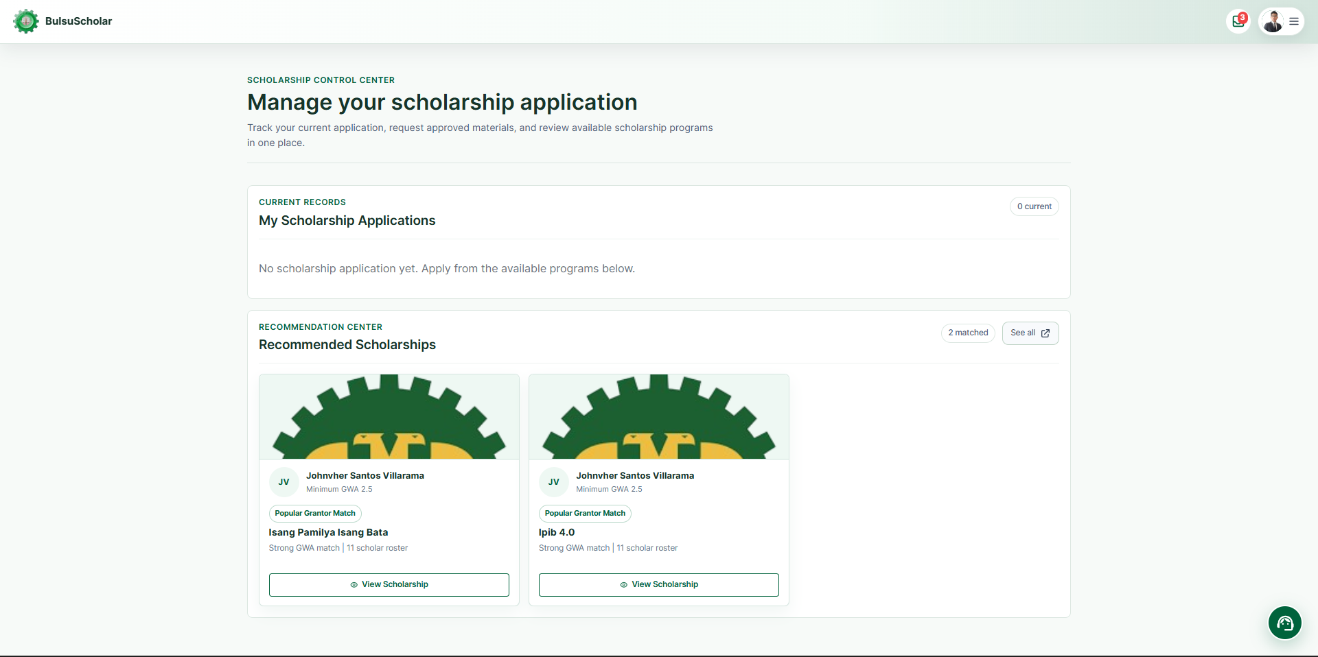
Figure 4.3. Available Scholarships
Figure 4.3 presents the available scholarships page. The interface displays scholarship opportunities that are currently posted and available for student application. Relevant information such as the scholarship description, eligibility requirements, documentary requirements, deadline, available slots, and duration is presented to help students determine whether a scholarship is appropriate before proceeding with an application.
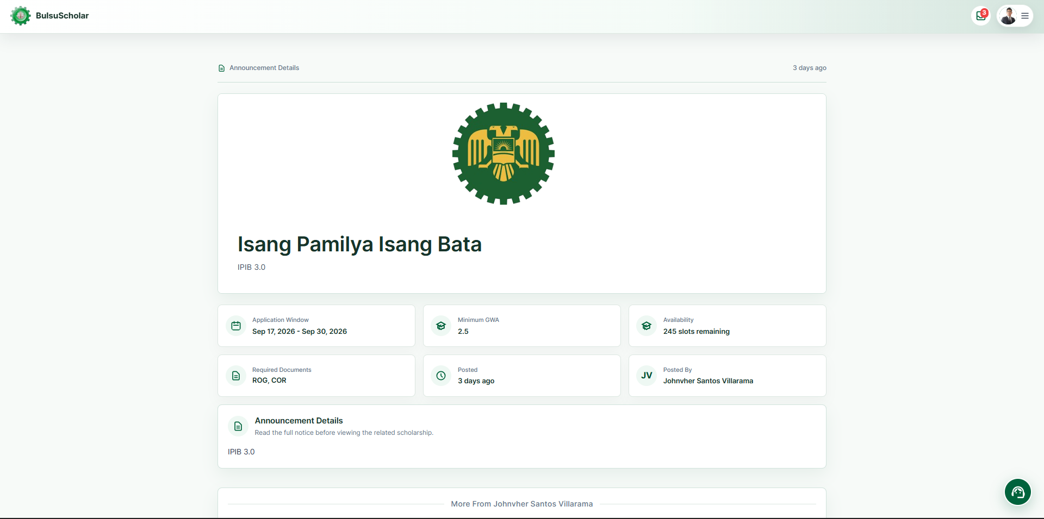
Figure 4.4. Scholarship Details
Figure 4.4 presents the detailed information for a selected scholarship program. The page provides students with the complete scholarship information and requirements that must be reviewed before applying. Presenting these details before submission helps ensure that students understand the scholarship conditions and required documents.
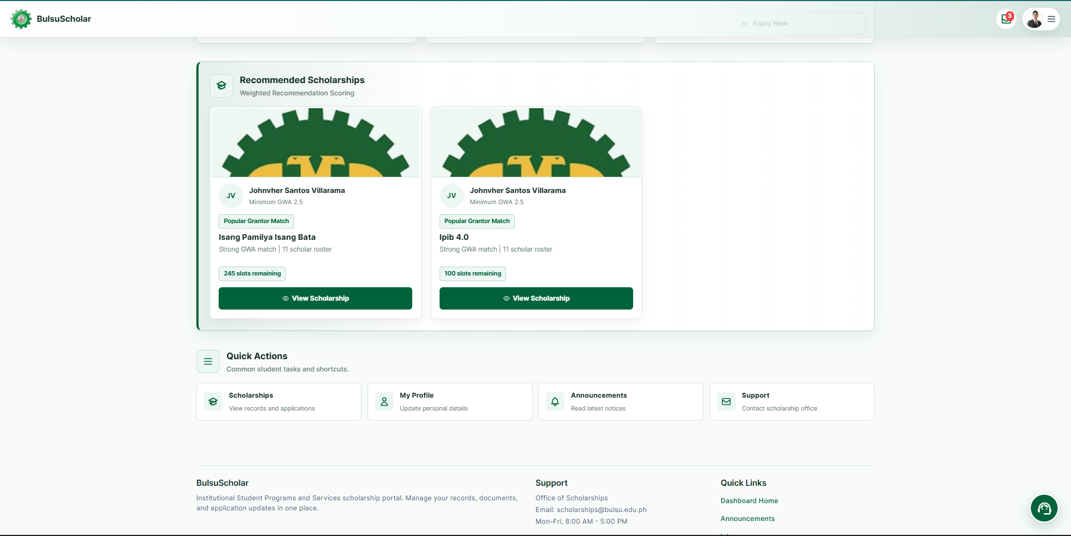
Figure 4.5. Scholarship Recommendation
Figure 4.5 presents the scholarship recommendation feature. The system compares the student's available profile and academic information with the eligibility requirements of scholarship programs stored in the system. Based on these criteria, the recommendation process identifies scholarship opportunities that correspond to the student's qualifications. The generated recommendations assist students in identifying potentially suitable scholarships but do not automatically guarantee scholarship approval.
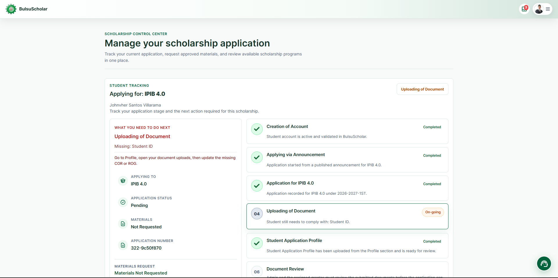
Figure 4.6. Scholarship Application
Figure 4.6 presents the scholarship application interface. Students can provide the required application information and submit the necessary documentary requirements for the selected scholarship program. The submitted information is stored in the centralized system and becomes available to authorized scholarship personnel for evaluation.
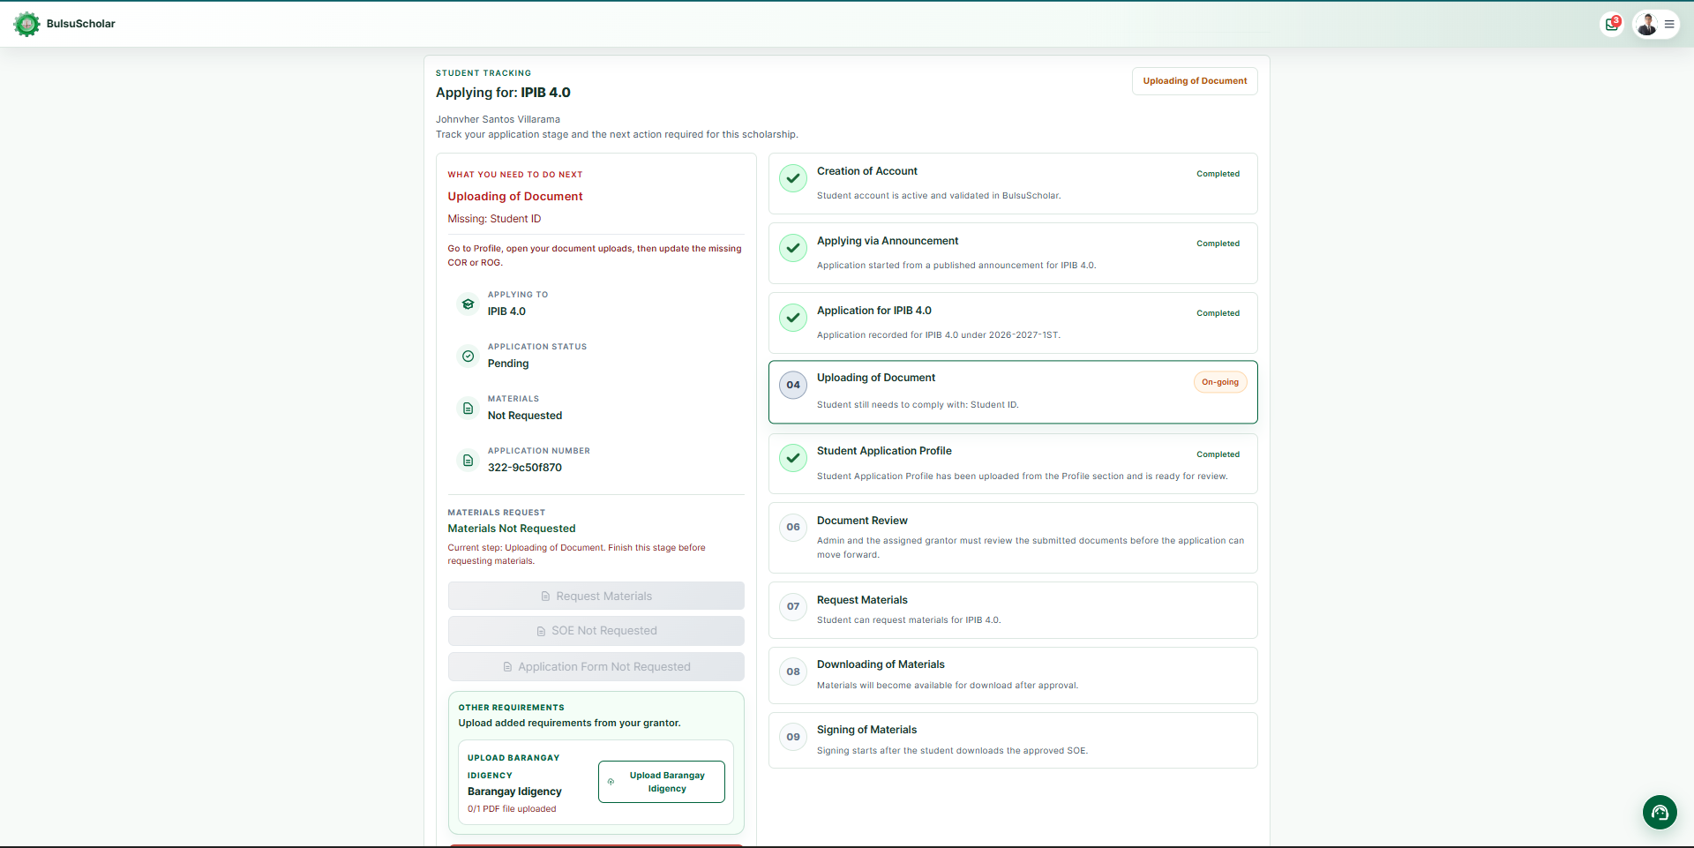
Figure 4.7. Application Tracking
Figure 4.7 presents the application tracking feature. The interface enables students to monitor the status of submitted applications and view updates made during the application process. The feature provides greater visibility into whether an application is pending evaluation, requires correction, has been approved, or has been rejected.
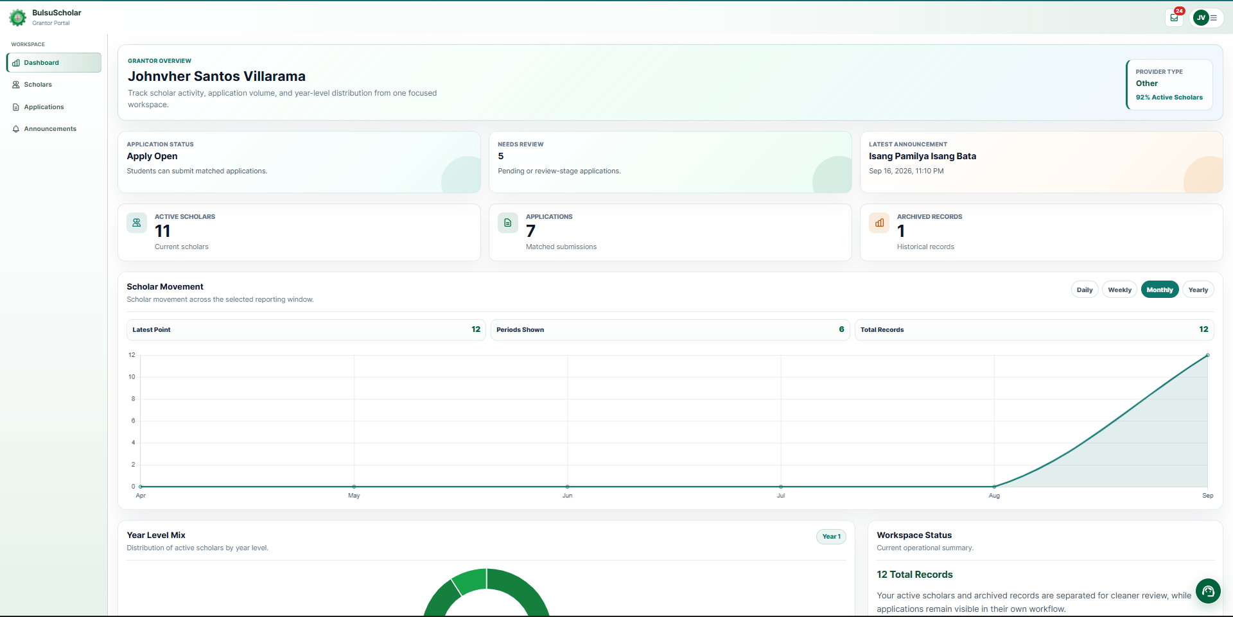
Figure 4.8. Grantor Dashboard
Figure 4.8 presents the dashboard provided to scholarship grantors. The dashboard gives authorized grantors access to scholarship postings, applicant records, evaluation functions, approval processes, scholar monitoring information, and other scholarship-related records. It serves as the primary interface for managing the scholarship programs assigned to the grantor.
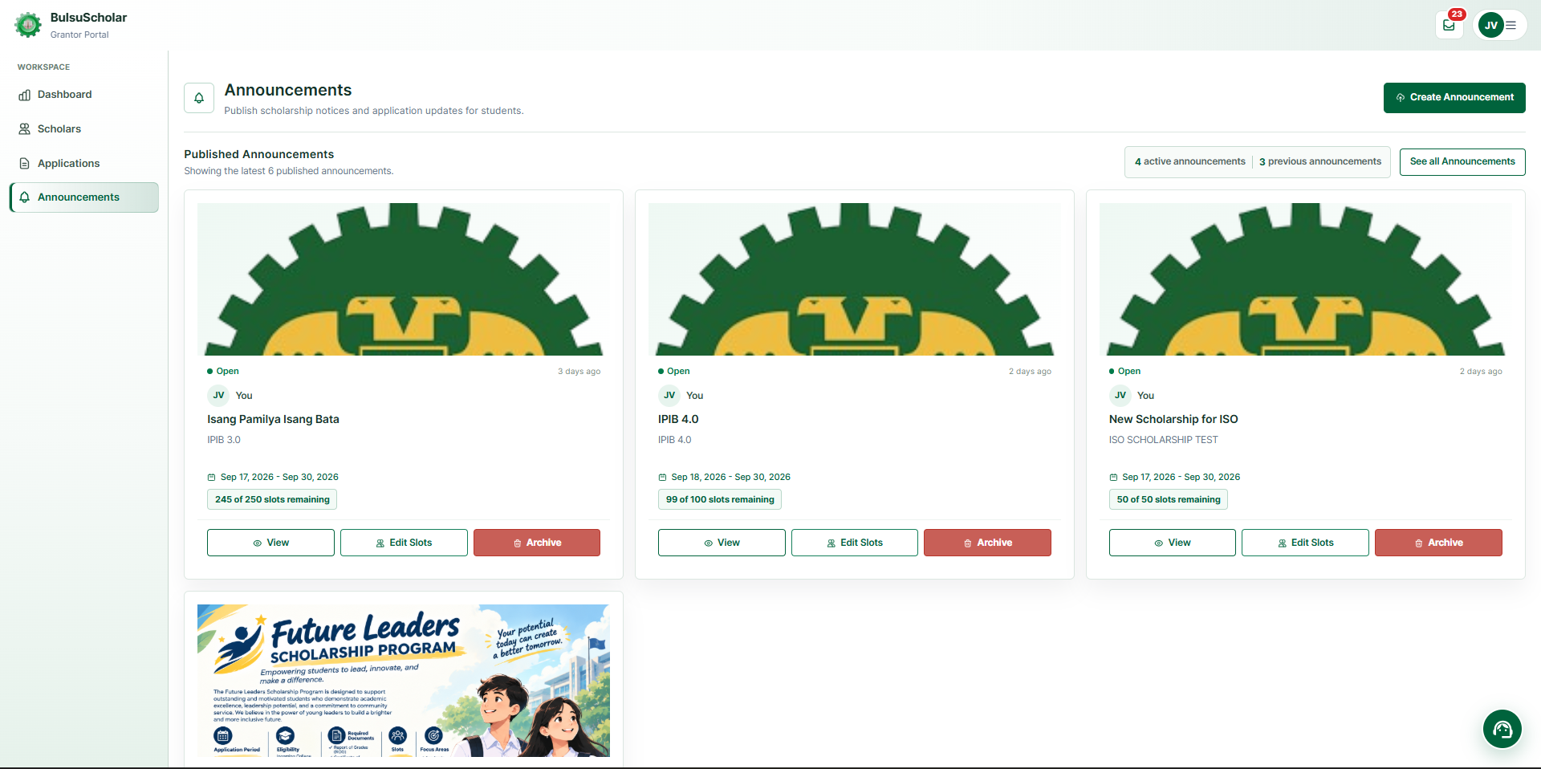
Figure 4.9. Scholarship Posting
Figure 4.9 presents the scholarship posting feature. Authorized users can create and manage scholarship opportunities by entering scholarship information, eligibility criteria, documentary requirements, deadlines, scholarship duration, and available slots. Once posted, the scholarship information becomes available to eligible system users.
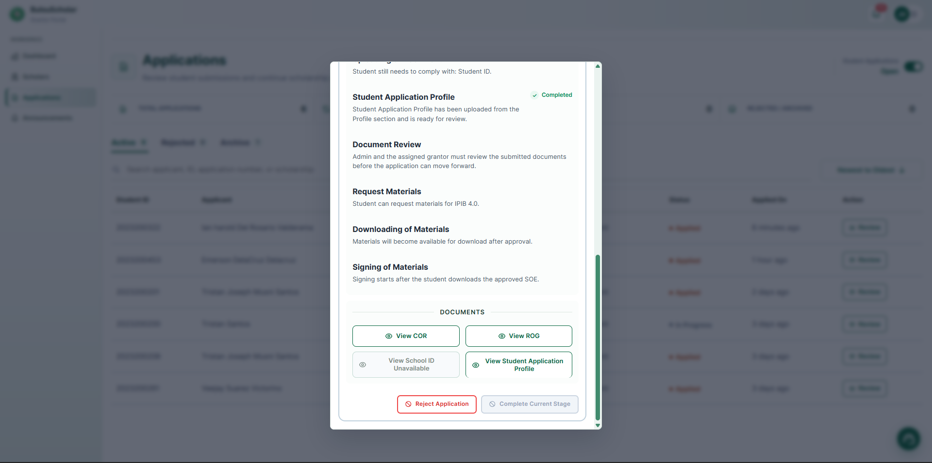
Figure 4.10. Applicant Evaluation
Figure 4.10 presents the applicant evaluation interface. Authorized grantors or coordinators can review student information, submitted documentary requirements, and other relevant application information. This allows scholarship personnel to determine whether the applicant satisfies the requirements of the selected scholarship before an approval decision is made.
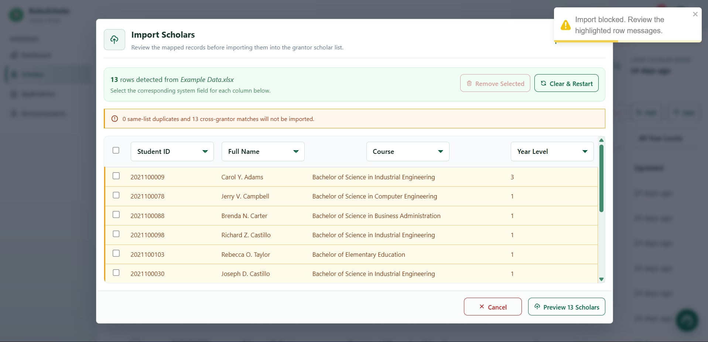
Figure 4.11. Duplicate Scholarship Validation
Figure 4.11 presents the duplicate-record and scholarship-conflict validation behavior supported by available system records.
The general matching process uses exact identifiers and similarity indicators to identify possible duplicate student identities; a similarity warning alone is not proof of a confirmed scholarship award. Official scholarship assignment separately checks recognized scholarship information, exact verified identity, academic cycle, and existing commitments. A conflicting current-cycle award prevents an additional automatic assignment.
General duplicate-record checking uses exact identity comparisons and similarity-based matching to identify records that may refer to the same individual. Possible duplicate identities may be flagged for authorized review. However, a similarity-based warning alone does not establish that a student has already received a scholarship or authorize another scholarship assignment.
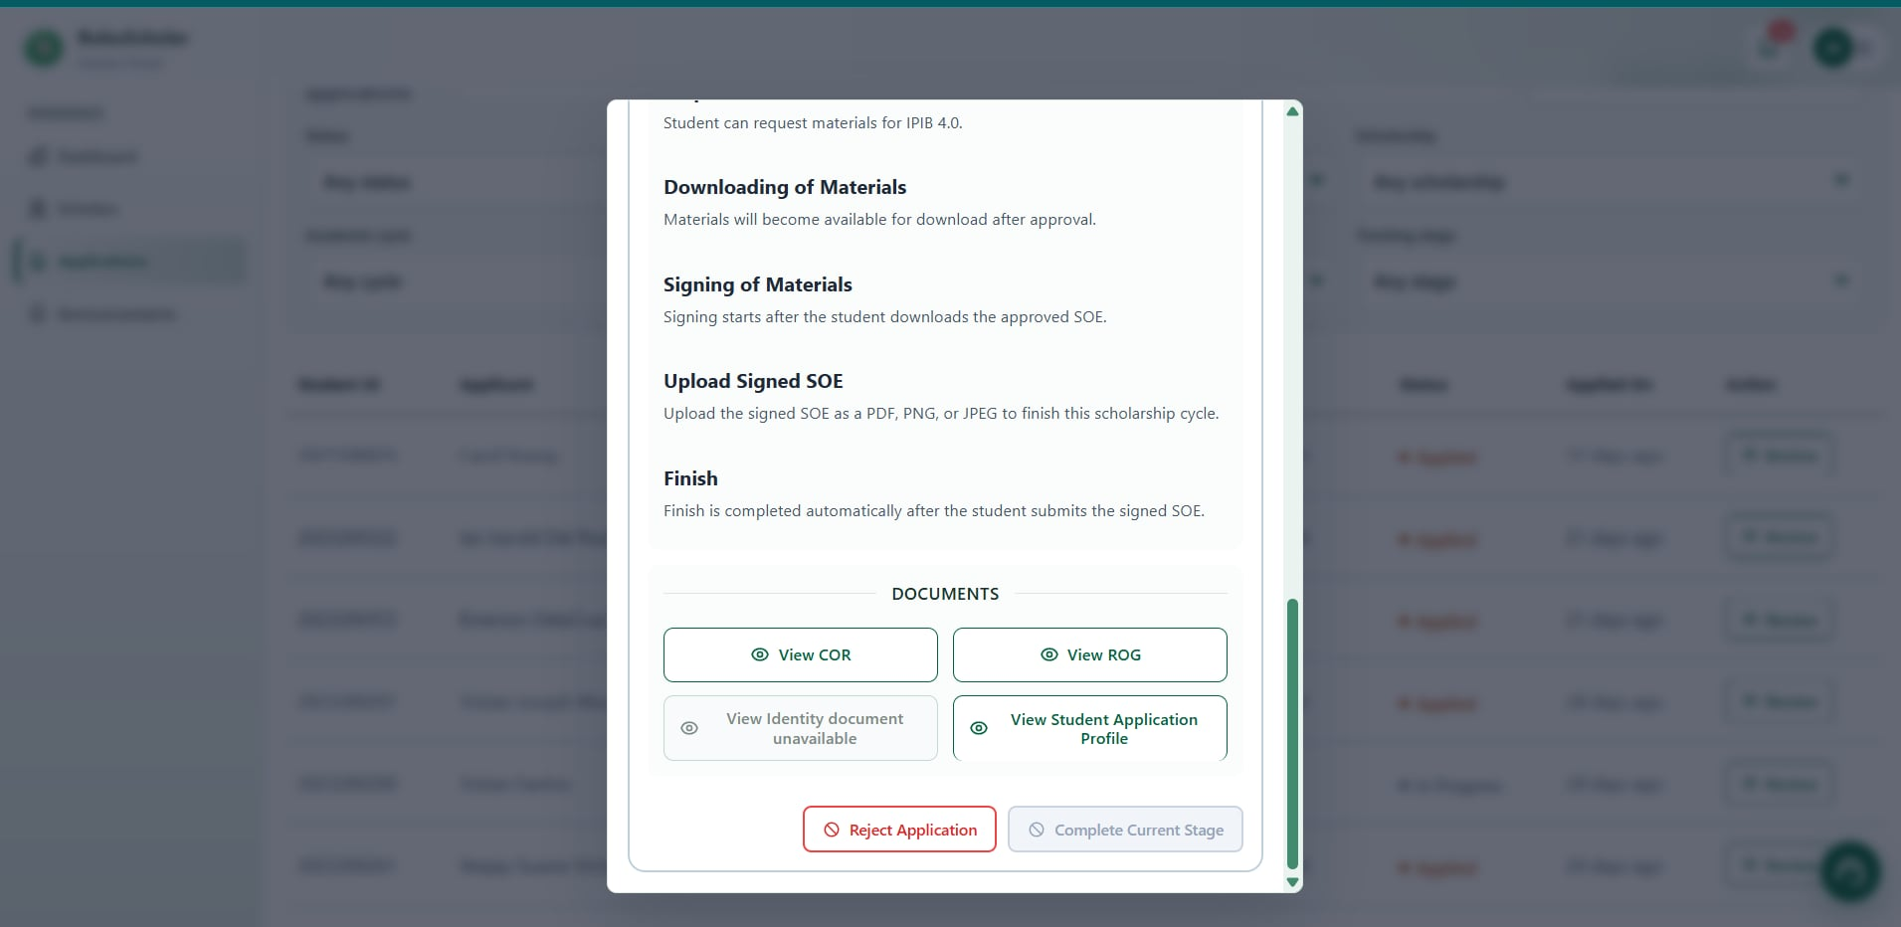
Figure 4.12. Approval Page
Figure 4.12 presents the scholarship approval interface. Authorized users can review the application, submitted requirements, eligibility information, and validation result before processing the application decision. Depending on the evaluation, an application may be approved, rejected, or returned for correction. When an application is approved, the system updates the student's scholarship record and identifies the scholarship as active.
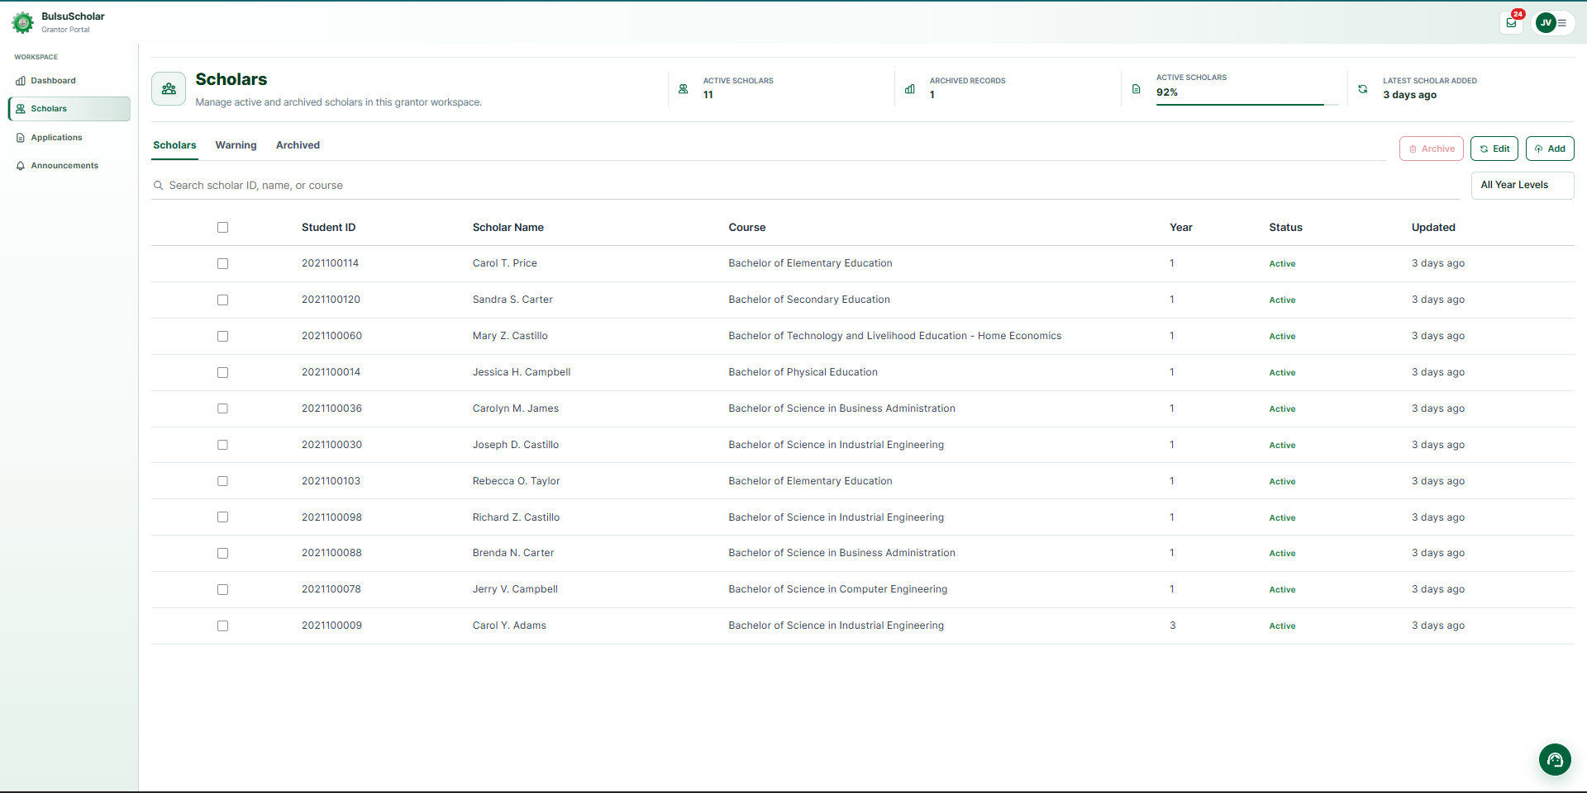
Figure 4.13. Scholar Monitoring
Figure 4.13 presents the scholar monitoring interface. The system maintains information concerning active scholars, compliance requirements, academic performance, scholarship status, renewal conditions, completion, returning student status, and other scholarship conditions. The monitoring feature assists authorized users in maintaining updated records throughout the scholarship lifecycle.
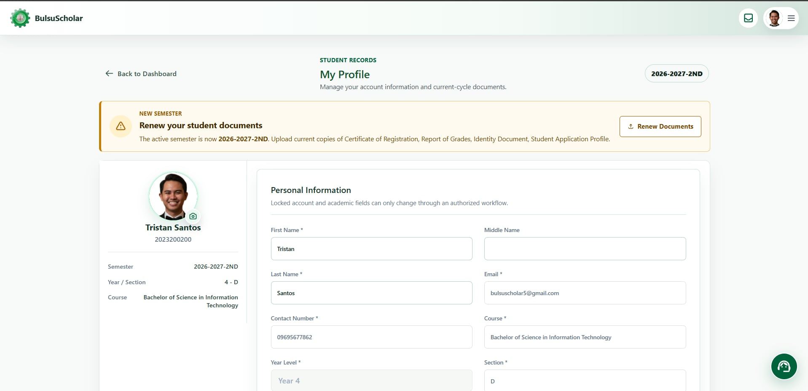
Figure 4.14. Renewal Monitoring
Figure 4.14 presents the scholarship renewal monitoring feature. The interface allows authorized users to review renewal requirements and determine the current renewal status of scholars. This functionality supports the continuation of scholarship records beyond the initial approval stage and helps monitor whether scholars satisfy the conditions required for renewal.
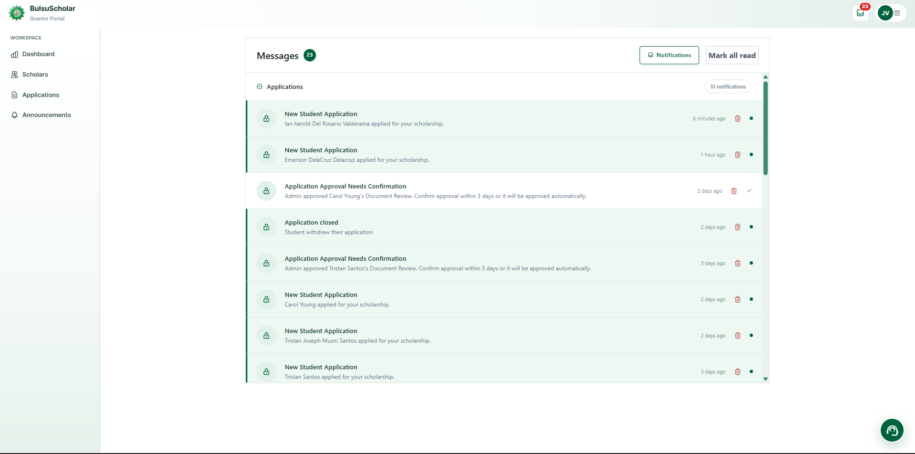
Figure 4.15. Notifications
Figure 4.15 presents the notification feature of the system. Notifications provide users with updates concerning application status, documentary requirements, deadlines, scholarship renewals, monitoring concerns, and other important scholarship-related announcements. This feature supports communication between students and scholarship personnel by providing scholarship updates through the centralized platform.

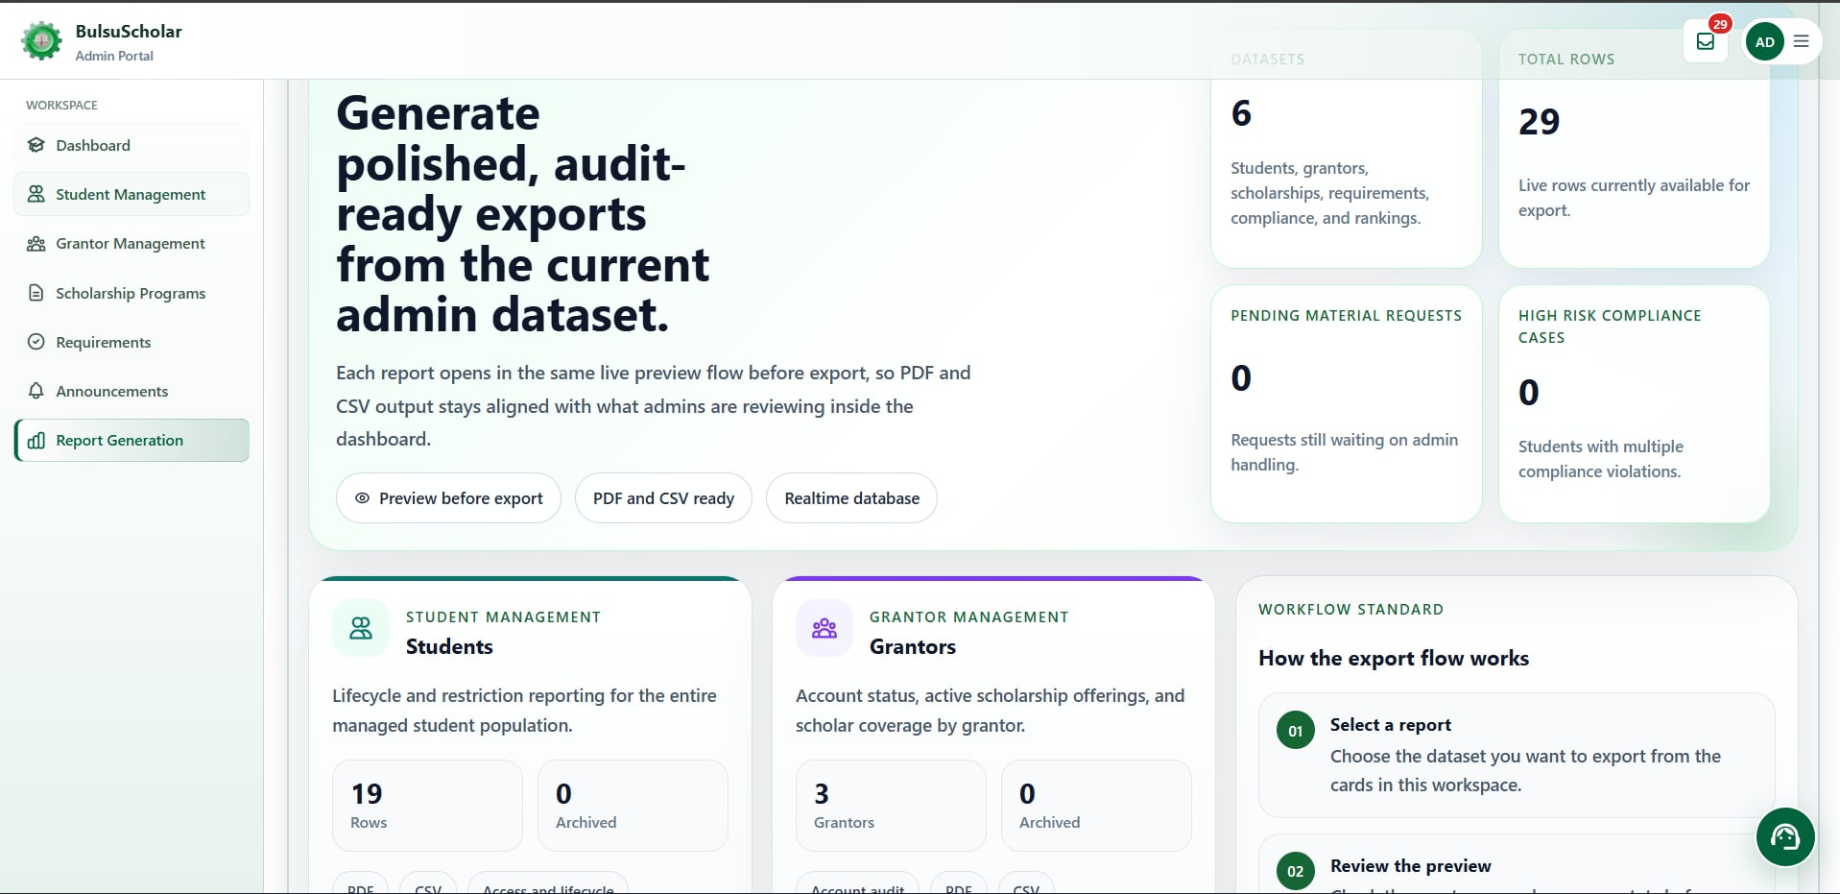
Figure 4.16. Reports and Dashboard
Figure 4.16 presents the reporting feature of the system. The system organizes scholarship information into reports and summaries related to applications, approved scholars, active scholarships, renewal status, compliance records, and flagged scholarship records. These reports provide administrators and scholarship personnel with consolidated information that can be used for monitoring and scholarship management activities.

Results and Discussion of the System's Evaluation
This section presents the evaluation results of the Centralized Scholarship Management and Tracking System for Bulacan State University – Bustos Campus. A total of 52 respondents participated in the system evaluation using two separate evaluation models based on their roles and expertise.
COR and ROG Functional Test Case Results

The COR and ROG functional test-case summary presents 20 selected document-processing test cases, identified as TC-16 through TC-35. These identifiers continue the numbering used for the 15-core automated backend test cases presented in Chapter III. These tests examined the extraction and validation of academic information, document identity and academic-cycle requirements, file-format restrictions, document access authorization, document renewal, and selected protected-document processing functions. For consistency with the existing test-case documentation, the additional selected cases were assigned reference identifiers TC-16 through TC-35. These identifiers serve as thesis reporting references and correspond to documented automated test scenarios or existing regression-test functions.

The reported results are based on the recorded execution evidence for the respective scenarios. Passing tests indicate that the actual observed behavior satisfied the defined expected conditions under the documented test environment and do not establish complete testing coverage across all document formats or production conditions.
Test ID | Functionality | Expected Result | Actual Result | Status
TC-16 | Valid COR PDF Upload | Accept valid COR PDF. | Valid COR uploaded successfully. | Pass
TC-17 | Invalid COR File Format | Reject PNG/JPG COR submissions. | Unsupported file rejected with an error message. | Pass
TC-18 | Valid COR Title | Recognize an approved COR title. | Valid COR title accepted. | Pass
TC-19 | Invalid COR Title | Reject a COR with an invalid title. | Invalid title rejected. | Pass
TC-20 | ROG Upload Prerequisite | Disable ROG upload before COR submission. | ROG upload remained disabled. | Pass
TC-21 | Valid ROG PDF Upload | Accept a valid ROG PDF. | Valid ROG uploaded successfully. | Pass
TC-22 | Valid ROG Title | Recognize a Report of Grades document. | Valid ROG title accepted. | Pass
TC-23 | Invalid ROG Title | Reject invalid ROG document titles. | Invalid ROG title rejected. | Pass
TC-24 | Current COR Cycle | Accept COR from the current semester. | Current-cycle COR accepted. | Pass
TC-25 | First-Semester COR | Accept the applicable first-semester COR. | First-semester COR accepted. | Pass
TC-26 | Previous-Cycle ROG | Require ROG from the applicable previous semester. | Previous-cycle ROG accepted. | Pass
TC-27 | First-Year ROG Exemption | Exempt eligible first-year, first-semester students from ROG. | ROG exemption applied. | Pass
TC-28 | Second-Semester ROG Requirement | Require ROG for applicable students. | Previous-cycle ROG required. | Pass
TC-29 | Outdated ROG | Reject a ROG older than the permitted academic cycle. | Outdated ROG rejected. | Pass
TC-30 | Academic-Cycle Error | Display an appropriate cycle-validation message. | Cycle error displayed. | Pass
TC-31 | First-Name Extraction | Autofill extracted first name. | First name autofilled correctly. | Pass
TC-32 | Last-Name Extraction | Autofill extracted last name. | Last name autofilled correctly. | Pass
TC-33 | GWA Extraction | Autofill applicable GWA from ROG. | GWA autofilled. | Pass
TC-34 | Name Variation | Allow applicable minor student-name variations. | Tested name variation accepted. | Pass
TC-35 | Reused COR File | Prevent reuse of an applicable COR file. | Reused file blocked. | Pass

Table x. COR and ROG Document Processing Functional Test Cases
Table x demonstrates COR and ROG Document Processing Functional Test Cases, the system's implementation of document-processing and validation functions under controlled testing conditions. The tested scenarios include academic-field recognition, Student ID validation, academic-cycle restrictions, document-access permissions, renewal requirements, and rejection of selected invalid file conditions.
The tests also demonstrate the distinction between academic-document processing and protected-document access operations. Document extraction and validation determine whether available information satisfies the applicable workflow conditions, whereas document-access tests verify restrictions on viewing or processing uploaded files.
The results are limited to the test cases and execution conditions documented in the automated test records. Additional exploratory testing identified validation limitations in certain document replacement and signup workflows, while OCR-related scenarios could not be fully evaluated in the local environment because the required processing dependencies were unavailable. These findings require separate consideration and should not be interpreted as passing automated safeguards.
Table X presents 20 selected COR and ROG functional test cases, identified as TC-16 through TC-35. The table summarizes the applicable document-processing functions, expected behavior, actual observations, and test statuses recorded for the selected conditions.
The test cases examine the acceptance and rejection of academic documents, identification of COR and ROG document titles, validation of academic-cycle requirements, extraction of selected student information, prevention of reused COR submissions, and document viewing and replacement.
The recorded results indicate that the selected functions produced their expected outcomes under the documented manual testing conditions. However, these results should not be interpreted as proof of universal document extraction accuracy or complete enforcement of student-identity and academic-cycle safeguards.
The separately conducted technical evaluation identified limitations involving selected signup and document-replacement operations. These limitations are presented independently to distinguish observed successful functional behavior from conditions requiring further implementation and verification.
Supplementary COR and ROG Extraction Accuracy Evaluation
A supplementary technical evaluation was conducted to measure the accuracy of selected academic fields extracted from compatible synthetic COR and ROG documents.
The evaluation included two synthetic Certificates of Registration and one synthetic Report of Grades. The system-generated extraction values were compared with independently established reference values for student identity and academic information.
The results of the field-level extraction evaluation are presented in the following table.
Document Type | Documents Tested | Fields Evaluated | Correct Fields | Accuracy
COR | 2 | 16 | 16 | 100.00%
ROG | 1 | 9 | 9 | 100.00%
Total | 3 | 25 | 25 | 100.00%
Table x. Supplementary Synthetic COR and ROG Field-Level Extraction Accuracy
The supplementary evaluation obtained 16 correct field comparisons from the two synthetic COR documents and nine correct field comparisons from the synthetic ROG document. All 25 evaluated fields matched their corresponding reference values, resulting in an observed field-level extraction accuracy of 100.00% within the selected synthetic sample.
This result demonstrates that the parser successfully extracted the evaluated information from the three compatible text-based PDF documents. However, the sample size was limited, and the evaluation did not establish general extraction accuracy across real student documents, different document layouts, or scanned academic records requiring Optical Character Recognition (OCR).
The result is therefore interpreted as a limited technical measurement and is not equivalent to the automated functional test pass rate or a predicted document-processing success rate.
Observed Document Validation Limitations
The supplementary technical evaluation also identified four validation limitations involving selected COR and ROG processing workflows.
The first limitation concerned a COR belonging to another student that was accepted through the tested profile replacement workflow. The second involved the acceptance of a ROG containing an incorrect academic period during document replacement. The third concerned an isolated signup-document operation that accepted a COR without extracted course information. The fourth involved the acceptance of a ROG containing a Student ID different from the corresponding signup identity.
These findings indicate that the validation conditions enforced during initial document submission and subsequent document replacement were not entirely consistent under the tested conditions.
Two additional OCR-related scenarios could not be completed because the required local document-processing dependencies were unavailable. Consequently, OCR extraction accuracy was not established.
The identified limitations demonstrate the need for additional validation safeguards, consistent document-ownership and academic-cycle verification, and further regression testing. These findings are reported separately from the successful automated functional tests to provide an accurate representation of the system's evaluated capabilities and remaining areas for improvement.
The Technology Acceptance Model (TAM) was administered to 47 user respondents, consisting of 44 students, 2 scholarship grantors, and 1 ISPS Coordinator. TAM evaluated the acceptability of the system in terms of Perceived Usefulness, Perceived Ease of Use, and Behavioral Intention.
The ISO/IEC 25010 Software Quality Model was administered separately to 5 IT professionals. The model evaluated the technical quality of the system in terms of Functional Suitability, Performance Efficiency, Compatibility, Usability, Reliability, Security, Maintainability, and Portability.

Users' Technology Acceptance Model (TAM) Evaluation Results
Table 4
Users' Perceived Usefulness Evaluation
Indicators | WM | SD | Verbal Interpretation
The system makes scholarship-related processes faster and more efficient. | 4.77 | 0.43 | Very High Acceptability
The system helps me access and manage scholarship information more effectively. | 4.72 | 0.58 | Very High Acceptability
The system makes it easier to monitor scholarship applications and their status. | 4.83 | 0.38 | Very High Acceptability
The system helps reduce the effort required in performing scholarship-related tasks. | 4.81 | 0.40 | Very High Acceptability
Overall, the system is useful in improving the scholarship management process. | 4.81 | 0.40 | Very High Acceptability
Average Mean | 4.79 | 0.33 | Very High Acceptability

Table 4 presents the evaluation of the 47 TAM user respondents in terms of Perceived Usefulness. The indicators obtained weighted mean scores of 4.77 for faster and more efficient scholarship-related processes, 4.72 for effective access and management of scholarship information, 4.83 for easier monitoring of scholarship applications and their status, 4.81 for reducing the effort required in performing scholarship-related tasks, and 4.81 for the overall usefulness of the system in improving the scholarship management process. The overall average mean of 4.79, with a standard deviation of 0.33, was interpreted as Very High Acceptability. This indicates that the respondents perceived the developed system as highly useful in supporting and improving scholarship-related processes.

Table 5
Users' Perceived Ease of Use Evaluation
Indicators | WM | SD | Verbal Interpretation
Learning how to use the system is easy for me. | 4.55 | 0.62 | Very High Acceptability
The system's menus, buttons, and functions are easy to understand. | 4.53 | 0.69 | Very High Acceptability
It is easy for me to navigate from one part of the system to another. | 4.62 | 0.57 | Very High Acceptability
I can perform scholarship-related tasks using the system without difficulty. | 4.49 | 0.66 | Very High Acceptability
Overall, I find the system easy to use. | 4.57 | 0.58 | Very High Acceptability
Average Mean | 4.55 | 0.53 | Very High Acceptability
Table 5 presents the evaluation of the 47 TAM user respondents in terms of Perceived Ease of Use. The indicators obtained weighted mean scores of 4.55 for ease of learning the system, 4.53 for the understandability of menus, buttons, and functions, 4.62 for ease of navigation, 4.49 for performing scholarship-related tasks without difficulty, and 4.57 for the overall ease of use of the system. The overall average mean of 4.55, with a standard deviation of 0.53, was interpreted as Very High Acceptability. This indicates that the respondents generally found the system easy to learn, navigate, understand, and operate
Table 6
Users' Behavioral Intention Evaluation
Indicators | WM | SD | Verbal Interpretation
I intend to use the system whenever I need to perform scholarship-related activities. | 4.68 | 0.52 | Very High Acceptability
I am willing to continue using the system in the future. | 4.60 | 0.58 | Very High Acceptability
I would prefer using this system over a manual scholarship process. | 4.83 | 0.43 | Very High Acceptability
I would recommend the use of this system to other appropriate users. | 4.79 | 0.41 | Very High Acceptability
I am willing to use the system regularly when it is implemented. | 4.51 | 0.88 | Very High Acceptability
Average Mean | 4.68 | 0.41 | Very High Acceptability
Table 6 presents the evaluation of the 47 TAM user respondents in terms of Behavioral Intention. The indicators obtained weighted mean scores of 4.68 for intention to use the system for scholarship-related activities, 4.60 for willingness to continue using the system in the future, 4.83 for preference for the system over a manual scholarship process, 4.79 for willingness to recommend the system to other appropriate users, and 4.51 for willingness to use the system regularly once implemented. The overall average mean of 4.68, with a standard deviation of 0.41, was interpreted as Very High Acceptability. This indicates a strong intention among the respondents to use, continue using, and recommend the developed system.

ISO/IEC 25010 Evaluation Results
The system quality evaluation covers the following ISO/IEC 25010 characteristics:
- Functional Suitability
- Performance Efficiency
- Compatibility
- Usability
- Reliability
- Security
- Maintainability
- Portability
Table 7
ISO/IEC 25010 Software Quality Evaluation Summary
Indicators | Average Mean | SD | Verbal Interpretation
Functional Suitability | 4.40 | 0.42 | Very High Acceptability
Performance Efficiency | 4.35 | 0.80 | Very High Acceptability
Compatibility | 4.65 | 0.42 | Very High Acceptability
Usability | 4.30 | 0.54 | Very High Acceptability
Reliability | 4.40 | 0.45 | Very High Acceptability
Security | 4.10 | 0.76 | High Acceptability
Maintainability | 4.00 | 0.61 | High Acceptability
Portability | 4.55 | 0.51 | Very High Acceptability
Overall Average Mean | 4.34 | 0.44 | Very High Acceptability

Table 7 presents the summary of the evaluation conducted by the 5 IT professionals based on the eight ISO/IEC 25010 software quality characteristics. Functional Suitability obtained an average mean of 4.40, Performance Efficiency 4.35, Compatibility 4.65, Usability 4.30, Reliability 4.40, Security 4.10, Maintainability 4.00, and Portability 4.55. The overall average mean was 4.34, interpreted as Very High Acceptability. Functional Suitability, Performance Efficiency, Compatibility, Usability, Reliability, and Portability received Very High Acceptability ratings, while Security and Maintainability received High Acceptability ratings. These results indicate that the system generally met the evaluated software quality characteristics, although further improvement may still be considered in security controls, protection of sensitive information, code organization, documentation, and ease of future system modification.

CHAPTER V:
SUMMARY OF FINDINGS, CONCLUSIONS AND RECOMMENDATIONS

Summary of Findings
After careful analysis of the data gathered and the evaluation results, the summary of findings is presented as follows:
1. The study successfully developed a Centralized Scholarship Management and Tracking System for Bulacan State University – Bustos Campus. The developed web-based system centralizes scholarship posting, student application, document submission, applicant evaluation, approval, scholar monitoring, renewal monitoring, notifications, and report generation within a unified platform for students, scholarship grantors, and administrators.
2. The developed system implements student-record verification, duplicate-record detection, and academic-cycle-aware scholarship-assignment safeguards using available internal scholarship information and validated external scholarship rosters stored within the centralized database. The validation mechanism employs exact identity checks, weighted similarity comparisons, and scholarship commitment validation to identify potential duplicates and prevent conflicting awards within the applicable academic cycle. Controlled technical tests support the implemented validation behavior under the evaluated conditions. However, the completeness of external scholarship detection remains dependent on the availability and accuracy of records entered into the system.
3. The developed system provides scholarship recommendations through predefined rule-based eligibility filtering and weighted recommendation scoring. The mechanism evaluates available student information against scholarship requirements and assigns ranking scores to eligible programs based on configured academic, roster, geographic, and completeness-related factors. The resulting recommendations assist students in identifying potentially suitable scholarship opportunities but do not represent machine-learning predictions or guarantee scholarship approval. The system also supports scholarship lifecycle management through application-status tracking, authorized approval processes, academic performance monitoring, compliance requirements, renewal tracking, and scholarship completion records.
4. The system was evaluated by 47 user respondents using the Technology Acceptance Model (TAM). Perceived Usefulness obtained an average mean of 4.79, Perceived Ease of Use obtained 4.55, and Behavioral Intention obtained 4.68. All three criteria were interpreted as Very High Acceptability. The overall TAM mean was 4.67, also interpreted as Very High Acceptability, indicating that the respondents generally perceived the system as useful, easy to use, and suitable for continued use in scholarship-related activities.
5. The technical quality of the developed system was evaluated by five IT professionals using the ISO/IEC 25010 Software Quality Model. Functional Suitability obtained 4.40, Performance Efficiency 4.35, Compatibility 4.65, Usability 4.30, Reliability 4.40, Security 4.10, Maintainability 4.00, and Portability 4.55. The overall average mean was 4.34, interpreted as Very High Acceptability. Functional Suitability, Performance Efficiency, Compatibility, Usability, Reliability, and Portability received Very High Acceptability, while Security and Maintainability received High Acceptability.

Conclusions
Based on the system development activities, documented functional and technical testing, and evaluation results, the researchers concluded that the developed BulsuScholar system substantially addressed the specific objectives of the study within its defined scope and evaluated conditions. The system provides centralized scholarship administration, student-record validation, rule-based scholarship recommendations, application and renewal monitoring, and reporting functions. However, the achievement of these objectives is interpreted in relation to the documented testing evidence, available scholarship records, and identified implementation limitations rather than as proof of complete operational reliability under all possible conditions.
The developed web-based system provides a centralized platform where students can view scholarship opportunities, submit applications and required documents, receive scholarship recommendations, and monitor the status of their applications. Scholarship grantors and administrators are provided with functions for scholarship posting, applicant evaluation, approval, scholar monitoring, renewal monitoring, notifications, and report generation.
The implemented validation and scholarship-assignment mechanisms support the prevention of conflicting scholarship awards through student-record verification, duplicate-detection procedures, and academic-cycle-aware commitment checks. The system distinguishes possible duplicate identities from confirmed scholarship assignments and preserves existing current-cycle awards when conflicting assignments are attempted. Previous-cycle scholarship records are retained for monitoring and historical references.
These mechanisms strengthen the management of scholarship records available within the centralized database. However, the system does not automatically identify scholarships that have not been entered or updated by authorized users, and similarity-based matching alone does not establish definitive student identity or scholarship-award authorization.
The scholarship recommendation and monitoring functions also support the different stages of the scholarship lifecycle. Recommendations assist students in identifying potentially suitable scholarship opportunities, while monitoring functions allow authorized users to keep track of active scholarships, academic performance, compliance requirements, renewal status, and scholarship completion.
Based on the final Technology Acceptance Model evaluation, the system obtained an overall mean of 4.67, interpreted as Very High Acceptability. Perceived Usefulness obtained 4.79, Perceived Ease of Use obtained 4.55, and Behavioral Intention obtained 4.68, with all three criteria interpreted as Very High Acceptability. These results indicate that the intended users generally perceived the system as useful, easy to use, and appropriate for continued use.
The ISO/IEC 25010 evaluation conducted by IT professionals resulted in an overall average mean of 4.34, interpreted as Very High Acceptability. The results indicate that the developed system generally met the assessed software quality characteristics, while Security and Maintainability, which received High Acceptability ratings, remain areas that may be further strengthened.
Overall, the findings indicate that the developed system provides an acceptable and organized centralized approach to scholarship management and tracking at Bulacan State University - Bustos Campus. By consolidating scholarship records, applications, validation, monitoring, notifications, and reporting within one platform, the system supports more efficient scholarship administration and improved access to scholarship-related information according to the users' respective roles.

Recommendations
The researchers recommend that future researchers and developers continue improving the Centralized Scholarship Management and Tracking System by extending its features and addressing the current limitations identified during the development of the study.
The researchers recommend exploring future direct integration with authorized external scholarship databases and providers. Although the developed system already supports the inclusion of externally sourced scholarship information through official roster imports and authorized record management, direct system-to-system integration may improve the completeness, timeliness, and consistency of scholarship information. Since the system already accepts authorized official roster imports, future development may explore secure, authorized interfaces with selected scholarship providers to reduce delays in updating external award information.
Such integration would require appropriate institutional permissions, data-sharing agreements, security safeguards, and cooperation with participating scholarship providers. Future integration should complement the existing roster-import functionality while strengthening scholarship validation and monitoring capabilities.
The researchers also recommend further strengthening the system's privacy, security, and operational recovery mechanisms. Future development may include dedicated malware scanning for uploaded documents, formal data and document retention policies, more comprehensive audit logging, stronger optional authentication mechanisms, and improved abuse protection. Future developers may also establish and regularly verify automated database and document backups, Point-in-Time Recovery where supported, and a documented restoration procedure tested in a non-production environment. These improvements may strengthen the protection, traceability, recoverability, and long-term management of scholarship-related information.

These improvements are recommended to strengthen the confidentiality, integrity, traceability, and recoverability of sensitive student and scholarship-related information while addressing the remaining operational limitations of the current system.
Future researchers may also consider developing a dedicated mobile application for the system. The current system is a web-based platform that can be accessed using supported web browsers. A mobile application may provide students, scholarship grantors, and administrators with another convenient means of accessing scholarship notifications, application information, monitoring records, and other scholarship-related services.
Lastly, future researchers may consider expanding the Centralized Scholarship Management and Tracking System for use on a larger scale beyond Bulacan State University – Bustos Campus. Future development may extend the system to other Bulacan State University campuses, such as the Malolos Campus and San Rafael Campus, while adapting the system to their respective scholarship processes, policies, user requirements, and administrative workflows. Expanding the system across multiple campuses may provide a more unified approach to scholarship management and allow scholarship records, monitoring, validation, and reporting to be handled more consistently across the university.

REFERENCES
Ablen, R. T., Flores, S. C., Pasturan, M. V. D., & Bertulfo, E. B. (2025). SMART-Scholar: A scholarship management and tracking system. Business, Education, Social Sciences, and Technology, 1(2), 71–76. https://doi.org/10.69478/BEST2025v1n2a011
Al-Ayyubi, M. S., & Maulana, B. (2023). Designing a web-based information system for scholarship management: Supporting access and rapid dissemination of information. ITEJ: Information Technology Engineering Journals, 8(1), 14–33. https://doi.org/10.24235/itej.v8i1.111
Alfonso, J. C. M., Carvajal, J. E. R., Herrera, M. R., Morante, M. J. G., Solomo, M. V. S., Angel, R. M. D., & Raguro, M. C. F. (2025). Mediskolar: A web-based scholarship management system with profile analysis using Analytical Hierarchy Process (AHP) and Decision Tree algorithm for Marikina City. 2024 IEEE 16th International Conference on Humanoid, Nanotechnology, Information Technology, Communication and Control, Environment, and Management (HNICEM), 1–5. https://doi.org/10.1109/HNICEM64917.2024.11258708
Amer, M. (2025). A smart scholarship management system: All-in-one solution [Undergraduate thesis, Lebanese American University].
Breiman, L., Friedman, J. H., Olshen, R. A., & Stone, C. J. (1984). Classification and regression trees. Wadsworth.
Daluyon, M. A. O., & Bilog, R. J. (2025). Scholarship management information system using machine learning models. Business, Education, Social Sciences, and Technology, 1(2), 163–168. https://doi.org/10.69478/BEST2025v1n2a024
Davis, F. D. (1989). Perceived usefulness, perceived ease of use, and user acceptance of information technology. MIS Quarterly, 13(3), 319–340. https://doi.org/10.2307/249008
FastAPI. (n.d.). FastAPI documentation. https://fastapi.tiangolo.com/
Fellegi, I. P., & Sunter, A. B. (1969). A theory for record linkage. Journal of the American Statistical Association, 64(328), 1183–1210. https://doi.org/10.1080/01621459.1969.10501049
Grassi, P. A., Garcia, M. E., & Fenton, J. L. (2020). Digital identity guidelines (NIST Special Publication 800-63-3). National Institute of Standards and Technology. https://doi.org/10.6028/NIST.SP.800-63-3
Ilgen, D. R., Hollenbeck, J. R., Johnson, M., & Jundt, D. (2005). Teams in organizations: From input-process-output models to IMOI models. Annual Review of Psychology, 56, 517–543. https://doi.org/10.1146/annurev.psych.56.091103.070250
International Organization for Standardization & International Electrotechnical Commission. (2023). Systems and software engineering—Systems and software Quality Requirements and Evaluation (SQuaRE)—System and software quality models (ISO/IEC 25010:2023). https://www.iso.org/standard/35733.html
Jibrin, M. A., Musa, M. N., & Tahir, S. (2016). Development of e-scholarship system. International Journal of Computer Science and Information Technologies, 7(2), 523–530.
Levenshtein, V. I. (1966). Binary codes capable of correcting deletions, insertions, and reversals. Soviet Physics Doklady, 10(8), 707–710.
OWASP Foundation. (n.d.). Authorization cheat sheet. OWASP Cheat Sheet Series. https://cheatsheetseries.owasp.org/cheatsheets/Authorization_Cheat_Sheet.html
Python Software Foundation. (2026). Python 3 documentation. https://docs.python.org/3/
Quinlan, J. R. (1993). C4.5: Programs for machine learning. Morgan Kaufmann.
Raya, A. M. (2021). Penerapan model waterfall pada sistem informasi beasiswa berbasis web. JURSIMA, 9(1), 82–88. https://doi.org/10.47024/jrs.v9i1.245
React. (n.d.). React documentation. https://react.dev/
Republic Act No. 10173. (2012). Data Privacy Act of 2012. Official Gazette of the Republic of the Philippines.
Sulaiman, M. N. H., & Ahmad, N. (2023). ScholarsAid: A personalized scholarship web application based on web scraping. Mathematical Sciences and Informatics Journal, 4(1), 11–22. https://doi.org/10.24191/mij.v4i1.21890
Supabase. (2026). Supabase database documentation. https://supabase.com/docs/guides/database/overview
Widyastuti, A., & Prasandha, D. (2025). Strengthening the administration system of scholarship data collection based on digital services to encourage good accountability and program benefits. Journal of Economic Education, 14(2), 33–43. https://doi.org/10.15294/jeec.v14i2.31989
Yan, K. (2024). Online students’ scholarship evaluation system. The Light Explorer, 9(2).

