EEL 6763 Lab 5 Report
Part 1:
- Case 1 gprof output and analysis:
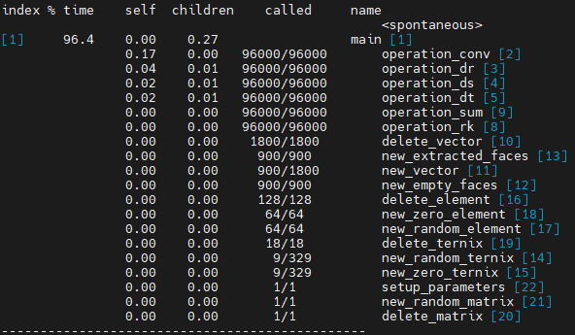
The case 1 profiling output shows that 96.4% of execution time comes from main, with a total runtime of 0.27 seconds in child calls. The dominant contributor in main is operation_conv, which accounts for 0.17s of the total 0.27s. The other operations contribute relatively small amounts of time. The non-operation functions (delete_vector through delete_matrix) have negligible impact on runtime. All this information indicates that in case 1, the workload is small, and performance is dominated by the convolution operation. Focusing optimization efforts on operation_conv would be the most beneficial.

- Case 2 gprof output and analysis:
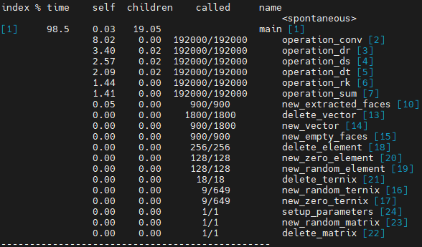
In case 2, the total execution time increases, and main still accounts for nearly all of the execution time (98.5%). For the most part, the same functions are the primary contributors. Two exceptions being operation_rk and operation_sum, which now account for ~1.4 seconds each. These functions were considered negligible in case 1. Overall, the results of this profile reinforce the information discussed in case 1. Optimization efforts should be focused on the operation_conv function, followed by the other operation functions. Non-operation functions had negligible impact on execution time.

- Case 2 gprof summary output:
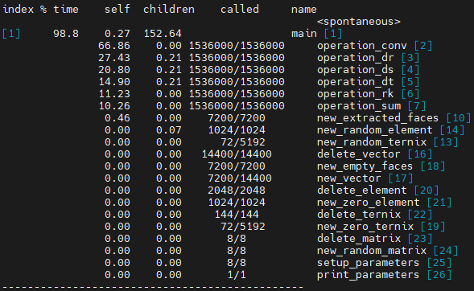

Part 2:

