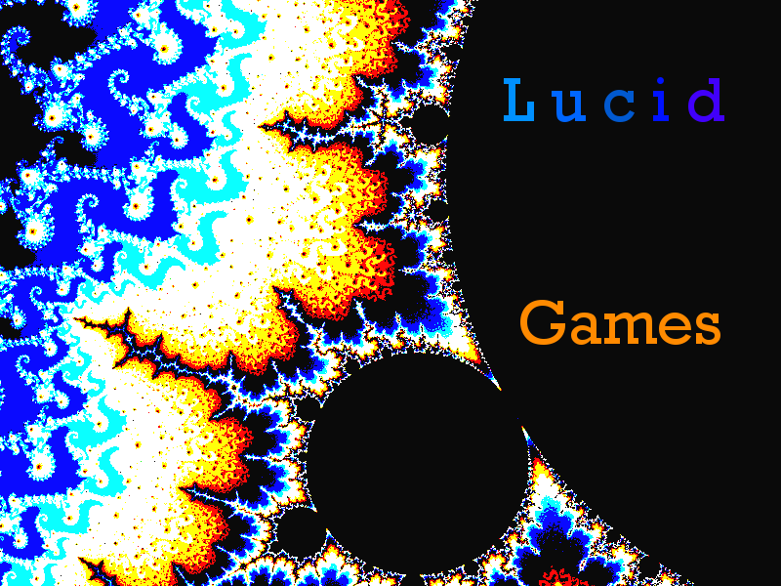

Design Document for:

Magic Balls

One Liner, i.e. The Ultimate Racing Game

“Something funny here!”™

All work Copyright ©2016 by Lucid Games

Written by Tristan Burgess

Version # 1.00

Design History

This section is to capture the history of this design doc to the Magic Balls game. Think of it like some kind of archaic, rudimentary VCS system that will show you the full history of diffs in the design of the game. As development progresses, potentially large changes in the overall design and scope of the game could occur. I will aim to capture these changes with explanations in this section of the document.

Version 1.0

Wow! You’re reading history in the making here, thank you! This is the first ever version of my design doc for Magic Balls. What a time to be alive!

Game Overview

Philosophy

Magic Balls is trying to bring back the 3D platformers that were so good, prevalent, and popular during the N64 days. While the biggest focus will be put on gameplay, rather than storytelling, the game will aim to touch on contemporary philosophical issues surrounding the future of AI and technology as a whole. The biggest leap I would hope to make with this game, however, is a complex yet fun and refreshing take on a 3D platformer. The targeting system with Magic Balls aims to feel like playing golf with explosive balls while running and getting shot at!

Common Questions

What is the game?

Magic Balls is an action-adventure/3D platformer set on a futuristic planet called Ro. You must master a complex yet well balanced and precise set of weapons and tools in order to beat otherwise indestructible foes. The on-the-fly precision required will give the game a kind of third-person-shooter feel, yet the weapons will also have various platform creating and environment manipulating elements that will allow the player to perform awesome trick shots that let them progress through the game.

Why create this game?

I’m creating this game because I miss the old 3D platformers that I grew up on, love ranged combat, and loved Angry Birds. A mechanic akin to a real time version of Angry Birds main mechanic, applied to platformer progression, seemed like such a fun idea that I just had to give it a shot.

Where does the game take place?

Magic Balls takes place mainly on planet Ro, one of three planets that were discovered as the first (and so far only) human-inhabitable planets after being forced to migrate from the Earth. Ro started out as a plain and desolate landscape, decorated with rich tritium deposits all throughout the surface and below. Humanity has since introduced artificial Earth-like wildlife to a section of the landscape called the Outside, resulting in a lush green surface decorated by large bright blue sections that denote the mines. The Inside is where the technocrats and their established government live, an extremely modern and futuristic city with advanced technological capabilities. The area is shaped like a giant circle, with the various sections covering a full circumference of a fraction of the radius of the circle.

What do I control?

You control Khan, the main protagonist of the game. Khans main abilities are to run, jump, target on the fly, target precisely, and lean to the left and right while doing precise targeting.

What is the main focus?

The main focus of the game is to break into the Inside from the Outside, and work your way through the innards of the Inside. The ultimate goal is to defeat the Government, who are corrupt and are oppressing your people for the sake of power and control.

What’s different?

Tell them what is different from the games that are attempting this in the market right now. This question comes up a lot.

Feature Set

General Features
- Modern 3D graphics and rendering brought by Unity.
- Story Mode and Custom Mode. Custom Mode lets you load maps from the game or custom maps from the internet to explore and experiment with the game mechanics.
- A robust map editor that enables endless variety in the creation of maps for Khan to explore.

Gameplay
- Master 5 different types of magic balls, each with their own unique abilities, advantages, and disadvantages.
- 2 different types of combat: OTFT (on the fly targeting), which uses a more traditional, manual aiming technique usable at any time, and Precision, which can only be used when not moving, and gives the player a large advantage in positioning and precision.
- 3D Platformer, they’re back, baby!

Editor
- Create new and exciting levels for Khan to explore and compete against friends.
- Randomize button gives you a randomly generated level that you can tweak to your liking.

The Game World

Overview

Ro is one of three in a closely-knit system of Earth-like planets. The world of Ro is beautiful yet cold with a large palette of blue shades dominating the atmosphere, surface, and mines. A hazy blue-green diffuse aurora covers much of the atmosphere. The Inside in contrast is almost entirely white and red, extremely shiny, and futuristic-looking.

It’s different on the Inside
The Outside on Ro still retains much of the qualities that made Earth what it was. Vast forests, wildlife, and rivers. The wildlife may be pretty radioactive, but eh, that’s fine, right? On complete contrast, the Inside is almost the exact opposite. There is virtually no wildlife on the Inside. The Inside is almost like a gigantic castle, but with white, red, and chrome interior, tiling, and AI robots patrolling and guarding the “streets”.

The Physical World

Key Locations

The Mines

The Barracks

Antechamber

Citizen Central

Praelucci

The Core

Travel

Travel on Ro for an Outsider will likely be entirely on foot. If I can find the time and get inspired to do at least a level with some kind of vehicles, I may change my mind.

Scale
As is default in the Unity engine, scale in the game world will be based on “meters”.

Time

Each level in the game will be re-playable and will have a score. Finishing the level in less time contributes to a higher score for you on the level!

Rendering System

Unity’s built in 3D rendering pipeline will be used. If details from the article linked below are needed, they will be added to this section:

http://docs.unity3d.com/Manual/Graphics.html
https://unity3d.com/learn/tutorials/modules/beginner/graphics/

Camera

The camera for Magic Balls will be fixed around a user set radius so that Khan can look around. Since this is a third person game, the minimum radius around the center of Khan’s head will be such that Khan is fully visible to the camera. The maximum radius will be a reasonable limit, such that the user cannot gain any significant tactical or strategical advantage in the game simply by zooming out the camera maximally.

Game Engine

The game engine to be used will be Unity 3D. The reason I have decided to go along with Unity is simply because that Unity has the workflow of game content creation that I have the most experience in, and feel the most comfortable with right now. Even better, using Unity will give me the opportunity to explore the possibility of making Magic Balls an Android/iOS game, and change my mind about it if the prototype yields a much better PC experience.

I don’t believe it necessary to go too much into detail in the features of Unity for the purposes of this design doc. However, I would like to touch on the features that will most likely be made of use in Magic Balls:

- Rigid body physics
- Rendering (see section above)
- GUI creation
- Asset management (see above)
- Camera systems
- Animation Systems (may use Blender a bit for this as well)
- Particle systems

The largest challenge for me, in all honesty, will be creating the art assets for the game. I am not an artist, in the sense that I do not hone or practice any drawing skills that I may have possessed if I did such practice. All of my talents and practice go in to software engineering and understanding the technical aspects of games. I may have to resort to programmer art for the demos, but finding a way to get the art I want for the game will be the largest development hurdle, I believe.

Images of Inspiration
General World Map
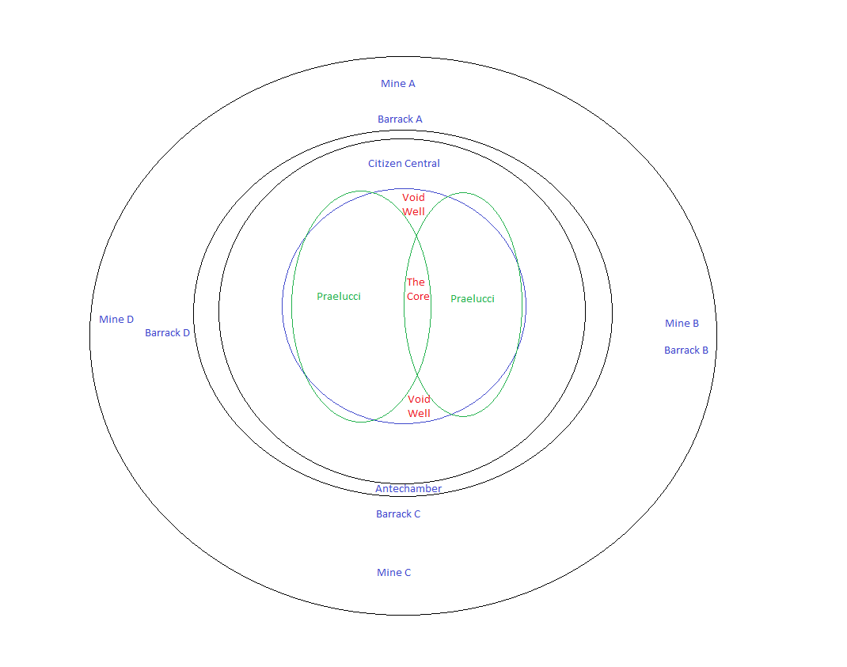
Inspiration for The Outside



Overall Aesthetic

Visual
The visual aesthetic of this game is twofold. On the Outside, the population is largely of those who were forced into manual labor for the benefit of the technocrats and the Government. This is partly reflected in the mainly blue palette that Ro takes on naturally. Their world is kind of depressing, even in its glowing beauty.
They would much rather be on the Inside, which is sleek, and has a white, chrome, and red color scheme, generally. Those living on the Inside have an insane amount of comfort and advance technology at their disposal, to make their lives easier in every way.
The art style will make no attempt at being realistic. I do not have any kind of team for that kind of venture. I hope to at least get a cartoon-like aesthetic that can be relatively simple to draw, yet still capture the emotions conveyed above.s

Audio
The musical aesthetic for this game may be a mix between industrial and IDM music. On the Outside, the world is very surreal despite the Earth-like parts. The radioactive wildlife are nothing like that of Earth and everything on that part of the planet should feel strange to the player, including the music (IDM). On the Inside, the technocrats and the government are very scary and robotic. They’re trying to dominate and take over the entire human race. On top of that, you need intense focus while you obliterate these guys (Industrial).

I am a huge fan of bitcrushing, and I believe that a focus on that aesthetic for the sound effects of this game will be most fitting.

Game Mechanics and Relationships

Player Experience Goals
- Gradually mastering a complex real time targeting system (Magic Balls) to destroy enemies
- Utilizing a combination of magic ball triggers and jumps to ascend platform mazes

Mechanics
- The main mechanics of the game arise from the use of magic balls.
- The launcher that the player uses will have a system for the use of english (the billiards term)
- Several magic balls will have a knockback effect that takes into account the distance from the enemy at which the magic ball was activated, up to a maximum knockback distance.
- After a magic ball is launched, the control ball is automatically loaded.
- After the control ball collides with a target, it is recalled near-instantaneously to the launcher for the next use

Dynamics
This mechanical system can quickly be brought to a dynamical hell, especially in 3D. To make sure the Player Experience Goals are met, the enemies must be fairly simple to defeat at first. An example dynamic that will teach the player more about the mechanics would be a simple encounter emphasizing the use of the Ice ball. The enemy stands still, guarding a walled platform, which is too tall for the player to reach on their own.
The player dodges basic shots coming from the enemy, while targeting and launching an Ice ball at the enemy. When the Ice ball is almost at the enemy, the player launches the target ball which then encapsulates the enemy in an ice brick and knocks the enemy back against the wall, thus allowing the player to jump up to the platform.

Balance
- Each magic ball has a number of strengths and weaknesses that will contribute to their overall balance in the game.
- Enemy players will similarly have strong abilities that will be balanced out by their ability to be affected by Khan’s magic balls.

