Tristen Goode

Documentation for Sprint 02

* Problem #1: /accounts/logout redirecting to admin logout page
  + Solution: In settings.py, put ‘django.contrib.admin’ after ‘garden_app’ so that the settings draw from garden_app first and Django.contrib.admin second, overriding the admin implementation of /logout.
  + Resource: <https://stackoverflow.com/questions/15467831/django-logout-redirects-me-to-administration-page>
* Problem #2: Successful login redirecting to /accounts/profile, which doesn’t have a view
  + Solution: change the LOGIN_REDIRECT_URL in settings to / so it takes you to the home screen
  + Resource: <https://forum.djangoproject.com/t/redirecting-user-to-page-after-login/14603>
* Resource used for testing: <https://developer.mozilla.org/en-US/docs/Learn/Server-side/Django/Testing>
  + setup creates an instance of the model to test
  + tests should cover methods and assertions of project
  + I.E. testing __str__ and get_absolute_url
  + 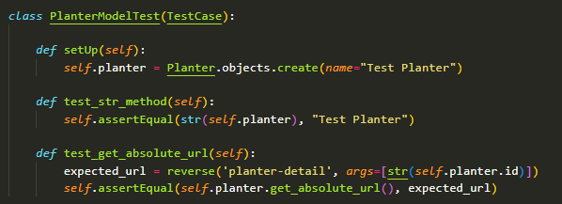
  + Calling py -3 manage.py test garden_app in cmd line makes a test database, runs your methods, and then destroys database. If tests could interfere with each other you can use a tearDown function to destroy that database within the tests
* Fail comes up like this:
  + - A computer screen shot of a blue screen

      Description automatically generated
  + Pass comes up like this:
    - A computer screen shot of a blue screen

      Description automatically generated
    - Note the OK instead of Traceback errors
* Selenium Webdriver Testing
  + Resources: <https://ordinarycoders.com/blog/article/testing-django-selenium>
  + First you must install Selenium
    - Inside VE – pip install selenium
      * Might have to use py -3 pip install selenium like I did to make sure it installs for the correct python version
    - Then install webdriver depending on browser of choice
    - Make the following imports
      * 
      * I also imported LiveServerTestCase from django.test so it would test it in the wild
  + My first test was to make sure it wouldn’t allow me to make edits without being an authorized user on the login page
    - A screen shot of a computer code

      Description automatically generated
    - Run test the same way as the unit testing
  + Error: ‘WebDruver’ object has no attribute ‘find_element_by_id’
    - I looked it up and couldn’t figure it out, so I went to ChatGPT which told me I was using the wrong syntax for this version of selenium, so I changed all the find_element_by_* to find_element(By.*, *) and imported by,
    - Example with second test testing login capabilities
      * A computer screen shot of a program code

        Description automatically generated
      * Import: 
  + Selenium tests worked as expected
* Drag ‘n’ Drop – Organizing some stuff
  + Implemented crud for planters (see previous documentation for more details)
  + Now needed some way to show the plants while in the planter list view
  + Tried:
    - A screen shot of a computer code

      Description automatically generated
    - As seen in the portfolio assignment
    - Didn’t work because it’s meant for one planter (self), so I needed to iterate through a list of planters and return them all
    - Tried a few variations before finally coming to
      * A screen shot of a computer program

        Description automatically generated
      * It goes through a planter given the query (each planter), gets the full number of plants inside, appends them to a list of plants, and then sends the context back as a list of the planter’s plants
    - Implemented in the HTML like so
      * A screen shot of a computer code

        Description automatically generated
      * It creates a u.l. inside a planter section and checks if there’s plants inside. If not, returns the no plants message. If there are, shows each plant as an item on the list, along with care instructions.
      * A screenshot of a computer

        Description automatically generated
* Drag ‘n’ Drop – Functionality
  + Resources:
    - <https://www.youtube.com/watch?v=5Fuwo4tVXmE>
    - <https://dev.to/nemecek_f/django-how-to-let-user-re-order-sort-table-of-content-with-drag-and-drop-3nlp>
    - <https://mdbootstrap.com/docs/standard/plugins/drag-and-drop/>
    - <https://stackoverflow.com/questions/74056879/using-htmx-javascript-in-django-template-not-defined>