Antiwork Visual Analysis Appendix
Exploratory topic-modeling figures for collaborator review
This appendix gathers the available aggregate graphics used to assess the corpus, document the reviewed theme map, describe longitudinal patterns, and evaluate topic-model stability. It is intended to accompany the analysis brief and manuscript, not replace their methods and limitations.
Scope note. The primary corpus contains 97,254 management-term r/antiwork posts from March 2021 through February 2025. Topic prevalence figures use all filtered posts as the denominator unless their captions state otherwise. The reviewed candidate-theme codebook contains 27 clusters and covers 18,506 posts (19.0% of the filtered corpus).
The appendix also includes the completed fixed RoBERTa whole-post polarity check. These estimates provide descriptive evidence about the problem-oriented sampling frame; they are not human-validated, management-targeted, or causal measures. Per-post labels and the four-post smoke-test graphic remain local.

Figure 1 From collection to estimates
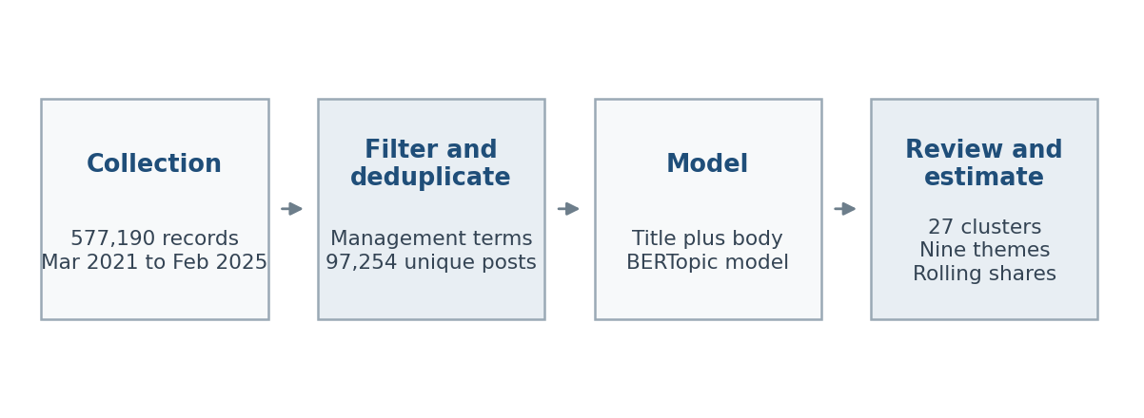
Collection, filtering, topic discovery, review, and descriptive estimation. The appendix uses aggregate evidence only; raw post text remains local.

Figure 2 Topic assignment coverage
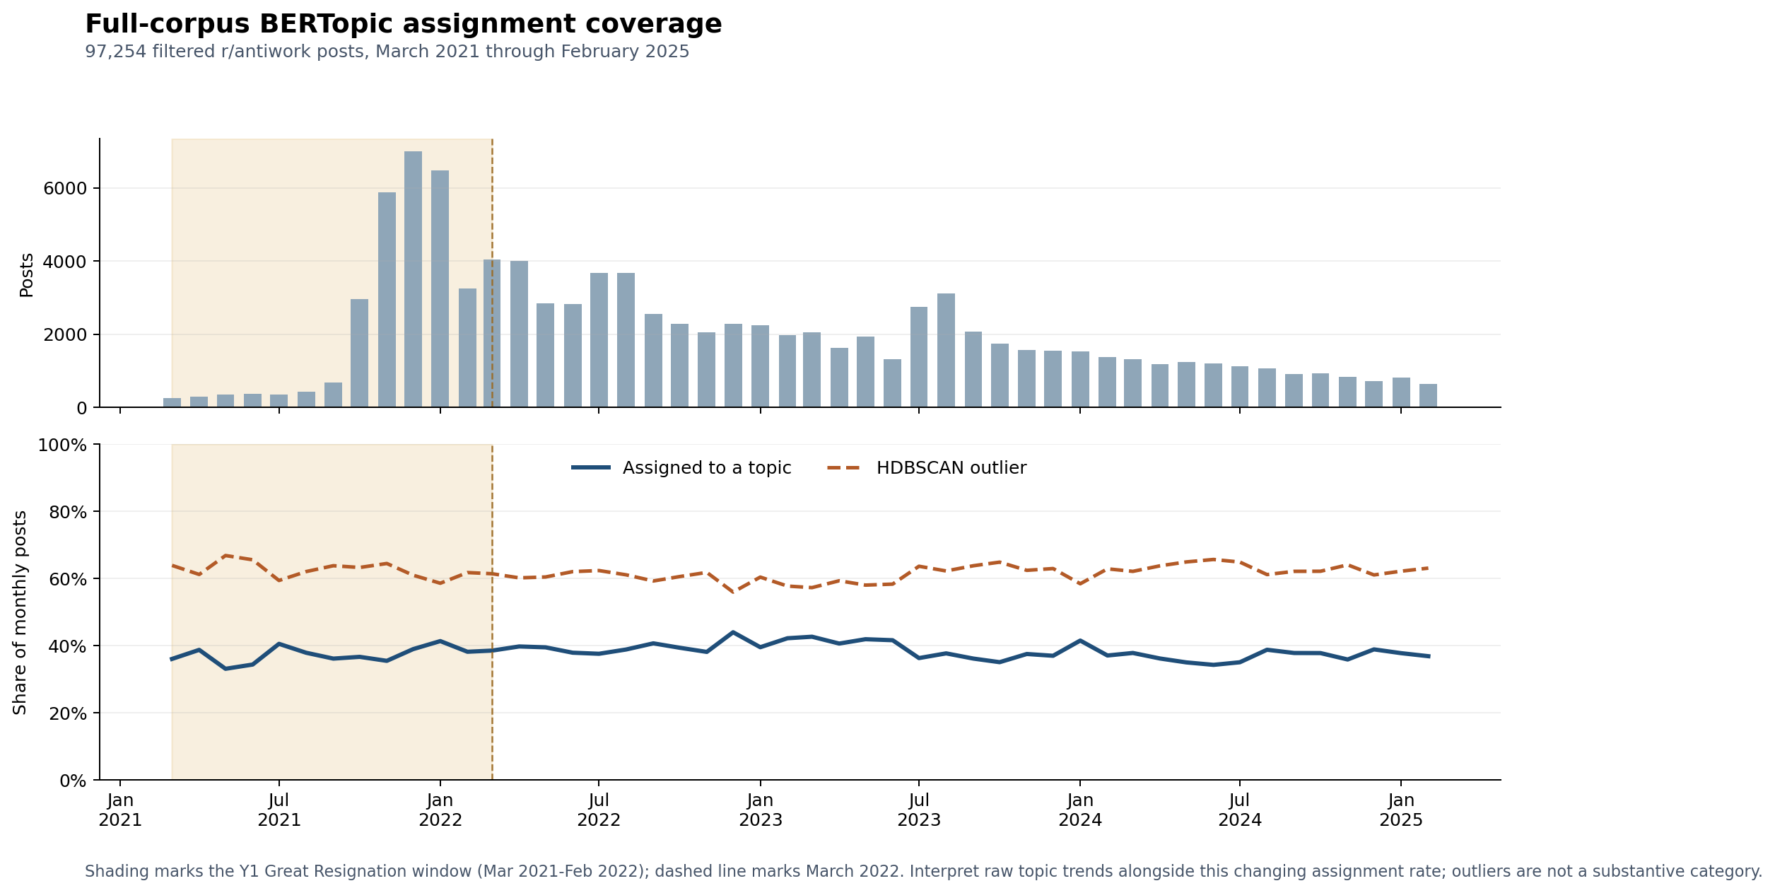
The share of filtered posts assigned to a non-outlier BERTopic cluster by month. Unassigned posts are a coverage limitation rather than a substantive category.

Figure 3 Main theme trends
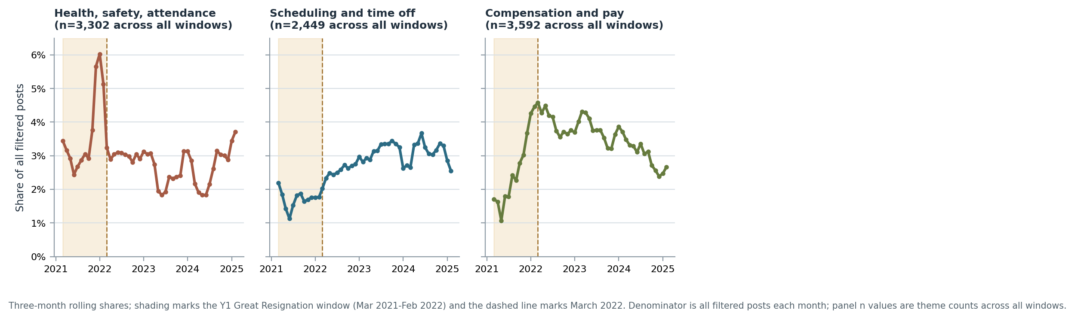
Three-month rolling prevalence for the themes central to the descriptive interpretation. Each series is divided by all filtered posts in that month.

Figure 4 Ten largest reviewed subthemes by month
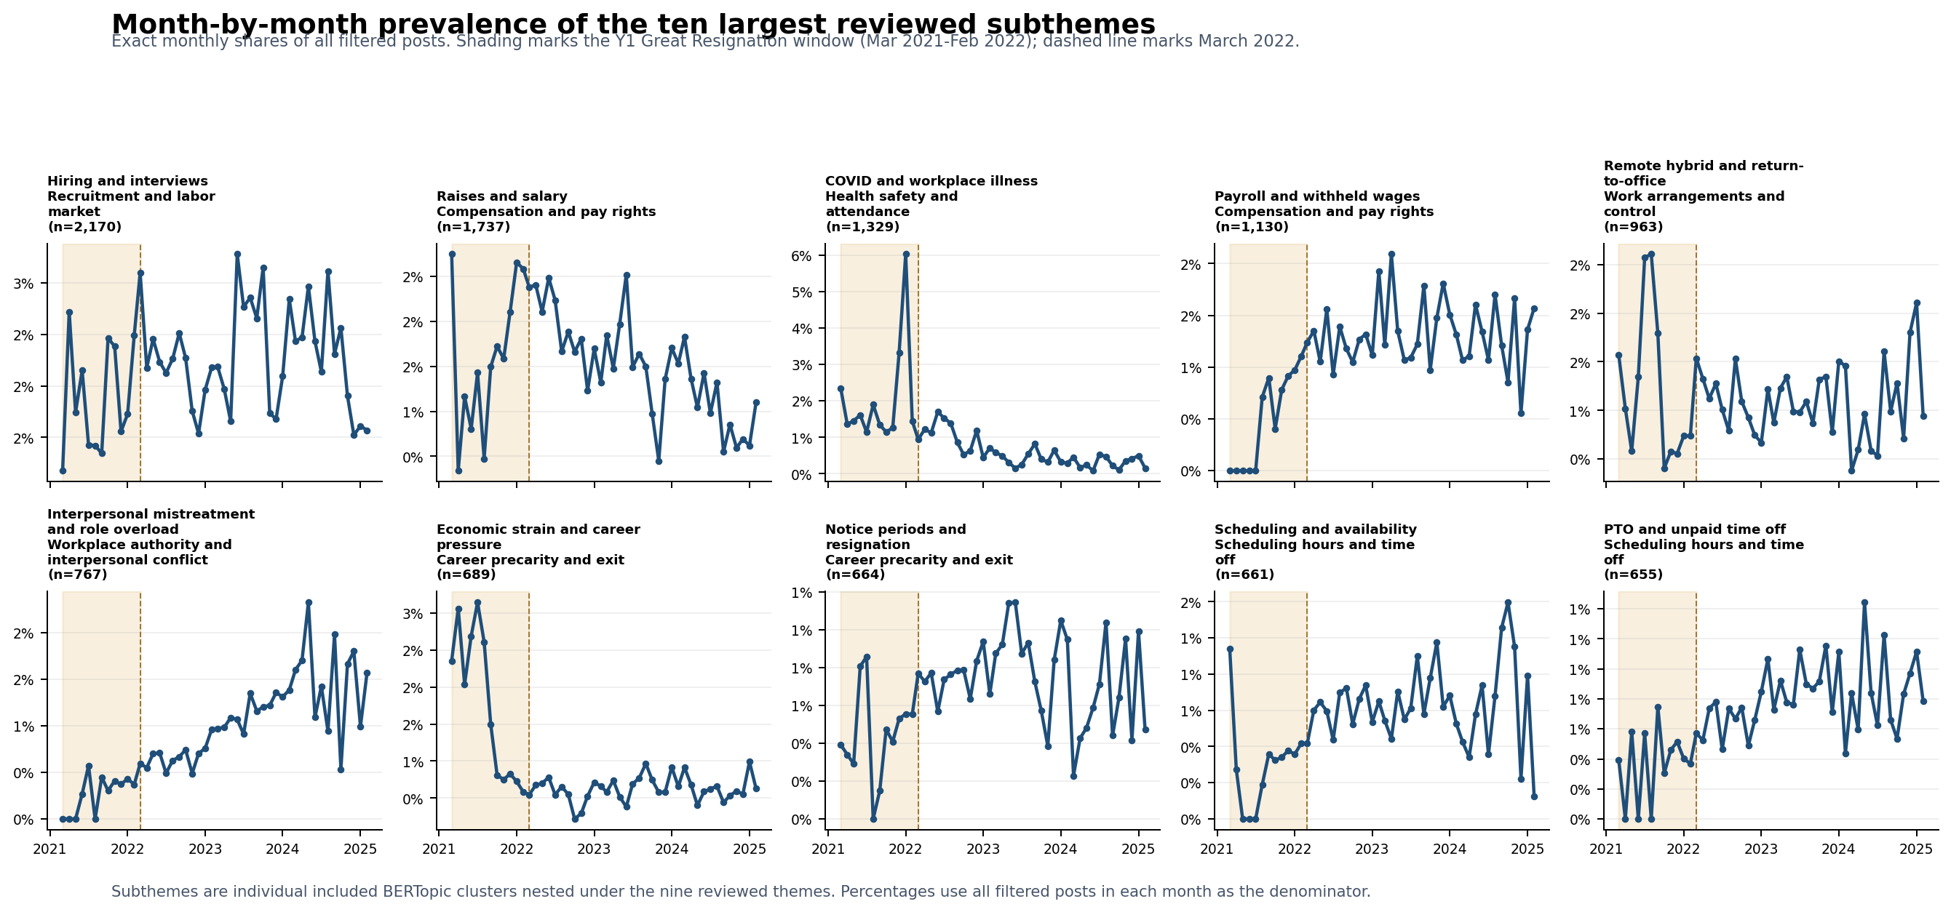
Exact month-by-month prevalence for the ten largest included BERTopic clusters, which are subthemes nested within the nine reviewed themes. Panel n values are full-period cluster sizes.

Figure 5 All reviewed theme trends
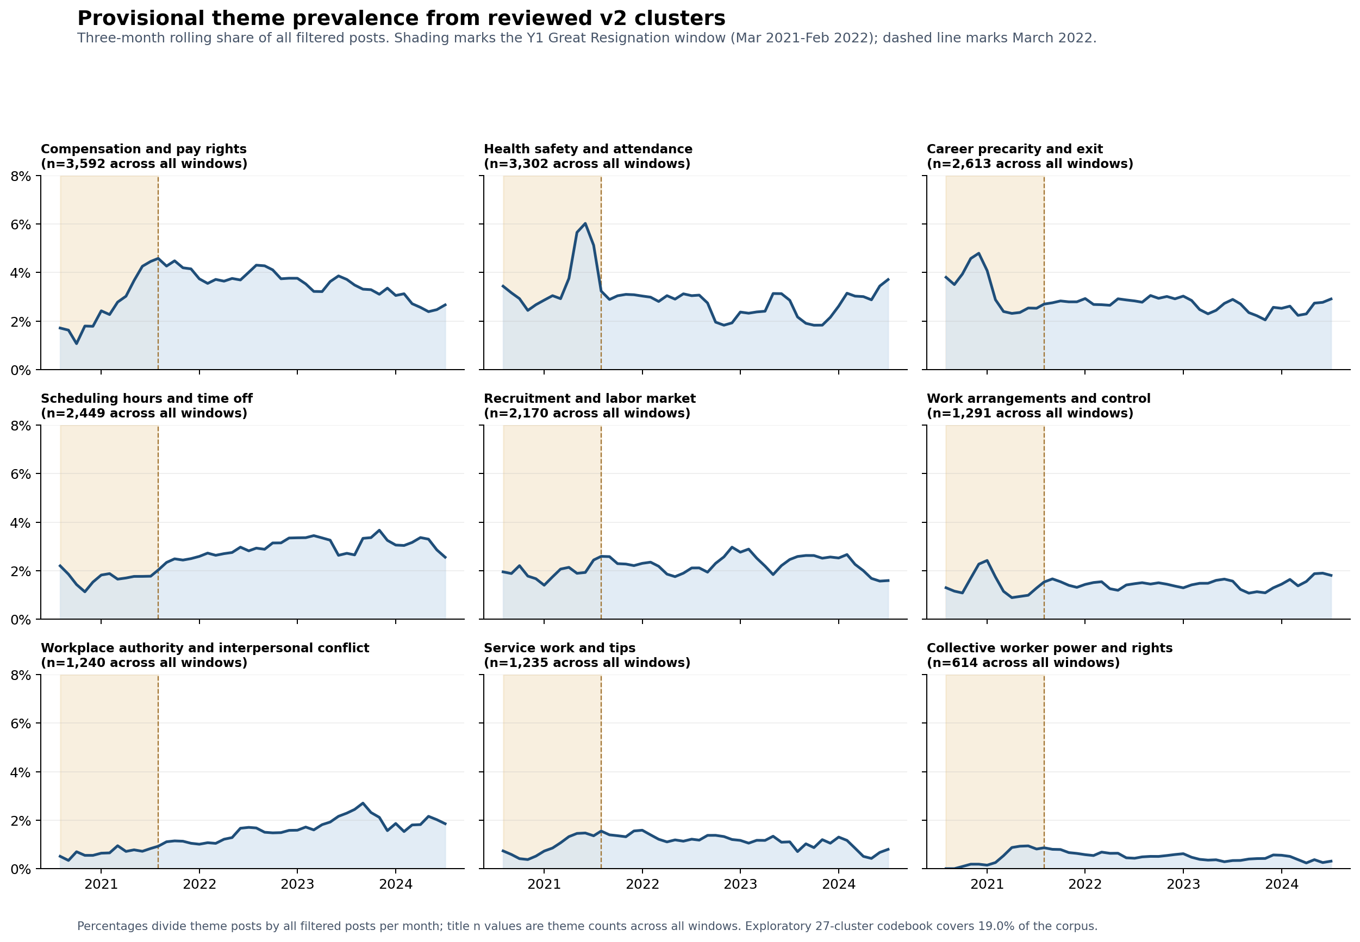
Monthly prevalence for all included candidate themes. The codebook covers 18,506 posts, or 19.0% of the filtered corpus.

Figure 6 Theme prevalence by rolling window
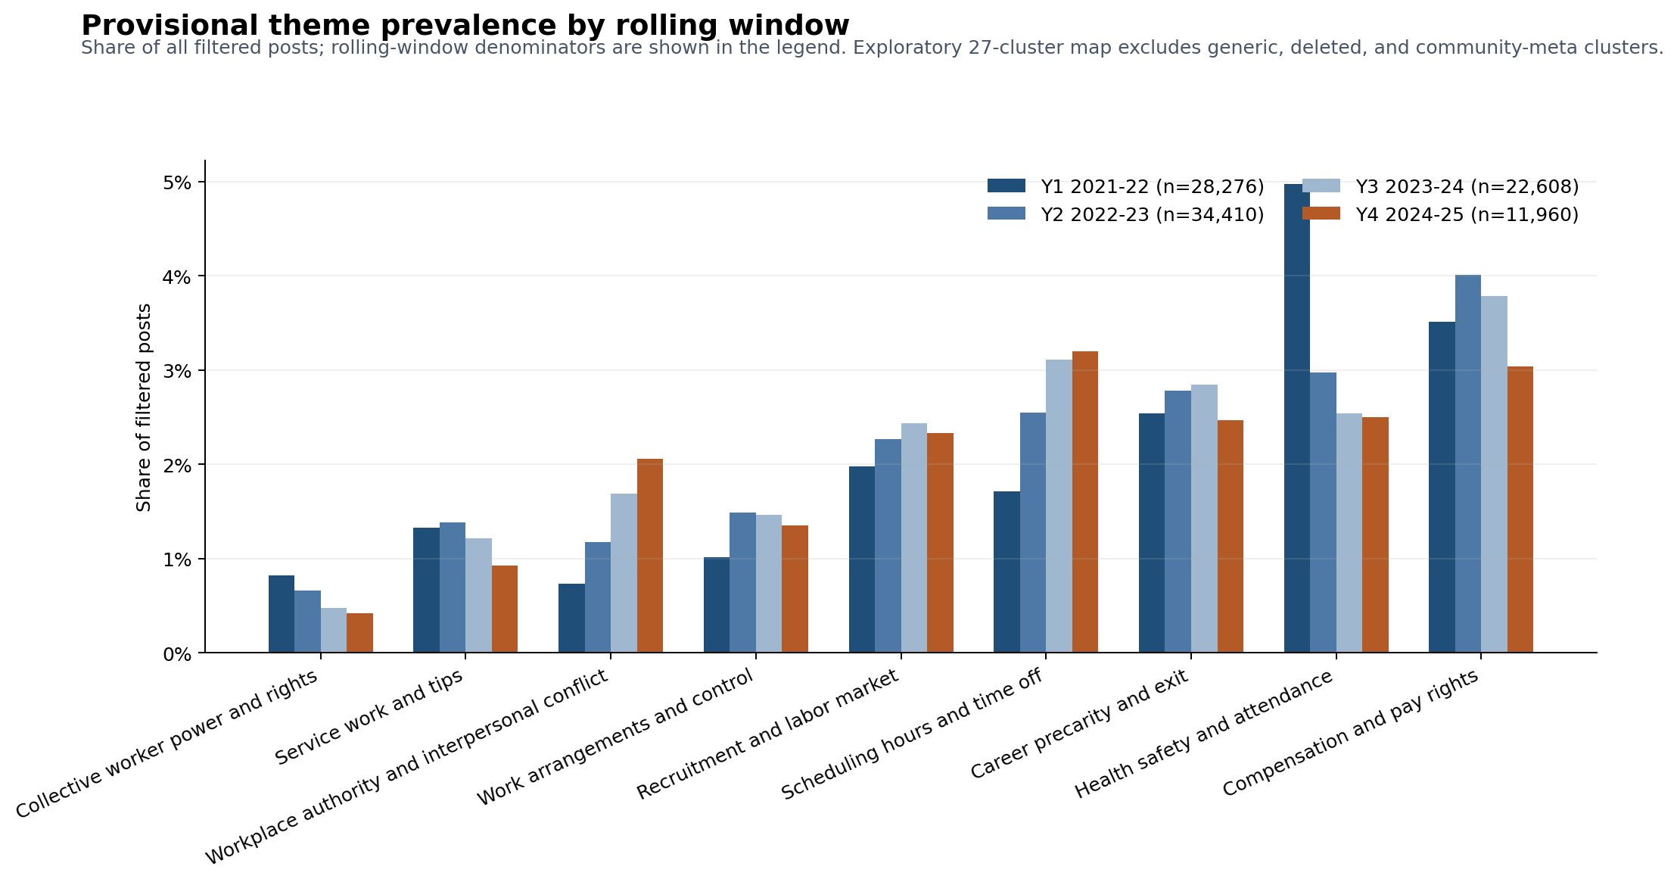
Exploratory theme prevalence across the four March-to-February rolling windows. These are shares of all filtered posts, not the full content taxonomy.

Figure 7 Y1 and Y4 theme comparison
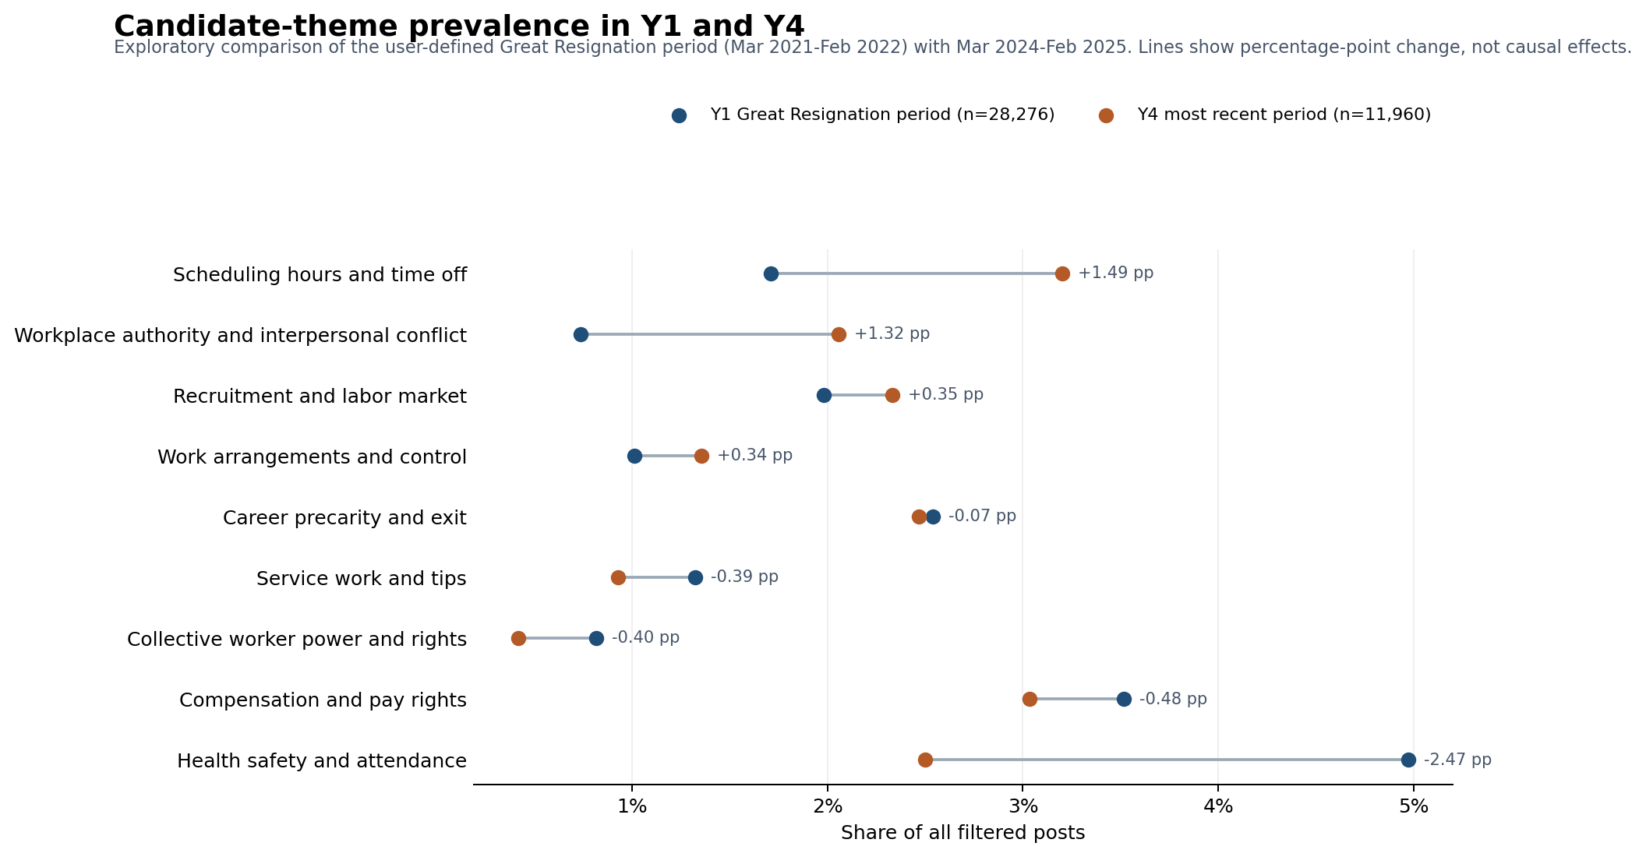
Exploratory Y1-to-Y4 comparison of candidate-theme prevalence. Y1 is labeled as the Great Resignation period (March 2021-February 2022); connecting lines show descriptive percentage-point change, not causal effects.

Figure 8 Anchor topic prevalence
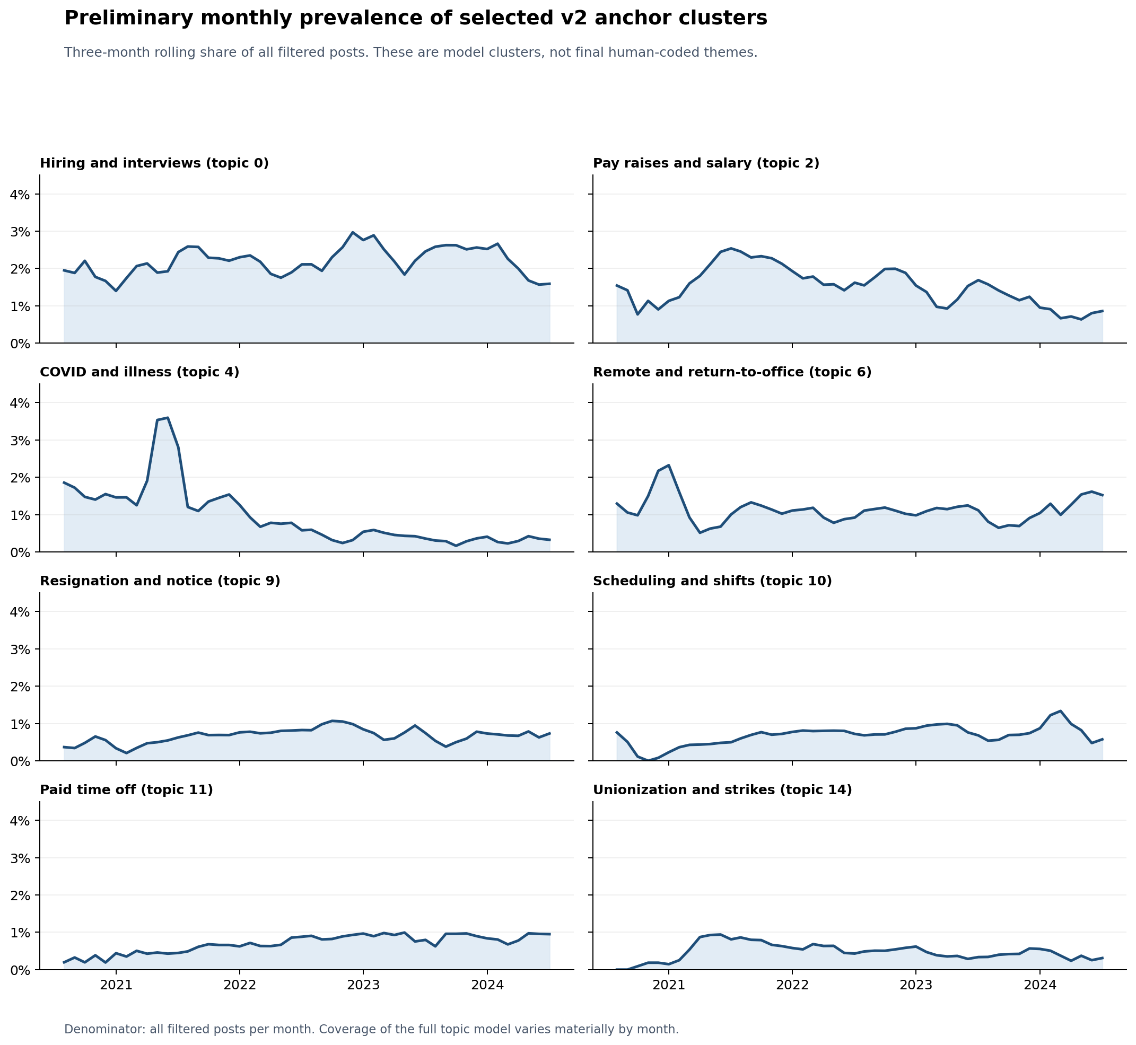
Monthly prevalence of selected anchor topics from the full-corpus model. This provides topic-level context alongside the reviewed-theme map.

Figure 9 Largest topic prevalence
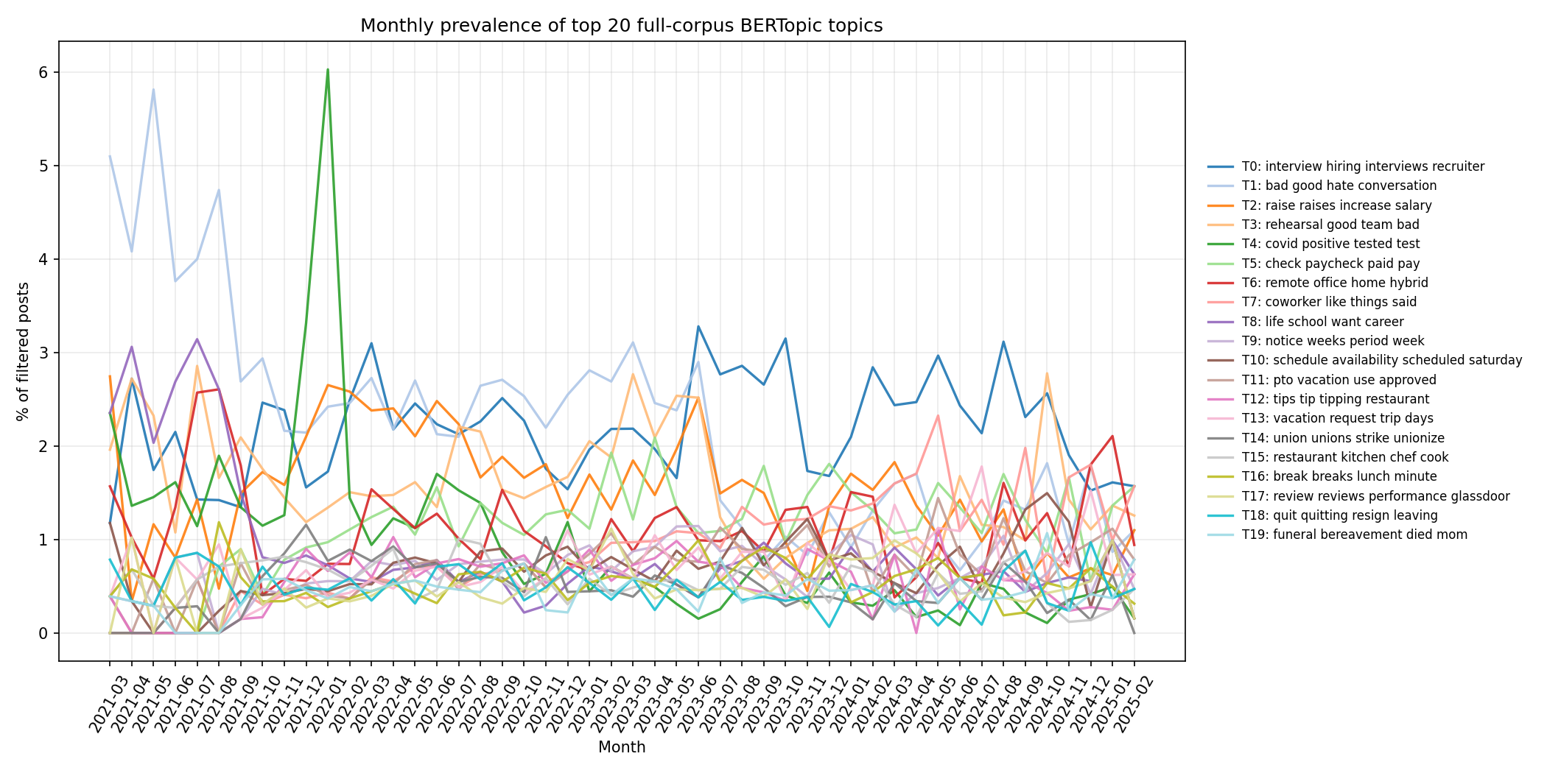
Monthly prevalence across the 20 most prevalent full-corpus model topics. This is exploratory descriptive context, not a codebook of final themes.

Figure 10 Theme and subtheme hierarchy
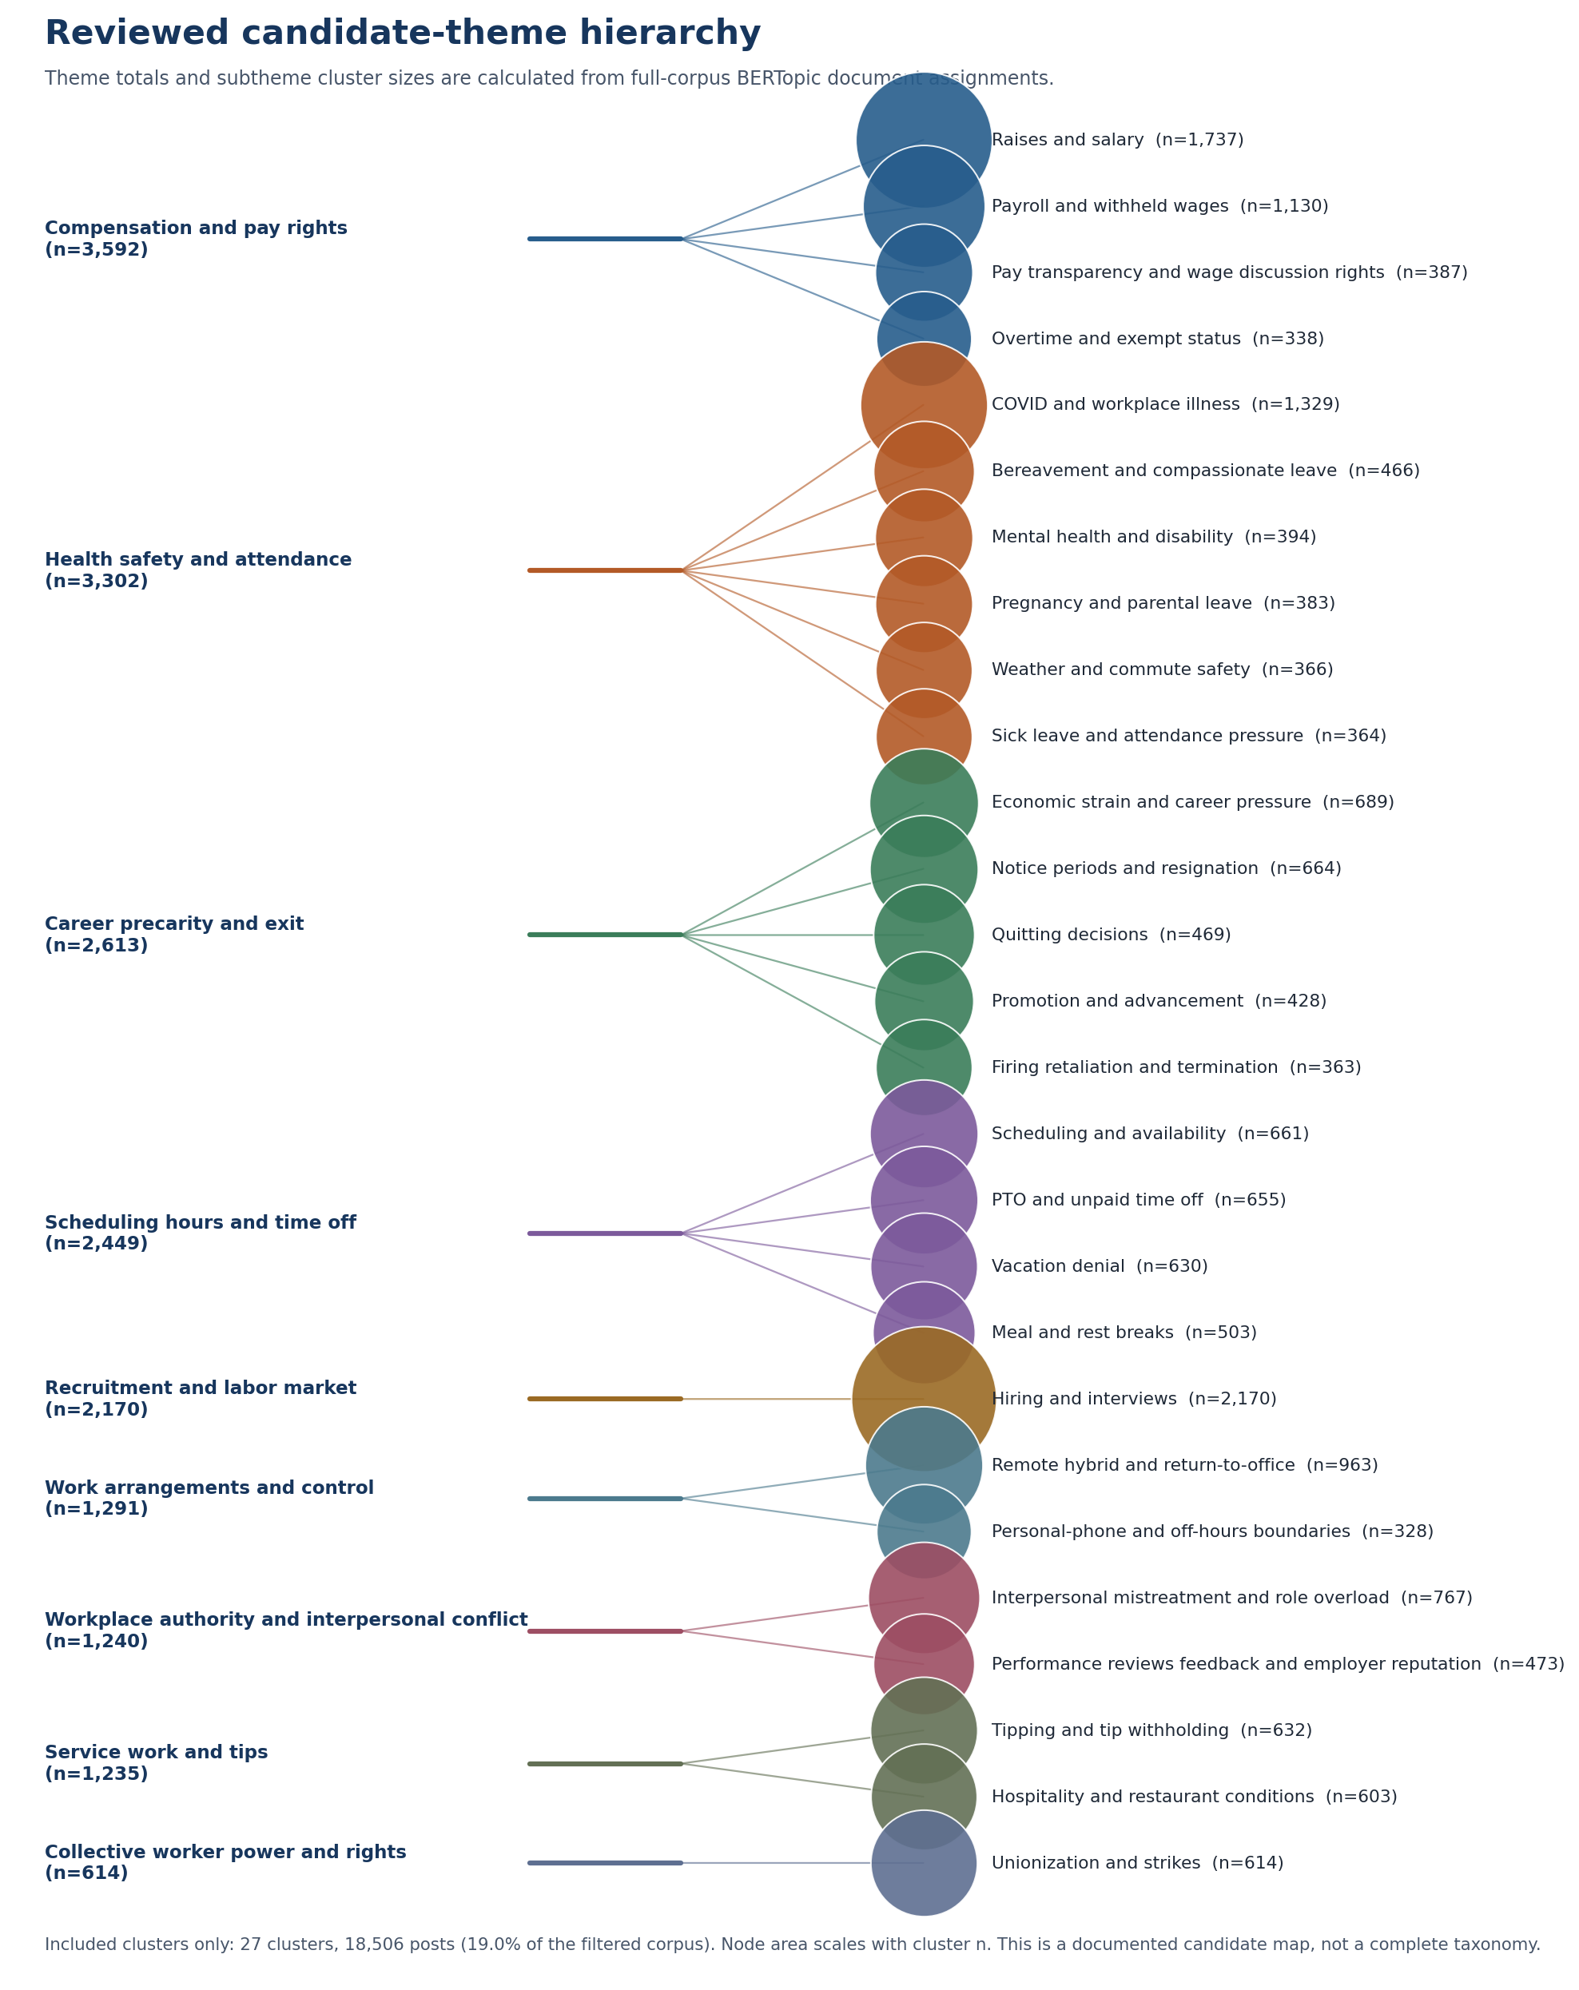
The nine reviewed candidate themes, their included subthemes, and full-corpus cluster sizes. Node area scales with cluster n.

Figure 11 Whole-corpus polarity by rolling window
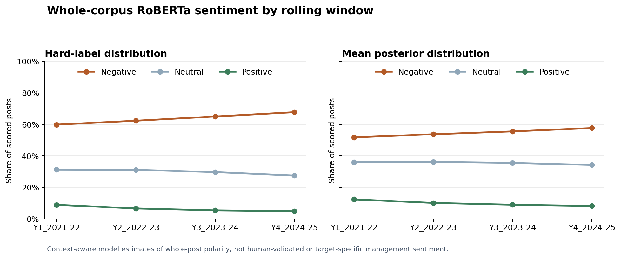
Context-aware whole-post RoBERTa polarity estimates for all 97,254 retained posts. They are model-based, not human-validated or management-targeted sentiment labels.

Figure 12 Polarity within reviewed themes
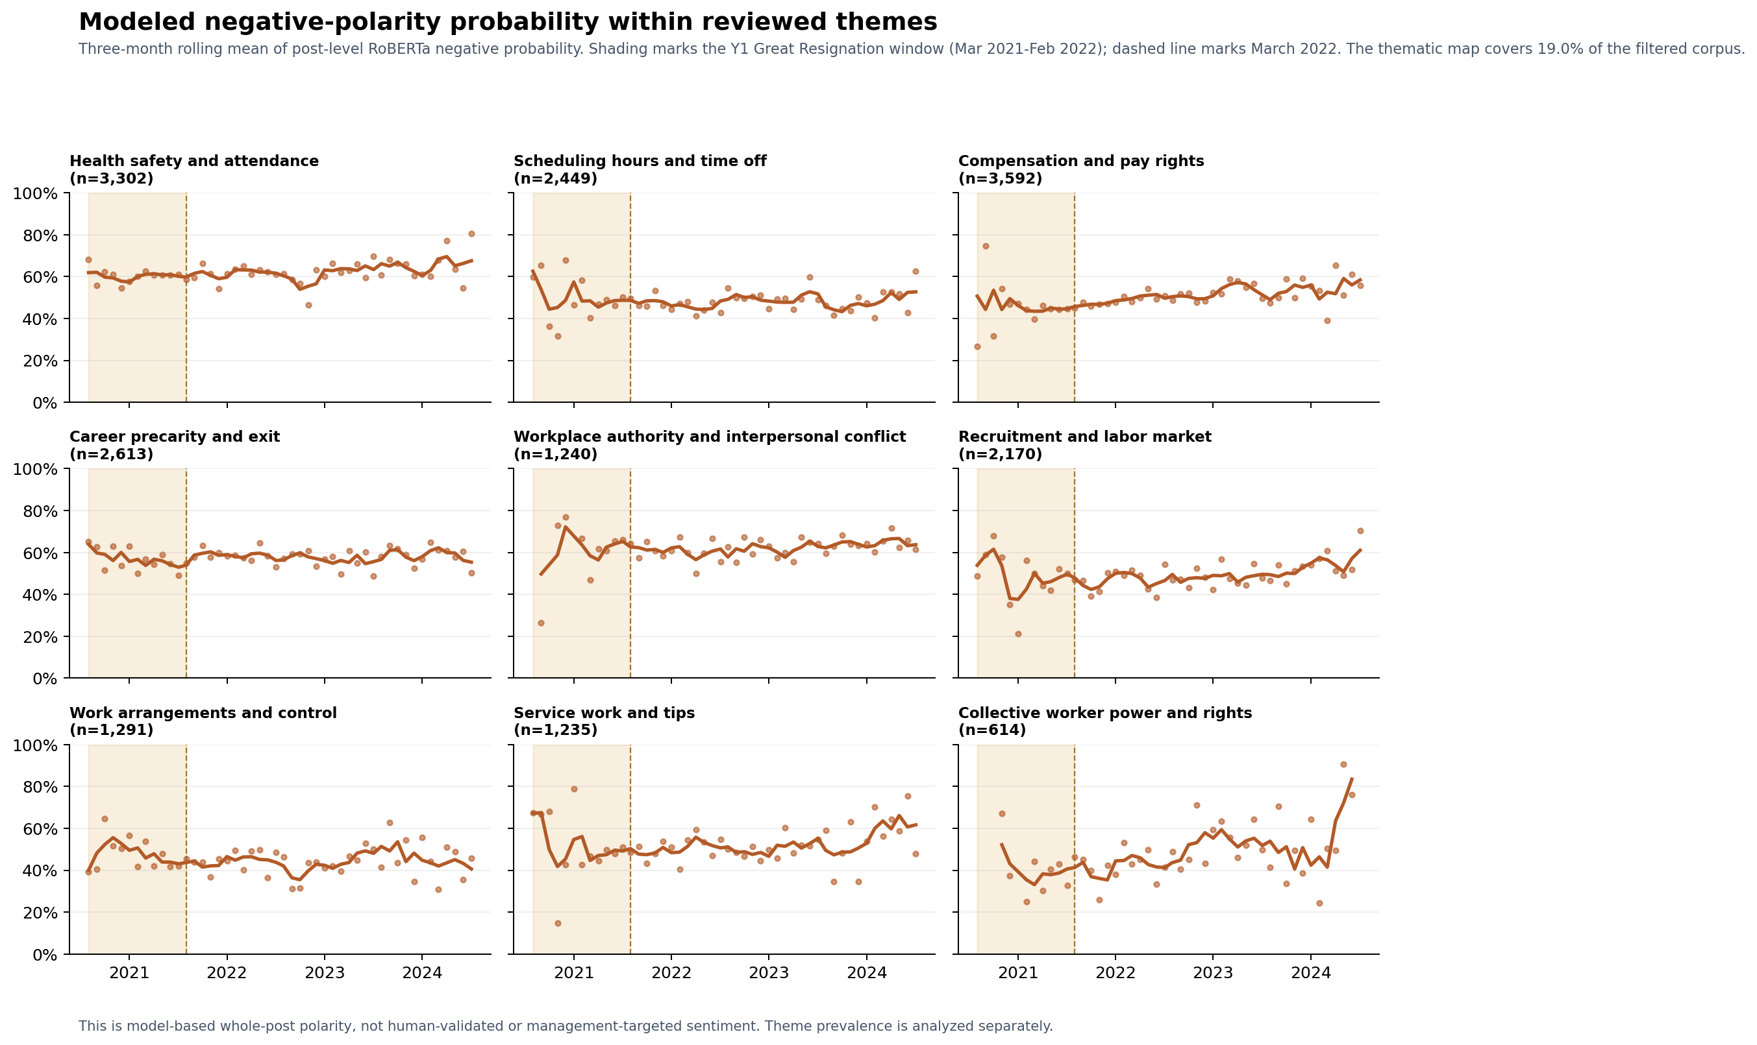
Three-month rolling mean of model-estimated negative whole-post polarity within each reviewed theme. It is conditional on theme assignment and distinct from theme prevalence.

Figure 13 Window alignment Y1 to Y2
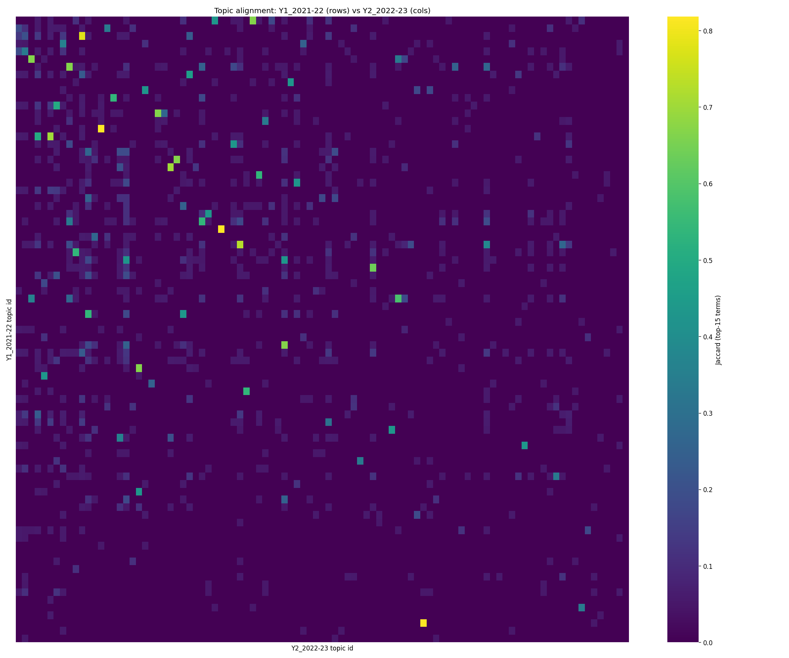
Conservative top-term alignment between adjacent rolling-window topic fits. It is supporting context for stability, not evidence of a persistent construct.

Figure 14 Window alignment Y2 to Y3
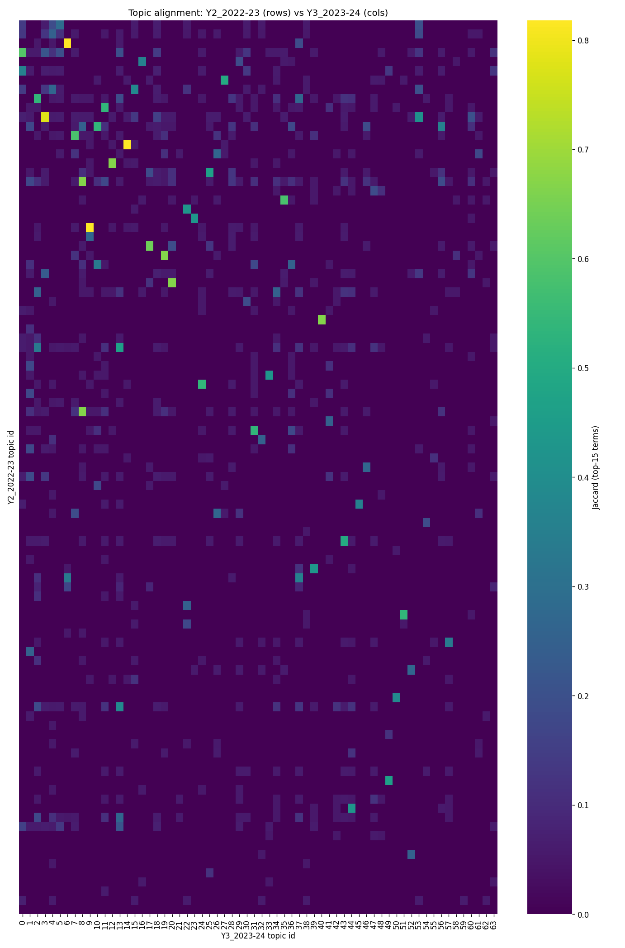
Conservative top-term alignment between adjacent rolling-window topic fits. It is supporting context for stability, not evidence of a persistent construct.

Figure 15 Window alignment Y3 to Y4
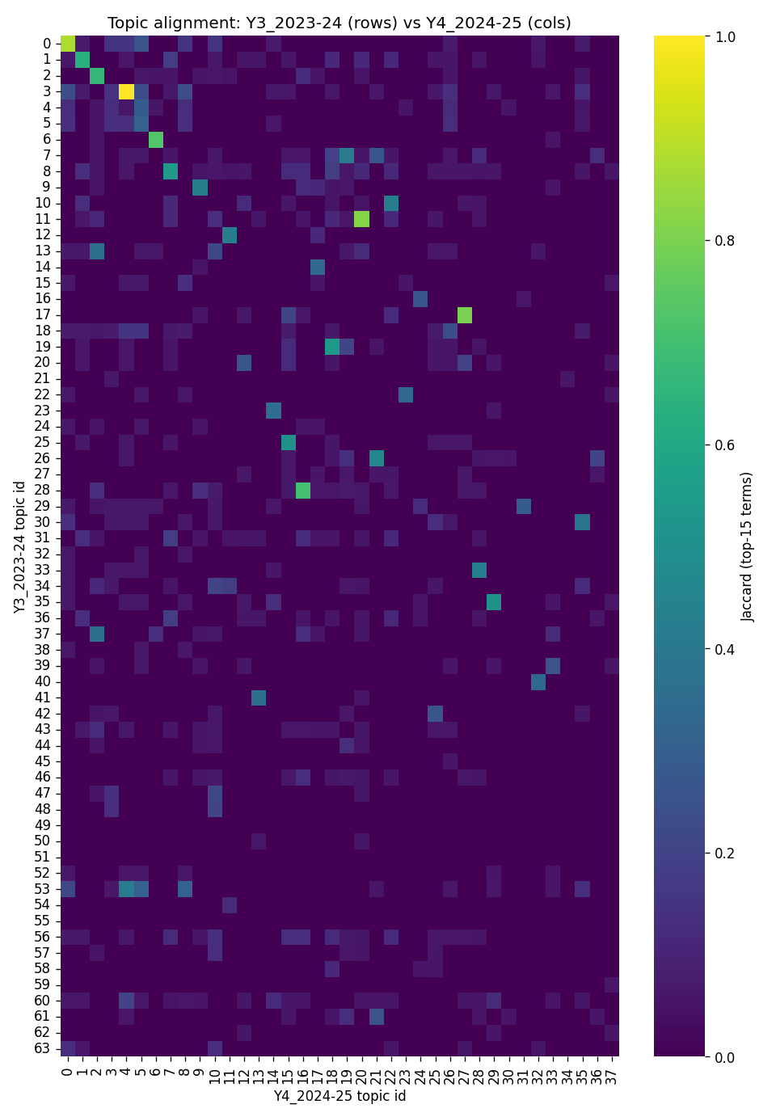
Conservative top-term alignment between adjacent rolling-window topic fits. It is supporting context for stability, not evidence of a persistent construct.

Figure 16 Window alignment Y1 to Y4
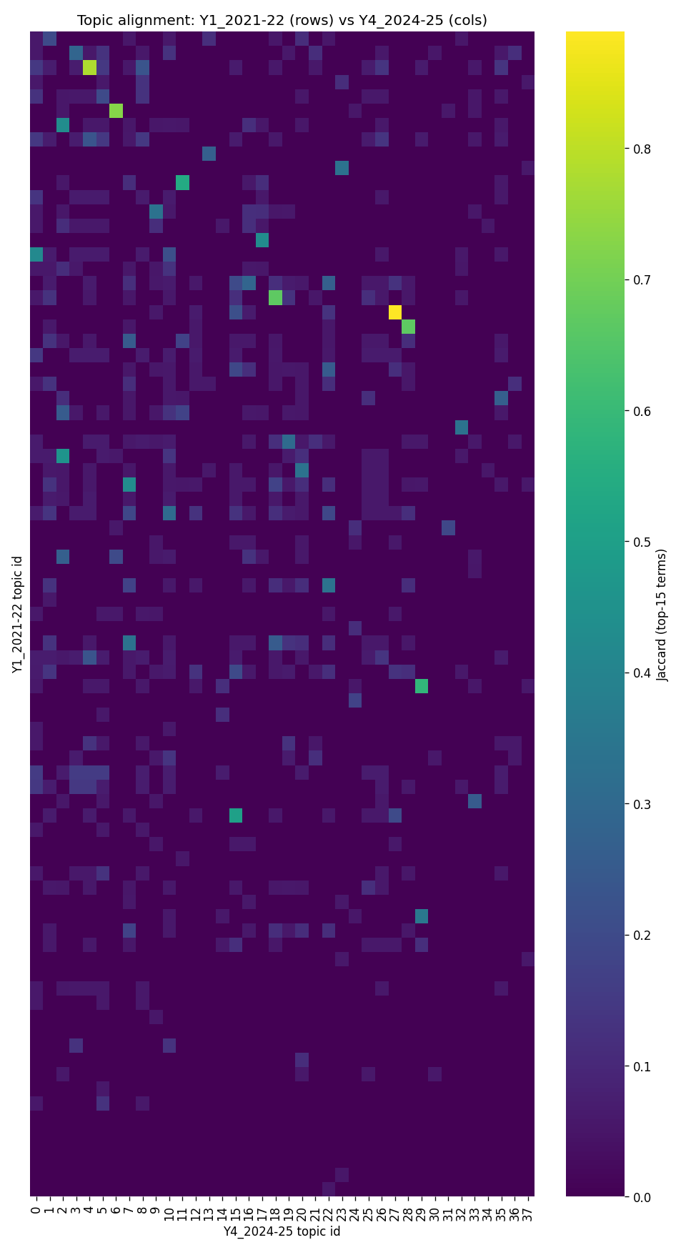
A long-range alignment comparison between the first and fourth rolling-window fits. Use this as a robustness diagnostic, not a claim of stable themes across all years.

