ANALYSIS BRIEF
Antiwork Topic Modeling
Exploratory longitudinal findings and writing handoff
97,254  filtered posts | 199  non-outlier clusters | 38.6%  topic assignment | 19.0%  theme-map coverage

Bottom line
Across 97,254 management-related r/antiwork posts from March 2021 through February 2025, the updated BERTopic analysis identifies a descriptive shift away from COVID-centered health and safety discussion and toward scheduling and time-off discussion. Compensation, career precarity, and recruitment remain present across the four rolling windows.
What I completed  Rebuilt the analysis with a modern BERTopic pipeline; exported document-level assignments and four rolling-window fits; finalized a 27-cluster, nine-theme codebook; and generated trends, figures, and a reproducibility record. | What the paper should claim  Descriptive prevalence patterns within the documented theme map. The paper should not claim causal effects, full-conversation prevalence, or sentiment change.

Headline patterns
Theme | Y1 | Y4 | Descriptive readout
Health safety and attendance | 4.97% | 2.50% | Down 2.47 pp; early COVID/illness concentration contracts.
Scheduling hours and time off | 1.71% | 3.20% | Up 1.49 pp; largest mapped theme in Y4.
Compensation and pay rights | 3.52% | 3.04% | Remains substantial in every window after a Y2 high.
Career precarity and exit | 2.54% | 2.47% | Broadly stable across four rolling windows.
All percentages use every filtered post in each rolling window as the denominator. They describe the mapped subset, not all potentially relevant content in the corpus.
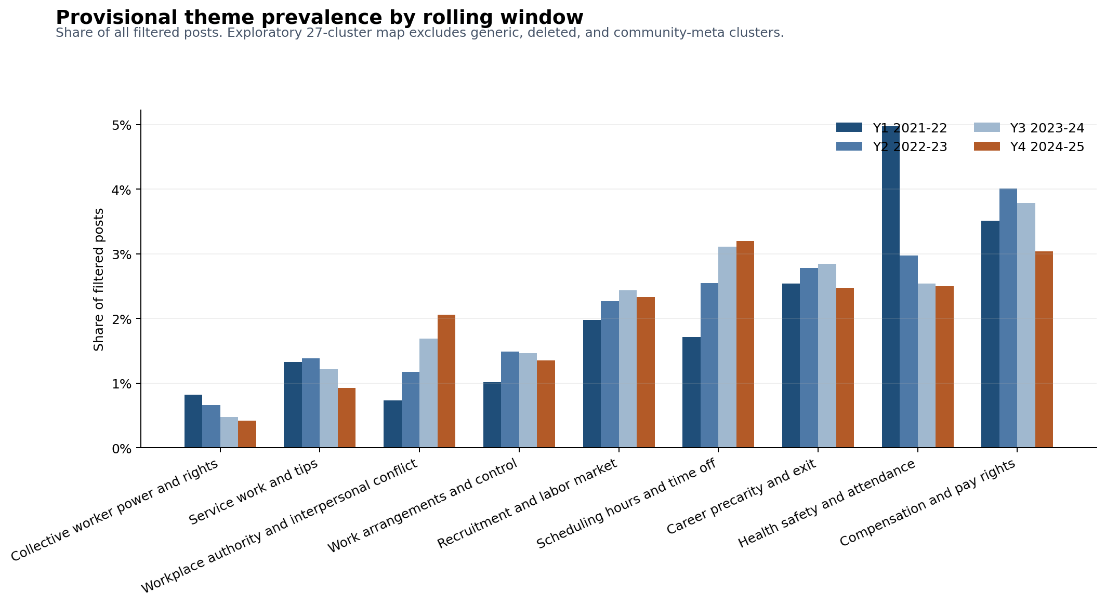
Figure 1. Exploratory prevalence by rolling window. The 27-cluster map excludes generic, deleted, and community-meta clusters.

Method and evidence boundary
Primary method  Sentence-transformer embeddings (all-MiniLM-L6-v2), UMAP, HDBSCAN, BERTopic topic representations, and a full-corpus model used for longitudinal prevalence. Per-window fits are supporting stability diagnostics. | Interpretation boundary  The model assigns 38.6% of posts to non-outlier clusters. The final theme map covers 18,506 posts: 19.0% of all filtered posts and 49.3% of assigned posts.

Coverage is visible, not hidden
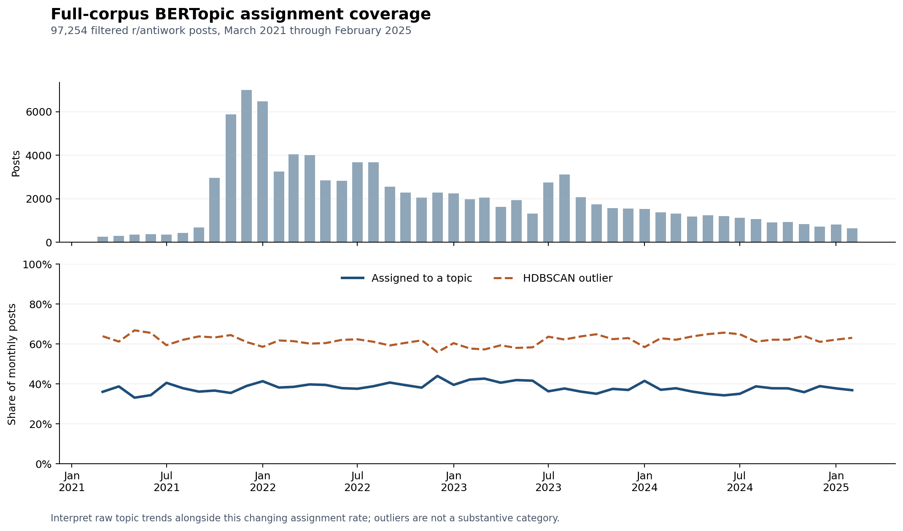
Figure 2. Assignment coverage varied from 33.1% to 44.0% by month. Outliers are a coverage limitation, not a substantive category.

Robustness checks completed
Check | Result
Corpus audit | Inputs contain 97,254 matching unique post IDs; the management-term filter re-matches 100% of retained posts.
Seed stability | Across three UMAP seeds on the same 10,000-post stratified sample, joint-inlier ARI was 0.900 to 0.966.
Window alignment | Conservative one-to-one term matching is supporting context, not proof of substantive persistence.
Text sensitivity | Titles-only clustering was stable but materially different from title-plus-body; title-plus-body remains the primary representation.
A larger all-mpnet-base-v2 encoder check was attempted but did not complete within the available CPU bound, so it is deferred and not treated as evidence.

What is left
Ready now  Results, figures, a theme codebook, coverage diagnostics, seed stability, text-mode sensitivity, and a bounded writing frame. The collaborator meeting can focus on interpretation and drafting. | Defer unless claims broaden  Sentiment annotation, a larger codebook, saved-model refit, TopicGPT comparison, and the MPNet check are useful extensions, not blockers for this exploratory paper.

Writing handoff
Draft in this order: method and sampling frame; coverage and descriptive results; limitations; then an exploratory discussion. Use the documented theme map and avoid causal, full-conversation, or sentiment claims.
Reproducible code and shareable evidence: https://github.com/v-tristow_microsoft/antiwork-topic-modeling
Core references: planning/WRITING_HANDOFF.md, planning/ROBUSTNESS.md, and planning/CANDIDATE_THEME_CODEBOOK.csv.
Meeting frame: the updated exploratory analysis is complete and ready to become a bounded, reproducible topic-prevalence paper, without sentiment or causal claims.

