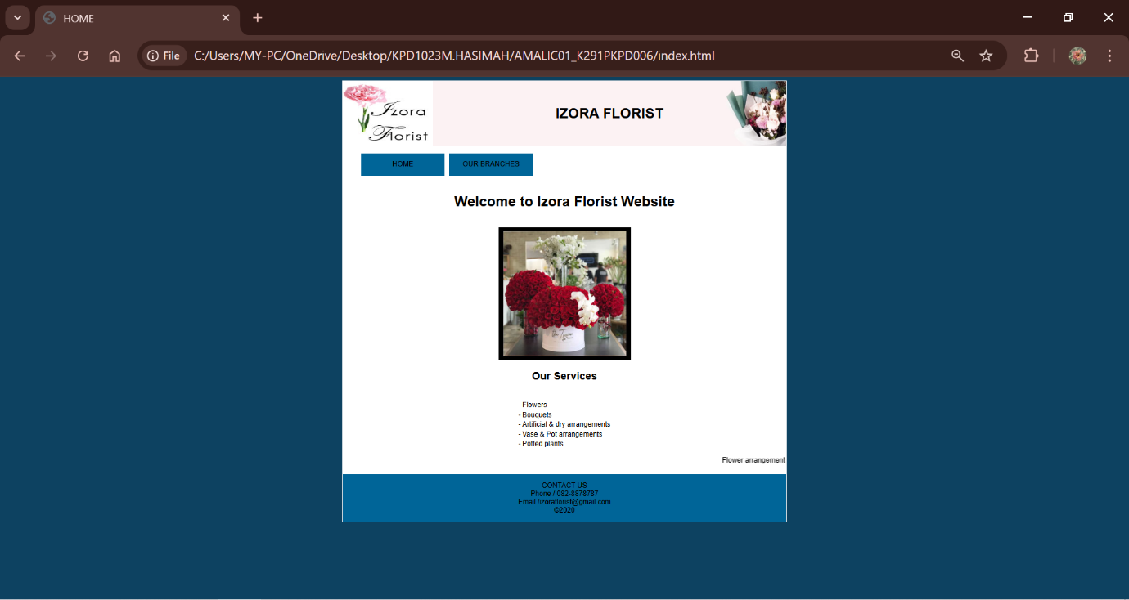

<!DOCTYPE html>
<html>
<head>
<meta charset="utf-8">
<meta name="viewport" content="width=device-width, initial-scale=1">
<title>HOME</title>
<style type="text/css">
body{
background-color: #0d4261;
font-family: arial;
font-color:black;
}

ul{
list-style-type: none;
}
#navbar
{
float: left;

}
#navbar>li
{
width: 190px;
float: left;
text-align: center;
margin-right:10px;
}
li a
{
background-color:#006598;
display: block;
text-decoration: none;
color: black;
line-height: 50px;
}

li>a:hover {background:#006598;
}

</style>
</head>
<body>
<table align="center" bgcolor="white">
<tr>
<td>
<img src="logo.jpg"width="200px" height="140px">
</td>
<td style="width: 800px; background-image: url(banner.jpg);">
<center><h1>IZORA FLORIST</h1></center>
</td>
</tr>
<tr>
<td colspan="2">
<ul id="navbar">

<li><a href="index.html"> HOME
</a></li>
<li><a href="branches.html"> OUR BRANCHES
</a></li>

</ul>
</td>

</tr>
<tr>
<td colspan="2">
<center>
<h1>Welcome to Izora Florist Website</h1>
<br>
<img src="flower1.jpg"
width="300px" height="300px">
<br>
<h2>Our Services</h2>
<br>
<center>
<table border="0">
<tr>
<td>-</td>
<td>Flowers</td>
</tr>
<tr>
<td>-</td>
<td>Bouquets</td>
</tr>
<tr>
<td>-</td>
<td>Artificial & dry arrangements</td>
</tr>
<tr>
<td>-</td>
<td>Vase & Pot arrangements</td>
</tr>
<tr>
<td>-</td>
<td>Potted plants</td>
</tr>
</table>
</center>
</center>
<p><marquee>Flower arrangements for occasions, event, celebrations, home, offices, hotels</marquee></p>

</td>
</tr>
<tr bgcolor="#006598">
<td colspan="2" align="center">
<p>
CONTACT US
<br>
Phone / 082-8878787
<br>
Email /izoraflorist@gmail.com
<br>
&copy2020
</p>
</td>
</tr>

</table>

</body>
</html>

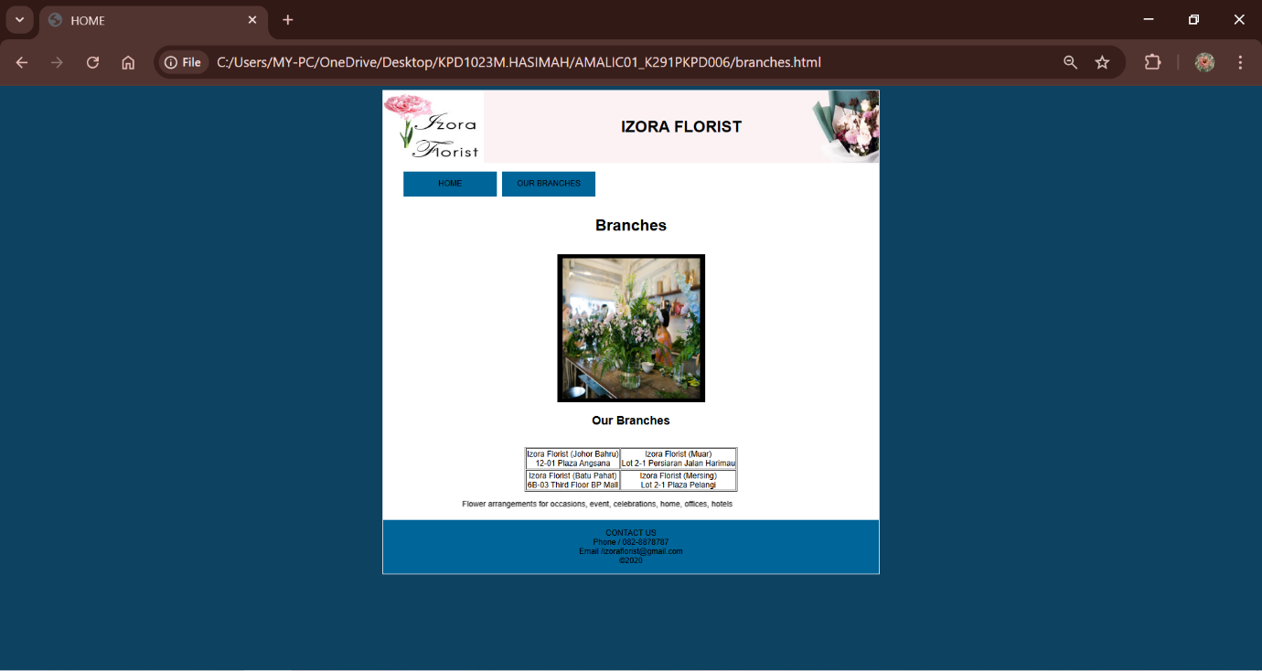

<!DOCTYPE html>
<html>
<head>
<meta charset="utf-8">
<meta name="viewport" content="width=device-width, initial-scale=1">
<title>HOME</title>
<style type="text/css">
body{
background-color: #0d4261;
font-family: arial;
font-color:black;
}

ul{
list-style-type: none;
}
#navbar
{
float: left;

}
#navbar>li
{
width: 190px;
float: left;
text-align: center;
margin-right:10px;
}
li a
{
background-color: #006598;
display: block;
text-decoration: none;
color: black;
line-height: 50px;
}

li>a:hover {background:#a3ca61;
}
</style>
</head>
<body>
<table align="center" bgcolor="white">
<tr>
<td>
<img src="logo.jpg"width="200px" height="140px">
</td>
<td style="width: 800px; background-image: url(banner.jpg);">
<center><h1>IZORA FLORIST</h1></center>
</td>
</tr>
<tr>
<td colspan="2">
<ul id="navbar">

<li><a href="index.html"> HOME
</a></li>
<li><a href="branches.html"> OUR BRANCHES
</a></li>

</ul>
</td>

</tr>
<tr>
<td colspan="2">
<center>
<h1>Branches</h1>
<br>
<img src="flower2.jpg"
width="300px" height="300px">
<br>
<h2>Our Branches</h2>
<br>
<center>
<table border="1">
<tr align="center">

<td>Izora Florist (Johor Bahru)
<br>
12-01 Plaza Angsana </td>

<td>Izora Florist (Muar)
<br>
Lot 2-1 Persiaran Jalan Harimau</td>

</tr>
<tr align="center">

<td>Izora Florist (Batu Pahat)
<br>
6B-03 Third Floor BP Mall</td>

<td>Izora Florist (Mersing)
<br>
Lot 2-1 Plaza Pelangi</td>
</tr>
</table>
</center>
</center>
<p><marquee>Flower arrangements for occasions, event, celebrations, home, offices, hotels</marquee></p>
</td>
</tr>
<tr bgcolor="#006598">
<td colspan="2" align="center">
<p>
CONTACT US
<br>
Phone / 082-8878787
<br>
Email /izoraflorist@gmail.com
<br>
&copy2020
</p>
</td>
</tr>

</table>

</body>
</html>

