

Aten v1.8
User Manual
Last Updated Tuesday, 03 December 2013

Disclaimer
Aten comes with ABSOLUTELY NO WARRANTY.
This is free software, and you are welcome to redistribute it under certain conditions. For more details read the GPL at http://www.gnu.org/copyleft/gpl.html.
Aten is under continual development and tweaking. If you have a feature suggestion, a feature request, or have found a bug or an idiosyncrasy, please contact me at tris@projectaten.net
Aten uses Space Group Info © 1994-96 Ralf W. Grosse-Kunstleve, the Qt toolkit © Nokia, and the readline library.
Some general notes:
First off, if you find that Aten doesn’t support the format you want, consider writing a filter to do so. And if you need help, please ask!
More so, if you find that Aten does support the format you want, but doesn’t appear to write it out correctly, please let me know.
For forcefield expression files written with Aten, I recommend that you check that the correct atom types get assigned to your molecule(s). Blind trust that this has actually occurred should only be employed once you are confident that the forcefield types are consistently correct! Larger forcefields, e.g. OPLS-AA by Jorgensen et al., do not have a complete set of type descriptions implemented in Aten. Once more, if your add some in, please send them to me so they can be included in a future revision of the code.
tris@projectaten.net
Acknowledgements
Aten is maintained entirely by T. Youngs. However, many people have contributed useful thoughts, ideas, bugfixes, and motivation to the project over its lifetime. These people are, in no particular order:
A. K. Croft and crew (Mac afficionado, supreme fault-finders)
S. Cromie (algebraic guidance)
A. Elena (bug-finder extraordinaire, ‘pathological case’-locator, Windows / Mac building and packaging)
D. Pashov (Windows / Mac building and packaging)
S. Norman (icon judgment)
N. C. Forero-Martinez and M. Smyth (bug finding, bug finding, and bug finding)
Table of Contents
1. Introduction 1
1.1. Overview 1
1.2. Feature Matrix 1
1.3. Supported File Formats 1
2. Installation 3
2.1. From Precompiled Packages (All Platforms) 3
2.2. From Source (Linux/Mac OS X) 3
2.3. From Source (Windows) 6
3. Frequently Encountered Problems 12
3.1. Configuration Errors 12
3.2. Compilation Errors 12
3.3. Usage Errors 13
4. Quickstart 15
4.1. Terminology 15
4.2. File Locations 16
4.3. Referencing Aten 17
5. Usage Examples 18
5.1. Creating a Bulk Water Model (GUI) 18
5.2. Building θ-Alumina from Basic Crystal Data 23
5.3. Creating an NaCl/Water Two-Phase System (GUI) 27
5.4. Building Ice I_{h} from Crystal Information (GUI) 33
5.5. Exporting Coordinates in Bohr (Filters) 36
5.6. Calculate Average Coordinates (CLI) 38
5.7. Self-Contained Liquid Chloroform Builder (Script) 39
5.8. Generating Images Without the GUI (CLI) 40
5.9. Calculating a Torsion Energy Profile (CLI) 41
5.10. Running a Script on Many Models (CLI/Batch) 42
5.11. Saving GAMESS-US Input with Options (CLI) 43
5.12. Printing all Bond Distances in a Model (CLI) 44
5.13. Creating a Porous Silica Model 45
6. Command Line Usage 46
6.1. Switch Order 46
6.2. Switches 46
6.3. Batch Processing Modes 53
7. The GUI 55
7.1. Overview 55
7.2. Mouse Control 56
7.3. Keyboard Shortcuts 58
7.4. The Main Toolbar 59
7.5. The ToolBox 61
7.6. Atom List Window 62
7.7. Build Window 63
7.8. Cell Definition Window 65
7.9. Cell Transform Window 66
7.10. Command Window 68
7.11. Disorder Builder Wizard 71
7.12. Forcefields Window 76
7.13. Fragments Window 79
7.14. Geometry Window 81
7.15. Glyphs Window 82
7.16. Grids Window 83
7.17. Messages Window 86
7.18. Pore Builder Window 87
7.19. Position Window 89
7.20. Select Window 92
7.21. Trajectory Window 94
7.22. Transform Window 95
7.23. ZMatrix Window 98
8. Command Language 99
8.1. Command Language Overview 99
8.2. Variable Types 105
8.3. Custom Dialogs 144
9. Command Reference 147
9.1. Atom Commands 147
9.2. Bond Commands 153
9.3. Building Commands 157
9.4. Cell Commands 165
9.5. Charges Commands 170
9.6. ColourScales Commands 172
9.7. Disorder Commands 175
9.8. Edit Commands 177
9.9. Energy Commands 179
9.10. Flow Commands 182
9.11. Forcefield Commands 187
9.12. Forces Commands 198
9.13. Glyph Commands 199
9.14. Grid Commands 205
9.15. Image Commands 212
9.16. Labeling Commands 214
9.17. Math Commands 216
9.18. Measuring Commands 219
9.19. Messaging Commands 222
9.20. Minimiser Commands 225
9.21. Model Extras Commands 228
9.22. Model Commands 230
9.23. Pattern Commands 237
9.24. Pores Commands 240
9.25. Read / Write Commands 242
9.26. Script Commands 252
9.27. Selection Commands 253
9.28. Site Commands 262
9.29. String Commands 264
9.30. System Commands 269
9.31. Trajectory Commands 272
9.32. Transform Commands 275
9.33. View Commands 282
10. Topics of Interest 286
10.1. Colourscales 286
10.2. Glyphs 287
10.3. Patterns 288
10.4. Partitioning Schemes 291
11. Filters 292
11.2. Trajectory Files 300
11.3. Reading and Writing 303
12. Forcefields and Typing 308
12.1. Overview 308
12.2. Supplied Forcefields 309
12.3. Keyword Reference 312
12.4. Rule-Based Forcefields 321
12.5. Typing 323
12.6. NETA Reference 329
13. Functional Forms 335
13.1. VDW Functional Forms 335
13.2. Bond Functional Forms Error! Bookmark not defined.
13.3. Angle Functional Forms Error! Bookmark not defined.
13.4. Torsion Functional Forms Error! Bookmark not defined.
14. External Programs 339
14.1. Movie Generation 339
14.2. MOPAC 339
15. Methods 340
15.1. Custom Algorithms 340
15.2. Literature Methods 345
16. Enumerations 346
16.1. Basis Shell Types 346
16.2. Bond Types 346
16.3. Bound Types 346
16.4. Cell Types 347
16.5. Colour Schemes 347
16.6. Combination Rules 347
16.7. Drawing Styles 348
16.8. Energy Units 348
16.9. Glyph Types 348
16.10. Grid Styles 349
16.11. Grid Types 349
16.12. Label Types 349
16.13. Monte Carlo Move Types 350
16.14. Output Types 350
16.15. Parse Options 351
16.16. Read Success Integers 351
16.17. ZMapping Types 351

Introduction

Overview
Aten will let you generate and edit coordinates for your simulations, and view any trajectories you might have generated. A set of tools in the GUI (and also accessible from the command line) enables you to change the geometry of bonds, angles, and torsions, translate atoms, create atoms, rotate groups of atoms, and cut, copy, and paste them around the place. All this can be done in the context of loading and saving in the format that you need - if the file format you need isn't currently a part of Aten, you yourself can write a filter to cover it.
Periodic systems are supported, be they crystals, liquids, gases, or a heady mixture. All editing functions that are possible for simple molecules apply to periodic systems as well. Moreover, given a basic unit cell a whole crystal or a larger supercell can be constructed. For any periodic system, a random ensemble of molecules can be added, allowing the facile creation of coordinates with which to begin your molecular dynamics simulations.
As well as coordinates, Aten has support for forcefields (in its own, plain-text format) and can automatically apply these forcefields to your system if correct type descriptions are present for the atom types in the forcefield. Then, in the same way as with coordinates, you may write out a forcefield description of your system in the format that you require it with a different filter. Please don't use Aten as a literal ‘black box’, though, and blindly write out forcefield files without checking them. While it will certainly make the process of generating your forcefield descriptions easier, the art of determining the correct types in the first place (and hence the correct forcefield terms) is not definite for larger forcefields that cover many atom types. Check the output – a cursory glance of the selected forcefield types is an excellent idea, and a good habit to get in to.
Aten is in continual development, so if you get stuck, find a bug, or have a suggestion to make, please go to the Support page of the website and visit the forums or send an email directly. Making Aten better depends to some degree on user feedback!

Feature Matrix
TODO

Supported File Formats
A list of formats currently supported by Aten follows as well as the file extensions and assigned filter IDs. Remember, adding support for other codes and formats is in your hands with Aten’s filters (see Section 11).
Table 1-1 Supported Model Formats
Format | Extension(s) | Nickname | ID | R/W | Notes
Aten Keyword Format | *.akf | akf | 1 | RW | Plain-text format used by Aten
Cambridge Structural Database Service | *.dat|*.fdat | csd | 7 | RO
Chem3D Cartesian Coordinates | *.cc1 | *.cc2 | Cc | 34 | RO
Crystallographic Information File | *.cif | cif | 8 | RO
DL_POLY Configuration | *CONFIG | *REVCON | dlpoly | 2 | RW
EPSR ATO Files | *.ato | ato | 18 | RW
GAMESS-US Output (Log) | *.log | gamuslog | 11 | RO
GAMESS-US Input File | *.inp | gamusinp | 5 | RW | Cartesian coordinates and Z-Matrices
Gaussian Input File | *.gjf | gjf | 17 | WO | Cartesian coordinates and Z-Matrices
Gromacs Configuration | *.gro | gro | 14 | RW
Mopac Archive File | *.arc | arc | 16 | RO
Mopac Control File | *.mop | mop | 4 | RW | Including periodic systems. Cartesian coordinates only.
MDL Molfile | *.mol | mol | 10 | RO
MSI (Cerius2) Model File | *.msi | msi | 12 | RO
Protein Databank (PDB) | *.pdb | pdb | 13 | RO
Quantum Espresso | *.in | in | 15 | RW
SIESTA Flexible Data Format | *.fdf | siesta | 9 | RW
Tripos Sybyl Mol2 | *.mol2 | mol2 | 6 | RW
XMol XYZ | *.xyz | xyz | 3 | RW

Table 1-2 Supported Trajectory Formats
Format | Extension(s) | Nickname | Notes
DL_POLY Formatted & Unformatted Trajectories | *HISu | *HISf | HISTORY | dlpoly
GAMESS-US Trj File | *.trj | trj | QM atoms in MD and IRC runs
PDB Trajectory (Multiple PDB file) | *.pdb | pdb
Siesta XV | *.XV | xv
XYZ Trajectory (Multiple XYZ file) | *.xyz | xyz

Table 1-3 Supported Grid Data Formats
Format | Extension(s) | Nickname | ID | Notes
Gaussian Cube | *.cube | cube | 1 | Also an importmodel filter
Probability density | *.pdens | pdens | 2 | Simple 3D volumetric data format
Surface | *.surf | surf | 3 | Simple 2D surface data format

Table 1-4 Supported Expression Data Formats
Format | Extension(s) | Nickname | ID | Read? | Write? | Notes
DL_POLY FIELD file | *.FIELD | FIELD | dlpoly | 1 | no | yes
Gromacs RTP file | *.rtp | rtp | -- | no | yes | Preliminary version.
Gromacs TOP file | *.top | top | 14 | no | yes

Installation

From Precompiled Packages (All Platforms)
The easiest way to get Aten is, of course, to download a precompiled installer for your system. Installers are available for Windows, Mac OS X, and many Linux distributions through the website (http://www.projectaten.net) and the OpenSuSE Build Service (http://download.opensuse.org/repositories/home:/trisyoungs/).

From Source (Linux/Mac OS X)
If you want to compile Aten by hand (e.g. if you’re keeping your own copy of the source and updating it via subversion) then these guides may help. They are very general and (unavoidably) quickly go out of date, but they should provide some info to at least get started. The Windows method is entirely different and somewhat more complicated than for Linux and Mac OS X, but a working approach is documented here.

Obtaining the Source

From the Website (as an Archive)
Go to http://www.projectaten.net and grab the tar.gz of the version you want, and unpack it with:

bob@pc:~> tar -zxvf aten-1.7.tar.gz

A directory called aten-nn.mm will be created containing all the guts of the code, ready to build, where nn.mm is the current version number.

From GoogleCode (with subversion)
If you want to build Aten from source and maintain a local copy so you can update it quickly to make the most of bugfixes and new features, this is the best way of doing it. You’ll need to have subversion (http://subversion.tigris.org/) installed, since the GoogleCode repository where Aten lives is a subversion-style repository. To get yourself a copy of the latest source, run the following command:

bob@pc:~> svn co http://aten.googlecode.com/svn/trunk ./aten-latest

Afterwards, you’ll have a complete copy of the source in a directory called aten-latest.

Installing Necessary Pre-requisites
Aten has a fairly modest set of external dependencies, namely Qt4 and readline. Since you’re building from source, all the development files related to these packages must also be installed. The C++ (g++) compiler and the automake/libtool packages are also a necessity.

Debian and Variants
On deb-based systems (e.g. Debian and Ubuntu) a command a bit like this should install all that you need:

bob@pc:~> sudo apt-get install autotools-dev libtool autoconf \
automake g++ libreadline5-dev libqt4-gui libqt4-opengl \
libqt4-core libqt4-dev

RPM-Based Systems
For most other Linux flavours the method of installing the necessary software really depends a lot on your personal preferences (or your system administrators). For instance, using zypper on an OpenSuSE distribution the command is (run as root) as follows:

bob@pc:~> zypper in readline-devel libqt4-devel libtool automake

Mac OS X
On Mac OS X you have two ways of installing Qt4. Nokia offer an installable disk image, providing Qt4 as a proper Framework (see http://qt.nokia.com/downloads). Alternatively, Qt4 is available on Fink (qt4-x11). If you're using the Fink installation of Qt4, then you'll also need pkg-config from the same source.

Configure

Make / Autotools
Configure the source with the following commands, run from the top level of the aten-latest or aten-nn.mm directory:

bob@pc:~> ./autogen.sh

This creates the necessary files needed to properly configure the build. If you unpacked the source from a tar.gz, it is not necessary to run autogen.sh.
Next, run the configure script to check for all programs and files that Aten depends on, and set up the build. If you plan on installing Aten ‘properly’ (i.e. install it on your machine so it is available to all users) the configure script will place all binaries and necessary files in /usr/local by default. This default location can be overridden by using the --prefix=<path> option. So, the plain command is:

bob@pc:~> ./configure

To set the installation location use, for example:

bob@pc:~> ./configure –-prefix=/home/software

On Mac OS X it is necessary to specify which Qt4 installation you have installed (i.e. Framework or Fink):

bob@pc:~> ./configure --with-qt=framework

or

bob@pc:~> ./configure --with-qt=fink

With the Fink installation you may also need to direct configure to the correct Qt4 development binaries either by setting your $PATH to /sw/lib/qt4-x11/bin:${PATH} or by running:

bob@pc:~> ./configure --with-qt=fink --with-qtdir=<path>

where <path> points to the location of the Qt4 development binaries. All being well, no errors should be encountered by either of these two scripts. Check out the FAQ for some commonly-encountered problems. If you get find yourself up against unresolvable issues, please email me and I’ll try to help.

CMake
An out-of-tree build is best. Make a directory somewhere, enter in to it, and run:

bob@pc:~> cmake /path/to/source/for/aten-nn.mm

For example:

bob@pc:~> cd ~
bob@pc:~> mkdir aten-build
bob@pc:~> cd aten-build
bob@pc:~> cmake ~/src/aten-1.7

Compile
Once successfully configured, build the source with:

bob@pc:~> make

This is probably a good time to make tea or brew coffee.

From Source (Windows)
Note that these instructions were written from the perspective of a Windows XP system. It’s likely that the procedure for Vista, Windows 7 etc. will be similar. First step, download and install the following:

Install Visual Studio C++ 2010
Get the C++ version of Visual Studio from http://www.microsoft.com/express/Windows/ – at the time of writing this was version 10.0, but earlier versions 8.0 and 9.0 are also fine). This will download a small web installer to your machine called vc_web.exe. Run this, and accept the license. You may choose not to install Silverlight since it is not necessary for Aten. Remember where the installation location is set to (by default it is C:\Program Files\Microsoft Visual Studio 10.0\) because you’ll need this later on for the installation of Windows PowerShell. Chances are you’ll need to restart your machine after the installation.

Install the Windows SDK
Get the Windows SDK from http://msdn.microsoft.com/en-us/windows/bb980924 (or search for ‘Windows SDK’ on the internet). Note that the download is described as being for ‘Windows 7 and .NET’ but this is fine since it’s backwardly compatible with XP. Run the installer (winsdk_web.exe) and accept the license, and again take note of the installation directories (since they need to be provided in the PowerShell setup later on). The default installation options are fine, although you can uncheck the installation of ‘Samples’ since they are not required. Once installation has finished, the Windows Help Centre may pop up and ask where your local resources are. This can safely be canceled.

Install CMake
Download the lastest CMake installer from http://www.cmake.org/ (version 2.8.4 at the time or writing) and install it. Make sure you choose to add CMake to the PATH for all users when running the installation.

Install Readline
Go to http://gnuwin32.sourceforge.net/packages/readline.htm (or search for ‘Windows Readline’ on the internet) and download the ‘Complete package, except sources’ installer (around 2.3 Mb). If you choose to install somewhere other than the default location, you’ll need to tweak the PowerShell profile given in Step 7.

Download GLext Header
Go to http://www.opengl.org/registry/api/glext.h and save the page as ‘glext.h’ somwhere like your ‘My Documents’ directory. Again, if you choose somewhere other than this location, you’ll need to tweak the PowerShell profile given in Step 7.

Download and Unpack Qt4 Source
Go to http://qt.nokia.com/downloads and download the LGPL package for Windows (approx 322 Mb) and run the installer file. Again, you may choose where to unpack the files to (the default is ‘C:\Qt\2010.05’ for the release downloaded here) but if you change the default you’ll need to modify the relevant paths accordingly in Step 7. You may choose not to install the MinGW part of the package since we will be using Visual Studio for the compilation. There is no need to run Qt Creator once the installation is finished.

Install and Setup Windows PowerShell
Download PowerShell from http://support.microsoft.com/kb/968930. Once installed, run PowerShell (its Start Menu entry is typically placed inside the ‘Accessories’ folder) and you should be presented with a blue shell, starting inside your Documents and Settings folder (C:\Documents and Settings\Your Name). First thing is to set up your profile with the relevant paths set so we can find the Visual Studio, readline, and Qt4 files. Such settings are stored in a file which doesn’t yet exist, and which is referenced by the environment variable $profile. You can type this into PowerShell and see exactly where it points to:

PS C:\Documents and Settings\Your Name> $profile

C:\Documents and Settings\Your Name\My Documents\WindowsPowerShell\Microsoft.PowerShell_profile.ps1

We must first create the directory where this file is expected to be:

PS C:\Documents and Settings\Your Name> mkdir "My Documents/WindowsPowerShell"

Directory: C:\Documents and Settings\Your Name\My Documents

Mode LastWriteTime Length Name
---- ------------- ------ ----
d---- 23/04/2011 11:05 WindowsPowerShell

PS C:\Documents and Settings\Your Name> ls "My Documents"

Directory: C:\Documents and Settings\Your Name\My Documents

Mode LastWriteTime Length Name
---- ------------- ------ ----
d---- 23/04/2011 10:49 Downloads
d-r-- 10/07/2009 23:41 My Music
d-r-- 08/04/2010 16:35 My Pictures
d---- 14/03/2011 08:47 My Received Files
d-r-- 26/06/2010 19:44 My Videos
d---- 23/04/2011 11:05 WindowsPowerShell
-a--- 23/04/2011 17:43 637740 glext.h

You can then create and edit the profile file directly with Notepad:

PS C:\Documents and Settings\Your Name> notepad $profile

In the empty file, paste the following into it and adjust any paths/versions as may be necessary.

# Setup Visual Studio and Windows SDK environment variables
if ( test-path -path $env:VS100COMNTOOLS )
{
echo "Setting Visual Studio environment"
$VCSTUDIO="C:\Program Files\Microsoft Visual Studio 10.0"
$WINSDK="C:\Program Files\Microsoft SDKs\Windows\v7.1"

# System variables
$env:VSINSTALLDIR = "$VCSTUDIO"
$env:VCINSTALLDIR = "$VCSTUDIO\VC"
$env:FrameworkDir = "C:\Windows\Microsoft.NET\Framework"
$env:FrameworkVersion = "v2.0.50727"
$env:FrameworkSDKDir = "$VCSTUDIO\SDK\v3.5"
$env:DevEnvDir = "$VCSTUDIO\Common7\IDE"

# Executable path
$env:PATH += ";$VCSTUDIO\Common7\IDE"
$env:PATH += ";$VCSTUDIO\VC\BIN"
$env:PATH += ";$VCSTUDIO\Common7\Tools"
$env:PATH += ";$VCSTUDIO\Common7\Tools\bin"
$env:PATH += ";$VCSTUDIO\VC\PlatformSDK\bin"
$env:PATH += ";$VCSTUDIO\SDK\v2.0\bin"
$env:PATH += ";$VCSTUDIO\VC\VCPackages"
$env:PATH += ";$WINSDK\Bin"

# Include directories
$env:INCLUDE += ";$VCSTUDIO\VC\ATLMFC\INCLUDE"
$env:INCLUDE += ";$VCSTUDIO\VC\INCLUDE"
$env:INCLUDE += ";$VCSTUDIO\VC\PlatformSDK\include"
$env:INCLUDE += ";$VCSTUDIO\SDK\v2.0\include"
$env:INCLUDE += ";$WINSDK\Include"

# Libraries
$env:LIB += ";$VCSTUDIO\VC\ATLMFC\LIB"
$env:LIB += ";$VCSTUDIO\VC\LIB"
$env:LIB += ";$VCSTUDIO\VC\PlatformSDK\lib"
$env:LIB += ";$VCSTUDIO\SDK\v2.0\lib"
$env:LIB += ";$WINSDK\Lib"
$env:LIBPATH += ";$VCSTUDIO\VC\ATLMFC\LIB"
}
else
{
echo "No Visual Studio installed, or incorrect version string used?"
}

# Setup Qt environment variables
$env:QTDIR="C:\Qt\2010.05"
if ( test-path -path $env:QTDIR )
{
$env:PATH += ";"+$env:QTDIR+"\qt\bin"
$env:INCLUDE += ";"+$env:QTDIR+"\qt\include"
$env:LIB += ";"+$env:QTDIR+"\qt\lib"
}

# Setup GnuWin32 environment variables
$env:INCLUDE += ";C:\Program Files\GnuWin32\include"
$env:LIB += ";C:\Program Files\GnuWin32\lib"
$env:PATH += ";C:\Program Files\GnuWin32\bin"

# Setup custom library and header environment variables
$env:INCLUDE += ";$HOME\My Documents"

By default, the running of scripts in PowerShell is (likely to be) disabled, meaning that the profile will not be loaded when PowerShell next starts up. To enable the execution of scripts, run the following command:

PS C:\Documents and Settings\Your Name> set-executionpolicy remotesigned

You need to answer Yes to the question which then pops up. Afterwards, close this shell by typing:

PS C:\Documents and Settings\Your Name> exit

…and then restart PowerShell. Your new profile should now be loaded, and you should see the ‘Setting local environment’ message which we added to it. All being well, there should be no error messages here – if there are, then its likely that there’s a mistake in one of the paths set in the profile.

Build Qt4
First stage is to configure Qt ready for building by running the following commands:

PS C:\Documents and Settings\Your Name> cd C:\Qt\2010.05\qt
PS C:\qt\2010.05\qt> ./configure -release -opensource -platform win32-msvc2010
-qt-libjpeg -qt-libmng -qt-libtiff -qt-libpng -qt-zlib -qt-gif -no-webkit
-no-script

This will take a few minutes. Once complete, build Qt with:

PS C:\qt\2010.05\qt> nmake

This will take a few more minutes (approximately one hour, depending on your system’s speed).

Download and Build Aten
Go to www.projectaten.net/download and get a zipped copy of the source. For this example the latest beta version is 1.7.1626, so the zipfile is called ‘aten-1.7.1626.zip’. Unpack the source somewhere – here it has been placed in the users’s home directory – and run cmake to generate the necessary makefiles:

PS C:\Documents and Settings\Your Name> cd aten-1.7.1626
PS C:\Documents and Settings\Your Name\aten-1.7.1626> cmake -G “NMake Makefiles”

Then, build Aten by running nmake:

PS C:\Documents and Settings\Your Name\aten-1.7.1626> nmake

Time to wait again, but hopefully after a little while you will see something resembling the following (the important part is the [100%] Built target Aten):

C:\Program Files\Microsoft Visual Studio 10.0\VC\INCLUDE\stdlib.h(433) : see declaration of 'getenv'
C:\Documents and Settings\Your Name\My Documents\aten-1.7.1626\src\main.cpp(52) : warning C4996: 'getenv': This function or variable may be unsafe. Consider using _dupenv_s instead. To disable deprecation, use _CRT_SECURE_NO_WARNINGS. See online help for details.
C:\Program Files\Microsoft Visual Studio 10.0\VC\INCLUDE\stdlib.h(433) : see declaration of 'getenv'
Linking CXX executable bin\Aten.exe
[100%] Built target Aten
PS C:\Documents and Settings\Your Name\My Documents\aten-1.7.1626>

If this is what you see, then you’ve built Aten successfully. You’ll need to point Aten to it’s data directory by hand. From the command line, you can run the following:

PS aten-1.7.1626> .\bin\Aten.exe --atendata .\data

You can also set up a shortcut to the executable and set the option there.

Potential Readline Errors
There is the potential for the build to fail on the basis of odd readline errors:

C:\Program Files\GnuWin32\include\readline/keymaps.h(97) : see declaration of 'rl_set_keymap'
C:\Program Files\GnuWin32\include\readline/readline.h(364) : error C2375: 'rl_get_keymap' : redefinition; different linkage
C:\Program Files\GnuWin32\include\readline/keymaps.h(94) : see declaration of 'rl_get_keymap'
NMAKE : fatal error U1077: 'C:\PROGRA~1\MICROS~1.0\VC\bin\cl.exe' : return code '0x2'
Stop.
NMAKE : fatal error U1077: '"C:\Program Files\Microsoft Visual Studio 10.0\VC\BIN\nmake.exe"' : return code '0x2'
Stop.
NMAKE : fatal error U1077: '"C:\Program Files\Microsoft Visual Studio 10.0\VC\BIN\nmake.exe"' : return code '0x2'
Stop.
PS C:\Documents and Settings\Your Name\My Documents\aten-1.7.1626>

These errors arise because the functions rl_*_* are declared differently between the readline.h and keymaps.h header files, but can be fixed as follows. Since keymaps are not used, the offending lines can be commented out in readline.h. Locate the file (by default, it is installed in C:\Program Files\GnuWin32\include\readline/readline.h) and edit it with Notepad or something similar. Put a comment marker /* at the very beginning of line 356, and a comment end marker */ at the very end of line 364. Rerun nmake and everything should be fine.

Anything Else?
Instead of downloading the zipped source of Aten, you could download a Windows subversion client and maintain an up-to-date copy of the source on your machine – useful if you want to frequently get the latest updates. There are many subversion clients available, but Win32svn (http://sourceforge.net/projects/win32svn/) works well for me.

Frequently Encountered Problems
What follows is a sort of mini FAQ detailing some commonly-encountered problems and issues when compiling and executing Aten for the first time, and also some of the more persistent problems that various platforms exhibit.

Configuration Errors

[ALL] ./autogen.sh: line 35: libtoolize: command not found
You need to install the libtool package - it should be on the original CD of your linux distro or on one of the billions of repository mirrors around the world.

[OSX] Error: Possibly undefined macro: AC_DEFINE
When running ./autogen.sh, autoconf sometimes fails with ‘configure.ac:16: error: possibly undefined macro: AC DEFINE’. This is related to the version of pkg-config you have installed (e.g. version 0.15.1 gives this error, but version 0.21 does not) with Fink / MacPorts. Upgrade to the latest version. Incidentally, the line-number reported (16) is not the actual location of the error - autoconf reports this wrongly (the actual error occurs later on with the ‘PKG CHECK MODULES(GTK28, ..., [AC DEFINE...’ command).

[OSX] Warning: Underquoted definition of PKG_CHECK_MODULES
Running ./autogen.sh, aclocal complains ‘/sw/share/aclocal/pkg.m4:5: warning: underquoted definition of PKG_CHECK_MODULES’ If pkgconfig is not installed this is likely to give rise to the said spurious error. Install pkgconfig from Fink / MacPorts to proceed.

[ALL] autogen.sh appears successful, but aclocal complains about ‘underquoted definition of AM PATH...’
These warnings should not have affected the generation of a working ./configure script. So you may as well move on to the next step in the build.

Compilation Errors

[ALL] Error: 'uic: File generated with too recent version of Qt Designer (4.0 vs. 3.x.x)'
This error can occur when both the Qt3 and Qt4 development packages are installed The $PATH is sometimes set so that the Qt3 binaries are found first, so the Meta-object compiler from Qt3 is called, and then the generated source includes the Qt4 headers. Running which moc will tell you which binary is being used - you can then run this binary with the -v option to check the version. If its version 3.x.x then you will need to reconfigure the build as follows.
Each of the three Qt4 utilities needed to compile Aten – moc, rcc, and uic – can be specified explicitly with three configure options; --with-qtmoc, --with-qtuic, and --with-qtrcc. Typically, the Qt3 binaries are located in /usr/lib/qt3/bin while the Qt4 binaries are in /usr/bin, but this may not be the case on your particular system. For the sake of argument, let’s say they are, then the configure command will be run as follows:

bob@pc:~/src/aten> ./configure –with-qtmoc=/usr/bin/moc –-with-qtuic=/usr/bin/uic –with-qtrcc=/usr/bin/rcc

[ALL] Error: 'This file was generated using the moc from 3.X.X. It cannot be used with the include files from this version...'
Again, this is usually related to both Qt3 and Qt4 development tools being installed simultaneously. See the previous question and its solution above.

[OSX] Undefined reference to ___stdoutp expected to be defined in /usr/lib/libSystem.B.dylib
Chances are you have an older operating system - Panther (10.3.9) is confirmed to show this error. Since the Universal Mac binaries are built on a machine with Snow Leopard (10.6) this error can only be avoided by upgrading your operating system or compiling Aten by hand.

Usage Errors

[LINUX] I saved an image from the GUI and it was completely black / corrupt. Why?
A common issue with (integrated) Intel graphics chips, but may affect others. There are some issues with the Qt code used to grab the current view as an image, but an alternative method is available and works. Try the prefs option 'aten.prefs.useframebuffer = TRUE;' to use the alternative method. If this remedies the problem, add the line to your preferences file. One caveat - although this appears to fix problems when saving images from the GUI, it does not (apparently) solve the problem when saving the image from the command line.

[ALL] Why is Aten’s main view corrupt/black? I can’t see anything!
This is a fairly common issue, and the exact causes are not known for sure. Certainly on some Linux machines the presence of an ATI graphics card seems to be related. Using the radeon or fglrx drivers supplied with the OS rather than the proprietary ati driver sometimes helps.
Forcing the main view widget to manually refresh itself usually solves the problem. To do this on the latest versions, activate Settings→Manual Swap Buffers from the main menu (on newer versions) or type the following into Aten’s command window:

aten.prefs.manualswapbuffers = TRUE;

If this remedies the problem, add the line to your user preferences file (see Section 4.2.2).

[WINDOWS] Aten fails to start, giving this message:
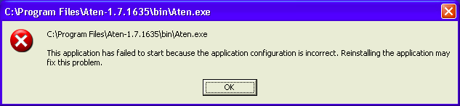
This descriptive (!) message suggests that the installation process failed, but this is not the case. The real reason for Aten’s failure is that your machine lacks the Visual Studio C++ 2008 runtime libraries. These can be freely downloaded from Microsoft’s website:
http://www.microsoft.com/downloads/en/details.aspx?familyid=a5c84275-3b97-4ab7-a40d-3802b2af5fc2&displaylang=en
Allternatively, search the internet for ‘Microsoft Visual C++ 2008 Redistributable Package SP1’. Note that it must be the Service Pack 1 version.

Quickstart
The following sections give an overview of the most important things to know about Aten. It’s only a few pages long, and its well worth taking five minutes to read it.

Terminology
It is useful to know exactly what a few terms mean in Aten’s world:

Model
A model is a single molecule, a snapshot of an ensemble of molecules in a liquid, a crystal’s unit cell – basically, any collection of atoms and bonds, optionally including a unit cell definition and/or a number of glyphs (annotations or shapes).

Pattern
A system containing many molecules can be described (and manipulated) efficiently through the recognition that there are sets of molecules of the same type. A pattern describes one such set of similar molecules, and a model’s pattern definition may contain many individual patterns. Many operations in Aten require that a pattern definition be present, and one is automatically created as and when necessary. See Section 10.3 for more information.

Filter
A filter is a set of commands (i.e. a program) which loads data in to or saves data from Aten. Aten depends on filters to be able to load and save models, forcefields, expressions, trajectories, and grid data. All filters are written in Aten’s own scripting language (which is based syntactically on C) and are loaded in on startup. New filters can be added at will (by the user) to cater for specific formats. See Section 11 for more information.

Expression
While a forcefield is a collection of terms (bonds, angles, van der Waals terms, etc.) which describe (usually) a large number of molecular types and systems, an expression is a subset of terms specific to one model.

NETA
Aten is able to automatically assign forcefield atom types to atoms in a model through the use of type descriptions in the Nested English Typing of Atoms (NETA) language. This is a simple, readable system for describing the connectivity and environment of individual atoms. See Section 12.5 for more information.

Fragment
A fragment is a molecule or structure which can be used to quickly build up a new model, or modify an existing one. For example, cyclohexane, or a tertiary butyl group.

File Locations

Installed / Provided Files
Aten depends on several sets of files in order to function properly and, generally-speaking, knows where to look for them. Sometimes, however, you may need to tell Aten where these files are (e.g. if you have not installed Aten after compiling the source yourself). There are several ways of achieving this. When running Aten from the command-line, the --atendata switch can be used to specify the location of Aten’s data files. For instance:

bob@pc:~> aten --atendata=/usr/software/aten/data

Alternatively, the environment variable $ATENDATA can be set. For example, in a bash-style shell:

bob@pc:~> export ATENDATA=/usr/software/aten/data

In both cases, Aten should be directed to the data directory; either it’s installed location or the directory in the top level of the source distribution.
The structure of the data directory is as follows:
data/filters | Contains stock filters for import and exporting data
data/fragments | Fragment models for drawing / modifying models
data/ff | Forcefield files
data/fftesting | Forcefields that are incomplete or have not been tested
data/partitions | Partition data for the disorder builder
data/test | Various test files (models, grids etc.) (not installed)

User Files
Aten will search for additional filters, fragments, and forcefields in a specific location in the user’s home directory. On Linux and Mac OS X systems this directory is called .aten, while on Windows the directory should be called simply aten (i.e. without the preceding dot). Within this directory exists (optionally) further directories named similarly to those in the data directory, in which user files of the relevant type should be located.
Finally, the two main preferences files are located in the user’s .aten (or aten) directory. Both are optional. The first, prefs.dat (or, alternatively, prefs.txt) is written by Aten from the Prefs window. While this file may be modified by hand, changes will be lost if overwritten by Aten. The second file, user.dat (or, alternatively, user.txt) is maintained entirely by the user, and should be used to change or set up exotic situations and preferences. For instance, a specific forcefield could be loaded automatically on startup.

Referencing Aten
Aten has been published in the Journal of Computational Chemistry, and the article can be found online here. The full reference is:
“Aten - An application for the creation, editing, and visualization of coordinates for glasses, liquids, crystals, and molecules”, T. G. A. Youngs, J. Comp. Chem. 31, 639-648 (2010).
It is not a requirement to cite Aten in your work, but if you feel that Aten has been particularly useful then the credit would be nice.

Usage Examples

Creating a Bulk Water Model (GUI)
Bulk (periodic) systems are the staple diet of the molecular dynamicist, particularly systems that are isotropic. This example illustrates how to generate a simple bulk configuration of liquid water.

Make a Water Molecule
We need a water molecule. We could load one in, but its marginally more interesting to build one from scratch. So, we’ll place an oxygen atom down somewhere and automatically add hydrogens to it.
Main Toolbar | Create a new, empty model (if you don’t have one already) with 
In the Build Window change the active element to oxygen on the Edit page by clicking 
Select the draw single atoms tool  and click once somewhere in the empty model to draw an oxygen atom
Add hydrogens to the model by clicking 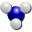AddH Model
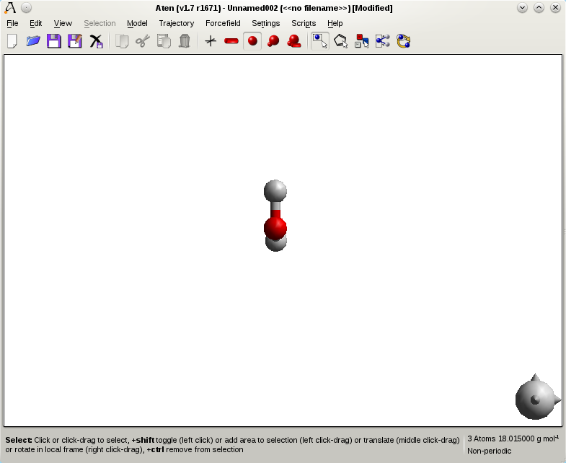

Run the Disorder Builder
The Disordered Builder adds molecules into a new or existing model with a unit cell. The only requirement of the Disorder Builder is that all the models you wish to add must be loaded into Aten before the builder is run. Everything else is handled by a wizard which guides you through the process.
Run the Disorder Builder wizard
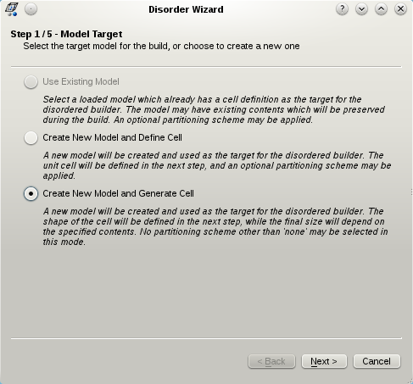
Step 1 is to select either an existing model (which has a unit cell) or choose to create a new one. Since the water molecule is the only one loaded in this example, the existing model option is grayed out in the graphic above. When creating a new model, there are two options for the generation of the unit cell – either you can specify the cell lengths and angles explicitly to get exactly the cell you want, or you can specify just the angles and relative lengths of the cell, which will then be enlarged automatically to contain whatever you choose to put inside it. For this example, we will do the latter, so select the last option and click Next.
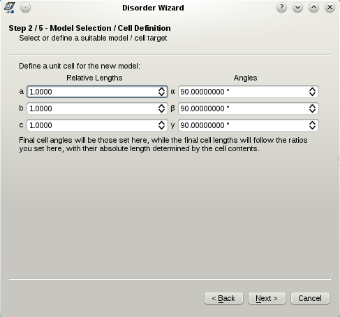
As mentioned, here we define exacly the angles of the cell, but any lengths we specify are relative lengths which will be scaled according to the number and density of the molecules we choose to put in the cell. We will leave them as they are for now, so we will end up with a cubic cell with some side length l.
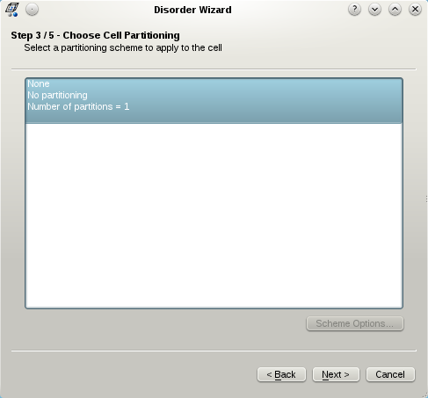
The Disorder Builder normally permits a partitioning scheme (see Section XXX) to be selected in order to partition molecules up into different regions in the cell. When generating a cell, however, this is not possible, so we must choose the basic cell option and click Next.
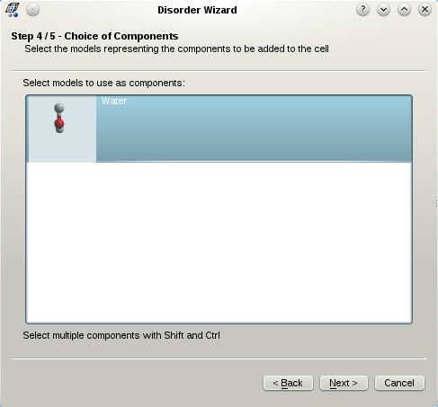
Next we must choose which models or components we wish to add into the new system. Here there is only one choice, the water model we created earlier, so select it ans press Next.
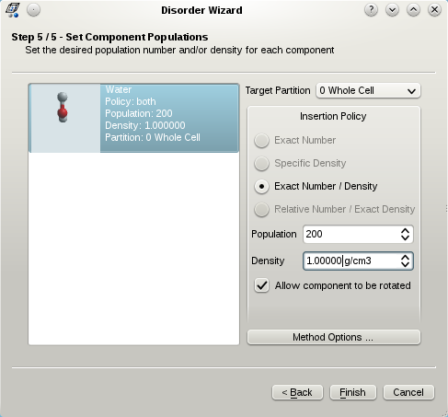
Finally, the most important step of the wizard is to define a policy for the insertion of each model we selected in the last step. There are usually four options here; either a specific number of molecules or a specific density (more correctly a specific partition density), and exact number and density, or a relative number and exact density. Since our cell size is to be automatically determined, only one of those four options is available, Exact Number / Density, since both pieces of information are required in order to work out the final cell volume. So, choose the number of water molecules to add, say 200, and the density you want them to have in the cell. Press Finish and the system will then be built.
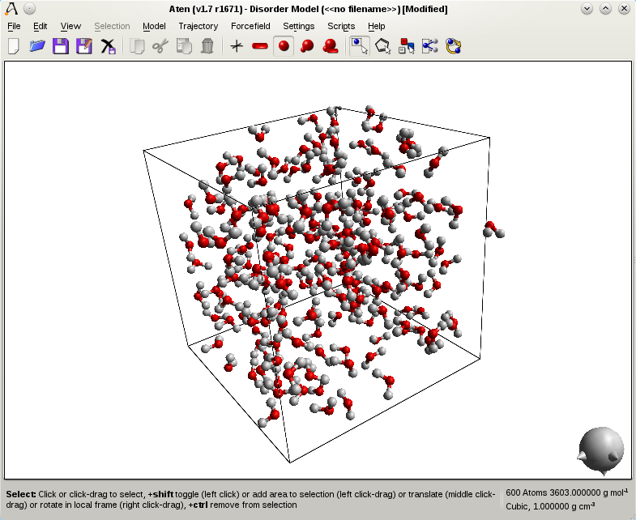

Script
When run from the command line the disorder builder always requires a model with a unit cell to be defined – only through the GUI is the model created automatically. This script defines a basic cubic cell in a new model before the disorder builder is run with the second argument set to FALSE (which indicates that the cell size is not fixed and should be adjusted to suit the defined molecule contents) and also minimises the system a little before saving out coordinates and a forcefield expression for DL_POLY.

newModel("water");
newAtom(O);
addHydrogen();
setupComponent("both", 1, 200, 1.0);

newModel("box");
cell(1.0,1.0,1.0,90,90,90);
disorder("None", FALSE);

loadFF("spce.ff");
mcMinimise(20);
sdMinimise(20);

saveExpression("dlpoly", "water.FIELD");
saveModel("dlpoly", "water.CONFIG");

quit();

Building θ-Alumina from Basic Crystal Data
Crystal structures are useful for many things, provided you can find them in electronic format. When you can't and are left with the bare crystallographic data in a paper things are slightly more troublesome. This was exactly my experience when working with θ-alumina – the crystal information is readily available in a paper by Zhou and Snyder (Acta. Cryst. B, 47, 617 (1991)), and here’s how to make use of it.

Create the Unit Cell
First, we create the crystal cell in which to add our atoms. From the paper we see it is a monoclinic cell with β = 103.83°, and side lengths a = 11.854, b = 2.904, and c = 5.622 Å. You may want to zoom out afterwards to get a proper look at the new cell.
Open the Cell Define Window
Add a unit cell to the model by checking the Has Cell? Checkbox, then go to the Define/View ABC page and set the cell lengths a, b, and c to 11.854, 2.904, and 5.622 respectively. Set the cell angle β to 103.83°, and click Define.
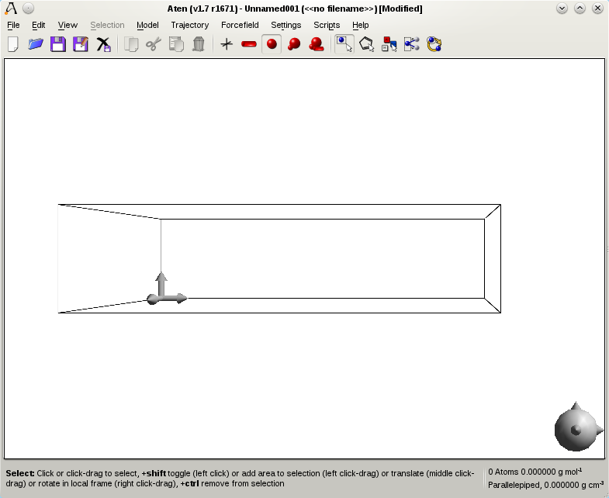

Add Symmetry Unique Atoms
There a five symmetry-unique atoms to add into the cell, which will in turn be used to generate the remaining 35 symmetry-related atoms to give the complete unit cell. To add the atoms we will use the Add Atom method in the editing tools available in the Build Window. Atom positions in the paper are given in fractional coordinates - we will create the atoms using these coordinates which will be converted to their ‘real’ equivalents by Aten (according to the current cell) as we add them.
In the Build Window change the active element on the Edit page to aluminium by clicking the periodic table button 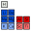 and selecting it there.
On the Add Atom panel in the Tools page make sure Fractional Coordinates is checked and then enter the following sets of coordinates, clicking Add after each set is entered:
x = 0.9166, y = 0.0, z = 0.2073
x = 0.6595, y = 0.0, z = 0.3165

Go back to the the Edit page and change the active element to oxygen by clicking the button. Then, return to the Tools page and add three more atoms at the following fractional coordinates:
x = 0.8272, y = 0.0, z = 0.4273
x = 0.495, y = 0.0, z = 0.2526
x = 0.1611, y = 0.0, z = 0.0984
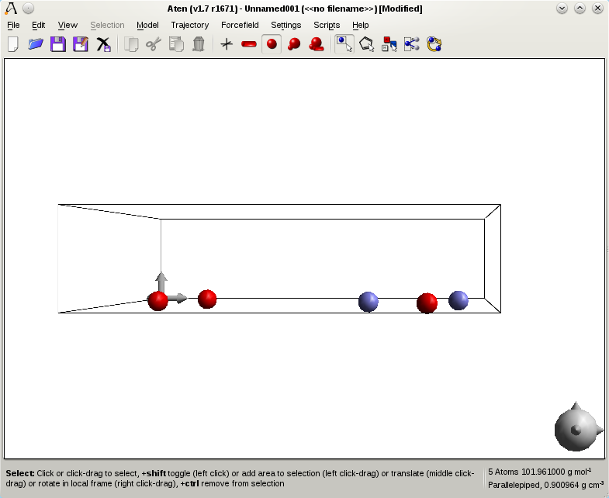

Assign the Spacegroup and Pack
To complete the model the spacegroup of the crystal must be set, so that generation of the symmetry-related atoms can be performed. This is all done on the Cell Define window. The spacegroup can be entered as either its numeric ID (as listed in the IUC Tables) or as the unformatted spacegroup name - θ-alumina belongs to spacegroup C2/m (number 12). Symmetry-related copies of the five atoms present in the cell can then be generated. Any overlapping atoms resulting from the application of the spacegroup’s generators are automatically removed.
Open the Cell Define Window again, and on the Spacegroup page enter the spacegroup as “C2/m” or “12” and press Set to assign the spacegroup to the model. Then, generate symmetry equivalent atoms by pressing the Pack button
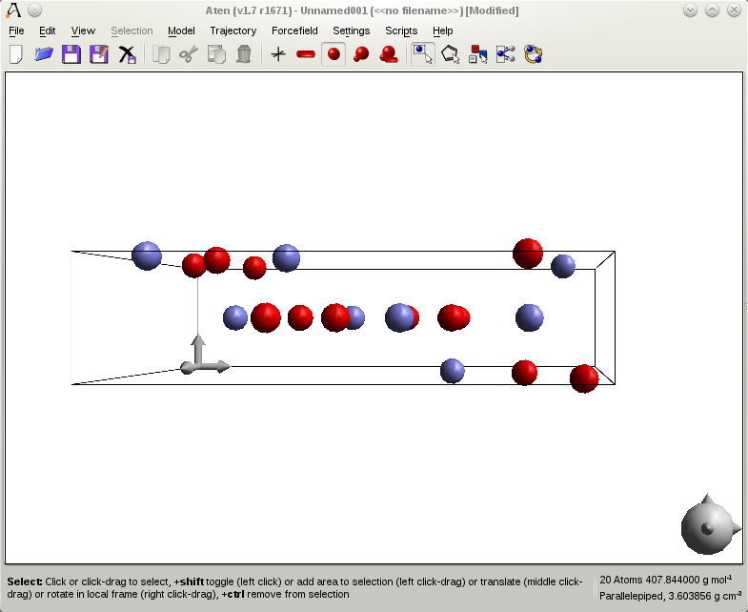

Replicate Cell and Recalculate Bonds
The basic crystal unit of θ-alumina isn’t too interesting on its own, so lets create a chunk to properly see the structure. Replicate the unit cell by 3 or 4 units in each positive direction (or more if you're feeling adventurous) and then calculate the bonding in the model.
Open the Cell Transform Window and on the Replicate page set each positive replication direction to 3 or 4. Press the Replicate button to generate the new supercell.
Back in the Build Window, go to the Edit page and Rebond the model.
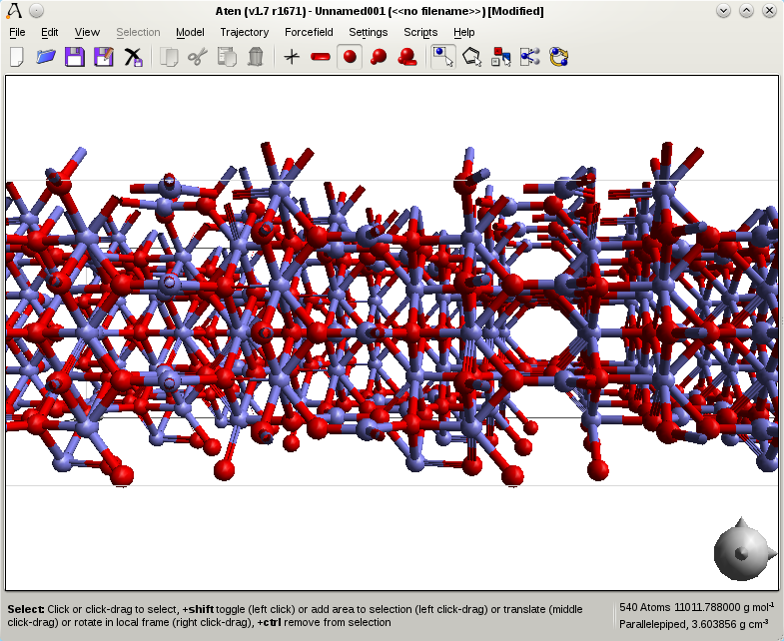

Script

newModel("alumina");
cell(11.854, 2.904, 5.622, 90, 103.83, 90);
newAtomFrac(Al,0.6595,0,0.3165);
newAtomFrac(Al,0.9166,0,0.2073);
newAtomFrac(O,0.8272,0,0.4272);
newAtomFrac(O,0.495,0,0.2526);
newAtomFrac(O,0.1611,0,0.0984);
spacegroup("C2/m");
pack();
replicate(0,0,0,3,3,3);
rebond();

Creating an NaCl/Water Two-Phase System (GUI)
It’s often necessary to create a larger system from a simple (or complex) unit cell, for example to generate bulk supercells of crystals, sufaces etc. The method outlined below shows how to do this for a simple crystal, and then extends this system to create a solid liquid interface.

Create the Template Model
First off, we will create a basic FCC template model which has a unit cell of exactly 1 Å, with atoms at {0,0,0}, {0.5,0.5,0}, {0.0,0.5,0.5}, and {0.5,0.0,0.5}, representing the basic positions of atoms in a face-centred cubic lattice.
Open the Cell Define Window
Add a unit cell to the model by checking the Has Cell? checkbox, then go to the Define/View ABC page and set the cell lengths a, b, and c to 1.0, then click Define.
Add the following four atoms to the model at the coordinates specified. Change the current element to Na with Pick on the Edit page in the Build Window, and use the Add Atom panel in the Tools page to create the atoms.
x = 0.0, y = 0.0, z = 0.0
x = 0.5, y = 0.5, z = 0.0
x = 0.0, y = 0.5, z = 0.5
x = 0.5, y = 0.0, z = 0.5
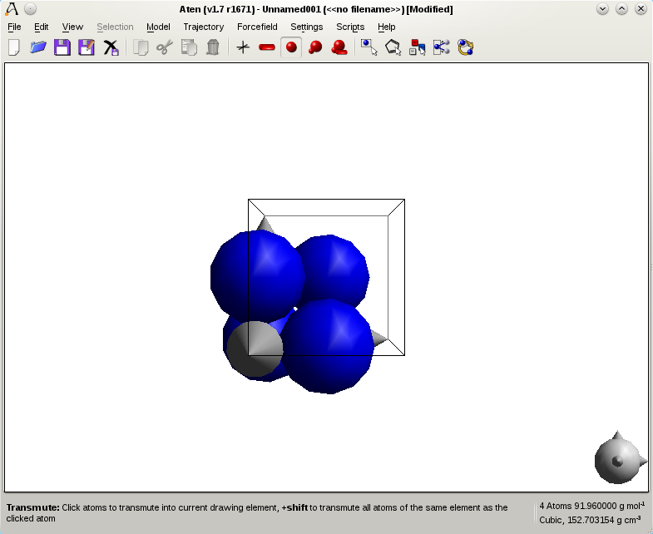

Create Interpenetrating Secondary Lattice
We need a second FCC lattice on which the chlorine atoms will sit. We could add them all by hand, but there are easier ways.
Ctrl-A | Select all the atoms in the model with the Ctrl-A shortcut, or go to the Edit menu and choose Select All.
Ctrl-C | Copy the current atom selection with Ctrl-C, or Edit→Copy.
Ctrl-V | Paste the copied atoms with Ctrl-V or Edit→Paste.
 | Open the Position Window and select the Flip page. Here we can mirror the coordinates of the current atom selection about its centre of geometry. So, mirror it once in any one of the x, y, or z directions (,, or ). Do not deselect the atoms afterwards, since we still need to transmute them into chlorines.
 | On the Edit page in the Build Window, set the current element to chlorine with Pick, and then click 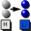 Transmute Sel.
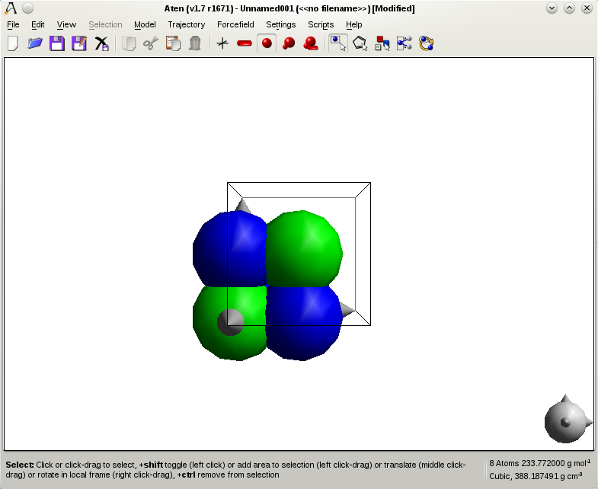

Scale and Replicate Unit Cell
We wish to scale the cubic unit cell of the model (currently with side length l = 1.0 Å) to correspond to the unit cell of sodium chloride (l = 5.628 Å). The cell can be scaled by a different amount in each Cartesian axis, but since we want to end up with a cubic cell we must scale each axis by the same amount.
Once the model represents proper the basic sodium chloride unit cell we can replicate it to create a larger system. Aten can replicate a basic cell by any integer or non-integer amount along each of the three principal cell axes, but here we will stick to integer amounts. The Replicate method also allows specification of both negative and positive replication amounts for each direction. Note that the values given in the Replicate page represent the total size which we require, so input values (negative/positive) of {0,0,0} and {1,1,1} will result in an unchaged cell.
On the Cell Transform Window go to the Scale page and enter a scale factor of 5.628 for each of x, y, and z. Press the Scale button to resize the unit cell.
Now, select the Replicate page and enter positive replication values of 5.0 for both x and z, and 2.0 for y, and press Replicate to create the supercell.
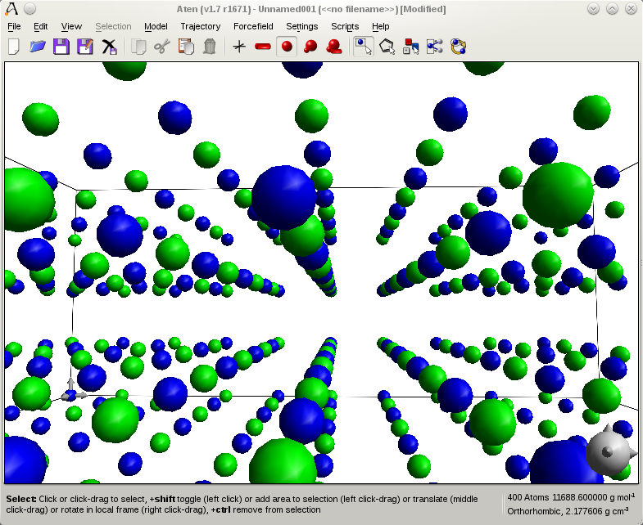

Create an Interface
It's a simple job to create an interface from the current system - all we need do is increase the cell dimension along the y direction (the cell’s b length).
Open the Cell Define Window, and either change the central number of the Matrix page or the b value on the Define/View ABC page. If you replicated the y direction by 2.0 earlier, then the current value of b should be 11.238 Å. Change it to 22.5 to roughly double the volume of the cell and create an interface in the xz plane.

Make a Water Model
We will now create a water molecule in a separate model so we can add it in to the NaCl cell using the Disorder Builder.
Main Toolbar | Create a new, empty model (if you don’t have one already) with
In the Build Window change the active element to oxygen on the Edit page by clicking
Select the draw single atoms tool Atom and click once somewhere in the empty model to create an oxygen
Add hydrogens to the model by clicking AddH Model

Add Water to the NaCl Cell
It’s time to run the disorder builder on the system. We’ll instruct the builder to add water in to the extended NaCl cell, but only into the part which is empty.
Run the Disorder Builder wizard
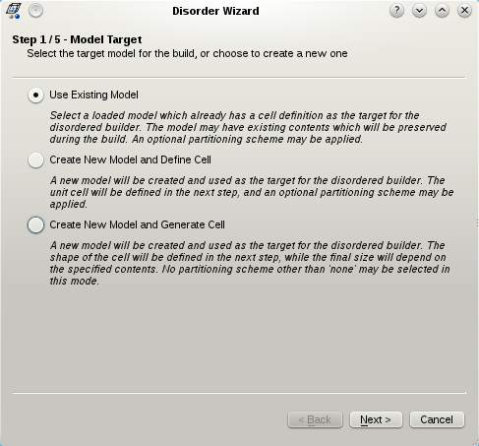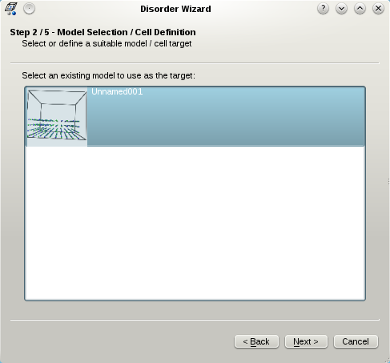
We wish to add in water to an existing system in this example, so choose the top option (Use Existing Model) and press Next. You then need to choose the target model for the builder, which is the extended NaCl system we just created. Select it and press Next.

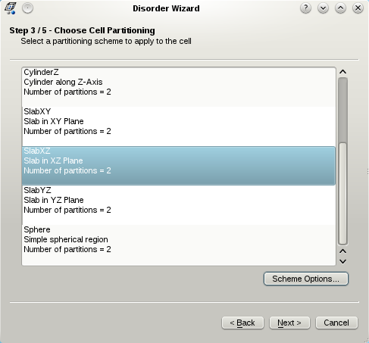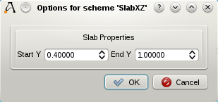
Now we choose the partitioning scheme for the system. We could be lazy and just choose “None”, since the NaCl lattice should ‘reject’ any water molecule we attempt to add over it. However, here we will choose an appropriate partitioning scheme for the task, “SlabXZ”. This will allow us to restrict water molecules to a specific y-range in the unit cell. Select “SlabXZ” and press the Scheme Options button to bring up the options dialog for the scheme. There you will see the start and end values of y for the slab (in fractional cell coordinates). The initial minimum limit of 0.4 is, luckily, appropriate for the system, but the upper bound needs to be set to 1.0. Press OK when done and then Next.
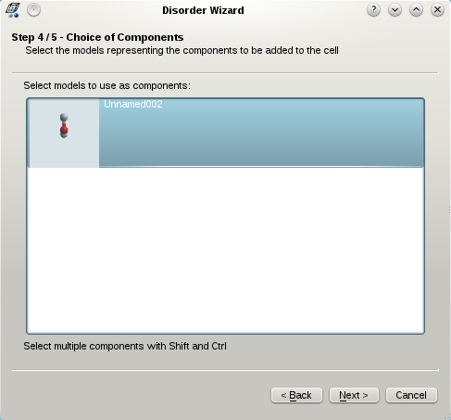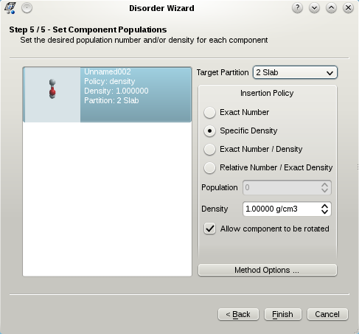
Finally, model selection and preparation. Select the water molecule from the list and press Next to get to the component setup page. We must change the Target Partition of the water molecule to 2 (the slab we defined earlier), and then request that a Specific Density of molecules be inserted into this partition (the default of 1.0 g cm^{–3} is fine). Once this information has been entered, press Finish to start the build.
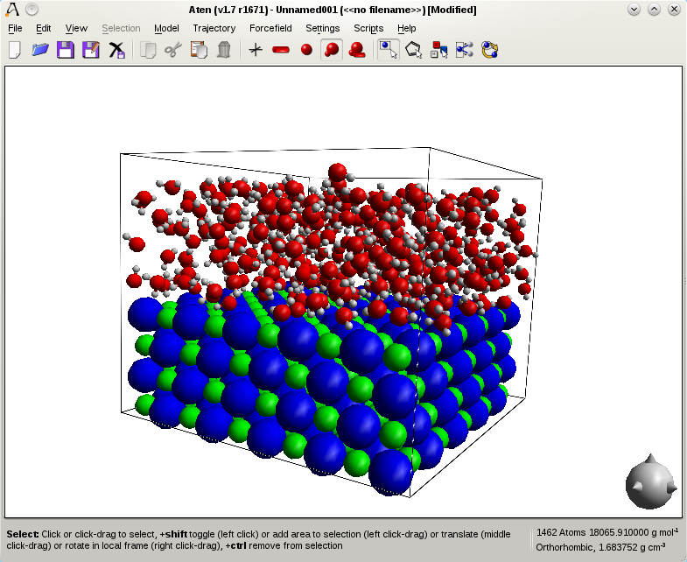

Script
The script below creates the water molecule as the first step to make life a little easier.

newModel("Water");
newAtom(O);
addHydrogen();
setupComponent("density", 2, 0, 1.0);

newModel("fcc");
cell(1,1,1,90,90,90);
newAtom(Na,0,0,0);
newAtom(Na,0.5,0.5,0);
newAtom(Na,0.5,0,0.5);
newAtom(Na,0,0.5,0.5);
selectAll();
copy();
paste();
flipX();
transmute(Cl);
scale(5.628,5.628,5.628);
replicate(0,0,0,5,2,5);
setCell("b",28.12);
disorder("SlabXZ,end=1.0");

Building Ice I_{h} from Crystal Information (GUI)
Similar in spirit to the alumina example (Section 5.2), here we create a single ice I_{h} crystal from the crystal information, and then replicate it to form a larger supercell. The crystal information used below is from Leadbetter et al., J. Chem. Phys., 82, 424 (1985), Table II (Structural parameters of ice at 5 K).

Create the Basic Unit Cell
First, we create the unit cell, which from the paper is orthorhombic with side lengths a = 4.5019, b = 7.7978, and c = 7.328 Å. There a five symmetry-unique atoms to add into the cell. This might seem odd given that this doesn't add up to a whole number of water molecules, but one of the water molecules lays with its oxygen on a mirror plane, and so only needs one hydrogen to be specified. Atom positions in the paper are given in fractional coordinates - we will create the atoms using these coordinates which will be converted by Aten into their real (cell) coordinates automatically.
Open the Cell Define Window
Add a unit cell to the model by checking the Has Cell? Checkbox, then go to the Define/View ABC page and set the cell lengths a, b, and c to 4.5019, 7.7978, and 7.328 respectively. Leave the cell angles all at 90°, and click Define.
In the Build Window change the active element on the Edit page to oxygen by clicking the button.
On the Add Atom panel in the Tools page make sure Fractional Coordinates is checked and then enter the following sets of coordinates, clicking Add after each set is entered:
x = 0.0, y = 0.6648, z = 0.0631
x = 0.5, y = 0.8255, z = -0.0631
Go back to the the Edit page and change the active element to hydrogen by clicking the  button. Then, return to the Tools page and add three more atoms at the following fractional coordinates:
x = 0.0, y = 0.6636, z = 0.1963
x = 0.0, y = 0.5363, z = 0.0183
x = 0.6766, y = -0.2252, z = -0.0183
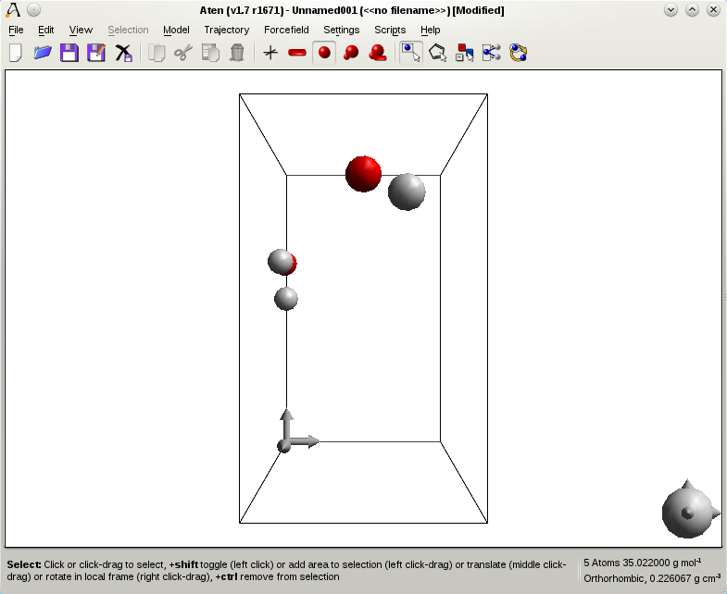

Set the Spacegroup and Pack
To complete the model the spacegroup of the crystal must be set so that generation of the symmetry-related atoms can be performed.
Open the Cell Define Window again, and on the Spacegroup page enter the spacegroup as “Cmc21” or “36” and press Set to assign the spacegroup to the model. Then, generate symmetry equivalent atoms by pressing the Pack button
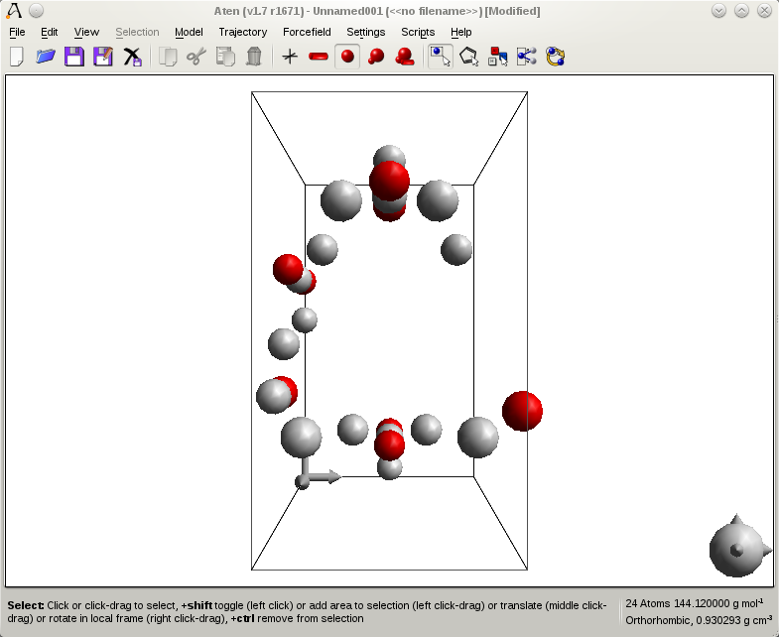

Replicate Cell and Calculate Bonding
The basic cell of ice I_{h} isn’t particularly interesting by itself, so we will replicate the cell to create a larger supercell, and then calculate bonds in the new model so that the hexagonal structure is clear to see.
On the Cell Transform Window go to the Scale page and enter a scale factor of 5.628 for each of x, y, and z. Press the Scale button to resize the unit cell.
Now, select the Replicate page and enter positive replication values of 5.0 for both x and z, and 2.0 for y, and press Replicate to create the supercell.
Back in the Build Window, go to the Edit page and Rebond the model.
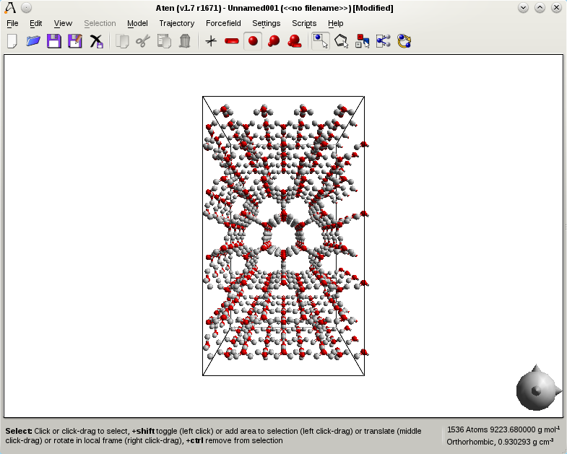

Script

newModel("ice");
cell(4.5019,7.7978,7.3280,90,90,90);
newAtomFrac(O,0,0.6648,0.0631);
newAtomFrac(O,0.5,0.8255,-0.0631);
newAtomFrac(H,0,0.6636,0.1963);
newAtomFrac(H,0,0.5363,0.0183);
newAtomFrac(H,0.6766,-0.2252,-0.0183);
spacegroup("Cmc21");
pack();
replicate(0,0,0,4,4,4);
rebond();

Exporting Coordinates in Bohr (Filters)
Aten works in units of Angstroms, but of course this does not suit every other computational code out there. Many physics code allow (or require) input in units of Bohr. The simplest way of generating coordinates in Bohr rather than Angstroms is to write a custom filter to output the data in the units that you want, converting to/from Angstroms on the fly. This example takes the existing xyz filter and creates a new ‘xyzbohr’ filter that does reads and writes in Bohr (note that Aten still works in Angstroms, however).
Firstly, copy the xyz filter that comes with Aten, probably in /usr/share/aten/data/filters on Linux/Mac, or C:\Program Files\Aten N.MMM on Windows, and copy this to your user filter directory. On Linux/Mac this is ~/.aten/filters, while on Windows this will be a directory called aten in your user home in Documents and Settings. Rename your copy of the file to xyzbohr.
To make this new filter file read and write in units of Bohr we need to simply divide or multiply by 0.5292, depending on whether we’re writing or reading the coordinates. SO, begin by changing the importmodel section (around line 23) to read:

i = newAtom(e, rx*0.5292, ry*0.5292, rz*0.5292);

So this just converts the units of Bohr in the file to Angstroms on input, right? The exportmodel section must be modified as well (around line 38):

for (Atom i=m.atoms; i != 0; ++i) writeLineF("%-8s %12.6f %12.6f %12.6f
%12.6f\n",i.symbol,i.rx*0.5292,i.ry*0.5292,i.rz*0.5292,i.q);

The importtrajectory section can be modified in a similar way, or can be removed if it is not required.
As it stands, this new xyzbohr filter will ‘hide’ the original xyz filter since both the nicknames and IDs are the same, and so they must be changed in the importmodel and exportmodel headers (and the importtrajectory if it is still there). Simply changing all occurrences of ‘xyz’ to something like ‘xyzb’ is enough, as well as choosing an ID for the new filter which is not currently in use (something above 100 is safe).
The next time Aten is run the user filter directory will be searched and the new xyzbohr filter will be loaded ready for use, just as the normal stock of filters are.
The entire new filter file looks like this:

# Bohr XYZ coordinates files (for v1.2+)
# Created: 19/07/2011
# Last modified: 19/07/2011
# ChangeLog:

filter(type="importmodel",name="XMol XYZ Coordinates (in Bohr)", nickname="xyzb", extension="xyzb", glob="*.xyzb", id=30)
{
# Variable declaration
int natoms,n,m;
string e,title;
double rx,ry,rz,q;
Atom i;

# Read data
while (!eof())
{
readLine(natoms);
getLine(title);
newModel(title);
for (n=1; n<=natoms; ++n)
{
readLine(e,rx,ry,rz,q);
i = newAtom(e, rx/0.529, ry/0.529, rz/0.529);
i.q = q;
}
rebond();
finaliseModel();
}
}

filter(type="exportmodel",name="XMol XYZ Coordinates (in Bohr)", extension="xyzb", glob="*.xyzb", nickname="xyzb", id=30)
{
# Variable declaration
Model m = aten.frame;

writeLine(m.natoms);
writeLine(m.name);
for (Atom i=m.atoms; i != 0; ++i) writeLineF("%-8s %12.6f %12.6f %12.6f %12.6f\n",i.symbol,i.rx*0.529,i.ry*0.529,i.rz*0.529,i.q);
}

Calculate Average Coordinates (CLI)
This example takes the supplied water trajectory and determines the average coordinates of all the individual water molecules. Note that no accounting for the periodicity of the system is taken into account.

vector xyz[aten.model.natoms];
int nframes = aten.model.nFrames;
int natoms = aten.model.nAtoms;
printf("Number of frames is %i\n", nframes);
for (Model f = aten.model.frames; f; ++f)
{
for (int n=1; n<=natoms; ++n) xyz[n] += f.atoms[n].r;
}
for (int n=1; n<=natoms; ++n) xyz[n] = xyz[n] / nframes;
Model f = aten.model.frames;
newModel("Average");
for (int n=1; n<= natoms; ++n)
{
newAtom(f.atoms[n].z, xyz[n].x, xyz[n].y, xyz[n].z);
}

Copy and save this to a file named avgeom.txt.
To run the example:

aten --zmap singlealpha data/test/water66-spcfw.CONFIG
-t data/test/water66-spcfw.HISu -s avgeom.txt

Self-Contained Liquid Chloroform Builder (Script)
This script (installed in the $ATENDATA/scripts directory) is an example of a completely self-contained script, depending on no external model or forcefield files. The chloroform model is built by hand, and the necessary forcefield is constructed in the script itself, before being used to create a box of liquid chloroform. Only the density of the liquid and the desired number of molecules are required in order to build the system, since the molecular volume is worked out from the density and the mass.
# Build chloroform system

# First, create chloroform model by transmuting a methane molecule.
# Since C-Cl distances will then be too short, we lengthen them afterwards
newModel("chloroform");
newAtom(C);
addHydrogen();
select(3,4,5);
transmute(Cl);
for (int n=3; n<6; ++n) setDistance(1,n,1.758);

# Set number of molecules and density required (g/cm3)
setupComponent("both", 1, 100, 1.483);

# Create a model with a basic unit cell - the disorder builder will adjust its size as necessary
newModel("box");
cell(1.0,1.0,1.0,90,90,90);
disorder("None", FALSE);

# Construct new forcefield (using AMBER params)
newFF("chloroformff");
units("kj");
# Taken from files at http://www.pharmacy.manchester.ac.uk/bryce/amber
typeDef(1,"CZ","CZ",C,"-Cl(n=3),-H","Chloroform carbon");
typeDef(2,"HZ","HZ",H,"-&1","Chloroform hydrogen");
typeDef(3,"Cl","Cl",Cl,"-&1","Chloroform chlorine");
interDef("lj",1,-0.3847,4.184*0.1094, 1.9080*2.0/2.0^(1.0/6.0));
interDef("lj",2,0.2659,4.184*0.0157, 1.187*2.0/2.0^(1.0/6.0));
interDef("lj",3,0.0396,4.184*0.3250, 2.0*2.0/2.0^(1.0/6.0));
bondDef("harmonic","CZ","HZ",2845.12,1.1);
bondDef("harmonic","CZ","Cl",1944.7232,1.758);
angleDef("harmonic","HZ","CZ","Cl",318.8208,107.68);
angleDef("harmonic","Cl","CZ","Cl",650.1936,111.3);
finaliseFF();
ffModel();

# Minimise our new system a little
mcMinimise(100);

saveModel("dlpoly", "chloroform.CONFIG");
saveExpression("dlpoly", "chloroform.FIELD");
quit();

Generating Images Without the GUI (CLI)
Sometimes it's useful to quickly generate images for a system from the command line, either because the system is prepared from the command line, or because generating hundreds of images through the GUI is insanely repetetive. To quickly save a picture of a system in it's ‘standard’ view orientation (i.s. as you would see it if you loaded it into the GUI) you can do the following:

aten data/test/cellulose.cif -c 'saveBitmap("png", "cellulose.png"); quit();'

Doing this will load the cellulose model, save an image of it, and then quit without ever starting the GUI. By default, the size of a saved image is 800x600, but optional arguments to the saveBitmap command allow this to be set explicitly.

Calculating a Torsion Energy Profile (CLI)
This example demonstrates a simple energy analysis procedure in which we load a model and perform a scan of a geometric parameter, calculating the energy at each step. The methanol model and OPLS-AA forcefield (both supplied with Aten) are used by the command, but of course can easily be substituted with your own choices. The command first sets the electrostatic calculation method to be the simple Coulomb sum (since the methanol model is non-periodic) and prior to the loop starting a text header is written. The loop iterates a variable phi over the range -180 to +180 degrees in steps of 5, and is used to set the torsion angle between atoms 2, 1, 4, and 6 (corresponding to one of the H–C–O–H torsions in the model). A line of output is written for each torsion angle considered, providing the total torsion, van der Waals, and electrostatic energy of the system at this geometry.

aten --ff oplsaa.ff data/test/methanol.inp -q
-c 'aten.prefs.elecMethod = "coulomb";
printf("Torsion Angle E(Torsion) E(VDW) E(Coulomb)\n");
for (double phi = -180.0; phi <= 180.0; phi += 5) {
setTorsion(2,1,4,6,phi);
printf("%12.6f %12.6f %12.6f %12.6f\n", phi, aten.model.torsionEnergy(), aten.model.vdwEnergy(), aten.model.elecEnergy()); } quit();'

Note that the use of the -q option means that only fundamental error messages and user output (through the printf statements in the command) is printed – all of Aten’s other working information is suppressed.

Running a Script on Many Models (CLI/Batch)
aten -c 'loadscript("test.script","ascript");' --keepnames *.gro --batch
-c 'runscript("ascript");'

Saving GAMESS-US Input with Options (CLI)
Batch conversion or saving between molecule formats which contain purely coordinate and cell information is relatively trivial, but when saving to file formats which contain many user-adjustable parameters (e.g. Gaussian or GAMESS-US input) it may also be desirable to set these options explicitly on the command-line with Aten, rather than editing the files afterwards.
For export filters which contain GUI dialog definitions allowing the user to set these options it is possible to modify the values of all the controls defined in the dialog from the command-line, simply by specifying the control name and new value the control should take on. The following example loads the supplied water model (in xyz format), performs a MOPAC minimisation on the model (with --batch mode), and then saves it as a GAMESS-US input file. The --export switch takes just the nickname of the export filter at its most basic, but can also be supplied with a comma-separated list of control names and values to set before writing the file(s). In this case, we request that a DFT calculation be performed with the B3LYP functional, using the MCP-DZP basis set, and allowing for 200 steps in the geometry optimisation. Note that all the GUI controls in the GAMESS-US export filter have been given names which relate directly to the block and keyword which they relate to in the input file.

bob@pc:~> aten data/test/water.xyz --export
"gamusinp,contrl_dfttyp=B3LYP,basis_gbasis=MCP-DZP,statpt_nstep=200" --batch -c
'mopacminimise();'

Alternatively, one may specify the --dialogs switch to force the export filter’s dialog box to be raised when running Aten from the command-line, allowing options to be set using the dialog (but without raising the full GUI).

Printing all Bond Distances in a Model (CLI)
Quickly getting at geometric data in a model file is often useful without having to go through the GUI, in order to quickly verify a geometry or get certain data into a file. The following command prints out all of the bond distances, including the indices of the atoms involved, from the command line:

bob@pc:~> aten data/test/methanol.inp -c 'for (Bond b = aten.model.bonds; b; ++b) printf("Distance %i-%i = %f\n", b.i.id, b.j.id, geometry(b.i,b.j)); quit();'

This will give you output along the following lines:

Autodetecting patterns for model 'Methanol'..
New pattern 'OCH4' added - startatom 1, 1 mols, 6 atoms per mol.
Pattern description completed (spans 6 atoms).
Done.
Augmenting bonds in pattern OCH4...
Distance 1-2 = 1.080000
Distance 1-3 = 1.080000
Distance 1-4 = 1.080000
Distance 1-5 = 1.080000
Distance 4-6 = 1.079999

All very good, but what about the extra information printed by Aten (such as pattern detection, etc.)? This can be inhibited by adding the -q switch to the command.

Creating a Porous Silica Model
This example takes an existing amorphous silica model (supplied with Aten) drills some cylindrical pores, hydroxylates the resulting internal surfaces, and fills the pore with a liquid.

Prepare the Template Model
Firstly, load the amorphous-silica.ato model file, and then calculate bonding within the model. The model has a monoclinic cell, just to make things interesting.
Open the Build Window and click the Rebond button to recalculate bonding between the atoms in the model (since they are currently all unbound).
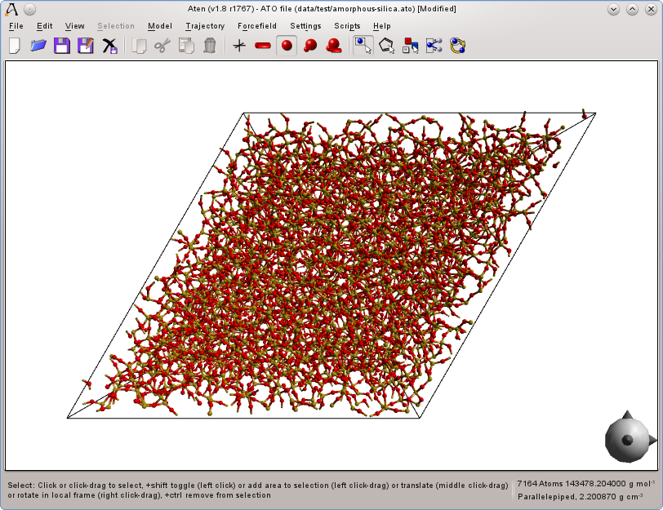

Drill Pores in the Model

Command Line Usage
From a shell, running Aten with no arguments will start up the code in GUI. If model files are provided on the command line, these will be loaded in so that, when the GUI starts, they may be hacked apart according to your desired tastes. The command-line is also a powerful way of editing without using the GUI at all. What follows is a description of the usage of command-line arguments, and a list of all recognised arguments.

Switch Order
Two important things to consider. Firstly, short options (e.g. ‘-b’, ‘-d’ etc.) may not be concatenated into one long specification of a short option (i.e. ‘-bd’) - they must be given separately as ‘-b -d’ or they will not be recognised. Secondly, the order of the given switches is important since their meaning is applied or acted out immediately. For example:

bob@pc:~> aten --nobond test1.xyz test2.xyz

will load the models ‘test1.xyz’ and ‘test2.xyz’, preventing recalculation of bonds between atoms in both. However:

bob@pc:~> aten test1.xyz --nobond test2.xyz

will only prevent recalculation of bonds for the second model. The reason for acting on switches and arguments in the order they are encountered on the command line is to allow for flexibility, especially when using Aten as a non-graphical processor.
Note: The position of debug switches or those affecting the verbosity of the program has no bearing on the timeliness of their effect – they are dealt with first by Aten regardless of where they appear in the program’s arguments.

Switches

A
--atendata <dir>
Tells Aten to use the specified dir as its data directory (where filters etc. are stored). This overrides the ATENDATA shell variable.

B
-b, --bohr
Specifies that the unit of length used in any models and grid data that follow is Bohr rather than Å, and should be converted to the latter.
--batch
Enter batch processing mode, modifying and saving models to their original filenames. See Section 6.3 for details and a list of other modes.
--bond
Force recalculation of bonding in loaded models, regardless of whether the filter used any of the rebond commands (see the list of bond-related commands in Section 9.2).

C
-c <commands>, --command <commands>
Provides a command or compound command to execute. Commands should be enclosed in single quotes (to prevent the shell from misquoting any character strings) and individual commands separated with semicolons. Commands provided in this way can be used to set up Aten in the way you want it from the command line, perform operations on model files before loading the GUI, or perform operations on model files without loading the GUI at all.
For example, to start the GUI with a new model named ‘cube’ that has a cubic cell of 30 Å side length:

bob@pc:~> aten -c 'newmodel("cube"); cell(30,30,30,90,90,90);'

Similarly, to load a model and make a duplicate copy of the atoms (pasted into the same model):

bob@pc:~> aten original.xyz -c 'selectall(); copy(); paste(10,10,10);'

In both cases the GUI initialises itself without being told, but this can be prevented with the quit command. Consider the last example – to save the newly-expanded model and quit without ever launching the GUI:

bob@pc:~> aten original.xyz -c 'selectall; copy; paste(10,10,10); savemodel("xyz", "pasted.xyz"); quit;'

Multiple sets of commands may be given:

bob@pc:~> aten source.xyz -c 'selectall; copy' target.xyz -c 'paste(10,10,10);'

Take care here, since the commands provided act on the current model, i.e. the one that was most recently loaded. Commands are available that select between the loaded models – see the list of model-related commands in Section 9.22.
--cachelimit <limit>
Sets the size limit for trajectory loading, in kilobytes. If an entire trajectory will fit into this cache, all frames in the trajectory are loaded immediately. If not, frames will be read from disk as and when required.
--centre
Force translation of non-periodic models centre-of-geometry to the origin, even if the centre command was not used in the corresponding filter.

D
-d [<type>], --debug [type]
Enables debugging of subroutine calls so that program execution can be traced, or enables extra debug output from specific types of routines (if type is given). Warning - this creates a lot of output, most of which is incomprehensible to people with their sanity still intact, but is useful to track the program up to the point of, say, a hideous crash. Valid type values are listed in Output Types in Section 16.14.
--dialogs
By default, filter and script user dialogs are not shown when performing functions on the command-line. This switch forces dialogs to be shown.
--double <name=value>
Creates a ‘floating’ variable name which is of type ‘double’ and that can be accessed from any subsequent script, command, or filter. Note that declarations of variables with the same name made in scripts, commands and filters will override any passed value names in order to avoid conflicts and breaking of existing filters and scripts. The intended use is to be able to pass values easily from the command-line into scripts or one-line commands.
For example, in a bash shell:

bob@pc:~> for num in 10.0 50.5 100.0; do aten --double d=$num -c 'printf("Value is %f\n", d); quit();' done

E
--export <nickname>
Enter export mode, where each model specified on the command line is loaded and saved in the format corresponding to the <nickname> specified. If specified in conjunction with --batch, batch export mode is entered instead, with commands run on models before being saved to the new format. See Section 6.3 for details and a list of other modes.
--exportmap <name=element,...>
Manually map assigned atom typenames in an expression to the names defined here when expressions are written to a file. For example:

bob@pc:~> aten --ff spc.ff data/test/water.xyz --exportmap "OW=Ospc,H=Hspc" -c 'saveexpression("dlpoly", "water.FIELD"); quit();'

writes the water forcefield with the OW and HW atomtype names mapped to Ospc and Hspc respectively.
--expression <file>
Loads the specified file as if it were an expression.

F
-f <nickname>, --format <nickname>
For any forthcoming model files provided as arguments on the command line, the specified model import filter is used to load them, regardless of their filename extension (or, indeed, actual format). Since Aten tends not to determine file formats by looking at their content, this is useful for when you know that file is in a particular format, but with an extension that doesn't help Aten recognise it as such.
--ff <file>
Loads the specified forcefield file, making it the current forcefield. If the desired forcefield is present in either Aten’s installed data/ directory or in your own .aten/ff directory (see Section 4.2), then just the filename need be given as Aten searches these locations by default.
--filter <file>
Load the specified file as if it were a filter file, installing any filters defined within it. Any filters already loaded that have the same ‘nickname’, ‘id’ etc. will be hidden by those loaded from file. See Section 11.1.3 for more information on overriding existing filters.
--fold
Force folding of atoms to within the boundaries of the unit cell (if one is present) in loaded models, even if the command fold was not used in the corresponding filter.

G
-g <file>, --grid <file>
Loads the specified grid data file, associating it to the current model, and making it the current grid. A model (even an empty one) must exist for a grid to be loaded.

H
-h, --help
Show the possible command-line switches and a short description of their meaning.

I
-i, --interactive
Starts Aten in interactive mode, where commands are typed and immediately executed. The GUI is not started by default, but may be invoked.
--int <name=value>
Creates a ‘floating’ integer variable name. See the --double switch for a full description.

K
-k, --keepview
Preserves the last stored view of models when the GUI starts, retaining any model rotations and camera transformations performed in scripts or on the command line (normally, the view is reset to display the entire model on startup).
--keepnames
If specified, for each model loaded the original atom names in the file will be preserved as a series of forcefield types generated within a new forcefield created specifically for the model. Elements are still determined from conversion of the atom names, and may still be mapped with the --map option. This option is useful for quickly creating a skeleton set of forcefield types from an existing model with type names, or to allow quick import and export of typed configurations without requiring the original forcefield file to be loaded.
Note that the --keeptypes and --keepnames switches are mutually exclusive.
--keeptypes
If specified, for each atom name converted to an element using a forcefield name match, the corresponding forcefield type will be assigned to the atom and fixed. Like the --keepnames switch, this is useful for preserving atom type data when importing certain models which do not store element information.
Note that the --keeptypes and --keepnames switches are mutually exclusive.

M
-m <name=element,...>, --map <name=element,...>
Manually map atom typenames occurring in model files to elements according to the rules defined here. For example:
bob@pc:~> aten --map 'CX=C,N_=P'

will result in atoms called CX being mapped to carbon, and atoms called N_ mapped to phosphorus (for whatever reason). These mappings are attempted prior to any z-mapping scheme defined in the filter, and so will take precedence over standard typename-to-element conversions.

N
-n
Create a new, empty model.
--nicknames
Print a list of all available import/output filter nicknames and quit.
--nobond
Prevent recalculation of bonding in loaded models, overriding filter directives. This basically means that, if a filter tries to run the rebond command, then specifying --nobond will prevent it.
--nocentre
Prevent translation of non-periodic models centre-of-geometry to the origin, overriding filter directives.
--nofold
Prevent initial folding of atoms to within the boundaries of the unit cell (if one is present) in loaded models, overriding the use of the fold command in the corresponding filters.
--nofragments
Prevent loading of fragments from both standard and user locations on startup.
--nofragmenticons
Prevent generation of fragment icons, used in the Fragment Library Window (see Section 7.13).
--noincludes
Prevent loading of global includes on startup.
--nolists
Prevent the use of OpenGL display lists for rendering. Simple vertex arrays will be used instead. Try this option out if rendering is corrupt or Aten crashed unexpectedly on startup. The rendering will be slower, but more compatible.
--nopack
Prevent generation of symmetry-equivalent atoms from spacegroup information in loaded models, overriding any occurrences of the pack command is used in the corresponding filter.
--nopartitions
Prevents loading of partitions on startup.
--noqtsettings
Don’t read in any system-stored Qt settings on startup (such as window positions, toolbar visibilities etc.) using the defaults instead.

P
--pack
Force generation of symmetry-equivalent atoms from spacegroup information in loaded models, even if the pack command was not used in the corresponding filter.
--pipe
Read and execute commands from piped input on startup.
--process
Enter process mode, where commands are run on models but no changes are saved – instead, the GUI is started once all commands have been executed. See Section 6.3 for details and a list of other modes.

Q
-q, --quiet
Prevents nearly all text output from Aten, including error messages and the like, but does allow printing of user output via the printf command in scripts and commands passed with --command. Useful in order to print clean data to a file or standard output.

S
-s <file>, --script <file>
Specifies that the script file is to be loaded and run before moving on to the next command-line argument. A script file is just a plain text file that contains sequence of commands to be executed, written in the command language style (see Section 8.1).
--string <name=value>
Creates a ‘floating’ string variable name. See the --double switch for a full description.

T
-t <file>, --trajectory <file>
Associates a trajectory file with the last loaded / current model.

U
-u <nlevels>, --undolevels <nlevels>
Set the maximum number of undo levels per model, or -1 for unlimited (the default).

V
-v, --verbose
Switch on verbose reporting of program actions.
--vbo
Attempt to use OpenGL vertex buffer objects when rendering, for maximum performance.

Z
-z <maptype>, --zmap <maptype>
Override the names to elements z-mapping style defined in file filters. For a list of possible mapping types see ZMapping Types in Section 16.17.

Batch Processing Modes
Aten has several batch or ‘offline’ processing modes that do not need the GUI to be invoked. These permit calculations, analyses or processes to be performed on multiple models in one simple command. Most work by storing any commands or command sequences supplied with --command until all models are loaded, and then running the commands on each loaded model in sequence. The modes are as follows:

Batch Mode
Invoked by the --batch switch, this mode runs all commands provided on all models, once the last model has been loaded. The models are then saved in their original format to the same filename. Note that, if the an export filter does not exist for the original model file format, changes to that model will not be saved. It is advisable to work on a copy of the model files when using this command, or to use batch export mode to save to a different format in order to preserve the original files. The GUI is not automatically started in batch mode.
For example, to transmute all iron atoms into cobalt for a series of xyz files named ‘complex_001.xyz’, ‘complex_002.xyz’ etc.

bob@pc:~> aten --batch -c 'select(Fe); transmute(Co);' complex_*.xyz

Export Mode
Invoked by the --export switch, in export mode each model file specified on the command line is loaded and immediately saved in the format specified by the provided nickname, allowing multiple files to be converted to a different format at once. The GUI is not automatically started in export mode.
For instance, to convert three DL_POLY CONFIG files and an xyz into mol2 format:

bob@pc:~> aten --export mol2 bio1.CONFIG bio2.CONFIG watercell.CONFIG random.xyz

If specified in conjunction with the --batch switch, batch export mode is entered instead, and any supplied commands are executed on each loaded model file before it is saved. The original model files are not modified.

Batch Export Mode
Invoked by providing the --batch and --export switches together, batch export allows a series of commands to be run on a set of loaded models, the results of which are then saved in new files in the model format provided to the --export switch. The GUI is not automatically started in batch export mode.
Let’s say that you have a directory full of xyz files that you wish to energy minimise with MOPAC2009 (see Section 14.2), centre at zero, and then save as input to GAMESS-US. This can be achieved with the following command:

bob@pc:~> aten --export gamusinp --batch –c ‘mopacminimise(); selectall(); centre();’ *.xyz

Various export options for the GAMESS-US filter (e.g. method type, basis set) can be set at the same time. See how to set filter options in Section 11.1.5, and Section 5.11 for an example.

Process Mode
Similar to the --batch switch, in that all commands supplied with --command are executed on each model, but in this case the results are not saved, and the GUI starts once processing is complete.

The GUI

Overview
Aten’s main window is predominantly taken up with the rendering canvas where model(s) are displayed. Multiple models may be displayed simultaneously – the ‘current’ model (i.e. the one to which all editing / data operations are send) always has a black box drawn around it. A single toolbar sits above the canvas providing quick access to file, edit, and select actions. All other functionality is contained with various tool windows. These tool windows are accessed by the ToolBox widget, which by default is the only window displayed on startup (if it is not visible, you can raise and centre it on the main window from the menu item Settings→Show Toolbox). At the foot of the window is a status bar reflecting the content of the current model, listing the number of atoms and the number of selected atoms (bold value in parentheses, but only if there are selected atoms), the mass of the model, and the cell type and density (if the model is periodic).
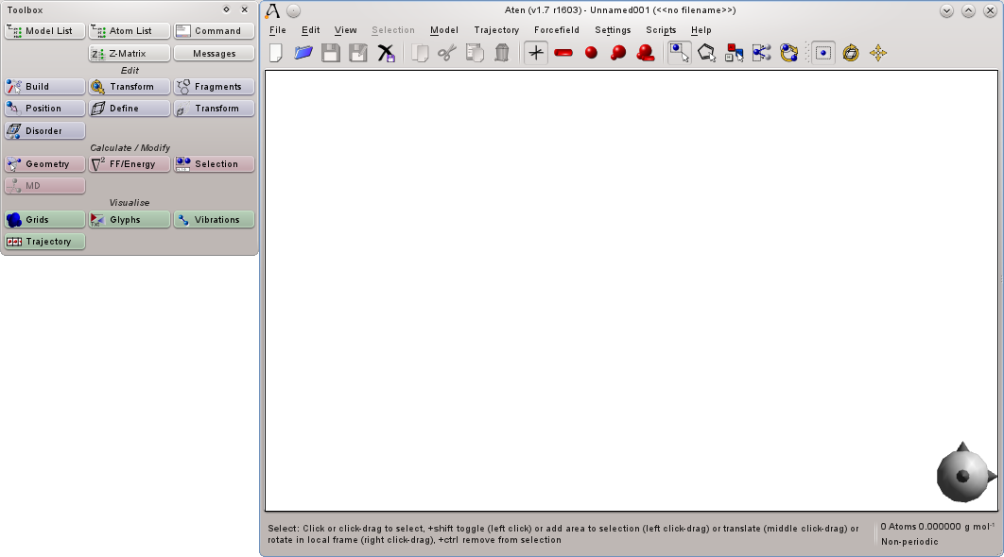
Figure 7-1 Aten’s main window and toolbox
The edges of the main window, around the canvas, are standard (Qt4) dock areas, in which the toolbox and any of the tool windows can be placed. Once you have the various subwindows set up how you like them, press Settings→Store Default Window State to remember these settings for when Aten next starts.

Mouse Control
Each of the mouse buttons has a different ‘style’ of action on the canvas, each of which can be set to the user’s taste in the preferences (menu item Settings→Preferences on Linux/Windows). In addition the Shift, Ctrl, and Alt keys modify or augment these default actions performed by the mouse. Standard settings out of the box are:
Table 7-1 Mouse Button Actions
Button | Key Modifier | Action
Left | None | Click on individual atoms to select exclusively  Click-hold-drag to exclusively select all atoms within rectangular region
 | Shift | Click on individual atoms to toggle selection state  Click-hold-drag to inclusively select all atoms within rectangular region
 | Ctrl | Click on individual atoms to toggle selection state  Click-hold-drag to inclusively deselect all atoms within rectangular region
Right | None | Click-hold-drag to rotate camera around model  Click on atom to show context (Selection) menu
 | Shift | Click-hold-drag to rotate view around z-axis (perpendicular to plane of screen)
 | Ctrl | Click-hold-drag to rotate selection in local (model) space
 | Ctrl+Shift | Click-hold-drag to rotate selection around z-axis in local (model) space
Middle | None | Click-hold-drag to translate camera
 | Ctrl | Click-hold-drag to translate selection in local (model) space

Manipulating the View
At its most basic Aten’s main view acts as a visualiser allowing models to be rotated, zoomed in and out, and drawn in various different styles. By default, the right mouse button is used to rotate the model in the plane of the screen (right-click and hold on an empty area of the canvas and move the mouse) and the mouse wheel zooms in and out. Note that right-clicking on an atom brings up the atom context menu (equivalent to main window’s Selection menu). The middle mouse button translates the model in the plane of the screen – again, click-hold and drag.
These rotation and translation operate only the position and orientation of the camera, with no modifications made to the actual coordinates of the model. The view can be reset at any time from the main menu (View→Reset) or by pressing Ctrl-R. Both the main menu (View→Style), the main toolbar, and the shortcuts Ctrl-1 to Ctrl-5 allow the drawing style of models to be changed between stick, tube, sphere, scaled sphere, and individual. The last option allows different view styles to be set for different atoms.
The Ctrl key changes the normal behaviour of the rotation and translation operations and forces them to be performed on the coordinates of the current atom selection instead of the camera. The centroid of rotation is the geometric centre of the selected atoms.

Atom Selection
Atom selection or picking is performed with the left mouse button by default – single-click on any atom to highlight (select) it. Single-clicks perform ‘exclusive’ selections; that is, all other atom(s) are deselected before the clicked atom is (re)selected. Clicking in an empty region of the canvas deselects all atoms. Clicking on an empty space in the canvas, holding, and dragging draws a rectangular selection region – releasing the mouse button then selects all atoms within this area. Again, this selection operation is exclusive. Inclusive selections (where already-selected atoms are not deselected) are performed by holding the Shift key while performing the above operations. Furthermore, single-clicking on a selected atom while holding Shift will deselect the atom.

Keyboard Shortcuts
Shortcut | Action | Description
Escape | Box Select | Cancel current mouse mode and return to basic box-select interaction mode
Ctrl-A | Select All | Select all atoms in the current model
Ctrl-C | Copy | Copy the current atom selection to the clipboard
Ctrl-Alt-C | Centre Selection | Centre the current atom selection at {0,0,0}
Ctrl-D | Deselect All | Deselect all atoms in the current model
Ctrl-Delete | Delete | Delete the current atom selection
Ctrl-F | Fold Atoms | Fold all atoms into the unit cell
Ctrl-Shift-F | Fold Molecules | Fold atoms into the unit cell, keeping molecules intact
Ctrl-H | Hide Selection | Hide all selected atoms
Ctrl-Shift-H | Show All Atoms | Unide any hidden atoms
Ctrl-I | Invert Selection | Toggle the selection state of all atoms
Ctrl-N | New | Create a new, empty model
Ctrl-O | Open | Load an existing model into Aten
Ctrl-P | Play/Pause | Play / pause current trajectory
Ctrl-R | Reset View | Reset the camera for the current model
Ctrl-S | Save | Save the current model under its original filename
Ctrl-V | Paste | Paste the contents of the clipboard to the current model
Ctrl-X | Cut | Copy the current selection to the clipboard and delete it
Ctrl-Y | Redo | Redo last undone operation
Ctrl-Z | Undo | Undo last operation
Ctrl-1 | Stick | View models as sticks
Ctrl-2 | Tube | View models as tubes
Ctrl-3 | Sphere | View models as tubes and spheres
Ctrl-4 | Scaled | View models as tubes and scaled spheres
Ctrl-5 | Individual | View models according to atom’s assigned styles
Ctrl-- | Zoom Out | Zoom out
Ctrl-+ | Zoom In | Zoom in
Ctrl-Alt-< | First Frame | Jump to first frame of current trajectory
Ctrl-Alt-> | Last Frame | Jump to last frame of current trajectory
Ctrl-Right | Next Model
F8 | Detect H-Bonds | Toggle detection and display of hydrogen bonds
F10 | Quick Command | Raise a dialog window allowing a quick command to be run

The Main Toolbar
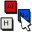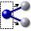
The main toolbar provides quick access to model load / save, edit, and selection operations. Left to right these icons are:
Icon | Action | Shortcut | Description
 | New | Ctrl-N | Create a new, empty model
 | Open | Ctrl-O | Load an existing model into Aten
 | Save | Ctrl-S | Save the current model under its original filename
 | Save As |  | Save the current model under a different filename
 | Close |  | Close the current model (prompting to save first if changes have been made)
 | Copy | Ctrl-C | Copy the current atom selection to (Aten’s internal) clipboard
 | Cut | Ctrl-X | Copy the current atom selection to the clipboard and then delete it
 | Paste | Ctrl-V | Paste the contents of the clipboard to the current model at the original coordinates. The pasted atoms then become the current selection. Note that pasted atoms are not translated to avoid overlap with existing atoms.
 | Delete | Ctrl-Delete | Delete the current atom selection
 | Stick | Ctrl-1 | Atoms are not explicitly drawn unless they possess no bonds, bonds are drawn using simple lines
 | Tube | Ctrl-2 | Atoms and bonds are drawn as tubes
 | Sphere | Ctrl-3 | Atoms are drawn as uniformly-sized spheres, with bonds drawn as tubes
 | Scaled | Ctrl-4 | Atoms are drawn as spheres whose size depends on their atomic radii, bonds are drawn as tubes
 | Individual | Ctrl-5 | Each atom is drawn according to its own assigned style
 | Box Select | Escape | Atoms may be (de)selected by clicking on them individually, or selected en masse with a click-hold-drag
 | Molecule Select |  | Bound fragments are selected by clicking on a single atom within that fragment
 | Element Select |  | Clicking on a single atom selects all atoms of the same element
 | Expand Selection |  | The current selection is expanded by following bonds attached to any select atoms
 | Invert Selection | Ctrl-I | Toggle the selection state of all atoms

The Mouse Toolbar
There is only one other toolbar in (newer versions of ) Aten – the Mouse toolbar. For multi-button mice each button can be assigned an invidual action (select, rotate model etc.). For those who use single-button rats, this toolbar changes the function of the first (or left) button between select / interact, rotate model, and translate model. Selecting these buttons overwrite the stored action for the left button in the Preferences.

Icon | Shortcut | Action
 | F1 | The left button selects and interacts with atoms
 | F2 | The left button rotates the view or selection
 | F3 | The left button translates the view or selection

The ToolBox
The ToolBox provides access to most of Aten’s functionality, allowing various different subwindows to be shown (and hidden).
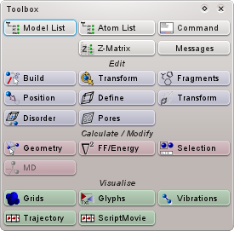
Figure 7-2 The ToolBox Window
Button | Window Function / Contents
 | List of models currently loaded
 | List of atoms in the current model
 | Runs single commands; Provides interactive shell; Load & run scripts
 | Edit Z-matrix for the current model
 | Draw atoms, chains of atoms, and bonds; Rebond & clear bonds
 | Transform the current atom selection (e.g. flip, rotate, matrix multiply)
 | Access to molecular fragments when in fragment drawing mode
 | Position the current atom selection (e.g. shift, translate, centre)
 | Define / create cell for the current model
 | Transform the cell for the current model
 | Run the Disorder builder
 | Tools for pore drilling
 | Measure distances and angles; Edit geometry of current atom selection
 | Load / edit forcefields; Perform geometry optimisation of models
 | Advanced atom selection tools
 | Grid manipulation and editing
 | Glyph manipulation and editing
 | Visualisation of molecular vibrations (if present)
 | Visualisation of associated trajectory (if present)

Atom List Window
The Atom List window provides a list of all atoms in the current model or frame, displaying elements, charges, and positions. If patterns have been defined for the model (see Section 10.3), the atoms in the list will be grouped according to their encompassing pattern, otherwise they are listed in one continuous run by ascending ID.
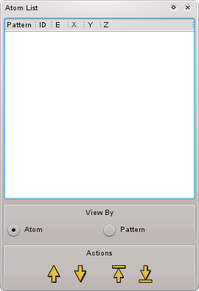
Figure 7-3 Atom List Window

Atom Selection
The selection of items in the atom list mirrors the selection in the current model - (de)selecting atoms in one will also (de)select them in the other. If patterns are defined, (de)selecting the pattern name in the list (de)selects all atoms making up the pattern.

Changing the Order of Atoms
The four buttons at the foot of the atom list allow the current selection of atoms to be moved up and down the list, useful for reordering atoms into a specific sequence. Selected atoms can be shifted up/down the list one place at a time, or all moved to the top or bottom of the list at once. In the latter case the order of the original selection is preserved.

Build Window
The primary function of the Build window is to allow for drawing, deletion, and transmuting of individual atoms and bonds using the mouse, along with drawing and automatic creation of bonds.
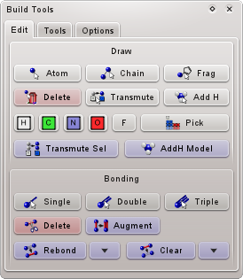
Figure 7-4 Build Window – Edit controls
The top half of the Edit page of the window provides tools to draw individual atoms, chains of atoms, and molecular fragments, allow the deletion and transmutation of atoms, and provide the ability to add hydrogen atoms automatically to atoms (or the whole model). Select the relevant tool, and simply click on atoms in the main view. The element of new atoms when drawing atoms or chains (as well as the transmutation target element) is determined by the currently-selected element button. The bottom half provides tools to draw individual bonds between atoms, or to calculate bonds automatically. Drawing a bond requires pairs of atoms to be clicked sequentially once the tool is activated.
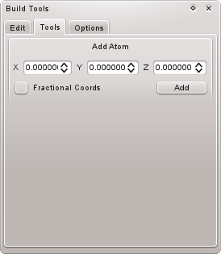
Figure 7-5 Build Window – Tools page
The Add Atom tool allows atoms to be created at specific positions in the model. Coordinates are entered and the atom created (with element defined by the current selected element on the Edit page) by pressing the Add button. If the Fractional Coords checkbox is ticked the coordinates are assumed to be fractional and are converted to cell coordinates as the atom is added. For example, setting coordinates to {0.5,0.5,0.5} will create an atom in the centre of the current unit cell.
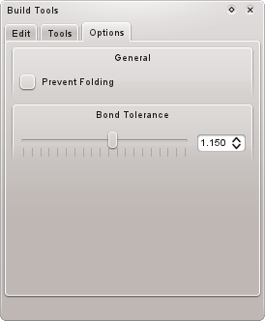
Figure 7-6 Build Window – Options page
Finally, the Options page allows various aspects of building to be adjusted.
When transforming atoms in a periodic system with the mouse (i.e. rotating or translating them) if any move outside the unit cell as a result of the transformation they are automatically folded back in to the confines of the cell. If the Prevent Folding checkbox is ticked, these folding operations will not occur.
All rebonding operations employ a tolerance or scaling factor in the calculation of distances between atoms, which can be adjusted with the Bond Tolerance slider. Larger values increase the maximum distance between atoms that will be recognised as a bond. Use restraint, however, as too large values will generate irregular bonding patterns.

Cell Definition Window
Allows the user to edit the unit cell specification of the current model, assign a crystallographic spacegroup, and perform spacegroup packing according to the spacegroup. Whether or not the current model possesses a unit cell is determined wholly by the Has Cell checkbox – if checked, the current model is periodic, if not, then it is an isolated collection of atoms.
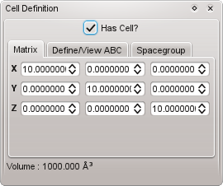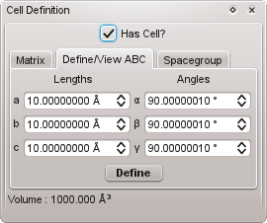
Figure 7-7 Cell Definition Window – Matrix and Define/View pages
If the model has a cell, its size and shape can be set in one of two ways. The primary method is though direct editing of the cell matrix on the Matrix page, which presents the individual components of the X (A), Y (B), and Z (C) axes. All values are in Angstroms, and any changes made here are immediately applied to the current model. Alternatively, the cell may be set by entering its lengths (in Angstroms) and angles (in degrees) on the Define/View ABC page and then pressing the Define button.
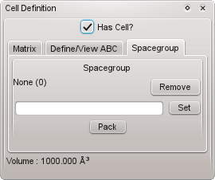
Figure 7-8 Cell Definition Window – Spacegroup page
The spacegroup assigned to the current model can be changed and removed on the Spacegroup page. On its own, an assigned spacegroup is just a number - no modifications to the atoms are made by changing the assigned spacegroup. Packing of atoms, however, is a different matter. Once a spacegroup is assigned, symmetry-equivalent atoms may be generated by use of the Pack button. This assumes that the current contents of the model represents the symmetry-unique set of atoms (i.e. the minimal generator set which, along with the spacegroup and unit cell, defines the entire crystal).

Cell Transform Window
Transformations of the unit cell and its contents can be made here, encompassing geometric scaling of the cell (and atoms contained within) and replication of the system in three dimensions.
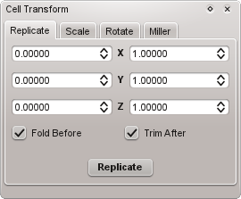
Figure 7-9 Cell Transform Window – Replicate page
The Replicate page allows the current cell to be replicated along its three principal axes in both positive and negative directions. The six inputs represent negative and positive replication values for each direction – most of the time its probably only useful to consider the positive (right-most) replication directions. Note that the numbers define the additional cells that will be created in addition to the original one. So, if all numbers are left at zero the original cell will remain untouched. Entering a value of 1 for each positive direction will give a 2×2×2 supercell of the original cell, and so on. The representative unit cells of replicated and partially replicated copies of the current cell are drawn onto the current model.
Atoms in the model are folded into the unit cell prior to replication, unless the Fold Before checkbox is unticked. Similarly, atoms that exist outside of the cell after replication are trimmed unless the Trim After checkbox is unchecked.
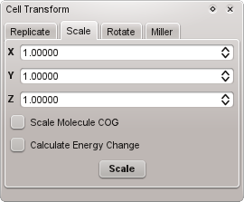
Figure 7-10 Cell Transform Window – Scale page
The Scale page allows the principal axes of the current unit cell to be arbitrarily scaled, along with the cell's contents. If a valid pattern description exists for the model, then the positions of individual molecules or bound fragments within the cell are scaled relative to their centres of geometry – all intramolecular distances within molecules remains the same as before the scaling. If this is undesirable (or unintended) then performing the scaling with no pattern definition will scale the position of each atom separately.
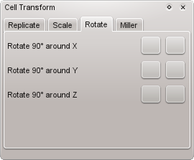
Figure 7-11 Cell Definition Window – Rotate page
Not currently implemented.
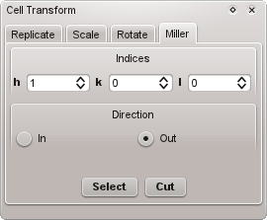
Figure 7-12 Cell Definition Window – Miller page
The Miller page allows the model to be cut so that various Miller surfaces are left behind. The hkl indices of the desired Miller plane should be entered in the three spin boxes, and the resulting plane(s) will be drawn onto the current model. The deletion of atoms can be done in one of two ways, removing either those atoms that are ‘inside’ or those atoms that are ‘outside’ of the defined Miller plane and its periodic or symmetric equivalent.

Command Window
The command window allows commands or sequences of commands to be run and stored for later use, allows management and execution of scripts, and provides access to searchable command help.
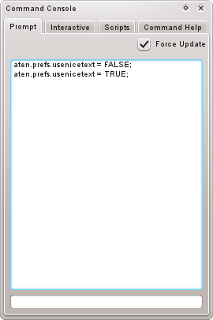
Figure 7-13 Command Window – Prompt page
Any command or compound command can be entered in the bottom editbox and will be executed immediately. This command will then be added to the list above, and can be single-clicked to return it to the editbox for tweaking or re-editing, or double-clicked to execute it again. The list of stored commands is saved when Aten exits, and loaded back in when restarted.
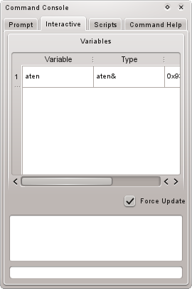
Figure 7-14 Command Window – Interactive page
For when single-line commands are too inflexible, the interactive page mimics a more ‘proper’ console-like environment. Here, variables can be defined in one instance and referred back to and manipulated in others, much like a normal shell. A list of variables currently defined in the local scope is shown in the uppermost part of the window.
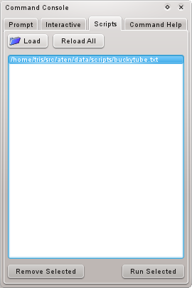
Figure 7-15 Command Window – Scripts page
Scripts can be loaded in from here and executed at will by double-clicking individual scripts in the list or selecting multiple scripts and clicking the Run Selected button. Any script files loaded in this way are remembered when Aten exits and are loaded back in when restarted. All scripts can be reloaded from disk (if, for example, changes have been made to one or more files after they were loaded in) by clicking the Reload All button.
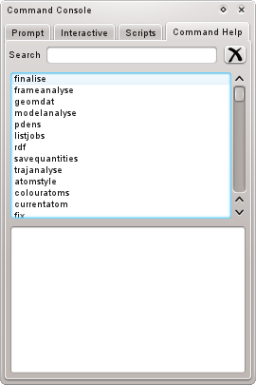
Figure 7-16 Command Window – Command Help page
All of Aten’s commands are listed in the panel in the upper half of the page, while the syntax and description of any command selected in the list is displayed in the lower half. The list can be searched by typing in a partial name in the Search box at the top.

Disorder Builder Wizard
The Disorder builder wizard generates a disordered system involving a collection of molecules. This can be a snapshot of a liquid suitable for use in a molecular dynamics program, a mixture of two or more species, an interface between two or more species, or something more exotic. The disordered builder requires that all molecules which are to be included in the system are currently loaded, and none must have its own cell defined. However, while all models which are to be ‘inserted into’ the final system may not possess a unit cell, a periodic model can be the target of the insertion, and may contain an existing collection of molecules / atoms.
In order to begin the disordered wizard, click on the Disorder icon in the Edit section of the main toolbox (see Section 7.5). This will present the first of five steps designed to guide you through the building of your system.

Selection of Target Model
In the first wizard screen, the type of model target for the builder is selected. If a cell has already been defined in a loaded model choose Use Existing Model. The existing model target may already contain molecules, and these will be preserved at their original coordinates during the build. The remaining two choices create a new model for the builder to work on, but differ in how the unit cell is to be defined. Create New Model and Define Cell creates a new model for the system with a specific unit cell definition provided by the user, while Create New Model and Generate Cell creates a new model with a general cell definition which states only the angles and relative cell lengths required. In the latter case, the final size of the cell will be calculated by Aten based on the number and density of the requested molecules defined in subsequent steps. Note that this choice restricts the policy by which molecules are added into the system, requiring a population and density to be specified for every component. Furthermore, only the basic ‘unit cell’ partitioning scheme may be selected.

Selection / Definition of Target Model
The second step in the disordered builder either requires selection of an existing model, or definition of the (basic) unit cell, depending on the choice in Step 1:
If Use Existing Model was selected in the previous step, a list of currently loaded molecules which have a unit cell are shown, from which one should be selected (left-hand screenshot). If either Create New Model and Define Cell or Create New Model and Generate Cell was selected in Step 1, the unit cell must now be defined (right-hand screenshot). In the case of the former, the exact cell definition must be given, and will not be changed further by Aten. In the case of the latter, the required cell angles should be given as normal, but the relative lengths of the cell axes should be given rather than the absolute lengths. These lengths are subsequently adjusted by Aten based on the number and density of species defined later on. For instance, defining the relative cell lengths {A, B, C} to be {1.0, 1.0, 1.0} will result in all sides of the cell being identical, while setting them to {1.0, 2.0, 1.0} will give a final cell where the B length is twice as long as both A and C (which are the same).

Choose Cell Partitioning
Aten allows each species to be added into a predefined region of the unit cell (unless the cell volume is to be generated, in which case only the basic ‘whole cell’ scheme is available). The various partitioning schemes available allow the cell to be split up into separate regions, for instance a spherical droplet in the middle of the cell. Many schemes have associated options which alter the size, shape, and position of the various partitions – select Scheme Options… to view and customise them. Partitions in the selected scheme are highlighted on the current unit cell as transparent areas.

Choice of Components
In step four the Disorder wizard provides a choice of components to be added into the system. Any loaded molecule which does not currently have a unit cell is displayed here, and any number of models may be selected for insertion.

Set Component Populations
Finally, the required populations and/or densities for each component model selected in the previous step must be set, as well as the target partition for each. There are four insertion policies available for each component:
Exact Number – The component will be added into the system/partition until the desired population has been reached. The density of the component in its partition is not important.
Specific Density – The component will be added into the system/partition until the desired density is reached. The population of the component is not important.
Exact Number / Density – The component will be added into the system/partition until both the specified population and density are reached. This is the only choice of policy if the cell size is to be determined by Aten (Create New Model and Generate Cell option in Step 1).
Relative Number / Exact Density – The component will be added into the system/partition until the specified density is reached. The total population of the component is variable but will depend on other components with the same policy selected. Over all such components, the relative population ratios between them will be maintained during the build. In this way, mixtures of specific mole ratio can be created, for example.
Note that, when specifying the density of a component, this refers to the density within that components target partition. This means that, when multiple components share the same partition (even in the basic unit cell scheme) the density refers to the total density of the partition, as calculated from the sum of contributions from each individual component. This simply means that the overall density should be defined when sharing partitions between components, rather than that required for each individual component.
The final step of the wizard also allows various parameters of the Disorder builder to be adjusted through the Method Options button. A brief description of these options follows:
TODO
The accuracy parameter determines what percentage error we will allow in actual vs requested densities
double accuracy = 0.01;
// The maxfailures limit is the number of successive failed insertions we allow before we reduce the scale factor
int maxFailures = 5;
// The reductionfactor is the factor by which we multiply scale factors after reaching the limit of unsuccessful insertions
double reductionFactor = 0.98;
// Minimum scale factor to allow
double minimumScaleFactor = 0.95;
// Maximum scale factor to allow
double maximumScaleFactor = 1.15;
// Number of tweaks to attempt, per component, per cycle
int nTweaks = 5;
// Maximum distance to translate molecule in tweak
double deltaDistance = 0.3;
// Maximum angle (each around X and Y) to rotate molecule in tweak
double deltaAngle = 5.0;
// Maxcycles and maxRecoveryCycles

Forcefields Window
The Forcefields is the place to go to load in and edit forcefields, perform atom typing on models, and calculate / minimise the energies of models. As well as being able to perform standard steepest descent and conjugate gradient minimisations, Aten also provides a molecular Monte Carlo minimiser, and the ability to run MOPAC directly from the GUI.
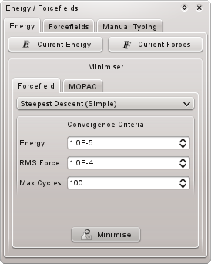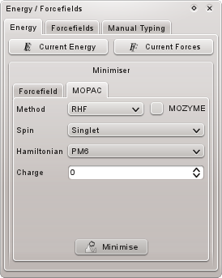
Figure 7-17 Forcefields Window – Energy minimisation controls

Energy Minimisation
The Energy page provides the means to perform geometry optimisations on loaded models using one of several methods. The forcefield selected in the Forcefields page is used to perform the minimisation, unless one has previously been explicitly associated to the model. The current energy and forces may also be calculated (akin to single-point energy calculations). The MOPAC minimiser requires that the locations of a valid MOPAC executable and temporary directory are defined – see Section 14.2 for more information. A job file is automatically written to disk and MOPAC executed when ‘Minimise’ is clicked, and the results loaded back in. Output of the program is buffered to the Messages window (see Section 7.17).

Forcefield Management
Forcefield files are managed through the Forcefields page. A list of currently-loaded forcefields is provided in the form of a drop-down list at the top; the selected item is the current default forcefield, and is used whenever one is required by a process but none has been linked to the target model. The forcefield selected in the list is the current forcefield, and the one used by all other actions on the page. Forcefields are loaded, unloaded, and edited with the buttons immediately underneath the list.
The Associate panel links the selected forcefield to one or more models and their patterns; the Current Model button links the current forcefield to the current model, while the All Models button links the current forcefield to all loaded models. The Pattern in Current Model button brings up a dialog listing the patterns of the current model, from which one is selected to link the forcefield to. A forcefield associated to an individual pattern will be used in preference to the forcefield associated with its parent model (and, if none is assigned, the default forcefield).
Automatic atom typing can also be performed (or removed) from here. Finally, you may check that a full expression is available for the current model by pressing the Create button in the Expression panel at the very bottom. The nearby checkbox determines whether atomic charges should be assigned from atom type information, or whether the current charges (if any) should be left intact.
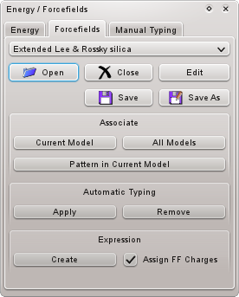
Figure 7-18 Forcefields Window – Forcefields page
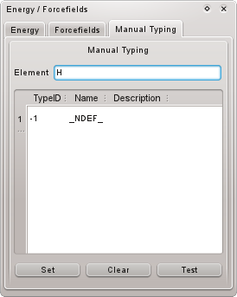
Figure 7-19 Forcefields Window – Manual typing page

Assigning Atom Types
Manual assignment of forcefield types can be performed in the Manual Typing page. The list gives all atom types in the current forcefield that are relevant to the element entered just above the list. One can be selected from the list and be manually assigned (forced) onto the current atom selection with the Set button. Such assignments will not be overwritten by subsequent automatic typings. Manual typings can be removed with the Clear button, and the currently selected atomtype can be tested for suitability on the current selection of atoms with the Test button.

Fragments Window
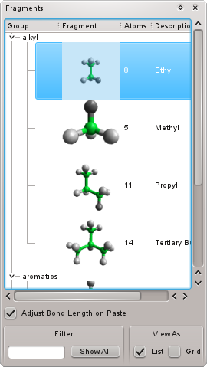
Figure 7-20 Fragments Window
When in fragment drawing mode, the Fragments window presents a list of all the available fragment models (in either List or Grid formats), and whichever is selected represents the current fragment to add in to the model. The current fragment is ‘attached’ to the mouse pointer when moving over the main canvas, and shows a preview of what will be the orientation and position of the fragment when a left-click is made.
If a fragment is drawn (attached) to an existing atom in a model, the resulting bond length is adjusted to match the two elements involved if the Adjust Bond Length on Paste checkbox is ticked.

Fragment Models
Fragment models are just normal models stored in specific places. The only real difference is that atoms with unknown element (integer ‘0’, or string ‘XX’) are slightly more useful than usual. These can act as anchor points for the fragment that do not correspond to the position of any ‘proper’ atom to allow for more control over the placement of structures - for instance, such an atom may be placed at the centre of a ring. It is important to note that all atoms with unknown element type are removed when the fragment is added to the current model.

Anchor Points
At any time, a single atom in the selected fragment represents the attachment point and appears directly under the mouse pointer. Any atom in the fragment can be selected as the current anchor point, and may be cycled through by pressing Alt. If the atom acting as the anchor point has at least one bond to another atom then a reference vector is constructed allowing the fragment to be oriented along vectors dependent on the current geometry of existing atoms, for example.

Placing Fragments in Free Space
Single-clicking in free space (i.e. not over an existing atom) places a copy of the current fragment in the current orientation in the current model. Click-dragging allows the fragment to be freely rotated about the anchor point before the placement is final. On placement, the anchor atom is pasted too unless it is of unknown element (see above).

Attaching to Existing Atoms
When moving over an existing atom with an anchor point that has at least one bond to another atom, the fragment is attached at a suitable geometry, provided the valency of the atom allows (if not, the atom will be surrounded by a crossed-out box and the fragment will temporarily disappear). A single-click will place the fragment in the shown position and orientation, while click-dragging rotates the fragment about the newly-formed bond to allow fine adjustment before the final placement. If the anchor point has no bonds to other atoms, the fragment is placed in no specific orientation, and click-dragging freely rotates the molecule about the anchor point. In both cases, the anchor atom is always removed when being added to the model since the existing atom which was clicked on will replace it in terms of position.
If the existing atom in the model has one or more other atoms attached to it, holding Shift will orient the fragment along an existing bond vector. In this case, both the anchor atom and the atom at the other end of the bond are removed when the fragment is placed. Pressing Ctrl cycles over the bonds of the existing atom.

Geometry Window
Simple measurements of distances, angles, and torsions between picked atoms or the current selection of atoms is possible from the measure toolbar.
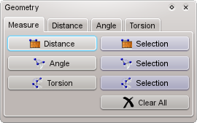
Figure 7-21 Geometry Window – Measure page
Distances, angles and torsions between atoms can be measure here – select the desired tool on the left-hand side and click the relevant number of atoms one-by-one in the main window. Alternatively, select a molecule or group of atoms for which you wish to measure all (bound) instances of a certain type of geometry, and press the corresponding button on the right-hand side. To clear all measurements from the current model, press the Clear All button.
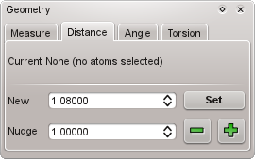
Figure 7-22 Geometry Window – Distance page (angle and torsion pages are similar)
The Distance, Angle, and Torsion pages of the Geometry window allow the specific geometry of a set of selected atoms to be set. Simply select, for example, two atoms from a model (note that they do not have to be connected by a bond) and set or adjust their distance from here. When choosing the Set Bond Length, Set Bond Angle, and Set Torsion Angle items on the atom context (or Selection) menu, the Geometry window is automatically presented on the correct page for the number of selected atoms.

Glyphs Window
TODO XXX
Glyphs Window
The glyphs window allows new glyphs to be created by hand, or existing glyphs in the model to be managed, edited, and deleted.
Figure 5.13. Glyphs Window

All glyphs in the current model are listed to the left. Selecting one will allow its properties to be edited on the right. The type of glyph can be changed also. Colours for individual glyph data (i.e. points) may be changed through the colour controls associated to each.

Grids Window
The Grids window provides management for grid data sets owned by the different models. All grid data sets held by the current model are displayed here. The appearance of individual grids may be changed, and axes / cutoffs changed. Grid data can also be cut, copied, and pasted to different models.
A ‘grid’ in Aten’s world can be more or less any kind of volumetric or surface data. For instance, orbital densities, 2D height maps, molecule probability densities etc. See the Grids section for more information.
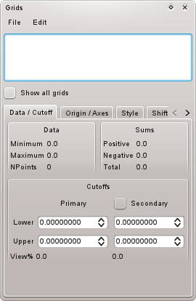
Figure 7-23 Grids Window – Data / Cutoff page

General Grid Management
Each grid in the list has associated with it a checkbox that determines whether or not it is currently visible. Below the list the minimum and maximum data values contained within the grid, and the current cutoffs (i.e. the values for which the isosurface is drawn at) for the primary and (optional) secondary surfaces to use when rendering the data. The File and Edit menus allow new grids to be loaded into the current model, and to cut, paste, and delete grids between models. Multiple grids may be selected at once in the listbox – in such a case any alterations made using the other controls are applied to all of the selected grids. In this way all cutoff values, for instace, may be set simultaneously to the same values for any number of loaded grids.
By default, only those grids associated to the current (active) model are visible, but all grids which exist within all models can be displayed with the Show All Grids checkbox.
The Secondary checkbox specified that a second isosurface should be created for the current grid. This is useful, for instance, to draw a second, transparent surface at a lower cutoff than the primary, or to display an isosurface encompassing the negated cutoff range of the primary (e.g. to display both signs of the wavefunction in orbital data).
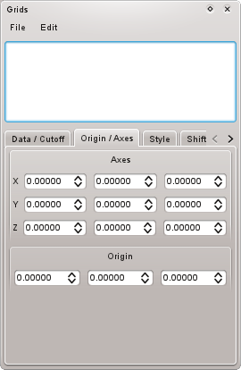
Figure 7-24 Grids Window – Origin / Axes page
The associated origin and axes to the currently selected grid can be modified here. In this way grid data may be arbitrarily flipped, stretched, and sheared, and its position in the local space of the model changed. All changes made are reflected immediately in the main view.
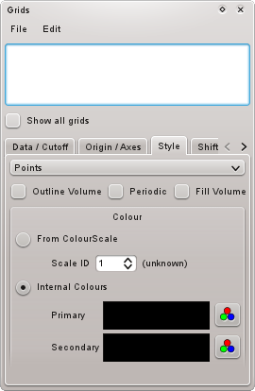
Figure 7-25 Grids Window – Style page
The general appearance of the selected grid can be modified in the Style page, with the main rendering style set with the combo box (see Section 16.10 for a list of possible styles). Optionally, a bounding box around the grid data may be drawn by selecting the Outline Volume checkbox. The Periodic checkbox influences the way 3D surfaces are drawn close to the boundaries of the grid. If unchecked, a ‘gap’ will appear near to the edges of the grid volume since there is insufficient data with which to generate gradient information. If checked, data points on the opposite site of the grid will be used in this region (useful, for instance, in the case of orbital information calculated in periodic systems). For volumetric data, sometimes it is useful to see the filled volume rather than the enclosing surface – checking Fill Volume will do just that.
Colours for the primary and (if active) secondary sufaces can be set to simple (single) colours by selecting Internal Colours and choosing whatever colour is desired from the colour selection buttons. Should a more useful colouring scheme be desired than the surfaces may be rendered using a colour scale (see Section 10.1), in which case the isovalue (if volumetric) or height (if a 2D grid) determines the colour of the data point. To do so, select From Colourscale, and choose the ID of the colour scale to use (from the ten definable in the program).
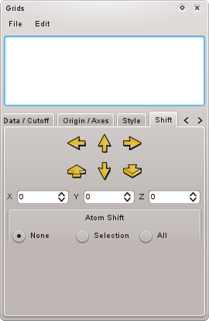
Figure 7-26 Grids Window – Shift page
The Shift page can be used to ‘translate’ the grid data points along each axis of the data set allowing, for instance, isosurface features of interest in a periodic grid to be displayed in a more central position. Note that no modification of the actual grid data is performed – the effect is entirely visual. The Atom Shift group allows translation of selected/all atoms in the parent model to be moved at the same time, so as to correlate them with the new positions of the grid data.

Orbitals Page
Not implemented yet.

Messages Window
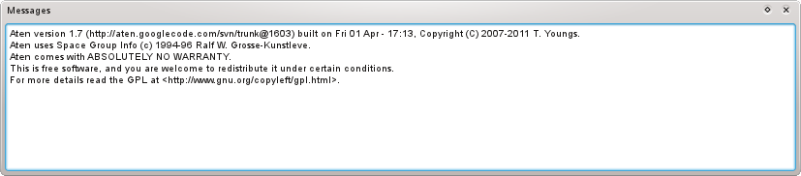
Figure 7-27 Messages Window
The messages window is simply that – a place for all of Aten’s text output to appear when the GUI is active. All error messages are printed to the messages window – if something doesn’t work as you expect it should (or, indeed, doesn’t work at all) there is usually a clue or, better, an explanation somewhere in the messages displayed here.
Sometimes messages will be printed which have the appearance of hyperlinks – these can be clicked on to perform various simple tasks on the model, relevant to the accompanying message.

Pore Builder Window
The Pore Builder Window offers some tools to make the construction of (regular) porous material systems a little easier, including when it comes to filling pores.
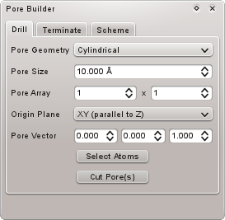
Figure 7-28 Pore Buider Window – Drill page
The Drill page provides tools to select and cut atoms from an array or pores of specified geometry in the current model. The Origin Plane determines the crystal face from which the pores originate, but from there the direction of drilling (the Pore Vector) may be set to anything although something coincident with the normal of the origin plane is probably sensible. The magnitude of this vector is unimportant, since it is normalised before use. Once all quantities are suitably defined, the atoms making up the pores may be simply selected (with Select Atoms) or deleted from the model (with Cut Pore(s)). The reason for providing both these actions is to allow for selection of atoms at the surfaces resulting from pore cutting, simply by increasing the Pore Size parameter a little.
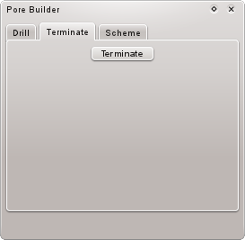
Figure 7-29 Pore Builder Window – Terminate page
At present, the Terminate page provides a single button which terminates (adds H or OH to) any atoms in the current selection which have fewer than their normal quota of bonds as a result of pore drilling (or by other means). H or OH are added to atoms until the correct number of bonds per atom is restored. Only O and Si are considered at present.
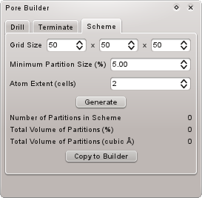
Figure 7-30 Pore Builder Window – Terminate page
The Scheme page permits a partitioning scheme (see Section 10.4) to be created from free space in the current model (not necessarily space created by pore drilling). The Grid Size determines how finely to divide up space in the current model – the defaults should be fine for most purposes, but exotic or very small shapes may require higher values. The minimum allowable size for a partition is given as a percentage of the total number of cells in the grid (Minimum Partition Size), below which any discovered regions of space are ignored. In order to correctly generate partitions it is often necessary to tweak the Atom Extent parameter. Any grid cell in which an atom exists is considered ‘full’ and not part of any partition, but in most cases this is not sufficient and more space must be excluded to account for the real space-filling of the atoms. The Atom Extent value defines a radius, in cells, within which additional cells around atoms will also be removed.
The Generate button will search for partitions in the model and overlay these partitions onto the main display, but will not copy the data to the Disorder builder. Once you are satisfied that the correct / relevant partitions have been discovered, the data can be made available in Disorder building by clicking Copy to Builder.

Position Window
Tools for the absolute positioning of atoms are available here. All work on the current selection of atoms in the current model.
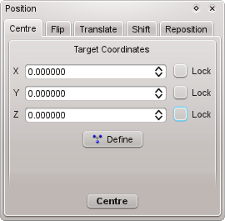
Figure 7-31 Position Window – Centre page
The Centre page allows the centre of geometry of the current selection to be positioned at absolute coordinates. The desired position is entered in the three input boxes, or can be defined from the geometric centre of a selection of atoms (prior to the positioning of a different set). Any (or all) of the Cartesian axes may be locked preventing coordinate adjustment along particular directions.
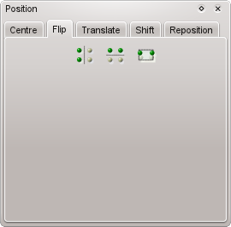
Figure 7-32 Position Window – Flip page
The Flip page mirrors the positions of atoms in the current selection through its centre of geometry in either the X, Y, or Z directions. Note that this tool currently works only along the Cartesian axes, and does not take into account the shape of any defined cell.
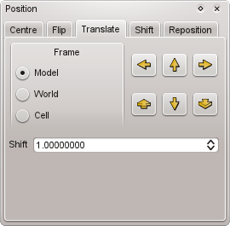
Figure 7-33 Position Window – Translate page
Translations of atoms within model (local), world (view) and cell frames of reference can be performed in the Translate page. The group of directional buttons move the selected atoms along the relevant axis within the selected frame of reference, and by the amount specified in the Shift control. For model and world reference frames the Shift control specifies the number of Angstroms moved along the axis in each step. For the cell reference frame it defines the fractional cell distance moved in each direction.
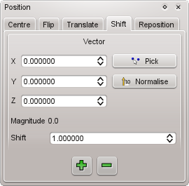
Figure 7-34 Position Window – Shift page
The vector along which to move the current selection is defined on the left hand side of the Shift page. Furthermore, the axis may be defined by Picking two atoms in the main window. The supplied vector does not need to be normalised, but thus may be performed through the Normalise button. The defined shift value dictates the multiple of the defined vector by which selected atoms are shifted.
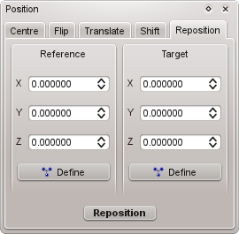
Figure 7-35 Position Window – Reposition page
The reposition page allows the centre of geometry of a selection of atoms to be moved from a reference coordinate (defined by the Reference panel) to a destination coordinate (defined by the Target panel). Either coordinate may be set from the centre of geometry of the current atom selection by pressing the relevant Define button.

Select Window
The select window provides a means to quickly access the capabilities of the select and deSelect commands from within the GUI. The total number of atoms selected along with their empirical formula is also displayed.
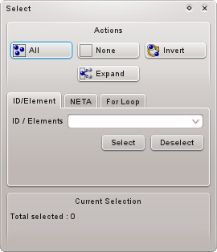
Figure 7-36 Select Window with ID / Element Tab open
Basic atom selection operations can be made using the All, None, Invert, and Expand buttons at the top of the window. The first three are self-explanatory, selecting all atoms, no atoms, and reversing the current selection respectively. The final button, Expand, looks at any bonds attached to any currently-selected atoms, and selects those atoms that are bound as well. Only the immediate bound neighbours of each atom are considered each time the expansion is made.
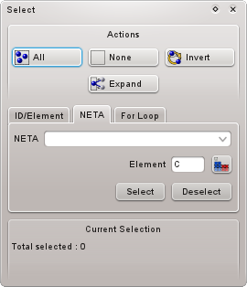 | 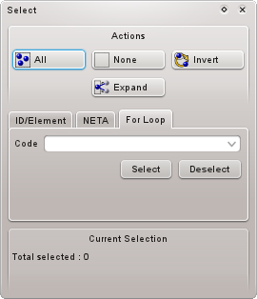
Figure 7-37 Select Window with NETA Tab open | Figure 7-38 Select Window with For Loop Tab open
Three more advanced selection methods are also available. In each case, selection or deselection of atoms based on the defined range(s) is made by the associated Select and Deselect buttons.
Selection by ID/Element Ranges
Ranges of atom IDs and/or elements are specified as ‘a-b’ where a and b are either both atom IDs or both element symbols. In addition, the ‘+’ symbol can be used before (as in ‘+a’) or after (as in ‘a+’) an atom ID or element symbol to mean, respectively, ‘everything up to and including a’ or ‘a and everything after’. Multiple selection ranges may be given, separated by commas.
Select by NETA Description
The NETA language implemented in Aten also makes for a powerful tool when selection specific atoms in a model based on their chemical environment. The relevant NETA description for the target atoms should be inserted into the Code editbox, and the corresponding Element set.
Select by For Loop
More advanced still, here a short snippet of command-language code can be written. The code is automatically inserted into a function which is subsequently used in a for loop of the following construction:

int shouldSelect(Atom i)
{
// … code is inserted here
}

for (Atom i = aten.model.atoms; i; ++i)
{
if (shouldSelect(i)) i.selected = TRUE;
}

Thus, the code should use the variable i to test for whatever criteria are necessary to cause the atom to be selected, and return TRUE (1) if it is to be selected, and FALSE (0) otherwise. In this mode, the Deselect button simply uses the reverse code:

int shouldDeselect(Atom i)
{
// … code is inserted here
}

for (Atom i = aten.model.atoms; i; ++i)
{
if (shouldDeselect(i)) i.selected = FALSE;
}

Trajectory Window
If a trajectory is associated to the current model, the trajectory window allows to skip through frames and playback the trajectory.
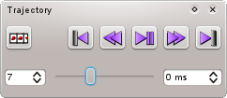
Figure 7-39 Trajectory Window
The 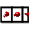 button serves to act as a toggle between displaying the actual trajectory frames and the parent model which ‘owns’ those trajectory frames. Its state is linked to the Trajectory→View Model and Trajectory→View Trajectory menu items of the main window, and vice versa. The set of standard playback controls allow individual frames to be skipped, as well as going straight to the beginning or end of the trajectory. The current frame may also be set with either the spin control or slider at the foot of the window. The delay between swapping of frames is controlled by the slider on the right where the delay can be set in milliseconds. Note that the actual speed of playback will also depend on the size of the system being viewed and the raw power of your graphics card.

Transform Window
For a selection of atoms, rotational or matrix-based transformations can be applied through the Atom Transform window.

Rotation About Arbitrary Axis
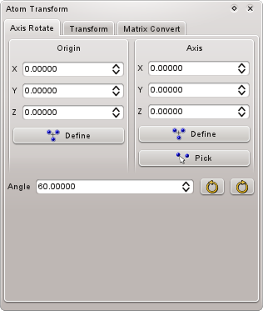
Figure 7-40 Transform Window – Axis Rotate page
The Rotate page allows an origin and a rotation axis about this origin to be defined about which to rotate atom selections. The origin and axis may be entered manually, can be determined from a current atom selection (Define buttons), or defined by the click-selection of two atoms (Pick button). Defining the rotation axis from the current selection will set the axis to the vector between the currently-defined origin and the centre of geometry of the current atom selection. Rotations of atom selections about this axis/origin combination are then made by defining the Angle of rotation (in degrees) and then applying the rotation either clockwise or anticlockwise.

Matrix Transformation
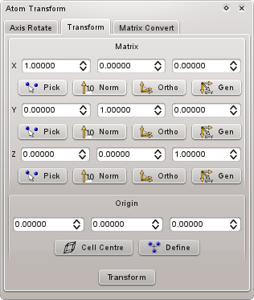
Figure 7-41 Transform Window – Transform page
From here a 3x3 transformation matrix can be applied to the current atom selection, and with a specific coordinate origin (not necessarily the centre of geometry of the selection). The Pick buttons allow selection of the various axes through click-selection of two atoms (not necessarily in the same model as the current atom selection), while the Normalise buttons will normalise each of the currently-defined axes to be of unit length. Finally, the Orthogonalise and Generate buttons allow particular axes to be orthogonalised relative to, or generated from, the other defined axes.

Matrix Conversion
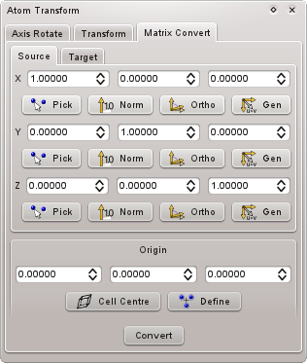
Figure 7-42 Transform Window – Matrix Convert page
It is possible to transform the orientation of a given set of atoms if a suitable pair of source and destination matrices are defined. The Source matrix defines what should be considered the current frame of reference for the current set of coordinates. Once the Convert button is pressed, a rotation matrix is generated such that, when applied to the Source matrix (and the current atom selection) it will be transformed into the Target matrix.
As for the matrix convert page, the Pick, Normalise, Orthogonalise, and Generate buttons allow each axis to be selected, normalised, orthogonalised relative to the others, and generated from the others respectively.

ZMatrix Window
ZMatrix Window
The z-matrix window allows the z-matrix for the current model to be viewed and its variables edited. Any changes made are reflected immediately in the coordinates of the model.
Figure 5.29. ZMatrix Window

Command Language

Command Language Overview
The scripting language in Aten is based syntactically on C/C++, with echoes of useful Fortran features included for good measure. This means that if you're familiar with C/C++ then controlling Aten from the command line, or writing a script, command, or filter should be relatively straightforward. There are lots of C primers on the web, so the following sections provide only a brief summary of the style of the language.

General Input Style
Keywords, variables, and function names are case sensitive, so ‘for’ is different from ‘For’ (all internal commands in Aten are in lowercase). Individual commands must be separated by a semicolon ‘;’, and newlines are optional. For example:

int i; printf("Hello there.\n"); i = 5;

...and...

int i;
printf("Hello there.\n");
i = 5;

...are equivalent. Whitespace characters (spaces and tabs) are ignored and may be present in any amount in any position in the code.
Individual lines or parts of them may be commented out. The presence of either the hash symbol # or // in a line means ‘ignore rest of line’. Note that the /*...*/ commenting style is not supported.

Variables
There are several standard rules for variables within Aten:
- They must be declared before use
- They are strongly-typed, i.e. they hold a specific type of value (e.g. an integer, a character string etc.)
- They must begin with an alpha character (‘a’ to ‘z’), but may otherwise consist of letters, numbers, and the underscore (‘_’)
- They may not be named the same as any existing function or internal keyword
- Since variables are strongly-typed, trying to set an integer variable from a string will not work since these are incompatible types. However, standard C-style string conversion functions are available - see String Commands in Section 9.29.
So, to initialise some variables, assign values to them, and print them out, we would do the following:

int i;

double result;

i = 10;

result = i*5.0;

printf("i multiplied by 5.0 = %f\n", result);

In addition to the standard int and double types, a string variable exists for the storage of arbitrary-length character strings, and do not need to have a length specified on their creation (they will adjust dynamically to suit the assigned contents). Literal character strings should be surrounded by double-quotes. A set of variable types exist that are able to contain references (not copies) of various objects within Aten, e.g. atoms, models, unit cells, etc. Variables of these types are declared in exactly the same way as normal variables (see Section 8.2 for a list of available types). A vector type is provided for convenience and stores a triplet of double values. There is no boolean type – use an int instead – but the built-in constants (see Section 8.1.4) TRUE and FALSE may be used in assignment, etc., and correspond to the integer values ‘1’ and ‘0’ respectively.
All variables will default to sensible values (e.g. empty string, numbers equal to zero) on initialisation. To create a variable with a specific value simply do the following:

int i=1,j=2,k=1001;
double myvar=0.0, angle = 90.0;

Arrays
Arrays of most variable types are allowed (some, for instance the Aten type, don't really make sense as an array). Arrays are requested by providing a constant size (or an expression) in square brackets after the name:

int values[100], i = 4;
double q[i];

Here, two arrays are created - an array of 100 integer numbers called values, and an array of four floating point numbers called q. Array indices always run from 1 to the size of the array, unlike C in which arrays run from 0 to N-1. Note that it is not possible to use a custom range of array indices, as is the case in Fortran.
Arrays can be initialised to a simple value on creation, setting all elements to the same value...

string s[4] = "Nothing";

...or each element to a different value using a list enclosed in curly brackets:

string s[4] = { "Nothing", "Nicht", "Nada", "Not a sausage" };

Also, all array elements can be set to the same value with a simple assignment:

int t[100];
t = 40;

Predefined Constants
Several predefined constants exist, and may not be overridden by variables of the same name. All predefined in constants are defined using uppercase letters, so the lower case equivalents of the names may be used as variables, functions etc.
Table 8-1 Built-In Constants
Name | Type | Value
ANGBOHR | double | 0.529177249
AVOGADRO | double | 6.0221415E23
DEGRAD | double | 57.295779578552
FALSE | int | 0
NULL | int | 0
PI | double | 3.14159265358979323846
TRUE | int | 1
In addition, all element symbols found in the input will be seen as their equivalent integer atomic number. So, instead of having to provide short strings containing the element name to, for example, the transmute command, simply the capitalised element name itself may be used. Thus...

transmute("Xe");
transmute(Xe);
transmute(54);

...are all entirely equivalent.

Blocks, Scope, and Variable Hiding
As with C, variable scope is employed in Aten meaning that a variable may be local to certain parts of the code / filter / script. In addition, two or more variables of the same name (but possibly different types) may peacefully co-exist in different scopes within the same code / filter / script. Consider this example:

int n = 4, i = 99;
printf("%i\n", i);
if (n == 4)
{
int i = 0;
printf("%i\n", i);
}
printf("%i\n", i);

...will generate the following output:

99
0
99

Why? Well, even though two variables called i have legitimately been declared, the second declaration is made within a different block, enclosed within a pair of curly braces. Each time a new block is opened it has access to all of the variables visible within the preceeding scope, but these existing variable names may be re-used within the new block in new declarations, and does not affect the original variable. Hence, in the example given above, after the termination of the block the final printf statement again sees the original variable i, complete with its initial value of 99 intact. Note that if a variable is re-declared within a scoping block, there is no way to access the original variable until the scoping block has been closed. Blocks can be nested to any depth.
One exception to this rule is when user functions are declared – inside the function no variables declared outside the function are visible. Usually this is the safest practice, since it means that the rest of the code cannot be corrupted by a rogue function. However, on occasion it is useful or necessary to be able to use a function to change a variable which exists in the main program or enclosing scope. Here we introduce the concept of global variables – variables that are declared in either the main program scope or within a function, but are also accessible by any other functions defined within that scope. Such variables can be created by using the global prefix as follows:

global int x = 2;
void doubleVariable()
{
x = 2 * x;
}

# Execute the function
doubleVariable();
printf(“x is %i\n”, x);

This will print “x is 4”. Without the global prefix on the declaration of the variable x, the code will not compile since, inside the function, the variable x is ‘hidden’ from this scope.

Functions
For functions that take arguments, the argument list should be provided as a comma-separated list in parentheses after the function name. For instance:

newAtom("C", 1.1, 0, 4.2);

Arguments may be constant values (as in this example), variables, arithmetic expressions, or any other function that returns the correct type. For functions that (optionally) do not take arguments, the empty parentheses may be omitted. A list of all functions, their arguments, and their return types is given in the command reference in Section 9.
All functions return a value, even if it is ‘no data’ (i.e. ‘void’ in C/C++). For instance, in the example above the newAtom command actually returns a reference to the atom it has just created, and this may be stored for later use:

Atom a;
a = newAtom("C", 1.0, 1.0, 1.0);

However, if the return value of any function is not required then it may simply be forgotten about, as in the example prior to the one above.

User Defined Functions
Custom functions may be defined and used in Aten, taking a list of variable arguments with (optional) default values. The syntax for defining a function is as follows:

type name ( arguments ) { commands }

type is one of the standard variable types and indicates the expected return value type for the function. If no return value is required (i.e. it is a subroutine rather than a function) then type should be replaced by the keyword void:

void name ( arguments ) { commands }

Once defined, functions are called in the same way as are built-in functions. The name of the function obeys the same conventions that apply to variable names, e.g. must begin with a letter, cannot be the name of an existing keyword, function, or variable. The arguments are specified in a similar manner to variable declarations. A comma-separated declaration list consisting of pairs of variable types and names should be provided, e.g.:

void testroutine ( int i, int j, double factor ) { ... }

Our new subroutine testroutine is defined to take three arguments; two integers, i and j, and a double factor. All three must be supplied when calling the function, e.g.

printf("Calling testroutine...\n");
int num = 2;
double d = 10.0;
testroutine(num, 4, d);
printf("Done.\n");

When defining the function/subroutine arguments, default values may be indicated, and permit the function to be called in the absence of one or more arguments. For instance, lets say that for our testroutine, the final argument factor is likely to be 10.0 on most occasions. We may then define a default value for this argument, such that if the function is called without it, this default value will be assumed:

void testroutine ( int i, int j, double factor = 10.0 ) { ... }

printf("Calling testroutine...\n");
int num = 2;
testroutine(num, 4);
testroutine(num, 4, 20.0);
printf("Done.\n");

Both methods of calling testroutine in this example are valid.

Return Values
For functions defined to return a specific type, at some point in the body of the function a suitable value should be returned. This is achieved with the return keyword. Consider this simple example which checks the sign of a numeric argument, returning 1 for a positive number and -1 for a negative number:

int checksign ( double num )
{
if (num < 0) return -1;
else return 1;
}

If an attempt is made to return a value whose type does not match the type of the function, an error will be raised. Note that, once a return statement is reached, the function is exited immediately. For functions that do not return values (i.e. those declared with void) then return simply exits from the function – no return value need, or should, be supplied.

Arithmetic Expressions and Operators
Arithmetic operates in the same way as in C, and utilises the same operator precedence etc. Similarly, comparison operators (less than, equal to etc.) are the same as those found in C.

Variable Types

Overview
For variables in Aten that are of reference type (i.e. the non-standard types) various sub-variables and functions may be accessed in the same way class members are utilised in C++. Each non-standard variable type is listed here along with the types and descriptions of their available subvariables / members.
In the same way that class members are accessed in C/C++, subvariables of reference types are accessed by use of the full stops between member names. For instance, the Atom type allows all the information of a given atom to be accessed. The following example illustrates the process of retrieving the third atom in the current model, finding its coordinates, and subsequently adjusting them:

Atom a = aten.model.atoms[3];
Vector v = a.r;
printf("Old coordinates are: %f %f %f\n", v.x, v.y, v.z);
v.x += 4.0;
a.r = v;
printf("New coordinates are: %f %f %f\n", a.rx, a.ry, a.rz);

Lots of paths are used here. Firstly, the global Atenvariable is used to get access to the current model and grab a reference to its third atom (aten.model.atoms[3]). Then, the coordinates of this atom are placed in a vector v by requesting the r subvariable from the stored Atom reference. We then adjust the vector and store the new coordinates in the atom.
All members can be read, but not all can be written back to – these are read-only members for which setting a value makes no sense. Members which can be modified are indicated with mark in the ‘RW’ column in the following tables.
Function members act in the same as subvariable members except that they take one or more arguments enclosed in parentheses immediately following the member name, just as command functions do.

Aten Type
The ‘master’ class type, Aten, is there to provide access to various other structures such as the list of loaded models, preferences, element data etc. It is available at all times from any command, script, or filter, and is always called Aten. Note that it is not possible to declare new variables of type Aten.
Table 8-2 Aten Type Members
Member | Type | RW | Description
elements | Element[] |  | Array of element data (masses, symbols, names, etc.)
frame | Model |  | The current model being displayed and the focus of editing, i.e. the current trajectory frame or, if no trajectory is associated to the current model then the current selected model is returned
model | Model |  | The current model selected (this is the parent model of a trajectory if a frame is currently being displayed)
models | Model[] |  | Array of all loaded models currently available
nelements | int |  | Number of chemical elements defined in the elements array
nmodels | int |  | Number of models (parent models, i.e. not including trajectory frames) currently loaded
prefs | Prefs |  | Program preferences

Aten Type Member Functions

convertEnergy
Syntax:
double convertEnergy ( double value, string oldunits )
Convert the supplied energy value from oldunits to the current, internal unit of energy in use by Aten. See also Energy Units (Section 16.8) and the relevant Prefs accessor.

findElement
Syntax:
Element findElement ( string name )
Convert the name specified into an Element, according to the current ZMapping Type (Section 16.17).

Atom Type
The Atom type encompasses a single atom in a model or frame.
Table 8-3 Atom Type Members
Member | Type | RW | Description
bit | int | • | Temporary integer value, with associated bit-setting functions (see Section 8.2.5)
bonds | Bond[] |  | List of bonds the atom is involved in
colour | double[4] | • | Custom colour of the atom (used when the Colouring Scheme, see Section 16.5, is set to ‘custom’)
data | string | • | Temporary character data stored on the atom (for use in filters etc.)
element | Element | • | Returns a pointer to the assigned element data of the atom
fixed | int | • | Whether the atom's position is fixed (1) or not (0)
f | Vector | • | Force vector
fracx | double | • | Position x-component in fractional cell coordinates
fracy | double | • | Position y-component in fractional cell coordinates
fracz | double | • | Position z-component in fractional cell coordinates
fx | double | • | Force x-component
fy | double | • | Force y-component
fz | double | • | Force z-component
hidden | int | • | Whether the atom is hidden (1) or visible (0)
id | int |  | Numerical ID of the atom within its parent model
mass | double |  | Atomic mass of the atom
name | string |  | Element name of the atom
q | double | • | Atomic charge associated to the atom
r | Vector | • | Position vector
rx | double | • | Position x-component
ry | double | • | Position y-component
rz | double | • | Position z-component
selected | int | • | Whether the atom is selected (1) or unselected (0)
style | string | • | The current Drawing Style of the atom (see Section 16.7)
symbol | string |  | Element symbol of the atom
type | FFAtom | • | Forcefield type of the atom
v | Vector | • | Velocity vector
vx | double | • | Velocity x-component
vy | double | • | Velocity y-component
vz | double | • | Velocity z-component
z | int | • | Atomic number of the atom

Atom Type Functions

addBit
Syntax:
void addBit ( int bit )
Add (set) the specified bit for this Atom. If it is desired to set the Atom’s bit to a certain value, use the accessor listed in Section 8.2.4.

copy
Syntax:
void copy ( Atom source )
Copy all information from the source Atom into this Atom, except for its id.

findBond
Syntax:
Bond findBond ( Atom i )
Return the Bond (if any) between this and the specified Atom i.

hasBit
Syntax:
int hasBit ( int bit )
Return whether this Atom has the specified bit set.

removeBit
Syntax:
void removeBit ( int bit )
Remove the specified bit from the Atom’s bit variable.

BasisPrimitive Type
The BasisPrimitive type provides access to basis primitive coefficient and exponent information in a basis shell.
Table 8-4 BasisPrimitive Type Members
Member | Type | RW | Description
exponent | double | • | Exponent of the basis primitive
coefficients | double[] | • | Coefficients of the basis primitive

BasisPrimitive Type Functions

addCoefficient
Syntax:
void addCoefficient ( double coeff )
Add a new coefficient to the basis primitive.

BasisShell Type
The BasisShell type contains information about a basis shell centred on a specific atom in a model, allowing a full basis set specification to be associated with a system.
Table 8-5 BasisShell Type Members
Member | Type | RW | Description
atomId | int | • | Atom ID on which the basis shell is centred
nPrimitives | int |  | Number of primitives defined for the basis shell
primitives | BasisPrimitive[] |  | List of primitives defined for the basis shell
type | string | • | The type (shape) of the basis shell. See Basis Shell Types in Section 16.1 for a list.

BasisShell Type Functions

addPrimitive
Syntax:
BasisPrimitive addprimitive ( double exponent, double coeff1 = 0.0 ... )
Add a new primitive to the basis shell, with the specified exponent and (optional) coefficients given.

Bond Type
The Bond type represents a chemical connection of some defined order between two atoms.
Table 8-6 Bond Type Members
Member | Type | RW | Description
i | Atom |  | First atom involved in the bond
j | Atom |  | Second atom involved in the bond
order | double |  | Bond order
type | string | • | Bond Type – see Section 16.2 for a list

Bond Type Functions

partner
Syntax:
Atom partner ( Atom i )
Return the other atom (i.e. not i) involved in the bond

Bound Type
The Bound type is used by the pattern type, and defines a single bound interaction (e.g. a bond, angle, or torsion) between a group of atoms within the pattern. It differs from the FFBound type since no forcefield information is stored locally in the structure.
Table 8-7 Bound Type Members
Member | Type | RW | Description
data | double |  | Parameters describing the bound interaction
escale | double |  | Electrostatic 1-4 scaling factor (for torsion interactions)
form | string |  | Functional form of the bound interaction
id | int[] |  | Array of atom IDs involved in the interaction
termed | int |  | Array index of forcefield term in relevant list (ffangles, ffbonds, or fftorsions) in local pattern
type | string |  | Returns the Bound Type (Section 16.3) of the interaction.
typenames | string[] |  | Array of typenames involved in the interaction
vscale | double |  | Short-range 1-4 scaling factor (for torsion interactions)

Bound Type Functions

parameter
Syntax:
double parameter ( string keyword )
Search for and return the named parameter of the bound interaction

ColourScale Type
The ColourScale type allows direct access to the points defined inside a colourscale.
Table 8-8 ColourScale Type Members
Member | Type | RW | Description
nPoints | int |  | Number of points contained in the colourscale
points | ColourScalePoint[] |  | Array of points in the colourscale

ColourScale Type Functions

addPoint
Syntax:
ColourScalePoint addPoint ( double value, double r, double g, double b, double a = 1.0)
Add a new point to the colourscale at point value and RGB(A) colour specified, the components of which should have values ranging from 0.0 to 1.0 inclusive).

clear
Syntax:
void clear ()
Clear all points contained in the colourscale

colour
Syntax:
void colour ( double value, double &r, double &g, double &b, double &a)
Retrieve the colour components for the value specified. The RGBA values of the colour will be placed in the supplied variables.

ColourScalePoint Type
The ColourScalePoint is a simple type which allows definition of the point colour.
Table 8-9 ColourScalePoint Type Members
Member | Type | RW | Description
colour | double[4] | • | Colour associated to the point

Dialog Type
The Dialog is a parent window control used to contain one or more Widgets designed to allow setting of options etc.
Table 8-10 Dialog Type Members
Member | Type | RW | Description
title | string | • | Text displayed in the Dialog’s titlebar
verticalFill | int | • | If TRUE then child widgets without specific coordinates will be created in a vertical stack. Otherwise child widgets will be added in a horizontal line

Dialog Type Functions
The Dialog is itself a Widget – for widget creation functions refer to Section 8.2.45 (the Widget variable).

asDouble
Syntax:
double asDouble ( string name )
Return the value of the named widget as a double.

asInteger
Syntax:
int asInteger ( string name )
Return the value of the named widget as an integer.

asString
Syntax:
string asString ( string name )
Return the value of the named widget as a string.

asVector
Syntax:
Vector asVector ( string name1, string name2, string name3 )
Return the values of the three named widgets as a Vector.

isInteger
Syntax:
int isInteger ( string name, int value )
Returns TRUE (1) if the named widget’s current value matches that provided, or FALSE (0) otherwise.

isRange
Syntax:
int isRange ( string name, int minValue, int maxValue )
Returns TRUE (1) if the named widget’s current value is within the range provided, or FALSE (0) otherwise.

isString
Syntax:
int isString ( string name, string value )
Returns TRUE (1) if the named widget’s current string value matches that provided, or FALSE (0) otherwise.

show
Syntax:
int show ( )
Shows (executes) the Dialog, blocking all input to Aten until it is accepted (OK) or rejected (Cancel).

widget
Syntax:
Widget widget ( string name )
Search for and return the named Widget.

Eigenvector Type
The Eigenvector type stores the coefficients of a complete molecular orbital for a specific model.
Table 8-11 Eigenvector Type Members
Member | Type | RW | Description
eigenvalue | double | • | Associated eigenvalue of the eigenvector
name | string | • | Name of the eigenvector, e.g. orbital symmetry
occupancy | double | • | Associated occupancy of the eigenvector
size | int | • | Current size of the eigenvector array. Can be set to reinitialise the array.
vector | double[] | • | The eigenvector data array

Element Type
The Element type stores all information describing a given chemical element, the full array of which is stored in the Aten type.
Table 8-12 Element Type Members
Member | Type | RW | Description
ambient | double[4] | • | Ambient colour of the element
colour | double[4] | • | Returns the ambient colour of the element. Set this property to define both ambient (supplied values) and diffuse (0.75*supplied values) components simultaneously
diffuse | double[4] | • | Diffuse colour of the element
mass | double |  | Atomic mass of the element
name | string |  | Capitalised name of the element
radius | double | • | Atomic radius of the element. Affects the scaled sphere rendering style and bond calculation.
symbol | string |  | Atomic symbol of the element
z | int | • | Atomic number of the element

EnergyStore Type
The EnergyStore type stores the last set of energy values calculated for a model or frame.
Table 8-13 EnergyStore Type Members
Member | Type | RW | Description
angle | double |  | Total angle energy
bond | double |  | Total bond energy
electrostatic | double |  | Total electrostatic energy (from Coulomb or Ewald sums)
torsion | double |  | Total torsion energy
total | double |  | Total of all energy components
ureyBradley | double |  | Total Urey-Bradley energy
vdw | double |  | Total van der Waals energy

FFAtom Type
The FFAtom type stores parameter data relevant to a specific atom type in a forcefield.
Table 8-14 FFAtom Type Members
Member | Type | RW | Description
charge | double | • | Charge associated to the type
data | double[6] | • | Parameter data for short-range potential
dataKeyword | string[] |  | Keyword names of the associated parameters, up to 'nparams'
dataNames | string[] |  | Proper names of the associated parameters, up to 'nparams'
description | string | • | Text data describing the type
equivalent | string | • | Equivalent name for the type
form | string | • | Functional form of short-range potential
id | int |  | Internal ID of the atom type within its parent forcefield
name | string | • | Name of the type
neta | string |  | The original type description used to identify the type
nParams | int |  | The number of parameters used by the functional form of the interaction
ff | Forcefield |  | Parent forcefield containing the type
z | int | • | Element id (Z) corresponding to the target element of this type

FFAtom Type Functions

dataD
Syntax:
double dataD ( string varname )
Return the value of the defined data item varname as a double if it has been defined in a data block in its encompassing forcefield.

dataI
Syntax:
int dataI ( string varname )
Return the value of the defined data item varname as an integer if it has been defined in a data block in its encompassing forcefield.

dataS
Syntax:
string dataS ( string varname )
Return the value of the defined data item varname as a string if it has been defined in a data block in its encompassing forcefield.

parameter
Syntax:
double parameter ( string name )
Return the value of the parameter name in the associated vdW data. See VDW Functional Forms in Section 13.1 for a list of parameter names in the supported vdW functions.

FFBound Type
The FFBound type stores parameter data relevant to a specific bound interaction within a pattern. It differs from the Bound type in that no atom ID information is stored.
Table 8-15 FFBound Type Members
Member | Type | RW | Description
data | double[] | • | Parameter data for the potential
dataKeyword | string[] |  | Keyword names of the associated parameters, up to 'nparams'
dataNames | string[] |  | Proper names of the associated parameters, up to 'nparams'
eScale | double[] | • | For torsion-type interactions, the electrostatic scaling factor between atoms 1 and 4
form | string | • | Functional form of intramolecular potential - see the Section 13 for lists of allowable functional forms for each intramolecular interaction type
nAtoms | int |  | Number of atoms involved in the bound interaction
nParams | int |  | The number of parameters used by the functional form of the interaction
type | string |  | Actual type of the bound interaction (bond, angle, etc.)
typeNames | String[] | • | Names of the atom types the interaction is relevant to
vScale | double[] | • | For torsion-type interactions, the VDW scaling factor between atoms 1 and 4

FFBound Type Functions

parameter
Syntax:
double parameter ( string name )
Search for and return the value of the parameter name within the bound interaction

Forcefield Type
The Forcefield type stores a complete set of atom types and ffbound interaction data.
Table 8-16 Forcefield Type Members
Member | Type | RW | Description
energyGenerators | int[] | • | Array of integers flagging which generator data are ‘energetic’ and should be converted
filename | string | • | Filename if the forcefield was loaded from a file
name | string | • | Name of the forcefield
nAngles | integer |  | Number of angle terms defined in the forcefield
nAtomtypes | integer |  | Number of atomtypes defined in the forcefield
nBonds | integer |  | Number of bond terms defined in the forcefield
nImpropers | integer |  | Number of improper dihedral terms defined in the forcefield
nTorsions | integer |  | Number of torsion terms defined in the forcefield

Forcefield Type Functions

addAngle
Syntax:
FFBound addAngle ( string form, string type_i, string type_j, string type_k, double data1, ... )
Create a new angle definition in the forcefield. See the angleDef command for a full description.

addBond
Syntax:
FFBound addBond ( string form, string type_i, string type_j, double data1, ... )
Create a new bond definition in the forcefield. See the bondDef command for a full description.

addInter
Syntax:
FFBound addInter ( string form, int typeid, double charge, double data1, ... )
Create a new interatomic definition in the forcefield. See the interDef command for a full description.

addTorsion
Syntax:
FFBound addTorsion ( string form, string type_i, string type_j, string type_k, string type_l, double data1, ... )
Create a new torsion definition in the forcefield. See the torsionDef command for a full description.

addType
Syntax:
FFAtom addType ( int typeid, string name, string equiv, string|int element, string neta, string description = "" )
Create a new type definition in the forcefield. See the typeDef command for a full description.

finalise
Syntax:
void finalise ( )
Finalise the forcefield. See the finaliseFF command for a full description.

findAngle
Syntax:
ffbound findAngle ( string type_i, string type_j, string type_k )
Search for an existing angle definition in the forcefield between the type names supplied.

findBond
Syntax:
FFBound findBond ( string type_i, string type_j )
Search for an existing bond definition in the forcefield between the type names supplied.

findImproper
Syntax:
FFBound findImproper ( string type_i, string type_j, string type_k, string type_l )
Search for an existing improper torsion definition in the forcefield between the type names supplied.

findTorsion
Syntax:
FFBound findTorsion ( string type_i, string type_j, string type_k, string type_l )
Search for an existing torsion definition in the forcefield between the type names supplied.

findUreyBradley
Syntax:
FFBound findUreyBradley ( string type_i, string type_j, string type_k )
Search for an existing Urey-Bradley definition in the forcefield between the type names supplied.

Glyph Type
The Glyph type contains information describing a single glyph within a model.
Table 8-17 Glyph Type Members
Member | Type | RW | Description
data | GlyphData |  | Individual data for each vertex of the glyph
nData | int |  | How many data points (vertices) are associated with this glyph's type
rotated | int | • | Flag to indicate whether the glyph’s rotation matrix has been modified (i.e. the glyph has been rotated). Setting this to '0' resets (and removes) any current rotation matrix (same as calling member function 'resetrotation').
rotation | double[9] | • | Rotation matrix for the glyph. Note that not all glyphs can be rotated (see the topic on Glyphs for more information.
selected | int | • | Whether the glyph is currently selected
solid | int | • | Specifies whether the glyph is drawn as a filled (solid) shape or in wireframe
text | string | • | Text data associated to the glyph. Not all glyphs use text
type | string | • | Style of the glyph – see Glyph Types (Section 16.9) for a list
visible | int | • | Flag indicating whether the glyph is currently visible

Glyph Type Functions

recolour
Syntax:
void recolour ( double r, double g, double b, double a = 1.0 )
Recolour all data vertices of the glyph to the specified RGB(A) value, each component of which should be in the range 0.0 to 1.0 inclusive.

resetRotation
Syntax:
void resetRotation ( )
Reset any rotation applied to the glyph

rotateX
Syntax:
void rotateX ( double angle )
Rotates the glyph by angle degrees about its x axis

rotateY
Syntax:
void rotateY ( double angle )
Rotates the glyph by angle degrees about its y axis

rotateZ
Syntax:
void rotateZ ( double angle )
Rotates the glyph by angle degrees about its z axis

GlyphData Type
The GlyphData type stores colour and position data for a single point in a Glyph.
Table 8-18 GlyphData Type Members
Member | Type | RW | Description
atom | Atom | • | Atom (if any) from which positional data is retrieved
atomData | int | • | Type of data to retrieve from specified atom (if any) - 0 = position, 1 = force, 2 = velocity
colour | double[4] | • | RGBA colour of the vertex (components ranging from 0.0 1.0)
vector | Vector | • | Vertex coordinates

Grid Type
The Grid type stores all information for a single grid structure associated to a model.
Table 8-19 Grid Type Members
Member | Type | RW | Description
axes | UnitCell |  | Axes system for the grid, stored in a unit cell structure
colour | double[4] | • | The primary colour of the grid data
cutoff | double | • | The lower primary cutoff value
name | string | • | Name associated to the grid data
nx | int |  | Size of grid data in the x-dimension
ny | int |  | Size of grid data in the y-dimension
nz | int |  | Size of grid data in the z-dimension
origin | Vector | • | Coordinates of the origin (lower left-hand corner) of the grid data
outlineVolume | int | • | Flag specifying whether a bounding volume cuboid should be drawn for the grid
periodic | int | • | Flag specifying whether the grid is periodic (e.g. at the edges data from opposite side should be used to form grid)
secondaryColour | double[4] | • | The secondary colour of the grid data
secondaryCutoff | double | • | The lower secondary cutoff value
secondaryUpperCutoff | double | • | The upper secondary cutoff value
shiftX | int | • | Shift value (in points) for the grid along its x-axis
shiftY | int | • | Shift value (in points) for the grid along its y-axis
shiftZ | int | • | Shift value (in points) for the grid along its z-axis
upperCutoff | double | • | The upper primary cutoff value
visible | int | • | Flag specifying whether the grid is visible (i.e. should be drawn in the model)

Grid Type Functions

data
Syntax:
double data ( int i, int j, int k = -1 )
Return the value of the datapoint at grid ‘coordinates’ (i,j,k).

shift
Syntax:
void data ( int dx, int dy, int dz, bool shiftAtoms = FALSE )
Shift the data contained within the grid by the number of cells specified in each of the x, y, and z directions. If the shiftAtoms parameter is TRUE then all atoms within the parent model are shifted by the corresponding amount in real space.

Measurement Type
The Measurement type stores the atom indexes and current value of a single measurement currently displayed on a model.
Table 8-20 Measurement Type Members
Member | Type | RW | Description
atoms | Atom[] |  | Array of atoms involved in the measurement
i | Atom |  | First atom involved in the measurement
j | Atom |  | Second atom involved in the measurement
k | Atom |  | Third atom involved in the measurement (if any)
l | Atom |  | Fourth atom involved in the measurement (if any)
literal | double |  | The literal value (e.g. distance, angle, or torsion angle) of the measurement using atom coordinates as-is without applying minimum image criteria in periodic systems
value | double |  | Value (e.g. distance, angle, or torsion angle) of the measurement

Model Type
The Model type contains all the information describing a single model within Aten, including bonds, grid data, measurements, etc..
Table 8-21 Model Type Members
Member | Type | RW | Description
angles | Measurement[] |  | List of current angle measurements in the model
atoms | Atom[] |  | Array of atoms in the model
bonds | Bond[] |  | Array of bonds defined in the model
cell | UnitCell | • | The model’s unit cell
componentDensity | double | • | Requested density of the model
componentPartition | int | • | The integer index of the partition which this model will be added to in the disordered builder
componentPolicy | string | • | Insertion policy for this model
componentPopulation | int | • | The number of times this model will be added to the specified partition in the disordered builder
distances | Measurement[] |  | List of current distance measurements in the model
eigenvectors | Eigenvector[] |  | List of current eigenvectors stored in the model
energy | EnergyStore |  | The model’s energy store, containing the total calculated energy and all associated contributions
ff | Forcefield | • | Forcefield associated to the model (if any)
ffAngles | FFBound[] |  | List of unique forcefield angle terms in the model
ffBonds | FFBound[] |  | List of unique forcefield bond terms in the model
ffMass | double |  | Forcefield mass of the current model, which can differ from the actual mass if united-atom types have been assigned
ffTorsions | FFBound[] |  | List of unique forcefield torsion terms in the model
ffTypes | FFAtom[] |  | Array of unique atom types used in the model
frame | Model |  | The current frame in the model's trajectory (if it has one)
frames | Model[] |  | Array of trajectory frame pointers (only if the trajectory is cached)
glyphs | Glyph[] |  | List of glyphs owned by the model
grids | Grid[] |  | List of grids owned by the model
id | int |  | The index of the model in Aten's internal list of loaded models
mass | double |  | Mass of the current model
name | string | • | Name of the model
nAngles | int |  | Number of angle measurements in the model
nAtoms | int |  | Number of atoms in the model
nBasisCartesians | int |  | Number of cartesian basis functions defined in stored basis shells
nBasisShells | int |  | Number of basis shells defined in the model
nBonds | int |  | Number of bonds in the model
nDistances | int |  | Number of distance measurements in the model
nFFAngles | int |  | Number of unique angle terms used in the model
nFFBonds | int |  | Number of unique bond terms used in the model
nFFTorsions | int |  | Number of unique torsion terms used in the model
nFFTypes | int |  | Number of unique atom types used in the model
nFrames | int |  | Number of frames in associated trajectory
nGlyphs | int |  | Number of glyphs owned by the model
nGrids | int |  | Number of grids owned by the model
nPatterns | int |  | Number of patterns defined for the model
nSelected | int |  | Number of atoms selected in the model
nTorsions | int |  | Number of torsion angle measurements in the model
nUnknown | int |  | Number of atoms in the model that are of unknown element
patterns | Pattern[] |  | Array of patterns currently defined for the model
selection | Atom[] |  | A list of atoms in representing the current atom selection of the model
torsions | Measurement[] |  | List of current torsion angle measurements in the model

Model Type Functions

atomWithBit
Syntax:
Atom atomWithBit ( int bit )
Returns the first Atom in the Model which has the specified value of bit (see the relevant accessor and commands in Sections 8.2.4 and 8.2.5 above.

copy
Syntax:
void copy ( Model source )
Copy all information from the source Model into this Model.

addHydrogen
Syntax:
void addHydrogen ( )
Hydrogen satisfy all atoms in the model. See the addHydrogen command for more details.

angleEnergy
Syntax:
double angleEnergy ( )
Calculates and returns the total angle energy for the current model.

augment
Syntax:
void augment ( )
Automatically detect and add multiple bonds in the system. See the augment command for more details.

bondEnergy
Syntax:
double bondEnergy ( )
Calculates and returns the total bond energy (including Urey-Bradley contributions) for the current model.

charge
Syntax:
void charge ( )
Assign charges to the model from the current forcefield. See the chargeFF command for more details.

clearBonds
Syntax:
void clearBonds ( )
Remove all bonds from the model. See the clearBonds command for more details.

clearCharges
Syntax:
void clearCharges ( )
Remove al charges from the model, setting them to zero. See the clearCharges command for more details.

clearSelectedBonds
Syntax:
void clearSelectedBonds ( )
Remove all bonds from the current atom selection. See the clearSelectedBonds command for more details.

copy
Syntax:
void copy ( )
Copy the current atom selection to the clipboard. See the copy command for more details.

cut
Syntax:
void cut ( )
Cut the current atom selection to the clipboard. See the cut command for more details.

delete
Syntax:
void delete ( )
Delete the current atom selection. See the delete command for more details.

elecEnergy
Syntax:
double elecEnergy ( )
Calculates and returns the total electrostatic energy for the current model, using the calculation method specified in the preferences.

expand
Syntax:
void expand ( )
Expand the current atom selection along bonds. See the expand command for more details.

finalise
Syntax:
void finalise ( )
Finalise the current model. See the finaliseModel command for more details.

interEnergy
Syntax:
double interEnergy ( )
Calculates and returns the total intermolecular (i.e. combined van der Waals and electrostatic) energy for the current model.

intraEnergy
Syntax:
double intraEnergy ( )
Calculates and returns the total intramolecular (i.e. combined bond, angle, and torsion) energy for the current model.

moveToEnd
Syntax:
void moveToEnd ( )
Move the current atom selection to the bottom (highest IDs) of the atom list. See the moveToEnd command for more details.

moveToStart
Syntax:
void moveToStart ( )
Move the current atom selection to the top (lowest IDs) of the atom list. See the moveToStart command for more details.

newAtom
Syntax:
Atomcommand.types.atom newAtom ( int|string el, double x = 0.0, double y = 0.0, double z = 0.0, double vx = 0.0, double vy = 0.0, double vz = 0.0, double fx = 0.0, double fy = 0.0, double fz )
Create a new atom in the model. See the newAtom command for more details.

newAtomFrac
Syntax:
Atomcommand.types.atom newAtomFrac ( int|string el, double x, double y, double z, double vx = 0.0, double vy = 0.0, double vz = 0.0, double fx = 0.0, double fy = 0.0, double fz )
Create a new atom in the model, in fractional coordinates. See the newAtomFrac command for more details.

newBasisShell
Syntax:
BasisShellcommand.types.basisshell newBasisShell ( atom|int i, string type )
Create a new basis shell definition in the model, centred on the specified atom/id, and of the given shell type. See the newBasisShell command for more details.

newBond
Syntax:
Bondcommand.types.bond newBond ( atom|int i, atom|int j, string|int bondtype = "" )
Create a new bond between atoms in the model. See the newBond command for more details.

newBondId
Syntax:
Bondcommand.types.bond newBondId ( int id_i, int id_j, string|int bondtype = "" )
Create a new bond between atom IDs in the model. See the Error! Reference source not found. command for more details.

newEigenvector
Syntax:
Eigenvectorcommand.types.eigenvector newEigenvector ( int size = (auto) )
Create a new eigenvector in the model of the specified size. If the size is not specified, the vector length is set to match the number of cartesian basis functions store with the current basis shell definitions in the model. See the newEigenvector command for more details.

newGlyph
Syntax:
Glyphcommand.types.glyph newGlyph ( string style, string options = "" )
Create a new glyph in the model. See the newGlyph command for more details.

newGrid
Syntax:
Gridcommand.types.grid newGrid ( string name )
Create a new gridh in the model. See the newGrid command for more details.

paste
Syntax:
void paste ( )
Paste the current clipboard contents into the model. See the paste command for more details.

rebond
Syntax:
void rebond ( )
Calculate bonds in the model. See the rebond command for more details.

rebondPatterns
Syntax:
void rebondPatterns ( )
Calculate bonds within patterns in the model. See the rebondPatterns command for more details.

rebondSelection
Syntax:
void rebondSelection ( )
Calculate bonds in the current selection. See the rebondSelection command for more details.

redo
Syntax:
void redo ( )
Redo the last undone change in the model. See the redo command for more details.

reorder
Syntax:
void reorder ( )
Reorder atoms so bound atoms have adjacent IDs. See the reorder command for more details.

saveBitmap
Syntax:
void saveBitmap ( string format, string filename, int width = auto, int height = auto, int quality = 100 )
Save a bitmap image of the current model view. See the saveBitmap command for more details.

selectAll
Syntax:
void selectAll ( )
Select all atoms in the model. See the selectAll command for more details.

selectionAddHydrogen
Syntax:
void selectionAddHydrogen ( )
Hydrogen satisfy all atoms in the current selection. See the selectionAddHydrogen command for more details.

selectNone
Syntax:
void selectNone ( )
Deselect all atoms in the model. See the selectNone command for more details.

selectTree
Syntax:
int selectTree ( atom i, bond exclude = NULL )
Select all atoms from atom i reachable by following any number of chemical bonds. See the selectNone command for more details.

shiftDown
Syntax:
void shiftDown ( int n = 1 )
Shift the current atom selection down one (or more) places in the atom list (towards higher IDs). See the shiftDown command for more details.

shiftUp
Syntax:
void shiftUp ( int n = 1 )
Shift the current atom selection up one (or more) places in the atom list (towards lower IDs). See the shiftUp command for more details.

showAll
Syntax:
void showAll ( )
Unhides any hidden atoms in the model. See the showAll command for more details.

toAngstroms
Syntax:
void toAngstroms ( )
Converts cell specification and atomic coordinates in the model from (assumed units of) Bohr into Angstroms. No changes to associated trajectory frames or grid data is made.

torsionEnergy
Syntax:
double torsionEnergy ( )
Calculates and returns the total torsion energy (including improper terms) for the current model.

transmute
Syntax:
void transmute ( int|string el )
Transmute all selected atoms to the specified element. See the transmute command for more details.

undo
Syntax:
void undo ( )
Undo the last change made to the model. See the undo command for more details.

vdwEnergy
Syntax:
double vdwEnergy ( )
Calculates and returns the total van der Waals energy for the current model.

Monte Carlo Type
The MonteCarlo type stores various quantities which affect both the Monte Carlo minimiser and the disorder builder (see Section 15.1.6). Variables of thie type cannot be created by the user – the sole instance of it exists as part of the Aten global variable.
Table 8-22 MonteCarlo Type Members
Member | Type | RW | Description
disorderAccuracy | double | • | Strictness of adherence to requested component populations and densities
disorderDeltaAngle | double | • | Maximum angle for molecular rotations
disorderDeltaDistance | double | • | Maximim distance for molecular translations
disorderMaxCycles | double | • | Maximum number of cycles to perform
disorderMaxFailures | double | • | Maximum failure rate per component before scale factor is reduced
disorderMaximumScaleFactor | double | • | Maximum scale factor to employ at start of build, and target scale factor for recovery
disorderMinimumScaleFactor | double | • | Minimum scale factor to allow in build
disorderNTweaks | int | • | Number of molecule tweaks to perform per disorder cycle
disorderRecoveryMaxCycles | int | • | Maximum number of recovery cycles to perform
disorderRecoveryMaxTweaks | int | • | Maximum number of tweaks to perform per cycle in recovery
disorderRecoveryThreshold | double | • | TODO
disorderReductionFactor | double | • | TODO
nCycles | int | • | Maximum number of Monte Carlo cycles to perform
temperature | double | • | Temperature for Monte Carlo ‘simulation’

MonteCarlo Type Functions

eAccept
Syntax:
double eAccept ( string moveType, double newValue = <none> )
Return the current acceptance energy threshold for the specified moveType, setting to the newValue if one is provided. See Section 16.13 for a list of move types.

maxStep
Syntax:
double maxStep ( string moveType, double newValue = <none> )
Return the current maximum step size for the specified moveType (if applicable), setting to the newValue if one is provided. See Section 16.13 for a list of move types.

moveAllowed
Syntax:
int moveAllowed ( string moveType, int newValue = <none> )
Return whether the specified moveType is allowed to take place, setting to the newValue if one is provided. See Section 16.13 for a list of move types.

nTrials
Syntax:
double nTrials ( string moveType, int newValue = <none> )
Return the current number of trials for each moveType, setting to the newValue if one is provided. See Section 16.13 for a list of move types.

Pattern Type
The Pattern type describes a single continuous collection of similar molecules/fragments within a model.
Table 8-23 Pattern Type Members
Member | Type | RW | Description
angles | Bound[] |  | Array of angle interactions in one molecule of the pattern
atoms | Atom[] |  | Array of atoms spanned by the pattern
bonds | Bound[] |  | Array of bond interactions in one molecule of the pattern
ff | Forcefield[] | • | Reference to the forcefield associated to the pattern (if any)
ffAngles | FFBound[] |  | List of unique forcefield angle terms in the pattern
ffBonds | FFBound[] |  | List of unique forcefield bond terms in the pattern
ffTorsions | FFBound[] |  | List of unique forcefield torsion terms in the pattern
ffTypes | FFAtom |  | Array of unique atom types used in the pattern
firstAtom | Atom[] |  | Reference to the first atom spanned by the pattern
firstAtomId | int |  | Atom ID of the first atom spanned by the pattern
fixed | int | • | Whether the coordinates of all atoms in the pattern are fixed in minimisation routines
lastAtom | Atom[] |  | Reference to the last atom spanned by the pattern
lastAtomId | int |  | Atom ID of the last atom spanned by the pattern
name | string | • | Name of the pattern
nAngles | int |  | Number of angles in one molecule of the pattern
nAtoms | int |  | Total number of atoms spanned by the pattern
nBonds | int |  | Number of bonds in one molecule of the pattern
nFFAngles | int |  | Number of unique angle terms used in the pattern
nFFBonds | int |  | Number of unique bond terms used in the pattern
nFFTorsions | int |  | Number of unique torsion terms used in the pattern
nFFTypes | int |  | Number of unique atom types used in the pattern
nMolAtoms | int |  | Number of atoms in one molecule of the pattern
nMols | int |  | Number of molecules (repeat units) in the pattern
nTorsions | int |  | Number of torsion interactions in one molecule of the pattern
torsions | Bound[] |  | Array of torsion interactions in one molecule of the pattern

Pattern Type Functions

atomsInRing
Syntax:
int atomsInRing ( int id_i, int id_j = -1 )
Return whether the supplied atom index (indices), given in local pattern atom numbering, is in a ring (the same ring)

cog
Syntax:
Vector cog ( int index )
Return calculated centre of geometry for the molecule index provided

com
Syntax:
Vector com ( int index )
Return calculated centre of mass for the molecule index provided

Prefs Type
The Prefs type contains all preferences and settings information detailing the inner bits and pieces of Aten. It exists as a single instance, owned by and available through the Aten master type.
Table 8-24 Prefs Type Members
Member | Type | RW | Description
angleLabelFormat | string | • | The C-style format to use for the numerical value of angle labels
aromaticRingColour | double[4] | • | Colour of aromatic ring circles
atomStyleRadius | double[4] | • | The atom radii used for selection and rendering in the four Drawing Styles (see Section 16.7)
backCull | int | • | Whether culling of backward-facing polygons should be performed
backGroundColour | double[4] | • | Background colour of the main canvas on which models are drawn
bondStyleRadius | double[4] | • | The bond radii used for selection and rendering in the four Drawing Styles (see Section 16.7)
bondTolerance | double | • | Tolerance used in automatic calculation of bonds between atoms
cacheLimit | int | • | The trajectory cache size (in kilobytes) - trajectory files calculated to have more than this amount of data will not be cached in memory
calculateIntra | int | • | Controls whether intramolecular contributions to the energy/forces are calculated
calculateVdw | int | • | Controls whether short-range van der Waals contributions to the energy/forces are calculated
chargeLabelFormat | string | • | C-style format for atomic charge labels
clipFar | double | • | The far clipping distance used when rendering
clipNear | double | • | The near clipping distance used when rendering
colourScales | ColourScale[10] |  | List of colourscales
colourScheme | string | • | The current Colour Scheme used to colour atoms and bonds (see Section 16.5)
combinationRule | string | • | Lennard-Jones parameter combination rule equations. See Combination Rules in Section 16.6 for a list
commonElements | string | • | Comma-separated list of common elements that appear in the Select Element dialog
dashedAromatics | int | • | Whether to render solid or dashed rings for aromatics
densityUnit | string | • | The unit of density to used when displaying cell densities
depthCue | int | • | Enables/disables depth cueing
depthFar | int | • | The far fog distance used when rendering (if depth cueing is enabled)
depthNear | int | • | The near fog distance used when rendering (if depth cueing is enabled)
distanceLabelFormat | string | • | The C-style format to use for the numerical value of distance labels
elecCutoff | double | • | The electrostatic cutoff distance
elecMethod | string | • | The method of electrostatic energy/force calculation
encoderArgs | string | • | Arguments to pass to the movie encoder. It should include the text strings FILES and OUTPUT will be replaced with a wildcard filelist and the output movie filename respectively.
encoderExe | string | • | Encoder executable, including full path if necessary.
energyUnit | double | • | Set the unit of energy to use
energyUpdate | int | • | Update frequency for the energy in various methods
ewaldAlpha | double | • | Convergence parameter in Ewald sum
ewaldKMax | int[3] | • | Vector of Ewald reciprocal space vector limits (kmax)
ewaldPrecision | double | • | Precision parameter to use when generating parameters in EwaldAuto
forceRhombohedral | int | • | For spacegroups that are detected to have a hexagonal basis, force packing to use generators in a rhombohedral basis
frameCurrentView | int | • | Whether to frame the current model with a box
frameWholeView | int | • | Whether to frame the entire view with a box
globeAxesColour | double[4] | • | Colour of axis pointers on the rotation globe
globeColour | double[4] | • | Colour of the actual rotation globe
globeSize | int | • | Size, in pixels, of the rotation globe in the lower-right-hand corner of the screen
glyphColour | double[4] | • | Default colour of all created glyphs
hDistance | double | • | Default H-X bond distance to use when adding hydrogen atoms
imageQuality | int | • | The general rendering quality (i.e. number of triangles used to generate primitive objects) of the images, used if 'reusequality' is set to FALSE (otherwise the current 'quality' value is used).
keyAction | string[3] | • | Current actions of the modifier keys Shift, Ctrl, and Alt
labelSize | int | • | Font pointsize for label text
levelOfDetailStartZ | double | • | Z-depth (in Angstroms) at which level of detail algorithm begins
levelOfDetailWidth | double | • | Z-width (in Angstroms) of each level of detail strip
levelsOfDetail | int | • | Number of levels of detail to employ
lineAliasing | int | • | Enables/disables line aliasing
manualSwapBuffers | int | • | Flag whether manual swapping of GL buffers is enabled
maxRings | int | • | Maximum allowable number of rings to detect within any single pattern
maxRingSize | int | • | Maximum size of ring to detect when atom typing
maxUndo | int | • | Maximum number of undo levels remembered for each model (-1 = unlimited)
modelUpdate | int | • | Update frequency for the current model in various methods
mopacExe | string | • | Location of MOPAC executable (including full path)
mouseAction | string[4] | • | Current actions of the Left, Middle, Right, and Wheel mouse buttons
mouseMoveFilter | int | • | Sets the degree to which mouse move events are filtered, with 1 being no filtering. Use this to reduce update lag on sluggish systems.
multiSampling | int | • | Enables/disables multisampling (hardware aliasing)
noQtSettings | int | • | Flag controlling whether OS-stored Qt settings are loaded on startup
partitionGrid | int[3] | • | Grid size to use for partitioning schemes
perspective | int | • | Whether perspective view is enabled
perspectiveFov | double | • | Field of vision angle to use for perspective rendering
polygonAliasing | int | • | Enables/disables polygon aliasing
renderStyle | string | • | The current model drawing style
quality | int | • | The general rendering quality (i.e. number of triangles used to generate primitive objects) of the main view. Higher values give rounder atoms but make rendering slower. See also the ‘imagequality’ setting.
replicateFold | int | • | Whether to fold atoms before cell replicate
replicateTrim | int | • | Whether to trim atoms after cell replicate
reuseQuality | int | • | Flag specifying whether to use the current rendering 'quality' value when saving images (FALSE) or the 'imagequality' value (TRUE).
selectionScale | double | • | Multiple of the standard atom radius to use for transparent selection spheres
shininess | int | • | The shininess of atoms (value must be between 0 and 127 inclusive)
specularColour | double[4] | • | Colour of all specular reflections
spotlight | int | • | Whether the spotlight is on or off
spotlightAmbient | double[4] | • | The ambient colour component of the spotlight
spotlightDiffuse | double[4] | • | The diffuse colour component of the spotlight
spotlightPosition | double[4] | • | Spotlight coordinates (in Å)
spotlightSpecular | double[4] | • | The specular colour component of the spotlight
stickNormalWidth | double | • | Line width of unselected stick atoms
stickSelectedWidth | double | • | Line width of selected stick atoms
tempDir | string | • | Temporary (working) directory for some operations (e.g. execution of MOPAC jobs)
textColour | double[4] | • | Colour of rendered text
transparencyBinWidth | double | • | Z-width of individual transparency bins
transparencyCorrect | int | • | Whether sort of transparent triangles is enabled. When enabled, any object which is to be drawn in a transparent colour is split into its component triangles and sorted over several bins (representing slices in the z direction). Rendering is a little slower with this option enabled, but corrects most transparency artefacts with sensible bin values.
transparencyNBins | int | • | The number of bins to use for sorting transparent triangles
transparencyBinStartZ | double | • | The z-depth at which binned transparency sorting begins. Before this value, all triangles are grouped (and rendered) together without sorting
transparentSelection | int | • | If set to 1 (TRUE) selected atoms are highlighted with transparent spheres, otherwise a simple wireframe style is used.
unitCellAxesColour | double[4] | • | Colour of unit cell axis pointers
unitCellColour | double[4] | • | Colour of unit cell
useFrameBuffer | int | • | Whether to use the grabFrameBuffer() method of the main widget instead of the normal renderPixmap() method when saving bitmap images. If saving an image results in a completely black or corrupt bitmap, try setting this to TRUE.
useNiceText | int | • | Whether QPainter (on/1/TRUE) or QGlWidget (off/0/FALSE) is used to render label text
vdwCut | double | • | The VDW cutoff distance
vibrationColour | double[4] | • | Colour of vibration vector arrows
viewRotationGlobe | int | • | Whether to draw a rotation globe in the lower right-hand corner for each model
warn1056 | int | • | Many changes to the typing language syntax were introduced in revision 1056, and a warning message was implemented. This can be turned off by setting this variable to FALSE
wireSelectionColour | double[4] | • | Colour of wire selection objects (if wireframe selection style is enabled)
zoomThrottle | double | • | Zooming ‘throttle’ value used to calm down or increase the distance jumped when zooming with the mouse

Site Type
Not currently used.
Table 6.38. Site Type Members
Member | Type | RW | Description

UnitCell Type
The UnitCell type contains a full unit cell specification for a model, including any associated spacegroup.
Table 8-25 UnitCell Type Members
Member | Type | RW | Description
a | double | • | Length of cell axis A
alpha | double | • | Angle between cell axes B and C
b | double | • | Length of cell axis B
beta | double | • | Angle between cell axes B and C
c | double | • | Length of cell axis C
ax | double | • | x-component of cell axis A
ay | double | • | y-component of cell axis A
az | double | • | z-component of cell axis A
bx | double | • | x-component of cell axis B
by | double | • | y-component of cell axis B
bz | double | • | z-component of cell axis B
centreX | double |  | x-coordinate at centre of defined cell
centreY | double |  | y-coordinate at centre of defined cell
centreZ | double |  | z-coordinate at centre of defined cell
cx | double | • | x-component of cell axis C
cy | double | • | y-component of cell axis C
cz | double | • | z-component of cell axis C
density | double |  | Density of the current cell
gamma | double | • | Angle between cell axes A and B
matrix | double[9] | • | Cell axis matrix containing all three cell vectors. For example, ax = matrix[1], ay = matrix[2], etc.)
sgId | int | • | Integer ID of the current spacegroup
sgName | string | • | Symbol of the current spacegroup
type | string |  | Type of the current unit cell (see Cell Types in Section 16.4)
volume | double |  | Volume of the cell in cubic Å

UnitCell Type Functions

copy
Syntax:
void copy ( UnitCell source )
Copy all information from the source UnitCell into this UnitCell.

fracToReal
Syntax:
Vector fracToReal ( double fracx, double fracy, double fracz )
Returns the real-space coordinates of the supplied fractional (cell) coordinates.

mim
Syntax:
Vector mim ( Atom i, Atom j )
Returns a vector containing the minimum image coordinates of the atom i with respect to the reference atom j. Note that the coordinates of both i and j are not modified in any way.

mimVector
Syntax:
Vector mimVector ( Atom i, Atom j )
Returns the minimum image vector from atom i to atom j. Note that the coordinates of both i and j are not modified in any way.

realToFrac
Syntax:
Vector realToFrac ( double x, double y, double z )
Returns the fractional coordinates of the supplied real-space coordinates.

translateAtom
Syntax:
Vector translateAtom ( Atom i, double dx, double dy, double dz )
Returns a vector corresponding to the original coordinates of Atom i translated by the specified fractional cell amounts in each cell axis direction. Note that the existing coordinates of i are not modified in any way.

Vector Type
The Vector type is a simple 3-vector class containing three double values.
Table 8-26 Vector Type Members
Member | Type | RW | Description
mag | double | • | Magnitude of the vector. Setting this value rescales the vector
x | double | • | The x component of the vector
y | double | • | The y component of the vector
z | double | • | The z component of the vector

Widget Type
The Widget is a control present in a GUI dialog created by the user, and provides functions to create further widgets (if the control supports doing so) and create dependency paths between itself and other widgets.
Table 8-27 Widget Type Members
Member | Type | RW | Description
enabled | int | • | Whether the widget is currently enabled (i.e. whether the user can interact with it)
verticalFill | int | • | If TRUE then child widgets without specific coordinates will be created in a vertical stack. Otherwise child widgets will be added in a horizontal line
visible | int | • | Whether the widget is visible in the GUI

Widget Type Functions
Most functions to create child widgets accept four optional integer arguments determining the position and size of the widget in the parent. These are:
l The coordinates of the left edge of the control
t The coordinates of the top edge of the control
xw The additional width to add to the control (default = 0)
xh The additional height to add to the control (default = 0)
If neither of the first two values are given (or both are set to -1) then the child widget’s position is determined automatically according to the current fill policy (see the fillVertical property). Otherwise, the widget will be positioned absolutely according to the l and t values (note that overlapping widgets is possible, and no checks are made to this end).

addButton
Syntax:
Widget addButton ( string name, string label, int l = <auto>, int t = <auto>, int xw = 0, int xh = 0 )
Add a new button widget to this widget.

addCheck
Syntax:
Widget addCheck ( string name, string label, int state, int l = <auto>, int t = <auto>, int xw = 0, int xh = 0 )
Add a new checkbox widget to this widget.

addCombo
Syntax:
Widget addCombo ( string name, string label, string items, int l = <auto>, int t = <auto>, int xw = 0, int xh = 0 )
Add a new combo widget (drop-down list) to this widget.

addDoubleSpin
Syntax:
Widget addDoubleSpin ( string name, string label, double min, double max, double step, double value, int l = <auto>, int t = <auto>, int xw = 0, int xh = 0 )
Add a new doublespin widget to this widget.

addEdit
Syntax:
Widget addEdit ( string name, string label, string text, int l = <auto>, int t = <auto>, int xw = 0, int xh = 0 )
Add a new single-line edit box to this widget.

addFrame
Syntax:
Widget addFrame ( string name, int l = <auto>, int t = <auto>, int xw = 0, int xh = 0 )
Add a simple frame to this widget.

addGroup
Syntax:
Widget addGroup ( string name, string label, int l = <auto>, int t = <auto>, int xw = 0, int xh = 0 )
Add a new groupbox to this widget.

addIntegerSpin
Syntax:
Widget addIntegerSpin ( string name, string label, int min, int max, int step, int value, int l = <auto>, int t = <auto>, int xw = 0, int xh = 0 )
Add a new integer spin widget to this widget.

addLabel
Syntax:
Widget addLabel ( string name, string text, int l = <auto>, int t = <auto>, int xw = 0, int xh = 0 )
Add a simple label to this widget.

addPage
Syntax:
Widget addPage ( string name, string label )
Add a new page to this widget, which must be either a tab widget or a stack widget.

addRadioButton
Syntax:
Widget addRadioButton ( string name, string label, string group, int state, int l = <auto>, int t = <auto>, int xw = 0, int xh = 0 )
Add a new radiobutton to this widget.

addRadioGroup
Syntax:
Widget addRadioGroup ( string name )
Add a new (invisible) radiobutton group to the widget (but whichi is owned by the parent Dialog).

addSpacer
Syntax:
void addSpacer ( int expandH, int expandV, int l = <auto>, int t = <auto>, int xw = 0, int xh = 0 )
A

addStack
Syntax:
Widget addStack ( string name, int l = <auto>, int t = <auto>, int xw = 0, int xh = 0 )
Add a new widget stack to this widget. Individual tabs should be added with the addPage function, called from the new stack widget.

addTabs
Syntax:
Widget addTabs ( string name, int l = <auto>, int t = <auto>, int xw = 0, int xh = 0 )
Add a new tabbed widget to this widget. Individual tabs should be added with the addPage function, called from the new tab widget.

onDouble
Syntax:
void onDouble ( double minval, double maxval, string event, string Widget, string property, double|int|string value = <auto> ... )
Define an action to be performed when this widget’s double value is within a certain range.

onInteger
Syntax:
void onInteger ( int minval, int maxval, string event, string Widget, string property, double|int|string value = <auto> ... )
Define an action to be performed when this widget’s integer value is within a certain range.

onString
Syntax:
void onString ( string text, string event, string widget, string property, double|int|string value = <auto> }
Define an action to be performed when this widget takes on a specific string value.

setProperty
Syntax:
void setProperty ( string property, string|int|double value }
Set the named widget property to the given value.

Custom Dialogs
Occasionally it is useful to be able to provide more control over the actions of a script or filter. For instance, in the latter case it is often desirable to provide a set of options which control the exact data that is written to the file on export or, conversely, to define which data is read in on import. User interaction can be achieved by the use of custom dialogs which display any number of standard GUI controls in a dialog window, allowing such options to be set. These dialogs can be called at any point in the execution of a script or filter.

Default and Temporary Dialogs
Each filter, script, or user-defined function within has a default dialog associated with it, and can be retrieved through the defaultDialog XXX command. This dialog always exists, and when repeatedly shown will retain the state of the GUI controls from the last execution. Alternatively a new, temporary dialog can be created at any point in the code by calling the createDialog function. This dialog is then populated with widgets, executed, the necessary data taken from it, and then destroyed.
Default Dialog – Allows for a persistent options dialog in which the states of child widgets are retained between shows.
Temporary Dialogs – Usually offer a more simplistic set of widgets whose states are not remembered between shows (obviously, because the Dialog is destroyed after use)
Default dialogs are commonly used in export Filters in order to allow a complete set of options to be set which define many control variables, and which it is desirable to remember for the next time the user saves a file in the same format.

For example, we we can set a string variable with one of several possible values using a combo box control in the GUI. When saving a file in a new format (or by selecting Export Options from the File menu) a dialog is shown in the GUI which contains all of the defined controls in the relevant filter, from which options can be set before the file is written. This would be written as follows in the filter file:

string runtype = option("Run Type", "combo", "check,run,restart,analyse", 2);

Note that when the filter code actually runs, the target variable runtype will be set with whatever value the control holds in the GUI (or the default if running from the command-line) – no questions are asked interactively at the points at which the option statements exist. So, the variable here will be guaranteed to take on one of the four possible values specified – either ‘check’, ‘run’, ‘restart’, or ‘analyse’.

Setting Options
All variables set from an option statement are guaranteed to take on at least the default value of the control when the filter or script executes. From the GUI it is possible to change the values of defined options, since an options dialog is presented once load/save filenames are selected and immediately before the filter actually executes. From the command line it is also possible to set options within the filter – whenever a filter nickname is provided, e.g. as for the first argument to the savemodel command, a list of variables and the value they should take can be provided as part of the string. Let us assume that there is a filter whose definition is as follows:

filter(type=”exportmodel”, extension=”crd”, nickname=”crd”)
{
# Define some options…
int n = option(“Number”, “intspin”, 0, 10, 1, 2);
string type = option(“Style”, “combo”, “alpha,beta,gamma”, 1);
...
}

Saving a file in this format (without setting any of the options) would be done with the following command:

savemodel(“crd”, “my_file.crd”);

The two variables n and type can be set to different values in the following way:

savemodel(“crd,n=6,type=beta”, “my_file.crd”);

Option Types
All available control types are listed in the following table. Note that all of the required data items must be given as arguments following the control type string in the option command.

Table 8-28 Option Types
Type | Required Data | Description
check | int state | A checkbox whose state is either off or on. Returns an integer value (‘1’ if the control is ticked, ‘0’ otherwise). The initial state (‘0’ or ‘1’) is supplied
combo | string items | A combobox is a drop-down list of predefined items, supplied as a comma-separated list. The default item selection should be provided as in integer index. The text of the selected item is returned.
combo | int default
doublespin | double min | Control allowing a real number to be input, strictly within the min/max range, and with start value specified. Up/down arrows to the side of the control adjust the current value by the 'step' value. A real number is returned.
doublespin | double max
doublespin | double step
doublespin | double start
edit | string value
intcombo | string items | Exactly the same as the ‘combo’ control above, but instead returns an integer value corresponding to the index of the selected entry.
intcombo | int default
intspin | int min | Control allowing an integer number to be input, strictly within the min/max range, and with start value specified. Up/down arrows to the side of the control adjust the current value by the 'step' value. An integer number is returned.
intspin | int max
intspin | int step
intspin | int start
label | None. | A simple text label, with no associated value.
radio | string group | A radio control is part of a set of checkable items, of which only one can be selected at any one point. The parent group does not need to be created beforehand - if the named group does not currently exist, it will be created. Note that the group widget itself is not visible, and so many contain any number of radio buttons spread over many tabs and pages.
radio | int checked
radiogroup | None. | A radio group is a collection of radio buttons, of which only one can be selected at any one time. A radiogroup only provides the means to collect a set of radio buttons together, and it not itself visible. The index of the selected item is returned.
stringradiogroup | None. | Same as ‘radiogroup’, except that the text label of the selected item is returned.

Option Layout
The layout of specified GUI controls is done in as simplistic a manner as possible, while still offering reasonable control over the positioning of elements. If no layout options are specified, all defined controls will be added one after the other in a single row, left-to-right, possibly stretching further than the screen can handle. At the very least, the newline command should be used to force a control option to start a new row of controls in the GUI. All controls are added into a grid (Qt’s QGridLayout) so that controls always line up nicely. It is also possible to group controls together in tabbed widgets and group boxes.
All controls (except the plain label) are two ‘units’ wide on the grid, and this should be borne in mind when stretching a single control to be the same width as a set of controls on a different row.

Command Reference

Atom Commands
Define and set properties of atoms.

atomStyle
Syntax:
void atomStyle ( string style )
Sets the individual drawing style for the current atom selection, used when the global drawing style is individual.
For example:

atomStyle("tube");

sets the current atom selection to be drawn in the ‘tube’ style. See Section 16.7 for a list of all available styles

currentAtom
Syntax:
atom currentAtom ( )
atom currentAtom ( atom|int id )
Return a reference to the current atom. If a new atom/id is provided the current atom is set before being returned.
For example:

atom i = currentAtom(1);

makes the first atom in the current model the current atom, and returns a reference to it.

fix
Syntax:
void fix ( atom|int id = 0 )
Fix the positions of the current atom selection (or individual atom specified) so that they remain in the same position following various methods (e.g. minimisations).
For example:

fix();

fixes the positions of all selected atoms.

for (int n=1; n<=10; ++n) fix(n);

fixes the positions of the first 10 atoms in the current model.

free
Syntax:
void free ( atom|int id = 0 )
Free the positions of previously fixed atoms in the current selection (or the individual atom specified).
For example:

free(5);

allows the fifth atom in the current model to be moved again.

getAtom
Syntax:
atom getAtom ( atom|int id )
Return a reference to the atom specified.
For example:

atom i = getAtom(3);

returns a reference to the third atom in the current model.

hide
Syntax:
void hide ( atom|int id = 0 )
Hides the current selection of atoms (or the supplied atom) from view, meaning they cannot be selected by direct clicking/highlighting in the GUI. They are still subject to transformation if they are selected by other means.
For example:

select(H);
hide();

selects and hides all hydrogen atoms in the current model.

setCharge
Syntax:
void setCharge ( double q )
void setCharge ( double q, int id )
Set the atomic charge of the current (or specified) atom.

setCoords
Syntax:
void setCoords ( double x, double y, double z )
void setCoords ( double x, double y, double z, int id )
Set the coordinates of the current (or specified) atom.

setElement
Syntax:
void setElement ( string|int element )
void setElement ( string|int element, int id )
Set the element of the current (or specified) atom.

setForces
Syntax:
void setForces ( double fx, double fy, double fz )
void setForces ( double fx, double fy, double fz, int id )
Set the forces of the current (or specified) atom.

setFx
Syntax:
void setFx ( double d )
void setFx ( double d, int id )
Set the x force of the current (or specified) atom.

setFy
Syntax:
void setFy ( double d )
void setFy ( double d, int id )
Set the y force of the current (or specified) atom.

setFz
Syntax:
void setFz ( double d )
void setFz ( double d, int id )
Set the z force of the current (or specified) atom.

setRx
Syntax:
void setRx ( double d )
void setRx ( double d, int id )
Set the x coordinate of the current (or specified) atom.

setRy
Syntax:
void setRy ( double d )
void setRy ( double d, int id )
Set the y coordinate of the current (or specified) atom.

setRz
Syntax:
void setRz ( double d )
void setRz ( double d, int id )
Set the z coordinate of the current (or specified) atom.

setVelocities
Syntax:
void setVelocities ( double vx, double vy, double vz )
void setVelocities ( double vx, double vy, double vz, int id )
Set the velocity components of the current (or specified) atom.

setVx
Syntax:
void setVx ( double d )
void setVx ( double d, int id )
Set the x velocity of the current (or specified) atom.

setVy
Syntax:
void setVy ( double d )
void setVy ( double d, int id )
Set the y velocity of the current (or specified) atom.

setVz
Syntax:
void setVz ( double d )
void setVz ( double d, int id )
Set the z velocity of the current (or specified) atom.

show
Syntax:
void show ( atom|int id = 0 )
Makes the current selection of atoms (or the supplied atom) visible again if they were previously hidden.

Bond Commands
Create bonds and perform automatic bonding operations.

augment
Syntax:
void augment ( )
Augments bonds in the current model, automatically determining multiple bonds based on the valency of atoms, and aromaticity based on double bonds in rings.
For example:

augment();

Augment method for a description of the rebonding algorithm implemented in Aten

bondTolerance
Syntax:
double bondTolerance ( )
double bondTolerance ( double tol )
Adjust the bond calculation tolerance. It may often be necessary to tweak the bond tolerance in order to get Aten to recognise patterns within models correctly. The current or new bond tolerance is returned.
For example:

bondTolerance(1.20);

sets the bonding tolerance to 1.2.

double tol = bondTolerance();

retrieve the current bond tolerance. See Section 15.1.5 for a description of the rebonding algorithm implemented in Aten

clearBonds
Syntax:
void clearBonds ( )
Delete all bonds in the current model.
For example:

clearBonds();

clearSelectedBonds
Syntax:
void clearSelectedBonds ( )
Delete all bonds in the current atom selection.
For example:

clearSelectedBonds();

newBond
Syntax:
void newBond ( atom|int i, atom|int j, )
void newBond ( atom|int i, atom|int j, string|int bondtype )
Create a new bond in the model between the specified atoms. The optional bondtype argument specified the type of bond: e.g. single (default), double, or triple. Alternatively, an integer number representing the bond order may be given.
For example:

newBond(4, 5, "double");

creates a double bond between the fourth and fifth atoms in the model.

newBond(1, 2, 3);

creates a triple bond between the first and second atoms in the model.

Atom i,j;
i = newAtom("C", 0, 0, 0);
j = newAtom("H", 0, 1.08, 0);
newBond(i, j, "single");

creates a new single bond between two atoms, supplied as references.

rebond
Syntax:
void rebond ( )
Calculate bonding in the current model.
For example:

rebond();

rebondpatterns
Syntax:
void rebondPatterns ( )
Calculate bonding in the current model, but restrict bond creation to between atoms in individual molecules of defined patterns.
For example:

rebondPatterns();

This command is useful when molecules in a system are too close together to have the correct bonding detected. In such a case, bonds and any old patterns in the model may be cleared, new patterns created by hand, and then 'rebondpatterns' used to calculate bonds only between the atoms of individual molecules in the defined patterns in order to recreate the original molecules.
For example:

# Delete existing bonds in model
clearBonds();
# Delete any existing patterns in the model
clearPatterns();
# Add new pattern: 100 molecules of benzene (12 atoms), followed by...
newPattern("benzene", 100, 12);
# ...50 molecules of diethyl-ether (15 atoms)
newPattern("ether", 50, 15);
# Calculate bonds within individual benzene and ether molecules
rebondPatterns();

rebondSelection
Syntax:
void rebondSelection ( )
Calculate bonding between atoms in the current atom selection.
For example:

rebondSelection();

Building Commands
Tools to build molecules from scratch, or finalise unfinished models. When creating atoms using the commands listed below, if the coordinates of the new atom are not specified then it is placed at the current pen position. In addition, the reference frame of the pen position is represented as a set of three orthogonal vectors defining the pen's local coordinate system (set initially to the Cartesian axes) centred at an arbitrary origin (the pen position). Subsequent rotations operate on these coordinate axes. Think of it as a 3D version of the old-school turtle.

addHydrogen
Syntax:
void addHydrogen ( )
void addHydrogen ( atom|int i )
Satisfy the valencies of all atoms in the current model by adding hydrogens to heavy atoms. If an integer id or atom reference is provided as the argument then the addition of hydrogen is restricted to the specified atom.
For example:

addHydrogen();

add hydrogens to all atoms in the current model.

addHydrogen(10);

add hydrogens to atom 10 only.

bohr
Syntax:
void bohr ( object x, ... )
Converts the specified object(s) data to Ǻ, assuming that it is currently specified in Bohr.
For example:

Atom i = aten.model.atoms[2];
bohr(i);

converts the coordinates of the supplied atom from Bohr to Ǻ.

chain
Syntax:
Atom chain ( int|string el )
Atom chain ( int|string el, int|string bondtype )
Atom chain ( int|string el, double x, double y, double z )
Atom chain ( int|string el, double x, double y, double z, int|string bondtype )
Create a new atom of element el at the current pen position (or the specified coordinates) bound to the last drawn atom with a single bond (or of type bondtype if it was specified). The element can be provided as a character string containing the element symbol or element name instead of the integer atomic number. A reference to the new atom is returned.
For example:

atom i = chain("C");

places a carbon atom at the current pen coordinates, and creates a single bond with the last drawn atom.

atom i = chain(8, "double");

places an oxygen atom at the current pen coordinates, and creates a double bond with the last drawn atom.

atom i = chain("Cl", 4.0, 5.0, 6.0, "single");

creates a chlorine at coordinates { 4.0, 5.0, 6.0 }, joined by a single bond to the last drawn atom.

endChain
Syntax:
void endChain ( )
Ends the current chain (so that the next atom drawn with ‘chain’ will be unbound).
For example:

endChain();

growAtom
Syntax:
Atom growAtom ( Element el, Atom|int *i, string geometry = "tetrahedral", double distance = <auto> )
Grows a new atom of the specified element from the specified target atom i. The position of the new atom will conform to the required geometry, and will have the specified distance from the target atom. If the supplied distance is negative, then the atomic radii of the target and new atoms are used to calculate the new bond length. If the target atom already has enough (or too many) atoms to prevent a new position from being calculated, then no atom is added. If a new atom is successfully added, it is returned.
For example:

Atom i = newAtom(P);
for (int n=0; n<6; ++n) growAtom(F, i, "octahedral");

creates a PF₆ (anion), with a perfect octahedral arrangement of F atoms, and calculating the bond distance from the atomic radii of P and F atoms.

locate
Syntax:
void locate ( double x, double y, double z )
Sets the pen position to the coordinates specified (in Ǻ).
For example:

locate(0.0, 0.0, 0.0);

moves the pen back to the coordinate origin.

move
Syntax:
void move ( double x, double y, double z )
Moves the pen position by the amounts specified (in Ǻ).
For example:

move(1.0, 1.0, 0.0);

moves the pen one Ǻ in both the positive x and y directions.

moveToEnd
Syntax:
void moveToEnd ( )
Move the current atom selection to the end of the list. The relative order of atoms in the selection is preserved.
For example:

select(H);
moveToEnd();

moves all hydrogen atoms to the end of the atom list.

moveToStart
Syntax:
void moveToStart ( )
Move the current atom selection to the start of the list. The relative order of the atoms in the selection is preserved.
For example:

selectType(O, “nbonds=2,-H(n=2)”);
moveToStart();

moves all water molecules to the start of the atom list.

newAtom
Syntax:
void newAtom ( int|string el )
void newAtom ( int|string el, double x, double y, double z )
void newAtom ( int|string el, double x, double y, double z, double vx, double vy, double vz )
void newAtom ( int|string el, double x, double y, double z, double vx, double vy, double vz, double fx, double fy, double fz )
Create a new atom of element el at the current pen position or, if provided, the specified coordinates (and optional velocities or velocities and forces). Either the integer atomic number or the symbol/name of the element may be used to identify the desired element. A reference to the new atom is returned.
For example:

Atom i = newAtom("N");

places a nitrogen atom at the current pen coordinates.

Atom i = newAtom(18, 5.2, 0, 0);

places an argon atom at the coordinates { 5.2, 0.0, 0.0 }.

newAtomFrac
Syntax:
void newAtomFrac ( int|string el, double x, double y, double z )
void newAtomFrac ( int|string el, double x, double y, double z, double vx, double vy, double vz )
void newAtomFrac ( int|string el, double x, double y, double z, double vx, double vy, double vz, double fx, double fy, double fz )
Create a new atom of element el at the specified fractional coordinates (velocities and forces are optional). Either the integer atomic number or the symbol/name of the element may be used to identify the desired element. A reference to the new atom is returned.
For example:

Atom i = newAtomFrac("C", 0.5, 0.5, 0.5);

places a carbon atom at the centre of the model’s cell.

reorder
Syntax:
void reorder ( )
Adjust the ordering of atoms in the current selection such that atoms in bound fragments/molecules have successive IDs. Useful to recover 'molecularity' in order to apply a suitable pattern description to the system.
For example:

reorder();

rotX
Syntax:
void rotX ( double angle )
Rotates the reference coordinate system about the x axis by angle degrees.
For example:

rotX(90.0);

rotates around the x axis by 90 degrees.

rotY
Syntax:
void rotY ( double angle )
Rotates the reference coordinate system about the y axis by angle degrees.
For example:

rotY(45.0);

rotates around the y axis by 45 degrees.

rotZ
Syntax:
void rotZ ( double angle )
Rotates the reference coordinate system about the z axis by angle degrees.
For example:

rotZ(109.5);

rotates around the z axis by 109.5 degrees.

selectionAddHydrogen
Syntax:
void selectionAddHydrogen ( )
Adds hydrogen atoms to the current atom selection only.

selectionGrowAtom
Syntax:
void selectionGrowAtom ( Element el, string geometry = "tetrahedral", double distance = <auto> )
Grows a new atom on each of the currently selected atoms, conforming to the specified geometry and distance (if provided). See the growAtom command for more information.

shiftDown
Syntax:
void shiftDown ( )
void shiftDown ( int n )
Move the current atom selection one (or n) places down in the atom list (i.e. towards higher IDs).
For example:

shiftDown(4);

moves the current atom selection down four places.

shiftUp
Syntax:
void shiftUp ( )
void shiftUp ( int n )
Move the current atom selection one (or n) places up in the atom list (i.e. towards lower IDs).
For example:

shiftUp();

moves the current atom selection up one place.

transmute
Syntax:
void transmute ( int|string el )
Transmute the current atom selection to the specified element.
For example:

transmute("F");

changes all atoms in the current selection to fluorine.

transmute(Cl);

changes all atoms in the current selection to chlorine.

transmute(6);

changes all atoms in the current selection to carbon

Cell Commands
Create, remove, modify, pack, and replicate the model's unit cell.

adjustCell
Syntax:
void adjustCell ( string parameter, double value )
Adjust a single unit cell parameter (one of a, b, c, alpha, beta, gamma, or one of the matrix elements ax, ay, az, ..., cz) by the given value. This does not set the specified parameter to the given value; instead the supplied value is added to the existing value of the parameter.
For example:

adjustCell("alpha",5.0);

increases the cell angle ‘alpha’ by 5 degrees.

adjustcell("c",-10.0);

decreases the cell length ‘c’ by 10 Ǻ.

cell
Syntax:
void cell ( double a, double b, double c, double alpha, double beta, double gamma )
Set cell lengths and angles of current model. This command will modify an existing cell or add a new cell to a model currently without a unit cell specification.
For example:

cell(20.0, 10.0, 10.0, 90.0, 90.0, 90.0);

sets the model's cell to be orthorhombic with side lengths 20x10x10 Ǻ.

cellAxes
Syntax:
void cellAxes ( double ax, double ay, double az, double bx, double by, double bz, double cx, double cy, double cz )
Set cell axes of current model. This command will modify an existing cell or add a new cell to a model currently without a unit cell specification.
For example:

cellAxes(15, 0, 0, 0, 15, 0, 0, 0, 15);

sets the model’s cell to be cubic with side length 15 Ǻ.

fold
Syntax:
void fold ( )
Fold all atoms so they are within the boundaries of the unit cell.
For example:

fold();

foldMolecules
Syntax:
void foldMolecules ( )
Fold all pattern molecules so the are unbroken across cell boundaries.
For example:

foldMolecules();

millerCut
Syntax:
void millerCut ( int h, int k, int l, bool inside = FALSE )
Remove all atoms from the unit cell that lay ‘outside’ the specified Miller plane (and its mirror, if it has one). If the final parameter is given as TRUE, then atoms 'inside' the bounding Miller plane(s) are selected.
For example:

millerCut(1,2,1,TRUE);

removes all atoms inside the two enclosing (121) planes.

noCell
Syntax:
void noCell ( )
Clears any cell description (removes periodic boundary conditions) from the current model.
For example:

noCell();

pack
Syntax:
void pack ( )
Perform spacegroup packing on the current model.
For example:

pack();

printCell
Syntax:
void printCell ( )
Prints the cell parameters of the current model.
For example:

printCell();

replicate
Syntax:
void replicate ( double negx, double negy, double negz, double posx, double posy, double posz )
Create a supercell of the current model, creating copies of the cell in each of the three cell axis directions. The number of cells to replicate in each positive and negative direction are specified as 'additional' cells beyond the original. So:

replicate(0, 0, 0, 0, 0, 0);

will do nothing at all to the model, while:

replicate(-5, 0, 0, 5, 0, 0);

will result in a supercell that consists of eleven copies of the original cell along the x-axis direction. Similarly,

replicate(0, 0, 0, 4, 4, 4);
replicate(-2, -2, -2, 2, 2, 2);

will both create a 5x5x5 arrangement of the original cell.

scale
Syntax:
void scale ( double x, double y, double z, bool calcenergy = FALSE )
Scale unit cell and its constituent atoms by the scale factors x, y, and z. The optional calcenergy parameter calculates the energy difference resulting from the scaling operation.
For example:

scale(1.0, 2.0, 1.0);

doubles the length of the y-axis of the system. x- and z-axes remain unchanged.

scaleMolecules
Syntax:
void scaleMolecules ( double x, double y, double z, bool calcenergy = FALSE )
Scale unit cell and centres-of-geometry of molecules within it by the scale factors x, y, and z. Within individual molecules the relative distances between atoms stays the same, but the centres-of-geometry of other molecules do not. The optional calcenergy parameter calculates the energy difference resulting from the scaling operation.
For example:

scaleMolecules(0.5, 0.5, 0.5);

halves the lengths of all axes, scaling the positions of the molecules to reflect the new size.

setCell
Syntax:
void setCell ( string parameter, double value )
Set a single unit cell parameter (one of a, b, c, alpha, beta, gamma, or one of the matrix elements ax, ay, az, ..., cz) to the given value.
For example:

setCell("beta", 101.0);

sets the cell angle beta to 101 degrees.

setCell("a", 15.5);

sets the cell length a to 15.5 Ǻ.

spacegroup
Syntax:
void spacegroup ( int|string sg )
Sets the spacegroup of the model, used for crystal packing.
For example:

spacegroup(12);

sets the model spacegroup to be C2/m (number 12).

spacegroup("P1/m");

sets the model spacegroup to P1/m.

Charges Commands
Assign partial charges to models, atoms, and patterns.

charge
Syntax:
double charge ( )
double charge ( double q )
Assigns a charge of q to each selected atom in the current model, or returns the total charge of the current selection if no value is supplied.
For example:

charge(1.0);

gives each atom in the current model's selection a charge of 1.0.

chargeFF
Syntax:
void chargeFF ( )
Assigns charges to all atoms in the current model based on the forcefield associated to the model and the current types of the atoms.
For example:

chargeFF();

chargeFromModel
Syntax:
void chargeFromModel ( )
Copies charges of all atoms in the current model to the atoms of the current trajectory frame.
For example:

chargeFromModel();

chargePAtom
Syntax:
void chargePAtom ( int id, double q )
Assigns a charge of q to atom id in each molecule of the current pattern.
For example:

chargePAtom(3, 0.1);

assigns a charge of 0.1 to the third atom in each molecule of the current pattern.

chargeType
Syntax:
void chargeType ( string fftype, double q )
Assigns a charge of q to each atom that is of type fftype in the current model.
For example:

chargeType("OW",-0.8);

gives a charge of -0.8 to every atom that has an assigned typename of OW.

clearCharges
Syntax:
void clearCharges ( )
Clears all charges in the current model, setting them to zero.
For example:

clearCharges();

ColourScales Commands
Define colourscales to colour objects. Each colourscale has a number of points defining colours at specific values - between adjacent points the colour is linearly interpolated. Points in a colourscale are numbered from 1 onwards. There are ten available colourscales, with IDs 1-10. Some of these have specific uses within Aten.
Colourscales for a discussion of colourscales and how they may be used within Aten.

addPoint
Syntax:
void addPoint ( int scaleid, double value, double r, double g, double b, double a = 1.0 )
Adds a new point to the end of the specified colourscale, at the point value and with the RGB[A] colour provided (each component of which should be in the range 0.0 to 1.0 inclusive).
For example:

addPoint(1, 15.0, 0.0, 1.0, 0.0);

adds a point to colourscale 1 at a value of 15.0 in a nasty green colour.

clearPoints
Syntax:
void clearPoints ( int scaleid )
Clears all points from the specified colourscale.
For example:

clearPoints(3);

clears all points from the third colourscale.

listScales
Syntax:
void listScales ( )
Lists the current types, colours, and ranges of the colourscales
For example:

listScales();

removePoint
Syntax:
void removePoint ( int scaleid, int pointid )
Remove a single point from the selected colourscale.
For example:

removePoint(1,4);

deletes the fourth point from colourscale 1.

scaleName
Syntax:
string scaleName ( int scaleid )
string scaleName ( int scaleid, string newname )
Retrieves the name of the colourscale id provided, or sets the name if a new name is provided). The name is displayed next to the gradient bar (if drawn).
For example:

scaleName(1, "Orientation");

renames the first colourscale to ‘Orientation’.

scaleVisible
Syntax:
void scaleVisible ( int scaleid, bool visible )
Sets whether the gradient bar for the specified colourscale should be drawn in the main view. Default is ‘off’ for all colourscales.
For example:

scaleVisible(9, "yes");

draws the gradient bar for the 9th colourscale in the main view.

setPoint
Syntax:
void setPoint ( int scaleid, int pointid, double value, double r, double g, double b, double a = 1.0 )
Sets the value and colour of an existing point in the specified colourscale.
For example:

setPoint(1, 2, -3.3, 1.0, 1.0, 1.0);

sets the second point on colourscale 1 to a value of -3.3 and white colour.

setPointColour
Syntax:
void setPointColour ( int scaleid, int pointid, double r, double g, double b, double a = 1.0 )
Sets the colour of an existing point in the specified colourscale.
For example:

setPointColour(5, 1, 0.0, 0.0, 1.0);

sets the first point on colourscale 5 to be coloured blue.

setPointValue
Syntax:
void setPointValue ( int scaleid, int pointid, double value )
Sets the value of an existing point in the specified colourscale.
For example:

setPointValue(4, 3, 0.1);

sets the third point of colourscale 4 to a value of 0.1.

Disorder Commands
Set up the disordered builder to create systems from individual components using Monte Carlo methods.

disorder
Syntax:
void disorder ( string scheme, bool fixedCell = TRUE )
Start the disordered builder on the current model (which must already possess a unit cell) employing the current scheme (which should correspond to the name of an available partitioning scheme). The size of the unit cell of the current model is, by default, not modified by the disorder builder, but this can be overridden by specifying fixedCell as FALSE. From the GUI, the equivalent of doing the latter is to specify the basic relative cell lengths and let the builder determine the final cell size.
For example:

disorder("CylinderX", FALSE);

runs the disorder builder using the ‘CylinderX’ partitioning scheme, and allows the cell size to change.

listComponents
Syntax:
void listComponents ( )
Prints a list of the currently requested populations, densities, and destination partitions for all models to be added during the disordered building process.
For example:

listComponents();

setupComponent
Syntax:
void setupComponent ( string policy, int partition = 1, int population = 0, double density = 0.0, bool rotate = TRUE )
Instead of setting up a model for insertion by the disorder builder by setting its relevant variables, the setupComponent command allows all variables for the current model to be set simultaneously. The policy should correspond to one of “none”, “number”, “density”, “both”, or “relative”, and determines the final population of the model in the resulting disordered model. See Section 7.11.5 for more information on the various insertion policy types. The partition id refers to the partition number into which the model should be inserted, as defined by the partitioning scheme selected when using the disorder command.
For example:

setupComponent("both", 2, 0, 0.8);

sets up the corrent model to be added into partition number 2 (in the example given in the disorder command given above, for example, this would correspond to the cylindrical region) with a final density of 0.8 g cm^{–3}.

Edit Commands
Standard editing commands.

copy
Syntax:
void copy ( )
Copy the current atom selection to the clipboard, ready for pasting.
For example:

copy();

cut
Syntax:
void cut ( )
Cut the current atom selection to the clipboard.
For example:

cut();

delete
Syntax:
void delete ( )
Delete the current atom selection.
For example:

delete();

paste
Syntax:
void paste ( )
Paste the copied atom selection.
For example:

paste();

redo
Syntax:
void redo ( )
Redo the last ‘undone’ operation.
For example:

redo();

undo
Syntax:
void undo ( )
Undo the last operation.
For example:

undo();

Energy Commands
Calculate energies for models and trajectory frames. All printing commands refer to the last energy calculated for either the model or a trajectory frame.

elec
Syntax:
void elec ( string type = "none" )
void elec ( "coulomb" )
void elec ( "ewald" double alpha, int kx, int ky, int kz )
void elec ( "ewaldauto" double precision )
Set the style of electrostatic energy calculation to use, either no electrostatics, coulombic (non-periodic) electrostatics, or Ewald-based electrostatics. For the latter, either the various parameters may be defined explicitly (when “ewald” is the chosen method) or may be estimated for the current system by using “ewaldauto”.

frameEnergy
Syntax:
double frameEnergy ( )
Calculate energy of the current frame of the trajectory associated with the current model.
For example:

double energy = frameEnergy();

modelEnergy
Syntax:
double modelEnergy ( )
Calculate the energy of the current model, which can then be printed out (in whole or by parts) by the other subcommands.
For example:

double e = modelEnergy();

printElec
Syntax:
void printElec ( )
Prints out the electrostatic energy decomposition matrix.
For example:

printElec();

printEwald
Syntax:
void printEwald ( )
Prints the components of the Ewald sum energy.
For example:

printEwald();

printInter
Syntax:
void printInter ( )
Prints out the total inter-pattern energy decomposition matrix.
For example:

printInter();

printIntra
Syntax:
void printIntra ( )
Prints out the total intramolecular energy decomposition matrix.
For example:

printIntra();

printEnergy
Syntax:
void printEnergy ( )
Prints the elements of the calculated energy in a list.
For example:

printEnergy();

printSummary
Syntax:
void printSummary ( )
Print out a one-line summary of the calculated energy.
For example:

printSummary();

printVdw
Syntax:
void printVdw ( )
Prints out the VDW energy decomposition matrix.
For example:

printVdw();

Flow Commands
Loop control and conditional statements.

do
Syntax:
do { commands } while { condition }
The do-while loop is cousin of the ‘for’ loop, except that there is no control variable. The termination of the loop depends on the condition which is tested at the end of every execution of the commands. If the condition evaluates to TRUE, the commands are executed again, and condition re-tested afterwards. If FALSE the loop ends.
For example:

int i = 1;
do { i = i * 2; printf("i = %d\n", i); } while (i < 100);

will print out the following:

i = 2
i = 4
i = 8
i = 16
i = 32
i = 64
i = 128

Note that the final value of i inside the loop is 128 (greater than 100) since the condition is only tested at the end of the execution of the commands. The while loop works in the same way, save that the condition is tested at the beginning of the loop, before commands are executed, rather than at the end.

for
Syntax:
for ( startvalue ; condition ; increment ) { commands }
Three separate components make up a 'for' loop. startvalue defines both the control variable (i.e. the variable that changes on each loop iteration) and optionally its starting value, the condition is tested on each loop iteration to see whether or not to continue with the loop, and finally the increment is an expression to modify the control variable after each iteration, setting it to a new value. If multiple commands are to make up the body of the loop (executed on each iteration) then they should be enclosed in curly brackets (as written in the syntax above). If only a single command is executed on each iteration, the curly brackets may be omitted.
Some examples:

for (int i=1; i<=10; i = i + 1) printf("%i\n", i);

Loop over and print all integers between 1 and 10. A local variable i is declared and initialised all in one go in the startvalue part of the loop. The 'long' way of incrementing the integer variable (i = i + 1) is typically not used in C/C++, most people preferring to take advantage of the C's useful postfix and prefix operators, as in the next example).

for (n = 100; n>0; --n) printf("Counting down... %i\n", n);

Here, an existing variable n is decreased from 100 to 1, printing out all numbers along the way. Note the usage of the double-minus '--' operator (the prefix decrease operator) which decreases its associated variable, in this case n. For integers, to decrease means to reduce the value by 1. For other types the meaning may vary – for instance, with reference types the '--' operator means 'previous item in the list', since all such objects in Aten (e.g. atoms) are stored in lists containing many objects of the same type. This makes iterating over, say, all atoms in a given model pretty easy...

for (atom a = aten.model.atoms; a; ++a)
{
printf("Atom id %i is element %s.\n", a.id, a.symbol);
}

In this example the variable a is declared and initialised to be a reference to the first atom in the current model. The condition part simply consists of the expression ‘a’, which effectively tests the reference address currently stored in a. Since any positive number equates to TRUE (see below for the if test) the loop will continue until a contains no reference. Since most all reference objects in Aten are stored internally in linked lists, the prefix increment operator (++) changes the value of the variable to be the reference of the next item in the list, or 0 if there are no more items. In this way, the whole list of atoms can be traversed and neatly ended once the final item in the list has passed.
A variant of the for loop described above is the for/in loop – here, only a control variable and initial value are supplied, both of which must be of pointer types. The loop itself will increase the value of the variable (i.e. skip to the next item in the linked list) until a NULL pointer is found. For example:

select(H);
for (atom i = aten.model.selection; i; ++i)
{
printf("Atom %i is selected\n", i.id);
}
for (atom ii in aten.model.selection)
{
printf("Atom %i is selected\n", ii.id);
}

This will select all hydrogen atoms in the current model then loop over the atom selection twice, once with a for loop and once with a for/in loop, both of which are equivalent.

if
Syntax:
if ( condition ) { commands } [ else if { commands }] [ else { commands }
The if statement permits sections of code to be executed based on the assessment of logical comparison of values. If the supplied condition evaluates to be TRUE then the following commands are executed, otherwise nothing happens. In the second form of the command, if the condition evaluates to be 'false' then the second set of commands are executed instead. If multiple commands are to be executed then they should be enclosed in curly brackets (as written in the syntax above). If only a single command is to be executed the curly brackets may be omitted.
Typically, comparisons are made between two variables, for example:

if ( var1 > var2 ) ...

checks for var1 being greater in value than var2, executing the following commands if this turns out to be true. The comparison operator may be any one of the following symbols:
Table 9-1 Comparison Operators
Operator | Meaning
== | Equal to
!= | Not equal to
<> | Not equal to
> | Greater than
< | Less than
>= | Greater than or equal to
<= | Less than or equal to
In truth, the condition part may be any expression, command, or amalgam of both, provided the end result of executing it is a single value. The type of the final result doesn't even matter, since conversion to a boolean is guaranteed. Deep down in the logic of Aten, integers are at the heart of it all, with zero or any negative number being FALSE, and any positive number meaning TRUE.
For example:

int i = 10;
if (i > 5) printf("Hooray!\n");

in this case 'Hooray!' will be printed, because i is greater than 5.

int i = 10, j = 20;
if (i > j) printf("Hooray!\n");

but in this case 'Hooray!' will not be printed, because i is not greater than j.

int i = 10, j = 20;
if (i > j) printf("Hooray!\n");
else { printf("Too small.\n"); i = j; }

Here, the test fails for the same reason, but since an else part was provided we still execute some commands (printing 'Too small.' and setting the variable i equal to j).
Since any positive number is TRUE, we can simply test the value of a variable.

int i = -55;
if (i) printf("Snoopy.\n");

Atom a = newAtom("H");
if (a) printf("New atom.\n");

In a similar way, a reference variable has a positive integer value at its heart, and so can also be tested in this way.

Atom a = newAtom("H");
double alpha = 100.0;
if ( (a) && (alpha < 50.0) ) printf("Alpha and atom are OK.\n");
else printf("No good!\n");

Two or more consecutive conditions can be tested in order to determine ‘truth’, in this case using the ‘and’ operator &&. Here, the value of the reference variable a and the value of alpha are both checked, and the text ‘Alpha and atom are OK.’ is only printed if both turn out to be TRUE.

if (time == 0) printf("There is no time.");
else if (time > 5) printf("There is more than enough time.");
else printf("There is only a little time.");

Multiple if tests can also be nested to create a sequence of tests. As soon as a condition is encountered that equates to 'true' the accompanying commands are executed and any subsequent 'else'd tests or commands are ignored.

return
Syntax:
return
return value
Used in (user-defined) functions, and returns control immediately back to the calling function. In the case of a void function, no return value must be specified. Similarly, for functions returning a value a valid value of that type must be given.

while
Syntax:
while ( condition ) { commands }
The while loop is another cousin of the for loop, and as with the do-while loop there is no control variable. The termination of the loop depends on the condition which is tested at the beginning of the loop, before execution of the commands. If TRUE, the commands are executed, but if FALSE the loop ends without executing the commands (and meaning that it is possible that the commands are never executed).
For example:

int i = 1024;
while (i > 100) { i = i / 2; printf("i = %d\n", i); }

will print out the following:

i = 512
i = 256
i = 128
i = 64

Forcefield Commands
Forcefield management and manual term creation.

angleDef
Syntax:
void angleDef ( string form, string type_i, string type_j, string type_k, double data1 ... )
Add an angle definition to the current forcefield. form should correspond to one of the implemented angle functional forms, while the three types refer to either type or equivalent names of defined atom types. Up to ten data parameters may be supplied.

autoConversionUnit
Syntax:
void autoConversionUnit ( string unit = “” )
Sets the target energy unit for automatic conversion of energetic forcefield parameters when writing out expresisons. Can only be used within a file filter definition. The 'unit' parameter should correspond to one of the energy units recognised by Aten (see energy units) or may be omitted to specify that no conversion of parameters from the current internal unit of energy should take place. Note that the conversion of energetic forcefield term parameters is performed only when accessing data through either the 'data' member or 'parameter' function of the forcefield atom, forcefield bound or bound variable types.
For example:

autoConversionUnit("kcal");

indicates that, no matter what the current internal unit of energy is, all energetic forcefield parameters, when accessed by the means listed above, will be automatically converted into units of kcal.

bondDef
Syntax:
void bondDef ( string form, string type_i, string type_j, double data1 ... )
Add a bond definition to the current forcefield. form should correspond to one of the implemented bond functional forms, while the two types refer to either type or equivalent names of defined atom types. Up to ten data parameters may be supplied.

clearExportMap
Syntax:
void clearExportMap ( )
Clear any manual export typemap definitions.
For example:

clearExportMap();

clearExpression
Syntax:
void clearExpression ( )
Removes any forcefield expression defined for the current model.
For example:

clearExpression();

clearMap
Syntax:
void clearMap ( )
Clear any manual typemap definitions.
For example:

clearMap();

clearTypes
Syntax:
void clearTypes ( )
Clear any previously-assigned atom types from the current model.
For example:

clearTypes();

createExpression
Syntax:
int createExpression ( bool noIntra = FALSE, bool noDummy = FALSE, bool assignCharges = TRUE )
Creates a suitable energy description for the current model. The optional flags control exactly what is in the created expression, or how it is created. The noIntra flag can be used to force the creation of an expression containing only atomtype (i.e. van der Waals) terms - in such a case, patterns will contain no definitions of intramolecular bonds, angles, and torsions whatsoever. The noDummy option indicates whether dummy intramolecular terms (of simple functional form and with all parameters set to zero) should be automatically added to the energy expression should no suitable terms be found in the associated forcefield(s). Finally, assignCharges specifies whether to assign charges to atoms from their assigned forcefield types (TRUE) or to leave atomic charges as they currently are (FALSE).
For example:

createExpression();

currentFF
Syntax:
void currentFF ( string|int|Forcefield ff )
Delete the specified forcefield (i.e. unload it) and remove all reference to it in all models.

deleteFF
Syntax:
void deleteFF ( string|int|Forcefield ff )
Delete the specified forcefield (i.e. unload it) and remove all reference to it in all models.

equivalents
Syntax:
void equivalents ( string name, string typeName(s) ... )
Define equivalent terms in the current forcefield. name is the new typename to which the list of quoted typenames are linked, for subsequent use in intramolecular term definitions. See the equivalents forcefield keyword for more information.

exportMap
Syntax:
void exportMap ( string maps )
Set up manual mappings that convert atomtype names when expression are exported. Works in the opposite way to the map command.
For example:

exportMap("CT=Ctet,N3=N");

converts the atomtype names CT and N3 so that they appear as Ctet and N in any expression files written out.

ffModel
Syntax:
void ffModel ( )
Associates current forcefield to the current model.
For example:

ffModel();

ffPattern
Syntax:
void ffPattern ( string pattern )
void ffPattern ( int patternid )
void ffPattern ( Pattern p )
Associates current forcefield to the current pattern, or one specified by either a reference, integer ID in the current model, or a pattern pointer.
For example:

ffPattern();

associates the current forcefield to the current pattern.

ffPattern("bulk");

associates the current forcefield to a pattern named bulk in the current model.

finaliseFF
Syntax:
void finaliseFF ( )
Perform necessary operations on the current forcefield once all data has been added. Must be called!

fixType
Syntax:
void fixType ( int typeId, Atom|int id = 0 )
Set the current atom selection, or the specified atom, to have the type id (in the current forcefield) specified. Types set in this manner will not be overwritten by tha typing routines, allowing specific types to be applied above the normal rules. Note that the type’s NETA description is not checked, and so any (even types not matching the base element) may be applied in this way.
For example:

typeDef(99, "NX", "NX", N, "-C(n=4)");
select(C);
fixType(99);

assigns newly-created type 99 (specific to nitrogen) to all carbons in the model.

freeType
Syntax:
void freeType ( Atom|int id = 0 )
For the current atom selection, or the specified atom, free any previously-fixed types
For example:

freeType(14);

frees any previously-set type on atom 14.

generateAngle
Syntax:
FFBound generateAngle ( Atom|int i, Atom|int j, Atom|int k)
Attempt to generate, from defined generator information in the current Forcefield, expression information for the angle between the specified atoms. The newly (or previously) generated term is returned.
For example:

newAtom(O);
addHydrogen();
FFBound generateAngle(2, 1, 3);

attemps to generate an angle term for the newly-created water molecule.

generateBond
Syntax:
FFBound generateBond ( Atom|int i, Atom|int j )
Attempt to generate, from defined generator information in the current Forcefield, expression information for the bond between the specified atoms. The newly (or previously) generated term is returned.

generateTorsion
Syntax:
FFBound generateTorsion ( Atom|int i, Atom|int j, Atom|int k, Atom|int l)
Attempt to generate, from defined generator information in the current Forcefield, expression information for the torsion between the specified atoms. The newly (or previously) generated term is returned.

generateTorsion
Syntax:
FFAtom generateVdw ( Atom|int i )
Attempt to generate, from defined generator information in the current Forcefield, a van der Waals term for the specified atom. The newly (or previously) generated term is returned.

getCombinationRule
Syntax:
string getCombinationRule ( string form, string parameter )
Returns the combination rule in use for the specifed parameter of the given functional form. The form and related parameter should correspond to those given in the VDW functional forms table. A string corresponding to one of the available combination rule options is returned.
For example:

string cr = getCombinationRule("lj", "epsilon");

getFF
Syntax:
Forcefield getFF ( string name )
Forcefield getFF ( int id )
Select the named forcefield (or forcefield with the specified id) and make it current, returning a reference to it in the process.
For example:

Forcefield uff = getFF("uff");

makes the loaded forcefield named uff the current one, and stores a reference to it.

interDef
Syntax:
void interDef ( string form, int typeId, double charge, double data1 ... )
Add a new short-range data definition to a type in the current forcefield. form should correspond to one of the implemented VDW functional forms. Up to ten parameters for the VDW potential may be given.

loadFF
Syntax:
Forcefield loadFF ( string file, string name )
Load a forcefield from file and reference it by name. Becomes the current forcefield.
For example:

loadFF("/home/foo/complex.ff", "waterff");

loads a forcefield called complex.ff and names it waterff.

map
Syntax:
void map ( string map, ... )
Set up manual typename mappings for atom names that do not readily correspond to element symbols, forcefield types etc. All atoms that are subsequently created using name as the element are automatically converted to the corresponding element.
For example:

map("CT1=C,CT2=C");

converts atoms with names CT1 and CT2 to carbon.

newFF
Syntax:
Forcefield newFF ( string name )
Create a new, empty forcefield with the given name and make it current. Returns a reference to the new forcefield.
For example:

Forcefield ff = newFF("testff");

printSetup
Syntax:
void printSetup ( )
Prints the current expression setup.
For example:

printSetup();

printType
Syntax:
void printType ( int id )
Prints the NETA description of type id in the current forcefield.
For example:

printType(99);

prints the NETA description of typ id 99.

recreateExpression
Syntax:
void recreateExpression ( bool noIntra = FALSE, bool noDummy = FALSE, bool assignCharges = TRUE )
Delete and recreate a suitable energy description for the current model. The optional noIntra, noDummy, and assignCharges flags control various aspects of parameter generation, as described in the createExpression.
For example:

recreateExpression();

saveExpression
Syntax:
int saveExpression ( string filter, string filename )
Export the forcefield expression for the current model in the format determined by the filter nickname, to the filename specified. Return value is 1 for successful write, or 0 otherwise.
For example:

saveExpression("dlpoly", "data.FIELD");

setCombinationRule
Syntax:
void setCombinationRule ( string form, string parameter, string rule )
Sets the combination rule to use for the specifed parameter of the given functional form. The form and related parameter should correspond to those given in the VDW functional forms table, while rule should correspond to one of the available combination rule options.
For example:

setCombinationRule("lj", "sigma", "geometric");

torsionDef
Syntax:
void torsionDef ( string form, string type_i, string type_j, string type_k, string type_l, double data1 ... )
Add a torsion definition to the current forcefield. form should correspond to one of the implemented torsion functional forms, while the four types refer to either type or equivalent names of defined atom types. Up to ten real-valued parameter values for the function may be provided.

typeDef
Syntax:
int typeDef ( int typeid, string name, string equiv, string|int element, string neta, string description = "" )
Add a new atom type definition to the current forcefield, with the identifying typeid and called name, with the equivalent typename equiv. The basic element of the new type is given as element, and neta is the NETA definition of the type. An optional string describing the type in more detail can be given in description. The command returns ‘1’ if the model was typed successfully or ‘0’ otherwise.
For example:

typeDef(101, "Ctet", C, "nbonds=4", "Standard tetrahedral carbon");

creates a new simple type for a carbon atom with four bonds.

typeModel
Syntax:
int typeModel ( )
Perform atom typing on the current model. Returns 1 if atom typing was performed successfully or 0 otherwise.
For example:

int success = typeModel();

typeTest
Syntax:
int typeTest ( int typeId, Atom|int id )
Test the current forcefield's atomtype typeId on the atom specified, returning the type score of the match (zero indicating no match).
For example:

int score = typeTest(112, 10);

tests type id 112 on the tenth atom in the model.

units
Syntax:
void units ( string unit )
Sets the units in which energetic parameters are given for the current forcefield. For a list of available units see Section 16.8.

Forces Commands
Calculate forces for models and trajectory frames.

frameForces
Syntax:
void frameForces ( )
Calculate the atomic forces of the current frame of the trajectory associated with the current model.
For example:

frameForces();

modelForces
Syntax:
void modelForces ( )
Calculate the atomic forces of the current model.
For example:

modelForces();

printForces
Syntax:
void printForces ( )
Print out the forces of the current model.
For example:

printForces();

Glyph Commands
Add glyphs to atoms in the model.

autoEllipsoids
Syntax:
void autoEllipsoids ( )
Note: Experimental Feature!
Using the current atom selection, this command creates ellipsoid glyphs that cover (or represent) individual bound fragments within the selection. An ellipsoid glyph is added for each bound fragment within the selection, positioned at the geometric centre of the bound fragment, and scaled in an attempt to cover all atoms within the bound fragment. Such things are useful when wanting to represent molecules by simple geometric shapes, rather than by their fine-grained atomic positions.
For instance, given a box full of benzene molecules:

selectAll();
autoEllipsoids();

will add on a flattened ellipsoid to each individual molecule. To do the same thing but using only the ring carbons to generate the ellipsoids:

select("C");
autoEllipsoids();

Now the ellipsoids will cover the carbon atoms in each ring, leaving the hydrogens poking out.

autoPolyhedra
Syntax:
void autoPolyhedra ( string options = "" )
Note: Very Experimental Feature!
In a similar way to the autoEllipsoids command, autoPolyhedra adds triangle glyphs to the current selection in an attempt to enclose certain atoms within solid structures. There are two principal modes of operation. The first (the default) assumes that the current atom selection consists of individual atoms that should be enclosed in a polyhedron made up from triangles added between triplets of bound neighbours. The carbon atom at the centre of methane would make a good example. The alternative mode (requested with the ‘fragments’ option) assumes that atoms within individual bound fragments in the current selection should be used as the vertices to form an enclosed shell.
Possible options are:
Table 9-2 AutoPolyhedra Options
Option | Effect
centres | Assume that the current selection consists of individual atomic centres that should be enclosed (the default)
fragments | Use individual bound fragments instead of assuming individual centres
nolink | Do not link the coordinates of generated glyphs to coordinates of the atoms (the default is to link glyph coordinates to atoms)
rcut=distance | Specifies the maximum distance allowed between vertices of a triangle

glyphAtomF
Syntax:
void glyphAtomF ( int n )
void glyphAtomF ( int n, Atom|int sourceAtom )
Set current (or specified) atom’s forces as data n in the current glyph.
For example:

glyphAtomF(1);

links the current atoms forces to the first datum in the current glyph.

glyphAtomR
Syntax:
void glyphAtomR ( int n )
void glyphAtomR ( int n, Atom|int sourceAtom )
Set current (or specified) atom's position as data n in the current glyph.
For example:

glyphAtomR(3, 55);

links the 55th atom’s position to the third datum in the current glyph.

glyphAtomV
Syntax:
void glyphAtomV ( int n )
void glyphAtomV ( int n, Atom|int sourceAtom )
Set current (or specified) atom's velocity as data n in the current glyph.
For example:

Atom i = newAtom("H");
glyphAtomV(2,i);

links the velocity of new atom i to the second datum in the current glyph.

glyphAtomsF
Syntax:
void glyphAtomsF ( Atom|int sourceAtom ... )
Accepts one or more atoms, setting consecutive data in the current glyph to the forces of the atoms / atom IDs provided.
For example:

glyphAtomsF(1, 2, 3);

links the forces of atoms 1, 2, and 3 to the first three glyph data.

glyphAtomsR
Syntax:
void glyphAtomsR ( Atom|int sourceAtom ... )
Accepts one or more atoms, setting consecutive data in the current glyph to the positions of the atoms / atom IDs provided.
For example:

glyphAtomsR(3, 10);

links the positions of atoms 3 and 10 to the first two glyph data.

glyphAtomsV
Syntax:
void glyphAtomsV ( Atom|int sourceAtom ... )
Accepts one or more atoms, setting consecutive data in the current glyph to the velocities of the atoms / atom IDs provided.
For example:

glyphAtomsV(9, 11, 13);

links the velocities of atoms 9, 11, and 13 to first three glyph data.

glyphColour
Syntax:
void glyphColour ( int n, double r, double g, double b, double a = 1.0 )
Set the colour of vertex n for the current glyph to the RGB(A) colour provided (each component of which should be in the range 0.0 to 1.0 inclusive).
For example:

glyphColour(1, 1.0, 0.0, 0.0);

sets the colour of the first vertex in the current glyph to red.

glyphData
Syntax:
void glyphData ( int n, double r, double g, double b )
Set vector data n for the current glyph to the fixed values provided.
For example:

glyphData(1, 0.0, 5.0, 2.4);

sets the first positional data in the glyph to {0.0, 5.0, 2.4}.

glyphSolid
Syntax:
void glyphSolid ( bool isSolid )
Sets the drawing style of the current glyph to solid (true) or wireframe (false) (if the glyph style permits).
For example:

glyphSolid("true");

glyphText
Syntax:
void glyphText ( string text )
Set the text data in the current glyph. For text-style glyphs, this is a necessary piece of data.
For example:

glyphText("Coordinate Origin");

newGlyph
Syntax:
Glyph newGlyph ( string style, string options = "" )
Create a new glyph of the specified style, and make it current. The colour of the glyph is set using the default glyph colour set in the global preferences. Valid glyph styles are listed in glyph types. Positional / size / scale vector data should be set afterwards with appropriate glyphAtom* and glyphData* commands.
One or more options may be given to the command. The list of possible options is:
Table 9-3 NewGlyph Options
Option | Effect
solid | Render the glyph in solid mode (if the glyph supports it). Same as calling ‘glyphSolid(TRUE);’ after creation
text=string | Set the character data associated to the glyph to string. Valid only for glyphs which display text
wire | Render the glyph in wireframe mode (if the glyph supports it). Same as calling ‘glyphSolid(FALSE);’ after creation
For example:

newGlyph("cube");

creates a new cube in the model.

newGlyph("text","text=\"I am some text\"");

creates a new text glyph in the model, reading “I am some text”. Note the need to escape the quotes surrounding the text.

newGlyph("tetrahedron", "wire");

creates a new wireframe tetrahedron in the model.

Grid Commands
Add gridded data to the current model.
Grid window for management of grids in the GUI.

addGridPoint
Syntax:
void addGridPoint ( int ix, int iy, int iz, double value )
Set a specific data point in the current grid.
For example:

addGridPoint(4, 1, 15, 4.123);

set the grid value at point { 4,1,15 } in the dataset to 4.123.

addNextGridPoint
Syntax:
void addNextGridPoint ( double value )
Add the next sequential grid point, starting at (1,1,1) and proceeding through dimensions as defined by the gridLoopOrder command (default is x→y→z, i.e. (1,1,1) is set first, then (2,1,1), (3,1,1) etc.).
For example:

addNextGridPoint(20.0);

sets the next grid point value to be 20.0.

finaliseGrid
Syntax:
void finaliseGrid ( )
Perform internal post-load operations on the grid. Must be called for every new grid, after all data has been read in.
For example:

finaliseGrid();

gridAlpha
Syntax:
double gridAlpha ( )
double gridAlpha ( double newAlpha )
Set the alpha value (transparency of the current surface), with 0.0 being fully opaque and 1.0 being fully transparent (i.e. invisible), or simply return the current alpha value if no new value is provided. Note that this command sets the alpha values for both the primary and secondary surface colours.
For example:

gridAlpha(0.5);

gridAxes
Syntax:
void gridAxes ( double ax, double ay, double az, double bx, double by, double bz, double cx, double cy, double cz )
Set the axes of the current grid, specified as three vectors.
For example:

gridAxes(1, 0, 0, 0, 1, 0, 0, 0, 1);

sets a cubic system of axes for the current grid.

gridAxes(0.8, 0, 0, 0.1, 0.6, 0, 0, 0, 0.7);

sets a monoclinic system of axes for the current grid.

gridColour
Syntax:
void gridColour ( double r, double g, double b, double a = 1.0 )
Set the internal colour of the primary grid surface to the RGB(A) value (each component of which should be in the range 0.0 to 1.0 inclusive).
For example:

gridColour(1.0, 1.0, 0.0);

sets the primary surface colour to yellow.

gridColourSecondary
Syntax:
void gridColourSecondary ( double r, double g, double b, double a = 1.0 )
Set the internal colour of secondary grid surface to the RGB(A) value supplied (each component of which should be in the range 0.0 to 1.0 inclusive).
For example:

gridColourSecondary(0.9, 0.9, 0.9);

sets the secondary surface colour to off-white.

gridColourScale
Syntax:
void gridColourScale ( int id )
Set the colourscale to use for the current grid to the colourscale ID specified, which should be in the range 1-10. If '0' is given as the argument, the internal colour of the grid data is used. Linking a colourscale to a grid will result in the minimum and maximum ranges of the grid being recalculated to ensure all points in the grid are covered by the scale, whose range is adjusted if necessary.
For example:

gridColourScale(4);

colours the grid data according to colourscale 4.

gridColourScale(0);

uses the internal colour(s) specified for the grid.

gridCubic
Syntax:
void gridCubic ( double l )
Sets up a cubic system of axes for the current grid.
For example:

gridCubic(0.5);

sets up a cubic system of axes, each grid point 0.5 Å apart in all directions.

gridCutoff
Syntax:
void gridCutoff ( double lowercut, [double uppercut] )
Sets the lower and (if supplied) upper cutoff values for the current grid.
For example:

gridCutoff(0.002,0.005);

sets the lower grid cutoff for the current grid to 0.002, and the upper grid cutoff to 0.005.

gridCutoffSecondary
Syntax:
void gridCutoffSecondary ( double lowercut, [double uppercut] )
Sets the lower and (if supplied) upper secondary cutoff values for the current grid.
For example:

gridCutoffSecondary(0.0014);

sets the secondary lower grid cutoff for the current grid to 0.0014, leaving the upper secondary cutoff unchanged.

gridLoopOrder
Syntax:
void gridLoopOrder ( string order )
Set the grid loop order to use with addnextgridpoint, affecting in which order the dimensions of the data grid are filled. order should be given as a string of three characters, e.g. ‘xyz’ (equivalent to ‘123’), ‘yxz’ (equivalent to ‘213’), etc.
For example:

gridLoopOrder("zyx");

sets the loop order to the reverse of the default, so that the z-index is filled first.

gridOrigin
Syntax:
void gridOrigin ( double x, double y, double z )
Sets the origin of the grid data, in Å.
For example:

gridOrigin(0, 10, 0);

sets the grid origin to be offset 10 Å along the y-axis.

gridOrtho
Syntax:
void gridOrtho ( double a, double b, double c )
Sets up an orthorhombic system of axes for the grid data.
For example:

gridOrtho(0.5, 0.5, 0.8);

sets up a system of axes elongated in the z-axis.

gridStyle
Syntax:
void gridStyle ( string style )
Determines how the current grid data is drawn on-screen. Valid styles are listed in Section 16.10.
For example:

gridStyle("triangles");

draws the current grid as a triangle mesh.

gridUseZ
Syntax:
int gridUseZ ( )
int gridUseZ ( bool usez )
For two-dimensional grid (i.e. surface) data this option controls whether the data value is used as the height (z) component of the surface, or if no data value is used and the surface is flat. If called with no arguments the current status of the option is returned (0 being off, and 1 being on).
For example:

gridUseZ("on");

gridVisible
Syntax:
int gridVisible ( )
int gridVisible ( bool visible )
Set the visibility of the current grid (i.e. whether it is drawn on screen).
For example:

gridVisible(FALSE);

initGrid
Syntax:
void initGrid ( string type, int nx, int ny, int nz )
Initialises the current grid to be of the specified grid type and with the dimensions specified (if the type requires it). This must be called before any calls to addpoint or addnextgridpoint are issued.
For example:

initGrid("regularxyz", 64, 128, 64);

initialises the current grid to be a regularly-spaced and hold a total of (gets calculator...) 524,288 points.

loadGrid
Syntax:
Grid loadGrid ( string filename )
Load an existing grid from the specified file, and add it to the current model. If successfully loaded, a reference to the new grid is returned.
For example:

Grid density = loadGrid("density.pdens");

loads a grid called “density.pdens” and attaches it to current model.

newGrid
Syntax:
Grid newGrid ( string name )
Creates a new, empty grid with the provided 'name' in the current model, and returns a reference to it.
For example:

Grid g = newGrid("charlie");

creates a new grid called, for some reason, “charlie”.

Image Commands
Save bitmap and vector images of the current view. The GUI is not required in order to save images – using these commands from the command-line, for example, works just as well (models still have a current view, even without the GUI, and can be rotated, translated etc. just as if they were in the GUI).

saveBitmap
Syntax:
void saveBitmap ( string format, string filename )
void saveBitmap ( string format, string filename, int width, int height )
void saveBitmap ( string format, string filename, int width, int height, int quality )
Saves the current view as a bitmap image. Allowable values for format are:
Table 9-4 Bitmap Formats
Format | Description
bmp | Windows Bitmap
jpg | Joint Photographic Experts Group
png | Portable Network Graphics
ppm | Portable Pixmap
xbm | X11 Bitmap
xpm | X11 Pixmap
If width and height are not specified the current dimensions of the view are used (800x600 if no GUI is present). The quality option determines the compression used on saved images, affecting, for example, the quality and size of jpegs and pngs, and should be an integer between 1 and 100 (with 100 being the best compression).
For example:

saveBitmap("bmp", "test.bmp");

saves the current view to a file test.bmp.

saveBitmap("png", "big.png", 5000, 5000, 10);

saves an enormous, highly uncompressed png.

saveMovie
Syntax:
void saveMovie ( string filename, string format, int width = -1 int height = -1 int quality = -1, int firstFrame = 1 int lastFrame = <last>, int interval = 1 )
Saves a movie of the trajectory associated to the current model. Note that a valid movie encoder must be installed (such as mencoder) and arguments must be set in the program preferences (see the Prefs variable). Aten will first save a series of png images of the width, height and quality specified to the temporary directory (also specified in the preferences) before passing them all to the provided encoder command. The encoder arguments should contain both the text ‘FILES’ and ‘OUTPUT’ – when it comes to running the commane, Aten will substitute ‘FILES’ for a wildcard list of image files, and ‘OUTPUT’ for the target movie filename. Note that the format of the output movie is entirely guided by the options passed to the encoder command.
As with the saveBitmap command, if width and height are not specified the current dimensions of the view are used (800x600 if no GUI is present), and the quality option determines the compression used on saved images. The other arguments are self-explanatory - firstframe and lastframe give the range of trajectory frames which will be saved, while the interval value determines the 'stride' between frames (i.e. 1 for every frame, 2 for every other frame, 10 for every tenth frame etc.).
For example:

saveMovie("traj.mpg", 1024, 1024, -1, 50, 1000, 50);

saves a movie called “traj.mpg” with size 1024x1024, beginning at frame 50 and writing every 50th frame until frame 1000.

Labeling Commands
Add and remove atom labels.

clearLabels
Syntax:
void clearLabels ( )
Remove all atom labels in the current model.
For example:

clearLabels();

label
Syntax:
void label ( string type, Atom|int id = 0 )
Adds the specified label to each atom in the current selection, or alternatively just to the atom specified. Valid types are listed in Section 16.12.
For example:

label("element");

adds element labels to the current atom selection.

removeLabel
Syntax:
void removeLabel ( string type, Atom|int id = 0 )
Remove the specified label (if it exists) from each atom in the current selection, or alternatively just from the atom specified.
For example:

removeLabel("equiv");

removes the forcefield equivalent type label from each atom in the current selection.

removeLabels
Syntax:
void removeLabels ( Atom|int id = 0 )
Remove all labels from all atoms in the current selection, or alternatively just the atom specified.

Math Commands
Standard mathematical functions.

abs
Syntax:
double abs ( int|double num )
Returns the absolute (positively-signed) value of num.

cos
Syntax:
double cos ( double angle )
Returns the cosine of angle (which should be given in degrees).

dotProduct
Syntax:
double dotproduct ( vector u, vector v )
Calculate and return the dot product of the two vectors u and v.

exp
Syntax:
double exp ( double x )
Returns the exponential of x.

ln
Syntax:
double ln ( double x )
Returns the natural base-e logarithm of x.

log
Syntax:
double log ( double x )
Returns the base-10 logarithm of x.

nint
Syntax:
int nint ( double x )
Returns the nearest integer value to x.

normalise
Syntax:
double normalise ( vector v )
Normalises the vector v, returning the magnitude of the vector before the normalisation was performed.
For example:

vector v = { 1, 2, 3 };
double mag = normalise(v);
printf("Normalised vector is { %f, %f, %f }, mag was %f\n", v.x, v.y, v.z, mag);

prints the following:

Normalised vector is { 0.267261, 0.534522, 0.801784 }, mag was 3.741657

random
Syntax:
double random ( )
Return a random real number between 0.0 and 1.0 inclusive.

randomI
Syntax:
int randomI ( int max = RANDMAX )
Return a random integer between 0 and RANDMAX inclusive, or 0 and max if it is supplied.

sin
Syntax:
double sin ( double angle )
Returns the sine of angle (which should be given in degrees).

sqrt
Syntax:
double sqrt ( double x )
Returns the square root of x.

tan
Syntax:
double tan ( double angle )
Returns the tangent of angle (which should be given in degrees).

Measuring Commands
Make measurements of distances, angles, and torsion angles (dihedrals) in models. Note that there are two distinct sets of commands – those which 'measure' and those which calculate 'geometry'. The former create visible measurements within the model (which can then be viewed in the GUI), while the latter simply determine and return geometric values. Both sets take a variable number of arguments which determine whether a distance, angle, or torsion is measured/determined.

clearMeasurements
Syntax:
void clearMeasurements ( )
Clear all measurements in the current model.
For example:

clearMeasurements();

geometry
Syntax:
double geometry ( Atom|int i, Atom|int j, Atom|int k = 0, Atom|int l = 0 )
This command is a general measuring tool, able to measure distances, angles, and torsions in the model, depending on how many arguments are supplied. Note that, unlike the measure command, the resulting measurement is not added to the Model’s internal list, and thus will not be displayed in the model.
For example:

double rij[50];
for (int i=1; i<=50; ++i) rij[i] = geometry(1,i);

calculates the distances between the first 50 atoms in the model and the first, regardless of whether they are bound or not

listMeasurements
Syntax:
void listMeasurements ( )
List all measurements in the current model.
For example:

listMeasurements();

prints out a list of measurements made so far.

measure
Syntax:
double measure ( Atom|int i, Atom|int j, Atom|int k = 0, Atom|int l = 0 )
This command is a general measuring tool, able to measure distances, angles, and torsions in the model, depending on how many arguments are supplied. Note that the resulting measurement is added to the Model's internal list, and will be displayed in the model. Also, note that measuring the same thing between the same atoms twice will remove the measurement from the Model.
For example:

double rij = measure(1, 2);

returns the distance between atoms 1 and 2.

double theta = measure(10, 20, 30);

returns the angle between atoms 10, 20, and 30.

double phi = measure(9, 8, 7, 6);
measure(9,8,7,6);

returns the torsion angle made between atoms 9, 8, 7, and 6, and then instantly removes it from the model by measuring it again.

measureSelected
Syntax:
void measureSelected ( int natoms )
This command is a general measuring tool to measure all of one particular type of interaction (i.e. bond distances, angles, or torsions) within the current atom selection. The single argument specifies the type of interaction to calculate by specifying thu number of atoms involved in the interaction – i.e. 2, 3, or 4 for bond distances, angles, and torsions respectively.
For example:

measureSelected(3);

calculates and displays all bond angles in the current atom selection.

Messaging Commands
Output messages from command lists / filters. All commands work like the C printf() command, and accept the same fundamental format specifiers. All output from these messaging commands is directed to either the GUI message box or stdout on the command line.

createDialog
Syntax:
Dialog createDialog ( string title = <none> )
Create a new, temporary Dialog with titlebar text title (if provided).
For example:

Dialog ui = createDialog("Choose a Number");
ui.addIntegerSpin("chooser", "Choice", 1, 100, 1, 25);
if (!ui.show()) error("Dialog Canceled. ");
else
{
int n = ui.asInteger("chooser");
printf("You chose %i\n", n);
}

defaultDialog
Syntax:
Dialog defaultDialog ( string title = <none> )
Returns the default Dialog structure for this filter / script / function, setting the window titlebar text to title, if it is provided.
For example:

Dialog ui = defaultDialog();
if (!ui.show()) error("Dialog Canceled. ");

error
Syntax:
void error ( string format, ... )
Print a message to screen and immediately exit the current command structure / filter.
For example:

int err=23;
error("Filter failed badly - error = %i.\n", err);

notifies the user that something bad probably happened and promptly exits.

printf
Syntax:
void printf ( string format, ... )
Standard printing command.
For example:

printf("Loading data...\n");

prints the string “Loading data...” to the screen.

printf("Number of atoms = %i\n", natoms);

prints the contents of the variable natoms to the screen.

showDefaultDialog
Syntax:
int showDefaultDialog ( string title = <none> )
Shows (executes) the default Dialog structure for this filter / script / function, setting the window titlebar text to title, if it is provided.
For example:

if (!showDefaultDialog()) error("Dialog Canceled. ");

verbose
Syntax:
void verbose ( string format, ... )
Prints a message, but only when verbose output is enabled (with the -v command-line switch).
For example:

verbose("Extra information for you.\n");

Minimiser Commands
Perform energy minimisation on models.

cgMinimise
Syntax:
void cgMinimise ( int maxsteps )
Geometry optimises the current model using the conjugate gradient method.
For example:

cgMinimise(20);

runs a conjugate gradient geometry optimisation for a maximum of 20 cycles.
Literature methods for details on the conjugate gradient method as it is implemented in Aten.

converge
Syntax:
void converge ( double econv, double fconv )
Sets the convergence criteria of the minimisation methods. Energy and force convergence values are given in the current working unit of energy in the program.
For example:

converge(1e-6, 1e-4);

sets the energy and RMS force convergence criteria to 1.0E-6 and 1.0E-4 respectively.

lineTol
Syntax:
void lineTol ( double tolerance )
Sets the tolerance of the line minimiser.
For example:

lineTol(1e-5);

sets the line tolerance to 1.0E-5.

mcMinimise
Syntax:
void mcMinimise ( int maxsteps )
Optimises the current model using a molecular Monte Carlo minimisation method.
For example:

mcMinimise(20);

runs a geometry optimisation for a maximum of 20 cycles.
Monte Carlo Minimiser method for details on the Monte Carlo minimisation method as it is implemented in Aten.

mopacMinimise
Syntax:
void mopacMinimise ( string options = "BFGS PM6 RHF SINGLET" )
Optimises the current model using the external MOPAC program (Copyright 2007, Stewart Computational Chemistry). Note that the program must be installed correctly as per the instructions provided with it, and the path to the MOPAC executable must be set in Aten’s preferences, as well as a suitable temporary working directory. The optional argument allows a specific MOPAC command to be provided for the minimisation, but sensible defaults are used if this is not provided.
For example:

mopacMinimise();

minimises the current model with the default options listed above.

mopacMinimise("UHF TRIPLET PM6-DH2");

minimises the current model assuming a triplet state with the UHF method and the PM6-DH2 hamiltonian.

sdMinimise
Syntax:
void sdMinimise ( int maxsteps )
Optimises the current model using the Steepest Descent method.
For example:

sdMinimise(100);

minimises the current model for a maximum of 100 steps with a simple steepest descent minimiser.

Model Extras Commands
Store and manipulate molecular orbital data, vibrations, and z-matrix elements.

newBasisShell
Syntax:
basisshell newBasisShell ( Atom|int id, string type )
Adds a new basis shell definition to the current model, returning the generated structure. The atomic centre on which the basis function exists must be provided either as an integer or an atom pointer (from which the integer ID is extracted). The type of the basis shell should correspond to one listed in basis shell types (see Section 16.1).
For example:

BasisShell = newBasisShell(15, "D");

creates a new D-orbital shell centred on atom 15.

newEigenvector
Syntax:
Eigenvector newEigenvector ( int size = <auto> )
Adds a new, empty eigenvector to the current model. If the size argument is given the eigenvector array will contain this many elements. Otherwise, the size of the array is determined by the total number of cartesian basis functions implied by the current basis shell definitions of the model.
For example:

Eigenvector = newEigenvector(180);

creates a new eigenvector which will contain 180 coefficients.

newVibration
Syntax:
Vibration newVibration ( string name = <auto> )
Adds a new, empty vibration definition to the current model.

printZMatrix
Syntax:
void printZMatrix ( )
Prints a Z-matrix for the current model to the console, creating one first if necessary.

Model Commands
Model creation and management.

createAtoms
Syntax:
void createAtoms ( )
Can be run when importing trajectory frames. Creates enough atoms in the current trajectory frame to match the parent model.
For example:

createAtoms();

currentModel
Syntax:
Model currentModel ( )
Model currentModel ( int id )
Model currentModel ( string name )
Model currentmodel ( Model m )
Returns a reference to the current model (if no argument is given) or selects the supplied model and makes it the current model. The model may be selected either by name, by its integer position in the list of loaded models (i.e. 1 to N), or a model-type variable containing a valid model reference may be passed.
For example:

currentModel(4);

selects the fourth loaded model.

currentModel("Protein coordinates");

selects the model named “Protein coordinates” (provided it exists).

Model m1, m2;
m1 = newModel("Test model 1");
m2 = newModel("Test model 2");
currentModel(m1);

creates two models, storing references to each, and then re-selects the first one and makes it the current target again.

deleteModel
Syntax:
void deleteModel ( int id )
void deleteModel ( string name )
void deleteModel ( Model m )
Deletes the current model (if no argument is given) or the supplied model.

finaliseModel
Syntax:
void finaliseModel ( )
Performs various internal tasks after a model has been fully created within a filter. Should be called after all operations on each created model have finished.
For example:

finaliseModel();

firstModel
Syntax:
model firstModel ( )
Makes the first loaded / created model the current model, and returns a reference to it.
For example:

firstModel();

getModel
Syntax:
Model getModel ( int id )
Model getModel ( string name )
Model getModel ( Model m )
Returns a reference to the requested model, but unlike currentModel does not make it the current model.
For example:

Model alpha = getModel("alpha2");

grabs a reference to the model named “alpha2”.

Model m = getModel(5);

gets a reference to the fifth loaded model.

info
Syntax:
void info ( )
Print out information on the current model and its atoms.
For example:

info();

lastModel
Syntax:
model lastModel ( )
Makes the last loaded / created model the current model, and returns a reference to it.
For example:

Model final = lastModel();

listModels
Syntax:
void listModels ( )
Lists all models currently available.
For example:

listModels();

loadModel
Syntax:
Model loadModel ( string filename )
Model loadModel ( string filename, string filter = <automatic> )
Load model(s) from the filename provided, autodetecting the format of the file. If the optional filter argument is present, then the file is forcibly loaded using the filter with the corresponding nickname. The last loaded model becomes the current model, to which a reference is returned.
For example:

Model m = loadModel("/home/foo/coords/test.xyz");

loads a model called test.xyz, returning a reference to it.

Model m = loadModel("/home/foo/coords/testfile", "xyz");

forces loading of the model testfile as an xyz file.

logInfo
Syntax:
void logInfo ( )
Prints out log information for the current model.

modelTemplate
Syntax:
void modelTemplate ( )
Can only be run when importing trajectory frames. Templates the atoms in the trajectory’s parent model by creating an equal number of atoms in the target trajectory frame, and copying the element and style data. Positions, forces, and velocities are not copied from the parent model atoms.
For example:

modelTemplate();

newModel
Syntax:
model newModel ( string name )
Create a new model called name which becomes the current model, and return a reference to it.
For example:

newModel("emptymodel");

creates a new, empty model called emptymodel and makes it current.

Model c12 = newModel("dodecane");

creates a new, empty model called dodecane, makes it current, and stores a reference to it in the variable c12.

nextModel
Syntax:
Model nextModel ( )
Skips to the next loaded model, makes it current, and returns a reference to it.
For example:

Model next = nextModel();

parentModel
Syntax:
void parentModel ( )
Makes the parent model of the current trajectory frame the current model.
For example:

parentModel();

prevModel
Syntax:
Model prevModel ( )
Skips to the previous loaded model, makes it current, and returns a reference to it.
For example:

model prev = prevmodel();

saveModel
Syntax:
int saveModel ( string format, string filename )
Save the current model in the format given (which should correspond to a model export Filter nickname) to the filename specified. If the save was successful, an integer value of '1' is returned, otherwise '0'.
For example:

int success = saveModel("xyz", "/home/foo/newcoords/test.config");

saves the current model in xyz format to the filename given.

saveSelection
Syntax:
int saveSelection ( string format, string filename )
Save the atom selection in the current model in the format given (which should correspond to a model export Filter nickname) to the filename specified. If the save was successful, an integer value of 1 is returned, otherwise 0. Unit cell information is also saved, if the model has any.

setName
Syntax:
void setName ( string name )
Sets the name of the current model.
For example:

setName("panther");

gives the current model the cool-sounding name of panther! Ahem.

showAll
Syntax:
void showAll ( )
Makes any previously-hidden atoms in the model visible again.

Pattern Commands
Automatically or manually create pattern descriptions for models.

clearPatterns
Syntax:
void clearPatterns ( )
Delete the pattern description of the current model. It’s a good idea to run this command before adding a pattern definition by hand with calls to newpattern.
For example:

clearPatterns();

createPatterns
Syntax:
void createPatterns ( )
Automatically detect and create the pattern description for the current model.
For example:

createPatterns();

currentPattern
Syntax:
Pattern currentPattern ( )
Pattern currentPattern ( string name )
Pattern currentPattern ( int id )
Get the named pattern or pattern with given id (if either was specified), returning its reference and setting it to be the current pattern.
For example:

Pattern p = currentPattern("liquid");

sets the pattern named 'liquid' in the current model to be the current pattern, setting its reference in the variable p.

Pattern p = currentPattern();

returns a reference to the current pattern.

getPattern
Syntax:
Pattern getPattern ( string name )
Pattern getPattern ( int id )
Get the named pattern, or pattern with id specified, returning its reference.
For example:

Pattern p = getPattern("solid");

gets the pattern named “solid” in the current model, setting its reference in the variable p.

getPattern(3);

gets the third pattern in the current model.

listPatterns
Syntax:
void listPatterns ( )
List the patterns in the current model.
For example:

listPatterns();

newPattern
Syntax:
Pattern newPattern ( string name, int nMols, int atomsPerMol )
Add a new pattern node to the current model, spanning nMols molecules of atomsPerMol atoms each, and called name. A reference to the new pattern is returned.
For example:

Pattern p = newPattern("water", 100, 3);

creates a new pattern description of 100 molecules of 3 atoms each named “water” (i.e. 100 water molecules) in the current model, and returns its reference

Pores Commands

createScheme
Syntax:
int createScheme ( string name, int nx = 50, int ny = 50, int nz = 50, double minSizePcnt = 0.05, int atomExtent = 2, bool copyToBuilder = TRUE )
Create a partitioning scheme (called name) from empty space in the current model. An nx×ny×nz grid is created and scheme partitions generated based on adjacent free cells in the grid once those containing atoms have been removed. Cells adjacent to those containing atoms are also removed, based on the atomExtent, which can be viewed as an integer defining the radius (in cells) of ‘spherical’ region around each atom. The defaults offer sensible values, but these may need to be tweaked when, for example, small pores are present. The minimum size (in grid cells) allowable for any discovered partition is governed by the minSizePcnt parameter multiplied by the total number of grid points. The final argument, copyToBuilder, determines whether the generated scheme is immediately copied to the Disorder builder, ready for use. The default is TRUE, but this can be set to FALSE if, for instance, you wish to adjust the other parameters in order to get the number and size of partitions you require first, before committing a scheme to the Disorder builder. The number of partitions found is returned.
For example:

createScheme("", 50, 50, 50, 10.0, );

drillPores
Syntax:
void drillPores ( string geometry, double sizeParameter, int nA, int nB, int originFace = 3, double vx = 0.0, double vy = 0.0, double vz = 1.0 )
Drills an nA × nB array of pores of the specified geometry in the current model. The originFace of the pores defaults to the XY (AB) plane, but the YZ (BC) and XZ (AC) faces may be selected instead by specifying originFace as 1 or 2 respectively. Similarly, the vector along which the individual pores are drilled defaults to be normal to the z axis (0.0,0.0,1.0), but may be specified to any other vector suitable. The vector is normalised before use, so a vector of any magnitude may be specified (for example, the components of a cell axis vector, making drilling pores along crystal axes quite simple).
At present, the only implemented geometry is “cylindrical”.
For example:

drillPores("cylindrical", 5.0, 3, 3);

creates a 3x3 array of cylindrical pores of radius 5.0 A along the z-axis (the default).

loadModel("data/test/amorphous-silica.ato");
drillPores("cylindrical", 5.0, 1, 3, 2, 25.0, 43.3013, 0.0);

creates a 1×3 array of cylindrical pores of radius 5.0 Å along the example amorphous silica model cell’s B axis.

selectPores
Syntax:
int selectPores ( string geometry, double sizeParameter, int nA, int nB, int originFace = 3, double vx = 0.0, double vy = 0.0, double vz = 1.0 )
This acts as a complement to the drillPores command, operating in exactly the same way except that atoms which would be in the pores are not deleted from the model. Obviously, this can be used to assess the exact positions of pores before they are cut from the model. Furthermore, once the pores have been drilled proper, by increasing the size parameter and using selectPores atoms in the pore wall can be selected and then OH terminated with the terminate command. The number of atoms selected is returned. Note that any existing atom selection is cleared before the new pore atoms are selected.
For example:

drillPores("cylindrical", 5.0, 3, 3);
selectPores("cylindrical", 7.0, 3, 3);

As in the drillPores example, a 3×3 array of pores is drilled, and then all atoms in a 2 Å ‘wall slice’ are selected around the edge of each pore.

terminate
Syntax:
void terminate ( )
Adds hydrogen atoms and OH groups to atoms in the current selection, in order to completely satisfy the bonding requirements of the selected atoms. Only affects oxygen and silicon atoms at present.
For example:

terminate();

Read / Write Commands
Methods of reading and writing data from / to files in import and export filters. Many commands here use formatting strings to provide formatted input and output. All reading and writing commands here work on input or output files as defined internally by the program.

addReadOption
Syntax:
void addReadOption ( string option )
Controls aspects of file reading. See Section 16.15 for a list of possible options.
For example:

addReadOption("stripbrackets");

eof
Syntax:
int eof ( )
Returns 1 if at the end of the current input file, 0 otherwise.
For example:

string s;
while (!eof()) { getLine(s): printf("%s\n", s); }

Reads in and prints out all lines in the current source file.

filterFilename
Syntax:
string filterFilename ( )
Returns the name of the current input or output file (typically useful from within an import or export filter).
For example:

string filename = filterFilename();

Puts the current source/destination filename in the variable filename.

find
Syntax:
int find ( string searchString )
int find ( string searchString, string lineVar )
Searches for the specified searchString in the input file, returning 0 if searchString is not found before the end of the file, and 1 if it is. The optional argument lineVar is a character variable in which the matching line (if any) is put. If the search string is not found the file position is returned to the place it was before the command was run.
For example:

int iresult = find("Final Energy:");

searches for the string 'Final Energy' in the input file, placing the result of the search in the variable iresult.

string line;
int n = find("Optimised Geometry:", line);

searches for the string “Optimised Geometry:” in the input file, placing the whole of the matching line from the input file in the variable line.

getLine
Syntax:
int getLine ( string destvar )
Read an entire line from the input file, and put it in the character variable provided. The line also becomes the current target for readnext. The command returns a Read Success integer (see Section 16.16).
For example:

string nextline;
int n = getLine(nextline);

gets the next line from the file and places it in the variable nextline.

nextArg
Syntax:
int nextArg ( int i )
int nextArg ( double d )
int nextArg ( string s )
Read the next whitespace-delimited chunk of text from the current file and place it in the variable supplied. Note that this command reads directly from the file and not the last line read with getline or readline (see the readnext command to read the next delimited argument from the last read line). The command returns TRUE (1) if an argument was successfully read, or FALSE (0) otherwise (e.g. if the end of the file was found).
The command will accept a variable of any ordinary type – one of int, double, or string – as its argument. Conversion between the text in the file and the target variable type is performed automatically.
For example:

int i;
int success = nextArg(i);

peekChar
Syntax:
string peekChar ( )
Peeks the next character that will be read from the source file, and returns it as a string. The actual file position for reading is unaffected.
For example:

string char = peekChar();

peekCharI
Syntax:
int peekCharI ( )
Peeks the next character that will be read from the source file, and returns it as an integer value representing the ASCII character code (see http://www.asciitable.com, for example). The actual file position for reading is unaffected.
For example:

int char = peekCharI();

readChars
Syntax:
string readChars ( int nChars, bool skipEol = TRUE )
Reads and returns (as a string) a number of characters from the input file. If skipEol is true (the default) then the end-of-line markers ‘\n’ and ‘\r’ will be ignored and will not count towards nChars – this is of most use when reading formatted text files and you want to ignore the fact that data is presented on many lines rather than one. If skipEol is false then ‘\n’ and ‘\r’ will count towards the total number of characters. Used on formatted text files, this might give you unexpected results.
For example:

string text = readChars(80);

reads the next 80 characters from the input file and puts it into the variable text.

readDouble
Syntax:
double readDouble ( )
double readDouble ( int nBytes )
Read a floating point value (the size determined from the machines ‘double’ size) from an unformatted (binary) input file. Alternatively, if a valid number of bytes is specified and corresponds to the size of another 'class' of double (e.g. long double) on the machine this size is used instead.
For example:

double x = readDouble();

reads a floating point value into the variable x.

readDoubleArray
Syntax:
int readDoubleArray ( double d[], int n )
Read n consecutive integer values (whose individual size is determined from the result of calling ‘sizeof(double)’) from an unformatted (binary) input file, placing in the array d provided. The size of the array provided must be at least n. The command returns a Read Success integer (see Section 16.16).
For example:

double data[45];
int success = readDoubleArray(data, 45);

reads 45 double numbers into the array data.

readInt
Syntax:
int readInt ( )
int readInt ( int nBytes )
Read an integer value (the size determined from the result of calling ‘sizeof(int)’) from an unformatted (binary) input file. Alternatively, if a valid number of bytes is specified and corresponds to the size of another class of int (e.g. long int) on the machine this size is used instead.
For example:

int i = readInt();

reads an integer number into the variable i.

readIntArray
Syntax:
int readIntArray ( int i[], int n )
Read n consecutive integer values (whose individual size is determined from the result of calling ‘sizeof(int)’) from an unformatted (binary) input file, placing in the array i provided. The size of the array provided must be at least n. The command returns a Read Success integer (see Section 16.16).
For example:

int data[100]; int success = readintarray(data, 100);

reads 100 integer numbers into the array data.

readLine
Syntax:
int readLine ( int|double|string var, ... )
Read a line of delimited items from the input file, placing them into the list of variable(s) provided. Conversion of data from the file into the types of the destination variables is performed automatically. The number of items parsed successfully is returned.
For example:

double x,y,z;
int n = readLine(x,y,z);

reads a line from the file and places the first three delimited items on the line into the variables x, y, and z.

readLineF
Syntax:
int readLineF ( string format, ... )
Read a line of data from the input file and separate them into the list of variable(s) provided, and according to the format provided. The number of items parsed successfully is returned.
For example:

double x,y,z;
int n = readLineF("%8.6f %8.6f %8.6f",x,y,z);

reads a line from the file, assuming that the line contains three floating point values of 8 characters length, and separated by a space, into the three variables x, y, and z.

readNext
Syntax:
int readNext ( int i )
int readNext ( double d )
int readNext ( string s )
Read the next delimited argument from the last line read with either getline or readline into the variable supplied. The command returns either TRUE for success or FALSE (e.g. if the end of file was reached without reading any non-whitespace characters, or an error was encountered).
For example:

double d;
int n = readNext(d);

read the next delimited argument into the double variable d.

readVar
Syntax:
int readVar ( string source, int|double|string var, ... )
Parse the contents of the supplied string source into the supplied variables, assuming delimited data items. Delimited items read from source are converted automatically to the type inferred by the target variable. The number of data items parsed successfully is returned.
For example:

string data = "rubbish ignore Carbon green 1.0 2.5 5.3";
string element, discard; vector v;
int n = readVar(data,discard,discard,element,discard,v.x,v.y,v.z,discard);
printf("Element = %s, n = %i\n", element, n);

outputs

Element = Carbon, n = 7

The character string in the variable data is parsed, with delimited chunks placed into the supplied variables. Note the repeated use of the variable discard, used to get rid of unwanted data. Also, note that there are not enough items in data to satisfy the final occurrence of discard, and so the function returns a value of 7 (as opposed to the actual number of target variables supplied, 8).

readVarF
Syntax:
int readVarF ( string source, string format, int|double|string var, ... )
Parse the contents of the supplied string source according to the supplied format string, placing in the supplied variables. The number of format specifiers successfully parsed (or, to look at it another way, the number of the supplied variables that were assigned values) is returned.
For example:

string a, b, data = "abc def123456.0";
double d; int i, n;
n = readVarF(data,"%3s %3s%4i%4f%8*",a,b,i,d);
printf("a = %s, b = %s, d = %f, i = %i, n = %i\n", a, b, d, i, n);

outputs

a = abc, b = def, d = 56.000000, i = 1234, n = 4

The supplied format string contains a single space in between the two ‘%3s’ specifiers, and is significant since it corresponds to actual (discarded) space when processing the format. Furthermore, the last specifier ‘%8*’ (discard 8 characters) is not fulfilled by the data string, and so the number of arguments successfully parsed is 4, not 5.

removeReadOption
Syntax:
void removeReadOption ( string option )
Removes a previously-set read option. See Section 16.15 for a list of possible options.
For example:

removeReadOption("skipblanks");

rewind
Syntax:
void rewind ( )
Rewind the input file to the beginning of the file.
For example:

rewind();

skipChars
Syntax:
void skipChars ( int n )
Skips the next n characters in the input file.
For example:

skipChars(15);

discards the next 15 characters from the input file.

skipLine
Syntax:
void skipLine ( int n = 1 )
Skips the next line in the file, or the next n lines if a number supplied.
For example:

skipLine();

skips the next line in the file.

skipLine(5);

discards 5 lines from the file.

writeLine
Syntax:
void writeLine ( int|double|string var, ... )
Write a line to the current output file that consists of the whitespace delimited contents of the supplied arguments. The contents of the arguments are formatted according to their type and suitable internal defaults. A newline character is appended automatically to the end of the written line.
For example:

writeLine("Number of atoms =", aten.model.nAtoms);

writes a line indicating the number of atoms in the model to the current output file.

writeLineF
Syntax:
void writeLineF ( string format, ... )
Write a formatted line to the current output file, according to the supplied format and any supplied arguments. Usage is the same as for the printf command. Note that a newline character is not automatically appended to the end of the written line, and one should be written explicitly using the escape sequence ‘\n’.
For example:

writeLineF("%s = %8i\n", "Number of atoms", aten.model.nAtoms);

writes a line indicating the number of atoms in the model to the current output file, e.g.:

Number of atoms = 3

writeVar
Syntax:
void writeVar ( string dest, ... )
Write to the supplied string variable dest the whitespace delimited contents of the supplied arguments. The contents of the arguments are formatted according to their type and suitable internal defaults. A newline character is appended automatically to the end of the written line.
For example:

string s;
writeVar(s,"Number of atoms =", aten.model.nAtoms);
writeLine(s);

same result as the example for the writeLine command, except that the final string is written to a variable first, and then the file.

writeVarF
Syntax:
void writeVarF ( string dest, string format, ... )
Write to the supplied string variable dest the string resulting from the supplied format and any other supplied arguments. Apart from the mandatory first argument being the destination string variable, usage is otherwise the same as the printf command. Note that a newline character is not automatically appended to the end of the written line, and one should be written explicitly using the escape sequence ‘\n’.
For example:

string s;
writeVarF(s,"%s = %8i\n", "Number of atoms", aten.model.nAtoms);
writeLine(s);

same result as the example for the writeLineF command, except that the final string is written to a variable first, and then the file.

Script Commands
Commands to load and run scripts.

listScripts
Syntax:
void listScripts ( )
Lists all loaded scripts.
For example:

listScripts();

loadScript
Syntax:
void loadScript ( string filename )
void loadScript ( string filename, string nickname )
Loads a script from the filename specified, giving it the optional nickname.
For example:

loadScript("scripts/liquid-water.txt", "water");

loads the script from “scripts/liquid-water.txt” and gives it the nickname “water”.

runScript
Syntax:
void runScript ( string name )
Executes the specified script.
For example:

runScript("water");

executes the water script loaded in the previous example.

Selection Commands
Select atoms or groups of atoms within the current model.

deSelect
Syntax:
int deSelect ( Atom|int|string selection, ... )
Deselect atoms in the current model, returning the number of atoms deselected by the provided selection arguments. One or more arguments may be supplied, and each may be of the type int, atom, or string. In the case of the first two types, individual atoms (or those corresponding to the integer id) are deselected. On the other hand, strings may contain ranges of atom IDs and element symbols permitting atoms to be deselected in groups. Ranges are specified as ‘a-b’ where a and b are either both atom IDs or both element symbols. In addition, the ‘+’ symbol can be used before (‘+a’) or after (‘a+’) an atom ID or element symbol to mean either ‘everything up to and including this’ or ‘this and everything after’. Within a string argument, one or more selection ranges may be separated by commas.
For example:

deSelect(5);

deselects the 5th atom.

deSelect("1-10,N");

deselects the first ten atoms, and all nitrogen atoms.

int n = deSelect("Sc-Zn");

deselects the first transition series of elements, returning the number of atoms that were deselected in the process.

deSelect("C+");

deselects all elements carbon and above.

deSelect(1, 2, 5, "8+");

deselects the first, second, and fifth atoms, as well as the eighth atom and all that occur after it.

deSelectF
Syntax:
int deSelectF ( string format, ... )
Deselect atoms using the same syntax as the deSelect command, but constructing the string using a C-style printf approach. Useful when two integer numbers defining a range of atoms to deselect are stored in two local variables, for instance, or when the selection range must change dynamically in a loop.
For example:

int i = 10;
deSelectF("%i-%i", i, i+10);

deselects atom ids 10 to 20 inclusive.

deSelectFor
Syntax:
int deSelectFor ( string code )
Compiles and executes the code supplied within a loop which runs over all atoms. The control variable of the loop in which the code is inserted is of type Atom and is named i. The code provided should use this pointer to decide whether or not the atom in question should be selected or not, returning TRUE or FALSE in the process. A return path resulting in FALSE need not be specified, since this is the default if the code supplied does not return a value.
For example:

deSelectFor("if (i.z == 6) return TRUE;");

will deselect all carbon atoms in the current model.

deSelectType
Syntax:
int deSelectType ( string|int|Element el, string neta )
Deselect all atoms in the current model matching the element and NETA type description specified.
For example:

deSelectType(H, "-O(-C)");

will deselect all hydrogen atoms bound to oxygen atoms which are, in turn, bound to carbon atoms (i.e. all hydroxyl hydrogens).

expand
Syntax:
int expand ( )
Expand the current selection of atoms by selecting any atoms that are directly bound to an already-selected atom. The number of atoms added to the previous selection is returned.
For example:

expand();

invert
Syntax:
int invert ( )
Inverts the selection of all atoms in the current model. Returns the number of atoms selected.
For example:

invert();

select
Syntax:
int select ( Atom|int|string selection, ... )
Select atoms in the current model, keeping any previous selection of atoms. See the deSelect command for a full description of the syntax. The number of atoms added to the existing selection is returned.
For example:

select("+5");

selects the first five atoms.

int n = select("+5,H");

selects the first five atoms and all hydrogens, storing the number of new atoms selected in the variable n.

selectAll
Syntax:
int selectAll ( )
Select all atoms in the current model. The number of selected atoms is returned.
For example:

selectAll();

selectFFType
Syntax:
int selectFFType ( string ffType )
Select all atoms with forcefield type ffType in the current model. The number of atoms selected is returned.
For example:

selectFFType("CT");

selects all atoms that have been assigned the forcefield type ‘CT’.

selectF
Syntax:
int selectF ( string format, ... )
Selects atoms according to a string generated from a C-style printf call. See the deSelectF command for a full description.

selectFor
Syntax:
int selectFor ( string code )
Select atoms using the supplied code, which is inserted inside a loop over all atoms in the current model. See the deSelectFor command for a full description.

selectInsideCell
Syntax:
int selectInsideCell ( bool useCog = FALSE )
Select all atoms whose coordinates are currently inside the confines of the unit cell (if one exists). If useCog is TRUE whole molecules are selected if their centre of geometry is within the unit cell. The number of newly-selected atoms is returned.
For example:

int n = selectInsideCell();

selectionCog
Syntax:
Vector selectionCog ( )
Return the centre of geometry of the current atom selection.
For example:

Vector v = selectionCog();
printf("Centre of geometry of current selection is: %f %f %f\n", v.x, v.y, v.z);

calculates and prints the centre-of-geometry of the current selection.

selectionCom
Syntax:
Vector selectionCom ( )
Return the centre of mass of the current atom selection.
For example:

Vector v = selectionCom();
newAtom(Be, v.x, v.y, v.z);

calculates the centre-of-mass of the current selection and creates a beryllium atom at those coordinates.

selectLine
Syntax:
int selectLine ( double lx, double ly, double lz, double x, double y, double z, double radius )
Selects all atoms that are within a distance radius from a line whose direction is {lx,ly,lz} and which passes through the point {x,y,z}. The number of newly-selected atoms is returned.
For example:

selectLine(0,0,1,0,0,0,5.0);

selects all atoms within 5 Å of a line running through the origin along the Cartesian z direction.

selectMiller
Syntax:
int selectMiller ( int h, int k, int l, int inside = FALSE )
Select all atoms that are ‘outside’ the specified Miller plane (and its mirror, if it has one). If the final parameter is specified as TRUE then atoms inside the specified Miller plane (and its mirror) are selected.
For example:

selectMiller(1, 1, 1);

selects all atoms located beyond the (111) plane in the unit cell.

selectMolecule
Syntax:
int selectMolecule ( Atom|int target )
Select all atoms in the molecule / fragment to which the supplied target atom belongs.
For example:

selectMolecule(5);

selects the bound fragment in which atom number 5 exists.

selectNone
Syntax:
void selectNone ( )
Deselect all atoms in the current model.
For example:

selectNone();

selectOverlaps
Syntax:
int selectOverlaps ( double dist = 0.2 )
Select all atoms that are within a certain distance of another, or the default of 0.2 Å if no argument is provided. The number of selected overlapping atoms is returned.
For example:

int noverlaps = selectOverlaps("0.1");

selects all atoms that are less than 0.1 Å away from another.

selectOutsideCell
Syntax:
int selectOutsideCell ( bool useCog = FALSE )
Select all atoms whose coordinates are currently outside the confines of the unit cell (if one exists). If useCog is TRUE whole molecules are selected if their centre of geometry is outside the unit cell. The number of newly-selected atoms is returned.
For example:

int n = selectOutsideCell();

selectPattern
Syntax:
int selectPattern ( int id, string name, Pattern p )
Selects all atoms in the current (or named/specified) pattern. Returns the number of atoms added to the existing selection.
For example:

selectPattern(2);

select all atoms in the second pattern of the current model.

selectPattern("bubble");

select all atoms in the pattern “bubble” of the current model.

selectRadial
Syntax:
int selectRadial ( Atom|int id, double r )
Select all atoms within r Å of the supplied target atom (which is also selected). Returns the number of atoms added to the existing selection.
For example:

int nclose = selectRadial(10, 4.5);

selects all atoms within 4.5 Å of atom 10, and returns the number selected.

selectTree
Syntax:
int selectTree ( Atom|int i, bond exclude = NULL )
Select all atoms which are reachable by following chemical bonds, starting from (and including) atom i. If a bond to exclude is provided, then this connection will not be followed during the selection process. This is useful when one wishes to select a ‘headgroup' fragment attached to an atom, without selecting the rest of the molecule. The number of atoms selected by the process is returned.
For example:

int nclose = selectTree(99);

selects all atoms reachable by following chemical bonds from (and including) atom 99.

selectType
Syntax:
int selectType ( int|string element, string neta )
Selects all atoms of the given element that also match the NETA description (see Section 12.5) given, allowing selections to be made based on the connectivity and local environment of atoms. The number of (previously unselected) atoms matched is returned.
For example:

int nch2 = selectType("C", "-H(n=2)");

selects all carbon atoms that are bound to two hydrogens.

Site Commands
Describe sites within molecules for use in analysis.
Note: These commands are outdated and may be removed completely in a future version.

getSite
Syntax:
void getSite ( string name )
Selects (makes current) the site referenced by name. If the site cannot be found an error is returned.
For example:

getSite("carb1");

makes “carb1” the current site.

listSites
Syntax:
void listSites ( )
Prints the list of sites defined for the current model.
For example:

listSites();

newSite
Syntax:
void newSite ( string name, string atomlist = "" )
Creates a new site name for the current model, based on the molecule of pattern, and placed at the geometric centre of the atom IDs given in atomlist. If no atoms are given, the centre of geometry of all atoms is used. The new site becomes the current site.
For example:

newSite("watercentre", "h2o");

adds a site called 'watercentre' based on the pattern called 'h2o' and located at the centre of geometry of all atoms.

newSite("oxy", "methanol", "5");

adds a site called ‘oxy’ based on the pattern called ‘methanol’ and located at the fifth atom in each molecule.

siteAxes
Syntax:
void siteAxes ( string x_atomlist, string y_atomlist )
Sets the local x (first set of atom IDs) and y (second set of atom IDs) axes for the current site. Each of the two axes is constructed by taking the vector from the site centre and the geometric centre of the list of atoms provided here. The y axis is orthogonalised with respect to the x axis and the z axis constructed from the cross product of the orthogonal x and y vectors.
For example:

siteAxes("1,2", "6");

sets the x axis definition of the current site to be the vector between the site centre and the average position of the first two atoms, and the y axis definition to be the vector between the site centre and the position of the sixth atom.

String Commands
Manipulation and conversion of string variables.

afterStr
Syntax:
string afterStr ( string source, string search, bool sourceOnFail = FALSE )
Return the part of the source string that comes after the first occurrence of the search string. If source doesn’t contain any occurrences of search an empty string is returned, unless the flag sourceOnFail is set to TRUE in which case the original source string is returned instead.
For example:

string fullname = "BobBobbinson";
string firstname = afterStr(name, "Bob");

sets the variable firstname to the value ‘Bobbinson’.

string text1, text2;
text1 = "No taxes on axes";
text2 = afterStr(text1, "x");

results in text2 having a value of ‘es on axes’.

atof
Syntax:
double atof ( string text )
Converts the supplied text into its floating point (double) representation. Equivalent to the standard C routine ‘atof’.
For example:

double x = atof("1.099d");

would set x to the value '1.099'.

atoi
Syntax:
int atoi ( string text )
Converts the supplied text into its integer representation. Equivalent to the standard C routine 'atoi'.
For example:

int i = atoi("000023");

would set i to the value '23'.

beforeStr
Syntax:
string beforeStr ( string source, string search, bool sourceOnFail = FALSE )
Return the part of the source string that comes before the first occurrence of the search string. If source doesn't contain any occurrences of search an empty string is returned, unless the flag sourceOnFail is set to TRUE in which case the original source string is returned instead.
For example:

string source, target;
source = "Engelbert";
target = beforeStr(source, "e");

places the text “Eng” in the variable target.

string text1 = "No taxes on axes";
string text2 = beforeStr(text1, " ax");

places the text “No taxes on” in the variable text2.

contains
Syntax:
int contains ( string source, string search )
Returns the number of times the search string is found in the source string. The function counts only non-overlapping occurrences of search.
For example:

string poem = "six sixes are thirty-six";
int count = contains(poem, "six");

sets count to ‘3’.

ftoa
Syntax:
string ftoa ( double d )
Converts the supplied double d into a string representation.
For example:

string num = ftoa(100.001);

would set num to the value’100.00’.

itoa
Syntax:
string itoa ( int i )
Converts the supplied integer i into a string representation.
For example:

string num = itoa(54);

would set num to the value “54”.

lowerCase
Syntax:
string lowerCase ( string source )
Returns the source string with all uppercase letters converted to lowercase.

replaceChars
Syntax:
string replaceChars ( string source, string searchChars, string replaceChar )
Searches through the supplied source string, and replaces all occurrences of the individual characters given in the string searchChars with the character supplied in replaceChar, returning the new string.
For example:

string newstring = replaceChars("Zero 2599 these numbers", "123456789", "0");

replaces any numeric character with a zero.

replaceStr
Syntax:
string replaceStr ( string source, string searchStr, string replaceStr )
Replaces all occurrences of searchStr with replaceStr in the supplied source string, returning the result.
For example:

string fruity = replaceStr("I don't like apples.", "apples", "oranges");

would change your fondness towards apples.

removeStr
Syntax:
string removeStr ( string source, string searchStr )
Removes all occurrences of searchStr from the source string, returning the result.
For example:

string debt = removeStr("I owe you 2 million dollars.", "million ");

would reduce your outgoings considerably.

sprintf
Syntax:
string sprintf ( string dest, string format, ... )
Prints a formatted string to the supplied variable dest, and is an alias for the writeVarF command.

stripChars
Syntax:
string stripChars ( string source, string charList )
Strip the supplied character(s) from the source string, returning the result.
For example:

string abc = stripChars("Oodles of noodles", "o");

places the text “Odles f ndles” in the variable abc.

string abc = "Oodles of noodles";
abc = stripChars(abc, "aeiou");

strips all vowels from the input string, placing the text’Odls f ndl’ in the variable abc.

toa
Syntax:
string toa ( string format, ... )
Returns a string formatted according to the supplied format.

upperCase
Syntax:
string upperCase ( string source )
Returns the source string with all lowercase letters converted to uppercase.

System Commands
System commands for controlling debug output, instantiation of the GUI, and exiting from the program.

debug
Syntax:
void debug ( string type )
Toggles debug output from various parts of the code. A full list of valid types is given in output types.
For example:

debug("parse");

getEnv
Syntax:
string getEnv ( string variable )
Retrieves the contents of the named environment variable so that transfer of useful quantities can be made to Aten through a shell.
For example:

string s = getEnv("HOSTNAME");

gets the name of the host Aten is running on (although what you would then usefully do with it I don’t know).
Better examples can be found in the resources section of the website.

getEnvF
Syntax:
double getEnvF ( string variable )
Retrieves the contents of the named environment variable, converting it to a floating-point (double) value in the process.
For example:

double d = getEnvF("num");

gets the shell variable num as a real number.

getEnvI
Syntax:
int getEnvI ( string variable )
Retrieves the contents of the named environment variable, converting it to an integer value in the process.
For example:

int i = getEnvI("count");

gets the shell variable count as an integer number.

gui
Syntax:
void gui ( )
Starts the GUI (e.g. from a script), if it isn't already running.
For example:

gui();

help
Syntax:

help command

Provide short help on the supplied command.
For example:

help cellaxes;

null
Syntax:
void null ( variable var, ... )
The null command accepts one or more pointer variables whose values are to be set to NULL (0).

searchCommands
Syntax:
void searchCommands ( string search )
Search all available commands for the (partial) command name specified.

seed
Syntax:
void seed ( int i )
Sets the random seed.
For example:

seed(3242638);

quit
Syntax:
void quit ( )
Quits out of the program.
For example:

quit();

Trajectory Commands
Open and associate trajectory files to models, and select frames to display/edit from the current trajectory.

addFrame
Syntax:
Model addFrame ( )
Model addFrame ( string title )
Append a new trajectory frame to the current model’s trajectory. The reference to the new frame is returned.
For example:

Model m = addFrame("new config");

clearTrajectory
Syntax:
void clearTrajectory ( )
Clear any associated trajectory and frame data in the current model.
For example:

clearTrajectory();

firstFrame
Syntax:
void firstFrame ( )
Select the first frame from trajectory of current model.
For example:

firstFrame();

lastFrame
Syntax:
void lastFrame ( )
Select last frame in trajectory of current model.
For example:

lastFrame();

loadTrajectory
Syntax:
int loadTrajectory ( string filename )
Associate trajectory in filename with the current model. An integer value of '1' is returned if the association was successful, or '0' otherwise.
For example:

int success = loadTrajectory("/home/foo/md/water.HISf");

opens and associated the formatted DL_POLY trajectory file “water.HISf” with the current model.

nextFrame
Syntax:
void nextFrame ( )
Select next frame from trajectory of current model.
For example:

nextFrame();

prevFrame
Syntax:
void prevFrame ( )
Select the previous frame from the trajectory of the current model.
For example:

prevFrame();

seekFrame
Syntax:
void seekFrame ( int frameno )
Seeks to the frame number specified.
For example:

seekFrame(10);

seeks to the 10th frame of the current trajectory.

Transform Commands
Commands to transform the current selection of the model.

axisRotate
Syntax:
void axisRotate ( Atom|int i, Atom|int i, double theta )
void axisRotate ( Atom|int i, Atom|int i, double theta, double ox, double oy, double oz )
void axisRotate ( double x, double y, double z, double theta )
void axisRotate ( double x, double y, double z, double theta, double ox, double oy, double oz )
Rotate the current selection by an angle theta (in degrees) about an axis defined either by the vector between two atom IDs or the vector components provided. If supplied, the rotation is performed using the coordinate origin specified by ox, oy, and oz, otherwise {0,0,0} is assumed.
For example:

axisRotate(4, 5, 90.0);

rotates the current selection 90 degrees about the axis formed by the vector between atom ids 4 and 5 (4→5).

axisRotate(0, 1, 0, -52.0);

rotates the current selection -52 degrees about the y-axis.

axisRotate(0, 1, 0, -52.0, 4.0, 4.0, 4.0);

rotates the current selection -52 degrees about the y-axis, but with the rotation centre at {4.0,4.0,4.0}.

centre
Syntax:
void centre ( double x, double y, double z, bool lockx = FALSE, bool locky = FALSE, bool lockz = FALSE )
Centre the current atom selection at the specified coordinates. The three optional arguments lockx, locky, and lockz specify one or more atomic coordinates that are to remain unchanged during the transformation.
For example:

centre(0.0, 0.0, 15.0);

centres the current selection at the coordinates (0 0 15).

flipX
Syntax:
void flipX ( )
Flip (negate) the x-coordinates of the current selection.
For example:

flipX();

flipY
Syntax:
void flipY ( )
Flip (negate) the y-coordinates of the current selection.
For example:

flipY();

flipZ
Syntax:
void flipZ ( )
Flip (negate) the z-coordinates of the current selection.
For example:

flipZ();

matrixConvert
Syntax:
void matrixConvert ( int i_sx, int j_sx, int i_sy, int j_sy, int i_sz, int j_sz, int i_tx, int j_tx, int i_ty, int j_ty, int i_tz, int j_tz )
void matrixConvert ( int i_sx, int j_sx, int i_sy, int j_sy, int i_sz, int j_sz, int i_tx, int j_tx, int i_ty, int j_ty, int i_tz, int j_tz, double oy, double oz, double oz )
void matrixConvert ( double s_ax, double s_ay, double s_az, double s_bx, double s_by, double s_bz, double s_cx, double s_cy, double s_cz, double t_ax, double t_ay, double t_az, double t_bx, double t_by, double t_bz, double t_cx, double t_cy, double t_cz )
void matrixConvert ( double s_ax, double s_ay, double s_az, double s_bx, double s_by, double s_bz, double s_cx, double s_cy, double s_cz, double t_ax, double t_ay, double t_az, double t_bx, double t_by, double t_bz, double t_cx, double t_cy, double t_cz, double oy, double oz, double oz )
From a defined frame of reference (i.e. a set of axes defining the spatial orientation), rotate the current selection from this frame into the second frame, using the coordinate origin supplied or {0,0,0} by default. In the first form six pairs of atom IDs define each matrix, with the vectors taken to be i→j in all cases (normalised to 1.0), and specifying the x, y, and z axes in turn. In the second, the matrices are given as two sets of nine numbers that define the vectors of the axes.
When supplying atom IDs, the x axis is taken to be absolute, the y-axis is orthogonalised w.r.t. the x-axis, and the z-axis is taken as the cross product between the x and y axes. Note that providing the definition of the z axis is still important, however, since the vector cross product is adjusted (if necessary) to point along the same direction as this supplied z-axis. When supplying the complete matrices no orthogonalisation or normalisation of the axes is performed (permitting arbitrary scale and shear operations).
For example:

matrixConvert(1, 2, 1, 3, 1, 4, 10, 11, 12, 13, 14, 15);

defines a the current selection's frame of reference as (in terms of atom IDs) X = (1→2), Y = (1→3), and Z = (1→4), which will be rotated such that it corresponds to the new frame of reference (again defined by atom IDs) X = (10→11), Y = (12→13), and Z = (14→15).

matrixConvert(-0.7348, -0.0192, -0.678, 0.4979, 0.6635, -0.5584, 0.4606, -0.7479, -0.47801, 1, 0, 0, 0, 1, 0, 0, 0, 1)

defines a the current selection's frame of reference as the vectors X={-0.7348, -0.0192, -0.678}, Y={0.4979, 0.6635, -0.5584}, and Z={0.4606, -0.7479, -0.47801}, which will be rotated into the standard reference frame.

matrixTransform
Syntax:
void matrixTransform ( double ax, double ay, double az, double bx, double by, double bz, double cx, double cy, double cz )
void matrixTransform ( double ax, double ay, double az, double bx, double by, double bz, double cx, double cy, double cz, double ox, double oy, double oz )
Transform the current selection by applying the defined matrix to each coordinate, operating about the supplied origin (or {0,0,0} by default). No orthogonalisation or normalisation of the defined axes is performed.
For example:

matrixTransform(1, 0, 0, 0, 1, 0, 0, 0, 1);

does absolutely nothing (multiplying by the identity matrix).

matrixTransform(1, 0, 0, 0, 1, 0, 0, 0, -1);

mirrors the current selection in the xy plane.

matrixTransform(0.5, 0, 0, 0, 0.5, 0, 0, 0, -1);

scales the x and y-coordinates of all selected atoms by 0.5, leaving the z coordinates intact.

reorient
Syntax:
void reorient ( Atom|int i_sx, Atom|int j_sx, Atom|int i_sy, Atom|int j_sy, Atom|int i_sz, Atom|int j_sz, double t_ax, double t_ay, double t_az, double t_bx, double t_by, double t_bz, double t_cx, double t_cy, double t_cz )
void reorient ( Atom|int i_sx, Atom|int j_sx, Atom|int i_sy, Atom|int j_sy, Atom|int i_sz, Atom|int j_sz, double t_ax, double t_ay, double t_az, double t_bx, double t_by, double t_bz, double t_cx, double t_cy, double t_cz, double ox, double oy, double oz )
Operates in exactly the same manner as matrixtransform except that the source matrix is defined from atoms (or their IDs) and the destination matrix is provided as a matrix.

setAngle
Syntax:
void setAngle ( Atom|int i, Atom|int j, Atom|int k, double angle )
Adjusts the angle made between atoms i-j-k so that it becomes the target value, moving the atom k and all its direct and indirectly-bound neighbours (except i and j). The coordinates of atom i and j remain unaffected.
This operation can only be performed when atoms j and k are not present in the same cyclic structure. The atoms i, j, and k do not have to be bound, so it is possible to move separate fragments relative to each other using this method.
For example:

setAngle(10,11,12,109.5);

sets the angle made between atoms 10, 11, and 12 to be 109.5°.

setDistance
Syntax:
void setDistance ( Atom|int i, Atom|int j, double dist )
Shifts the atom j and all its direct and indirectly-bound neighbours (except i) so that the distance between i and j is dist. The coordinates of atom i remain unaffected.
This operation can only be performed for atoms which are not present in the same cyclic structure, e.g. trying to set the distance of two atoms in a benzene ring is not allowed. However, note that the two atoms i and j do not have to be bound, so it is possible to move separate fragments further apart by this method.
For example:

setDistance(1,4,4.9);

sets the distance between atoms 1 and 4 to be 4.9 Å.

setTorsion
Syntax:
void setTorsion ( Atom|int i, Atom|int j, Atom|int k, Atom|int l, double angle )
Adjusts the atoms i and l (and all their attached neighbours) to give the torsion angle specified. The coordinates of atoms j and k remain unaffected.
This operation can only be performed for atoms which are not present in the same cyclic structure, e.g. trying to set the distance of two atoms in a benzene ring is not allowed.

translate
Syntax:
void translate ( double dx, double dy, double dz )
Translates the current selection by the specified vector.
For example:

translate(1, 0, 0);

moves the current selection 1 Å along the x axis.

translateAtom
Syntax:
void translateAtom ( double dx, double dy, double dz )
Translates the current atom by the specified vector.
For example:

translateAtom(1, 0, -1);

translates the current atom 1 Å along x and -1 Å along z.

translateCell
Syntax:
void translateCell ( double fracX, double fracY, double fracZ )
Translates the current selection by the fractional cell vectors specified. The model must have a unit cell for this command to work.
For example:

translateCell(0, 0.5, 0);

translates the current selection by an amount equivalent to half of the current cell’s B vector.

translateWorld
Syntax:
void translateWorld ( double dx, double dy, double dz )
Translates the current selection by the Å amounts specified, with the XY plane parallel to the monitor screen.
For example:

translateWorld(0, 0, 10);

translates the current selection 10 Å ‘into’ the screen.

mirror
Syntax:
void mirror ( string axis )
Mirror the current selection in the specified plane about its geometric centre.
For example:

mirror("y");

mirrors the current selection about the y axis.

View Commands
Commands to change the current model’s view.

axisRotateView
Syntax:
void axisRotateView ( double ax, double ay, double az, double angle )
Rotate the current view angle degrees about an axis defined between the supplied point {ax,ay,az} and the origin.

getView
Syntax:
void getView ( )
Outputs the rotation matrix elements and position vector of the camera for the current model. The list of numbers may be passed directly to the setView command to re-create the view exactly.
For example:

getView();

orthographic
Syntax:
void orthographic ( )
Set the view for all models to be an orthographic projection.
For example:

orthographic();

perspective
Syntax:
void perspective ( )
Set the view for all models to be a perspective projection.
For example:

perspective();

resetView
Syntax:
void resetView ( )
Resets the view rotation and zoom for the current model.
For example:

resetView();

rotateView
Syntax:
void rotateView ( double rotx, double roty )
Rotates the current view by rotx degrees around the x axis and roty degrees around the y axis.
For example:

rotateView(10.0, 0.0);

setView
Syntax:
void setView ( double ax, double ay, double az, double bx, double by, double bz, double cx, double cy, double cz, double x, double y, double z )
Sets the rotation matrix and position vector of the camera for the current model. The output of getView can be passed to setView to recreate an existing camera rotation and position.
For example:

setView(1, 0, 0 ,0, 0, 1, 0, -1, 0, 0.0, 0.0, -10.0);

sets a view with the z axis pointing up, and the y axis normal to the screen (i.e. rotated 90 degrees around the x axis)

speedTest
Syntax:
void speedTest ( int nRenders = 100 )
Performs a quick speed test based on rendering of the current model and general view.
For example:

speedTest();

spins the current model for the default of 100 rendering passes.

speedTest(2000);

spins the current model for 2000 rendering passes.

translateView
Syntax:
void translateView ( double x, double y, double z )
Translates the camera viewing the current model.
For example:

translateView(0.0, 0.0, 1.0);

viewAlong
Syntax:
void viewAlong ( double x, double y, double z )
Sets the current view so that it is along the specified vector.
For example:

viewAlong(0, 0, -1);

view the current model along the negative z-axis.

viewAlongCell
Syntax:
void viewAlongCell ( double x, double y, double z )
Sets the current view so that is along the specified cell vector.
For example:

viewAlongCell(1, 0, 0);

view the current model along the cell’s x axis.

zoomView
Syntax:
void zoomView ( double dz )
Zooms the view by the specified amount.
For example:

zoomView(10.0);

moves the camera 10 Å forwards along the z-direction.

zoomView(-5);

moves the camera 5 Å backwards along the z-direction.

Topics of Interest

Colourscales
TODO

Glyphs
A ‘glyph’ in Aten is any of a series of primitives (or shapes, or objects) that can be rendered in addition to the components that make up a standard model (i.e. atoms, bonds, and unit cell). These can be used to illustrate points of interest in a system, illustrate some vector quantity, or draw whole new objects from scratch. Glyphs can be drawn at fixed positions within a model, or can have their vertices linked to existing atoms, enabling them to be moved in conjunction with the model’s atoms. Some glyphs can also be rotated about their current position.
A glyph requires from one to four vertices to be set, depending on the type. A different colour may be assigned to each vertex enabling, for example, each corner of a triangle to possess a different colour. The available glyph types and the roles of the four possible coordinates are:
Table 10-1 Glyph Types
Glyph | Rot? | r₁ | r₂ | r₃ | r₄
arrow | No | Tail coords | Head coords
cube | Yes | Centroid | XYZ scaling factors
ellipsoid
ellipsoidxyz
line | No | Start coords | End coords
quad | No | Vertex 1 | Vertex 2 | Vertex 3 | Vertex 4
sphere | Yes | Centroid | XYZ scaling factors
svector | No
tetrahedron | Yes | Vertex 1 | Vertex 2 | Vertex 3 | Vertex 4
text | No | Mid-left anchor of text
text3d | No | Mid-left anchor of text
triangle | No | Vertex 1 | Vertex 2 | Vertex 3
tubearrow | No | Tail coords | Head coords
vector | No | Centroid | Pointing vector

Patterns
Patterns in Aten represent collections of molecules of the same type, and are used primarily in the forcefield engine where they allow the construction of compact descriptions of systems where many similar molecules exist (e.g. liquids). A set of patterns describing the contents of a model is often referred to as a pattern description. Such a description is generated automatically as and when required by Aten, and so in most cases should not need to be defined manually by the user. When Aten fails to find a suitable pattern for a model this is often an indication that a bond is missing (perhaps the bond tolerance is too low?) or the atoms present in the system are not in exactly the order you think they are. When Aten fails to find a proper pattern definition for a system, some operations will not be performed (e.g. folding molecules back into the cell with Model→Fold Molecules). In these cases it is best to take a careful look at the ordering of atoms and their bonds within a system to try and fix the cause of the problem, but a default pattern can be enforced if absolutely necessary through the main menu’s Forcefield→Add Default Pattern option. This description adds in a simple pattern that encompasses all atoms in the model, and therefore always succeeds, at the expense of inefficiency.
A collection of atoms can live quite happily on its own in Aten, and can be moved around, rotated, deleted and added to at will. However, if you want to calculate the energy or forces of a collection of atoms (or employ methods that use such quantities) then a description of the interactions between the atoms is required. Creating a suitable expression is the process of taking a system of atoms and generating a prescription for calculating the energy and/or forces arising from these interactions from any standard classical forcefield available.
Patterns describe systems in terms of their constituent molecular units. For an N-component system (a single, isolated molecule is a 1-component system) there are N unique molecule types which are represented as, ideally, a set of N patterns. Forcefield sub-expressions can then be created for each pattern and applied to each molecule within it, allowing the expression for the entire system to be compact and efficient. Each pattern contains a list of intramolecular terms (bonds, angles etc.), atom types, and van der Waals parameters for a single molecule that can then be used to calculate the energy and forces of M copies of that molecule.

Determination of Patterns
From the atoms and the connectivity between them Aten will automatically determine patterns for systems of arbitrary complexity. The ordering of atoms is important, however, and the atoms belonging to a single molecule must not be interspersed by those from others. In other words, the atoms belonging to one instance of a molecule must be listed consecutively in the model. There are also many ways to represent the same system of atoms, all of which (from the point of view of the program) are equivalent and will produce the same total energies and atomic forces.
Consider the following examples:
Table 10-2 Pattern Examples
 | System | Atom Ordering | Automatic Pattern
1 | 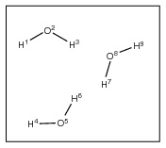 | H1 O2 H3  H4 O5 H6  H7 O8 H9 | HOH(3)
2 | 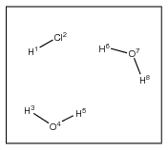 | H1 Cl2  H3 O4 H5  H6 O7 H8 | HCl(1) HOH(2)
3 | 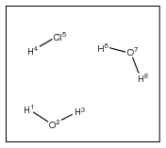 | H1 O2 H3  H4 Cl5  H6 O7 H8 | HOH(1) HCl(1) HOH(1)
4 | 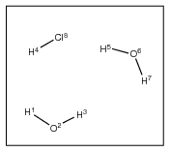 | H1 O2 H3  H4  H5 O6 H7  Cl8 | HOH(1) H(1) HHO(1) Cl(1)

In 1) the three water molecules are identical with respect to the ordering of the atoms, so our description consists of a single pattern describing one HOH moiety. Obvious, huh? The two-component system illustrated in 2) has all molecules of the same type one after the other, giving a simple two-term pattern. However, in 3) the two water molecules are separated (in terms of their order) by the HCl, and so a three-term pattern results. In 4) there are, from the point of view of the program, three distinct molecules, since the ordering of atoms in the two water molecules is different, and so three terms are again necessary in the pattern description.
There are likely to be many possible pattern descriptions for systems, some of which may be useful to employ, and some of which may not be. Take the well-ordered system 1) – four different ways to describe the system are:
HOH(3)
HOH(1) HOH(1) HOH(1)
HOH(2) HOH(1)
HOH(1) HOH(2)
All are equivalent and will give the same energies / forces. Sometimes it is useful to treat individual molecules as separate patterns in their own right since it allows for calculation of interaction energies with the rest of the molecules of the system.

Pattern Granularity
Patterns work on the basis of bound fragments/molecules, and a molecule cannot be split up smaller than this – for instance in the examples above water cannot be represented by ‘HO(1) H(1)’ since this would ‘neglect’ a bond. However, there is nothing to stop a pattern ‘crossing’ individual molecules. Consider again the example 1) above. Three further (reiterating the point, equivalent) ways of writing the pattern description are:
HOHHOH(1) HOH(1)
HOH(1) HOHHOH(1)
HOHHOHHOH(1)
Here, we have encompassed individual molecular entities into supermolecular groups, and as long as there are no bonds 'poking out' of the pattern, this is perfectly acceptable. Although this coarse-graining is a rather counter-intuitive way of forming patterns, it nevertheless allows them to be created for awkward systems such as that in 4) above. We may write the following valid patterns for this arrangement of atoms:
HOHHHOHCl(1)
HOH(1) HHOHCl(1)
HOHHHO(1) HCl(1)
Note that, when automatically creating patterns, if Aten stumbles across a situation that confuses it, the default pattern of one supermolecule will be assumed, i.e. X(1) where 'X' is all atoms in the model. This will work fine in subsequent energy calculations etc., but will result in rather inefficient performance.

Partitioning Schemes
TODO

Filters
Filters determine the model/trajectory, grid/surface, and forcefield expression formats that Aten can read and write. They are essentially small programs written in Aten’s internal command language (based syntactically on C/C++) and are stored as plain text files. These files are parsed and ‘compiled’ when Aten starts up. This has several advantages:
- Users may add support for their own particular formats at will.
- No recompilation of Aten is necessary when adding new filters or adjusting old ones
- Potentially any file format can be supported, even binary formats
With this flexibility, of course, come some modest disadvantages:
- Speed - the C-style code contained within filters is, strictly speaking, interpreted, it is by no means as fast as properly compiled code
- File formats that need particularly awkward operations requiring a more ‘complete’ C language may be difficult to implement
These two points aside, though, filters make Aten a powerful and flexible tool, adaptable to conform to many different program/code input and output formats.
As mentioned, the programming language used by filters is essentially a subset of C, implemented with the same syntax and style (see the command language overview in Chapter 9 for a description), but includes several hundred custom commands to control Aten in order to build up atoms in models, access data etc. So, if you already know C or C++, writing a filter should be a breeze. If you don’t, it’s not too difficult to pick up, and there are plenty of filters already written to use as worked examples.
When a filter is called in order to write out data, no references to any of the current (i.e. displayed or selected) data are sent directly to the filter itself. Instead, this must be probed by using the Aten master reference available to all scripts, commands and filters. Within Aten the currently displayed model may be deduced, as well as the current frame (if a trajectory is associated). In most cases for model export filters, the path ‘aten.frame’ should be used to determine the model data that should be written.

Filter Contents
A filter is a plain text file containing one or more C-style programs that permit the input or output of data in a specific format. For example, a purely model-oriented filter file may contain two filters, one to read in files of the specified format, and one to write the data out again. Each individual filter is given a short nickname, a shell-style glob, and possibly several other bits of data that allow files to be recognised (if the file extensions defined for it are not enough).
Different filters that recognise the same file type may be provided if necessary, each performing a slightly different set of import or export commands (if it is not convenient to do so within a single filter), and all will appear in the drop-down list of filters in file dialogs within the program. Note that in batch, command-line, or scripting mode, filters are either selected automatically based on the filename, extension, or contents, or picked by matching only the associated nickname. In the former case, the first filter that matches the extension is used.

Filter Locations
A basic stock of filters is provided with Aten and installed with the program - several default locations are searched for these filters on startup. Alternatively, if Aten fails to find these filters, or you wish to point it to a suitable directory by hand, either the $ATENDATA environment variable may be set to the relevant path (on Windows, this variable is set by the installer) or the --atendata command-line option may be used to provide the path.
Additional filters may be placed in a user’s .aten directory, e.g. ~bob/.aten/filters/.

Overriding Existing Filters
Filters that possess the same ID or nickname as other filters of the same type may be loaded simultaneously, with the last to be loaded taking preference over the other. Thus, an importmodel filter nicknamed xyz from Aten’s installed filter stock will be overridden by one of the same nickname present in a user’s .aten/filters (or aten/filters on Windows) directory. Similarly, both these filters will be overridden by one of the same nickname loaded by hand from the command line (with the --filter switch). Note that this only holds true for filters referenced by nickname or determined automatically by Aten when loading data - from the GUI all filters are available in the file dialogs.

Filter Definitions
Filter definitions are made in a filter file in a similar way to declaring a user subroutine or function (see Section 8.1.7). The filter keyword marks the start of a filter definition, and contains a list of properties in parentheses that define the subsequent filter, its name, and how to recognise the files (from their filenames and/or contents) that it is designed for. The definition of the filter to import XYZ-style model data is as follows:

filter(type="importmodel", name="XMol XYZ Coordinates", nickname="xyz", extension="xyz", glob="*.xyz", id=3)
{
commands
...
}

The comma-separated list of properties defines the type of filter (‘type="importmodel"’) and how to recognise files of that type (e.g., ‘extension="xyz"’), amongst other things.
The full list of possible properties is as follows:
Table 11-1 Filter Definition Keyword Summary
Property | Description
exact | Comma-separated list of filenames that are of this type
extension | Comma-separated list of filename extensions that indicate files of this type
glob | Shell-style glob to use in file fialogs in order to filter out files of the described type
id | Numerical ID of the filter to enable partnering of import/export filters for files of the same type
name | Descriptive name for the filter, shown in file dialogs etc.
nickname | Short name used by commands in order to identify specific filters
search | Provides a string to search for in the file. If the string is found, the file is identified as being readable by this filter type. The number of lines searched is governed by the within property
type | Defines the kind of filter that is described (i.e. if it loads/saves, acts on models/grid data etc.) so that Aten knows when to use it. Must always be defined!
within | Specifies the number of lines to search for any supplied search strings
zmap | Determines which zmapping style to employ when converting atom names from the file

exact
Syntax:
exact=”name1,name2,...”
Occasionally (and annoyingly) files have no extension at all, instead having short, fixed names, which must be checked for literally when probing files. This command defines one or more explicit filenames that identify files targeted by this filter. Multiple names may be given, separated by commas or whitespace. Exact filename matching is case-insensitive.
For example:

exact="coords"

associates any file called ‘coords’ to this filter.

exact="results,output"

associates any files called ‘results’ or ‘output’ to this filter.

extension
Syntax:
extension=”extension1,extension2...”
Sets the filename extension(s) that identify files to be read / written by this filter. When files are being probed for their type, in the first instance the filename is examined and the extension (everything after the last ‘.’) is compared to those defined in filter sections by this command. Multiple file extensions may be given, separated by commas or whitespace. File extension matching is case-insensitive.
For example:

extension="xyz"

means that files with extension ‘.xyz’ will be recognised by this filter.

extension="xyz,abc,foo"

means that files with extensions ‘.xyz’, ‘.abc’, and ‘.foo’ will be recognised by this filter.

glob
Syntax:
glob=”*|*.ext”
Sets the file dialog filter extension to use in the GUI, and should be provided as a shell-style glob.
For example:

glob="*.doc"

filters any file matching ‘*.doc’ in the relevant GUI file selector dialogs.

id
Syntax:
id=n
When separate import and export filters for a given file type have been provided it is prudent to associate the pair together so that Aten knows how to save the data that has just been loaded in. Each filter has a user-definable integer ID associated with it that can be used to link import and export filters together. For example, if a model import filter has an ID of 7, and a model export filter also has this ID, then it will be assumed that the two are linked, and that a model saved with export filter 7 can be subsequently loaded with import filter 7. If the ID for a filter is not set it defaults to -1, and it is assumed that no partner exists and the file cannot be directly saved back into this format.
For example:

id=13

See the list of supported formats in Table 1-1 to Table 1-4 to find which ids are currently in use.

name
Syntax:
name=”long name of filter”
Sets the long name of the filter, to be used as the filetype description of files identified by the filter. This name will appear in the file type lists of file dialogs in the GUI, and also in the program output when reading / writing files of the type.
For example:

name="SuperHartree Coordinates File"

nickname
Syntax:
nickname=”short name of filter”
Sets a nickname for the filter, which allows it to be identified easily in the command language and, importantly, from the command line. It should be a short name or mnemonic that easily identifies the filter. No checking is made to see if a filter using the supplied nickname already exists.
For example:

nickname="shart"

sets the nickname of the filter to ‘shart’.

nickname="zyx"

sets the nickname of the filter to ‘zyx’.

search
Syntax:
search=”string to search”
Occasionally, checking the contents of the file is the easiest way to determining its type, and is probably of most use for the output of codes where the choice of filename for the results is entirely user-defined. For example, most codes print out a whole load of blurb and references at the very beginning, and usually searching for the program name within this region is enough to identify it. For files that are only easily identifiable from their contents and not their filename, plain text searches within files can be made to attempt to identify them. Individual strings can be given to the search keyword, and may be specified multiple times. The default is to search the first 10 lines of the file for one or more of the defined search strings, but this can be changed with the within property.
For example:

search="UberCode Version 20.0"

matches the filter to any file containing the string ‘UberCode Version 20.0’ within its first 10 lines (the default).

search="SIESTA"

searches the first 10 lines of the file for the string ‘SIESTA’.

search=""GAMESS VERSION = 11 APR 2008 (R1)"

attempts to identify output from a specific version of GAMESS-US.

type
Syntax:
type=”filtertype”
The 'type' keyword must be provided an all filter definitions - an error will be raised if it is not. It specifies which class of data the filter targets (e.g. models, grid data etc.) and whether it is an import or export filter. A given filter may only have one type specified, for which the possible values are:
Table 11-2 Filter Types
Type | Description
exportexpression | Describes how to export forcefield descriptions (expressions) for models
exportgrid | Describes how to export grid-style data
exportmodel | Describes how to write out model data
exporttrajectory | Filter suitable for the export of trajectory data
importexpression | Describes how to load in forcefield-style expressions
importgrid | Describes how to read gridded volumetric or surface data from files. Any grids created in these sections must have the finaliseGrid command called on them, otherwise they will not be registered properly within the program.
importmodel | Describes how to import model data, including atoms, cell and spacegroup data, bonds, glyphs etc. Any models created in ‘importmodel’ filters must have the finaliseModel command called on them, otherwise they will not be registered properly within the program.
importtrajectory | Read frames from trajectory files. See the section on trajectories (Section 11.2) for additional information on how trajectories are handled within Aten.

For example:

type="importgrid"

type="exportmodel"

within
Syntax:
within=n
Defines the maximum number of lines at the beginning of the file that will be searched for string definitions (default is 10).
For example:

within=50

specifies that the first 50 lines should be searched for identifying strings.

zmap
Syntax:
zmap=”zmaptype”
By default, it is assumed that the commands which create new atoms will be given a proper element symbol from which to determine the atomic number. Case is unimportant, so na, Na, and NA will all be interpreted as atomic number 11 (sodium). Where element symbols are not used in the model file, there are several alternative options that tell these commands how to convert the element data they are passed into atomic numbers. For example, the ff style is particularly useful when loading in coordinate files which contain forcefield atom type names that do not always correspond trivially to element information (e.g. DL_POLY configurations).
For example:

zmap="numeric"

indicates that atomic numbers are provided in place of element names and no conversion should be performed. See Table 16-17 for a list of available z-mapping methods.

Filter Options
When writing data, in many cases all the information that the filter wants to write is contained within the current model, for example when outputting simple file formats such as xyz or Aten’s own akf format. In other cases ther may be additional data for which would be nice to have some control over, and which lays beyond atoms and bondes. The best example is probably the input formats for nearly all ab initio codes which contain (as well as the atomic coordinates) statements and additional data necessary to control the running of the code itself. It is not a problem to write out static lines of control commands from the output filter, but it would of course also be nice to be able to tailor this output from within the GUI (or from the command-line). This can be achieved by assigning values to variables in the filter through the use of Custom Dialogs (see Section 8.3).

Trajectory Files
Trajectory files usually mean one of two things – either a sequence of frames from a molecular dynamics simulation trajectory, or a sequence of configurations from a geometry optimisation of some kind. Either way, both boil down to the same thing from Aten's perspective, that is a set of models in a sequence. In terms of displaying such a set of models, either they may be loaded as individual models (i.e. having a separate tab in the GUI) or the sequence of models may be associated to a single 'parent' model. Most commonly, the latter is the preferred method (especially when large numbers of models are present in the trajectory).
There are two related ways to get this data into Aten. From the perspective of molecular dynamics simulations, the parent model or configuration and the trajectory frames are stored in separate files. In this case, the model can be loaded first, and then the trajectory file attached or associated to this model afterwards. From the perspective of geometry optimisations, for example, the parent configuration (i.e. the starting point of the optimisation) and the sequence of coordinates are most often stored in the same output file. In this case, the importmodel filter can detect the presence of the additional trajectory frames and manually attach them to the parent model. The following sections explain the details of how both methods work.

Trajectories in Separate Files
DL_POLY, being a molecular dynamics code, stores its configuration and trajectory data in separate files. Filters are supplied with Aten that read in DL_POLY trajectories, and so this example will revolve around those filters.

Necessity for a Master Configuration?
Thus far, it has been implicity stated that the 'master' configuration and the trajectory files come necessarily as a pair - the master configuration is read in, and then the trajectory associated to it. This implies that the trajectory file is somehow tied to the master configuration - perhaps the trajectory file does not contain information such as the number of atoms or element data, and so a ‘reference’ configuration is necessary? Of course, this may not always be the case, and it is possible that some trajectory formats will store all the necessary information needed in order to fully generate the trajectory configurations. DL_POLY trajectories do, in fact, contain all the necessary data, but even so the master configuration is still used as a template for the trajectory data, and is used to check that the correct number of atoms are present etc. It comes down to a matter of preference as to whether the master configuration should be demanded, or whether the trajectory can itself be associated to any (even an empty) model. Remember, importtrajectory filters always attach the trajectory data to an existing model.

ImportTrajectory Filters
An importtrajectory filter is written in a slightly different way to other filter types. Since trajectory files may contain header data which is written once at the beginning of the file, preceeding the frame data, there are potentially two separate sets of data to read from trajectory files - header data and (individual) frame data. So, rather than putting the code to read this data directly in the main body of the filter, two functions should be defined instead, one for reading the header (which must be called readHeader), and one for reading an individual frame (which must be called readFrame). Note that, if a given trajectory format does not contain a header, the corresponding function may be left empty, but must still be defined and should return a value of ‘1’. Both functions take no arguments, and must return an integer. A template for an importtrajectory filter is thus:

filter(type=”importtrajectory”, name="Example Filter Template")
{
int readHeader()
{
// Code to read header data goes here
}

int readFrame()
{
// Code to read frame data goes here
}
}

The functions must take responsibility for informing Aten when the desired data cannot be read. Both should return a value of ‘1’ if the data was read successfully, and should return ‘0’ if an error is encountered.

Header Data
When opening a trajectory file with an importtrajectory filter, the first thing Aten does is attempt to read any header information from the file by calling the readHeader function defined in the filter. Since a trajectory file may not contain a header, and consists simply of individual frames back to back, in these situations the readHeader function defined in the filter should not read any data. The filter definition then becomes simply:

filter(type='importtrajectory', name="Example Filter Template")
{
int readHeader()
{
// No header, so just return
return 1;
}

int readFrame()
{
// Code to read frame data goes here
}
}

Here, the readHeader function always succeeds, so Aten always thinks it has successfully read a header.

Frame Data
If readHeader is successful, Aten proceeds to read the first frame (by calling the readFrame function) in order to get an idea of the size of an individual frame, and hence the total number of frames in the trajectory. Of course, this assumes that all frames take up the same number of bytes in the file, and may not always be the case, especially for plain-text trajectory files. Thus, the frame estimate output by Aten should not necessarily be taken as gospel.
Unless an error is encountered when reading the test frame (i.e. readFrame returns '0' or FALSE) the trajectory file is then rewound to the end of the header section (start of the frame data). One of two things then happens. Since trajectory files are typically enormous (hundreds or thousands of megabytes) then it is unwise to try and load the whole trajectory into memory at once. Aten knows this, and from the estimated frame size also knows roughly how big the whole trajectory is. If the total trajectory file size is greater than an internally-defined limit (the “trajectory cache size”) then only a single frame is stored at any one point. If the total size is smaller then this limit, the whole trajectory is cached in memory. Both have their advantages and disadvantages, as listed in the following sections.

Uncached Frames
If the trajectory is too big to be stored in memory, Aten only holds a single frame in memory at any one time. This means that:
- Memory use is minimised since only a single frame is loaded at any time
- Performance is slower – moving between frames means data must be read from disk
- Edits are forgotten – changes (both atomic and stylistic) made to the loaded frame are forgotten when a different frame is read
Aten tries to minimise the seek time between frames by storing file offsets of frames it has already read in. However, since trajectory frames can be different sizes Aten never tries to 'jump' ahead in the file based on the size of a single frame. Skipping immediately to the final frame in the trajectory will, thus, read all frames along the way and store file offsets for all frames. Then, seeking to any individual frame is a much quicker process.
Although style and editing changes are forgotten between frames, the overall camera view of the model is linked to that of the master configuration and so is retained between frames. If the trajectory cannot be cached and you require changes (edits or styles) to be made to each frame (e.g. for the purposes of making a movie of the trajectory) then a script is the way to go (load frame, apply edits, save image, etc.).

Cached Frames
If the trajectory is small enough to be stored in memory, Aten reads in all frames at once. This means that:
- Memory use is increased
- Performance is optimal - speed of moving between frames is fast because all frames are in memory
- Edits are retained - edits can be made to individual frames and will be remembered on moving to a different frame
The size of the cache can be adjusted either from the command line with the --cachelimit switch or by setting the cachelimit member of the Prefs variable within Aten. No check is made of the new cache limit with respect to the memory available on the machine on which Aten is running, so use with care.
In the current versions of Aten, the total trajectory size is determined from the size of the frame on disk, whereas it would be more appropriate to use the size of the frame in memory. This will change in a future release.

Reading and Writing
Formatted output in Aten is based largely on string formatting in C, so if you're familiar with C then this should be a breeze. If you’re a Soldier of Fortran, then the principles are very similar. If you're familiar with neither, then now's the time to learn.

Formatted Output
Formatted output corresponds to output to either the screen or to files, and is used in the following commands:
Table 11-3 Formatted Output Commands
Command | Function
error | Write a message to the screen and immediately terminate execution of the current script / filter / command structure
printf | Write a message to the screen
verbose | Write a message to the screen, provided verbose output mode is on
writelinef | Write a formatted line to the current output file
writevarf | Write a formatted string to a variable (equivalent to the C 'sprintf' command)

Basic Strings
Formatting a string for output, as mentioned elsewhere on numerous occasions, works the same as for C. The C printf command (equivalent to the command of the same name in Aten) takes a character string as its first argument, and at its simplest, this is all that is required:

printf("Hello");

This prints ‘Hello’ to the screen (minus the quotes). Importantly, however, a newline character is not printed, meaning that the next thing you try and printf will appear on the same line. For instance:

printf("Hello");
printf("There.");

would output:

HelloThere.

The end of a character constant in the printf command does not implicitly mean ‘and this is the end of the line’ - you must indicate the end of the line yourself by placing '\n' at the point where you wish the line to end. So:

printf("Hello\n");
printf("There.");

would output:

Hello
There.

Newlines (\n) are an example of escaped characters - the backslash ‘\’ indicates that the following character, in this case ‘n’, is not to be treated as a normal ‘n’, but instead will take on its alternative meaning, in this case a newline character. There are one or two other escaped characters recognised - see Escaped Characters for a list. Note that the newline token can appear anywhere in the string, and any number of times. So:

printf("Hello\nThere\n.");

would output:

Hello
There
.

Printing Data
Being able to print simple text strings is good, but not nearly enough. The first argument to the 'printf' command must always be a character string, but any number of additional arguments may be provided. Now, these additional arguments may be number constants, other character strings, variables, etc., and may be output in the resulting string by referencing them with ‘specifiers’ placed within the first example. One example of a specifier is %i which is shorthand for saying ‘an integer value’ – if used within the character string provided to printf, the command will expect an integer constant or variable to be provided as an additional argument. For example:

printf("This number is %i.\n", 10);

will print

This number is 10.

Similarly,

int value = 1234;
printf("Constant is %i, variable is %i.\n", 10, value);

will print

Constant is 10, variable is 1234.

There are other specifiers suitable for different types of data – see Section 11.3.4. The way data is presented by the specifier in the final output can also be controlled (e.g. for numerical arguments the number of decimal places, presence of exponentiation, etc., can be defined).

Formatted Input
Formatted input corresponds to input from either files or string variables, and is used in the following commands:
Table 11-4 Formatted input commands
Command | Function
readLineF | Read a formatted line from the current input file
readVarF | Read a formatted string from a variable

Note that the meaning of the formatting string changes slightly here - in essence, the type and formats of the specifiers are used to break up the supplied string into separate arguments, which are then placed in the provided corresponding variable arguments. When reading in string data, note that blank characters are significant and will be retained. To strip trailing blank characters (spaces and tabs) when reading a fixed-length string in a format, supply the length as a negative number.

Specifiers
The list of allowable variable specified corresponds more or less exactly to that found in C, with some small omissions and minor inclusions. For a full list see the reference page at cplusplus.com or cppreference.com. The list of printf features that are not (currently) supported in Aten are as follows:
- The pointer specifier %p is not supported. To print out reference addresses, use %li
- The single-character specifier %c is not supported
- Output of long doubles by prefixing a specifier with L (e.g. %Le) is not supported

Extra Specifiers Within Aten
As well as the mostly complete standard set of specifiers provided by C, Aten also includes some other useful specifiers that may be used in formatted input and output.
Table 11-5 Extra read/write specifiers
Specifier | Meaning
%* | Relevant to formatted input only. Discard the next item, regardless of its type. A corresponding variable argument need not be provided
%r | Read characters (starting from the next delimited argument) until the end of the input line is encountered (i.e. ‘rest-of-line’ specifier). A corresponding string variable should be provided

Escaped Characters
Table 11-6 Escaped characters in format strings
Escape Sequence | Meaning
\n | Print newline (next character will appear on the next line)
\r | Carriage return
\t | Tab character

Delimited Reading and Writing
Formatting strings (or ‘format specifiers’) can be used to specify the layout of data items on a line when reading or writing data, but if the data are separated by whitespace characters such as spaces or tabs (or, alternatively, commas), such delimited data can be read in more easily. In such cases, it is not necessary to know beforehand the number of characters taken up by each item on the line, since the delimiters separate adjacent data items. A simplified method for reading and writing can be employed in these cases.
Commands providing delimited reading and writing are:
Table 11-7 Delimited read/write commands
Command | Function
readLine | Read delimited items from a source file, placing into the variables provided
readNext | Read the next delimited item from a source file, placing into the variable provided
readVar | Read delimited items from a source variable, placing into the variables provided
writeLine | Write the supplied items to a single line in the output file, separating them with whitespace
writeVar | Write the supplied items to a supplied string variable, separating them with whitespace

Note that all are called the same as their formatted counterparts, but minus the 'f' at the end of the name.

Delimited Data Example
Consider this example datafile:

Na 0.0 1.0 0.0
Cl 1.0 0.0 0.0
Na 0.0 -1.0 0.0

Since the data items (element type and coordinates) are separated by whitespace, we need only provide the target variables to the relevant command - a formatting string, as is demanded by the printf command, is not required. Using the readLine command, the following code will parse this data correctly:

double x,y,z;
string el;
while (!eof()) { readline(el,x,y,z); newatom(el,x,y,z); }

The variables el, x, y, and z will, at any one time, contain the element type and coordinates from one line of the file. In an analogous manner, the data may be written out again with the corresponding writeLine command:

for (atom i = aten.model.atoms; i; ++i) writeline(i.symbol,i,rx,i.ry,i.rz);

Each line will have the individual data items separated by a single space.
The readNext command reads in a single delimited item from a source file, preserving the remainder of the input line for subsequent operations. If there is no data left on the current line, a new line is read and the first delimited item is returned. The example above might be written in a slightly clunkier form as:

double x,y,z;
string el;
while (!eof())
{
readnext(el);
readnext(x);
readnext(y);
readnext(z);
newatom(el,x,y,z);
}

For all delimited reading operations, items of data read from the line are converted automatically into the type of the destination variable. So, the atom coordinates read in above, which are put into double-type variables, could equally well be put into string variables. Standard C routines are used to convert data items in this way, and only some conversions make sense. For instance, attempting to read an item which is a proper character string (such as element symbol/name data) into a double or integer variable does not make sense. No error message will be raised, and the variables will likely be set to a value of zero (or whatever passes for 'zero' in the context of the type).
For all delimited writing operations, a suitable standard format specifier is chosen with which to write out the data.

Unformatted Reading and Writing
TODO

Forcefields and Typing

Overview
If you're doing anything interesting with a model or a molecule, a suitable forcefield description of the system is a must. A forcefield contains lists of parameters that describe the interactions between atoms, for example bonds, angles, and van der Waals interactions. More specifically, a forcefield contains parameters to describe many such interactions in many different types of molecule or chemical environment. An ‘expression’, referred to throughout the manual, should be thought of as the subset of terms from a given forcefield necessary to describe all the interactions within a model.
Aten has its own free format for forcefield files, described in the following sections. Once loaded in, the energy and forces in Models can then be calculated, and allows energy minimisation etc. More so, once a set of forcefield parameters has been read in and used to describe a model, this expression can be written out using a custom format ready for input into something else.

File Format
The basic forcefield file format is designed to be as readable as possible by both machine and user. Lines are free format, meaning that any number of tabs, commas, and spaces may separate items. Text items should be enclosed with either double or single quotes if they themselves contain these delimiters (in particular, this applies to NETA descriptions). There is no terminating symbol at the end of a line, c.f. the command language where a ‘;’ typically ends every command.
The majority of data is contained within blocks in the file. Blocks begin with a specific keyword (e.g. inter), contain one or more lines of definitions, and are terminated by an 'end' keyword. Forcefield files may contain many blocks of the same type, permitting terms of the same type but with differing functional forms to be defined easily.
More advanced forcefields may contain generator sections and functions that enable them to either generate all their parameters on the fly from a basic set of data, or fill in missing terms that are not defined in any blocks.

Example - SPC Water
The format is keyword-based and as simple as possible. Most input is enclosed within blocks, beginning with a keyword and terminated after several lines of data with and 'end' statement. As an example of the overall structure of a forcefield, consider the simple point charge (SPC) forcefield for water as is provided with Aten:

name "SPC Water"
units kj

types
1 HW H "nbonds=1"
2 OW O "-H,-H"
end

inter lj
1 HW 0.41 0.0 0.0
2 OW -0.82 0.650 3.166
end

bonds constraint
HW OW 4184.0 1.000
end

angles bondconstraint
HW OW HW 4184.0 1.62398
end

After giving the forcefield a name and defining the energy units used for the parameters, the two types of atom described by the forcefield (OW and HW) are listed. A unique id, type name, base element, and type description are provided, providing Aten with all it needs to be able to recognise and type these atoms within a model. For each of these types the van der Waals data are provided in the Lennard-Jones style (inter lj) – again, the type id and type name are specified, followed by the atomic charge and the epsilon and sigma values. Note here that there are default combination rules set for each functional form - see VDW functional forms for a list. Finally, the single bond and angle within the molecule are defined. The type names involved in the interactions are given, followed by the necessary parameters for the functional form specified (‘constraint’ for the bond, and ‘bondconstraint’ for the angle). And that's it. Detailed explanations of each section follow. A more complete test forcefield supplied with Aten can be found in data/ff/test.ff.

Supplied Forcefields
A handful of forcefields ready-formatted for import into Aten are provided with the code and are listed here. It should be a relatively straightforward process to convert others, unless the functional forms used are not yet implemented (but sure, if you ask then I will add them). If you export an expression from Aten, please check the parameters in the file are what you actually want. Aten is designed to ease the pain of setting up a simulation in this manner, but is not intended as a black box.

Canongia-Lopes & Padua Ionic Liquids (cldp-il.ff)
All-atom ionic liquids forcefield of Canongia Lopes et al. covering various cation/anion combinations.
References
- J. N. Canongia Lopes, A. A. H. Padua, J. Phys. Chem. B, 110 (39), 19586-19592 (2006)
- J. N. Canongia Lopes, A. A. H. Padua, J. Phys. Chem. B, 108 (43), 16893-16898 (2004)
- J. N. Canongia Lopes, J. Deschamps, A. A. H. Padua, J. Phys. Chem. B, 108 (30), 11250 (2004)
- J. N. Canongia Lopes, J. Deschamps, A. A. H. Padua, J. Phys. Chem. B, 108 (6), 2038-2047 (2004)

Youngs, Kohanoff, & Del Pópolo [dmim]Cl (dmimcl-fm.ff)
Force-matched model for the ionic liquid dimethylimidazolium chloride only. Integer charges on ions.
References
- T. G. A. Youngs, J. Kohanoff, and M. G. Del Pópolo, J. Phys. Chem. B, 110 (11), 5697-5707 (2006)

Youngs & Hardacre [dmim]Cl (dmimcl-fm2.ff)
Second force-matched model for the ionic liquid dimethylimidazolium chloride only. Non-integer charges on ions.
References
- T. G. A. Youngs and C. Hardacre, ChemPhysChem, 9 (11), 1548-1558 (2008)

Jorgensen at al. OPLS-AA (oplsaa.ff)
Original OPLS-AA forcefield of Jorgensen et al. Thanks to W. Jorgensen for supplying the parameter data.
References
- W. L. Jorgensen, D. S. Maxwell, and J. Tirado-Rives, J. Am. Chem. Soc. 118, 11225-11236 (1996).
- W. L. Jorgensen and N. A. McDonald, Theochem 424, 145-155 (1998).
- W. L. Jorgensen and N. A. McDonald, J. Phys. Chem. B 102, 8049-8059 (1998).
- R. C. Rizzo and W. L. Jorgensen, J. Am. Chem. Soc. 121, 4827-4836 (1999).
- M. L. Price, D. Ostrovsky, and W. L. Jorgensen, J. Comp. Chem. 22 (13), 1340-1352 (2001).
- E. K. Watkins and W. L. Jorgensen, J. Phys. Chem. A 105, 4118-4125 (2001).
Note: NETA definitions have been written for a large number of types in the forcefield, but not all.

Berensen et al. Simple Point Charge Water (spc.ff)
Rigid, simple point charge model for water
References
- H. J. C. Berendsen, J. P. M. Postma, W. F. van Gunsteren and J. Hermans, in Intermolecular Forces, B. Pullman (ed.), Reidel, Dordrecht, 1981, p331.

Berensen et al. Extended Simple Point Charge Water (spce.ff)
Simple point charge model for water, modified to reproduce molecular dipole in the liquid phase.
References
- J. C. Berendsen, J. R. Grigera and T. P. Straatsma, J. Phys. Chem. 91, 6269-6271 (1987)

Rappe et al. Universal Forcefield (uff.ff)
Universal forcefield for the whole periodic table by Rappe et al.
References
- A. K. Rappe, C. J. Casewit, K. S. Colwell, W. A. Goddard III, and W. M. Skiff, J. Am. Chem. Soc. 114, 10024-10039 (1992)
Notes:
- Generated terms should be checked by hand if forcefield expressions are exported.
- Detection of some atomtypes, namely transition metals, is imperfect.
- Warning: Generation of terms (especially angles) needs to undergo proper testing! If you wish to help, please contact me.

Mayo, Olafson & Goddard II's Generic Forcefield (testing/dreiding.ff)
Universal forcefield for the whole periodic table.
References
- S.L. Mayo, B.D. Olafson, and W.A. Goddard III, J. Phys. Chem. 94, 8897-8909 (1990).
Notes:
- dreiding.ff currently lives in the testing/ directory since it is a rule-based forcefield and is currently being rewritten.
- Generated terms should be checked by hand if forcefield expressions are exported.
- Detection of some atomtypes, namely transition metals, is imperfect.
- Warning: Generation of terms (especially angles) needs to undergo proper testing! If you wish to help, please contact me.

General Amber Forcefield (testing/gaff.ff)
General Amber forcefield containing precalculated terms for most intramolecular terms, and generator section for any that are missing.
References
- J. Wang, R. M. Wolf, J. W. Caldwell, P. A. Kollman, and D. A. Case, J. Comp. Chem. 25, 1157-1174 (2004)
Notes:
- gaff.ff currently lives in the testing/ directory since it's rule-based part has not been implemented yet.

Liu, Wu & Wang's United-Atom Ionic Liquids Forcefield (lww-il.ff)
United atom ionic liquids forcefield for a handful of cations and anions.
References
- X. Zhang, F. Huo, Z. Liu, W. Wang, W. Shi, and E. J. Maginn, J. Phys. Chem. B 113, 7591-7598 (2009)
- Z. Liu, X. Wu, and W. Wang, Phys. Chem. Chem. Phys. 8, 1096-1104 (2006)

Keyword Reference

General Keywords
General keywords are simple keywords that take single items of data as arguments.

name
Syntax:
name "name of forcefield"
Sets the name of the forcefield as it appears in the program.
For example:

name "Test Forcefield"

sets the name of the forcefield to "Test Forcefield".

units
Syntax:
units energyunit
Specifies the units of energy used for energetic forcefield parameters. Any energetic parameters specified in the forcefield are converted from the units specified here into the internal units of energy once loading of the forcefield has completed.
For example:

units kcal

indicates that any energetic values supplied in the forcefield are in kilocalories per mole.

convert
Syntax:
convert name ...
Only relevant if a data block exists, the convert keyword takes a list of parameter names defined in the data block(s), and marks them as being (or containing) a unit of energy. When Aten converts between energy units, these marked parameters will be converted also.
For example:

convert Dij e_sep

indicates that the defined data variables Dij and e_sep are energy-based and should be converted when necessary.

Block Keywords
All lists of terms, types, and extraneous data are specified in the form of blocks. Each keyword in this section marks the start of block, and must at some point be terminated by an end keyword. Blocks contain one or more lines of data, the contents of which is detailed in each section. In addition each keyword may take one or more (optional or required) values.

angles
Syntax:
angles form
typename_i typename_j typename_k data1 [data2 ...]
end
Definitions of intramolecular angle terms are given in angles blocks. Multiple angles blocks may exist, each defining a subset of terms, and each possessing a different functional form, specified by the form argument (see Section Error! Reference source not found. for a list of valid forms).
The three typenames identify the particular angle to which the parameters are relevant. Note that typenames given for an angle i-j-k will also match an angle k-j-i. Data parameters should be provided in the required order for the specified form.
For example:

angles harmonic
HT CT HT 80.0 109.4
end

provides parameters for an H-C-H angle using the harmonic potential.

bonds
Syntax:
bonds form
typename_i typename_j data1 [data2...]
end
Definitions of intramolecular bond terms are given in bonds blocks. Multiple bonds blocks may exist, each defining a subset of terms, and each possessing a different functional form, specified by the form argument (see Section Error! Reference source not found. for a list of valid forms)
The two typenames identify the particular bond to which the parameters are relevant. Note that typenames given for a bond i-j will also match a bond j-i. Data parameters should be provided in the required order for the specified form.
For example:

bonds constraint
HT CT 4000.0 1.06
end

provides parameters for an H-C bond using the constraint potential.

data
Syntax:
data "type name, ..."
typeid typename data1 [data2 ...]
end
The data block defines additional generic data for each atom type. The additional data can be accessed through the datad, datai, and datas members of the FFAtom type.
The quoted argument supplied to the block defines the data types and names to be expected for each specified atom type, and furthermore stricly defines the order in which they must be given. Any of the standard simple variable types int, double, and string may be used.
Following the identifying typeid and typename data items are given one after the other and in the order they are declared in the block keyword argument.
For example:

data "string dogtype, int bridge, int likespasta, double numtoes"
1 OW "redsetter" 1 0 9
2 HW "dalmation" 1 1 64
end

This defines a quartet of extra data (albeit random, odd data...) for each of the specified atom types.
For forcefields which rely on functions to generate the necessary function data, the data block should be used to define additional data for each atom type. For example, the GAFF forcefield is able to generate extra intramolecular terms if the relevant definitions are not already defined in the forcefield, and the UFF and DREIDING forcefields contain no pre-defined intramolecular terms whatsoever.

defines
Syntax:
defines
definename "NETA string"
end
The defines block makes it possible to state commonly-used or lengthy chunks of NETA that do not belong to any specific atom type, and which can then be reused multiple times in many different atom type descriptions. Each definition in the block is given an identifying unique name which allows it to be referenced with the ‘$’ symbol.
The NETA descriptions provided for each definition must be valid, or the forcefield will not be loaded. In subsequent NETA definitions for atom types the definitions may be inserted by stating $definename. For example:

defines
water_oxygen.."-O(nh=2,nbonds=2)"
end

...

types
1 HW2 H "nbonds=1,$water_oxygen" "Water hydrogen"
end

equivalents
Syntax:
equivalents
alias typename [typename ...]
end
In forcefields, the most detailed information provided is typically the short-range intermolecular and charge parameters, with different values (or at least different charges) given to each individual atom type. Usually, intramolecular terms are more general and don't depend so much on the exact atom type. For example, given a tetrahedral carbon CT and three different aliphatic hydrogens H1, H2, and H3, the bond between the carbon and any of the three hydrogen types will likely be the same with respect to the force constant, equilibrium distance etc.
So, the forcefield will have to contain three intramolecular bond definitions covering CT-H1, CT-H2, and CT-H3, each having the same parameters, right? Not necessarily. While this is perfectly acceptable, for large forcefields the number of redundant terms may become quite large, and even for small forcefields with only a handful of terms, adding in duplicate data might irk the more obsessive amongst us. On these occasions, atomtype equivalents can be defined, which effectively link a set of atomtypes to a single identifying name that can then be used in any intramolecular parameter definitions.
In the waffle above, aliasing the three hydrogens H1, H2, and H3 to a single typename H1 can be done as follows:

equivalents
H1 H2 H3
end

Note that the aliased name does not have to be an atomtype name already defined in a types section.

function
Syntax:
function
type functionname ( argument list )
{
}
end
The function block contains all the function definitions relevant to rule-based forcefields (Section 1.1). The function(s) should be written in the standard command language style (Section 8.1.1).
For example:

function
int generatebond(ffbound data, atom i, atom j)
{
# Calculate bond potential parameters between supplied atoms i and j
data.form = "morse";
return 1;
}
end

defines the function to be used when generation of a bond term is required. Only functions with certain names will be recognised and used properly by Aten. See the functions section (12.4.1) in rule-based forcefields for more information and a list of valid function declarations that may be made.

generator
Syntax:
generator "type name, ..."
The generator block is defunct as of code revision 1267. Use the data block instead.

inter
Syntax:
inter form
typeid typename charge data1[data2 ...]
end
Intermolecular van der Waals parameters and the charge associated with each atom type belong in the inter section. There may be multiple inter sections within the same forcefield file, but parameters for an individual atomtype may be defined only once.
The inter keyword begins a block of intermolecular parameter definitions, and the single argument form should specify the functional form of the intermolecular interactions contained within. typeid and typename refer to a single type defined in a types section, charge is the atomic charge of this atomtype, and then follows the data describing the interaction. The order of the values given should correspond to the order of parameters expected for the specified functional form (see Section 13.1 for a list of valid forms and their parameters).
For example, the Lennard-Jones potential takes two parameters – ‘epsilon’ and ‘sigma’, in that order. For a chloride atomtype with ID 24, if ‘epsilon’ = 0.5, ‘sigma’ equals 3.0, and the charge on the atomtype is -1 e, the corresponding entry in the inter block will be:

24 Cl -1.0 0.5 3.0

Some functional forms have default values for some parameters used in the functional form, and need not be specified (if there are any, these are shown in Section 13.1). For this reason, it is important not to add any unnecessary extra data to the entries in the 'inter' block, since this may overwrite a default parameter that results in literal chaos.

torsions
Syntax:
torsions form [escale vscale]
typename_i typename_j typename_k typename_l data1 [data2...]
end
Definitions of intramolecular torsion terms are given in torsions blocks. Multiple torsions blocks may exist, each defining a subset of terms, and each possessing a different functional form, specified by the form argument (see Section Error! Reference source not found. for a list of valid forms). For torsions the electrostatic and VDW 1-4 interactions (i.e. those between atoms i and l in a torsion i-j-k-l) are scaled by some factor between 0.0 and 1.0. The optional escale and vscale arguments specify these scaling factors – if they are not provided, they both default to 0.5.
The four typenames identify the particular torsion to which the parameters are relevant. Note that typenames given for a torsion i-j-k-l will also match a torsion l-k-j-i. Data parameters should be provided in the required order for the specified form.
For example:

torsions cos
HT CT OC HO 3.0 5.0 0.0
end

provides parameters for an H-C-O-H torsion using the cosine potential.

torsions cos3 0.8333333 0.25
CT CT CT O1 1.0 -2.0 0.0
CT CT CT O2 0.5 -1.4 1.0
end

defines two C-C-C-O torsions of the triple cosine form, and with custom scale factors.

types
Syntax:
types
typeid typename element NETA [description]
end
The core of the forcefield file is the types section, listing the ids, names, and elements of the different atom types present in the forcefield, as well as a description telling Aten how to recognise them.
The typeid is an integer number used to identify the type. It should be positive, and must be unique amongst all those defined in a single forcefield. typename is the actual name of the atom type (OW, C1, N_ar etc.), and is referred to in the other sections of the forcefield file, and element is the type’s element symbol as found in the periodic table (O, C, N, etc.). The string NETA defines how Aten should recognise this particular type (in quotes if necessary), optionally followed by a short text description of the type (which appears in lists within the program to help identify particular types). Atom types may be defined over multiple types blocks within the same file if necessary, but while more than one types block may exist, but all type IDs must be unique over all such blocks.
For example:

types
35 CT C "nbonds=4" "Simple tetrahedral carbon"
end

describes a bog-standard tetrahedral carbon called CT, and assigns it an ID of 35.

uatypes
Syntax:
uatypes
typeid typename element mass NETA [description]
end
The uatypes section contains exactly the same information as the types block except that a mass must also be provided. In the types block it is assumed that the character element of the type also implicitly defines the mass (as would be expected). In the case of united-atom forcefields, this is not necessarily the case. Thus, the uatypes block allows a mass to be associated in order to account for the light atoms subsumed into the heavy atom’s mass. This information can be accesses through the mass member of the FFAtom variable type.
For example:

uatypes
10 CH2 C 14.0265 "nbonds=2,nh=0" "United atom methylene carbon"
end

describes a united-atom methylene carbon, with mass of 14.0265 (C+2H).

ureybradleys
Syntax:
ureybradleys form
XXXX
end

Wildcards
In any of the typenames given in the specification of intramolecular interactions, a wildcard character ‘*’ may be used to ‘finish off’ any or all of the typenames (or replace individual typenames entirely). In doing so, a single definition is able to match more than one set of typenames.
For example:

bonds harmonic
CT H* 4184.0 1.06
end

will describe bonds between CT and any other atom beginning with an H.
Using a * on its own will match any typename in that position. As an extreme example:

angles harmonic
* * * 418.4 109.4
end

will match any angle. Be careful - when Aten is creating expressions and searching for specific interactions between atom types, as soon as an intramolecular definition is found that matches it is used, and no further searching is done. So, loose definitions involving wildcards should be put near to the end of the block in which they occur.

Rule-Based Forcefields
Forcefields exist where individual intramolecular parameter definitions (i.e. those provided by the bonds, angles, and torsions blocks) are not necessary. Instead, such parameters are constructed as and when necessary using a set of parameters that depend only on the atomtypes involved. These forcefields are so-called ‘rule-based’, and are often able to describe enormously varied systems from a small set of defining parameters.
Rule-based forcefields are defined in exactly the same way as normal forcefields, save for the lack of blocks that define intramolecular terms. Instead, the per-atomtype parameters must be provided instead, and for all atomtypes defined in the types section(s). This generator data is then used by the equations defined within the code to construct the necessary intramolecular terms when required. One or more data blocks should be used to define this data for each atomtype.

Functions
In a rule-based forcefield all the useful function declarations which calculate the correct parameters (usually from values supplied in a data block) must be made within a single function block in the forcefield file. When calling the functions, Aten provides the necessary structure in which the generated parameters should be stores. In the case of the VDW-generating function, the actual atomtype structure which is missing the data is passed (see the FFAtom variable type). In the case of intramolecular interactions, Aten creates and passes a new, empty FFBound container in which the functional form of the interaction and the relevant data values should be set. A number of FFAtom references are also provided, corresponding to the atom types involved in the bound interaction, and from which the necessary data values may be retrieved using the relevant data accessors. For bound interactions it is not necessary to set the equivalent names of the involved atom types since this is done automatically.

The recognised function names and their arguments are as follows:

anglegenerator
Syntax:
int anglegenerator ( FFBound newdata, Atom i, Atom j, Atom k )
Called whenever function data for an unrecognised angle (between the atom types currently assigned to atoms i, j, and k) is needed. Generated parameters should be store in the passed newdata structure

bondgenerator
Syntax:
int bondgenerator ( FFBound newdata, Atom i, Atom j )
Called whenever function data for an unrecognised bond (between the atom types currently assigned to atoms i and j) is needed. Generated parameters should be store in the passed newdata structure

torsiongenerator
Syntax:
int torsiongenerator ( FFBound newdata, Atom i, Atom j, Atom k, atom l)
Called whenever function data for an unrecognised torsion (between the atom types currently assigned to atoms i, j, k, and l) is needed. Generated parameters should be store in the passed newdata structure

vdwgenerator
Syntax:
int vdwgenerator ( FFAtom data )
Called whenever descriptive VDW data is missing from an atom type (which is passed into the function and should have the correct data placed in it)

Typing
We are all familiar with talking about atoms being chemically different depending on the functional group in which they exist - e.g. ether, carbonyl, and alcoholic oxygens - and this categorisation of atoms forms basis of forcefield writing. That is, a large number of different molecules and types of molecule should be described by a small set of different atoms, i.e. atom types. At the simplest level, the connectivity of an atom is enough to uniquely identify its specific type.
Some methods to use this information to uniquely assign types to atomic centres involve deriving a unique integer from the local connectivity of the atom (e.g. the SATIS method REF XXX), but including information beyond second neighbours is rather impractical. Others use a typing 'language' to describe individual elements of the topology of atoms in molecules, and are flexible enough to be able to describe complex situations in a more satisfactory way (e.g. that employed in Vega ref XXX). Aten uses the latter style and provides a clear, powerful, and chemically-intuitive way of describing atom types in, most importantly, a readable and easily comprehended style.
Type descriptions are used primarily for assigning forcefield types, but also make for an extremely useful way to select specific atoms as well.

Language Examples
Type descriptions in Aten use connectivity to other atoms as a basis, extending easily to rings (and the constituent atoms), lists of allowable elements in certain connections, atom hybridicities, and local atom geometries. Descriptions can be nested to arbitrary depth since the algorithm is recursive, and may be re-used in other atom's type descriptions to simplify their identification. Time to jump straight in with some examples. Note that these examples only serve to illustrate the concepts of describing chemical environment at different levels. They may not provide the most elegant descriptions to the problem at hand, don't take advantage of reusing types (see Section 12.5.4), and certainly aren’t the only ways of writing the descriptions.

Example 1 - Water
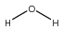
Consider a water molecule. If you were describing it in terms of its structure to someone who understands the concept of atoms and bonds, but has no idea what the water molecule looks like, you might say:

A water molecule contains an oxygen that is connected two hydrogen atoms by single bonds

...or even...

It's an oxygen atom with two hydrogens on it

Given this degree-level knowledge, to describe the individual oxygen and hydrogen atoms in the grand scheme of the water molecule exactly, you might say:

A 'water oxygen' is an oxygen atom that is connected to two hydrogen atoms through single bonds

...and...

A 'water hydrogen' is a hydrogen that is connected by a single bond to an oxygen atom that itself is connected by a single bond to another (different) hydrogen atom

The extra information regarding the second hydrogen is necessary because otherwise we could apply the description of the 'water hydrogen' to the hydrogen in any alcohol group as well. Similarly, we might mistake the oxygen in the hydroxonium ion [H₃O]⁺ as being a ‘water oxygen’, when in fact it is quite different. In this case, we could extend the description to:

A 'water oxygen' is an oxygen atom that is connected to two hydrogen atoms through single bonds, and nothing else

An atom description in Aten is a string of comma-separated commands that describe this kind of information. So, to tell the program how to recognise a water oxygen and a water hydrogen, we could use the following type descriptions (written in the proper forcefield input style for the types block:

1 OW O "nbonds=2,-H,-H" # Water oxygen
2 HW H "-O(nbonds=2,-H,-H)" # Water hydrogen

Aten now recognises that a water oxygen (OW) is ‘an oxygen atom that has exactly two bonds & is bound to a hydrogen & is bound to another hydrogen’. Similarly, a water hydrogen (HW) is ‘a hydrogen bound to an oxygen atom that; has two bonds to it, and is bound to a hydrogen, and is bound to another hydrogen’. In the type descriptions above the dash ‘-‘ is short-hand for saying ‘is bound to’, while the bracketed part after ‘-O’ in the water hydrogen description describes the required local environment of the attached oxygen. Using brackets to describe more fully the attached atoms is a crucial part of atom typing, and may be used to arbitrary depth (so, for example, we could add a bracketed description to the hydrogen atoms as well, if there was anything left to describe). If necessary, descriptions can be written that uniquely describe every single atom in a complex molecule by specifying completely all other connections within the molecule. This should not be needed for normal use, however, and short descriptions of atom environment up to first or second neighbours will usually suffice.

Example 2 - 3-hydroxypropanoic acid
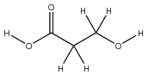
Assuming that the OH group in the carboxylic acid functionalisation will have different forcefield parameters to the primary alcohol at the other end of the molecule, here we must describe the first and second neighbours of the oxygen atoms to differentiate them.
To begin, we can describe the carbon atoms as either two or three different types – either methylene/carboxylic acid, or carboxylic acid/adjacent to a carboxylic acid/adjacent to alcohol. For both, we only need describe the first neighbours of the atoms. For the first:

3 C(H2) C "nbonds=4,-H,-H,-C" # Methylene Carbon
4 C_cbx C "nbonds=3,-O(bond=double),-O,-C" # Carboxylic Acid C

Note the ordering of the oxygen connections for the carboxylic acid carbon, where the most qualified carbon is listed first. This is to stop the doubly-bound oxygen being used to match -O, subsequently preventing a successful match. This is a general lesson – bound atoms with the most descriptive terms should appear at the beginning of the type description (as it is read left-to-right) and those with the least left until the end.
Where all three carbons need to be identified separately, we may write:

5 C(OH) C "nbonds=4,-H,-H,-C,-O" # CH2 adjacent to OH
6 C(COOH) C "nbonds=4,-H,-H,-C,-C" # CH2 adjacent to COOH
7 C_cbx C "nbonds=3,-O(bond=double),-O,-C" # Carboxylic Acid C

Let us now assume that the hydrogens within the alcohol and carboxylic acid groups must also be seen as different types. In this case, the second neighbours of the atoms must be considered:

8 HO H "-O(-C(-H,-H))" # Alcoholic H
9 H_cbx H "-O(-C(-O(bond=double)))" # Carboxylic acid H

The assignment is thus based entirely on the nature of the carbon atom to which the OH group is bound since this is the next available source of connectivity information. The determination of the three different oxygen atoms is similar:

10 OH O "-H,-C(-H,-H)" # Alcoholic O
11 O_cbx O "-C(-O(-H))" # Carboxylic acid =O
12 OH_cbx O "-H,-C(-O(bond=double))" # Carboxylic acid O(H)

Of course, we could just have specified nbonds=1 for the doubly-bound oxygen of the carboxylic acid group, but this ‘hides’ information as to the true connectivity of the atom.

Example 3 - N,N,2,5-tetramethylpyridin-4-amine
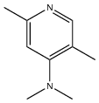

At last, a proper problem - an asymmetric substituted pyridine. Lets assume that we need to distinguish between every non-hydrogen atom – we’ll skip describing the hydrogen atoms for now, but note that this is most easily achieved by specifying directly the atomtype that the H is bound to (see later on). Let’s start with the pyridine nitrogen. We basically need to say that its in a 6-membered aromatic ring:

13 N_py N "ring(size=6,aromatic)" # Pyridine N

TODO

Description Depth
Many subtleties related to the form of type descriptions are perhaps evident from the examples given above. It is useful to think of type descriptions as having many different ‘depths’, loosely corresponding to the number of bonds followed away from a central atom (the target atom, or the one currently being tested against the type description). The target atom of the type description is the root of the description since all connections are defined relative to this atom. A type description requiring specific connections to this target atom is using the target atom’s bonds in order to identify it - atoms to a depth of 1 bond are being used to describe the atom. If these bound atoms are in turn described by their bound neighbours then atoms to a depth of two bonds are being used.
For example:
Table 12-1 NETA Descript Depth Examples
Example Description | Effective Depth
nbonds=4 | Zero - contains specifications relevant to the root atom only
nbonds=4,-H,-C | 1 - root commands and first bound neighbours
nbonds=4,-H,-C(-H(n=3)) | 2 - root commands, first and second bound neighbours
Any depth of description can be handled by Aten, becoming as complex as is necessary to uniquely identify the target atom.

Type Scores
In a forcefield with many defined types, more than one type may match an atom in a molecule. In order to best assign types to atoms, Aten scores each type description according to the number of terms defined within it, one point for each term satisfied. Once a matching type for an atom is located in the forcefield it is assigned to that atom, but the search for a better-scoring type continues. If a match with a higher score is found it replaces the previously-assigned type. If a match with the same score is found, the previous type is not replaced.

Non-Matching Types (Score = -1)
When a type description is tested for a given atom, it accumulates points for each term in the description that is satisfied by the environment of the atom. As soon as a term is found that is not satisfied, however, the score is reset to -1 and the match will fail. All terms in a type description must be satisfied in order for the type to be assigned to an atom.

Empty Types (Score = 1)
A type description containing no terms has a maximum score of 1 (coming from a match of the element type). Hence:

99 Cgen C "" # Generic carbon

matches any carbon in any system, but will be replaced fairly easily by other types since it has such a low score.

Normal Types (Score > 1)
For a type in which all terms are matched successfully, one point is scored for each individual term. All of the following types have a potential maximum score of 3 (don't forget, one point comes from matching the element):

100 C1 C "nbonds=2,linear" # Carbon A
101 C2 C "-C,-C" # Carbon B
102 C3 C "-C(n=2)" # Carbon C
102 C4 C "=C" # Carbon D

Moreover, they all potentially match the same atom (for example the central carbon in 1,2-propadiene). Since they have the same score, the first type C1 will match and persist over the other three, since only types with higher (not equivalent) scores can replace it.

Reusing Types
Once a complex NETA definition has been made for a given atom type, it is often useful to be able to reference this type in order to save repeating the same description for a closely-bound atom. The ampersand symbol allows you to do this, and specifies an integer type id to match rather than an element. As an example, consider the following definitions for trifluoroethanol from the OPLS-AA forcefield where the environment for each atom is described in full for each type:

160 CT C "-H,-H,-O(-H),-C(-F(n=3))" "CH2 in trifluoroethanol"
161 CT C "-F(n=3),-C(nh=2,-O(-H))" "CF3 in trifluoroethanol"
162 OH O "-H,-C(nh=2,-C(-F(n=3)))" "OH in trifluoroethanol"
163 HO H "-O(-C(nh=2,-C(-F(n=3))))" "HO in trifluoroethanol"
164 F F "-C(-F(n=3),-C(nh=2,-O(-H)))" "F in trifluoroethanol"
165 HC H "-C(nh=2,-O(-H),-C(-F(n=3)))" "H in trifluoroethanol"

For each atom type, the whole of the trifluoroethanol molecule is described, but each type tends to share a common chunk of NETA definitions with the other types. As an alternative, then, we can define one or two of the involved types explicitly as above, and then specify the rest of the types relative to this one:

160 CT C "-H,-H,-O(-H),-C(-F(n=3))" "CH2 in trifluoroethanol"
161 CT C "-&160" "CF3 in trifluoroethanol"
162 OH O "-&160" "OH in trifluoroethanol"
163 HO H "-O(-&160)" "HO in trifluoroethanol"
164 F F "-C(-&160)" "F in trifluoroethanol"
165 HC H "-&160" "H in trifluoroethanol"

Much neater! Or should that be ‘not much NETA’? Hmmm. Anyway, reusing types in this way is a powerful way to reduce the complexity of type descriptions required for a given molecule or fragment. Typically it is advisable to pick an atom that is fairly central to the molecule and bears a lot of connections, and provide an unambiguous type description.

NETA Reference
This section lists all the available commands that may make up a type description. Many keywords only make sense within the bracketed parts of keywords that expand the depth of the description. For instance, it is meaningless to specify the connection type with the bond keyword in the root of a typing command since no connections are relevant at this point.

~X (any bond to X)
~X specifies that a connection to X must exist, but makes no demand of the type (bond order) of the connection. X may be an element symbol, an id for another type specifier, or a list in square brackets containing one or both of these to allow more flexible specifications. Specifying an unknown connection with ~X is often useful in, for example, aromatic rings or conjugated systems where the connection might be either a double or single bond.
Table 12-2 NETA ‘~X’ Keyword Examples
Command | Meaning
~C | Any bond to a carbon atom
~&101 | Any bond to an atom which matches type ID 101 (see Reusing Types in section 12.5.4)
~[N,S,P] | Any connection to either nitrogen, sulfur, or phosphorous
!~O | Explicitly states that there should not be a bond to an oxygen atom

–X (single bond to X)
-X specifies that a single bond to X must exist. X may be either an element symbol, an id for another type specifier, or a list containing one or both of these to allow more flexible specifications. If used inside the bracketed part of a ring description this only indicates that the atom/type should be present within the cycle – the connection to the target atom is unimportant. If used in a chain keyword the connection type is honoured.
Table 12-3 NETA ‘–X’ Keyword Examples
Command | Meaning
-H | A single bond to a hydrogen atom
-&120 | A single bond to an atom which matches type ID 120 (see Reusing Types in section 12.5.4)
-[C,N] | A single bond to either a carbon or a nitrogen
-[F,Cl,Br,I,At] | A single bond to any halogen atom
-[&10,&11,&18,-Kr] | A single bond to an atom with type ID 10, 11, or 18, or a krypton atom

=X (double bond to X)
=X specifies that a double bond to X must exist. Equivalent to writing ~X(bond=double). X may be either an element symbol, an id for another type specifier, or a list containing one or both of these to allow more flexible specifications. If used inside the bracketed part of a ring description this only indicates that the atom/type should be present within the cycle – the connection to the target atom is unimportant. If used in a chain keyword the connection type is honoured.
Table 12-4 NETA ’=X’ Keyword Examples
Command | Meaning
=O | A double bond to an oxygen atom
=&4 | A double bond to an atom which matches type ID 4 (see Reusing Types in section 12.5.4)

bond
The bond keyword defines the specific type of the connection (see Bond Types in Section 16.2) required for a bound atom. The keyword should be used inside bracketed parts of bound atom descriptions. It is important to note that the bond keyword should only be used in conjunction with the ~X (any bond to) specifier, since the specific connection demanded by the -X and =X specifiers will override any bond declarations.
Table 12-5 NETA 'bond' Keyword Examples
Command | Meaning
~O(bond=double) | A double bond to an oxygen atom (equivalent to =O)
~&55(bond=triple) | A triple bond to an atom which matches type ID 55 (see Reusing Types in section 12.5.4)
~C(bond=single) | A single bond to a carbon atom (a very explicit way of writing simply -C)

chain
The chain command provides an easy was of specifying a linear sequence of atoms from the current atom forward. Within the bracketed part, a sequence of connections are listed in the order in which they are to appear. Atoms in the chain are specified in the same way as other connections (e.g. -C(nbonds=2)) but should not be separated by commas. The repeat keyword n may also be specified at some point in the bracketed part to define that more than one of the defined chains is required. Note that, if all atoms specified for the chain are matched, but the actual chain in the model is longer, a positive match will be returned. Thus, it is usually a good idea to define the last atom in the chain more explicitly to prevent false matches.
Table 12-6 NETA ‘chain’ Keyword Examples
Command | Meaning
chain(-C-C-C-C) | Specifies a (minimum) four-carbon chain of any degree of saturation
chain(-C(nh=2)-C(nh=2)-C(nh=2)-C(nh=3)) | Explicity specifies an all-atom butyl chain

n
The n keyword, when placed in the bracketed parts of bound atom, ring, and chain descriptions requires that they are matched a number of times rather than just once.
Table 12-7 NETA ‘n’ Keyword Examples
Command | Meaning
-C(n=4,-H(n=3)) | Describes the central carbon in neopentane (2,2-dimethylpropane) which is bound to four methyl groups
ring(size=4,n=3) | Specifies that the target atom should be present in three unique four-membered rings
chain(-C-C-C~N(bond=triple),n=4) | Requests that the atom has four cyanoethyl groups hanging off it

nbonds
nbonds specifies the exact number of connections that an atom must possess.
Table 12-8 NETA ‘nbonds’ Keyword Examples
Command | Meaning
nbonds=2 | Demand that the atom has exactly two connections
~N(nbonds=1) | Describes a nitrogen with only one bond, perhaps an sp1 nitrogen with a triple bond

nh
The nh keyword is shorthand for explicitly specifying the number of attached hydrogens to the target atom or a bound atom. It is equivalent to stating -H(n=m).
Table 12-9 NETA ‘nh’ Keyword Examples
Command | Meaning
-C(nh=2) | Atom is bound to a methylene carbon with exactly two hydrogens on it

aromatic
aromatic indicates either that an atom must be present in an aromatic environment (e.g. in an aromatic ring), or that a ring should itself be aromatic.
Table 12-10 NETA ‘aromatic’ Keyword Examples
Command | Meaning
~N(aromatic) | Specifies a nitrogen connected by any bond which is present in an aromatic environment
-C(ring(aromatic)) | Single bond to a carbon atom which is in an aromatic ring

noring
noring indicates that the atom must not be present in any rings.
Table 12-11 NETA ‘noring’ Keyword Examples
Command | Meaning
-O(noring) | Single bond to an oxygen which is not present in a ring

planar
The planar keyword specifies that the atom target should be planar, which is to say no bond from the atom may be more than 15° out of the plane formed by the first two bonds to the atom)
Table 12-12 NETA ‘planar’ Keyword Examples
Command | Meaning
-C(planar) | Single bond to a carbon atom which is roughly planar

ring
ring denotes that the target atom (if specified in the root of the description) or a bound atom (if used inside the associated bracketed part) should be present in a ring structure of some kind. The ring keyword alone simply demands that the atom is present inside a ring of some size, but may take an optional bracketed part describing more fully the number of atoms in the ring, and the individual nature of each of these atoms. Within the bracketed part, bound atoms may be specified as usual in the contained neta, but the connection type is irrelevant as it is only the presence of those particular atoms within the ring that is considered important.
Bound atom descriptions given inside the bracketed part should again be listed in order of decreasing complexity. Multiple rings may be specified with separate ring keywords, allowing the location of fused ring atoms.
Table 12-13 NETA ‘ring’ Keyword Examples
Command | Meaning
ring(size=6,~C(n=6),aromatic) | Benzene-style carbon
-C(ring(size=6,-C(n=6,nh=2))) | Carbon atom in cyclohexane

size
Only relevant in the bracketed part of a ring keyword, size requests the exact number of atoms comprising the cycle. Note that this may be used independently of the implicit size suggested by the number of atom descriptions supplied, or in conjunction with a partial list of atoms.
Table 12-14 NETA ‘size’ Keyword Examples
Command | Meaning
ring(size=7) | Specifies a 7-membered ring

Geometries
These keywords requests that the target atom (if specified in the root of the type description) or a bound atom (if used inside the associated bracketed part) should possess a certain physical geometry in terms of its connections. The number of bonds to the target atom and the angles between them are used to determine the geometry.
Note that, for some geometry types, there are several ways for the atom to have this geometry.

unbound
An unbound atom, i.e. one with zero bonds to other atoms. Only makes sense when used in the root of a type description.

onebond
onebond requests that the atom has exactly one bond (of any type).

linear
Two bonds to the atom in a linear arrangement (angle i-j-k > 170°).

tshape
Three bonds to the atom in a tshape geometry (with two bonds making an angle > 170°).

trigonal
Three bonds in a trigonal planar arrangement, with the largest of the three angles between 115 and 125°.

tetrahedral
tetrahedral geometries are possible for atoms with; exactly two bonds making an angle between 100 and 115°; exactly three bonds with the largest of the angles between 100 and 115°, and; exactly four bonds to the atom, with the average of the angles laying between 100 and 115°.

sqplanar
Four bonds to the atom in a square planar (sqplanar) arrangement, with the average of the angles laying between 115 and 125°.

tbp
Five bonds to the atom are assumed to be trigonal bipyramidal (tbp) geometry.

octahedral
Six bonds to the atom are assumed to be in an octahedral arrangement.

Functional Forms
All forcefield term functional forms are listed in the following sections, along with their parameters (default values for which follow in brackets, if they exist).

VDW Functional Forms
Table 13-1 VDW Functional Forms
Name | Keyword | Form U_{ij} = | Param | Rule
Lennard-Jones 12-6 | lj | $$4ϵ\left[{\left(σ/{r_{ij}}\right)}^{12}-{\left(σ/{r_{ij}}\right)}^{6}\right]$$ | ϵ | Geom
Lennard-Jones 12-6 | lj |  | σ | Arith
Lennard-Jones 12-6 (Geometric rules) | ljgeom | $$4ϵ\left[{\left(σ/{r_{ij}}\right)}^{12}-{\left(σ/{r_{ij}}\right)}^{6}\right]$$ | ϵ | Geom
Lennard-Jones 12-6 (Geometric rules) | ljgeom |  | σ | Geom
Inverse Power | inversepower | $${ϵ\left(r/{r_{ij}}\right)}^{n}$$ | ϵ | Geom
Inverse Power | inversepower | $${ϵ\left(r/{r_{ij}}\right)}^{n}$$ | r | Arith
Inverse Power | inversepower | $${ϵ\left(r/{r_{ij}}\right)}^{n}$$ | n (1.0) | Arith
Lennard-Jones AB | ljab | $$A/{r_{ij}^{12}}-B/{r_{ij}^{6}}$$ | A | Geom
Lennard-Jones AB | ljab | $$A/{r_{ij}^{12}}-B/{r_{ij}^{6}}$$ | B | Geom
UFF Lennard-Jones 12-6 | ufflj | $$D_{ij}\left[{\left(σ/{r_{ij}}\right)}^{12}-n{\left(σ/{r_{ij}}\right)}^{6}\right]$$ | Dij | Geom
UFF Lennard-Jones 12-6 | ufflj |  | σ | Geom
UFF Lennard-Jones 12-6 | ufflj |  | n (2.0) | Arith
Buckingham exp6 | buck | $$Ae^{-Br_{ij}}-C/{r_{ij}^{6}}$$ | A | Geom
Buckingham exp6 | buck | $$Ae^{-Br_{ij}}-C/{r_{ij}^{6}}$$ | B | Geom
Buckingham exp6 | buck | $$Ae^{-Br_{ij}}-C/{r_{ij}^{6}}$$ | C | Geom
Morse | morse | $$E_{0}\left[{\left(1-e^{-k\left(r_{ij}-r_{0}\right)}\right)}^{2}-1\right]$$ | E₀ | Geom
Morse | morse |  | k | Arith
Morse | morse |  | r₀ | Geom

Bond Functional Forms
Table 13-2 Bond Functional Forms
Name | Keyword | Form | Param
Ignore | ignore
Constraint | constraint | $$\frac{k}{2}\left(r-r_{0}\right)$$ | k
Constraint | constraint | $$\frac{k}{2}\left(r-r_{0}\right)$$ | r₀
Harmonic | harmonic | $$\frac{k}{2}{\left(r-r_{0}\right)}^{2}$$ | k
Harmonic | harmonic | $$\frac{k}{2}{\left(r-r_{0}\right)}^{2}$$ | r₀
Morse | morse | $$E_{0}{\left(1-e^{-k\left(r_{ij}-r_{0}\right)}\right)}^{2}$$ | E₀
Morse | morse |  | k
Morse | morse |  | r₀

Angle Functional Forms
Table 13-3 Angle Functional Forms
Name | Keyword | Form | Param
Ignore | ignore
Harmonic | harmonic | $$\frac{k}{2}{\left(θ-θ_{0}\right)}^{2}$$ | k
Harmonic | harmonic | $$\frac{k}{2}{\left(θ-θ_{0}\right)}^{2}$$ | θ₀
Cosine | cos | $$k\left(1+s\cos\left(nθ-θ_{0}\right)\right)$$ | k
Cosine | cos | $$k\left(1+s\cos\left(nθ-θ_{0}\right)\right)$$ | n
Cosine | cos | $$k\left(1+s\cos\left(nθ-θ_{0}\right)\right)$$ | θ₀
Cosine | cos | $$k\left(1+s\cos\left(nθ-θ_{0}\right)\right)$$ | s (1.0)
Double Cosine | cos2 | $$k\left(C_{0}+C_{1}\cos\left(θ\right)+C_{2}\cos\left(2θ\right)\right)$$ | k
Double Cosine | cos2 |  | C₀
Double Cosine | cos2 |  | C₁
Double Cosine | cos2 |  | C₂
Harmonic Cosine | harmcos | $$\frac{k}{2}{\left(\cos\left(θ\right)+\cos\left(θ_{0}\right)\right)}^{2}$$ | k
Harmonic Cosine | harmcos |  | θ₀
Constraint (1-3 Bond) | bondconstraint | $$\frac{k}{2}{\left(r-r_{0}\right)}^{2}$$ | k
Constraint (1-3 Bond) | bondconstraint | $$\frac{k}{2}{\left(r-r_{0}\right)}^{2}$$ | r₀

Torsion Functional Forms
Table 13-4 Torsion Functional Forms
Name | Keyword | Form | Param
Cosine | cos | $$k\left(1+s\cos\left(nφ-φ_{eq}\right)\right)$$ | k
Cosine | cos | $$k\left(1+s\cos\left(nφ-φ_{eq}\right)\right)$$ | n
Cosine | cos | $$k\left(1+s\cos\left(nφ-φ_{eq}\right)\right)$$ | ϕ_{eq}
Cosine | cos | $$k\left(1+s\cos\left(nφ-φ_{eq}\right)\right)$$ | s (1.0)
Triple Cosine | cos3 | $$\frac{1}{2}\sum_{i=1}^{3}{k_{i}\left(1+{\left(-1\right)}^{i+1}\cos\left(iφ\right)\right)}$$ | k₁
Triple Cosine | cos3 |  | k₂
Triple Cosine | cos3 |  | k₃
Quadruple Cosine | cos4 | $$\frac{1}{2}\sum_{i=1}^{4}{k_{i}\left(1+{\left(-1\right)}^{i+1}\cos\left(iφ\right)\right)}$$ | k₁
Quadruple Cosine | cos4 |  | k₂
Quadruple Cosine | cos4 |  | k₃
Quadruple Cosine | cos4 |  | k₄
Triple Cosine + Constant | cos3c | $$k_{0}+\frac{1}{2}\sum_{i=1}^{3}{k_{i}\left(1+{\left(-1\right)}^{i+1}\cos\left(iφ\right)\right)}$$ | k₀
Triple Cosine + Constant | cos3c |  | k₁
Triple Cosine + Constant | cos3c |  | k₂
Triple Cosine + Constant | cos3c |  | k₃
Cosine Product | coscos | $$\frac{1}{2}k\left(1-\cos\left(nφ_{eq}\right)\cos\left(nφ\right)\right)$$ | k
Cosine Product | coscos |  | n
Cosine Product | coscos |  | ϕ_{eq}
Dreiding Cosine | dreiding | $$\frac{1}{2}k\left(1-\cos\left(n\left(φ-φ_{eq}\right)\right)\right)$$ | k
Dreiding Cosine | dreiding |  | n
Dreiding Cosine | dreiding |  | ϕ_{eq}

External Programs

Movie Generation

MOPAC
Aten can make use of MOPAC (any version) if it is installed correctly on your machine. All that is required is for the path to the binary to be set in the program preferences, along with a suitable temporary directory in which the calculations will run. Either go to the External Programs tab in the Preferences window (Settings→Preferences)

Methods
Some things in Aten are implemented from existing routines and algorithms. Some have been written from scratch, even when existing algorithms were available, either as an attempt to improve those existing algorithms or simply to learn more by working out how best to go about solving a given problem. A selection of algorithms are detailed in the following pages, grouped into those that were re-used from the literature, and those that were written specifically for Aten.
It should be pointed out that, in the eventuality that somebody notices that one of Aten’s ‘custom’ algorithms is actually a reproduction of an existing method, then fair enough - send me the reference and I'll be happy to move it to the proper section.

Custom Algorithms

NETA
NETA stands for the Nested English Typing Algorithm – a fairly dull acronym, all said and done, but with the advantage that it is ‘Aten’ backwards. NETA is an attempt to provide a descriptive atom typing language that is:
- Easily readable
- Easily written from a small subset of keywords
- Recursive and able to describe complex molecules
It's closest relative that I'm aware of in the literature is the ATDL as implemented in Vega-ZZ,[[1] but was (genuinely) conceived without prior knowledge of that system. NETA tries to keep the language simple enough that it can almost be read aloud an make sense, given one or two special syntactic tokens, rather than needlessly use numerical codes and spurious symbols to signify certain quantities or create an ultra-compact language. The former destroys readability and the latter promotes convolution, neither of which help when trying to interpret old rules or write new ones. So, for the most part NETA is keyword-based, with a limited number of fairly 'natural' symbols employed to denote common terms.
Typing begins from a provided set of atoms and bonds (i.e. the chemical graph). The connectivity between atoms must be 'set' prior to typing, either by automatic calculation of bonds based on distance criteria, manually adding them by hand, or reading them from the input model file. The typing algorithm itself makes no additions or changes to the connectivity of the input structure.
NETA requires a knowledge of species/molecule types in the model is required. For single molecule systems there is 1 distinct molecule (species) and 1 occurrence of it. For condensed phases, e.g. liquids, there are 1 or more species each with many copies of the molecule. In the interests of efficiency for the following routines, Aten attempts to generate a valid pattern description of the system if one is not present already. This essentially picks out the individual species and the number of molecules of each, and permits the typing routines to consider only one molecule of each species when determining atom types etc. The assumption here is that, since all molecules in a given species will have the same chemical graph, atom types can be worked out for a single molecule and then duplicated on all of the others.
Following detection of a suitable pattern description, several tasks are then performed:

Cycle Detection
Firstly, any cyclic structures within a single molecule are detected up to a maximum (adjustable) ring size. This is achieved from a series of simple recursive searches beginning from each atom with more than one bond. A sequence of 'walks' along bonds are made in order to form a path of some specified length (i.e. ring size). If the final atom in this path shares a bond with the starting atom, a cycle has been found. If not, the final atom is removed and replaced with another. If there are no more atoms to try in this final position, the preceeding atom in the path is removed and replaced with another, and so on. Each unique ring (its size and pointers to the sequence of constituent atoms) is stored in the pattern.

Assignment of Atom Environment
From the list of bound neighbours, each atom is assigned a simple hybridicity based on the character of the bonds it is involved in, mainly used for the determination of aromatic cycles in the next step.

Ring Types
Once atom hybridicities have been assigned, ring types can be determined. Rings are classed as either aliphatic, aromatic, or non-aromatic (i.e. a mix of resonant and aliphatic bonds that is not itself aromatic.
Now, working only with the representative molecule of each pattern, associated (or current) forcefield(s) are searched for types that match the contained atoms. Each NETA description whose character element is the same as a given atom is tested, and a score is obtained. If this score is non-zero and positive then the atomtype is a match and is assigned to the atom if it has no previous type, or if the score is higher than the previous one. See atom type scoring in Section 12.5.3 for more information.
[1] Pedretti, A.; Villa, L.; Vistoli, G. "Theoretical Chemistry Accounts", 109, 229-232 (2003).

Augment
Augmentation of bonds, as far as Aten is concerned, means to take a collection of atoms with basic connectivity (i.e. all single bonds, as per the result of rebonding) and assign multiple bonds where necessary. The method is based loosely on previously described algorithms.[1]
The basis of the method involves modifying the bond order of a particular connection to best satisfy the bonding requirements of the two involved atoms, for example making sure all carbon atoms possess an optimal total bond order of 4. However, many atoms (in particular S and P) happily exist with more than one total bond order (e.g. P) - the methodology borrowed from [1] solves this problem by scoring the total bond order for each particular element ranging from zero (meaning ‘natural’ or ‘no penalty’) to some positive number. The higher the positive number, the more ‘unhappy’ the element is with this number of bonds. For example, hydrogen atoms score 0 for a total bond order of 1, a small positive number (2) for no bonds (hydrogen ion) and a very large positive value (here, 32) for any other bond order. In this way we penalise the total bond orders that an atom does not naturally take on, and always tend towards the lowest score (i.e. the natural total bond order) wherever possible. When modifying the bond order of a particular connection, the total bond order scores of both atoms are calculated once for the current connection and again for the potential new bond order of the connection. If the new score is lower, the change of bond order is accepted.

Pattern Detection
As with many other routines in Aten, a suitable pattern description is first detected for the system in order to isolate individual molecular species and make the algorithm as efficient as possible.

Augmentation of Terminal Bonds
Bonds that involve a heavy (i.e. non-hydrogen) atom connected to no other atoms (e.g. C=O in a ketone) are treated before all others. The bond order is modified such that the total bond order score for both atoms is as low as possible.

Augmentation of Other Bonds
Following optimisation of terminal bonds, all other bonds are modified using exactly the same procedure.

Second Stage Augmentation
The above two steps are enough to correctly determine multiple bonds in a chemically-correct molecule, provided no cyclic moities are present in the system. The second stage is designed to correct improper augmentations within cycles, or shift existing augmentations around cycles such that other (missing) multiple bonds may be created.
For each existing multiple bond in each cyclic structure in each pattern's molecule, a simple re-augmentation of the constituent bonds is first attempted in order to try and lower the total bond order score for the whole ring (i.e. the sum of the individual bond order scores of every atom present in the cycle). Then, each bond in the ring is considered in sequence. If the bond is a double bond, then we attempt to convert this into a single bond and make the two adjacent bonds in the ring double bonds in an attempt to ‘aromaticise’ the ring. The total bond order score is checked and, if lower than the previous score, the change is accepted. If not, the change is reversed and the next bond is considered. By performing these secondary adjustments the double-bond pattern of many complex (poly)aromatics can be correctly (and fully automatically) detected.
[1] “Automatic atom type and bond type perception in molecular mechanical calculations”, J. Wang, W. Wang, P. A. Kollman, and D. A. Case, Journal of Molecular Graphics and Modelling, 25 (2), 247-260 (2006).

Autoellipsoids
TODO

Autopolyhedra
TODO

Rebond
The most common means of determining connectivity between a collection of atoms is based on simple check of the actual distance between two atoms and the sum of their assigned radii:
{img align="center" src=show_image.php?id=116}
The two σ represent the radii of atoms i and j which have coordinates x_{i}, y_{i}, z_{i} and x_{j}, y_{j}, z_{j}. The parameter α is an adjustable tolerance value to enable fine-tuning, and using Aten’s set of built-in radii[1] usually lays between 1.0 and 2.0. For molecules or periodic systems of modest size the method can be used as is, but for large systems of many atoms the use of a double loop over atoms results in a very slow algorithm.
Aten overcomes this slowdown for larger systems by partitioning the system up into a series of overlapping ‘cuboids’. For a system of N particles in a periodic box (or an isolated system with an orthorhombic pseudo-box determined by the extreme positions of atoms), the volume is partitioned into a number of subvolumes of some minimum size in each direction. The minimum size of any one of the subvolume’s dimensions is chosen relative to the maximum bond length possible given the largest elemental radius and the current bond tolerance α. A single loop over atoms is then performed to associate them to these subvolumes. Each atom belongs to at least one cuboid, determined by its absolute position in the system, and commonly belongs to one other cuboid, determined by adding half of the cuboids dimensions on to the atoms position. While a little counterintuitive, potentially adding atoms to a neighbouring cuboid along this diagonal vector allows the final calculation of distances between pairs of atoms to consider only eight neighbouring (more correctly, overlapping) subvolumes rather than the 26 needed if each atom belongs exclusively to only one cuboid. For atoms that exist in subvolumes along the edges of the whole volume, these are also added to the subvolume(s) on the opposite side(s) to account for minimum image effects in periodic systems.
Once the effort has been made to assign atoms to cuboids, the final loops to calculate distances runs over a much reduced subset of atom pairs owing to the partitioning. A loop over cuboids is performed, first considering all atom pairs within the same cuboid, and then extending this to consider distances between a particular atom of this central cuboid and its eight ‘overlapping’ neighbours.
There is some redundancy of atom pairs since the same pair may be considered twice when taking into account the overlapping cuboids. However, in the interests of facile book-keeping this is not checked for explicitly during the running of the algorithm.
[1] ”Covalent radii revisited”, B. Cordero, V. Gómez, A. E. Platero-Prats, M. Revés, J. Echeverría, E. Cremades, F. Barragán and S. Alvarez, Dalton Trans. (2008) (DOI: ihttp://dx.doi.org/10.1039/b801115j)

Disorder Builder
TODO

Literature Methods
The following table lists common literature methods implemented in Aten, noting any implementation differences etc.
Table 15-1 Literature Methods
Name | Description / Notes
Ewald Sum | Electrostatic energy and forces for periodic systems. Implemented as described in: XXX
Conjugate Gradient
Marching Cubes | Isosurface generation from regular gridded data. No pathological cases are accounted for. See implementation details in: XXX
Steepest Descent

Enumerations
The following tables list sets of keywords relevant to various data (e.g. bond types), to be used when setting or checking such values.

Basis Shell Types
A list of recognised types of basis shell recognised by the BasisShell type.
Table 16-1 Basis shell type keywords
Value | Description | nCartesians
S | Standard S-shell | 1
L | Combined S/P shell | 4
P | Standard P-shell | 3
D | Standard D-shell | 5
F | Standard F-shell | 7

Bond Types
A bond between atoms is of one of the following types:
Table 16-2 Bond type keywords
Value | Description
any | Special case, never assigned to an actual bond but used in bond-matching functions
single | A single bond
double | A double bond
triple | A triple bond
aromatic | An aromatic bond, assigned automatically by the atom typing routines

Bound Types
Possible intramolecular bound interaction types are:
Table 16-3 Bound type keywords
Value | Description
angle | A normal angle interaction between three bound atoms
bond | A normal bond interaction between two bound atoms
improper | An improper torsion between four (not necessarily bound) atoms
torsion | A proper torsion interaction between four bound atoms
ub | A Urey-Bradley 1,3 term between two atoms at the extreme of a related angle

Cell Types
A model’s unit cell is, at any given time, one of the following:
Table 16-4 Cell type keywords
Value | Description
none | The model has no unit cell (i.e. it is non-periodic)
cubic | The model's unit cell is cubic, with A=B=C and alpha=beta=gamma=90
orthorhombic | The model's unit cell is an orthorhombus, with any cell lengths and alpha=beta=gamma=90
parallelepiped | The model's unit cell is monoclinic or triclinic, with any cell lengths and angles

Colour Schemes
Available atomic colouring schemes are:
Table 16-5 Colour scheme keywords
Value | Description
charge | Atoms and connected bonds are coloured according to their charge
element | Atoms and connected bonds are coloured according to their element
force | Atoms and connected bonds are coloured according to the force acting on the atom
velocity | Atoms and connected bonds are coloured according to the velocities of the atoms
custom | Atoms and connected bonds are coloured according to the custom colours set on individual atoms

Combination Rules
Combination rule equations as used when combining similar Lennard Jones parameters.
Table 16-6 Combination rules
Keyword | Description
arithmetic | The arithmetic mean of two values : a = 0.5*(b*c)
geometric | The geometric mean of two values : a = sqrt(b*c)
custom1 | Custom combination rule
custom2 | Custom combination rule
custom3 | Custom combination rule

Drawing Styles
Available drawing styles for individual atoms are:
Table 16-7 Draw style keywords
Value | Description
stick | Atoms and connected bonds are drawn using simple lines
tube | Atoms and connected bonds are drawn using 'capped' cylinders
sphere | Atoms and connected bonds are drawn using spheres and cylinders, with all atoms the same size
scaled | Atoms and connected bonds are drawn using spheres and cylinders, with all atoms sized according to their atomic radius set in the preferences

Energy Units
A list of energy units supported by Aten
Table 16-8 Energy unit keywords
Value | Description | Joule Equivalent
j | Joules per mole (J/mol) | 1.0
kj | KiloJoules per mole (kJ/mol) | 1000.0
cal | Calories per mole (cal/mol) | 4.184
kcal | KiloCalories per mole (kcal/mol) | 4184.0
K | Kelvin (K) | 1.0 / (503.2166 / 4184.0)
ev | Electronvolts per mole (eV/mol) | 96485.14925
ha | Hartrees per mole (Ha/mol) | 2625494.616

Glyph Types
Available glyph types (drawing objects) are:
Table 16-9 Glyph type keywords
Value | Description
arrow | Simple arrow
cube | A cuboid
ellipsoid | An ellipsoid, oriented by face and edge vectors
ellipsoidxyz | An ellipsoid, oriented by an explicit set of provided axes
line | A line between two points
quad | A quad (made up of two triangles)
sphere | A sphere or spheroid
svector | A sense vector
tetrahedron | Regular tetrahedron
text | Text rendered at 2D screen coordinates
text3d | Text rendered at 3D model coordinates
triangle | Regular triangle
tubearrow | A fully 3D arrow
vector | An arrow centred on a point and pointing along a specified local vector

Grid Styles
Available drawing styles for surface/grid data:
Table 16-10 Grid style keywords
Value | Description
grid | All data points are drawn as simple dots at their coordinate positions (the cutoff value is ignored)
points | Data points above the cutoff are drawn as simple dots at their coordinate positions
triangles | A triangulated wireframe isosurface is drawn between points above the cutoff value
solid | A trangulated solid isosurface is drawn between points above the cutoff value

Grid Types
Available grid types:
Table 16-11 Grid type keywords
Value | Description
regularxy | Two-dimensional surface data on a regularly-spaced XY grid. The grid size must be specified on creation (with the initGrid command).
regularxyz | Three-dimensional volumetric data on a regularly spaced XYZ grid. The grid size must be specified on creation (with the initGrid command).
freexyz | Three-dimensional data not restricted to a regular grid. No grid size specification is necessary.

Label Types
Valid label types are as follows:
Table 16-12 Label type keywords
Value | Description
charge | Atomic charge currently assigned to the atom
element | Element symbol of the atom
ffequiv | Forcefield equivalent name from the assigned forcefield atom type (or the forcefield atom type name if no equivalent applies)
id | Integer atom ID
type | Assigned forcefield atom type name (if any)

Monte Carlo Move Types
Valid move types for the Monte Carlo minimiser are as follows:
Table 16-13 Monte Carlo move type keywords
Value | Description
translate | Molecule translations
rotate | Molecule rotations
zmatrix | Molecule z-matrix moves (not yet implemented)
insert | Insertion moves
delete | Deletion moves (not yet implemented)

Output Types
Valid output types (or debug modes) are as follows:
Table 16-14 Output type keywords
Value | Description
all | Enable output of all types listed in this table
calls | Print out entrances and exits to most subroutines to enable quick tracing of crash locations
commands | Trace execution of commands in command lists (e.g. filters) and print information on variable access paths
gl | Debug OpenGL calls and graphics capabilities as best as is possible
parse | Debug file-reading and argument parsing routines
typing | Print (lots of) information regarding setting and matching of atom type descriptions
verbose | Enable a little extra output (but not much)

Parse Options
These options determine how general parsing of plain text files proceeds, as well as controlling delimited argument parsing.
Table 16-15 Parse option keywords
Value | Description
noescapes | Treat backslash as a normal character
normalcommas | Treate commas as normal characters rather than delimiters
skipblanks | Blank lines (or those containing comments) are automatically skipped
stripbrackets | Normal parentheses are automatically stripped from the input file
stripcomments | Remove comments from file (text starting with ‘//’ or ‘#’)
usecurlies | Data within curly brackets will be parsed as a single argument
usequotes | Phrases enclosed in quotes will be parsed as a single argument

Read Success Integers
Integer return values for many read/write operations.
Table 16-16 Read/write return values
Value | Description
0 | Success - no errors encountered
1 | The read/write operation failed before it was completed
-1 | End-of-file was encountered during read operation

ZMapping Types
Table 16-17 Map type keywords
Value | Description
alpha | Convert based on the alpha part of the name only. Leading or trailing numbers and symbols are discarded. The alpha part is assumed to be an element symbol
auto | Attempts several of the other conversions of increasing complexity until a match is found
ff | Search through the names of atomtypes in currently-loaded forcefields, assigning elements based on matches found
firstalpha | Convert based on the first alpha part of the name only (i.e. until a non-alpha character is found). The alpha part is assumed to be an element symbol
name | The name is assumed to be an actual element name, and is converted to the relevant element number
numeric | Use the numeric part of the name as the element number
singlealpha | Convert based on the first alphabetic character encountered - useful only when single-character element symbols are likely to be found (e.g. for pure organic CHON systems)

batch processing, 47, 48, 52, 53
Command Line Switches
--atendata, 46
-b, 46
--batch, 47
--bohr, 46
--bond, 47
-c, 47
--cachelimit, 47
--centre, 48
--command, 47
-d, 48
--debug, 48
--dialogs, 48
--double, 48
--export, 48
--exportmap, 48
--expression, 49
-f, 49
--ff, 49
--filter, 49
--fold, 49
--format, 49
-g, 49
--grid, 49
-h, 49
--help, 49
-i, 50
--int, 50
--interactive, 50
-k, 50
--keepnames, 50
--keeptypes, 50
--keepview, 50
-m, 50
--map, 50
-n, 51
--nobond, 51
--nocentre, 51
--nofold, 51
--nofragmenticons, 51
--nofragments, 51
--noincludes, 51
nolists, 51
--nolists, 51
--nopack, 51
--nopartitions, 51
--noqtsettings, 51
--pack, 52
--pipe, 52
process, 52
quiet, 52
-s, 52
--script, 52
--string, 52
-t, 52
--trajectory, 52
-u, 52
--undolevels, 52
-v, 53
vbo, 53
--vbo, 53
--verbose, 53
-z, 53
--zmap, 53
Command Line Switches:, 52
commands
abs, 216
addFrame, 272
addGridPoint, 205
addHydrogen, 158
addNextGridPoint, 205
addPoint, 172
addReadOption, 242
adjustCell, 165
afterStr, 264
angleDef, 187
atof, 264
atoi, 264
atomStyle, 148
augment, 154
autoConversionUnit, 187
autoEllipsoids, 199
autoPolyhedra, 199
axisRotate, 275
axisRotateView, 282
beforeStr, 265
bohr, 158
bondDef, 187
bondTolerance, 154
cell, 165
cellAxes, 165
centre, 275
cgMinimise, 225
chain, 159
charge, 170
chargeFF, 170
chargeFromModel, 170
chargePAtom, 171
chargeType, 171
clearBonds, 154
clearCharges, 171
clearExportMap, 188
clearExpression, 188
clearLabels, 214
clearMap, 188
clearMeasurements, 219
clearPatterns, 237
clearPoints, 172
clearSelectedBonds, 155
clearTrajectory, 272
clearTypes, 188
contains, 265
converge, 225
copy, 177
cos, 216
createAtoms, 230
createDialog, 222
createExpression, 189
createPatterns, 237
createScheme, 240
currentAtom, 148
currentFF, 189
currentModel, 230
currentPattern, 237
cut, 177
debug, 269
defaultDialog, 222
delete, 177
deleteFF, 189
deleteModel, 231
deSelect, 253
deSelectF, 254
deSelectFor, 254
deSelectType, 254
disorder, 175
do, 182
dotProduct, 216
drillPores, 240
elec, 179
endChain, 159
eof, 242
equivalents, 189
error, 222
exp, 216
expand, 255
exportMap, 189
ffModel, 190
ffPattern, 190
filterFilename, 242
finaliseFF, 191
finaliseGrid, 205
finaliseModel, 231
find, 243
firstFrame, 272
firstModel, 231
fix, 148
fixType, 191
flipX, 276
flipY, 276
flipZ, 276
fold, 166
foldMolecules, 166
for, 182
frameEnergy, 179
frameForces, 198
free, 149
freeType, 191
ftoa, 266
generateAngle, 191
generateBond, 192
generateTorsion, 192
geometry, 219
getAtom, 149
getCombinationRule, 192
getEnv, 269
getEnvF, 269
getEnvI, 270
getFF, 193
getLine, 243
getModel, 231
getPattern, 238
getSite, 262
getView, 282
glyphAtomF, 200
glyphAtomR, 200
glyphAtomsF, 201
glyphAtomsR, 201
glyphAtomsV, 201
glyphAtomV, 201
glyphColour, 202
glyphData, 202
glyphSolid, 202
glyphText, 203
gridAlpha, 206
gridAxes, 206
gridColour, 206
gridColourScale, 207
gridColourSecondary, 207
gridCubic, 207
gridCutoff, 208
gridCutoffSecondary, 208
gridLoopOrder, 208
gridOrigin, 209
gridOrtho, 209
gridStyle, 209
gridUseZ, 210
gridVisible, 210
gui, 270
help, 270
hide, 149
if, 184
info, 232
initGrid, 210
interDef, 193
invert, 255
itoa, 266
label, 214
lastFrame, 272
lastModel, 232
lineTol, 225
listComponents, 175
listMeasurements, 219
listModels, 232
listPatterns, 238
listScales, 172
listScripts, 252
listSites, 262
ln, 216
loadFF, 193
loadGrid, 211
loadModel, 233
loadScript, 252
loadTrajectory, 273
locate, 160
log, 216
logInfo, 233
lowerCase, 266
map, 194
matrixConvert, 276
matrixTransform, 277
mcMinimise, 226
measure, 220
measureSelected, 220
millerCut, 166
mirror, 281
modelEnergy, 179
modelForces, 198
modelTemplate, 233
mopacMinimise, 226
move, 160
moveToEnd, 160
moveToStart, 160
newAtom, 161
newAtomFrac, 161
newBasisShell, 228
newBond, 155
newBondId, 156
newEigenvector, 228
newFF, 194
newGlyph, 203
newGrid, 211
newModel, 234
newPattern, 238
newSite, 262
newVibration, 228
nextArg, 243
nextFrame, 273
nextModel, 234
nint, 217
normalise, 217
null, 270
orthographic, 282
pack, 167
parentModel, 234
paste, 177
peekChar, 244
peekCharI, 244
perspective, 282
prevFrame, 273
prevModel, 235
printCell, 167
printElec, 180
printEnergy, 181
printEwald, 180
printf, 223
printForces, 198
printInter, 180
printIntra, 180
printSetup, 194
printSummary, 181
printType, 194
printVdw, 181
printZMatrix, 228
quit, 271
random, 217
randomI, 217
readChars, 244
readDouble, 245
readDoubleArray, 245
readInt, 246
readIntArray, 246
readLine, 246
readLineF, 247
readNext, 247
readVar, 248
readVarF, 248
rebond, 156
rebondpatterns, 156
rebondSelection, 157
recreateExpression, 195
redo, 178
removeCell, 168
removeLabel, 214
removeLabels, 215
removePoint, 173
removeReadOption, 249
removeStr, 267
reorder, 162
reorient, 278
replaceChars, 266
replaceStr, 267
replicate, 167
resetView, 283
return, 185
rewind, 249
rotateView, 283
rotX, 162
rotY, 162
rotZ, 163
runScript, 252
saveBitmap, 212
saveExpression, 195
saveModel, 235
saveMovie, 212
saveSelection, 235
scale, 168
scaleMolecules, 168
scaleName, 173
scaleVisible, 173
sdMinimise, 226
searchCommands, 271
seed, 271
seekFrame, 274
select, 255
selectAll, 256
selectF, 256
selectFFType, 256
selectFor, 256
selectInsideCell, 256
selectionAddHydrogen, 163
selectionCog, 257
selectionCom, 257
selectLine, 257
selectMiller, 258
selectMolecule, 258
selectNone, 258
selectOutsideCell, 259
selectOverlaps, 259
selectPattern, 259
selectPores, 241
selectRadial, 260
selectTree, 260
selectType, 260
setAngle, 278
setCell, 169
setCharge, 150
setCombinationRule, 195
setCoords, 150
setDistance, 279
setElement, 150
setForces, 150
setFx, 151
setFy, 151
setFz, 151
setId, 151
setName, 235
setPoint, 174
setPointColour, 174
setPointValue, 174
setRx, 151
setRy, 152
setRz, 152
setTorsion, 279
setupComponent, 175
setVelocities, 152
setView, 283
setVx, 152
setVy, 152
setVz, 152
shiftDown, 163
shiftUp, 163
show, 153
showAll, 236
showDefaultDialog, 223
sin, 217
siteAxes, 263
skipChars, 249
skipLine, 249
spacegroup, 169
speedTest, 284
sprintf, 267
sqrt, 218
stripChars, 268
tan, 218
terminate, 241
toa, 268
torsionDef, 196
translate, 279
translateAtom, 280
translateCell, 280
translateView, 284
translateWorld, 280
transmute, 164
typeDef, 196
typeModel, 196
typeTest, 196
undo, 178
units, 197
upperCase, 268
verbose, 223
viewAlong, 284
viewAlongCell, 284
while, 186
writeLine, 250
writeLineF, 250
writeVar, 251
writeVarF, 251
zoomView, 285
forcefield keywords
angles, 313
bonds, 314
convert, 313
data, 314
defines, 315
equivalents, 316
function, 316
generator, 317
inter, 317
name, 312
torsions, 318
types, 318
uatypes, 319
units, 312
NETA keywords
any bond to, 329
aromatic, 332
bond, 330
chain, 330
double bond to, 330
linear, 333
n, 331
nbonds, 331
nh, 331
noring, 332
octahedral, 334
onebond, 333
planar, 332
ring, 332
single bond to, 329
size, 333
sqplanar, 334
tbp, 334
tetrahedral, 334
trigonal, 334
tshape, 333
unbound, 333
Patterns, 15, 288
Default, 288
types
Aten, 105
Atom, 106
BasisPrimitive, 107
BasisShell, 108
Bond, 108
Bound, 109
ColourScale, 109
ColourScalePoint, 110
Dialog, 110
Eigenvector, 112
Element, 112
EnergyStore, 113
FFAtom, 113
FFBound, 114
Forcefield, 115
Glyph, 117
GlyphData, 119
Grid, 119
Measurement, 120
Model, 120
MonteCarlo, 131
Pattern, 133
Prefs, 134
UnitCell, 138
Vector, 139
Widget, 140

Combination rule used to generate cross-terms – either Geometric or Arithmetic.

