Web Design Document

**Site Goal:** Provide information about me

**Audience:** Our audience is for anyone who wants to learn more about me

**Desktop and Phone Wireframe:** this shows a typical page for desktop and smart phone display.

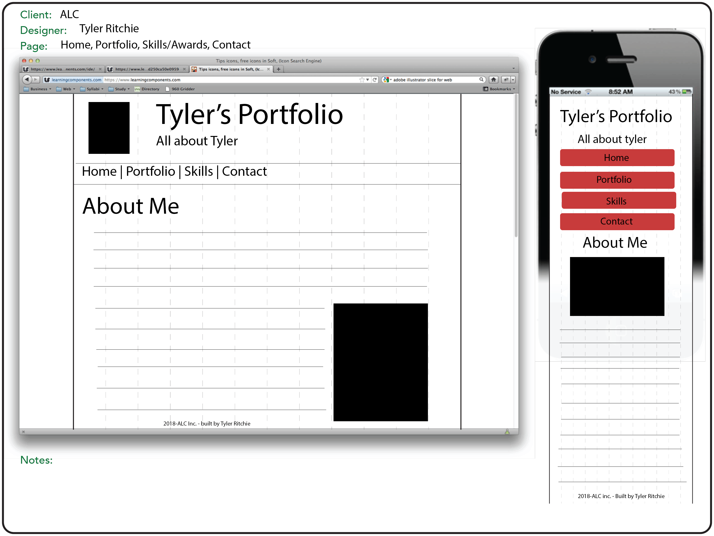

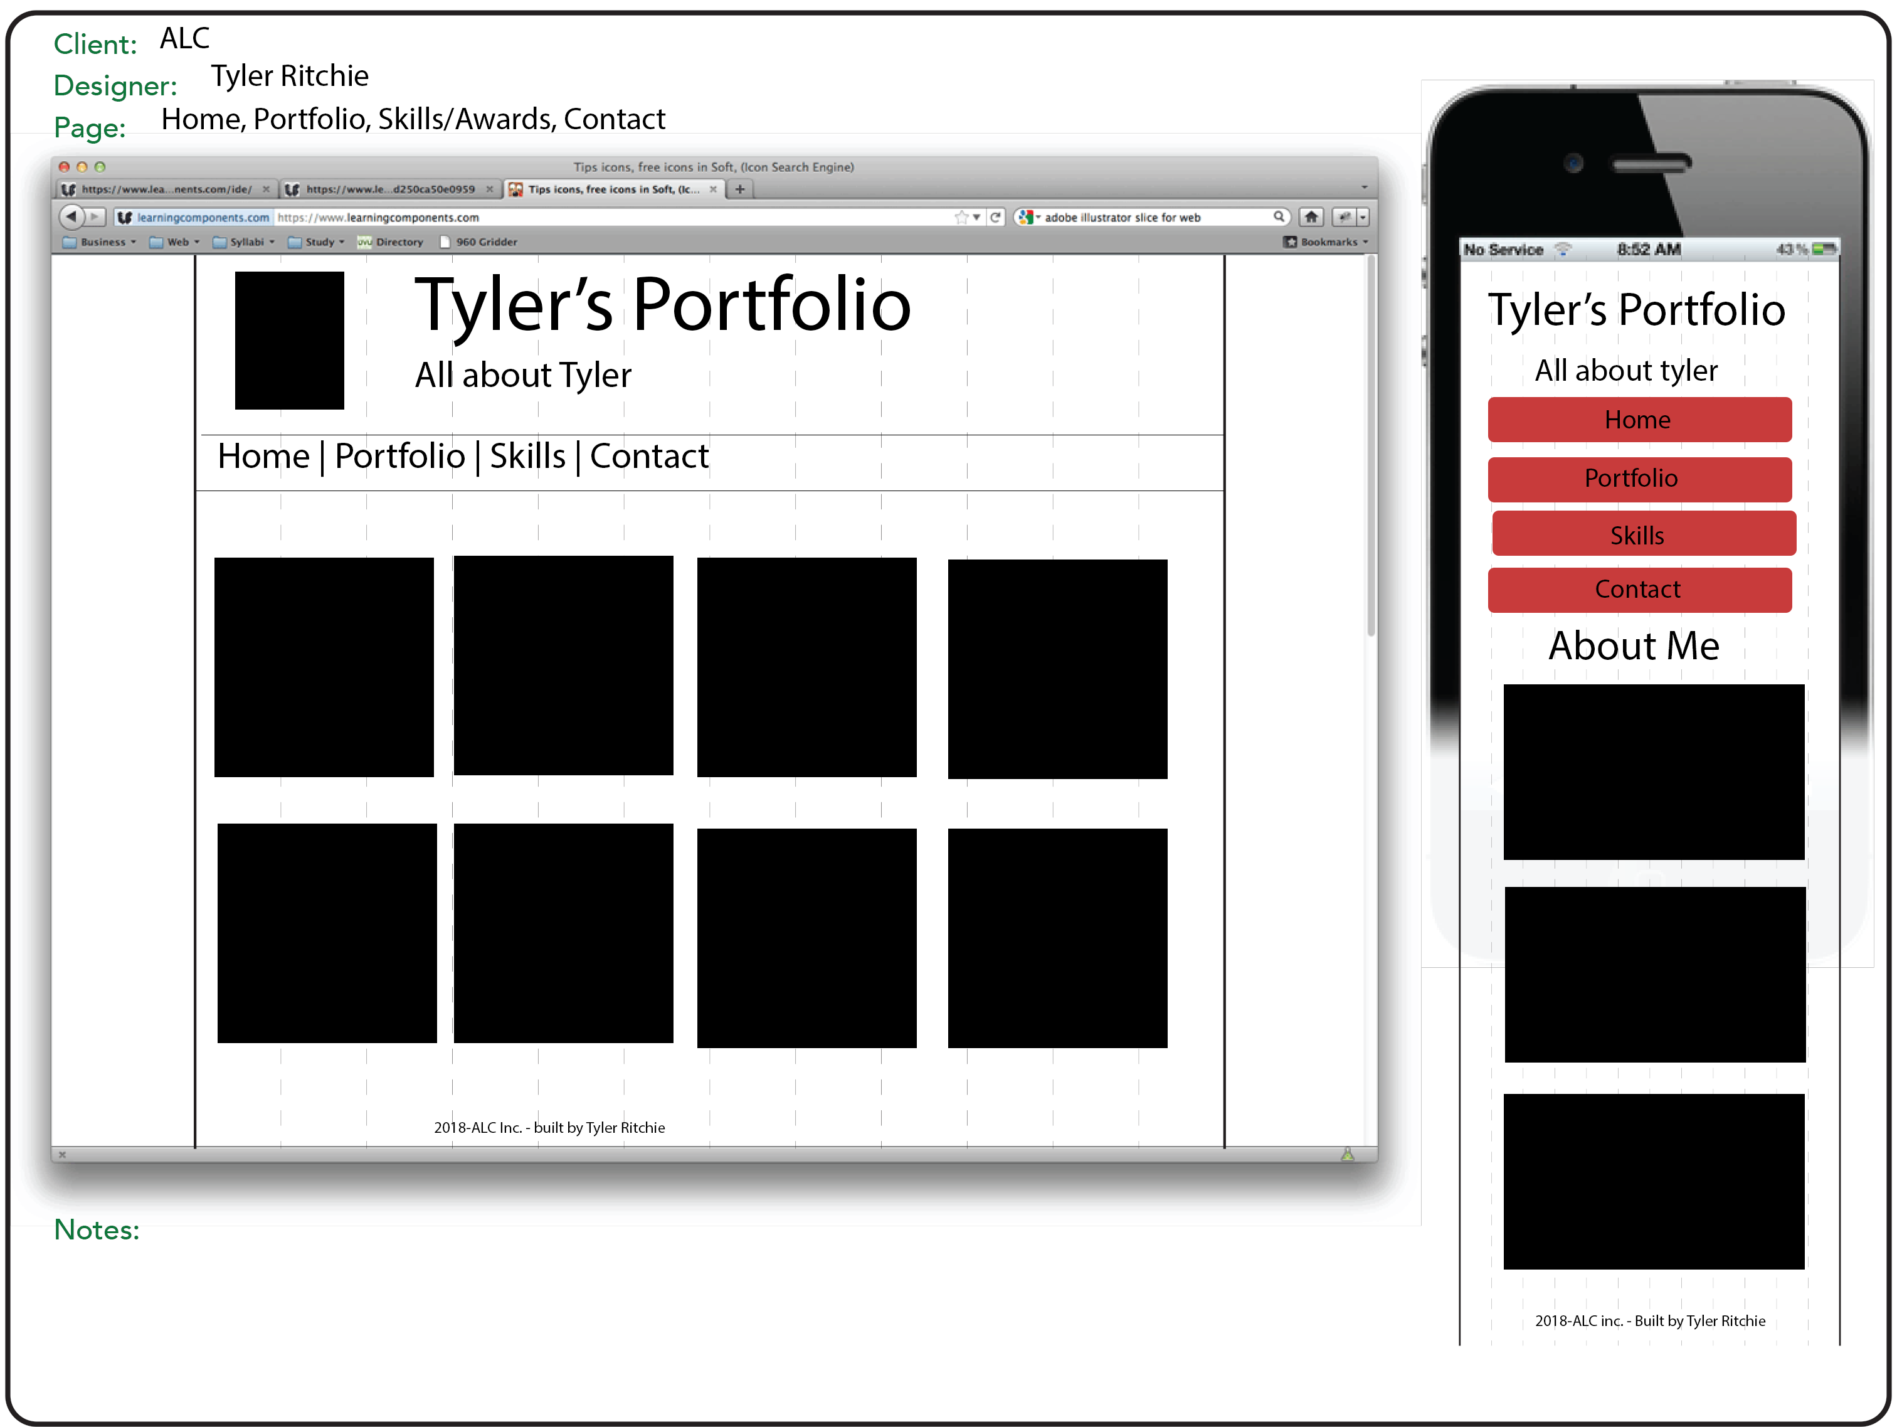

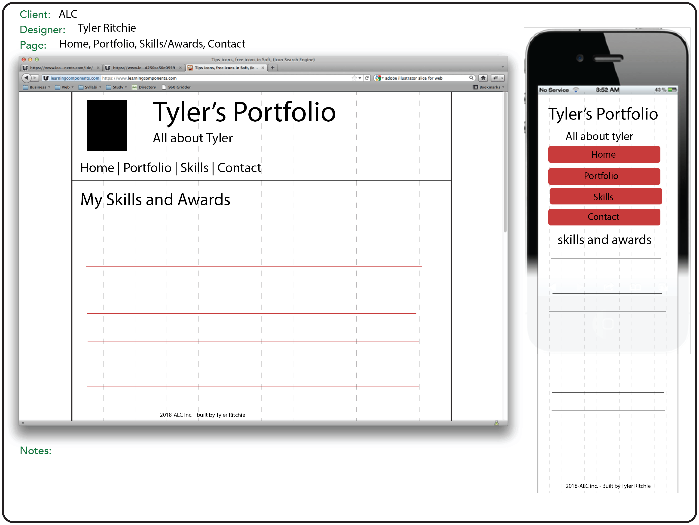

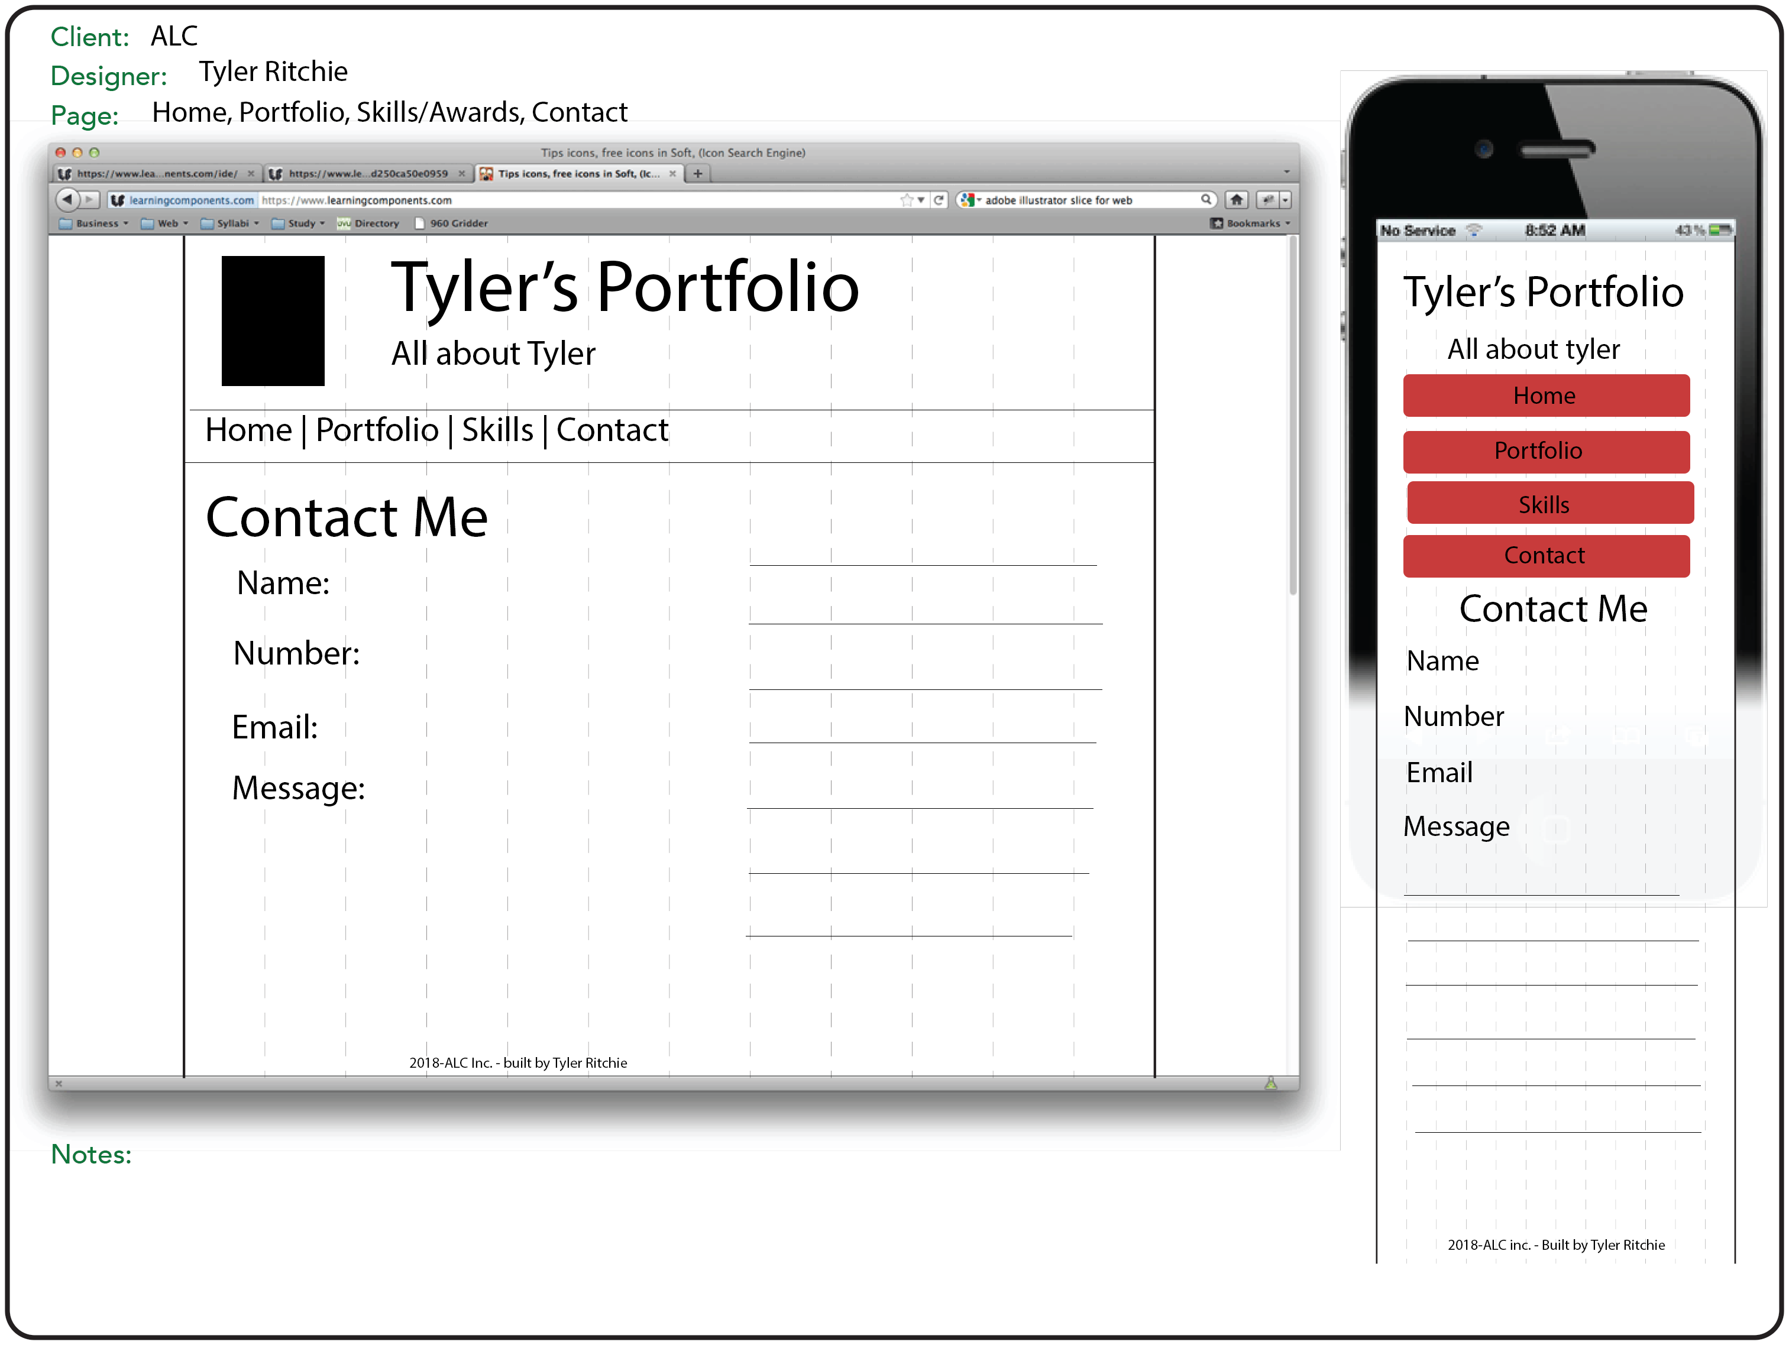

**Site Map**: All pages will be linked together and will be accessible from the navigation bar.

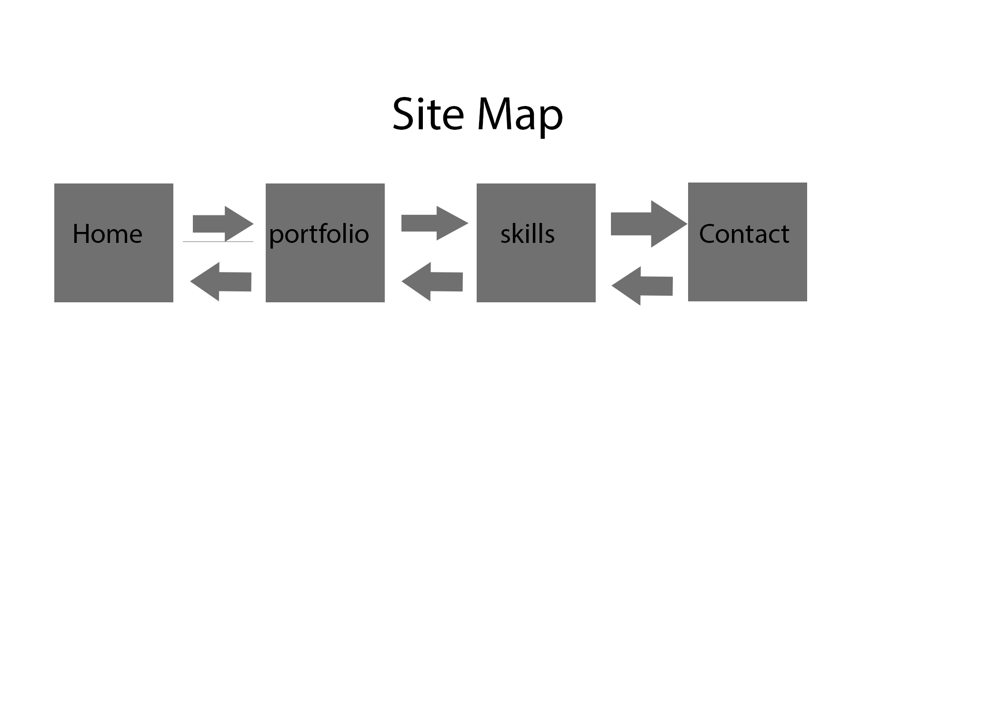**Color Scheme**: These colors are very fun and light which draws the audience to the page.

