QUALITY ASSURANCE / ISTQB v4.0
TEST PLAN
API & AUTOMATION SCOPE
Pickleball Court & Coach Booking System (PCS)
Document Control | Value
Version | v1.2
Prepared by | LÊ THỊ VĂN ANH - QA Leader
Reviewed by | TRƯƠNG QUANG TUÂN - Tester 1
Approved by | TRẦN QUỐC SANG - Project Manager
Date | 19/07/2026
Status | Review - current execution blockers recorded

Internal project document

Document information
Field | Value
Project Name | Pickleball Court & Coach Booking System (PCS)
Document Title | TEST PLAN - API & AUTOMATION SCOPE
Version | v1.2
Prepared By | LÊ THỊ VĂN ANH - QA Leader
Reviewed By | TRƯƠNG QUANG TUÂN - Tester 1
Approved By | TRẦN QUỐC SANG - Project Manager
Date | 19/07/2026
Status | Review

Revision history
Version | Date | Author | Description
1.0 | 10/6/2026 | LÊ THỊ VĂN ANH | Initial API and automation test plan.
1.1 | 10/07/2026 | LÊ THỊ VĂN ANH | Updated Vitest workspace and QA Dashboard scope.
1.2 | 19/07/2026 | LÊ THỊ VĂN ANH | Reconciled technology versions and recorded current execution blockers.

Contents
1. Introduction
2. Project Overview
3. Test Objectives
4. Test Scope
5. Test Items
6. Test Types
7. Test Approach / Strategy
8. Entry Criteria
9. Exit Criteria
10. Test Environment
11. Test Tools
12. Test Data Management
13. Roles and Responsibilities
14. Test Schedule
15. Defect Management Process
16. Risks and Mitigation
17. Test Deliverables
18. Communication Plan
19. Approvals
Appendices A-D

1. INTRODUCTION
This Test Plan defines the approach, scope, schedule, resources, controls, and completion criteria for API integration and automation testing of PCS. It provides a shared basis for planning, execution, defect triage, reporting, and release decisions.
Testing protects the core business flow - account access, court and coach booking, promotion validation, payment confirmation, and operational reporting - while reducing regression risk across Next.js route handlers, service modules, SQL Server interactions, and external integrations.
Objective: Provide repeatable, risk-based evidence that critical PCS workflows behave correctly and that known blockers are visible before release approval.

2. PROJECT OVERVIEW
PCS supports online court and coach reservations, player matching, payment processing, promotions, reviews, notifications, administrative reporting, and AI-assisted customer interaction. The solution uses separate frontend and backend Next.js applications plus a FastAPI-based AI service and a React/Vite QA dashboard.
Area | Verified repository baseline
Frontend | Next.js 15.x, React 18.3, TypeScript
Backend | Next.js 16.2, React 19.2, Node.js route handlers
Database | Microsoft SQL Server through mssql; repositories mocked in automated tests
Authentication | JWT, bcrypt/bcryptjs, Google OAuth integration
Payments | PayOS SDK/webhook routes; refund helper integrations
AI service | FastAPI/Python service for chatbot and player/coach scoring
QA dashboard | Vite/React dashboard generated from test and coverage artifacts

3. TEST OBJECTIVES
- Verify critical authentication, court, booking, coach, payment, promotion, review, notification, reporting, matching, and AI rules.
- Validate API status codes, authorization gates, input validation, repository interactions, and external callback handling.
- Detect overlap, boundary, timezone, voucher, refund, and security defects early.
- Maintain a repeatable regression suite and publish evidence through JSON/HTML coverage and the PCS QA Dashboard.
- Target at least 90% statement coverage and 85% branch coverage for explicitly targeted business-logic modules.

4. TEST SCOPE

4.1 In scope
Module | Coverage focus
Authentication | Registration/login validation, duplicate checks, JWT issuance and access control
Court & Booking | Court availability, time-slot overlap, daily limits, booking lifecycle and holds
Coach | Coach profiles, approval status and appointment slots
Payment & Refund | Checkout creation, PayOS webhook handling, status changes and refund rules
Promotion | Active dates, minimum order thresholds and invalid voucher handling
Other services | Reviews, notifications, reports, player matching and AI fallbacks
Automation assets | Vitest workspace/configuration, shared test data, mocks, coverage output and dashboard scripts

4.2 Out of scope
- High-volume load, stress and endurance testing.
- Production payment execution and production customer data.
- Comprehensive mobile-device and cross-browser manual certification.
- Infrastructure penetration testing and third-party vendor certification.
- Formal UAT execution by customer stakeholders.

5. TEST ITEMS
Item | Repository location / description
API test suites | tests/api/auth.api.test.ts, booking.api.test.ts, court.api.test.ts, payment.api.test.ts
Unit suites | tests/unit/*.test.ts covering 12 service-oriented areas
UI suite | frontend/tests/ui/login.ui.test.tsx
Shared data and mocks | tests/data/testData.ts; tests/mock/*.ts; setupBackendTests.ts; setupTests.ts
Payment route | backend/src/app/api/payments/payos-webhook/route.ts
Workspace configuration | vitest.workspace.ts and vitest.config.ts
Dashboard | scripts/generate-dashboard-data.ts, scripts/serve-dashboard.js, test-dashboard-src/

6. TEST TYPES
Test type | Purpose
Unit testing | Isolate service/business rules using mocked repositories and dependencies.
API integration testing | Exercise route-handler behavior with request and repository mocks.
UI component testing | Validate login form behavior in JSDOM with React Testing Library.
Regression testing | Re-run automated suites after changes to detect unintended impact.
Security-focused testing | Check authentication, authorization, validation and webhook trust boundaries.
Coverage analysis | Measure statement, branch, function and line execution with V8 coverage.

7. TEST APPROACH / TEST STRATEGY
Testing is automated-first, risk-based, and aligned with the repository's Vitest workspace. Backend suites run in a Node environment; frontend component tests run in JSDOM. Database and third-party behavior is isolated with mocks so that failures can be reproduced deterministically.
Level | Approach | Primary evidence
Unit | White-box branch and error-path validation | Vitest unit suite results
API integration | Request/response and service interaction checks | API suite results and status assertions
UI component | Black-box validation of login interactions | React Testing Library assertions
Regression | Full workspace execution after material changes | JSON test report and dashboard
Coverage | V8 instrumentation with excluded build/test artifacts | HTML/JSON coverage reports

Test design techniques
- Equivalence partitioning for valid/invalid credentials and promotion eligibility.
- Boundary value analysis for time slots, daily booking limits, rating ranges and discount thresholds.
- Decision tables for compound registration validation and payment state rules.
- State transition testing for booking/payment lifecycle changes.
- Use-case testing for book-court-and-pay end-to-end behavior.

8. ENTRY CRITERIA
- Requirements and acceptance criteria for the target module are available and reviewed.
- Target route/service implementation compiles and is reachable by the test workspace.
- Root and application dependencies required by imported modules are installed.
- Shared mocks and deterministic test data are prepared.
- Test environment variables contain only sandbox/non-production credentials.
- The build under test is identified and deployed to the intended test environment.

9. EXIT CRITERIA
Criterion | Target | Current assessment (19/07/2026)
Planned tests executed | 100% | Not met - 7 suites failed during collection
Executed tests pass | 100% | Met for executed set - 35/35 passed
Critical/high defects | 0 open | Pending triage of collection blockers
Targeted statement coverage | >= 90% | Baseline report states 92.50%; rerun required after blockers
Targeted branch coverage | >= 85% | Baseline report states 88.75%; rerun required after blockers
Dashboard and reports | Generated and reviewable | Artifacts exist; refresh after successful full run

Release gate: The document remains in Review status until all suites collect and execute successfully, results are refreshed, and blocking defects are closed or formally accepted.

10. TEST ENVIRONMENT
Component | Configuration
Operating system | Windows 10/11 development environment
Runtime | Node.js; Python/FastAPI for AI service
Test framework | Vitest 3.0.7 declared at repository root
Backend test environment | Node with backend aliases and setupBackendTests.ts
Frontend test environment | JSDOM with setupTests.ts
Coverage provider | @vitest/coverage-v8 3.0.7
Database | Mocked Microsoft SQL Server connections
External services | Mocked PayOS, email/OAuth, refund and AI dependencies

11. TEST TOOLS
Tool | Purpose
Vitest | Unit, API integration, UI and regression execution
React Testing Library | DOM rendering and interaction assertions
V8 coverage | Statement, branch, function and line metrics
TypeScript / tsx | Typed test and dashboard scripts
Postman assets | Manual API collection/environment support
Vite + React dashboard | Visual test, traceability, coverage and defect reporting
Git / npm scripts | Version control and repeatable execution commands

12. TEST DATA MANAGEMENT
Reusable payloads are centralized in tests/data/testData.ts and module-specific mocks in tests/mock/. Tests must reset mock state between cases, avoid real customer data, and use deterministic timestamps and identifiers where business rules are time-sensitive.
Dataset | Purpose | Control
Valid/invalid auth | Token and validation paths | Synthetic identities only
Overlapping slots | Booking-conflict detection | Fixed court/date/time records
Voucher boundaries | Expiry and order thresholds | Dates relative to controlled clock
Payment callbacks | Signature and status transitions | Sandbox/mock payloads
Large/edge records | Boundary and resilience paths | Generated, non-production data

13. ROLES AND RESPONSIBILITIES
Role / person | Responsibilities
Project Manager - Trần Quốc Sang | Approve scope and deliverables; coordinate use cases and decision-table requirements.
QA Leader - Lê Thị Văn Anh | Own plan, framework, API automation, execution evidence, dashboard and defect lifecycle.
Tester 1 - Trương Quang Tuân | Develop unit tests, maintain workspace configuration and peer-review QA outputs.
Developer 1 - Nguyễn Đào Văn Quý | Implement/fix backend APIs, repository hooks and route defects.
Developer 2 - Lê Hữu Sơn | Implement/fix frontend login and validation behavior.

14. TEST SCHEDULE
Phase | Start | End | Owner
Test planning | 01/10/2023 | 07/10/2023 | Project Manager / QA Lead
Vitest workspace setup | 08/10/2023 | 12/10/2023 | QA Lead / Tester 1
API automation | 13/10/2023 | 20/10/2023 | QA Lead
Coverage instrumentation | 21/10/2023 | 24/10/2023 | QA Lead
Dashboard deployment | 25/10/2023 | 27/10/2023 | QA Lead
Regression and defect review | 28/10/2023 | 01/11/2023 | QA Team
v1.2 verification and closure | 19/07/2026 | TBD | QA Lead / Developers

15. DEFECT MANAGEMENT PROCESS
Workflow: New -> Assigned -> In Progress -> Fixed -> Retest -> Closed

Severity | Definition | Response expectation
Critical | Crash, data corruption, unauthorized access, or total loss of a core workflow. | Immediate triage; release blocker
High | Payment/booking/security rule failure with no acceptable workaround. | Fix before release
Medium | Incorrect non-critical behavior or reporting with a workaround. | Schedule and retest
Low | Cosmetic, warning, wording or minor usability issue. | Backlog unless release-critical

Each defect record must include an identifier, environment/build, summary, preconditions, reproducible steps, expected and actual results, severity, priority, owner, evidence, status, and retest result.
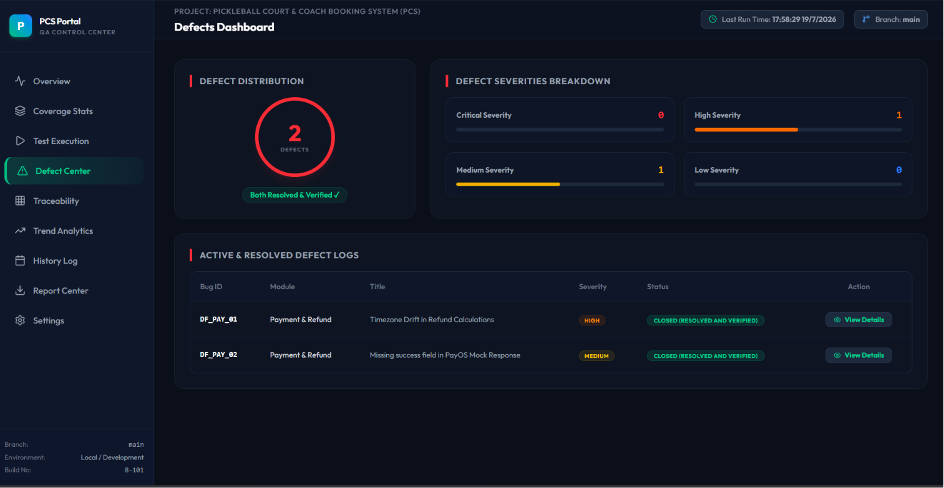

16. RISKS AND MITIGATION
Risk | Impact | Mitigation / contingency
Root dependency resolution mismatch | High | Install or expose application dependencies to the root Vitest workspace; lock versions; rerun all suites.
Deprecated workspace configuration | Medium | Migrate vitest.workspace.ts projects into test.projects in vitest.config.ts before the next major Vitest upgrade.
Timezone drift | High | Pin Asia/Ho_Chi_Minh or use controlled clocks for time-sensitive cases.
Mock divergence from production | High | Review mock contracts against repository and provider interfaces each sprint; retain a small sandbox integration set.
Incomplete API routes | Medium | Mock stable interfaces to author tests early; track blocked cases explicitly.
Misleading aggregate coverage | Medium | Report targeted-module coverage separately from full-workspace coverage and document exclusions.

17. TEST DELIVERABLES
- Approved Test Plan (this document).
- Automated unit, API integration, and UI test suites.
- JSON/HTML coverage reports and machine-readable test results.
- PCS QA Dashboard and generated dashboard data.
- Test execution, summary, automation, data, traceability, decision-table and use-case reports.
- Defect report with retest evidence.
- Postman collection and environment for supported manual checks.
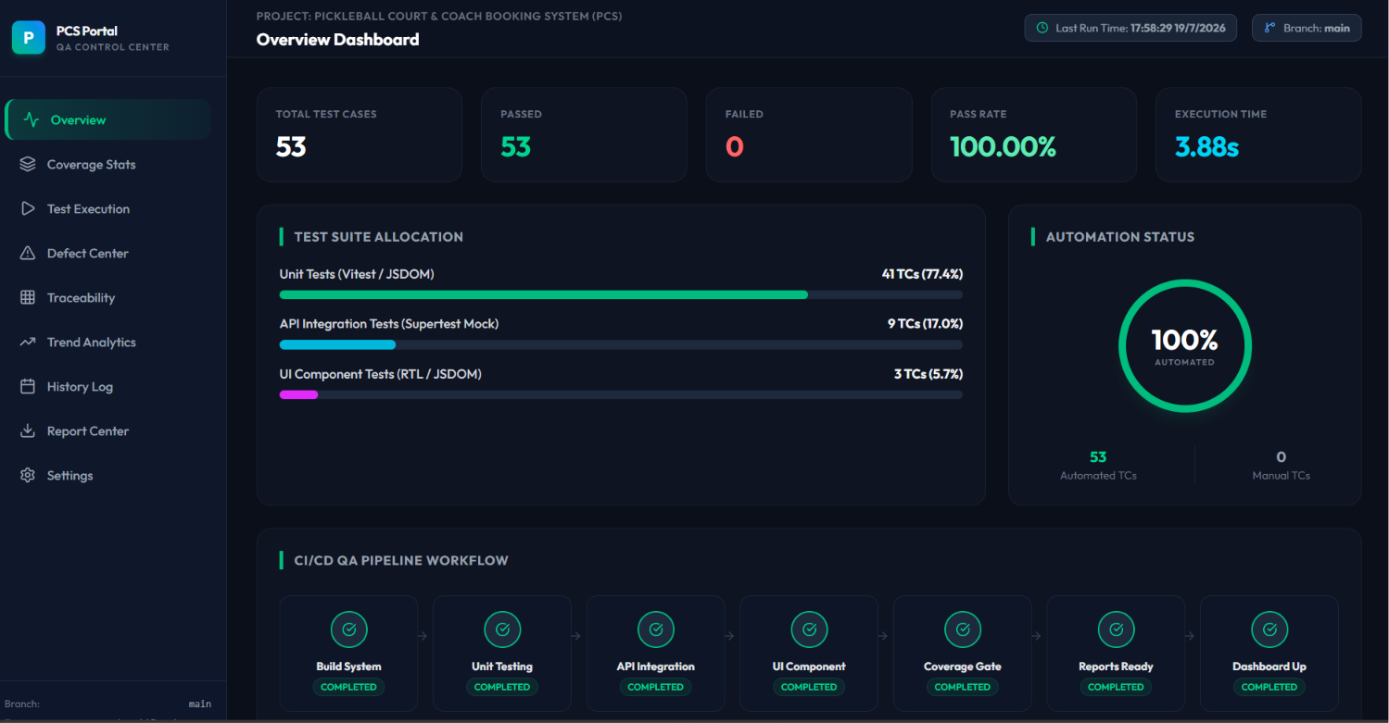
QA Overview Dashboard

18. COMMUNICATION PLAN
Activity | Frequency | Participants | Output
QA stand-up | Daily during execution | QA Lead, Tester 1 | Progress, blockers, next actions
Defect triage | Twice weekly / as needed | QA, developers, PM | Severity, ownership, target fix
Status report | Weekly | QA Lead, PM, stakeholders | Execution, coverage, defects, risk
Release review | At exit gate | PM, QA Lead, relevant owners | Go/no-go recommendation

19. APPROVALS
Name | Role | Signature | Date
TRẦN QUỐC SANG | Project Manager | Pending v1.2 approval
LÊ THỊ VĂN ANH | QA Leader | Prepared | 19/07/2026
TRƯƠNG QUANG TUÂN | Tester 1 / Reviewer | Pending review

APPENDIX A - TEST CASE TEMPLATE
Field | Required content
Test Case ID | Unique identifier, e.g. TC_API_09
Module | Functional area under test
Preconditions | Required initial state and data
Test Steps | Numbered execution actions
Expected Result | Observable acceptance condition
Actual Result | Observed result and evidence
Status | Pass / Fail / Blocked / Not Run

APPENDIX B - DEFECT REPORT TEMPLATE
Field | Required content
Defect ID | Unique identifier, e.g. DF_PAY_01
Summary | Concise defect statement
Steps to Reproduce | Repeatable sequence including data
Expected / Actual | Acceptance condition and observed behavior
Severity / Priority | Critical-High-Medium-Low / P1-P2-P3
Status / Owner | Lifecycle state and accountable person
Evidence | Logs, screenshots, response payloads or test output

APPENDIX C - DECISION TABLE SAMPLE
Registration validation example
Conditions / result | TC1 | TC2 | TC3 | TC4 | TC5 | TC6 | TC7 | TC8
Email valid & unique | Y | Y | Y | Y | N | N | N | N
Phone valid & unique | Y | Y | N | N | Y | Y | N | N
Password strong | Y | N | Y | N | Y | N | Y | N
Expected result | Success | Err Pass | Err Phone | Err Both | Err Email | Err Both | Err Both | Err All

APPENDIX D - USE CASE TESTING SAMPLE
UC-04: Book court and pay online
Step | User / system action | Expected result
1 | Select court and 09:00-10:00 slot | Slot is validated and held according to booking rules.
2 | Proceed to online payment | Backend creates a PayOS payment link/QR for the pending order.
3 | PayOS sends signed callback | Webhook validates the callback before accepting the update.
4 | Process valid payment result | Order becomes Paid and the reserved slot is unavailable to others.

APPENDIX E - CURRENT VERIFICATION RECORD
Metric | Result
Command | npm test -- --reporter=json --outputFile=tmp-test-results.json
Executed tests | 35 passed, 0 failed, 0 pending
Suite collection | 37 passed; 7 failed; overall run unsuccessful
Collection blockers | Missing root-resolvable packages: @react-oauth/google, nodemailer, axios, exceljs, google-auth-library
Configuration warning | vitest.workspace.ts is deprecated; migrate to test.projects
Disposition | Resolve dependencies/configuration, rerun full suite, refresh coverage and seek approval
