IFN 680 Project 7 – Improving DDPM (Group 1)
Tri Tin Vo (n12501034), Hanmin Park (n12340626)

Introduction
Denoising Diffusion Probabilistic Models (DDPMs) generate images by learning to reverse a progressive noising process (Ho et al., 2020). The noise schedule determines how noise is added to images during the forward diffusion process, and the rate of noise addition can vary depending on the schedule. Nichol and Dhariwal (2021) suggested that the linear schedule can destroy image information faster than necessary, leaving the later timesteps close to pure noise, whereas the cosine schedule adds noise more gradually and preserves image information for longer. Based on this, the project investigates whether a cosine schedule allows a denoising diffusion probabilistic model to generate high-quality samples using fewer time steps than a linear schedule.

Methodology
The baseline conditional DDPM was trained on the modified MNIST dataset containing 20 × 20 grayscale images, which were normalised to [-1, 1]. A conditional U-Net was trained to predict the added Gaussian noise using MSE loss, with the digit label used as a condition. Both models used the same architecture, dataset, learning rate (2 × 10⁻⁴), 100 epochs, and 1,000 diffusion timesteps. The difference between the two models was the noise schedule, with one using a linear schedule and the other using a cosine schedule. For each model, the checkpoint with the lowest training loss across the 100 epochs was selected as the final model.
The linear beta schedule was defined using β₀ = 10⁻⁴ and β₁ = 0.02, as shown in Equation (1).
$βₜ = β₀ + (β₁ - β₀) · t/(T - 1)$ (1)
The cosine schedule was defined as shown in Equation (2), where s = 0.008 was used as a small offset.
$ᾱₜ = f(t)/f(0), f(t) = cos²(((t/T + s)/(1 + s)) · π/2)$ (2)
The corresponding beta values were calculated from consecutive cumulative alpha values, where βₜ = 1 − ᾱₜ / ᾱₜ₋₁.

Experiments
Training loss was monitored across 100 epochs to assess the convergence of both models. As shown in Figure 1, both models reached their lowest training loss at epoch 97 and showed stable convergence throughout training.
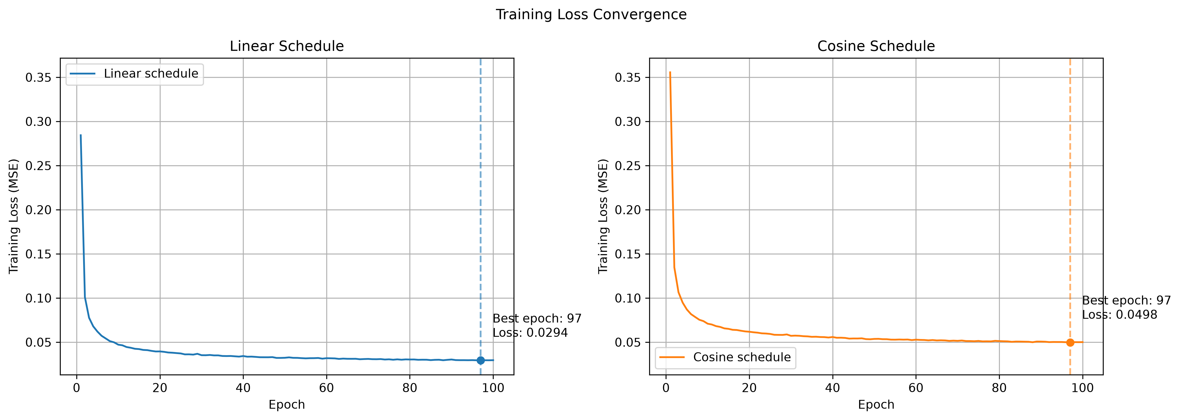
Figure 1. Training Loss Convergence of Linear and Cosine Schedule Models
The reverse denoising process was examined at t = 500, 250, 100, 50, 25, and 0 to observe the denoising progress at different timesteps. The result shows that the cosine schedule produced recognizable digit structures earlier in the denoising process than the linear schedule, particularly at t = 500 (Figure 2).
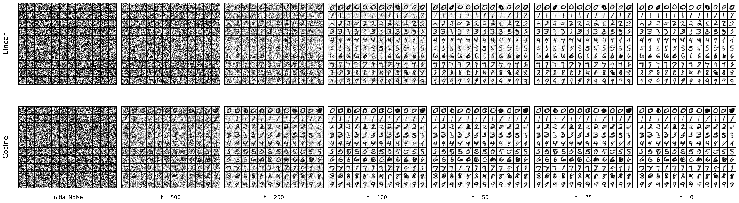
Figure 2. Denoising Progress of Linear and Cosine Schedule Models
However, in the final generated samples, both models produced recognizable digits, while the visual improvement in image quality with the cosine schedule was limited compared to the linear schedule (Figure 3). More specifically, some samples generated by the cosine model appeared inconsistent with the target digit class or showed thicker and bolder digit shapes.
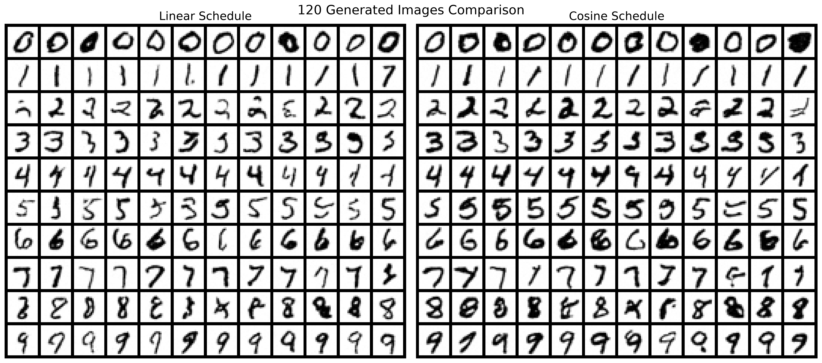
Figure 3. Generated Samples from Linear and Cosine Schedule Models

Discussion
In this experiment, both models generated well-recognizable digits at the end of the denoising process using 1,000 timesteps. However, the cosine model produced recognizable digit structures earlier during reverse denoising, particularly around t = 500, while the linear samples remained noisier at the same timestep.
This may be related to the more gradual noising process of the cosine schedule. Nichol and Dhariwal (2021) explained that the linear schedule continues to add noise even when samples have already become highly noisy, causing image information to be destroyed more quickly. In contrast, the cosine schedule adds noise more gradually than the linear schedule and preserves image information for longer during forward diffusion. This difference could explain the earlier recovery observed with the cosine model.
Both models were trained for 100 epochs, and the best-performing model for each schedule was selected at epoch 97. The linear and cosine models required similar training times of 834.31 and 835.15 seconds, respectively, indicating that the cosine schedule had little impact on model training time. Overall, the results provide partial support for the hypothesis, which is that a cosine schedule may allow a denoising diffusion probabilistic model to generate high-quality samples using fewer time steps than a linear schedule, as earlier recovery was observed with the cosine schedule, although generation with fewer actual timesteps was not directly evaluated.

Conclusion
The cosine schedule produced recognizable digit structures earlier during denoising than the linear schedule, even though both models maintained reasonable generation quality at the final timestep. Future work could evaluate generation using fewer diffusion timesteps, for example, 500 or 100, to examine how reducing the number of timesteps affects generation quality. Additionally, exploring alternative noise schedules, such as a sigmoid schedule, is suggested to investigate whether they can result in different denoising patterns.

References
Ho, J., Jain, A., & Abbeel, P. (2020). Denoising Diffusion Probabilistic Models. Advances in Neural Information Processing Systems, 33.
Nichol, A. Q., & Dhariwal, P. (2021). Improved Denoising Diffusion Probabilistic Models. Proceedings of the 38th International Conference on Machine Learning, 139, 8162–8171.

