A Level Computer Science Non-Examined Assessment (NEA)

Sam Leonard

# Analysis

## Identification and Background to the Problem

The problem my project tries to solve is how to look at devices on a network from a “bbox” perspective and gain information about what services are running. Services are programs whose entire purpose is to provide a *service* to other programs. For example a server hosting a website would be running a service whose purpose is to send the webpage to people who try to connect to the website.

There are a number of steps a device has to go through from when it is turned on until it can connect to the internet. There are many more steps than those listed below, but the most important ones are.

1. Loading networking drivers
2. Starting dhcp daemon
3. Broadcasting dhcp request for an ipaddr
4. Obtaining assigned an ipaddr

Starting from a Linux computer being switched on, the first step is that the kernel needs to load the networking drivers. The kernel is the basis for the operating system, it is what interacts with the hardware in the most fundamental way. Drivers are small bits of code which the kernel can load in order to interact with certain hardware modules. These can range from graphics drivers for games to use graphics cards, to networking drivers which interact with the nic.

Once the kernel has loaded the required drivers and the system has booted, the networking ‘daemons’ must be started. In Linux, a daemon is a program that runs all the time in the background to serve a specific purpose or utility. For example, when I start my laptop, the following daemons start: upow (power management), sysd (manages the creation of all processes), dbus (manages inter-process communication), iwd (manages my WiFi connections) and finally dhcpcd, which manages all interactions with the network around dhcp.

Once the daemons are all started, the dhcp client can issue commands to the daemon for it to carry out. The dhcp client is simply a daemon that runs in the background to carry out any interactions between the current machine and the dhcp server. The dhcp server is normally the WiFi router or network switch for the local network and it manages a list of which computer has which ipaddr and negotiates with new computers trying to join a network to get them a free ipaddr. The dhcp client starts the dhcp address negotiation with the server by sending a discover message with the address 255.255.255.255, which is the IP limited broadcast address, which means that whatever is listening at the other end will forward this pkt on to everyone on the subnet. When the dhcp server (normally the router, sometimes a separate machine) on the subnet receives this message it reserves a free ipaddr for that client and then responds with a dhcp offer that contains the address the server is offering, the length of time the address is valid for and the subnet mask of the network. The client must then respond with a dhcp request message to request the offered address, this is in case of multiple DHCP servers offering addresses. Finally the dhcp server responds with a dhcp acknowledge message showing that it has received the request. Figure [dhcp_negotiate] shows a pkt capture from my laptop where I turned WiFi off, started wireshark listening and plugged in an Ethernet cable, I have it showing only the dhcp pkts so that it is clear to see the entire dhcp negotiation including the 255.255.255.255 limited broadcast destination address and the 0.0.0.0 unassigned address in the source column. I mention using wireshark to do packet capturing above without explaining what either packet capturing or wireshark are so I will do that here. Packets I define below and wireshark is simply a tool which intercepts all the network communications on a single computer and records them to a file as well as displaying them to the user as well as performing some analysis and dissecting each of the protocols used. This means that I can record the dhcp negotiation shown below and show it to you using wireshark to get all the information out of the packets being sent over the wire.

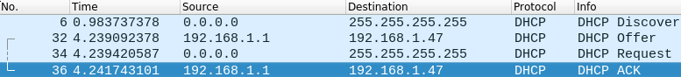

dhcp address negotiation

[dhcp_negotiate]

All computer networking is encapsulated in the osi which has 7 layers:

Application: apis, etc…

Presentation: encryption/decryption, encoding/decoding, decompression etc…

Session: Managing sessions, php session IDs etc…

Transport: TCP and UDP among others.

Network: ICMP and IP among others.

Data Link: MAC addressing, Ethernet protocol etc…

Physical: The physical Ethernet cabling/nic.

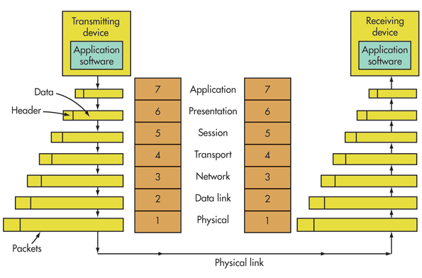

OSI model diagram, source: https://www.electronicdesign.com

[osi_model]

Each of these layers is essential to the running of the internet but a single communication might not include all of the layers. These communications are all based on the most fundamental part of the internet: the pkt. Packets are sequences of ones and zeros sent between computers which are used to transfer data as well as to control how networks function. They consist of different layers of information each specifying where the pkt where should go next at a different level along with fundamentally the data/instructions contained in the innermost layer. When pkts are sent between computers a certain number of layers are stripped off by each computer so that it knows where to send the pkt next at which point it will add all the layers back again, this time with the instructions needed to go from the current computer to the next one on its route. Each of these layers actually consists of a number of fields at the start called a header some layers also append a footer to the end of the packet. The actual data being transferred in the packet can be quite literally anything, http transfers websites so html files and images etc…. In particular there are two pieces of information stored in headers which together define the final destination of the packet: the ipaddr and the port number. The ipaddr defines the destination machine and the port number defines which “port” on the remote machine the packet should be sent to. Ports are essential entrances to a computer, for example if a computer was a hotel the ipaddr would be the address and location of the hotel and the port number would be the room inside the hotel. There are 65535 ports and 0 is a special reserved port. Both tcp and udp use ports, tcp ports are mainly used for transferring data where reliability is a concern, as tcp has built in checks for packet loss whereas udp does not and as such is used for purposes where speed is more important and missing some data is inconsequential, such as video streaming and playing games.

I’m going to use the example of getting a very simple static HTML page with an image inside. The code for the page is shown in listing [examplepage]. In figure 1 you can see how the page renders. However, far more interestingly is how the browser retrieved the page, in figure 2 you can see the full sequence of pkts that were exchanged for the browser to get the resources it needed to render the page. The page is hosted using Python3’s http.server module which is a quick and easy way to serve HTML pages and other content locally without the hassle of setting up a full blown web server such as Nginx or Apache. Python’s http.server just makes the current directory open on port 8000. From there navigating to /example.html will render the page. Breaking figure 2 down pkt one shows the browser receiving the request from the user to display http://192.168.1.47:8000/example.html and attempting to connect to 192.168.1.47 on port 8000. Packets two and three show the negotiation of this request through to the full connection being made. The browser now makes an http GET request for the page example.html over the established TCP connection as shown in pkt 4. The server then acknowledges the request and sends a pkt with the PSH flag set as shown in pkts 6 and 7. The PSH flag is a request to the browser to say that it is OK to received the buffered data, i.e. example.html. The browser then sends back an acknowledgement and the server sends the page as shown in pkts 7 and 8. Finally the browser sends a final acknowledgement of having received the page before initiating a graceful session teardown by sending a FIN ACK pkt which indicates the end of a session. Once the server responds to the FIN ACK with its own the browser sends a final acknowledgement. This then repeats itself when the browser parses the HTML and realises there’s an image which it needs to get from the server as well, except the image is a larger file and so takes a few more PSH pkts. In figure [ladder] you can see a ladder diagram which show the entire transaction symbolically. I have also colour coded figure [ladder] with green arrow heads to the initial handshakes, blue for the HTTP protocol transactions and red for the TCP connection teardown packets.

This shows clearly the interaction between each of the different layers in the OSI model, the browser at level 7: Application rendering the webpage. Level 6: Presentation is skipped as we have no files which need to be served compressed because they are so large. Level 5: Session is shown by the TCP session negotiation and graceful teardown of the TCP session. Level 4: Transport is shown when the image and webpage are transferred from the server to the browser. Level 3/2/1 are shown in figure 3 where you can see the IP layer information along with Ethernet II and finally frame 4 which is the bytes that went down the wire.

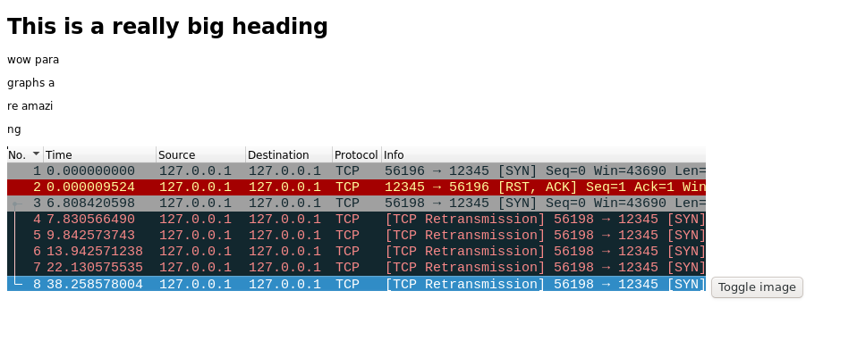

A basic static html webpage.

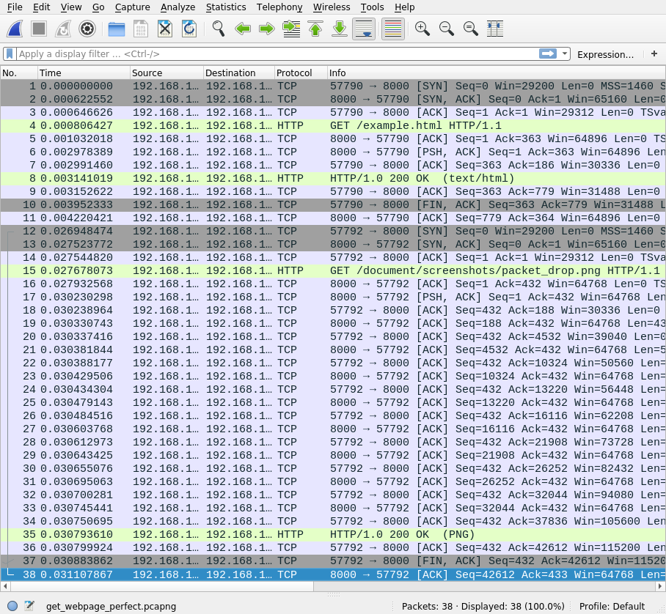

A full chain of pkts that shows retrieving a basic webpage from the server.

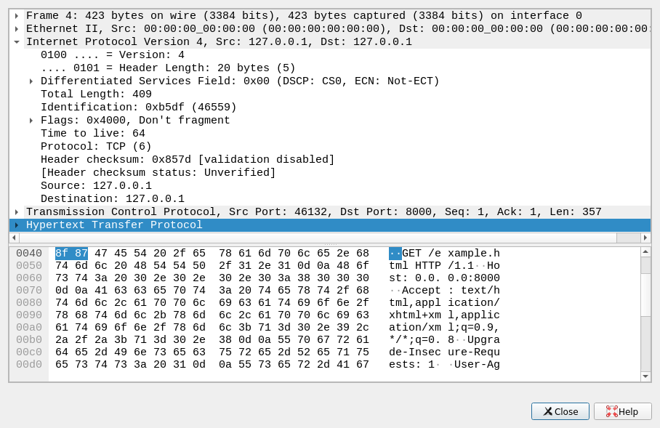

A look inside a TCP pkt.

<!DOCTYPE html>  
<html>  
<head>  
<title>Wow I can add titles</title>  
</head>  
<body>  
  
<h1>This is a really big heading</h1>  
<p>wow para</p>  
<p>graphs a</p>  
<p>re amazi</p>  
<p>ng</p>  
 <script type="text/javascript">  
 function imgtog() {  
 if (document.getElementById("img").style.display == "none") {  
 document.getElementById("img").style = "block"  
 } else {  
 document.getElementById("img").style.display = "none"  
 }  
 }  
  
 </script>  
  
<img id="img" src="document/screenshots/packet_drop.png">  
  
<button onclick="imgtog()">Toggle image</button>  
  
  
</body>  
</html>

## Analysis of problem

The problem with looking at a network from the outside is that the purpose of the network is to allow communication inside of the network, thus very little is exposed externally. This presents a challenge as we want to know what is on the network as well as what each of them is running which is not always possible due to the limited information that services will reveal about themselves. Firewalls also play large part in making scanning networks difficult, as sometimes they simply drop pkts instead of sending a tcp RST pkt (reset connection pkt). Dropping a packet means that when a packet is received, no response is sent back – as if the connection was just “dropped”. When firewalls drop pkts, it becomes exponentially more difficult, to determine the state of any port on the target machine, as you don’t know whether your pkt was corrupted, or lost in transit, or if it was just dropped.  
  
To demonstrate this I will show three things:

1. A successful connection over tcp.
2. An attempted connection to a closed port.
3. An attempted connection with a firewall rule to drop packets.

First, a successful tcp connection. For a tcp connection to be established there is a three way handshake between the communicating machines. First, the machine trying to establish the connection sends a tcp SYN packet to the other machine, this packet holds a dual purpose, to ask for a connection and if it is accepted to SYNchronise the sequence numbers being used to detect whether packets have been lost in transport. The receiving machine then replies with a tcp SYN ACK which confirms the starting sequence number with the SYN part and ACKnowledges the connection request. The sending machine then acknowledges this by sending a final tcp ACK packet back. This connection initialisation is shown in figure [data_transfer] by packets one, two and three. Data transfer can then commence by sending a tcp packet with the PSH and ACK flags set along with the data in the data portion of the packet, this is shown in figure 6 where wireshark allows us to take a look inside the packet to see the data being sent in the packet along with the PSH and ACK flags being set. The code I used to generate these is shown in figures 4 and 5. Breaking the code down in figure 5 you can see me initialising a socket object then I bind it to localhost (127.0.0.1) port 12345 localhost is just an address which allows connections between programs running on the same computer as connections are looped back onto the current machine, hence its alternative name: the loopback address. I then tell it to listen for incoming connections, the one just means how many connections to keep as a backlog. I then accept the connection from the program in figure 4, line 3. I then tell the program to listen for up to 1024 bytes in the data part of any TCP packets sent. The program in figure 4 then sends some data which we then see printed to the screen in figure 5, both programs then close the connection.

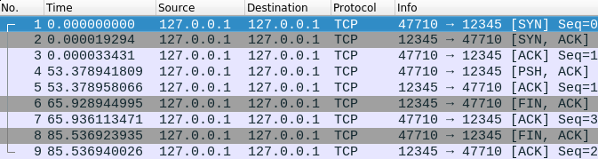

Packets starting a TCP session, transferring some data then ending it.

[data_transfer]

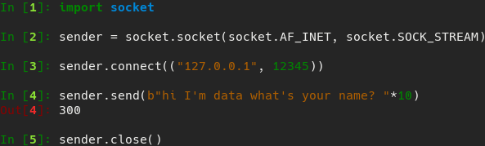

Transferring some basic text data over a TCP connection.

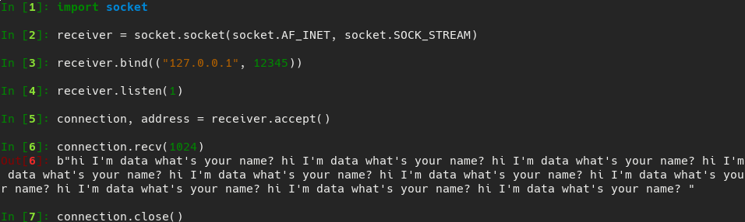

Receiving some basic text data over a TCP connection.

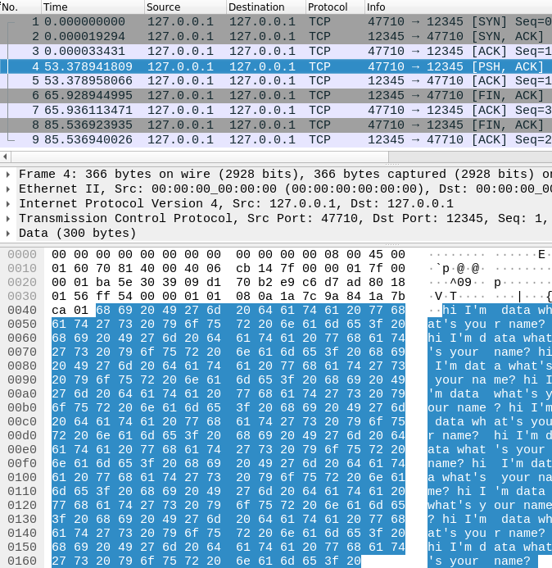

Highlighted packet carrying the data being transferred in figure 4.

Second, an attempted connection to a closed port. In figure 7 packet one you can see the same tcp SYN packet as we saw in the attempted connection to an open port, as you would expect. The difference comes in the next packet with the tcp RST flag being sent back. This flag means to reset the connection, or if the connection is not yet established as in this case it means that the port is closed, hence why the packet is highlighted red in figure 7. The code used to generate this is shown in figure [firewall_code] line two shows the initialisation of a socket object. In line 3 the program tries to connect to port 12345 on localhost again, except this time we get a connection refused error back this shows us that the remote host sent a tcp RST packet back, which is reflected in figure 7.

Third, I will show a connection where the firewall is configured to drop the packet. However, first I will explain a bit about firewalls and how they work. Firewalls are essentially the gatekeepers of the internet; they decide whether a packet gets to pass or whether they shall not pass. Firewalls work by a set of rules which decide what to do with a particular packet. Such a rule might be that it is coming from a certain ipaddr or has a particular destination port. The actions taken after the packet has had its fate decided by the rules can be one of the following three (on iptables on Linux): ACCEPT, DROP and RETURN. ACCEPT does exactly what you think it would and lets the packet through; DROP simply drops the packet and sends no reply whatsoever: RETURN is more complicated and has no effect on how port scanning is done, and as such we will ignore it. A common set of rules for something like a webserver would be to DROP all incoming packets and then allow exceptions for certain ports i.e. port 80 for http or 443 for https. I will be using a Linux utility called iptables for implementing all firewall rules on my system for demonstration purposes. Packet number three in figure 7 shows the connection request from line 4 of [firewall_code] except that I have enabled a firewall rule to drop all pkts from the address 127.0.0.1, using the iptables command as so: iptables -I INPUT -s 127.0.0.1 -j DROP. This command reads as for all pkts arriving (-I INPUT) with source address 127.0.0.1 (-s 127.0.0.1) drop them sending no response (-j DROP). With this firewall rule in place you can see in figure 7 pkt 3 receives no response and as such Python assumes that the pkt just got lost and as such tries to send the pkt again repeatedly, this continued for more than 30 seconds before a stopped it as shown by the time column in figure 7 and the final KeyboardInterrupt in figure [firewall_code]. The amount of time that a system will wait still trying to reconnect depends on the OS and a other factors but the minimum time is 100 seconds as specified by RFC 1122, on most systems it will be between 13 and 30 minutes according the Linux manual page on tcp.

man 7 tcp:  
tcp_retries2 (integer; default: 15; since Linux 2.2)  
 The maximum number of times a TCP packet is retransmitted in  
 established state before giving up. The default value is 15,  
 which corresponds to a duration of approximately between 13 to  
 30 minutes, depending on the retransmission timeout. The RFC  
 1122 specified minimum limit of 100 seconds is typically deemed  
 too short.

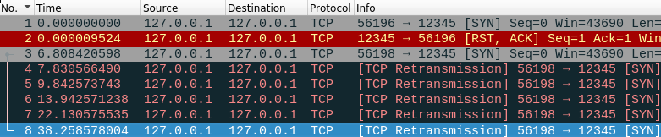

Attempted connection to a closed port with and without firewall rule to drop pkts.

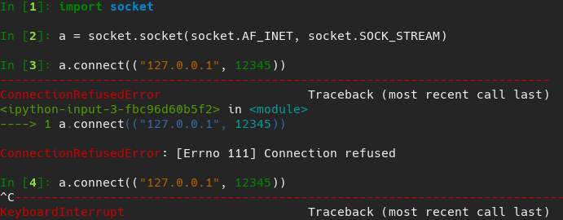

The code used to produce firewall pkt dropping example in figure 7

[firewall_code]

Having explained firewalls, how they affect port scanning and other things above I will now explain what I am actually trying to achieve with my project and how I am going to do it. I am trying to make a tool similar to nmap which will be able to detect the state (as in whether the port is open/closed or filtered etc) of ports on remote machines, detect which hosts are up on a subnet and finally I want to be able to try to detect what services are listening behind any of the ports. I am going to be writing in Python version 3.7.2 as it is the latest stable release of Python 3 and has many features which are not in even fairly recent versions such as 3.5, the biggest one of these being fstrings which are where I can put a single a ‘f’ before a string and then any formatting options I put inside using curly braces are expanded and formatted accordingly. This allows for a clear and consistent string formatting syntax which I will use extensively. I will be using Python in particular as a language because it is very readable and has extensive low level bindings to C networking functions with the socket module allowing me to write code quickly which is easily understandable and has a clear purpose and at the same time be able to use low level networking functions and even changing the behaviour at this low level with socket.setsockopt. As well as this the socket module allows me to open sockets that communicate using many different protocols such as tcp, udp and icmp just to name a few. These features combine to make Python a great language for writing networking software with a high level of abstraction. In regards to the OSI model my code will sit with the user interface at level 7 specifying what to do at a high level then the actual scanning takes place at levels 3, 4 and 5 with host detection being at level 3. Port scanning will be taking place At level 4 for tcp SYN scanning and udp scanning. Whereas connect() scanning and version detection will sit at level 5. Finally I will look at what is actually handling all of the networking on my machine. My machine runs Linux and as such all networking is handled by system calls to the Linux kernel. For example the socket.connect method is just a call to the underlying Linux kernel’s connect syscall but presenting a kinder call signature to the user as the Python socket library does some processing before the syscall is made.

## Success Criteria

1. Probe another computer’s networking from a bbox perspective. [blackbox]
2. To help the user with usage/help messages when prompted. [usage]
3. Translate cidr specified subnets into a list of domains. [cidr]
4. Send icmp ECHO requests to determine whether a machine is active or not. [ping]
5. Perform any scan type without first checking whether the host is up. [nocheck]
6. Detect whether a TCP port is open (can be connected to). [tcpopen]
7. Detect whether a TCP port is closed (will refuse connections). [tcpclosed]
8. Detect whether a TCP port is filtered (a firewall is preventing or monitoring access). [tcpfiltered]
9. Detect whether a UDP port is open (can be connected to). [udpopen]
10. Detect whether a UDP port is closed (will refuse connections). [udpclosed]
11. Detect whether a UDP port is filtered (a firewall is preventing or monitoring access). [udpfiltered]
12. Detect the operating system of another machine on the network solely from sending packets to the machine and interpreting the responses. [osdetect]
13. Detect what service is listening behind a port. [servicedetect]
14. Detect the version of the service running behind a port. [versiondetect]

## Description of current system or existing solutions

Nmap is currently the most popular tool for doing port scanning and host enumeration. It supports the scanning types for determining information about remote hosts.

* tcp: SYN
* tcp: Connect()
* tcp: ACK
* tcp: Window
* tcp: Maimon
* tcp: Null
* tcp: FIN
* tcp: Xmas
* udp
* Zombie host/idle
* sctp: INIT
* sctp: COOKIE-ECHO
* IP protocol scan
* ftp: bounce scan

As well as supporting a vast array of scanning types it also can do service version detection and operating system detection via custom probes. Nmap also has script scanning which allows the user to write a script specifying exactly how they want to scan e.g. to circumvent port
knocking (where pkts must be sent to a sequence of ports in order before access to the finalportis allowed). It also supports a plethora of options to avoid firewalls or ids such as sending pkts with spoofed csums/source addresses and sending decoy probes. Nmap can do many more things than I have listed above as is illustrated quite clearly by the fact there is an entire working on using nmap (<https://nmap.org/book/>). The following is an example nmap scan which I did on my home network: nmap -sC -sV -oA networkscan 192.168.1.0/24. Breaking it down this means to enable script scanning -sc, enable version detection -sV and then output all results in all the common formats: XML, nmap and greppable, using the base name networkscan which produces three files: networkscan.(nmap,gnmap,xml). Before I go into what each file contains I will explain some terminology, greppable is anything which can be easily searched with the Linux grep which stands for Globally search a Regular Expression and Print, which basically means look in files for lines that contain a certain word or pattern, for example finding all lines with the word “hi” in them in the file “document” grep hi document. Onto the files: networkscan.nmap contains what would usually be printed by nmap while the scan is being run, it looks like this:

# Nmap 7.70 scan initiated Wed Apr 10 19:36:18 2019 as:  
 nmap -sC -sV -oA /home/tritoke/thing 192.168.1.0/24  
Nmap scan report for router.asus.com (192.168.1.1)  
Host is up (1.0s latency).  
Not shown: 995 closed ports  
PORT STATE SERVICE VERSION  
53/tcp open domain (generic dns response: NOTIMP)  
| fingerprint-strings:   
| DNSVersionBindReqTCP:   
| version  
|_ bind  
80/tcp open http ASUS WRT http admin  
|_http-server-header: httpd/2.0  
|_http-title: Site doesn't have a title (text/html).  
515/tcp open printer  
8443/tcp open ssl/http ASUS WRT http admin  
|_http-server-header: httpd/2.0  
|_http-title: Site doesn't have a title (text/html).  
| ssl-cert: Subject: commonName=192.168.1.1/countryName=US  
| Not valid before: 2018-05-05T05:05:17  
|_Not valid after: 2028-05-05T05:05:17  
9100/tcp open jetdirect?  
1 service unrecognized despite returning data.  
 If you know the service/version,  
please submit the following fingerprint at  
https://nmap.org/cgi-bin/submit.cgi?new-service :  
SF-Port53-TCP:V=7.70%I=7%D=4/10%Time=5CAE3DC5%P=x86_64-pc-Linux  
-gnu%r(DNSVSF:ersionBindReqTCP,20,"\0\x1e\0\x06\x85\x85\0\x01\0   
\0\0\0\0\0\x07version\SF:x04bind\0\0\x10\0\x03")%r(DNSStatusReq  
uestTCP,E,"\0\x0c\0\0\x90\x04\0\0SF:\0\0\0\0\0\0");  
Service Info: CPE: cpe:/o:asus:wrt_firmware

Above is just the report for one such device in the report as the full thing is over 200 lines lone. In it you can see information such as which ports are open and what services are running behind them as this is my router you can see port 8443 which nmap has recognised to be hosting the ASUS web admin from which you can configure the route. Then after than some other associated information extracted from the server. Most of this extra information is from the -sC flag which is script scanning and allows advanced interaction with running services specifically to gain more information by providing specialised probing per protocol. We can also see at the end an unrecognised service which nmap shows us the data it returned and asks us to submit a new service report at a given URL if we recognise the service. This system of submitting fingerprints of services is how nmap is so good at recognising services: it has a lot of data to look at and learn from in regards to service fingerprinting.

Next networkscan.gnmap:

# Nmap 7.70 scan initiated Wed Apr 10 19:36:18 2019 as:  
 nmap -sC -sV -oA /home/tritoke/networkscan 192.168.1.0/24  
Host: 192.168.1.1 (router.asus.com) Status:  
Host: 192.168.1.1 (router.asus.com) Ports: 53/open/tcp//domain//  
 (generic dns response: NOTIMP)/, 80/open/tcp//http//ASUS  
 WRT http admin/,515/open/tcp//printer///,  
 8443/open/tcp//ssl| http//ASUS WRT http  
 admin/,9100/open/tcp//jetdirect?///  
 Ignored State: closed (995)  
Host: 192.168.1.8 (android-25a97e36c2e74456) Status: Up  
Host: 192.168.1.8 (android-25a97e36c2e74456) Ports: 5060/  
 filtered/tcp//sip/// Ignored State: closed (999)

Again this is not all of the file as it is very large. As you can see above all of the information is on a single line for each type of scan, this is useful if you want to scan a large number of hosts and just want to know which hosts are up you can do grep 'Status: Up' networkscan.gnmap which outputs this:

$ grep 'Status: Up' networkscan.gnmap  
Host: 192.168.1.1 (router.asus.com) Status: Up  
Host: 192.168.1.8 (android-25a97e36c2e74456) Status: Up  
Host: 192.168.1.10 (diskstation) Status: Up  
Host: 192.168.1.88 () Status: Up  
Host: 192.168.1.88 () Status: Up  
Host: 192.168.1.117 () Status: Up  
Host: 192.168.1.159 (groot) Status: Up  
Host: 192.168.1.159 (groot) Status: Up  
Host: 192.168.1.176 (ET0021B7C01F2E) Status: Up

Showing you clearly the hosts which are online and then their host names. Other ways to use this output format would be to find out which ports are open on only one machine, or which hosts have a webserver running on them or a vulnerable version of a mail server etc. In general it is useful for when you want to filter results.

Finally we have xml format:

<?xml version="1.0" encoding="UTF-8"?>  
<!DOCTYPE nmaprun>  
<?xml-stylesheet href="file:///usr/bin/../share/nmap/nmap.xsl" type="text/xsl"?>  
<!-- Nmap 7.70 scan initiated Wed Apr 10 19:36:18 2019 as: nmap -sC -sV -oA /home/tritoke/thing 192.168.1.0/24 -->  
<nmaprun scanner="nmap" args="nmap -sC -sV -oA /home/tritoke/thing 192.168.1.0/24" start="1554921378" startstr="Wed Apr 10 19:36:18 2019" version="7.70" xmloutputversion="1.04">  
<verbose level="0"/>  
<debugging level="0"/>  
<host starttime="1554921379" endtime="1554923187"><status state="up" reason="syn-ack" reason_ttl="0"/>  
<address addr="192.168.1.1" addrtype="ipv4"/>  
<hostnames>  
<hostname name="router.asus.com" type="PTR"/>  
</hostnames>  
<ports><extraports state="closed" count="995">  
<extrareasons reason="conn-refused" count="995"/>  
</extraports>  
<port protocol="tcp" portid="53"><state state="open" reason="syn-ack" reason_ttl="0"/><service name="domain" extrainfo="generic dns response: NOTIMP" servicefp="SF-Port53-TCP:V=7.70%I=7%D=4/10%Time=5CAE3DC5%P=x86_64  
-pc-Linux-gnu%r(DNSVersionBindReqTCP,20,&quot;\0\x1e\0\x06\x85\x85\0  
\x01\0\0\0\0\0\0\x07version\x04bind\0\0\x10\0\x03&quot;)%r  
(DNSStatusRequestTCP,E,&quot;\0\x0c\0\0\x90\x04\0\0\0\0\0\0\0\0&quot;);" method="probed" conf="10"/><script id="fingerprint-strings" output="&#xa; DNSVersionBindReqTCP: &#xa; version&#xa; bind"><elem key="DNSVersionBindReqTCP">&#xa; version&#xa; bind</elem>  
</script></port>

It is verbose in the extreme contains the reason why each port has the state it does as well as a vast amount of other data that the other scans didn’t include as well as this it is not very human readable meaning that this format is more likely available because it is easier for other programs to parse than the other formats. As well as this the verbosity can be good if you really need to dive into why a port was marked as closed etc or the exact bytes that a service replied with.

In terms of where nmap lives in the software stack is that it is an application at level 7 when the user interacts with it but it uses several libraries which interact at level 2 which it uses to get the raw headers of the packets being sent and thus gain information from them. Nmap has virtually no competitors other than possibly Angry IP Scanner which is another open source network scanner expect it has a much smaller user base.

Before I go into diagrams I will explain some terminology I have used: “parse the arguments” means to taking the string of text that the user enters after the program name i.e. program <text> it is these texts that represent the arguments, parsing the arguments means turning those strings into useful information that the program can use, for example my program will allow people to enter port number they want to scan and I want them to be able to do this by specifying a range of ports as in 10-20 which would mean ports 10, 11,…, 20, thus an example of parsing would be turning 10-20 into a list of numbers from 10 to 20.“probes” refer to the actual packets being sent to the server, I will refer to anything sent from my code to another machine as being a “probe”. “hosts”, hosts refer to other machines on the network which we are scanning.

## Prospective Users

The prospective users of this system would be system administrators, penetration testers or network engineers. In my case my prospective users would be my school’s system administrators and it would allow them to see an outsiders perspective on for example the server running the school’s website page or to see if any of the programs on the servers were leaking information through banners etc. (most services send a banner with information like what protocol version they use and other information). Banners are short strings of text which a service or program will send to identify itself when it receives a new connection. They often contain information such as protocol version etc, which allows the connecting client to know how to communicate with the service. However, they can also reveal too much information such as the version number of the service running, if the service version is old then it is likely that bugs will have been found in the program since then this information could allow an attacker to gain access to the server by exploiting the vulnerability in that service. This can obviously be prevented by keeping services up to date, however, that is not always possible so as a best practice banners should reveal the minimum amount of information possible such that the client can interact with the service.

I plan to use my schools system administrators as a user in order to gain some feedback.

## Data Dictionary

While my program is running it will need to store many different things in memory:

* The list of hosts to scan
* The list of ports to scan on each host
* The state of each port we are scanning on each host
* The packet received by the listening socket (temporarily before processing)
* Various counters and positional indicators are almost inevitable
* The probes to be used for version detection

I am going to try to estimate the amount of RAM my program will use based on scanning a cidr specified subnet of 192.168.1.0/24, and the most common ports 1000 ports of each machine I will not consider version detection as I am unsure of how I will implement it currently. To measure the size of object in python we can use the getsizeof function provided by the sys module, I also have a file called ‘hosts’ which contains the addresses specified by 192.168.1.0/24 and a file ‘ping_bytes’ which contains 4 captured packets from the ping command which I captured during an early exploratory testing phase.

>>> with open("hosts", "r") as f:  
... hosts = f.read().splitlines()  
...   
>>> import sys  
>>> sys.getsizeof(hosts)  
2216  
>>> ports = list(range(1000))  
>>> sys.getsizeof(ports)  
9112  
>>> len(hosts)*sys.getsizeof(ports) / 2**10 # 2*10 is one kibibyte  
2278.0  
>>> sys.getsizeof(True)  
28  
>>> len(hosts)*(sys.getsizeof(True)) / 2**10  
7.0  
>>> pings[0]  
'45 00 00 54 0f 82 40 00 40 01 2d 25 7f 00 00 01 7f 00 00 01 08 00 41 c5 02 4f 00 01 cd ef 0f 5c de 9b 0d 00 08 09 0a 0b 0c 0d 0e 0f 10 11 12 13 14 15 16 17 18 19 1a 1b 1c 1d 1e 1f 20 21 22 23 24 25 26 27 28 29 2a 2b 2c 2d 2e 2f 30 31 32 33 34 35 36 37'  
>>> from binascii import unhexlify  
>>> ping = unhexlify(pings[0].replace(" ", "")) # turn the string of numbers into a bytes object  
>>> sys.getsizeof(ping)  
117  
>>> len(hosts)*sys.getsizeof(ping) / 2**10  
29.25  
>>> 2278.0 + 7.0 + 29.25 + 2.22  
2316.47

As shown in Listing [testingsize] we can see that by far the most space intensive item stored by our program will be the port numbers for each host, making up just less that ninety six percent of the total space used by the mock data I created. However, overall 2.3 mebibytes is not a huge amount of data by any means.

|  |  |  |  |
| --- | --- | --- | --- |
| Holding | Data type | Space used /Kib | Percentage of total |
| ports | List[int] | 2278 | 98.34 |
| hosts | List[str] | 2.22 | 0.1 |
| port state | List[bool] | 7 | 0.3 |
| packets | List[bytes] | 29.25 | 1.26 |

## Data Flow Diagram

In my application there will be three way information flow:

1. Sending packets out from my application
2. Receiving packets back from the targets
3. Transferring data between functions

My program will only hold information in memory and provides no utility for saving the information from scans, this is because on the target systems (Linux/unix based machines) the shell which is used to run commands has a very simple and ubiquitous way to placing output in files by use of unix “pipes” which are how unix based operating systems how interprocess communications. An example for saving nmap output would be nmap 192.168.1.0 > outputfile.nmap, thus removing any need for reimplementing an existing utility.

## Description of Solution Details

I will be using Python version 3.7.2 for my project because I am already familiar with Python’s syntax and its socket library has a very nice high level api for making system calls to the kernel’s low level networking functions. This makes it very nice for a networking project like mine as it allows me to easily prototype and explore many ideas about how I could implement my solution without wasting vast amounts of time.

The first point of the success criteria that I wanted to get a feel for was receiving and sending icmp ECHO requests aka pings. icmp as a protocol sits at layer 3 of the osi this means it is a layer below what you are normally give access to in the socket module. This means instead of getting a bytes object with just the data from the header you instead get a bytes object which contains the entire packet and you have to dissect it yourself to get the information out of it, this can be quite difficult if it weren’t for the struct module. The struct module provides a convenient API for converting between packed values i.e. packets in network endianness to unpacked values i.e. a double representing the current time in local endianness. Interactions with the socket module are mainly through the pack and unpack functions. For each of these functions you provide a format specifier defining how to unpack/pack the bytes/values. In Listing [echosend] you can see an example of me using the struct.pack function to pack the values which comprise an icmp ECHO REQUEST into a packet and sending it the localhost address (127.0.0.1). This program is effectively the complement to the program listed in listing [echorecv] which uses struct.unpack to unpack value from the received icmp packet before printing the fields out to the terminal. Listing [echosend] makes use of the IP checksum function which I wrote. In figure 8 you can see the output when I run the command ping 127.0.0.1 which the code in figure[echorecv] is listening for packets.

#!/usr/bin/python3.7  
import socket  
import struct  
import os  
import time  
import array  
  
from os import getcwd, getpid  
import sys  
sys.path.append("../modules/")  
  
import ip_utils  
  
  
ICMP_ECHO_REQUEST = 8  
  
# opens a raw socket for the ICMP protocol  
ping_sock = socket.socket(socket.AF_INET, socket.SOCK_RAW, socket.IPPROTO_ICMP)  
# allows manual IP header creation  
# ping_sock.setsockopt(socket.SOL_IP, socket.IP_HDRINCL, 1)  
  
ID = os.getpid() & 0xFFFF  
  
# the two zeros are the code and the dummy checksum, the one is the sequence number  
dummy_header = struct.pack("bbHHh", ICMP_ECHO_REQUEST, 0, 0, ID, 1)  
  
data = struct.pack("d", time.time()) + bytes((192 - struct.calcsize("d")) * "A", "ascii")  
  
checksum = ip_utils.ip_checksum(dummy_header+data)  
  
header = struct.pack("bbHHh", ICMP_ECHO_REQUEST, 0, checksum, ID, 1)  
  
packet = header + data  
  
ping_sock.sendto(packet, ("127.0.0.1", 1))

#!/usr/bin/python3.7  
  
import socket  
import struct  
import time  
from typing import List  
  
# socket object using an IPV4 address, using only raw socket access, set ICMP protocol   
ping_sock = socket.socket(socket.AF_INET, socket.SOCK_RAW, socket.IPPROTO_ICMP)  
  
packets: List[bytes] = []  
  
while len(packets) < 1:  
 recPacket, addr = ping_sock.recvfrom(1024)  
 ip_header = recPacket[:20]  
 icmp_header = recPacket[20:28]  
  
 ip_hp_ip_v, ip_dscp_ip_ecn, ip_len, ip_id, ip_flgs_ip_off, ip_ttl, ip_p, ip_sum, ip_src, ip_dst = struct.unpack('!BBHHHBBHII', ip_header)  
  
 hl_v = f"{ip_hp_ip_v:08b}"  
 ip_v = int(hl_v[:4], 2)  
 ip_hl = int(hl_v[4:], 2)  
 dscp_ecn = f"{ip_dscp_ip_ecn:08b}"  
 ip_dscp = int(dscp_ecn[:6], 2)  
 ip_ecn = int(dscp_ecn[6:], 2)  
 flgs_off = f"{ip_flgs_ip_off:016b}"  
 ip_flgs = int(flgs_off[:3],2)  
 ip_off = int(flgs_off[3:], 2)  
 src_addr = socket.inet_ntoa(struct.pack('!I', ip_src))  
 dst_addr = socket.inet_ntoa(struct.pack('!I', ip_dst))  
  
 print("IP header:")  
 print(f"Version: [{ip_v}]\nInternet Header Length: [{ip_hl}]\nDifferentiated Services Point Code: [{ip_dscp}]\nExplicit Congestion Notification: [{ip_ecn}]\nTotal Length: [{ip_len}]\nIdentification: [{ip_id:04x}]\nFlags: [{ip_flgs:03b}]\nFragment Offset: [{ip_off}]\nTime To Live: [{ip_ttl}]\nProtocol: [{ip_p}]\nHeader Checksum: [{ip_sum:04x}]\nSource Address: [{src_addr}]\nDestination Address: [{dst_addr}]\n")  
  
 msg_type, code, checksum, p_id, sequence = struct.unpack('!bbHHh', icmp_header)  
 print("ICMP header:")  
 print(f"Type: [{msg_type}]\nCode: [{code}]\nChecksum: [{checksum:04x}]\nProcess ID: [{p_id:04x}]\nSequence: [{sequence}]"  
 packets.append(recPacket)  
open("current_packet", "w").write("\n".join(" ".join(map(lambda x: "{x:02x}", map(int, i))) for i in packets))

def ip_checksum(packet: bytes) -> int:  
 """  
 ip_checksum function takes in a packet  
 and returns the checksum.  
 """  
 if len(packet) % 2 == 1:  
 # if the length of the packet is odd, add a NULL byte  
 # to the end as padding to make it even in length  
 packet += b"\0"  
  
 total = 0  
 for first, second in (  
 packet[i:i+2]  
 for i in range(0, len(packet), 2)  
 ):  
 total += (first << 8) + second  
  
 # calculate the number of times a  
 # carry bit was added and add it back on  
 carried = (total - (total & 0xFFFF)) >> 16  
 total &= 0xFFFF  
 total += carried  
  
 if total > 0xFFFF:  
 # adding the carries generated a carry  
 total &= 0xFFFF  
 total += 1  
  
 # invert the checksum and take the last 16 bits  
 return (~total & 0xFFFF)

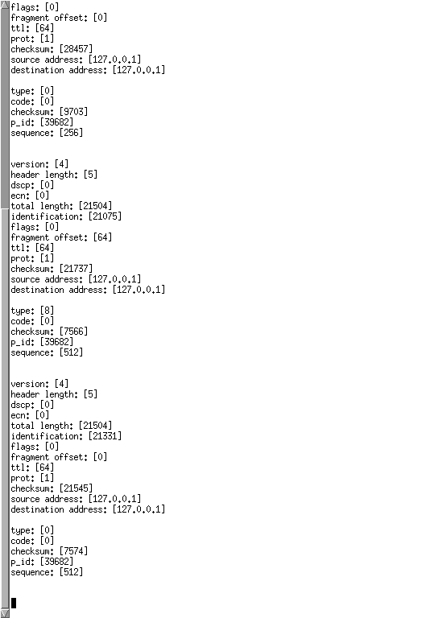

Dissecting an icmp ECHO REQUEST packet.

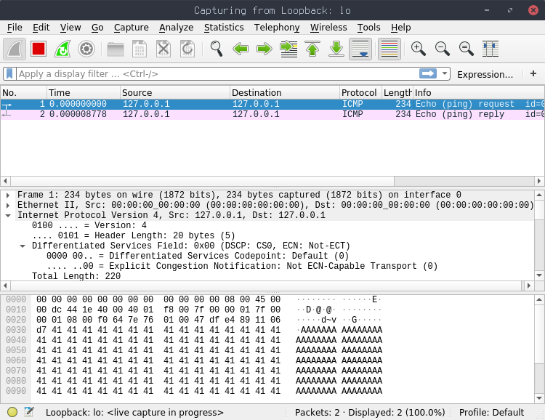

Screenshot of wireshark showing a successful send of an icmp ECHO REQUEST packet.

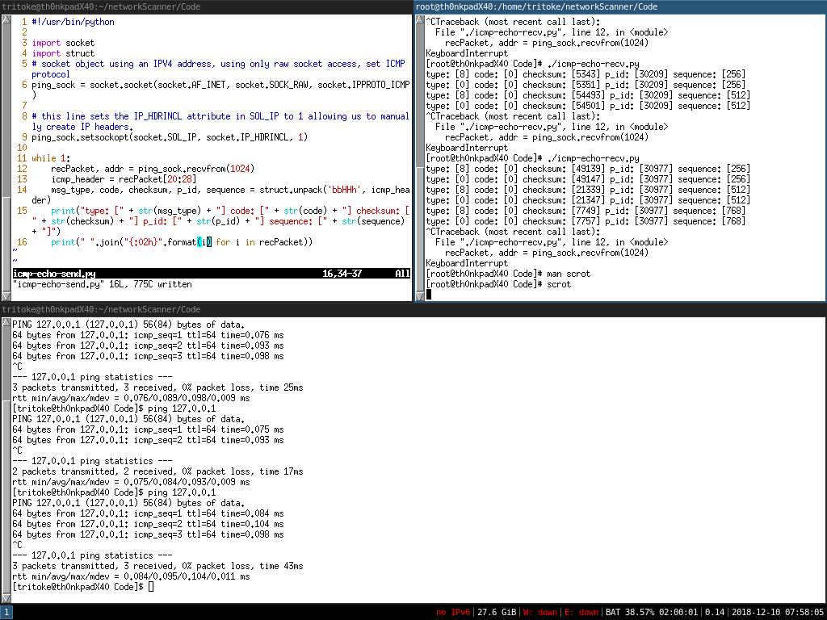

Screenshot showing me first successfully dissecting an icmp ECHO REQUEST packet.

Having done these prototypes I have identified that it would probably be best to abstract the code for dissecting all the headers i.e. icmp, tcp and ip into classes where I can just pass the received packet into the class and have it dissect it for me and then I will also get access to some of the benefits of classes such as the __repr__ method which is called when you print classes out and allows me to control what is printed out. Before I started to write the final piece I wanted to make a prototype ping scanner, as this would allow me to get a feel for making a scanner as well as further exploring low level protocol interactions.

#!/usr/bin/python3.7  
from os import getcwd, getpid  
import sys  
sys.path.append("../modules/")  
  
import ip_utils  
  
import socket  
from functools import partial  
from itertools import repeat  
from multiprocessing import Pool  
from contextlib import closing  
from math import log10, floor  
from typing import List, Tuple  
import struct  
import time  
  
  
def round_significant_figures(x: float, n: int) -> float:  
 """  
 rounds x to n significant figures.  
 round_significant_figures(1234, 2) = 1200.0  
 """  
 return round(x, n-(1+int(floor(log10(abs(x))))))  
  
  
def recieved_ping_from_addresses(ID: int, timeout: float) -> List[Tuple[str, float, int]]:  
 """  
 Takes in a process id and a timeout and returns the list of addresses which sent  
 ICMP ECHO REPLY packets with the packed id matching ID in the time given by timeout.  
 """  
 ping_sock = socket.socket(socket.AF_INET, socket.SOCK_RAW, socket.IPPROTO_ICMP)  
 time_remaining = timeout  
 addresses = []  
 while True:  
 time_waiting = ip_utils.wait_for_socket(ping_sock, time_remaining)  
 if time_waiting == -1:  
 break  
 time_recieved = time.time()  
 recPacket, addr = ping_sock.recvfrom(1024)  
 ip_header = recPacket[:20]  
 ip_hp_ip_v, ip_dscp_ip_ecn, ip_len, ip_id, ip_flgs_ip_off, ip_ttl, ip_p, ip_sum, ip_src, ip_dst = struct.unpack('!BBHHHBBHII', ip_header)  
 icmp_header = recPacket[20:28]  
 msg_type, code, checksum, p_id, sequence = struct.unpack('bbHHh', icmp_header)  
 time_remaining -= time_waiting  
 time_sent = struct.unpack("d", recPacket[28:28+struct.calcsize("d")])[0]  
 time_taken = time_recieved - time_sent  
 if p_id == ID:  
 addresses.append((str(addr[0]), float(time_taken), int(ip_ttl)))  
 elif time_remaining <= 0:  
 break  
 else:  
 continue  
 return addresses  
  
  
with closing(socket.socket(socket.AF_INET, socket.SOCK_RAW, socket.IPPROTO_ICMP)) as ping_sock:  
 addresses = ip_utils.ip_range("192.168.1.0/24")  
 local_ip = ip_utils.get_local_ip()  
 if addresses is not None:  
 addresses_to_scan = filter(lambda x: x!=local_ip, addresses)  
 else:  
 print("error with ip range specification")  
 exit()  
 p = Pool(1)  
 ID = getpid()&0xFFFF  
 replied = p.apply_async(recieved_ping_from_addresses, (ID, 2))  
 for address in zip(addresses_to_scan, repeat(1)):  
 try:  
 packet = ip_utils.make_icmp_packet(ID)  
 ping_sock.sendto(packet, address)  
 except PermissionError:  
 pass  
 p.close()  
 p.join()  
 hosts_up = replied.get()  
 print("\n".join(map(lambda x: f"host: [{x[0]}]\tresponded to an ICMP ECHO REQUEST in {round_significant_figures(x[1], 2):<10} seconds, ttl: [{x[2]}]", hosts_up)))

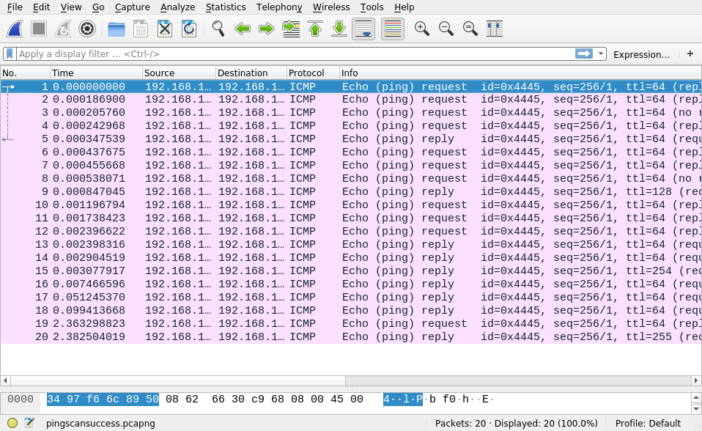

Screenshot of wireshark showing a successful ping scan.

$ sudo ./ping_scan.py  
host: [192.168.1.1] responded to an ICMP ECHO REQUEST in 0.00037 seconds, ttl: [64]  
host: [192.168.1.35] responded to an ICMP ECHO REQUEST in 0.00042 seconds, ttl: [128]  
host: [192.168.1.37] responded to an ICMP ECHO REQUEST in 0.002 seconds, ttl: [64]  
host: [192.168.1.117] responded to an ICMP ECHO REQUEST in 0.0017 seconds, ttl: [64]  
host: [192.168.1.176] responded to an ICMP ECHO REQUEST in 0.0014 seconds, ttl: [254]  
host: [192.168.1.14] responded to an ICMP ECHO REQUEST in 0.0072 seconds, ttl: [64]  
host: [192.168.1.246] responded to an ICMP ECHO REQUEST in 0.049 seconds, ttl: [64]  
host: [192.168.1.8] responded to an ICMP ECHO REQUEST in 0.099 seconds, ttl: [64]

Now that I have done these prototypes I am fairly certain about how I will structure the rest of my scanners, how to interact with Python’s socket programming interface and how I can use the struct module to make and dissect packets. My general plan for the scanners will be to start a process that listens for responses for a set amount of time and then start sending the packets in a different process before waiting for the listening process to get all the responses back and collecting the results from that process.

## Acceptable Limitations

Originally I had planned to include dedicated operating system detection as an option however, I ran out of time having implemented version detection. However, it still does Operating system detection partially as some services are Linux only and while doing service and version detection especially the cpe parts of the matched service/version will contain operating system information, such as microsoft ActiveSync would indicate that the system being scanned was a windows system which is reflected in the match directive and attached CPE information:

match activesync m|^.\0\x01\0[^\0]\0[^\0]\0[^\0]\0[^\0]\0[^\0]\0.  
*\0\0\0$|s p/Microsoft ActiveSync/ o/Windows/ cpe:/a:microsoft:ac  
tivesync/ cpe:/o:microsoft:windows/a

## Test Strategy

I am going to use two different methods to test my program:

1. Unit testing
2. Wireshark

I am using two separate testing strategies because they are both good at different things, both of which I need to show that my project works. First, I am using unit testing to test some general purpose functions which are pure functions (are independent of the current state of the machine) such as ip_range() and other functions which I can just check the returned value against what it should be.

Wireshark is useful for the other half of the program which uses impure functions and the low level networking e.g. make_tcp_packet(). Wireshark makes this easy by allowing capture of all the pkts going over the wire, as well as this it has a vast array of pkt decoders (2231 in my install) which it can use to dissect almost any pkt that would be on the network. The main benefit of wireshark is that I can see my scanners sending pkts and then check whether the parsers that I have written for the different protocols are working. I can also check that the csums in each of the various protocols is valid as wireshark does csum verification for various protocols.

I will be running these tests on my laptop which is a thinkpad T480 running arch Linux with kernel version 5.0.7. I am using wireshark version 3.1.0, Python version 3.7.2 and pytest version 4.3.1. I am also using pyenv version 1.2.9 to manage the version of python in my python environment. I am using no modules outside of the python standard library so that my program is as portable as possible and its functionality is as reproducible as possible.

To do the unit testing side of my testing you will need python 3.7.2 and pytest 4.3.1 to run the tests you will need to run python -m pytest inside the Code directory, this will call pytest and then it will find the tests inside the tests directory and run them, it will then display the number of tests that passed along with lots of information on the tests that failed such as what the arguments were etc…Pytest does this via introspection of the comparison and assert commands, this means that it uses its own versions of those commands which allow it to get more information out about what went wrong. Such as which element in a list was the one that caused the comparison to return false etc.

The wireshark side of the testing you will need a version of wireshark and iptables. You will then need to set up wireshark in listen mode on the right interface so that it captures the packets that my program is sending, from there you can inspect the sent packets and determine whether they fit what was expected in the test description or whether they don’t match at all. For filtered packet tests you will need to run the command iptables -I INPUT -s 127.0.0.1 -j DROP and scan the localhost address and after the test you need to run the command iptables -F to flush all the iptables rules to prevent any confusion in future caused by an firewall rule that shouldn’t be there.

# Design

## Overall System Design (High Level Overview)

There are two types of scanning implemented for different scan types in my program.

* Connect()
* Version
* Listener / Sender

Connect() scanning is the simplest in that it takes in a list of ports and simply calls the socket.connect() method on it and sees whether it can connect or not and the ports are marked accordingly as open or closed.

Version scanning is very similar to Connect() scanning in that it takes in a list of ports and connects to them, except it then sends a probe to the target to elicit a response and gain some information about the service running behind the port.

Listener / sender scanning does exactly what it says on the tin: it sets up a “listener” in another process to listen for responses from the host which the “sender” is sending pkts to. It can then differentiate between open, open|filtered, filtered and closed ports based on whether it receives a pkt back and what flags (part oftcp pkts are a one byte long section which store “flags” where each bit in the byte represents a different flag) are set in the received pkt.

## Design of User Interfaces HCI

I am designing my system to have a similar interface to the most common tool currently used: nmap. This is because I believe that having a familiar interface will not only make it easier for someone who is familiar with nmap to use my tool it also makes it so that anything learnt using either tool is applicable to both which benefits everyone.

Based on this perception I plan to use the same option flags as nmap as well as similar help messages and an almost identical call signature (how the program is used on the command line).  
Running ./netscan.py <options> <target specification should be almost identical to nmap <options> <target specification> in terms of which scan types will be run, which hosts will be scanned and which ports are scanned. Below you can see a concept help message for my program with all the arguments I plan to implement.

usage: netscan.py <options> <target specification>  
  
required arguments: target specification  
  
optional arguments: -h, --help -Pn, -sL, -sn, -sS,  
 -sT, -sU, -sV, -p, --ports,  
 --exclude_ports

It shows clearly which are required arguments and which are optional ones. It also shows that some some arguments to be called with either a short format e.g. -p and with a more verbose format --ports this allows the user to be clearer if they are using the tool as part of an automated script to perform scanning as it should be more clearer what the more verbose flags do. If the user enters erroneous data they should be greeted by a ValueError which will explain exactly what the issue was with their input and will print out the argument that caused the error.

## System Algorithms

## Input data Validation

I plan to perform data validation in all of the functions in the fundamental modules which will hold the basic functionality for my project e.g. scanning functions etc…. This is because my project will revolve heavily around these functions and they will need to be as error free as possible. Adding input validation to these core functions will enable me to find errors in my code earlier for example passing a function a list of string instead of just a string might work in some cases but the function will have a completely different result and these types of programming errors can be quite hard to debug as they might not generate errors too often but will still break the application. Although it helps when programming it will mainly be there to guide the user by showing them where in their arguments the problem is which is far more useful than some program which simply exit with no extra information, just error occurred.

An example for a Python ValueError could be trying to turn the string "I love beans" into an integer. This will result in the following error message: ValueError: invalid literal for int() with base 10: 'I love beans' This informs you that you have tried to turn "I love beans" into an integer with base 10 and it is invalid which is clear and helpful error message because it tells you what you tried to do that went wrong and it tells you what you argument was the one which caused the error.

## Algorithm for complex structures

[ip_range]

# Technical Solution

I have placed all of my code in Appendix 6. I will be going through each of the items in this appendix and explaining what they do.

Appendix 6.1 contains all the code which I wrote while in an early experimentation phase where I was testing out how I was planning to make and structure the project.

Appendix 6.2 contains all the code which I wrote while writing my initial prototype of my ping scanner which uses icmp ECHO REQUEST messages to detect hosts which are online on a given subnet. It is used to meet success criteria [ping].

Appendix 6.3 contains all the code which I wrote while writing a tool which can translate a cidr specified subnet into the list of ip addresses for that subnet, it has logic to exclude the broadcast address and host addresses for each subnet. This is used to meet success criteria [cidr].

Appendix 6.4 contains all of the prototypes for tcp based scanning which are contained in the sub Appendices 6.4.1 and 6.4.2. Appendix 6.4.1 contains all of the code which I created whilst prototyping connect scanning. It satisfies success criteria [tcpopen] and [tcpclosed]. Appendix 6.4.2 contains all of the code I wrote while prototyping tcp SYN scanning. It satisfies success criteria [tcpopen], [tcpclosed] and [tcpfiltered].

Appendix 6.5 contains all of the code I wrote while prototyping udp scanning. It satisfies success criteria [udpopen], [udpclosed] and [udpfiltered].

Appendix 6.6 contains all of the code I wrote while prototyping version detection scanning. It satisfies success criteria [servicedetect] and [versiondetect].

Appendix 6.7 contains all of the modules I wrote to help me make me with creating my main application which I will come on to later. These modules mainly contain code which I reuse often such as code to calculate an ip checksum or validate an ipaddr.

Appendix 6.8 contains a script I wrote which will run each of the prototype applications I made. This doesn’t satisfy any of the success criteria but was very useful for solving issues I had with importing python modules where due to the directory structure everything as to do started from the root of the directory structure otherwise everything goes a bit mad, and this was my solution for running everything at the root of the directory structure as this sits at the root and can call the main() function defined in each of the modules along with also being able to import all of the modules in the modules directory.

Appendix 6.9 contains the code for my final application which satisfies all of the success criteria bar [osdetect] which is partially completed via version detect scanning.

Appendix 6.10 contains all of the for my unit tests which I run using python -m pytest and it automatically goes and runs each function and can give me verbose information on each one. I have named all of the test functions in a very verbose way and I only test one thing in each function. This means that it is much easier for me to read from the name of a failed test exactly what went wrong with what function and what argument caused it. An example of this can be seen in figure 12 where I have changed on of the tests so that it fails. You can see in that it shows me a clear difference between what was expected on one side of the assertion statement and then what actually happened on the other side. In this case it shows that in the left set there is an extra element of 192.168.1.1 and in the right an extra element of 192.168.1.0, this is very helpful for preventing regressions in the code where I would write feature and accidentally break another piece of functionality.

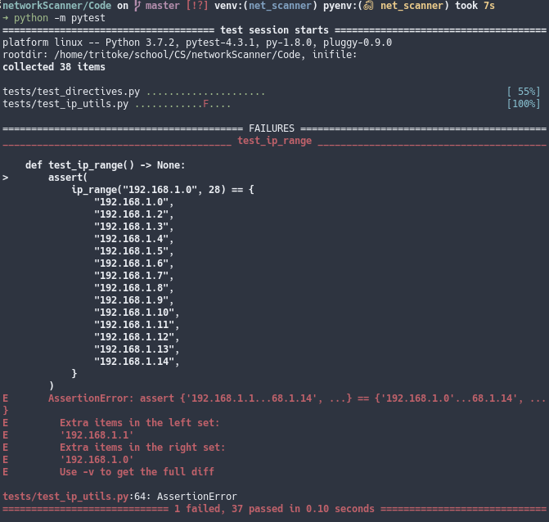

A screenshot of running pytest with a deliberately broken test.

# Testing

## Test Plan

I will be testing my application using a combination of unit tests and wireshark where applicable. Unit tests are more suitable to doing tests on specific functions to make sure that regressions don’t occur while developing the application. A regression is a when a feature or change that was implemented into the program is by accident and would cause the application to break. Wireshark I will use to show the scanning portion of my code and where external connections are made/custom packets created. The following are the tests using wireshark, the unit tests are in Appendix 6.10.

## Testing Evidence

### Printing a usage message when run without parameters

To show this I will run my program passing it no parameters. This should print out a message of the form: USAGE: ./<program> <required> <parameters> where everything in angle brackets should be replaced by what is necessary for my program. In figure 13 you can see me run ./netscan.py with no parameters and it prints out the required usage message telling me that I am missing the target_spec parameter, this shows that it passed this test. This shows success criteria [usage].

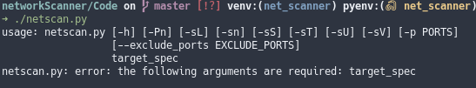

Screenshot showing my program being run without parameters.

### Printing a help message when passed -h

To show this I will run my program with the -h flag. This should print out a message showing each of the options as well as what each of them do. It should also print out whether they are positional arguments or optional arguments and if an argument can have two forms then it should print out both forms of the flag, i.e. -p --ports. In figure 14 you can see me run my program with the -h flag and it proceeds to print of a help message with messages with what each option is for as well as short and long form of arguments, this shows my program passed this test. This shows success criteria [usage].

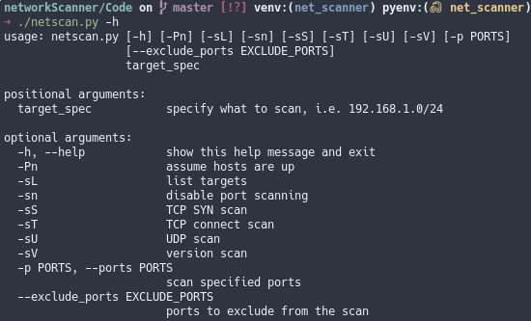

Screenshot showing my program being run with the -h flag.

### Printing a help message when passed -help

To show this I will run my program with the --help flag. This should produce the exact same output as with -h. This shows the exact same message as in the test of -h. To prove this if I take the sha1sum of the output for both flags we can see that the hashes are identical and therefore the originals were also identical, this is shown in figure 16. This shows success criteria [usage].

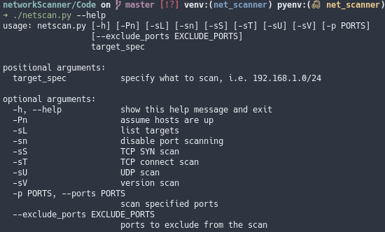

Screenshot showing my program being run with the help flag.

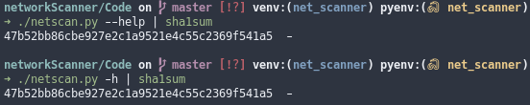

Screenshot showing the hashes of the two help messages.

### Scanning a subnet with ICMP ECHO REQUEST messages

To show this I will run my program with the -sn flag and specify the subnet of my local network 192.168.178.0/24. This should produce a list of all the hosts which are up on the network. In figure 17 you can see you can see my program’s output showing that the hosts:

* 192.168.178.60
* 192.168.178.56
* 192.168.178.30
* 192.168.178.1

all responded with icmp ECHO REPLY messages, this is reflected in a packet capture I took while performing the scan. A section of this scan is shown in figure 18 where you can see some of icmp ECHO REQUEST messages my program sent, along with some of the requests to hosts that don’t exist, note the different addresses in the source and destination fields and the Echo (ping) request vs reply in the info column. This successfully shows success criteria [blackbox] and [ping].

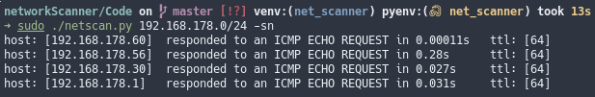

Screenshot showing the output of a scan of my local network.

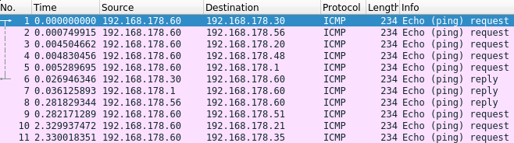

Screenshot showing a selection of the packets being sent by this scan.

### Translating a CIDR specified subnet into a list of IP addresses

To show this I will run my program with the -sL flag and I will specify a small subnet of 192.168.1.0/28 (I have chosen such a small subnet such that it will fit on my terminal and therefore in a screenshot). I expect the list of addresses to be 192.168.1.1 - 192.168.1.14. To prove that my program works I will screenshot the output when run with the stated parameters and I will use a website to translate the same subnet and show that it displays the same addresses as my program. In figure 19 you can see that the output from my program matches the expected list of IP addresses from 192.168.1.1 to 192.168.1.14 which is also shown by the screen shot of the same subnet translated by the ipcalc utility on Linux. This proves my program works and covers success criteria [cidr].

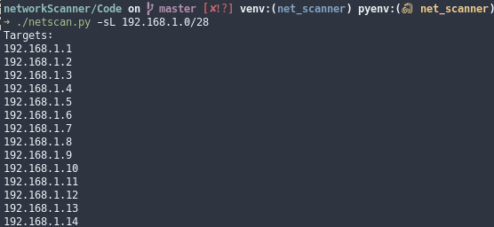

Screenshot showing the output of my program when asked to translate the subnet 192.168.1.0/28.

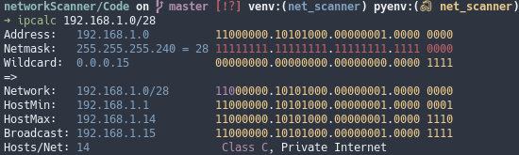

Screenshot showing the range displayed by the ipcalc utility when asked to calculate the same subnet.

### Scanning without first checking whether hosts are up.

To show this I will perform a TCP scan on a small subnet where I know there are no hosts and show that the scan continues despite there actually being no host on the other end. To do this I will pass the -Pn flag and I will specify the subnet 192.168.43.0/28 which I know has no has no hosts on it. I will also specify -p 12345 to only scan port 12345 so that there are fewer requests in the packet capture. Finally I will specify -sS to do tcp SYN SCANNING.I expect to see a multiple of 14 arp messages. This is because I don’t know how many times my nic will retry at getting the destination mac address. It needs to destination mac address to send the packet to its destination as we are scanning a private IP range of my router. In figure 21 you can see the output of my program when run with the specified flags, you can see that as expected it showed that there were no open ports on those machines as they don’t exist. In figure 22 you can see the packet capture of the packets my code sent, however, there are only ARP messages, this is because we are scanning in the private IP range of my router which was the only way I could guarantee that there was no machine at the other end. However, this is as expected, as well as this we can see 42 arp requests, which is arp requests, which would indicate each scan made three arp requests before giving up. This shows my program can perform scans without first checking if the host is up, showing success criteria [nocheck].

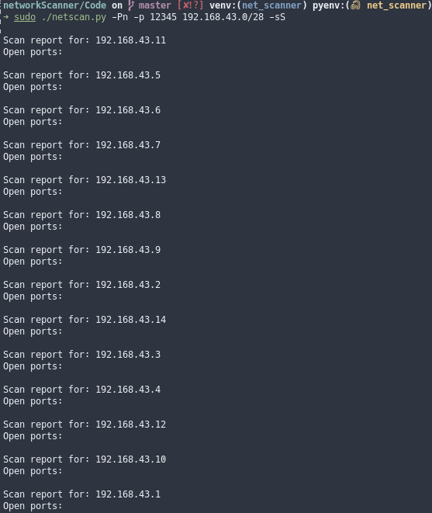

Screenshot showing the output from my code when asked to port scan a subnet with no machines behind the addresses.

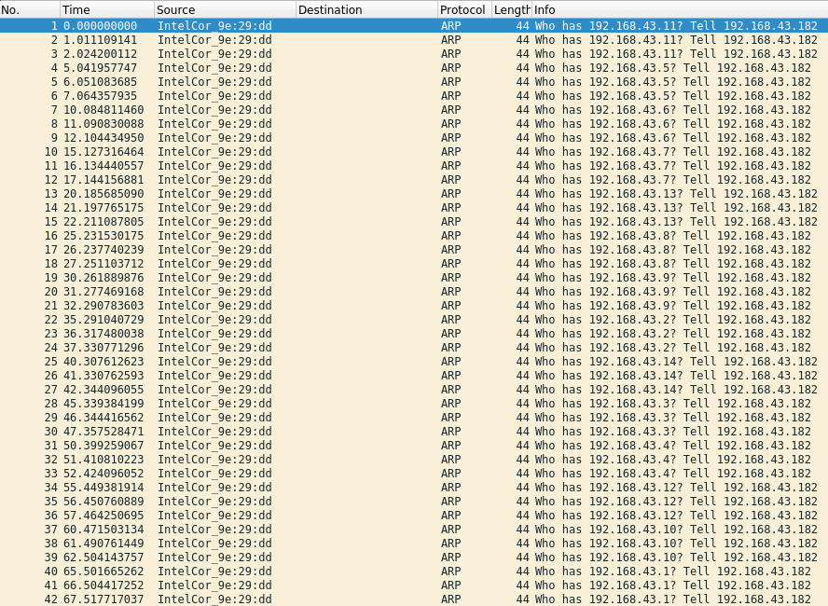

Screenshot showing the ARP requests my NIC sent to attempt to determine where to send the attempted connection packets.

### Detecting whether a TCP port is open

To show this I will perform a tcp Connect() scan on my local machine while running a script which will listen on port 12345 for any connections and send back a message. To do this I will pass my program the flags -sT and -p 12345 as well as specifying localhost to scan (127.0.0.1). I expect to see a tcp SYN-ACK handshake between my program and the script and then my program to output that the port is open. In figure 25 you can see the expected tcp SYN-ACK handshake performed by my program and the script in figure 23. You can see the output of my program in figure 24, as expected it outputs that port 12345 is open. This shows success criteria [blackbox] and [tcpopen].

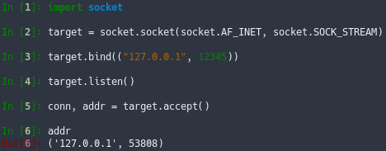

Screenshot showing the script I ran to accept a connection on localhost port 12345.

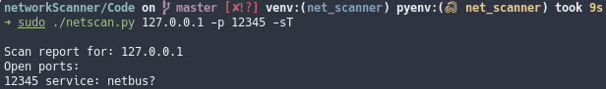

Screenshot showing the output of my script when run with the specified flags and while the script in figure 23 was running.

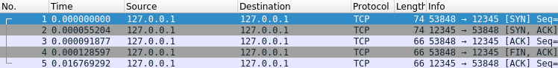

Screenshot showing the packet capture of the TCP SYN-ACK handshake performed by the scan in figure 24 with the script in 23.

### Detecting whether a TCP port is closed

To show this I will perform a tcp Connect() scan on my local machine except instead of running a script to catch the request I will just let it try to connect to the closed port. I expect to see a tcp SYN packet sent to the port and then a RST, ACK packet sent back, my program should output no open ports. To do this I will pass my program the same options as in the test for a tcp open port. In figure 27 you can see the attempted connection to 127.0.0.1 port 12345 along with the RST, ACK packet afterwards indicating the port is closed. This is reflected in figure 26 with no open ports showing success criteria [blackbox] and [tcpclosed].

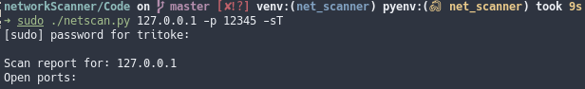

Screenshot showing the output of my program when run with the specified options.

 Screenshot showing the packet capture of the TCP SYN-RST closed port indication caused by the scan in figure 26. 

Screenshot showing the packet capture of the TCP SYN-RST closed port indication caused by the scan in figure 26.

### Detecting whether a TCP port is filtered

To show this I will perform a tcp SYN scan on localhost port 12345 except I will also introduce a firewall rule to drop all requests to localhost. I expect this to produce no response to the initial SYN packet sent by my program and my program to output that port as filtered. To test this I will run my program with the flags -sS,-p 12345,-Pn this will cause it to not check whether the host is up, to perform a tcp SYN scan and only scan port 12345. I will also introduce a firewall rule using the Linux iptables utility to drop all requests to localhost as so: iptables -I INPUT -s 127.0.0.1 -j DROP. The output of my program is shown in figure 28 you can see that port 12345 is displayed as filtered and in the packet capture shown in figure 29 you can see that there is no response to our initial packet which corresponds to what I thought would happen with an iptables rule in place to drop packets. This shows success criteria [blackbox] and [tcpfiltered].

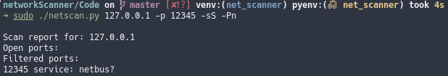

Screenshot showing the output of my program when run with the specified options and a firewall in place to drop all packets to 127.0.0.1.

 Screenshot showing the packet capture of the scan in figure 28 

Screenshot showing the packet capture of the scan in figure 28

### Detecting whether a UDP port is open

To show this I will perform a udp scan on a script I have already written while developing udp scanning which can be seen in listing [udpopenscript]. I expect to see my program output port 12345 as open and in the packet capture I expect to see two udp packets followed by two response udp packets from my listener program. I will test this using the following flags: -Pn,-p 12345,-sU these translate to scanning port 12345 over UDP and not checking the host is up beforehand. In figure 30 you can see the output of my program when run as specified and you can see that it correctly detects port 12345 as being open. In figure 31 you can see the packet capture of my program being run however, this is not as I expected, I didn’t foresee the icmp destination unreachable messages, these are sent by the kernel in response to the UDP probe which it doesn’t know what to do with, however, apart from those the capture shows everything as expected. This shows success criteria [blackbox] and [udpopen].

import socket  
from contextlib import closing  
  
with closing(  
 socket.socket(  
 socket.AF_INET,  
 socket.SOCK_DGRAM  
 )  
) as s:  
 s.bind(("127.0.0.1", 12345))  
 print("opened port 12345 on localhost")  
 while True:  
 data, addr = s.recvfrom(1024)  
 s.sendto(bytes("Well hello there good sir.", "utf-8"), addr)

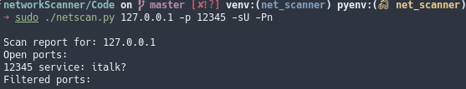

Screenshot showing the output of my program when run with the options specified above, and the script in listing [udpopenscript] is running.

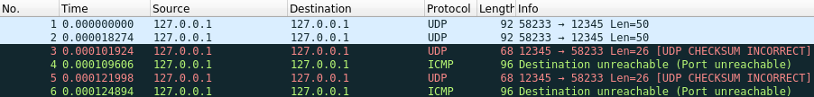

screenshot showing the packet capture of the scan in figure 30

### Detecting whether a UDP port is closed

To show this I will perform a udp scan on a port which has no service listening behind it. I expect my program to print out no filtered ports and no open ports showing that the port was closed. In the packet capture I expect to see three udp packets and three response icmp packets. To test this I will use my program with the following flags: -p 12345,-Pn,-sU which perform a udp port scan without first checking if the host is up. In figure 32 you can see the output of my program when run with the options specified above, you can see that there are no ports displayed as either open or filtered, this shows the my program successfully marked the port as closed. This shows success criteria [blackbox] and [udpclosed].

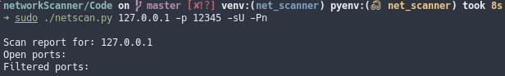

screenshot showing the output of my program when scanning with the options specified above.

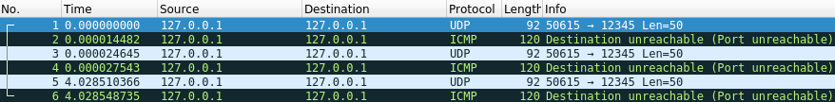

screenshot showing the packet capture of the scan in figure 32

### Detecting whether a UDP port is filtered

To show this I will use my program to perform a udp scan on my local machine with a firewall rule to drop any ports sent to the localhost address. I expect to see my program to output the port as filtered and in the packet capture I expect to see three udp packets with no response to any of them. In figure 34 you can see my program correctly identifies the port as being filtered and in figure 35 you can see the packet capture of the scan which also as expected shows the three udp packets with no reply packets. This shows success criteria [blackbox] and [udpfiltered].

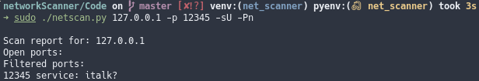

screenshot showing the output of my program when scanning with the options specified above.

 screenshot showing the packet capture of the scan in figure 34 

screenshot showing the packet capture of the scan in figure 34

### Detecting the operating system of another machine

I haven’t directly added this as a feature to my project partly because I didn’t have time and also because it is partially achieved by version scanning in that if a particular service is detected and that service is OS dependent then you can be fairly certain that machine is running that OS.For example if a machine is open on tcp port 22 and SSH is detected to be running behind that port then they are likely to be running a Linux machine. Even more likely if the scan reveals some further information such as the cpe. In figure 36 you can see a scan of my machine where I have ssh running, my program reveals that the version is 7.9 and the vendor is openbsd which is a unix like operating system, this shows that my ssh version is unix based and therefore I am likely to be running on Linux, which is the case. So although it is not directly a feature in a round a bout way. This partially completes success criteria [osdetect].

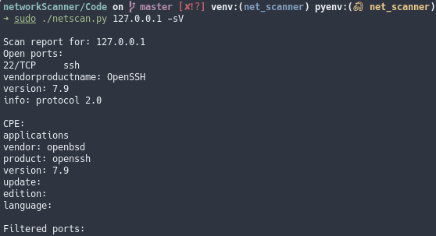

screenshot showing a version scan of my local machine.

### Detecting the service and its version running behind a port

To show this I will use my program to perform a version detection scan on my local machine while I am running ssh. I expect to see my program identify that ssh is running on tcp port 22 and that it detects it as OpenSSH version 7.9. To test this I will run my program with the -sV flag to indicate version detection and I will run it against the localhost address. In figure [versiondetect] you can see that my program successfully identified ssh as running on tcp port 22 as well as the expected identification of OpenSSH version 7.9 operating on protocol version 2. It also identified some CPE information such as OpenSSH coming from the openbsd distribution. This shows success criteria [blackbox], [servicedetect] and [versiondetect].



screenshot showing a version scan of my local machine running ssh.

### User enters invalid ip address

To show this I will run my program with the target_spec option being 300.300.300.300 which is an invalid IPv4 because each of the octets is not between 0 and 255. I expect to see my program raise a python value error saying that this is an invalid dot form ip address, and displaying 300.300.300.300 as the invalid ip address. In figure 38 you can see my program’s output for this invalid IP address. This shows a successful pass as it correctly identifies the invalid IP and displays the error and the argument that caused the error to the user.

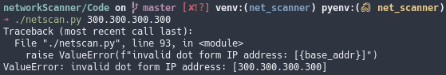

Screenshot showing the output from an invalid IP address being used.

### User enters invalid number of network bits

To show this I will run my program and ask it to list the ip addresses specified by the subnet 192.168.1.0/33 ip addresses are only 32 bits long so specifying 33 network bits has no meaning and thus is invalid data. I expect my program to raise a ValueError and print out that it was an invalid number of network bits that caused the error along with 33 being the network bits. In figure 39 you can see that my program successfully identified the invalid number of network bits and raised the expected error and printed the expected information.

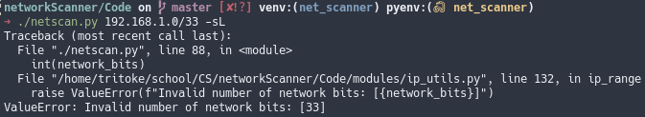

Screenshot showing the output of my program when passed an invalid number of network bits.

### User enters an invalid port number to scan

To show this I will run my program with the argument -p 99999 as port number can only go up to 65535 this is erroneous data and as such should generate an error message specifying that you have tried to scan an invalid destination port. In figure 40 you can see that my program successfully identified 99999 as an invalid destination port and printed the correct error message accordingly

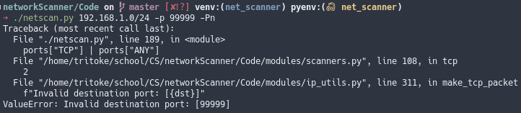

Screenshot of my program showing the output from an invalid port number.

### User enters an invalid number of network bits and a bad IP address

## Test Table

|  |  |  |  |  |  |
| --- | --- | --- | --- | --- | --- |
| Test No. | Test Data | Expectation | Result | Fig | Success Criteria |
|  |  | usage message | Pass | 13 | [usage] |
|  | -h | help message | Pass | 14 | [usage] |
|  | --help | help message | Pass | 15 | [usage] |
|  | -sL | print addresses | Pass | 19 | [cidr] |
|  | -sn | ping scan | Pass | 17 | [ping] |
|  | -Pn | assume host up | Pass | 21 | [nocheck] |
|  | -sS|sT | TCP port open | Pass | 24 | [tcpopen] |
|  | -sS|sT | TCP port closed | Pass | 26 | [tcpclosed] |
|  | -sS | TCP port filtered | Pass | 28 | [tcpfiltered] |
|  | -sU | UDP port open | Pass | 30 | [udpopen] |
|  | -sU | UDP port closed | Pass | 32 | [udpclosed] |
|  | -sU | UDP port filtered | Pass | 34 | [udpfiltered] |
|  | -sV | OS detection | Partial | 36 | [osdetect] |
|  | -sV | service detection | Pass | 36 | [servicedetect] |
|  | -sV | version detection | Pass | 36 | [versiondetect] |
|  |  | invalid IP | Pass | 38 |  |
|  |  | invalid subnet | Pass | 39 |  |
|  |  | invalid port number | Pass | 40 |  |

# Evaluation

## Reflection on final outcome

Overall I am very happy with how my program has turned out. Starting this project I did not believe I could do anywhere near as much as I have done. This is partly because I started this project to learn more about low level networking and networking in general because it was one of the areas where I didn’t know much about and as such I didn’t know how difficult any of it would be. I greatly enjoyed learning about all these networking topics from how the order that bytes are packed into the packet matters enormously, to how you are actually automatically assigned an IP address when you join a network.

There are many areas where I encountered difficulty in this project while developing this program. The first problem was understanding what a packet it is and how do I send one that I have made myself using python, there seemed to be very little in the way of documentation so I ended up reading lots of peoples answers to stack overflow questions where they have had similar problems. Once I knew that I could simply open a socket in raw mode and use the socket.sendto method to send any arbitrary bytes to an address and Python would handle the IP header things got a lot easier from this perspective. The next major problem was getting the checksum correct for tcp packets because they use a psuedo header which is sort of a header made from some fields in the ip header but which are not in the tcp header and they are used to calculate the checksum for the tcp header. Figuring out how to pack these properly and in what endianness turned out to be one of the biggest difficulties in getting tcp SYN scanning working. I had a completely different problem when it came to implementing udp scanning. This is because when a udp packet arrives and is destined for a closed port an icmp destination unreachable message is sent back and on linux systems these are time limited to a maximum of one per second thus I had to come up with a strategy that could deal with this. In the end I just added a maximum wait time for each packet I sent and listened that long for an icmp destination unreachable message. Finally implementing version scanning came with its own host of problems from parsing the file which defines the probes and all the directives which are needed to interpret the service’s response to actually matching the returned data using a regular expression that was parsed from a file. When Python parses text from a file it reads the literal characters so an escaped newline \n would be read as a literal backslash then an n when instead we want the regular expression to match a newline.

## Evaluation against objectives, end user feedback

## Potential improvements

# Technical Solution

## icmp_ping

#!/usr/bin/env python  
import socket  
import struct  
import os  
import time  
from modules.ip_utils import ip_checksum  
  
  
def main() -> None:  
 ICMP_ECHO_REQUEST = 8  
  
 # opens a raw socket for the ICMP protocol  
 ping_sock = socket.socket(  
 socket.AF_INET,  
 socket.SOCK_RAW,  
 socket.IPPROTO_ICMP  
 )  
 # allows manual IP header creation  
 # ping_sock.setsockopt(socket.SOL_IP, socket.IP_HDRINCL, 1)  
  
 ID = os.getpid() & 0xFFFF  
  
 # the two zeros are the code and the dummy checksum, the one is the  
 # sequence number  
 dummy_header = struct.pack("bbHHh", ICMP_ECHO_REQUEST, 0, 0, ID, 1)  
  
 data = struct.pack(  
 "d", time.time()  
 ) + bytes(  
 (192 - struct.calcsize("d")) * "A",  
 "ascii"  
 )  
 # the data to send in the packet  
 checksum = socket.htons(ip_checksum(dummy_header + data))  
 # calculates the checksum for the packet and psuedo header  
 header = struct.pack("bbHHh", ICMP_ECHO_REQUEST, 0, checksum, ID, 1)  
 # packs the packet header  
 packet = header + data  
 # concatonates the header and the data to form the final packet.  
 ping_sock.sendto(packet, ("127.0.0.1", 1))  
 # sends the packet to localhost

#!/usr/bin/env python  
from modules import headers  
import socket  
from typing import List  
  
  
def main() -> None:  
 # socket object using an IPV4 address, using only raw socket access, set  
 # ICMP protocol  
 ping_sock = socket.socket(  
 socket.AF_INET,  
 socket.SOCK_RAW,  
 socket.IPPROTO_ICMP  
 )  
  
 packets: List[bytes] = []  
  
 while len(packets) < 1:  
 recPacket, addr = ping_sock.recvfrom(1024)  
 ip = headers.ip(recPacket[:20])  
 icmp = headers.icmp(recPacket[20:28])  
  
 print(ip)  
 print()  
 print(icmp)  
 print("\n")  
  
 packets.append(recPacket)

## ping_scanner

#!/usr/bin/env python  
from modules import headers  
from modules import ip_utils  
import socket  
import struct  
import time  
from contextlib import closing  
from itertools import repeat  
from math import log10, floor  
from multiprocessing import Pool  
from os import getpid  
from typing import Set, Tuple  
  
  
def sig_figs(x: float, n: int) -> float:  
 """  
 rounds x to n significant figures.  
 sig_figs(1234, 2) = 1200.0  
 """  
 return round(x, n - (1 + int(floor(log10(abs(x))))))  
  
  
def ping_listener(  
 ID: int,  
 timeout: float  
) -> Set[Tuple[str, float, headers.ip]]:  
 """  
 Takes in a process id and a timeout and returns  
 a list of addresses which sent ICMP ECHO REPLY  
 packets with the packed id matching ID in the time given by timeout.  
 """  
 ping_sock = socket.socket(  
 socket.AF_INET,  
 socket.SOCK_RAW,  
 socket.IPPROTO_ICMP  
 )  
 # opens a raw socket for sending ICMP protocol packets  
 time_remaining = timeout  
 addresses = set()  
 while True:  
 time_waiting = ip_utils.wait_for_socket(ping_sock, time_remaining)  
 # time_waiting stores the time the socket took to become readable  
 # or returns minus one if it ran out of time  
  
 if time_waiting == -1:  
 break  
 time_recieved = time.time()  
 # store the time the packet was recieved  
 recPacket, addr = ping_sock.recvfrom(1024)  
 # recieve the packet  
 ip = headers.ip(recPacket[:20])  
 # unpack the IP header into its respective components  
 icmp = headers.icmp(recPacket[20:28])  
 # unpack the time from the packet.  
 time_sent = struct.unpack(  
 "d",  
 recPacket[28:28 + struct.calcsize("d")]  
 )[0]  
 # unpack the value for when the packet was sent  
 time_taken: float = time_recieved - time_sent  
 # calculate the round trip time taken for the packet  
 if icmp.id == ID:  
 # if the ping was sent from this machine then add it to the list of  
 # responses  
 ip_address, port = addr  
 addresses.add((ip_address, time_taken, ip))  
 elif time_remaining <= 0:  
 break  
 else:  
 continue  
 # return a list of all the addesses that replied to our ICMP echo request.  
 return addresses  
  
  
def main() -> None:  
 with closing(  
 socket.socket(  
 socket.AF_INET,  
 socket.SOCK_RAW,  
 socket.IPPROTO_ICMP  
 )  
 ) as ping_sock:  
 ip_addresses = ["127.0.0.1"] # ip_utils.ip_range("192.168.43.0", 24)  
 # generate the range of IP addresses to scan.  
 # get the local ip address  
 addresses = [  
 ip  
 for ip in ip_addresses  
 if (  
 not ip.endswith(".0")  
 and not ip.endswith(".255")  
 )  
 ]  
  
 # initialise a process pool  
 p = Pool(1)  
 # get the local process id for use in creating packets.  
 ID = getpid() & 0xFFFF  
 # run the listeners.ping function asynchronously  
 replied = p.apply_async(ping_listener, (ID, 5))  
 time.sleep(0.01)  
 for address in zip(addresses, repeat(1)):  
 try:  
 packet = ip_utils.make_icmp_packet(ID)  
 ping_sock.sendto(packet, address)  
 except PermissionError:  
 ip_utils.eprint("raw sockets require root priveleges, exiting")  
 exit()  
 p.close()  
 p.join()  
 # close and join the process pool to so that all the values  
 # have been returned and the pool closed  
 hosts_up = replied.get()  
 # get the list of addresses that replied to the echo request from the  
 # listener function  
 print("\n".join(  
 f"host: [{host}]\t" +  
 "responded to an ICMP ECHO REQUEST in " +  
 f"{str(sig_figs(taken, 2))+'s':<10s} " +  
 f"ttl: [{ip_head.time_to_live}]"  
 for host, taken, ip_head in hosts_up  
 ))

## subnet_to_addresses

#!/usr/bin/env python  
import re  
from modules.ip_utils import ip_range, dot_to_long  
  
  
if __name__ == '__main__':  
 from argparse import ArgumentParser  
 parser = ArgumentParser()  
 parser.add_argument(  
 "ip_subnet",  
 help="The CIDR form ip/subnet that you wish to print" +  
 "the IP addresses specified by."  
 )  
 args = parser.parse_args()  
 CIDR_regex = re.compile(r"(\d{1,3}\.\d{1,3}\.\d{1,3}\.\d{1,3}/\d+)")  
 search = CIDR_regex.search(args.ip_subnet)  
 if search:  
 ip, network_bits = search.group(1).split("/")  
 print("\n".join(  
 sorted(  
 ip_range(ip, int(network_bits)),  
 key=dot_to_long  
 )  
 ))

## tcp_scan

### connect_scan

#!/usr/bin/python3  
from contextlib import closing  
import socket  
LOCAL_IP = "192.168.1.159"  
PORT = 22  
  
address = ("127.0.0.1", 22)  
  
with closing(  
 socket.socket(  
 socket.AF_INET,  
 socket.SOCK_STREAM  
 )  
) as s:  
 try:  
 s.connect(address)  
 print(f"connection on port {PORT} succedded")  
 except ConnectionRefusedError:  
 print(f"port {PORT} is closed")

#!/usr/bin/python3  
  
from typing import List, Set  
  
  
def connect_scan(address: str, ports: Set[int]) -> List[int]:  
 import socket  
 from contextlib import closing  
 open_ports: List[int] = []  
 for port in ports:  
 # loop through each port in the list of ports to scan  
 try:  
 with closing(  
 socket.socket(  
 socket.AF_INET,  
 socket.SOCK_STREAM  
 )  
 ) as s:  
 # open an IPV4 TCP socket  
 s.connect((address, port))  
 # attempt to connect the newly created socket to the target  
 # address and port  
 open_ports.append(port)  
 # if the connection was successful then add the port to the  
 # list of open ports  
 except ConnectionRefusedError:  
 pass  
 return open_ports  
  
  
def main() -> None:  
 open_ports = connect_scan("192.168.43.225", set(range(65535)))  
 print("\n".join(map(lambda x: f"port: [{x}]\tis open", open_ports)))

### syn_scan

#!/usr/bin/python3.7  
from contextlib import closing  
import socket  
import ip_utils  
  
dest_port = 22  
src_port = ip_utils.get_free_port()  
local_ip = ip_utils.get_local_ip()  
dest_ip = "192.168.1.159"  
local_ip = dest_ip = "127.0.0.1"  
loc_long = ip_utils.dot_to_long(local_ip)  
  
SYN = 2  
RST = 4  
  
  
  
with closing(  
 socket.socket(  
 socket.AF_INET,  
 socket.SOCK_RAW,  
 socket.IPPROTO_TCP  
 )  
) as s:  
 tcp_packet = ip_utils.make_tcp_packet(  
 src_port,  
 dest_port,  
 local_ip,  
 dest_ip,  
 SYN  
 )  
 if tcp_packet is not None:  
 s.sendto(tcp_packet, (dest_ip, dest_port))  
 else:  
 print(f"Couldn't make TCP packet with supplied arguments:",  
 f"source port: [{src_port}]",  
 f"destination port: [{dest_port}]",  
 f"local ip: [{local_ip}]",  
 f"destination ip: [{dest_ip}]",  
 f"SYN flag: [{SYN}]",  
 sep="\n")

#!/usr/bin/python3.7  
from modules import headers  
from modules import ip_utils  
import socket  
from contextlib import closing  
from multiprocessing import Pool  
from typing import List, Set, Tuple  
  
  
def syn_listener(address: Tuple[str, int], timeout: float) -> List[int]:  
 """  
 This function is run asynchronously and listens for  
 TCP ACK responses to the sent TCP SYN msg.  
 """  
 print(f"address: [{address}]\ntimeout: [{timeout}]")  
 open_ports: List[int] = []  
 with closing(  
 socket.socket(  
 socket.AF_INET,  
 socket.SOCK_RAW,  
 socket.IPPROTO_TCP  
 )) as s:  
 s.bind(address)  
 # bind the raw socket to the listening address  
 time_remaining = timeout  
 print("started listening")  
 while True:  
 time_taken = ip_utils.wait_for_socket(s, time_remaining)  
 # wait for the socket to become readable  
 if time_taken == -1:  
 break  
 else:  
 time_remaining -= time_taken  
 packet = s.recv(1024)  
 # recieve the packet data  
 tcp = headers.tcp(packet[20:40])  
 if tcp.flags == 0b00010010: # syn ack  
 print(tcp)  
 open_ports.append(tcp.source)  
 # check that the header contained the TCP ACK flag and if it  
 # did append it  
 else:  
 continue  
 print("finished listening")  
 return open_ports  
  
  
def syn_scan(dest_ip: str, portlist: Set[int]) -> List[int]:  
 src_port = ip_utils.get_free_port()  
 # request a local port to connect from  
 local_ip = ip_utils.get_local_ip()  
 p = Pool(1)  
 listener = p.apply_async(syn_listener, ((local_ip, src_port), 5))  
 # start the TCP ACK listener in the background  
 print("starting scan")  
 for port in portlist:  
 packet = ip_utils.make_tcp_packet(src_port, port, local_ip, dest_ip, 2)  
 # create a TCP packet with the syn flag  
 with closing(  
 socket.socket(  
 socket.AF_INET,  
 socket.SOCK_RAW,  
 socket.IPPROTO_TCP  
 )  
 ) as s:  
 s.sendto(packet, (dest_ip, port))  
 # send the packet to its destination  
  
 print("finished scan")  
 p.close()  
 p.join()  
 open_ports = listener.get()  
 # collect the list of ports that responded to the TCP SYN message  
 print(open_ports)  
 return open_ports  
  
  
def main() -> None:  
 dest_ip = "127.0.0.1"  
 syn_scan(dest_ip, set(range(2**16)))

## udp_scan

#!/usr/bin/ python  
from contextlib import closing  
import ip_utils  
import socket  
  
dest_ip = "192.168.1.1"  
dest_port = 68  
local_ip = ip_utils.get_local_ip()  
local_port = ip_utils.get_free_port()  
  
local_ip = dest_ip = "127.0.0.1"  
  
address = (dest_ip, dest_port)  
  
with closing(  
 socket.socket(  
 socket.AF_INET,  
 socket.SOCK_RAW,  
 socket.IPPROTO_UDP  
 )) as s:  
 try:  
 pkt = ip_utils.make_udp_packet(  
 local_port,  
 dest_port,  
 local_ip,  
 dest_ip  
 )  
 if pkt is not None:  
 packet = bytes(pkt)  
 s.sendto(packet, address)  
 else:  
 print(  
 "Error making packet.",  
 f"local port: [{local_port}]",  
 f"destination port: [{dest_port}]",  
 f"local ip: [{local_ip}]",  
 f"destination ip: [{dest_ip}]",  
 sep="\n"  
 )  
 except socket.error:  
 raise

#!/usr/bin/env python  
from modules import headers  
from modules import ip_utils  
import socket  
import time  
from collections import defaultdict  
from contextlib import closing  
from multiprocessing import Pool  
from typing import Set, DefaultDict  
  
  
def udp_listener(dest_ip: str, timeout: float) -> Set[int]:  
 """  
 This listener detects UDP packets from dest_ip in the given timespan,  
 all ports that send direct replies are marked as being open.  
 Returns a list of open ports.  
 """  
  
 time_remaining = timeout  
 ports: Set[int] = set()  
 with socket.socket(  
 socket.AF_INET,  
 socket.SOCK_RAW,  
 socket.IPPROTO_UDP  
 ) as s:  
 while True:  
 time_taken = ip_utils.wait_for_socket(s, time_remaining)  
 if time_taken == -1:  
 break  
 else:  
 time_remaining -= time_taken  
 packet = s.recv(1024)  
 ip = headers.ip(packet[:20])  
 udp = headers.udp(packet[20:28])  
 # unpack the UDP header  
 if dest_ip == ip.source and ip.protocol == 17:  
 ports.add(udp.src)  
  
 return ports  
  
  
def icmp_listener(src_ip: str, timeout: float = 2) -> int:  
 """  
 This listener detects ICMP destination unreachable  
 packets and returns the icmp code.  
 This is later used to mark them as either close, open|filtered, filtered.  
 3 -> closed  
 0|1|2|9|10|13 -> filtered  
 -1 -> error with arguments  
 open|filtered means that they are either open or  
 filtered but return nothing.  
 """  
  
 ping_sock = socket.socket(  
 socket.AF_INET,  
 socket.SOCK_RAW,  
 socket.IPPROTO_ICMP  
 )  
 # open raw socket to listen for ICMP destination unrechable packets  
 time_remaining = timeout  
 code = -1  
 while True:  
 time_waiting = ip_utils.wait_for_socket(ping_sock, time_remaining)  
 # wait for socket to be readable  
 if time_waiting == -1:  
 break  
 else:  
 time_remaining -= time_waiting  
 recPacket, addr = ping_sock.recvfrom(1024)  
 # recieve the packet  
 ip = headers.ip(recPacket[:20])  
 icmp = headers.icmp(recPacket[20:28])  
 valid_codes = [0, 1, 2, 3, 9, 10, 13]  
 if (  
 ip.source == src_ip  
 and icmp.type == 3  
 and icmp.code in valid_codes  
 ):  
 code = icmp.code  
 break  
 elif time_remaining <= 0:  
 break  
 else:  
 continue  
 ping_sock.close()  
 return code  
  
  
def udp_scan(  
 dest_ip: str,  
 ports_to_scan: Set[int]  
) -> DefaultDict[str, Set[int]]:  
 """  
 Takes in a destination IP address in either dot or long form and  
 a list of ports to scan. Sends UDP packets to each port specified  
 in portlist and uses the listeners to mark them as open, open|filtered,  
 filtered, closed they are marked open|filtered if no response is  
 recieved at all.  
 """  
  
 local_ip = ip_utils.get_local_ip()  
 local_port = ip_utils.get_free_port()  
 # get local ip address and port number  
 ports: DefaultDict[str, Set[int]] = defaultdict(set)  
 ports["REMAINING"] = ports_to_scan  
 p = Pool(1)  
 udp_listen = p.apply_async(udp_listener, (dest_ip, 4))  
 # start the UDP listener  
 with closing(  
 socket.socket(  
 socket.AF_INET,  
 socket.SOCK_RAW,  
 socket.IPPROTO_UDP  
 )  
 ) as s:  
 for _ in range(2):  
 # repeat 3 times because UDP scanning comes  
 # with a high chance of packet loss  
 for dest_port in ports["REMAINING"]:  
 try:  
 packet = ip_utils.make_udp_packet(  
 local_port,  
 dest_port,  
 local_ip,  
 dest_ip  
 )  
 # create the UDP packet to send  
 s.sendto(packet, (dest_ip, dest_port))  
 # send the packet to the currently scanning address  
 except socket.error:  
 packet_bytes = " ".join(map(hex, packet))  
 print(  
 "The socket modules sendto method with the following",  
 "argument resulting in a socket error.",  
 f"\npacket: [{packet_bytes}]\n",  
 "address: [{dest_ip, dest_port}])"  
 )  
  
 p.close()  
 p.join()  
  
 ports["OPEN"].update(udp_listen.get())  
  
 ports["REMAINING"] -= ports["OPEN"]  
 # only scan the ports which we know are not open  
 with closing(  
 socket.socket(  
 socket.AF_INET,  
 socket.SOCK_RAW,  
 socket.IPPROTO_UDP  
 )  
 ) as s:  
 for dest_port in ports["REMAINING"]:  
 try:  
 packet = ip_utils.make_udp_packet(  
 local_port,  
 dest_port,  
 local_ip,  
 dest_ip  
 )  
 # make a new UDP packet  
 p = Pool(1)  
 icmp_listen = p.apply_async(icmp_listener, (dest_ip,))  
 # start the ICMP listener  
 time.sleep(1)  
 s.sendto(packet, (dest_ip, dest_port))  
 # send packet  
 p.close()  
 p.join()  
 icmp_code = icmp_listen.get()  
 # recieve ICMP code from the ICMP listener  
 if icmp_code in {0, 1, 2, 9, 10, 13}:  
 ports["FILTERED"].add(dest_port)  
 elif icmp_code == 3:  
 ports["CLOSED"].add(dest_port)  
 except socket.error:  
 packet_bytes = " ".join(map("{:02x}".format, packet))  
 ip_utils.eprint(  
 "The socket modules sendto method with the following",  
 "argument resulting in a socket error.",  
 f"\npacket: [{packet_bytes}]\n",  
 "address: [{dest_ip, dest_port}])"  
 )  
 # this creates a new set which contains all the elements that  
 # are in the list of ports to be scanned but have not yet  
 # been classified  
 ports["OPEN|FILTERED"] = (  
 ports["REMAINING"]  
 - ports["OPEN"]  
 - ports["FILTERED"]  
 - ports["CLOSED"]  
 )  
 # set comprehension to update the list of open filtered ports  
 return ports  
  
  
def main() -> None:  
 ports = udp_scan("127.0.0.1", {22, 68, 53, 6969})  
 print(f"Open ports: {ports['OPEN']}")  
 print(f"Open or filtered ports: {ports['OPEN|FILTERED']}")  
 print(f"Filtered ports: {ports['FILTERED']}")  
 print(f"Closed ports: {ports['CLOSED']}")

#!/usr/bin/env python  
  
import socket  
from contextlib import closing  
  
with closing(  
 socket.socket(  
 socket.AF_INET,  
 socket.SOCK_DGRAM  
 )  
) as s:  
 s.bind(("127.0.0.1", 12345))  
 print("opened port 12345 on localhost")  
 while True:  
 data, addr = s.recvfrom(1024)  
 s.sendto(bytes("Well hello there good sir.", "utf-8"), addr)

## version_detection

#!/usr/bin/env python  
from typing import Dict, Set, Pattern, Tuple, DefaultDict  
from functools import reduce  
from collections import defaultdict  
from modules import directives  
import re  
import operator  
  
# type annotaion for the container which  
# holds the probes. I have abstracted it from  
# the function definition because multiple functions  
# depend on it and they weren't all getting updated  
# if I needed to change the function signature.  
PROBE_CONTAINER = DefaultDict[str, Dict[str, directives.Probe]]  
  
  
def parse_ports(portstring: str) -> DefaultDict[str, Set[int]]:  
 """  
 This function takes in a port directive  
 and returns a set of the ports specified.  
 A set is used because it is O(1) for contains  
 operations as opposed for O(N) for lists.  
 """  
 # matches both the num-num port range format  
 # and the plain num port specification  
 # num-num form must come first otherwise it breaks.  
 proto_regex = re.compile(r"([ TU]):?([0-9,-]+)")  
 # THE SPACE IS IMPORTANT!!!  
 # it allows ports specified before TCP/UDP ports  
 # to be specified globally as in for all protocols.  
  
 pair_regex = re.compile(r"(\d+)-(\d+)")  
 single_regex = re.compile(r"(\d+)")  
 ports: DefaultDict[str, Set[int]] = defaultdict(set)  
 # searches contains the result of trying the pair_regex  
 # search against all of the command seperated  
 # port strings  
  
 for protocol, portstring in proto_regex.findall(portstring):  
 pairs = pair_regex.findall(portstring)  
 # for each pair of numbers in the pairs list  
 # seperate each number and cast them to int  
 # then generate the range of numbers from x[0]  
 # to x[1]+1 then cast this range to a list  
 # and "reduce" the list of lists by joining them  
 # with operator.ior (inclusive or) and then let  
 # ports be the set of all the ports in that list.  
 proto_map = {  
 " ": "ANY",  
 "U": "UDP",  
 "T": "TCP"  
 }  
 if pairs:  
 def pair_to_ports(pair: Tuple[int, int]) -> Set[int]:  
 """  
 a function to go from a port pair i.e. (80-85)  
 to the set of specified ports: {80,81,82,83,84,85}  
 """  
 start, end = pair  
 return set(range(start, end+1))  
 # ports contains the set of all ANY/TCP/UDP specified ports  
 ports[proto_map[protocol]] = set(reduce(  
 operator.ior,  
 map(pair_to_ports, pairs)  
 ))  
  
 singles = single_regex.findall(portstring)  
 # for each of the ports that are specified on their own  
 # cast them to int and update the set of all ports with  
 # that list.  
 ports[proto_map[protocol]].update(map(int, singles))  
  
 return ports  
  
  
def parse_probes(probe_file: str) -> PROBE_CONTAINER:  
 """  
 Extracts all of the probe directives from the  
 file pointed to by probe_file.  
 """  
 # lines contains each line of the file which doesn't  
 # start with a # and is not empty.  
 lines = [  
 line  
 for line in open(probe_file).read().splitlines()  
 if line and not line.startswith("#")  
 ]  
  
 # list holding each of the probe directives.  
 probes: PROBE_CONTAINER = defaultdict(dict)  
  
 regexes: Dict[str, Pattern] = {  
 "probe": re.compile(r"Probe (TCP|UDP) (\S+) q\|(.*)\|"),  
 "match": re.compile(" ".join([  
 r"(?P<type>softmatch|match)",  
 r"(?P<service>\S+)",  
 r"m([@/%=|])(?P<regex>.+?)\3(?P<flags>[si]*)"  
 ])),  
 "rarity": re.compile(r"rarity (\d+)"),  
 "totalwaitms": re.compile(r"totalwaitms (\d+)"),  
 "tcpwrappedms": re.compile(r"tcpwrappedms (\d+)"),  
 "fallback": re.compile(r"fallback (\S+)"),  
 "ports": re.compile(r"ports (\S+)"),  
 "exclude": re.compile(r"Exclude T:(\S+)")  
 }  
  
 # parse the probes out from the file  
 for line in lines:  
 # add any ports to be excluded to the base probe class  
 if line.startswith("Exclude"):  
 search = regexes["exclude"].search(line)  
 if search:  
 # parse the ports from the grouped output of  
 # a search with the regex defined above.  
 for protocol, ports in parse_ports(search.group(1)).items():  
 directives.Probe.exclude[protocol].update(ports)  
 else:  
 print(line)  
 input()  
  
 # new probe directive  
 if line.startswith("Probe"):  
 # parse line into probe protocol, name and probestring  
 search = regexes["probe"].search(line)  
 if search:  
 try:  
 proto, name, string = search.groups()  
 except ValueError:  
 print(line)  
 raise  
 probes[name][proto] = directives.Probe(proto, name, string)  
 # assign current_probe to the most recently added probe  
 current_probe = probes[name][proto]  
 else:  
 print(line)  
 input()  
  
 # new match directive  
 elif line.startswith("match") or line.startswith("softmatch"):  
 search = regexes["match"].search(line)  
 if search:  
 # the remainder of the string after the match  
 version_info = line[search.end()+1:]  
 # escape the curly braces so the regex engine doesn't  
 # consider them to be special characters  
 pattern = bytes(search.group("regex"), "utf-8")  
 # these replace the literal \n, \r and \t  
 # strings with their actual characters  
 # i.e. \n -> newline character  
 pattern = pattern.replace(b"\\n", b"\n")  
 pattern = pattern.replace(b"\\r", b"\r")  
 pattern = pattern.replace(b"\\t", b"\t")  
 matcher = directives.Match(  
 search.group("service"),  
 pattern,  
 search.group("flags"),  
 version_info  
 )  
 if search.group("type") == "match":  
 current_probe.matches.add(matcher)  
 else:  
 current_probe.softmatches.add(matcher)  
  
 else:  
 print(line)  
 input()  
  
 # new ports directive  
 elif line.startswith("ports"):  
 search = regexes["ports"].search(line)  
 if search:  
 for protocol, ports in parse_ports(search.group(1)).items():  
 current_probe.ports[protocol].update(ports)  
 else:  
 print(line)  
 input()  
 # new totalwaitms directive  
 elif line.startswith("totalwaitms"):  
 search = regexes["totalwaitms"].search(line)  
 if search:  
 current_probe.totalwaitms = int(search.group(1))  
 else:  
 print(line)  
 input()  
  
 # new rarity directive  
 elif line.startswith("rarity"):  
 search = regexes["rarity"].search(line)  
 if search:  
 current_probe.rarity = int(search.group(1))  
 else:  
 print(line)  
 input()  
  
 # new fallback directive  
 elif line.startswith("fallback"):  
 search = regexes["fallback"].search(line)  
 if search:  
 current_probe.fallback = set(search.group(1).split(","))  
 else:  
 print(line)  
 input()  
 return probes  
  
  
def version_detect_scan(  
 target: directives.Target,  
 probes: PROBE_CONTAINER  
) -> directives.Target:  
 for probe_dict in probes.values():  
 for proto in probe_dict:  
 target = probe_dict[proto].scan(target)  
 return target  
  
  
def main() -> None:  
 print("reached here")  
 probes = parse_probes("./version_detection/nmap-service-probes")  
 open_ports: DefaultDict[str, Set[int]] = defaultdict(set)  
 open_filtered_ports: DefaultDict[str, Set[int]] = defaultdict(set)  
 open_filtered_ports["TCP"].add(22)  
 open_ports["TCP"].update([1, 2, 3, 4, 5, 6, 8, 65,  
 20, 21, 23, 24, 25])  
  
 target = directives.Target(  
 "127.0.0.1",  
 open_ports,  
 open_filtered_ports  
 )  
 target.open_ports["TCP"].update([1, 2, 3])  
 print("BEFORE")  
 print(target)  
 scanned = version_detect_scan(target, probes)  
 print("AFTER")  
 print(scanned)

## modules

#!/usr/bin/env python  
from collections import defaultdict  
from contextlib import closing  
from dataclasses import dataclass, field  
from functools import reduce  
from string import whitespace, printable  
from typing import (  
 DefaultDict,  
 Dict,  
 Set,  
 List,  
 Pattern,  
 Match as RE_Match,  
 Tuple  
)  
from . import ip_utils  
import operator  
import re  
import socket  
import struct  
  
  
class Match:  
 """  
 This is a class for both Matches and  
 Softmatches as they are actually the same  
 thing except that softmatches have less information.  
 """  
 options_to_flags = {  
 "i": re.IGNORECASE,  
 "s": re.DOTALL  
 }  
 letter_to_name = {  
 "p": "vendorproductname",  
 "v": "version",  
 "i": "info",  
 "h": "hostname",  
 "o": "operatingsystem",  
 "d": "devicetype"  
 }  
 cpe_part_map: Dict[str, str] = {  
 "a": "applications",  
 "h": "hardware platforms",  
 "o": "operating systems"  
 }  
 # look into match.expand when looking at the substring version info things.  
  
 def __init__(  
 self,  
 service: str,  
 pattern: bytes,  
 pattern_options: str,  
 version_info: str  
 ):  
 self.version_info: Dict[str, str] = dict()  
 self.cpes: Dict[str, Dict[str, str]] = dict()  
 self.service: str = service  
 # bitwise or is used to combine flags  
 # pattern options will never be anything but a  
 # combination of s and i.  
 # the default value of re.V1 is so that  
 # re uses the newer matching engine.  
 flags = reduce(  
 operator.ior,  
 [  
 self.options_to_flags[opt]  
 for opt in pattern_options  
 ],  
 0  
 )  
 try:  
 self.pattern: Pattern = re.compile(  
 pattern,  
 flags=flags  
 )  
 except Exception as e:  
 print("Regex failed to compile:")  
 print(e)  
 print(pattern)  
 input()  
  
 vinfo_regex = re.compile(r"([pvihod]|cpe:)([/|])(.+?)\2([a]*)")  
 cpe_regex = re.compile(  
 ":?".join((  
 "(?P<part>[aho])",  
 "(?P<vendor>[^:]*)",  
 "(?P<product>[^:]*)",  
 "(?P<version>[^:]*)",  
 "(?P<update>[^:]*)",  
 "(?P<edition>[^:]*)",  
 "(?P<language>[^:]*)"  
 ))  
 )  
  
 for fieldname, _, val, opts in vinfo_regex.findall(version_info):  
 if fieldname == "cpe:":  
 search = cpe_regex.search(val)  
 if search:  
 part = search.group("part")  
 # this next bit is so that the bytes produced by the regex  
 # are turned to strings  
 self.cpes[Match.cpe_part_map[part]] = {  
 key: value  
 for key, value  
 in search.groupdict().items()  
 }  
 else:  
 self.version_info[  
 Match.letter_to_name[fieldname]  
 ] = val  
  
 def __repr__(self) -> str:  
 return "Match(" + ", ".join((  
 f"service={self.service}",  
 f"pattern={self.pattern}",  
 f"version_info={self.version_info}",  
 f"cpes={self.cpes}"  
 )) + ")"  
  
 def matches(self, string: bytes) -> bool:  
 def replace_groups(  
 string: str,  
 original_match: RE_Match  
 ) -> str:  
 """  
 This function takes in a string and the original  
 regex search performed on the data recieved and  
 replaces all of the $i, $SUBST, $I, $P occurances  
 with the relavant formatted text that they produce.  
 """  
 def remove_unprintable(  
 group: int,  
 original_match: RE_Match  
 ) -> bytes:  
 """  
 Mirrors the P function from nmap which  
 is used to print only printable characters.  
 i.e. W\0O\0R\0K\0G\0R\0O\0U\0P -> WORKGROUP  
 """  
 return b"".join(  
 i for i in original_match.group(group)  
 if ord(i) in (  
 set(printable)  
 - set(whitespace)  
 | {" "}  
 )  
 )  
 # if i in the set of all printable characters,  
 # excluding those of which that are whitespace characters  
 # but including space.  
  
 def substitute(  
 group: int,  
 before: bytes,  
 after: bytes,  
 original_match: RE_Match  
 ) -> bytes:  
 """  
 Mirrors the SUBST function from nmap which is used to  
 format some information found by the regex.  
 by substituting all instances of `before` with `after`.  
 """  
 return original_match.group(group).replace(before, after)  
  
 def unpack_uint(  
 group: int,  
 endianness: str,  
 original_match: RE_Match  
 ) -> bytes:  
 """  
 Mirrors the I function from nmap which is used to  
 unpack an unsigned int from some bytes.  
 """  
 return bytes(struct.unpack(  
 endianness + "I",  
 original_match.group(group)  
 ))  
  
 text = bytes(string, "utf-8")  
 # fill in the version information from the regex match  
 # find all the dollar groups:  
 dollar_regex = re.compile(r"\$(\d)")  
 # find all the $i's in string  
 numbers = set(int(i) for i in dollar_regex.findall(string))  
 # for each $i found i  
 for group in numbers:  
 text = text.replace(  
 bytes(f"${group}", "utf-8"),  
 original_match.group(group)  
 )  
 # having replaced all of the groups we can now  
 # start doing the SUBST, P and I commands.  
 subst_regex = re.compile(rb"\$SUBST\((\d),(.+),(.+)\)")  
 # iterate over all of the matches found by the SUBST regex  
 for match in subst_regex.finditer(text):  
 num, before, after = match.groups()  
 # replace the full match (group 0)  
 # with the output of substitute  
 # with the specific arguments  
 text.replace(  
 match.group(0),  
 substitute(int(num), before, after, original_match)  
 )  
  
 p_regex = re.compile(rb"\$P\((\d)\)")  
 for match in p_regex.finditer(text):  
 num = match.group(1)  
 # replace the full match (group 0)  
 # with the output of remove_unprintable  
 # with the specific arguments  
 text.replace(  
 match.group(0),  
 remove_unprintable(int(num), original_match)  
 )  
  
 i_regex = re.compile(br"\$I\((\d),\"(\S)\"\)")  
 for match in i_regex.finditer(text):  
 num, endianness = match.groups()  
 # this means replace group 0 -> the whole match  
 # with the output of the unpack_uint  
 # with the specified arguments  
 text.replace(  
 match.group(0),  
 unpack_uint(  
 int(num.decode()),  
 endianness.decode(),  
 original_match  
 )  
 )  
  
 return text.decode()  
  
 search = self.pattern.search(string)  
 if search:  
 # the fields to replace are all the CPE groups,  
 # all of the version info fields.  
 self.version_info = {  
 key: replace_groups(value, search)  
 for key, value in self.version_info.items()  
 }  
 self.cpes = {  
 outer_key: {  
 inner_key: replace_groups(value, search)  
 for inner_key, value in outer_dict.items()  
 }  
 for outer_key, outer_dict in self.cpes.items()  
 }  
  
 return True  
 else:  
 return False  
  
  
@dataclass  
class Target:  
 """  
 This class holds data about targets to  
 scan. the dataclass decorator is simply  
 a way of python automatically writing some  
 of the basic methods a class for storing data  
 has, such as __repr__ for printing information  
 in the object etc.  
 """  
 address: str  
 open_ports: DefaultDict[str, Set[int]]  
 open_filtered_ports: DefaultDict[str, Set[int]]  
 services: Dict[int, Match] = field(default_factory=dict)  
  
 def __repr__(self) -> str:  
 def collapse(port_dict: DefaultDict) -> str:  
 """  
 Collapse a list of port numbers so that  
 only the unique ones and the start and end  
 of a sequence are displayed.  
 1,2,3,4,5,7,9,11,13,14,15,16,17 -> 1-5,7,9,11,13-17  
 """  
 store_results = list()  
 for key in port_dict:  
 # items is a sorted list of a set of ports.  
 items: List[int] = sorted(port_dict[key])  
 key_result = f'"{key}":' + "{"  
 # if its an empty list return now to avoid errors  
 if len(items) != 0:  
 new_sequence = False  
 # enumerate up until the one before  
 # the last to prevent index errors.  
 for index, item in enumerate(items[:-1]):  
 # if its the first one add it on  
 if index == 0:  
 key_result += f"{item}"  
 # if its a sequence start one else put a comma  
 if items[index+1] == item+1:  
 key_result += "-"  
 else:  
 key_result += ","  
 # if the sequence breaks then put a comma  
 elif item+1 != items[index+1]:  
 key_result += f"{item},"  
 new_sequence = True  
 # if its a new sequence the put the `-`s in  
 elif item+1 == items[index+1] and new_sequence:  
 key_result += f"{item}-"  
 new_sequence = False  
 # because we only iterate to the one before  
 # the last element, add the last element on to the end.  
 key_result += f"{items[-1]}" + "}"  
 store_results.append(key_result)  
 # format the final result  
 result = "{" + ", ".join(store_results) + "}"  
 return result  
  
 open_ports = collapse(self.open_ports)  
 open_filtered_ports = collapse(self.open_filtered_ports)  
 return ", ".join((  
 f"Target(address=[{self.address}]",  
 f"open_ports=[{open_ports}]",  
 f"open_filtered_ports=[{open_filtered_ports}]",  
 f"services={self.services})"  
 ))  
  
  
class Probe:  
 """  
 This class represents the Probe directive of the nmap-service-probes file.  
 It holds information such as the protocol to use, the string to send,  
 the ports to scan, the time to wait for a null TCP to return a banner,  
 the rarity of the probe (how often it will return a response) and the  
 probes to try if this one fails.  
 """  
  
 # a default dict is one which takes in a  
 # "default factory" which is called when  
 # a new key is introduced to the dict  
 # in this case the default factory is  
 # the set function meaning that when I  
 # do exclude[protocol].update(ports)  
 # but exclude[protocol] has not yet been defined  
 # it will be defined as an empty set  
 # allowing me to update it with ports.  
 exclude: DefaultDict[str, Set[int]] = defaultdict(set)  
 proto_to_socket_type: Dict[str, int] = {  
 "TCP": socket.SOCK_STREAM,  
 "UDP": socket.SOCK_DGRAM  
 }  
  
 def __init__(self, protocol: str, probename: str, probe: str):  
 """  
 This is the initial function that is called by the  
 constructor of the Probe class, it is used to define  
 the variables that are specific to each instance of  
 the class.  
 """  
 if protocol in {"TCP", "UDP"}:  
 self.protocol = protocol  
 else:  
 raise ValueError(  
 f"Probe object must have protocol TCP or UDP not {protocol}.")  
 self.name: str = probename  
 self.string: str = probe  
 self.payload: bytes = bytes(probe, "utf-8")  
 self.matches: Set[Match] = set()  
 self.softmatches: Set[Match] = set()  
 self.ports: DefaultDict[str, Set[int]] = defaultdict(set)  
 self.totalwaitms: int = 6000  
 self.tcpwrappedms: int = 3000  
 self.rarity: int = -1  
 self.fallback: Set[str] = set()  
  
 def __repr__(self) -> str:  
 """  
 This is the function that is called when something  
 tries to print an instance of this class.  
 It is used to reveal information internal  
 to the class.  
 """  
 return ", ".join([  
 f"Probe({self.protocol}",  
 f"{self.name}",  
 f"\"{self.string}\"",  
 f"{len(self.matches)} matches",  
 f"{len(self.softmatches)} softmatches",  
 f"ports: {self.ports}",  
 f"rarity: {self.rarity}",  
 f"fallbacks: {self.fallback})"  
 ])  
  
 def scan(self, target: Target) -> Target:  
 """  
 scan takes in an object of class Target to  
 probe and attempts to detect the version of  
 any services running on the machine.  
 """  
 # this constructs the set of all ports,  
 # that are either open or open_filtered,  
 # and are in the set of ports to scan for  
 # this particular probe, this means that,  
 # we are only connecting to ports that we  
 # know are not closed and are not to be excluded.  
  
 ports_to_scan: Set[int] = (  
 (  
 target.open_filtered_ports[self.protocol]  
 | target.open_ports[self.protocol]  
 )  
 ) - Probe.exclude[self.protocol] - Probe.exclude["ANY"]  
 # if the probe defines a set of ports to scan  
 # then don't scan any that aren't defined for it  
 if self.ports[self.protocol] != set():  
 ports_to_scan &= self.ports[self.protocol]  
 for port in ports_to_scan:  
 # open a self closing IPV4 socket  
 # for the correct protocol for this probe.  
 with closing(  
 socket.socket(  
 socket.AF_INET,  
 self.proto_to_socket_type[self.protocol]  
 )  
 ) as sock:  
 # setup the connection to the target  
 try:  
 sock.connect((target.address, port))  
 # if the connection fails then continue scanning  
 # the next ports, this shouldn't really happen.  
 except ConnectionError:  
 continue  
 # send the payload to the target  
 sock.send(self.payload)  
 # wait for the target to send a response  
 time_taken = ip_utils.wait_for_socket(  
 sock,  
 self.totalwaitms/1000  
 )  
 # if the response didn't time out  
 if time_taken != -1:  
 # if the port was in open_filtered move it to open  
 if port in target.open_filtered_ports[self.protocol]:  
 target.open_filtered_ports[self.protocol].remove(port)  
 target.open_ports[self.protocol].add(port)  
  
 # recieve the data and decode it to a string  
 data_recieved = sock.recv(4096)  
 # print("Recieved", data_recieved)  
 service = ""  
 # try and softmatch the service first  
 for softmatch in self.softmatches:  
 if softmatch.matches(data_recieved):  
 service = softmatch.service  
 target.services[port] = softmatch  
 break  
 # try and get a full match for the service  
 for match in self.matches:  
 if service in match.service.lower():  
 if match.matches(data_recieved):  
 target.services[port] = match  
 break  
 return target  
  
  
PROBE_CONTAINER = DefaultDict[str, Dict[str, Probe]]  
  
  
def parse_ports(portstring: str) -> DefaultDict[str, Set[int]]:  
 """  
 This function takes in a port directive  
 and returns a set of the ports specified.  
 A set is used because it is O(1) for contains  
 operations as opposed for O(N) for lists.  
 """  
 # matches both the num-num port range format  
 # and the plain num port specification  
 # num-num form must come first otherwise it breaks.  
 proto_regex = re.compile(r"([ TU]?):?([0-9,-]+)")  
 # THE SPACE IS IMPORTANT!!!  
 # it allows ports specified before TCP/UDP ports  
 # to be specified globally as in for all protocols.  
  
 pair_regex = re.compile(r"(\d+)-(\d+)")  
 single_regex = re.compile(r"(\d+)")  
 ports: DefaultDict[str, Set[int]] = defaultdict(set)  
 # searches contains the result of trying the pair_regex  
 # search against all of the command seperated  
 # port strings  
  
 for protocol, portstring in proto_regex.findall(portstring):  
 pairs = pair_regex.findall(portstring)  
 # for each pair of numbers in the pairs list  
 # seperate each number and cast them to int  
 # then generate the range of numbers from x[0]  
 # to x[1]+1 then cast this range to a list  
 # and "reduce" the list of lists by joining them  
 # with operator.ior (inclusive or) and then let  
 # ports be the set of all the ports in that list.  
 proto_map = {  
 "": "ANY",  
 " ": "ANY",  
 "U": "UDP",  
 "T": "TCP"  
 }  
 if pairs:  
 def pair_to_ports(pair: Tuple[str, str]) -> Set[int]:  
 """  
 a function to go from a port pair i.e. (80-85)  
 to the set of specified ports: {80,81,82,83,84,85}  
 """  
 start, end = pair  
 return set(range(  
 int(start),  
 int(end)+1  
 ))  
 # ports contains the set of all ANY/TCP/UDP specified ports  
 ports[proto_map[protocol]] = set(reduce(  
 operator.ior,  
 map(pair_to_ports, pairs)  
 ))  
  
 singles = single_regex.findall(portstring)  
 # for each of the ports that are specified on their own  
 # cast them to int and update the set of all ports with  
 # that list.  
 ports[proto_map[protocol]].update(map(int, singles))  
  
 return ports  
  
  
def parse_probes(probe_file: str) -> PROBE_CONTAINER:  
 """  
 Extracts all of the probe directives from the  
 file pointed to by probe_file.  
 """  
 # lines contains each line of the file which doesn't  
 # start with a # and is not empty.  
 lines = [  
 line  
 for line in open(probe_file).read().splitlines()  
 if line and not line.startswith("#")  
 ]  
  
 # list holding each of the probe directives.  
 probes: PROBE_CONTAINER = defaultdict(dict)  
  
 regexes: Dict[str, Pattern] = {  
 "probe": re.compile(r"Probe (TCP|UDP) (\S+) q\|(.*)\|"),  
 "match": re.compile(" ".join([  
 r"(?P<type>softmatch|match)",  
 r"(?P<service>\S+)",  
 r"m([@/%=|])(?P<regex>.+?)\3(?P<flags>[si]*)"  
 ])),  
 "rarity": re.compile(r"rarity (\d+)"),  
 "totalwaitms": re.compile(r"totalwaitms (\d+)"),  
 "tcpwrappedms": re.compile(r"tcpwrappedms (\d+)"),  
 "fallback": re.compile(r"fallback (\S+)"),  
 "ports": re.compile(r"ports (\S+)"),  
 "exclude": re.compile(r"Exclude T:(\S+)")  
 }  
  
 # parse the probes out from the file  
 for line in lines:  
 # add any ports to be excluded to the base probe class  
 if line.startswith("Exclude"):  
 search = regexes["exclude"].search(line)  
 if search:  
 # parse the ports from the grouped output of  
 # a search with the regex defined above.  
 for protocol, ports in parse_ports(search.group(1)).items():  
 Probe.exclude[protocol].update(ports)  
 else:  
 print(line)  
 input()  
  
 # new probe directive  
 if line.startswith("Probe"):  
 # parse line into probe protocol, name and probestring  
 search = regexes["probe"].search(line)  
 if search:  
 try:  
 proto, name, string = search.groups()  
 except ValueError:  
 print(line)  
 raise  
 probes[name][proto] = Probe(proto, name, string)  
 # assign current_probe to the most recently added probe  
 current_probe = probes[name][proto]  
 else:  
 print(line)  
 input()  
  
 # new match directive  
 elif line.startswith("match") or line.startswith("softmatch"):  
 search = regexes["match"].search(line)  
 if search:  
 # the remainder of the string after the match  
 version_info = line[search.end()+1:]  
 # escape the curly braces so the regex engine doesn't  
 # consider them to be special characters  
 pattern = bytes(search.group("regex"), "utf-8")  
 # these replace the literal \n, \r and \t  
 # strings with their actual characters  
 # i.e. \n -> newline character  
 pattern = pattern.replace(b"\\n", b"\n")  
 pattern = pattern.replace(b"\\r", b"\r")  
 pattern = pattern.replace(b"\\t", b"\t")  
 matcher = Match(  
 search.group("service"),  
 pattern,  
 search.group("flags"),  
 version_info  
 )  
 if search.group("type") == "match":  
 current_probe.matches.add(matcher)  
 else:  
 current_probe.softmatches.add(matcher)  
  
 else:  
 print(line)  
 input()  
  
 # new ports directive  
 elif line.startswith("ports"):  
 search = regexes["ports"].search(line)  
 if search:  
 for protocol, ports in parse_ports(search.group(1)).items():  
 current_probe.ports[protocol].update(ports)  
 else:  
 print(line)  
 input()  
 # new totalwaitms directive  
 elif line.startswith("totalwaitms"):  
 search = regexes["totalwaitms"].search(line)  
 if search:  
 current_probe.totalwaitms = int(search.group(1))  
 else:  
 print(line)  
 input()  
  
 # new rarity directive  
 elif line.startswith("rarity"):  
 search = regexes["rarity"].search(line)  
 if search:  
 current_probe.rarity = int(search.group(1))  
 else:  
 print(line)  
 input()  
  
 # new fallback directive  
 elif line.startswith("fallback"):  
 search = regexes["fallback"].search(line)  
 if search:  
 current_probe.fallback = set(search.group(1).split(","))  
 else:  
 print(line)  
 input()  
 return probes

import struct  
import socket  
from typing import Dict  
  
  
class ip:  
 """  
 A class for parsing, storing and displaying  
 data from an IP header.  
 """  
 def __init__(self, header: bytes):  
 # first unpack the IP header  
 (  
 ip_hp_ip_v,  
 ip_dscp_ip_ecn,  
 ip_len,  
 ip_id,  
 ip_flgs_ip_off,  
 ip_ttl,  
 ip_p,  
 ip_sum,  
 ip_src,  
 ip_dst  
 ) = struct.unpack('!BBHHHBBHII', header)  
 # now deal with the sub-byte sized components  
 hl_v = f"{ip_hp_ip_v:08b}"  
 ip_v = int(hl_v[:4], 2)  
 ip_hl = int(hl_v[4:], 2)  
 # splits hl_v in ip_v and ip_hl which store the IP version number and  
 # header length respectively  
 dscp_ecn = f"{ip_dscp_ip_ecn:08b}"  
 ip_dscp = int(dscp_ecn[:6], 2)  
 ip_ecn = int(dscp_ecn[6:], 2)  
 # splits dscp_ecn into ip_dscp and ip_ecn  
 # which are two of the compenents  
 # in an IP header  
 flgs_off = f"{ip_flgs_ip_off:016b}"  
 ip_flgs = int(flgs_off[:3], 2)  
 ip_off = int(flgs_off[3:], 2)  
 # splits flgs_off into ip_flgs and ip_off which represent the ip header  
 # flags and the data offset  
 src_addr = socket.inet_ntoa(struct.pack('!I', ip_src))  
 dst_addr = socket.inet_ntoa(struct.pack('!I', ip_dst))  
 self.version: int = ip_v  
 self.header_length: int = ip_hl  
 self.dscp: int = ip_dscp  
 self.ecn: int = ip_ecn  
 self.len: int = ip_len  
 self.id: int = ip_id  
 self.flags: int = ip_flgs  
 self.data_offset: int = ip_off  
 self.time_to_live: int = ip_ttl  
 self.protocol: int = ip_p  
 self.checksum: int = ip_sum  
 self.source: str = src_addr  
 self.destination: str = dst_addr  
  
 def __repr__(self) -> str:  
 return "\n\t".join((  
 "IP header:",  
 f"Version: [{self.version}]",  
 f"Internet Header Length: [{self.header_length}]",  
 f"Differentiated Services Point Code: [{self.dscp}]",  
 f"Explicit Congestion Notification: [{self.ecn}]",  
 f"Total Length: [{self.len}]",  
 f"Identification: [{self.id:04x}]",  
 f"Flags: [{self.flags:03b}]",  
 f"Fragment Offset: [{self.data_offset}]",  
 f"Time To Live: [{self.time_to_live}]",  
 f"Protocol: [{self.protocol}]",  
 f"Header Checksum: [{self.checksum:04x}]",  
 f"Source Address: [{self.source}]",  
 f"Destination Address: [{self.destination}]"  
 ))  
  
  
class icmp:  
 """  
 A class for parsing, storing and displaying  
 data from an IP header.  
 """  
 # relates the type and code to the message  
 messages: Dict[int, Dict[int, str]] = {  
 0: {  
 0: "Echo reply."  
 },  
 3: {  
 0: "Destination network unreachable.",  
 1: "Destination host unreachable",  
 2: "Destination protocol unreachable",  
 3: "Destination port unreachable",  
 4: "Fragmentation required, and DF flag set.",  
 5: "Source route failed.",  
 6: "Destination network unknown.",  
 7: "Destination host unknown.",  
 8: "Source host isolated.",  
 9: "Network administratively prohibited.",  
 10: "Host administratively prohibited.",  
 11: "Network unreachable for ToS.",  
 12: "Host unreachable for ToS.",  
 13: "Communication administratively prohibited.",  
 14: "Host precedence violation.",  
 15: "Precedence cutoff in effect."  
 },  
 4: {  
 0: "Source quench."  
 },  
 5: {  
 0: "Redirect datagram for the network",  
 1: "Redirect datagram for the host.",  
 2: "Redirect datagram for the ToS & network.",  
 3: "Redirect datagram for the ToS & host."  
 },  
 8: {  
 0: "Echo request."  
 },  
 9: {  
 0: "Router advertisment"  
 },  
 10: {  
 0: "Router discovery/selection/solicitation."  
 },  
 11: {  
 0: "TTL expired in transit",  
 1: "Fragment reassembly time exceeded."  
 },  
 12: {  
 0: "Bad IP header: pointer indicates error.",  
 1: "Bad IP header: missing a required option.",  
 2: "Bad IP header: Bad length."  
 },  
 13: {  
 0: "Timestamp"  
 },  
 14: {  
 0: "Timestamp reply"  
 },  
 15: {  
 0: "Information request."  
 },  
 16: {  
 0: "Information reply."  
 },  
 17: {  
 0: "Address mask request."  
 },  
 18: {  
 0: "Address mask reply."  
 }  
 }  
  
 def __init__(self, header: bytes):  
 (  
 ICMP_type,  
 code,  
 csum,  
 remainder  
 ) = struct.unpack('!bbHI', header)  
  
 self.type: int = ICMP_type  
 self.code: int = code  
 self.checksum: int = csum  
  
 self.message: str  
 try:  
 self.message = icmp.messages[self.type][self.code]  
 except KeyError:  
 # if we can't assign a message then just set a description  
 # as to what caused the failure.  
 self.message = f"Failed to assign message: ({self.type/self.code})"  
  
 self.id: int  
 self.sequence: int  
 if self.type in {0, 8}:  
 self.id = socket.htons(remainder >> 16)  
 self.sequence = socket.htons(remainder & 0xFFFF)  
 else:  
 self.id = -1  
 self.sequence = -1  
  
 def __repr__(self) -> str:  
 return "\n\t".join((  
 "ICMP header:",  
 f"Message: [{self.message}]",  
 f"Type: [{self.type}]",  
 f"Code: [{self.code}]",  
 f"Checksum: [{self.checksum:04x}]",  
 f"ID: [{self.id}]",  
 f"Sequence: [{self.sequence}]"  
 ))  
  
  
class tcp:  
 def __init__(self, header: bytes):  
 (  
 src_prt,  
 dst_prt,  
 seq,  
 ack,  
 data_offset,  
 flags,  
 window_size,  
 checksum,  
 urg  
 ) = struct.unpack("!HHIIBBHHH", header)  
  
 self.source: int = src_prt  
 self.destination: int = dst_prt  
 self.seq: int = seq  
 self.ack: int = ack  
 self.data_offset: int = data_offset >> 4  
 self.flags: int = flags + ((data_offset & 0x01) << 8)  
 self.window_size: int = window_size  
 self.checksum: int = checksum  
 self.urg: int = urg  
  
 def __repr__(self) -> str:  
 return "\n\t".join((  
 "TCP header:",  
 f"Source port: [{self.source}]",  
 f"Destination port: [{self.destination}]",  
 f"Sequence number: [{self.seq}]",  
 f"Acknowledgement number: [{self.ack}]",  
 f"Data offset: [{self.data_offset}]",  
 f"Flags: [{self.flags:08b}]",  
 f"Window size: [{self.window_size}]",  
 f"Checksum: [{self.checksum:04x}]",  
 f"Urgent: [{self.urg}]"  
 ))  
  
  
class udp:  
 def __init__(self, header: bytes):  
 # parse udp header  
 (  
 src_port,  
 dest_port,  
 length,  
 checksum  
 ) = struct.unpack("!HHHH", header)  
  
 self.src: int = src_port  
 self.dest: int = dest_port  
 self.length: int = length  
 self.checksum: int = checksum  
  
 def __repr__(self) -> str:  
 return "\n\t".join((  
 "UDP header:",  
 f"Source port: {self.src}",  
 f"Destination port: {self.dest}",  
 f"Length: {self.length}",  
 f"Checksum: {self.checksum:04x}"  
 ))

import array  
import socket  
import struct  
import select  
import time  
  
from contextlib import closing  
from functools import singledispatch  
from itertools import islice, cycle  
from sys import stderr  
from typing import Set, Union  
  
  
def eprint(*args: str, **kwargs: str) -> None:  
 """  
 Mirrors print exactly but prints to stderr  
 instead of stdout.  
 """  
 print(*args, file=stderr, **kwargs) # type: ignore  
  
  
def long_to_dot(long: int) -> str:  
 """  
 Take in an IP address in packed 32 bit int form  
 and return that address in dot notation.  
 i.e. long_to_dot(0x7F000001) = 127.0.0.1  
 """  
 # these are long form values for 0.0.0.0  
 # and 255.255.255.255  
 if not 0 <= long <= 0xFFFFFFFF:  
 raise ValueError(f"Invalid long form IP address: [{long:08x}]")  
 else:  
 # shift the long form IP along 0, 8, 16, 24 bits  
 # take only the first 8 bits of the newly shifted number  
 # cast them to a string and join them with '.'s  
 return ".".join(  
 str(  
 (long >> (8*(3-i))) & 0xFF  
 )  
 for i in range(4)  
 )  
  
  
def dot_to_long(ip: str) -> int:  
 """  
 Take an ip address in dot notation and return the packed 32 bit int version  
 i.e. dot_to_long("127.0.0.1") = 0x7F000001  
 """  
  
 # dot form ips: a.b.c.d must have each  
 # part (a,b,c,d) between 0 and 255,  
 # otherwise they are invalid  
  
 parts = [int(i) for i in ip.split(".")]  
  
 if not all(  
 0 <= i <= 255  
 for i in parts  
 ):  
 raise ValueError(f"Invalid dot form IP address: [{ip}]")  
  
 if len(parts) != 4:  
 raise ValueError(f"Invalid dot form IP address: [{ip}]")  
  
 else:  
 # for each part of the dotted IP address  
 # bit shift left each part by eight times  
 # three minus it's position. This puts the bits  
 # from each part in the right place in the final sum  
 # a.b.c.d -> a<<3*8 + b<<2*8 + c<<1*8 + d<<0*8  
 return sum(  
 part << ((3-i)*8)  
 for i, part in enumerate(parts)  
 )  
  
  
@singledispatch  
def is_valid_ip(ip: Union[str, int]) -> bool:  
 """  
 checks whether a given IP address is valid.  
 """  
  
  
@is_valid_ip.register  
def _(ip: int):  
 # this is the int overload variant of  
 # the is_valid_ip function.  
 try:  
 # try to turn the long form ip address  
 # to a dot form one, if it fails,  
 # then return False, else return True  
 long_to_dot(ip)  
 return True  
 except ValueError:  
 return False  
  
  
# the type ignore comment is required to stop  
# mypy exploding over the fact I have defined `_` twice.  
@is_valid_ip.register # type: ignore  
def _(ip: str):  
 # this is the string overload variant  
 # of the is_valid_ip function.  
 try:  
 # try to turn the dot form ip address  
 # to a long form one, if it fails,  
 # then return False, else return True  
 dot_to_long(ip)  
 return True  
 except ValueError:  
 return False  
  
  
def is_valid_port_number(port_num: int) -> bool:  
 """  
 Checks whether the given port number is valid i.e. between 0 and 65536.  
 """  
 # port numbers must be between 0 and 65535(2^16 - 1)  
 if 0 <= port_num < 2**16:  
 return True  
 else:  
 return False  
  
  
def ip_range(ip: str, network_bits: int) -> Set[str]:  
 """  
 Takes a Classless Inter Domain Routing(CIDR) address subnet  
 specification and returns the list of addresses specified  
 by the IP/network bits format.  
 If the number of network bits is not between 0 and 32 it raises an error.  
 If the IP address is invalid according to is_valid_ip it raises an error.  
 """  
  
 if not 0 <= network_bits <= 32:  
 raise ValueError(f"Invalid number of network bits: [{network_bits}]")  
  
 if not is_valid_ip(ip):  
 raise ValueError(f"Invalid IP address: [{ip}]")  
 # get the ip as long form which is useful  
 # later on for using bitwise operators  
 # to isolate only the constant(network) bits  
 ip_long = dot_to_long(ip)  
  
 # generate the bit mask which specifies  
 # which bits to keep and which to discard  
 mask = int(  
 f"{'1'*network_bits:0<32s}",  
 base=2  
 )  
 lower_bound = ip_long & mask  
 upper_bound = ip_long | (mask ^ 0xFFFFFFFF)  
  
 # turn all the long form IP addresses between  
 # the lower and upper bound into dot form  
 if network_bits <= 30:  
 return set(  
 long_to_dot(long_ip)  
 for long_ip in  
 range(lower_bound+1, upper_bound)  
 )  
 else:  
 return set(  
 long_to_dot(long_ip)  
 for long_ip in  
 range(lower_bound, upper_bound+1)  
 )  
  
  
  
def get_local_ip() -> str:  
 """  
 Connects to the google.com with UDP and gets  
 the IP address used to connect(the local address).  
 """  
 with closing(  
 socket.socket(  
 socket.AF_INET,  
 socket.SOCK_DGRAM  
 )  
 ) as s:  
 try:  
 s.connect(("google.com", 80))  
 ip, _ = s.getsockname()  
 except:  
 ip = "127.0.0.1"  
 return ip  
  
  
def get_free_port() -> int:  
 """  
 Attempts to bind to port 0 which assigns a free port number to the socket,  
 the socket is then closed and the port number assigned is returned.  
 """  
  
 with closing(  
 socket.socket(  
 socket.AF_INET,  
 socket.SOCK_STREAM  
 )  
 ) as s:  
 s.bind(('', 0))  
 _, port = s.getsockname()  
 return port  
  
  
def ip_checksum(packet: bytes) -> int:  
 """  
 ip_checksum function takes in a packet  
 and returns the checksum.  
 """  
 if len(packet) % 2 == 1:  
 # if the length of the packet is odd, add a NULL byte  
 # to the end as padding  
 packet += b"\0"  
  
 total = 0  
 for first, second in (  
 packet[i:i+2]  
 for i in range(0, len(packet), 2)  
 ):  
 total += (first << 8) + second  
  
 # calculate the number of times a  
 # carry bit was added and add it back on  
 carried = (total - (total & 0xFFFF)) >> 16  
 total &= 0xFFFF  
 total += carried  
  
 if total > 0xFFFF:  
 # adding the carries generated a carry  
 total &= 0xFFFF  
 total += 1  
  
 # invert the checksum and take the last 16 bits.  
 return (~total & 0xFFFF)  
  
  
def make_icmp_packet(ID: int) -> bytes:  
 """  
 Takes an argument of the process ID of the calling process.  
 Returns an ICMP ECHO REQUEST packet created with this ID  
 """  
  
 ICMP_ECHO_REQUEST = 8  
 # pack the information for the dummy header needed  
 # for the IP checksum  
 dummy_header = struct.pack(  
 "bbHHh",  
 ICMP_ECHO_REQUEST,  
 0,  
 0,  
 ID,  
 1  
 )  
 # pack the current time into a double  
 time_bytes = struct.pack("d", time.time())  
 # define the bytes to repeat in the data section of the packet  
 # this makes the packets easily identifiable in packet captures.  
 bytes_to_repeat_in_data = map(ord, " y33t ")  
 # calculate the number of bytes left for data  
 data_bytes = (192 - struct.calcsize("d"))  
 # first pack the current time into the start of the data section  
 # the pack the identifiable data into the rest  
 data = (  
 time_bytes +  
 bytes(islice(cycle(bytes_to_repeat_in_data), data_bytes))  
 )  
 # get the IP checksum for the dummy header and data  
 # and switch the bytes into the order expected by the network  
 checksum = socket.htons(ip_checksum(dummy_header + data))  
 # pack the header with the correct checksum and information  
 header = struct.pack(  
 "bbHHh",  
 ICMP_ECHO_REQUEST,  
 0,  
 checksum,  
 ID,  
 1  
 )  
 # concatonate the header bytes and the data bytes  
 return header + data  
  
  
def make_tcp_packet(  
 src: int,  
 dst: int,  
 from_address: str,  
 to_address: str,  
 flags: int) -> bytes:  
 """  
 Takes in the source and destination port/ip address  
 returns a tcp packet.  
 flags:  
 2 => SYN  
 18 => SYN:ACK  
 4 => RST  
 """  
 # validate that the information passed in is valid  
 if flags not in {2, 18, 4}:  
 raise ValueError(  
 f"Flags must be one of 2:SYN, 18:SYN,ACK, 4:RST. not: [{flags}]"  
 )  
 if not is_valid_ip(from_address):  
 raise ValueError(  
 f"Invalid source IP address: [{from_address}]"  
 )  
 if not is_valid_ip(to_address):  
 raise ValueError(  
 f"Invalid destination IP address: [{to_address}]"  
 )  
 if not is_valid_port_number(src):  
 raise ValueError(  
 f"Invalid source port: [{src}]"  
 )  
 if not is_valid_port_number(dst):  
 raise ValueError(  
 f"Invalid destination port: [{dst}]"  
 )  
 # turn the ip addresses into long form  
 src_addr = dot_to_long(from_address)  
 dst_addr = dot_to_long(to_address)  
  
 seq = ack = urg = 0  
 data_offset = 6 << 4  
 window_size = 1024  
 max_segment_size = (2, 4, 1460)  
 # pack the dummy header needed for the checksum calculation  
 dummy_header = struct.pack(  
 "!HHIIBBHHHBBH",  
 src,  
 dst,  
 seq,  
 ack,  
 data_offset,  
 flags,  
 window_size,  
 0,  
 urg,  
 *max_segment_size  
 )  
 # pack the psuedo header that is also needed for the checksum  
 # just because TCP and why not  
 psuedo_header = struct.pack(  
 "!IIBBH",  
 src_addr,  
 dst_addr,  
 0,  
 6,  
 len(dummy_header)  
 )  
  
 checksum = ip_checksum(psuedo_header + dummy_header)  
 # pack the final TCP packet with the relevant data and checksum  
 return struct.pack(  
 "!HHIIBBHHHBBH",  
 src,  
 dst,  
 seq,  
 ack,  
 data_offset,  
 flags,  
 window_size,  
 checksum,  
 urg,  
 *max_segment_size  
 )  
  
  
def make_udp_packet(  
 src: int,  
 dst: int  
) -> bytes:  
 """  
 Takes in: source IP address and port, destination IP address and port.  
 Returns: a UDP packet with those properties.  
 the IP addresses are needed for calculating the checksum.  
 """  
 # validate data passed in  
 if not is_valid_port_number(src):  
 raise ValueError(  
 f"Invalid source port: [{src}]"  
 )  
 if not is_valid_port_number(dst):  
 raise ValueError(  
 f"Invalid destination port: [{dst}]"  
 )  
 data = b"Most services don't respond to an empty data field"  
 # pack the data  
 # and return the packed bytes  
 # UDP checksum is optional over IPv4  
 return struct.pack(  
 "!HHHH",  
 src,  
 dst,  
 8+len(data),  
 0  
 ) + data  
  
  
def wait_for_socket(sock: socket.socket, wait_time: float) -> float:  
 """  
 Wait for wait_time seconds or until the socket is readable.  
 If the socket is readable return a tuple of the socket and the time taken  
 otherwise return None.  
 """  
  
 start = time.time()  
 is_socket_readable = select.select([sock], [], [], wait_time)  
 taken = time.time() - start  
 if is_socket_readable[0] == []:  
 return float(-1)  
 else:  
 return taken

from modules import headers  
from modules import ip_utils  
import socket  
import struct  
import time  
from collections import defaultdict  
from contextlib import closing  
from typing import Tuple, Set, DefaultDict  
  
  
PORTS = DefaultDict[str, Set[int]]  
  
  
def ping(  
 ID: int,  
 timeout: float  
) -> Set[Tuple[str, float, headers.ip]]:  
 """  
 Takes in a process id and a timeout and returns  
 a list of addresses which sent ICMP ECHO REPLY  
 packets with the packed id matching ID in the time given by timeout.  
 """  
 ping_sock = socket.socket(  
 socket.AF_INET,  
 socket.SOCK_RAW,  
 socket.IPPROTO_ICMP)  
 # opens a raw socket for sending ICMP protocol packets  
 time_remaining = timeout  
 addresses = set()  
 recieved_from = set()  
 while True:  
 time_waiting = ip_utils.wait_for_socket(ping_sock, time_remaining)  
 # time_waiting stores the time the socket took to become readable  
 # or returns minus one if it ran out of time  
  
 if time_waiting == -1:  
 break  
 time_recieved = time.time()  
 # store the time the packet was recieved  
 recPacket, addr = ping_sock.recvfrom(1024)  
 # recieve the packet  
 ip = headers.ip(recPacket[:20])  
 # unpack the IP header into its respective components  
 icmp = headers.icmp(recPacket[20:28])  
 # unpack the time from the packet.  
 time_sent = struct.unpack(  
 "d",  
 recPacket[28:28 + struct.calcsize("d")]  
 )[0]  
 # unpack the value for when the packet was sent  
 time_taken: float = time_recieved - time_sent  
 # calculate the round trip time taken for the packet  
 if icmp.id == ID:  
 # if the ping was sent from this machine then add it to the list of  
 # responses  
 ip_address, port = addr  
 # this is to prevent a bug where IPs were being added twice  
 if ip_address not in recieved_from:  
 addresses.add((ip_address, time_taken, ip))  
 recieved_from.add(ip_address)  
 elif time_remaining <= 0:  
 break  
 else:  
 continue  
 # return a list of all the addesses that replied to our ICMP echo request.  
 return addresses  
  
  
def udp(dest_ip: str, timeout: float) -> Set[int]:  
 """  
 This listener detects UDP packets from dest_ip in the given timespan,  
 all ports that send direct replies are marked as being open.  
 Returns a list of open ports.  
 """  
  
 time_remaining = timeout  
 ports: Set[int] = set()  
 with socket.socket(  
 socket.AF_INET,  
 socket.SOCK_RAW,  
 socket.IPPROTO_UDP  
 ) as s:  
 while True:  
 time_taken = ip_utils.wait_for_socket(s, time_remaining)  
 if time_taken == -1:  
 break  
 else:  
 time_remaining -= time_taken  
 packet = s.recv(1024)  
 ip = headers.ip(packet[:20])  
 udp = headers.udp(packet[20:28])  
 if dest_ip == ip.source and ip.protocol == 17:  
 ports.add(udp.src)  
  
 return ports  
  
  
def icmp_unreachable(src_ip: str, timeout: float = 2) -> int:  
 """  
 This listener detects ICMP destination unreachable  
 packets and returns the icmp code.  
 This is later used to mark them as either close, open|filtered, filtered.  
 3 -> closed  
 0|1|2|9|10|13 -> filtered  
 -1 -> error with arguments  
 open|filtered means that they are either open or  
 filtered but return nothing.  
 """  
  
 ping_sock = socket.socket(  
 socket.AF_INET,  
 socket.SOCK_RAW,  
 socket.IPPROTO_ICMP  
 )  
 # open raw socket to listen for ICMP destination unrechable packets  
 time_remaining = timeout  
 code = -1  
 while True:  
 time_waiting = ip_utils.wait_for_socket(ping_sock, time_remaining)  
 # wait for socket to be readable  
 if time_waiting == -1:  
 break  
 else:  
 time_remaining -= time_waiting  
 recPacket, addr = ping_sock.recvfrom(1024)  
 # recieve the packet  
 ip = headers.ip(recPacket[:20])  
 icmp = headers.icmp(recPacket[20:28])  
 valid_codes = [0, 1, 2, 3, 9, 10, 13]  
 if (  
 ip.source == src_ip  
 and icmp.type == 3  
 and icmp.code in valid_codes  
 ):  
 code = icmp.code  
 break  
 elif time_remaining <= 0:  
 break  
 else:  
 continue  
 ping_sock.close()  
 return code  
  
  
def tcp(address: Tuple[str, int], timeout: float) -> PORTS:  
 """  
 This function is run asynchronously and listens for  
 TCP ACK responses to the sent TCP SYN msg.  
 """  
 ports: DefaultDict[str, Set[int]] = defaultdict(set)  
 with closing(  
 socket.socket(  
 socket.AF_INET,  
 socket.SOCK_RAW,  
 socket.IPPROTO_TCP  
 )) as s:  
 s.bind(address)  
 # bind the raw socket to the listening address  
 time_remaining = timeout  
 while True:  
 time_taken = ip_utils.wait_for_socket(s, time_remaining)  
 # wait for the socket to become readable  
 if time_taken == -1:  
 break  
 else:  
 time_remaining -= time_taken  
 packet = s.recv(1024)  
 # recieve the packet data  
 tcp = headers.tcp(packet[20:40])  
 if tcp.flags & 2: # syn flags set  
 ports["OPEN"].add(tcp.source)  
 elif tcp.flags & 4:  
 ports["CLOSED"].add(tcp.source)  
 else:  
 continue  
 return ports

import socket  
import time  
from modules import directives  
from modules import headers  
from modules import ip_utils  
from modules import listeners  
from collections import defaultdict  
from contextlib import closing  
from itertools import repeat  
from multiprocessing import Pool  
from os import getpid  
from typing import Set, Tuple  
  
  
def ping(addresses: Set[str]) -> Set[Tuple[str, float, headers.ip]]:  
 """  
 Send an ICMP ECHO REQUEST to each address  
 in the set addresses. Then return a set which  
 contains all the addresses which replied and  
 which have the correct ID.  
 """  
 with closing(  
 socket.socket(  
 socket.AF_INET,  
 socket.SOCK_RAW,  
 socket.IPPROTO_ICMP  
 )  
 ) as ping_sock:  
 # get the local ip address  
 addresses = {  
 ip  
 for ip in addresses  
 if (  
 not ip.endswith(".0")  
 and not ip.endswith(".255")  
 )  
 }  
  
 # initialise a process pool  
 p = Pool(1)  
 # get the local process id for use in creating packets.  
 ID = getpid() & 0xFFFF  
 # run the listeners.ping function asynchronously  
 replied = p.apply_async(listeners.ping, (ID, 5))  
 time.sleep(0.01)  
 for address in zip(addresses, repeat(1)):  
 try:  
 packet = ip_utils.make_icmp_packet(ID)  
 ping_sock.sendto(packet, address)  
 except PermissionError:  
 ip_utils.eprint("raw sockets require root priveleges, exiting")  
 exit()  
 p.close()  
 p.join()  
 # close and join the process pool to so that all the values  
 # have been returned and the pool closed  
 return replied.get()  
  
  
def connect(address: str, ports: Set[int]) -> Set[int]:  
 """  
 This is the most basic kind of scan  
 it simply connects to every specififed port  
 and identifies whether they are open.  
 """  
 import socket  
 from contextlib import closing  
 open_ports: Set[int] = set()  
 for port in ports:  
 # loop through each port in the list of ports to scan  
 try:  
 with closing(  
 socket.socket(  
 socket.AF_INET,  
 socket.SOCK_STREAM  
 )  
 ) as s:  
 # open an IPV4 TCP socket  
 s.connect((address, port))  
 # attempt to connect the newly created socket to the target  
 # address and port  
 open_ports.add(port)  
 # if the connection was successful then add the port to the  
 # list of open ports  
 except (ConnectionRefusedError, OSError) as e:  
 pass  
 return open_ports  
  
  
def tcp(dest_ip: str, portlist: Set[int]) -> listeners.PORTS:  
 src_port = ip_utils.get_free_port()  
 # request a local port to connect from  
 if "127.0.0.1" == dest_ip:  
 local_ip = "127.0.0.1"  
 else:  
 local_ip = ip_utils.get_local_ip()  
 p = Pool(1)  
 listener = p.apply_async(listeners.tcp, ((local_ip, src_port), 5))  
 time.sleep(0.01)  
 # start the TCP ACK listener in the background  
 for port in portlist:  
 # flag = 2 for syn scan  
 packet = ip_utils.make_tcp_packet(  
 src_port,  
 port,  
 local_ip,  
 dest_ip,  
 2  
 )  
 with closing(  
 socket.socket(  
 socket.AF_INET,  
 socket.SOCK_RAW,  
 socket.IPPROTO_TCP  
 )  
 ) as s:  
 s.sendto(packet, (dest_ip, port))  
 # send the packet to its destination  
 p.close()  
 p.join()  
 ports = listener.get()  
 ports["FILTERED"] = portlist - ports["OPEN"] - ports["CLOSED"]  
 if local_ip == "127.0.0.1":  
 ports["OPEN"] -= set([src_port])  
  
 return ports  
  
  
def udp(  
 dest_ip: str,  
 ports_to_scan: Set[int]  
) -> listeners.PORTS:  
 """  
 Takes in a destination IP address in either dot or long form and  
 a list of ports to scan. Sends UDP packets to each port specified  
 in portlist and uses the listeners to mark them as open, open|filtered,  
 filtered, closed they are marked open|filtered if no response is  
 recieved at all.  
 """  
  
 local_port = ip_utils.get_free_port()  
 # get port number  
 ports: listeners.PORTS = defaultdict(set)  
 ports["REMAINING"] = ports_to_scan  
 p = Pool(1)  
 udp_listen = p.apply_async(listeners.udp, (dest_ip, 4))  
 time.sleep(0.01)  
 # start the UDP listener  
 with closing(  
 socket.socket(  
 socket.AF_INET,  
 socket.SOCK_RAW,  
 socket.IPPROTO_UDP  
 )  
 ) as s:  
 for _ in range(2):  
 # repeat 3 times because UDP scanning comes  
 # with a high chance of packet loss  
 for dest_port in ports["REMAINING"]:  
 try:  
 packet = ip_utils.make_udp_packet(  
 local_port,  
 dest_port  
 )  
 # create the UDP packet to send  
 s.sendto(packet, (dest_ip, dest_port))  
 # send the packet to the currently scanning address  
 except socket.error:  
 packet_bytes = " ".join(map(hex, packet))  
 print(  
 "The socket modules sendto method with the following",  
 "argument resulting in a socket error.",  
 f"\npacket: [{packet_bytes}]\n",  
 "address: [{dest_ip, dest_port}])"  
 )  
  
 p.close()  
 p.join()  
  
 ports["OPEN"].update(udp_listen.get())  
 # if we are on localhost remove the scanning port  
 if dest_ip == "127.0.0.1":  
 ports["OPEN"] -= set([local_port])  
 ports["REMAINING"] -= ports["OPEN"]  
 # only scan the ports which we know are not open  
 with closing(  
 socket.socket(  
 socket.AF_INET,  
 socket.SOCK_RAW,  
 socket.IPPROTO_UDP  
 )  
 ) as s:  
 for dest_port in ports["REMAINING"]:  
 try:  
 packet = ip_utils.make_udp_packet(  
 local_port,  
 dest_port  
 )  
 # make a new UDP packet  
 p = Pool(1)  
 icmp_listen = p.apply_async(  
 listeners.icmp_unreachable,  
 (dest_ip,),  
 )  
 # start the ICMP listener  
 time.sleep(0.01)  
 s.sendto(packet, (dest_ip, dest_port))  
 # send packet  
 p.close()  
 p.join()  
 icmp_code = icmp_listen.get()  
 # receive ICMP code from the ICMP listener  
 if icmp_code in {0, 1, 2, 9, 10, 13}:  
 ports["FILTERED"].add(dest_port)  
 elif icmp_code == 3:  
 ports["CLOSED"].add(dest_port)  
 except socket.error:  
 packet_bytes = " ".join(map("{:02x}".format, packet))  
 ip_utils.eprint(  
 "The socket modules sendto method with the following",  
 "argument resulting in a socket error.",  
 f"\npacket: [{packet_bytes}]\n",  
 "address: [{dest_ip, dest_port}])"  
 )  
 # this creates a new set which contains all the elements that  
 # are in the list of ports to be scanned but have not yet  
 # been classified  
 ports["OPEN|FILTERED"] = (  
 ports["REMAINING"]  
 - ports["OPEN"]  
 - ports["FILTERED"]  
 - ports["CLOSED"]  
 )  
 del(ports["REMAINING"])  
 # set comprehension to update the list of open filtered ports  
 return ports  
  
  
def version_detect_scan(  
 target: directives.Target,  
 probes: directives.PROBE_CONTAINER  
) -> directives.Target:  
 for probe_dict in probes.values():  
 for proto in probe_dict:  
 target = probe_dict[proto].scan(target)  
 return target

## examples

#!/usr/bin/env python  
from icmp_ping import icmp_echo_recv, icmp_echo_send  
from ping_scanner import ping_scan  
from tcp_scan.connect_scan import scan_port_list as connect_scan_list  
from tcp_scan.syn_scan import scan_port_list as syn_scan_list  
from udp_scan import scan_port_list as udp_scan_list  
from version_detection import version_detection  
  
examples = {  
 "icmp_echo_recv": icmp_echo_recv.main,  
 "icmp_echo_send": icmp_echo_send.main,  
 "ping_scanner": ping_scan.main,  
 "connect_scan": connect_scan_list.main,  
 "syn_scan": syn_scan_list.main,  
 "udp_scan": udp_scan_list.main,  
 "version_detection": version_detection.main,  
}  
  
print("\n\t".join(("Programs:", *examples)))  
  
while True:  
 print()  
 program = input("Enter the name of the example program to run: ")  
 if program.lower() in {"quit", "q", "end", "exit"}:  
 break  
 found = False  
 for name in examples:  
 if name.startswith(program.lower()):  
 program = name  
 print(f"Running: {program}")  
 examples[program]()  
 found = True  
 if not found:  
 print(  
 "The program name must exactly match one of the following examples"  
 )  
 print("\n".join(examples))

## netscan

#!/usr/bin/env python  
import re  
from argparse import ArgumentParser  
from collections import defaultdict  
from math import floor, log10  
from modules import (  
 scanners,  
 ip_utils,  
 directives,  
)  
from typing import (  
 DefaultDict,  
 Dict,  
)  
  
top_ports = directives.parse_ports(open("top_ports").read())  
services: DefaultDict[str, Dict[int, str]] = defaultdict(dict)  
for match in re.finditer(  
 r"(\S+)\s+(\d+)/(\S+)",  
 open("version_detection/nmap-services").read()  
):  
 service, portnum, protocol = match.groups()  
 services[protocol.upper()][int(portnum)] = service  
  
parser = ArgumentParser()  
parser.add_argument(  
 "target_spec",  
 help="specify what to scan, i.e. 192.168.1.0/24"  
)  
parser.add_argument(  
 "-Pn",  
 help="assume hosts are up",  
 action="store_true"  
)  
parser.add_argument(  
 "-sL",  
 help="list targets",  
 action="store_true"  
)  
parser.add_argument(  
 "-sn",  
 help="disable port scanning",  
 action="store_true"  
)  
parser.add_argument(  
 "-sS",  
 help="TCP SYN scan",  
 action="store_true"  
)  
parser.add_argument(  
 "-sT",  
 help="TCP connect scan",  
 action="store_true"  
)  
parser.add_argument(  
 "-sU",  
 help="UDP scan",  
 action="store_true"  
)  
parser.add_argument(  
 "-sV",  
 help="version scan",  
 action="store_true"  
)  
parser.add_argument(  
 "-p",  
 "--ports",  
 help="scan specified ports",  
 required=False,  
 default=top_ports  
)  
parser.add_argument(  
 "--exclude_ports",  
 help="ports to exclude from the scan",  
 required=False,  
 default=""  
)  
  
args = parser.parse_args()  
  
# check whether the address spec is in CIDR form  
CIDR_regex = re.compile(r"(\d{1,3}\.\d{1,3}\.\d{1,3}\.\d{1,3})/(\d{1,2})")  
search = CIDR_regex.search(args.target_spec)  
if search:  
 base_addr, network_bits = search.groups()  
 addresses = ip_utils.ip_range(  
 base_addr,  
 int(network_bits)  
 )  
else:  
 base_addr = args.target_spec  
 if not ip_utils.is_valid_ip(base_addr):  
 raise ValueError(f"invalid dot form IP address: [{base_addr}]")  
 addresses = {base_addr}  
  
  
def error_exit(error_type: str, scan_type: str, scanning: str) -> bool:  
 messages = {  
 "permission": "\n".join((  
 "You have insufficient permissions to run this type of scan",  
 "EXITING!"  
 ))  
 }  
 print(f"You tried to scan {scanning} using scan type: {scan_type}")  
 try:  
 print(messages[error_type])  
 except KeyError:  
 print(f"ERROR MESSAGE NOT FOUND: {error_type}")  
 exit(-1)  
  
  
if args.sL:  
 print("Targets:")  
 print("\n".join(sorted(addresses, key=ip_utils.dot_to_long)))  
else:  
 if args.sn:  
 def sig_figs(x: float, n: int) -> float:  
 """  
 rounds x to n significant figures.  
 sig_figs(1234, 2) = 1200.0  
 """  
 return round(x, n - (1 + int(floor(log10(abs(x))))))  
  
 try:  
 print("\n".join(  
 f"host: [{host}]\t" +  
 "responded to an ICMP ECHO REQUEST in " +  
 f"{str(sig_figs(taken, 2))+'s':<10s} " +  
 f"ttl: [{ip_head.time_to_live}]"  
 for host, taken, ip_head in scanners.ping(addresses)  
 ))  
 except PermissionError:  
 error_exit("permission", "ping scan", str(addresses))  
  
 else:  
 if args.Pn:  
 targets = [  
 directives.Target(  
 addr,  
 defaultdict(set),  
 defaultdict(set)  
 )  
 for addr in addresses  
 ]  
 else:  
 try:  
 targets = [  
 directives.Target(  
 addr,  
 defaultdict(set),  
 defaultdict(set),  
 )  
 for addr, _, _ in scanners.ping(addresses)  
 ]  
 except PermissionError:  
 error_exit("permission", "ping_scan", str(addresses))  
 # define the ports to scan  
 if args.ports == "-":  
 # case they have specified all ports  
 ports = {  
 "UDP": set(range(1, 65536)),  
 "TCP": set(range(1, 65536)),  
 }  
 elif isinstance(args.ports, str):  
 # case they have specifed ports  
 ports = directives.parse_ports(args.ports)  
 else:  
 # default  
 ports = args.ports  
  
 # exclude all the ports speified to be excluded  
 to_exclude = directives.parse_ports(args.exclude_ports)  
 ports["TCP"] -= to_exclude["TCP"]  
 ports["TCP"] -= to_exclude["ANY"]  
 ports["UDP"] -= to_exclude["UDP"]  
 ports["UDP"] -= to_exclude["ANY"]  
  
 # if version scanning is desired  
 if args.sV:  
 probes = directives.parse_probes(  
 "./version_detection/nmap-service-probes"  
 )  
  
 for target in targets:  
 if not args.sU and not args.sT or args.sS:  
 try:  
 tcp_ports = scanners.tcp(  
 target.address,  
 ports["TCP"] | ports["ANY"]  
 )  
 except PermissionError:  
 error_exit("permission", "tcp_scan", target.address)  
 target.open_ports["TCP"].update(tcp_ports["OPEN"])  
 target.open_filtered_ports["TCP"].update(tcp_ports["FILTERED"])  
 if args.sT:  
 target.open_ports["TCP"].update(  
 scanners.connect(  
 target.address,  
 ports["TCP"] | ports["ANY"]  
 )  
 )  
 if args.sU:  
 try:  
 udp_ports = scanners.udp(  
 target.address,  
 ports["UDP"] | ports["ANY"]  
 )  
 except PermissionError:  
 error_exit("permission", "udp_scan", target.address)  
  
 target.open_ports["UDP"].update(  
 udp_ports["OPEN"]  
 )  
 target.open_filtered_ports["UDP"].update(  
 udp_ports["FILTERED"]  
 )  
 target.open_filtered_ports["UDP"].update(  
 udp_ports["OPEN|FILTERED"]  
 )  
 if args.sV:  
 target = scanners.version_detect_scan(target, probes)  
 # display scan info  
 print()  
 print(f"Scan report for: {target.address}")  
 # print(target)  
 print("Open ports:")  
 for proto, open_ports in target.open_ports.items():  
 for port in open_ports:  
 try:  
 service_name = services[proto][port]  
 except KeyError:  
 service_name = "unknown"  
 if port in target.services:  
 exact_match = target.services[port]  
 print(  
 f"{port}/{proto}{exact_match.service:>8s}"  
 )  
 # print version information  
 for key, val in exact_match.version_info.items():  
 print(f"{key}: {val}")  
 if exact_match.cpes:  
 print()  
 print("CPE:")  
 for cpe_type, cpe_vals in exact_match.cpes.items():  
 print(cpe_type)  
 try:  
 del(cpe_vals["part"])  
 except KeyError:  
 pass  
 for key, val in cpe_vals.items():  
 print(f"{key}: {val}")  
 print()  
 else:  
 print(f"{port} service: {service_name}?")  
  
 print("Filtered ports:")  
 for proto, filtered_ports in target.open_filtered_ports.items():  
 for port in filtered_ports:  
 try:  
 service_name = services[proto][port]  
 except KeyError:  
 service_name = "unknown"  
 print(f"{port} service: {service_name}?")

## tests

from modules.ip_utils import (  
 dot_to_long,  
 long_to_dot,  
 ip_range,  
 is_valid_ip,  
 is_valid_port_number,  
 ip_checksum,  
 make_tcp_packet,  
 make_udp_packet,  
 make_icmp_packet,  
)  
from binascii import unhexlify  
  
  
def test_dot_to_long_private_ip() -> None:  
 assert(dot_to_long("192.168.1.0") == 0xC0A80100)  
  
  
def test_long_to_dot_private_ip() -> None:  
 assert(long_to_dot(0xC0A80100) == "192.168.1.0")  
  
  
def test_dot_to_long_localhost() -> None:  
 assert(dot_to_long("127.0.0.1") == 0x7F000001)  
  
  
def test_long_to_dot_localhost() -> None:  
 assert(long_to_dot(0x7F000001) == "127.0.0.1")  
  
  
def test_is_valid_ip_localhost_long() -> None:  
 assert is_valid_ip(0x7F000001)  
  
  
def test_is_valid_ip_localhost() -> None:  
 assert is_valid_ip("127.0.0.1")  
  
  
def test_is_not_valid_ip_5_zeros_dotted() -> None:  
 assert not is_valid_ip("0.0.0.0.0")  
  
  
def test_is_not_valid_ip_5_255s_long() -> None:  
 assert not is_valid_ip(0xFF_FF_FF_FF_FF)  
  
  
def test_is_valid_port_number_0() -> None:  
 assert is_valid_port_number(0)  
  
  
def test_is_valid_port_number_65535() -> None:  
 assert is_valid_port_number(65535)  
  
  
def test_is_not_valid_port_number_negative_one() -> None:  
 assert not is_valid_port_number(-1)  
  
  
def test_is_not_valid_port_number_65536() -> None:  
 assert not is_valid_port_number(65536)  
  
  
def test_ip_range() -> None:  
 assert(  
 ip_range("192.168.1.0", 28) == {  
 "192.168.1.1",  
 "192.168.1.2",  
 "192.168.1.3",  
 "192.168.1.4",  
 "192.168.1.5",  
 "192.168.1.6",  
 "192.168.1.7",  
 "192.168.1.8",  
 "192.168.1.9",  
 "192.168.1.10",  
 "192.168.1.11",  
 "192.168.1.12",  
 "192.168.1.13",  
 "192.168.1.14",  
 }  
 )  
  
  
def test_ip_checksum_verify() -> None:  
 packet = unhexlify(  
 "45000073000040004011b861c0a80001c0a800c7"  
 )  
 assert ip_checksum(packet) == 0  
  
  
def test_ip_checksum_generate() -> None:  
 packet = unhexlify(  
 "450000730000400040110000c0a80001c0a800c7"  
 )  
 assert ip_checksum(packet) == 0xB861  
  
  
def test_make_tcp_packet() -> None:  
 correct = unhexlify(  
 "e54700500000000000000000600204002af50000020405b4"  
 )  
 info = 58695, 80, "192.168.1.45", "192.168.1.28", 2  
 assert correct == make_tcp_packet(*info)  
  
  
def test_make_udp_packet() -> None:  
 correct = unhexlify(  
 "e5470050003a0000"  
 )  
 info = 58695, 80  
 # clipping the packet at 8 simply removes the data section  
 assert correct == make_udp_packet(*info)[:8]

from modules.directives import (  
 parse_ports  
)  
from collections import defaultdict  
from typing import DefaultDict  
  
  
def test_parse_probes_single() -> None:  
 portstring = "12345"  
 expected: DefaultDict[str, set] = defaultdict(set)  
 expected["ANY"] = set([12345])  
 assert expected == parse_ports(portstring)  
  
  
def test_parse_probes_range() -> None:  
 portstring = "10-20"  
 expected: DefaultDict[str, set] = defaultdict(set)  
 expected["ANY"] = set(range(10, 21))  
 assert expected == parse_ports(portstring)  
  
  
def test_parse_probes_single_and_range() -> None:  
 portstring = "1,2,3,10-20,6,7,8"  
 expected: DefaultDict[str, set] = defaultdict(set)  
 expected["ANY"] = set([1, 2, 3, *range(10, 21), 6, 7, 8])  
 assert expected == parse_ports(portstring)  
  
  
def test_parse_probes_tcp_single() -> None:  
 portstring = "T:12345"  
 expected: DefaultDict[str, set] = defaultdict(set)  
 expected["TCP"] = set([12345])  
 assert expected == parse_ports(portstring)  
  
  
def test_parse_probes_tcp_range() -> None:  
 portstring = "T:10-20"  
 expected: DefaultDict[str, set] = defaultdict(set)  
 expected["TCP"] = set(range(10, 21))  
 assert expected == parse_ports(portstring)  
  
  
def test_parse_probes_tcp_single_and_range() -> None:  
 portstring = "T:1,2,3,10-20,6,7,8"  
 expected: DefaultDict[str, set] = defaultdict(set)  
 expected["TCP"] = set([1, 2, 3, *range(10, 21), 6, 7, 8])  
 assert expected == parse_ports(portstring)  
  
  
def test_parse_probes_udp_single() -> None:  
 portstring = "U:12345"  
 expected: DefaultDict[str, set] = defaultdict(set)  
 expected["UDP"] = set([12345])  
 assert expected == parse_ports(portstring)  
  
  
def test_parse_probes_udp_range() -> None:  
 portstring = "U:10-20"  
 expected: DefaultDict[str, set] = defaultdict(set)  
 expected["UDP"] = set(range(10, 21))  
 assert expected == parse_ports(portstring)  
  
  
def test_parse_probes_udp_single_and_range() -> None:  
 portstring = "U:1,2,3,10-20,6,7,8"  
 expected: DefaultDict[str, set] = defaultdict(set)  
 expected["UDP"] = set([1, 2, 3, *range(10, 21), 6, 7, 8])  
 assert expected == parse_ports(portstring)  
  
  
def test_parse_probes_any_and_tcp_single() -> None:  
 portstring = "12345 T:12345"  
 expected: DefaultDict[str, set] = defaultdict(set)  
 expected["TCP"] = set([12345])  
 expected["ANY"] = set([12345])  
 assert expected == parse_ports(portstring)  
  
  
def test_parse_probes_any_and_tcp_range() -> None:  
 portstring = "10-20 T:10-20"  
 expected: DefaultDict[str, set] = defaultdict(set)  
 expected["TCP"] = set(range(10, 21))  
 expected["ANY"] = set(range(10, 21))  
 assert expected == parse_ports(portstring)  
  
  
def test_parse_probes_any_and_tcp_single_and_range() -> None:  
 portstring = "1,2,3,10-20,6,7,8 T:1,2,3,10-20,6,7,8"  
 expected: DefaultDict[str, set] = defaultdict(set)  
 expected["TCP"] = set([1, 2, 3, *range(10, 21), 6, 7, 8])  
 expected["ANY"] = set([1, 2, 3, *range(10, 21), 6, 7, 8])  
 assert expected == parse_ports(portstring)  
  
  
def test_parse_probes_any_and_udp_single() -> None:  
 portstring = "12345 U:12345"  
 expected: DefaultDict[str, set] = defaultdict(set)  
 expected["UDP"] = set([12345])  
 expected["ANY"] = set([12345])  
 assert expected == parse_ports(portstring)  
  
  
def test_parse_probes_any_and_udp_range() -> None:  
 portstring = "10-20 U:10-20"  
 expected: DefaultDict[str, set] = defaultdict(set)  
 expected["UDP"] = set(range(10, 21))  
 expected["ANY"] = set(range(10, 21))  
 assert expected == parse_ports(portstring)  
  
  
def test_parse_probes_any_and_udp_single_and_range() -> None:  
 portstring = "1,2,3,10-20,6,7,8 U:1,2,3,10-20,6,7,8"  
 expected: DefaultDict[str, set] = defaultdict(set)  
 expected["UDP"] = set([1, 2, 3, *range(10, 21), 6, 7, 8])  
 expected["ANY"] = set([1, 2, 3, *range(10, 21), 6, 7, 8])  
 assert expected == parse_ports(portstring)  
  
  
def test_parse_probes_udp_and_tcp_single() -> None:  
 portstring = "U:12345 T:12345"  
 expected: DefaultDict[str, set] = defaultdict(set)  
 expected["TCP"] = set([12345])  
 expected["UDP"] = set([12345])  
 assert expected == parse_ports(portstring)  
  
  
def test_parse_probes_udp_and_tcp_range() -> None:  
 portstring = "U:10-20 T:10-20"  
 expected: DefaultDict[str, set] = defaultdict(set)  
 expected["TCP"] = set(range(10, 21))  
 expected["UDP"] = set(range(10, 21))  
 assert expected == parse_ports(portstring)  
  
  
def test_parse_probes_udp_and_tcp_single_and_range() -> None:  
 portstring = "U:1,2,3,10-20,6,7,8 T:1,2,3,10-20,6,7,8"  
 expected: DefaultDict[str, set] = defaultdict(set)  
 expected["TCP"] = set([1, 2, 3, *range(10, 21), 6, 7, 8])  
 expected["UDP"] = set([1, 2, 3, *range(10, 21), 6, 7, 8])  
 assert expected == parse_ports(portstring)  
  
  
def test_parse_probes_all_single() -> None:  
 portstring = "12345 U:12345 T:12345"  
 expected: DefaultDict[str, set] = defaultdict(set)  
 expected["TCP"] = set([12345])  
 expected["UDP"] = set([12345])  
 expected["ANY"] = set([12345])  
 assert expected == parse_ports(portstring)  
  
  
def test_parse_probes_all_range() -> None:  
 portstring = "10-20 U:10-20 T:10-20"  
 expected: DefaultDict[str, set] = defaultdict(set)  
 expected["TCP"] = set(range(10, 21))  
 expected["UDP"] = set(range(10, 21))  
 expected["ANY"] = set(range(10, 21))  
 assert expected == parse_ports(portstring)  
  
  
def test_parse_probes_all_single_and_range() -> None:  
 portstring = "1,2,3,10-20,6,7,8 U:1,2,3,10-20,6,7,8 T:1,2,3,10-20,6,7,8"  
 expected: DefaultDict[str, set] = defaultdict(set)  
 expected["TCP"] = set([1, 2, 3, *range(10, 21), 6, 7, 8])  
 expected["UDP"] = set([1, 2, 3, *range(10, 21), 6, 7, 8])  
 expected["ANY"] = set([1, 2, 3, *range(10, 21), 6, 7, 8])  
 assert expected == parse_ports(portstring)