yes on both

sorry don't understand why that's a problem

you have 20 -> 10 and 21 -> 51 consistently on both

24/7 instructions have us change ports 47 and 48 for lacp

interface eth1/51
description aws_to_drfw5_p21
switchport
switchport mode access
switchport access vlan 3811
spanning-tree port type edge
interface port-channel47
description trunk_to_thr1wan9k
switchport mode trunk
switchport trunk allowed vlan 3811
interface eth1/47
channel-group 47 mode active
interface eth1/48
channel-group 47 mode active

OK, but that's just ports why can't we use 51 instead? seems like it's ultimately same thing, just change trunk config, right?

Port 51 is not part of lacp in 24/7 instructions

Port 10 is not even mentioned in instructions.

yes, but that's not the key, is it? since it's plugged in, does the port matter?

the LACP switchport, etc.. matters, but does actual port

We could not create bond last time we tried because we create lacp with ports 47 48 but we had port 20 into port 10 and port 21 into port 51

The way I setup servers i would plug two interfaces from servers to same port on both switches

For example port 20/21 from palo FWDR5 should go to port 47 on both switches and ports 20/21 FWDR6 to port 48 pn both switches

correct, but why does it matter if it's 48 or 51? as long as there is interface and right switch. Sorry really confused why that's an issue. As long as the switch is right, port config is right, trunk is right...

We just need to add matching interfaces to lacp configured on both switches

We created lacp with ports 47 and 48 but firewall is pluged into port 10

exactly, if it is 48 or 51 shouldn't matter at all, as long as it is switchport with channel-group

it was not even close

can't say I understood that comment, sorry

Everyone This is a false positive or do we need to do something?
Screenshot 2025-04-04 at 4.42.06 PM.png
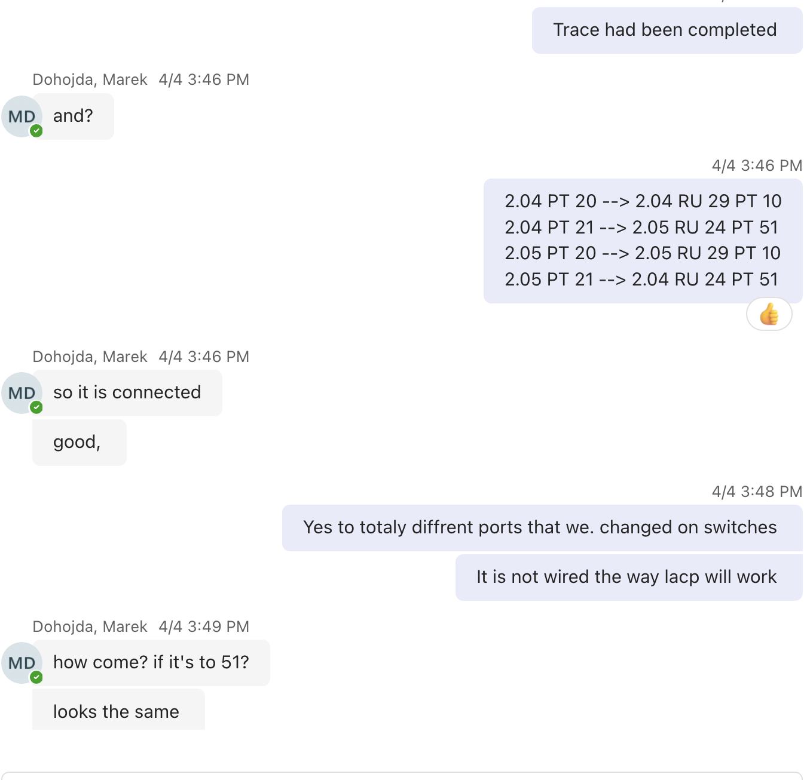
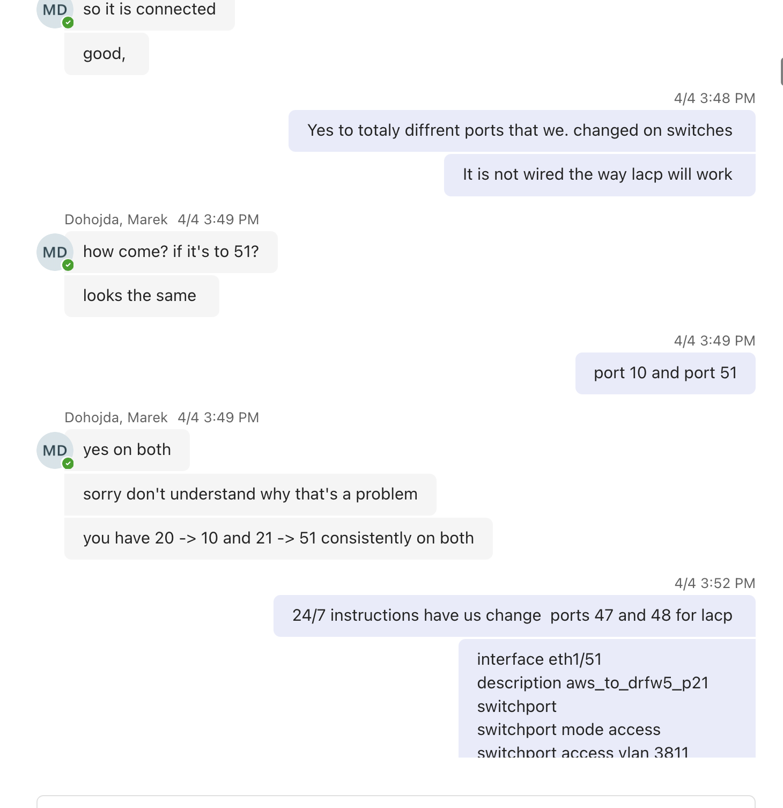

Requirements for an LDAPS certificate
To enable LDAPS, you must install a certificate that meets the following requirements:
- The LDAPS certificate is located in the Local Computer’s Personal certificate store (programmatically known as the computer’s MY certificate store).
- A private key that matches the certificate is present in the Local Computer’s store and is correctly associated with the certificate. The private key must not have strong private key protection enabled.
- The Enhanced Key Usage extension includes the Server Authentication (1.3.6.1.5.5.7.3.1) object identifier (also known as OID).
- The Active Directory fully qualified domain name of the domain controller (for example, dc01.contoso.com) must appear in one of the following places:
  - The Common Name (CN) in the Subject field
  - DNS entry in the Subject Alternative Name extension.
- The certificate was issued by a CA that the domain controller and the LDAPS clients trust. Trust is established by configuring the clients and the server to trust the root CA to which the issuing CA chains.
- Use the Schannel cryptographic service provider (CSP) to generate the key.

