ip access-group ACL-INTERNET-TO-COBANK in
ip access-group ACL-COBANK-TO-INTERNET out
ip tcp adjust-mss 1400

199.119.72.104

Jack, Chris,

We are adding VDIs to our environment. These VDIs will be used to send Interest Rate Summary files on a daily basis to your SFTP server.
We connect to your SFTP server via an IPSec Tunnel from our two data centers:

IPSec Tunnel Remote: 50.57.5.196
In Address Group: FundingCorp_RemoteA
Add 172.16.116.201 - 172.16.116.206

IPSec Tunnel Remote: 173.203.188.220
In Address Group: FundingCorp_RemoteB
Add 172.20.116.201 - 172.20.116.207
vpndenext2

crypto map outside_crypto_map 240 set peer 50.57.5.196
tunnel-group 50.57.5.196 type ipsec-l2l
tunnel-group 50.57.5.196 general-attributes
tunnel-group 50.57.5.196 ipsec-attributes

crypto map outside_crypto_map 245 set peer 173.203.188.220
tunnel-group 173.203.188.220 type ipsec-l2l
tunnel-group 173.203.188.220 general-attributes
tunnel-group 173.203.188.220 ipsec-attributes

ccess-list CoBank-2-FundingCorp extended permit ip object-group FundingCorp_local object-group FundingCorp_remote log
access-list CoBank-2-FundingCorpA extended permit ip object-group FundingCorp_local object-group FundingCorp_RemoteA log
access-list CoBank-2-FundingCorpB extended permit ip object-group FundingCorp_local object-group FundingCorp_RemoteB log
nat (inside,outside) source static FundingCorp_local FundingCorp_local destination static FundingCorp_remote FundingCorp_remote
crypto map outside_crypto_map 240 match address CoBank-2-FundingCorpA
crypto map outside_crypto_map 245 match address CoBank-2-FundingCorpB

access-list CoBank-2-FundingCorpA extended permit ip object-group FundingCorp_local object-group FundingCorp_RemoteA log
access-list CoBank-2-FundingCorpB extended permit ip object-group FundingCorp_local object-group FundingCorp_RemoteB log

object-group network FundingCorp_local
network-object host 172.29.116.20
network-object host 172.29.116.17
FundingCorp_RemoteA

object-group network FundingCorp_remote
network-object host 172.16.0.184
network-object host 172.20.0.39
network-object host 172.31.101.109
network-object host 172.31.102.109
network-object host 172.16.0.162
network-object host 172.16.0.172
network-object host 172.20.0.23
network-object host 172.20.0.25
network-object host 172.20.0.27
network-object object 172.31.113.161
network-object object 172.31.113.162
network-object object 172.31.113.163
network-object object 172.31.113.164
network-object object 172.31.113.165
network-object host 172.31.102.111
network-object host 172.16.0.178
network-object host 172.16.0.179
network-object host 172.20.0.47
network-object host 172.20.0.49
network-object host 172.16.1.177
network-object host 172.16.0.156
network-object host 172.20.0.153
network-object object 172.16.0.178
network-object object 172.20.0.164
network-object object 172.16.0.130
network-object object 172.16.3.173
network-object object 172.20.0.221
object-group network FundingCorp_local
network-object host 172.29.116.20
network-object host 172.29.116.17

object-group network FundingCorp_RemoteA
network-object host 172.31.101.109
network-object host 172.31.102.109
network-object host 172.16.0.172
network-object object 172.31.113.161
network-object object 172.31.113.162
network-object object 172.31.113.163
network-object object 172.31.113.164
network-object object 172.31.113.165
network-object host 172.16.0.156
network-object host 172.16.0.178
network-object object 172.16.0.130
network-object object 172.16.3.173
network-object object 172.31.113.166
network-object object 172.31.113.167
object-group network FundingCorp_RemoteB
network-object host 172.31.101.109
network-object host 172.31.102.109
network-object object 172.31.113.161
network-object object 172.31.113.162
network-object object 172.31.113.163
network-object object 172.31.113.164
network-object object 172.31.113.165
network-object host 172.20.0.153
network-object object 172.20.0.164
network-object object 172.20.0.221
network-object object 172.31.113.166
network-object object 172.31.113.167

network-object object 172.16.116.206
old switches
interface Loopback0
ip address 172.30.96.248 255.255.255.255

interface FastEthernet1
vrf forwarding mgmtVrf
ip address 172.30.97.27 255.255.255.128

ip address 172.30.97.26

CoBank

swdenacc1

username admin privilege 15 password Cobank1#

interface Loopback0
ip address 172.30.96.249 255.255.255.255

router ip host vrf Mgmt-intf tools.cisco.com 72.163.4.38

interface GigabitEthernet0
vrf forwarding Mgmt-intf

username master privilege 15 secret Cobank1#

ip address 172.30.97.57
config t
aaa authentication login default local
aaa authentication login console local
aaa authentication enable default none
add aaa authorization exec default group radius local
line vty 0 15
login local
bootflash:cat4500e-universalk9.SPA.03.08.07.E.152-4.E7.bin
ip domain-name na.cobank2.corp

vrf definition mgmtVrf
!
address-family ipv4
exit-address-family
!
address-family ipv6
exit-address-family
!
ip tftp source-interface FastEthernet1
ip route vrf mgmtVrf 0.0.0.0 0.0.0.0 172.30.97.1
ip tacacs source-interface Loopback0
ip ssh version 2

permit tcp any host 172.30.119.230 eq www
permit tcp any host 172.30.119.230 eq 443
permit tcp any host 172.30.119.230 eq 8443
permit tcp any host 172.30.119.230 eq 8905
permit udp any host 172.30.119.230 eq 8905
permit udp any host 172.30.119.230 eq 8906
permit tcp any host 172.30.119.230 eq 8080
permit udp any host 172.30.119.230 eq 9996
remark ISEDEN3
permit tcp any host 172.30.119.233 eq www
permit tcp any host 172.30.119.233 eq 443
permit tcp any host 172.30.119.233 eq 8443
permit tcp any host 172.30.119.233 eq 8905
permit udp any host 172.30.119.233 eq 8905
permit udp any host 172.30.119.233 eq 8906
permit tcp any host 172.30.119.233 eq 8080
permit udp any host 172.30.119.233 eq 9996
permit tcp any host 172.30.108.34 eq 4001
permit tcp any host 172.30.108.34 eq 4002
permit tcp any host 172.30.108.35 eq 4001
permit tcp any host 172.30.108.35 eq 4002
permit tcp any host 172.30.108.36 eq 4001
permit tcp any host 172.30.108.36 eq 4002
permit tcp any host 172.30.108.37 eq 4001
permit tcp any host 172.30.108.37 eq 4002
ip access-list extended ACL-DEFAULT
remark DHCP
permit udp any eq bootpc any eq bootps
remark DNS
permit udp any any eq domain
remark Ping
permit icmp any any
remark Allow host to ISE Servers for base network authentication
remark ISEDEN4
permit tcp any host 172.30.119.230 eq www
permit tcp any host 172.30.119.230 eq 443
permit tcp any host 172.30.119.230 eq 8443
permit tcp any host 172.30.119.230 eq 8905
permit udp any host 172.30.119.230 eq 8905
permit udp any host 172.30.119.230 eq 8906
permit tcp any host 172.30.119.230 eq 8080
permit udp any host 172.30.119.230 eq 9996
remark ISEDEN3
permit tcp any host 172.30.119.233 eq www
permit tcp any host 172.30.119.233 eq 443
permit tcp any host 172.30.119.233 eq 8443
permit tcp any host 172.30.119.233 eq 8905
permit udp any host 172.30.119.233 eq 8905
permit udp any host 172.30.119.233 eq 8906
permit tcp any host 172.30.119.233 eq 8080
permit udp any host 172.30.119.233 eq 9996
permit tcp any host 172.30.108.34 eq 4001
permit tcp any host 172.30.108.34 eq 4002
permit tcp any host 172.30.108.35 eq 4001
permit tcp any host 172.30.108.35 eq 4002
permit tcp any host 172.30.108.36 eq 4001
permit tcp any host 172.30.108.36 eq 4002
permit tcp any host 172.30.108.37 eq 4001
permit tcp any host 172.30.108.37 eq 4002
remark ISEWDL4
permit tcp any host 172.30.128.74 eq www
permit tcp any host 172.30.128.74 eq 443
permit tcp any host 172.30.128.74 eq 8443
permit tcp any host 172.30.128.74 eq 8905
permit udp any host 172.30.128.74 eq 8905
permit udp any host 172.30.128.74 eq 8906
permit tcp any host 172.30.128.74 eq 8080
permit udp any host 172.30.128.74 eq 9996
remark ISEWDL3
remark ISEWDL4
permit tcp any host 172.30.128.74 eq www
permit tcp any host 172.30.128.74 eq 443
permit tcp any host 172.30.128.74 eq 8443
permit tcp any host 172.30.128.74 eq 8905
permit udp any host 172.30.128.74 eq 8905
permit udp any host 172.30.128.74 eq 8906
permit tcp any host 172.30.128.74 eq 8080
permit udp any host 172.30.128.74 eq 9996
remark ISEWDL3
permit tcp any host 172.30.128.76 eq www
permit tcp any host 172.30.128.76 eq 443
permit tcp any host 172.30.128.76 eq 8443
permit tcp any host 172.30.128.76 eq 8905
permit udp any host 172.30.128.76 eq 8905
permit udp any host 172.30.128.76 eq 8906
permit tcp any host 172.30.128.76 eq 8080
permit udp any host 172.30.128.76 eq 9996
permit tcp any host 172.30.148.11 eq 4001
permit tcp any host 172.30.148.11 eq 4002
permit tcp any host 172.30.148.12 eq 4001
permit tcp any host 172.30.148.12 eq 4002
permit tcp any host 172.30.122.205 eq 4001
permit tcp any host 172.30.122.205 eq 4002
permit tcp any host 172.30.122.206 eq 4001
permit tcp any host 172.30.122.206 eq 4002
permit tcp any host 172.30.119.150 eq 88
permit tcp any host 172.30.119.150 eq 135
permit tcp any host 172.30.119.150 eq 139
permit tcp any host 172.30.119.150 eq 389
permit tcp any host 172.30.119.150 eq 445
permit tcp any host 172.30.119.150 range 49152 65535
permit udp any host 172.30.119.150 eq 389

remark ISEWDL3
permit tcp any host 172.30.128.76 eq www
permit tcp any host 172.30.128.76 eq 443
permit tcp any host 172.30.128.76 eq 8443
permit tcp any host 172.30.128.76 eq 8905
permit udp any host 172.30.128.76 eq 8905
permit udp any host 172.30.128.76 eq 8906
permit tcp any host 172.30.128.76 eq 8080
permit udp any host 172.30.128.76 eq 9996
permit tcp any host 172.30.148.11 eq 4001
permit tcp any host 172.30.148.11 eq 4002
permit tcp any host 172.30.148.12 eq 4001
permit tcp any host 172.30.148.12 eq 4002
permit tcp any host 172.30.122.205 eq 4001
permit tcp any host 172.30.122.205 eq 4002
permit tcp any host 172.30.122.206 eq 4001
permit tcp any host 172.30.122.206 eq 4002
permit tcp any host 172.30.119.150 eq 88
permit tcp any host 172.30.119.150 eq 135
permit tcp any host 172.30.119.150 eq 139
permit tcp any host 172.30.119.150 eq 389
permit tcp any host 172.30.119.150 eq 445
permit tcp any host 172.30.119.150 range 49152 65535
permit udp any host 172.30.119.150 eq 389
permit tcp any host 172.30.119.151 eq 88
permit tcp any host 172.30.119.151 eq 135
permit tcp any host 172.30.119.151 eq 139
permit tcp any host 172.30.119.151 eq 389
permit tcp any host 172.30.119.151 eq 445
permit tcp any host 172.30.119.151 range 49152 65535
permit udp any host 172.30.119.151 eq 389
remark Deny all
deny ip any any

interface GigabitEthernet0
vrf forwarding Mgmt-intf
ip address 172.30.97.57 255.255.255.128
negotiation auto
!

ip ssh version 2
crypto key generate rsa general-keys modulus 2048

aaa new-model
aaa authentication login default local

aaa 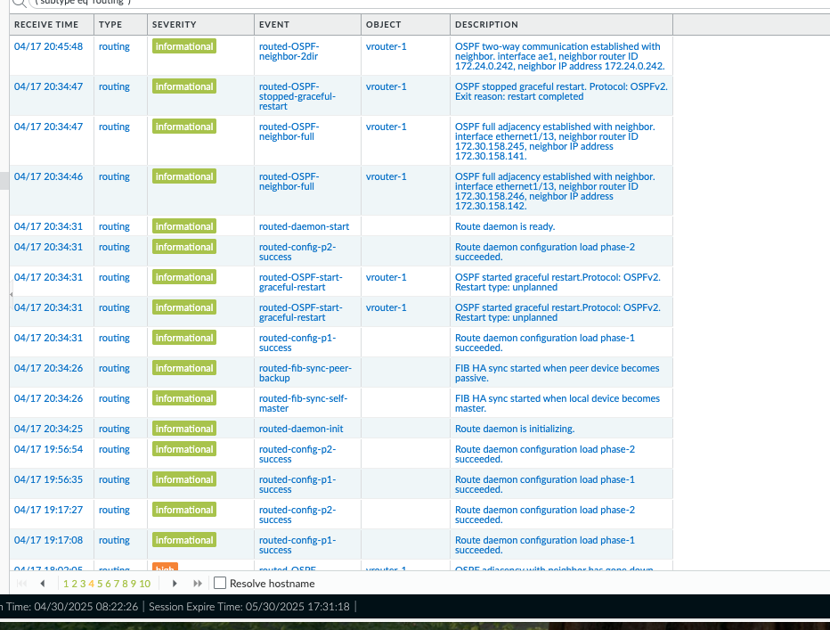 authorization commands 15 default local if-authenticated

Gi1/0/23 thr1wan9k connected 150 a-full a-1000 10/100/1000BaseTX
Gi1/0/24 thr2wan9k notconnect 150 auto auto 10/100/1000BaseTX

