1. 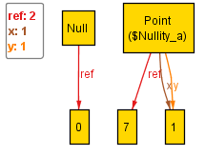Set 0 violated the nullity rule since a point was not equal to itself. Below is the code for reproducing the error.

Point p = **new** Point(1,1);

System.***out***.printf("Expected: %b, Actual: %b", **false**, p.equals(**null**));

1. 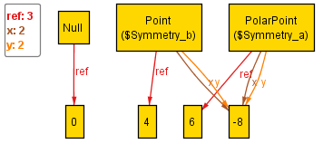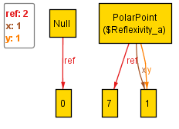Set 1 violated the reflexivity and symmetry rules.

PolarPoint p1 = **new** PolarPoint(**new** Point(1, 1));

System.***out***.println("Reflexitvity violation: p1 != p1");

System.***out***.printf("Expected: true, Actual: %b\n", p1.equals(p1));

Point p2 = **new** Point(-8, -8);

PolarPoint p3 = **new** PolarPoint(p2);

System.***out***.println("Symmetry violation: p2 != p3 but p3 = p2");

System.***out***.printf("Expected: false, false, Actual: %b, %b\n", p2.equals(p3), p3.equals(p2));

1. 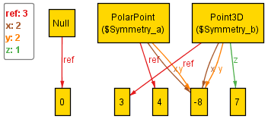Set 2 violated symmetry.

Point p1 = **new** Point(-8, -8);

Point3D p2 = **new** Point3D(-8, -8, 7);

System.***out***.println("Symmetry violation: p1 = p2 but p2 != p1");

System.***out***.printf("Expected: false, false, Actual: %b, %b", p1.equals(p2),

p2.equals(p1));

1. 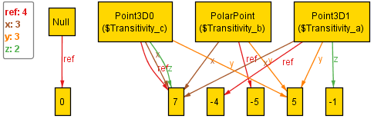Set 3 violated transitivity.

Point3D p1 = **new** Point3D(7, 5, -1);

PolarPoint p2 = **new** PolarPoint(**new** Point(7, 5));

Point3D p3 = **new** Point3D(7, 5, 7);

System.***out***.println("Transitivity violation: p1 = p2, p2 = p3, but p1 != p3");

**boolean** c1 = p1.equals(p2);

**boolean** c2 = p2.equals(p3);

**boolean** c3 = p1.equals(p3);

System.***out***.printf("Expected: false, false, false, Actual: %b, %b, %b",

c1, c2, c3);

1. Set 4 did not violate any principles.
2. 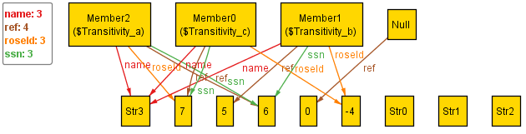Set 5 violated transitivity

Member a = **new** Member("Str$3", 7, 6);

Member b = **new** Member("Str$3", -4, 6);

Member c = **new** Member("Str$3", -4, 7);

System.***out***.println("Transitivity error: a = b, b = c, a != c");

**boolean** c1 = a.equals(b);

**boolean** c2 = b.equals(c);

**boolean** c3 = a.equals(c);

System.***out***.printf("Expected: false, false, false, Actual: %b, %b, %b",

c1, c2, c3);