**Michael Trittin**

**Homework 5**

1. See code
2. Win State  
   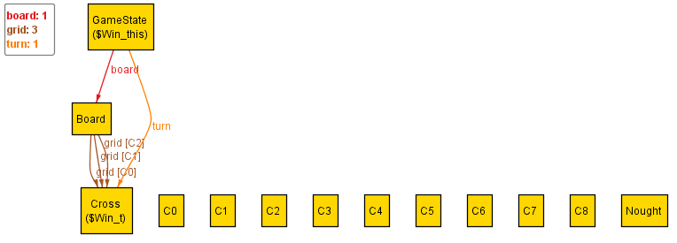

|  |  |  |
| --- | --- | --- |
| X | X | X |
|  |  |  |
|  |  |  |

1. Draw State  
   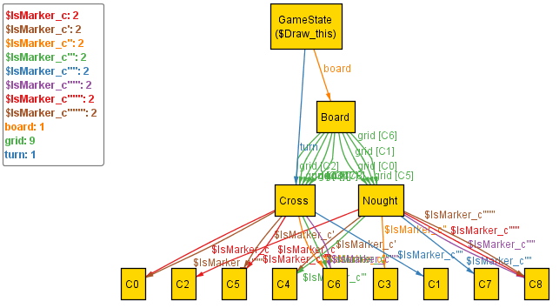

|  |  |  |
| --- | --- | --- |
| O | O | X |
| X | O | O |
| O | X | X |

1. Winning Trace  
   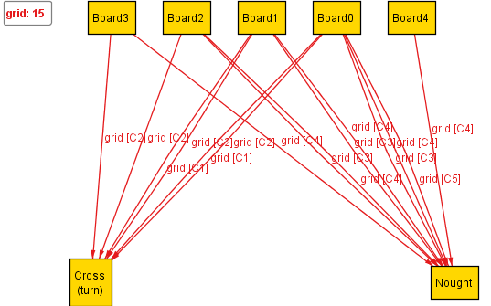

|  |  |  |  |  |  |  |  |  |  |  |  |  |  |  |  |  |  |  |  |  |  |  |  |  |  |  |  |  |  |
| --- | --- | --- | --- | --- | --- | --- | --- | --- | --- | --- | --- | --- | --- | --- | --- | --- | --- | --- | --- | --- | --- | --- | --- | --- | --- | --- | --- | --- | --- |
| |  |  |  | | --- | --- | --- | |  |  |  | |  | O |  | |  |  |  | | |  |  |  | | --- | --- | --- | |  |  | X | |  | O |  | |  |  |  | | |  |  |  | | --- | --- | --- | |  |  | X | | O | O |  | |  |  |  | |
| |  |  |  | | --- | --- | --- | |  | X | X | | O | O |  | |  |  |  | | |  |  |  | | --- | --- | --- | |  | X | X | | O | O | O | |  |  |  | |  |

1. Draw Trace  
   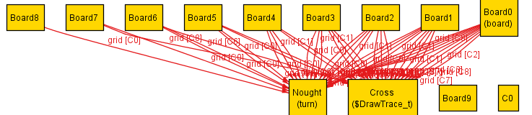

|  |  |  |  |  |  |  |  |  |  |  |  |  |  |  |  |  |  |  |  |  |  |  |  |  |  |  |  |  |  |
| --- | --- | --- | --- | --- | --- | --- | --- | --- | --- | --- | --- | --- | --- | --- | --- | --- | --- | --- | --- | --- | --- | --- | --- | --- | --- | --- | --- | --- | --- |
| |  |  |  | | --- | --- | --- | | O |  |  | |  |  |  | |  |  |  | | |  |  |  | | --- | --- | --- | | O |  |  | |  |  |  | |  |  | X | | |  |  |  | | --- | --- | --- | | O | O | X | | X | O |  | | O | X | X | |
| |  |  |  | | --- | --- | --- | | O | O | X | | X | O | O | | O | X | X | |  |  |