**Michael Trittin**

**Lab 5**

1. All the processes have something to send: P2 sends to P0, P0 to P1, and P1 to P2  
   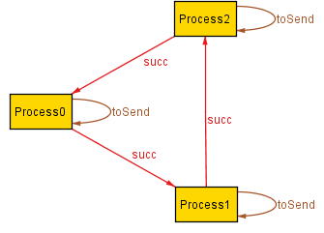   
   P0 decides to send to P2, P0 and P1 stay the same  
     
   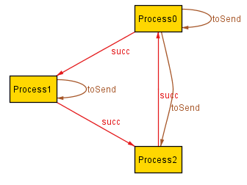  
   P1 sends to P2  
   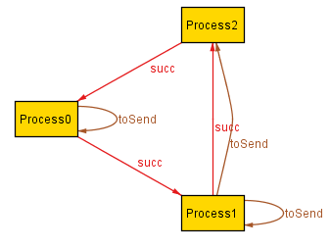  
   P2, since it was sent messages by both P0 and P1, is elected  
   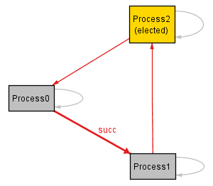
2. Assertion of AtMostOneElected is valid
3. I got a counterexample where the model did not ever elect a leader since the model did not ensure progression for each successive state.
4. No counterexample found for AtLeastOneElected since the assertion ensures that every successive state has progression, and thus we always reach an election within the target time.
5. At time 13, Alloy cannot find an instance that avoids a looping state. Time 12 is the limit for 3 Processes without a looping state.