**Michael Trittin**

**Homework 7**

**Problem 1.**

1. The procedure works by providing the SAT solver with the appropriate variables and the conditions which apply to those variables. The SAT solver will compose these initial values into boolean expressions, and attempt to find a solution which the expressions hold true for (SAT). On the first run, this will generate 0, 0, 0 as a solution, and go no further because our conditions do not specify that we want to maximize the values. In order to maximize, we need to use CEGAR, which will incrementally maximize each variable until it finds UNSAT.  
     
   Optimal Solution:  
   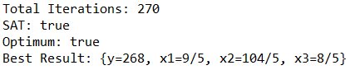

**Problem 2-4.**

1. Yices produced a solution (SAT), which means that the min method will not work correctly for values a = -1, b = 0.  
   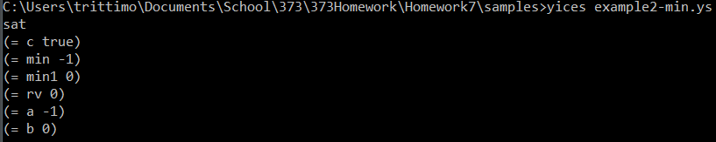
2. There are no bad values for max that Yices could find  
   
3. There are bad values with a = 0, b = 0, c = 1.  
   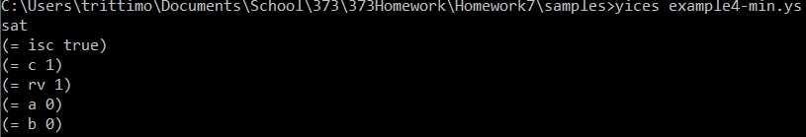

**Problem 5.**