

Software Testing and Quality Assurance

Assignment # 4

White box testing and unit test

Prepared by:

motaz hashhoush - 11924224

Supervisors:

Dr.Mustafa Assaf

## Method [add]

### paths

* s -> (22,23) -> E

## Method [subtract]

### paths

* s -> (27,28) -> E

## Method [multiply]

### paths

* s -> (32,33) -> E

## 

## 

## Method [divide]

### paths

* s -> 37 -> (38, 39) -> E
* s -> 37 -> 40 -> 41 -> E
* s -> 37 -> 40 -> (42,43,44) -> E

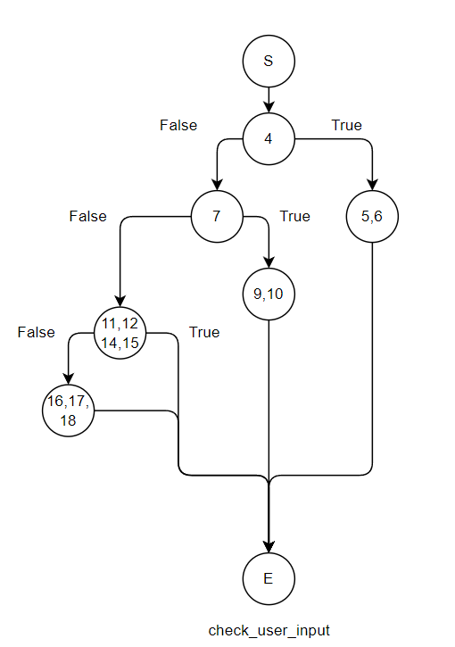

## Method [check_user_input]

### paths

* s -> 4-> (5, 6) -> E
* s -> 4 -> 7 -> (9,10 )-> E
* s -> 4-> 7-> (11,12,14,15) -> E
* s -> 4-> 7-> (11,12,14,15) -> (16,17,18) -> E

## Method [isExit]

### paths

* s -> 79-> 80 -> E
* s -> 79 -> 81 -> 82 -> E
* s -> 79-> 81-> 83-> E

## Method [calculate]

paths

* s -> 50-> (51,52) -> E
* s -> 50-> (53,54,55,56) -> 58-> 59-> 75-> E
* s -> 50-> (53,54,55,56) -> 58-> 61-> 62-> 75-> E
* s -> 50-> (53,54,55,56) -> 58-> 61-> 64-> 65-> 75->E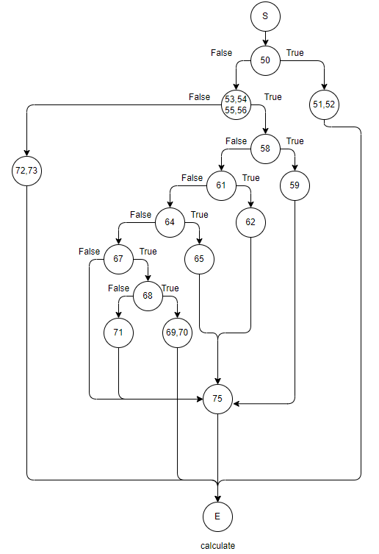
* s -> 50-> (53,54,55,56) -> 58-> 61-> 64-> 67-> 68-> (69,70)->E
* s -> 50-> (53,54,55,56) -> 58-> 61-> 64-> 67-> 68-> 71->75->E
* s -> 50-> (53,54,55,56) -> 58-> 61-> 64-> 67->75->E
* s -> 50-> (53,54,55,56) -> (72,73)->E

The minimal number of paths that achieve 100% code statement coverage

* s -> (32,33) -> E
* s -> (27,28) -> E
* s -> (22,23) -> E