PRODUCT OVERVIEW · OCTOBER 2026

Vaani
A voice agent that gets names right.
Vaani answers the phone for a lending company (an NBFC). Callers speak Hindi, Hinglish, Marathi, Tamil or Indian English. Before Vaani can help, it has to hear a name, a date of birth, a loan ID or a city correctly through noisy speech recognition. This overview covers the whole system and spends most of its length on the hardest part: matching a spoken name to the right record.
2 helplines: customers and staff · 25 agent tools with access rules · 50 test scenarios · 982 matcher test items · 201 automated tests
WHY LETTER MATCHING FAILS

Two letters apart can be the same place. One letter apart can be a different person.
Baadmer → Barmer Same district
heard | b | aa | d | m | e | r
record | b | a | r | m | e | r
cost | 0 | 0.25 | 0.35 | 0 | 0 | 0
Letter edits: 2 Vaani's sound distance: 0.60
Vowel length (aa/a) is a small change. The retroflex flap ड़ is heard as r and written as d, a known confusion that costs 0.35.
Mohan → Rohan Different people
heard | m | · | o | h | a | n
record | · | r | o | h | a | n
cost | 0.85 | 0.85 | 0 | 0 | 0 | 0
Letter edits: 1 Vaani's sound distance: 1.70
m is made with the lips, r with the tongue tip. They share nothing, so the cheapest path drops one sound and adds the other.
THE CORE TASK

One person, many spellings
Speech recognition returns Hindi and Marathi in Devanagari, Tamil in Tamil script, and English in whatever Roman spelling the model guesses. Customer records are stored in Roman letters. So the same customer can reach the system as Sultan Meena, सुल्तान मीणा, or Meena Sultan, and the same district as Barmer, Baadmer or बाड़मेर.
The usual tool for fuzzy matching is letter edit distance (Levenshtein). It treats every letter change as equally bad. That is wrong for speech in both directions, as the two examples above show. English phonetic codes such as Metaphone don't help much either, because their rules were written for English spelling.
Vaani compares sounds instead of letters. It converts every input into one phonetic alphabet, splits it into sounds, and prices each difference by how alike the two sounds are when spoken.
HOW THE MATCHER WORKS

From what was heard to a scored match, in five steps
Each step runs in plain Python in identify/. No model is involved, so the same input always gives the same answer.

1. Convert every script into one phonetic alphabet
Devanagari and Tamil are converted to lowercase Roman with long vowels doubled (aa, ee, oo) and retroflex consonants marked (ṭ ḍ ṇ ḷ ṛ). Two language rules matter most. Hindi drops the silent inherent vowel (schwa deletion), so मोहन becomes mohan, not mohana. Tamil voices a stop between vowels or after a nasal, so முருகன் becomes murugan, not murukan.
बाड़मेर → baaṛmer
सुल्तान मीणा → sultaan meeṇaa
முருகன் → murugan

2. Fold English-style spellings
Roman spellings of Indian names follow English habits that hide the sound. A short list of rewrites removes them: ck and q become k, a final -ey becomes e (Pandey, Dubey), ay before a consonant becomes ai (Sanjay, Jaipur), and doubled consonants collapse (Pillai and Pilai).
Pandey → pande distance to Pande: 0.00
Sanjay → sanjai distance to संजय: 0.00

3. Split into sounds
The folded text is cut into sounds by greedy longest match against an inventory of 37 consonants and 10 vowels. Aspirates such as kh and bh count as one sound, not two letters.
baaṛmer → b · aa · ṛ · m · e · r
shrivastav → sh · r · i · v · a · s · t · a · v
lakhnau → l · a · kh · n · au

4. Price each difference by how the sounds are made
Every consonant is described by where it is made in the mouth, how it is made, whether it is voiced, and whether it is aspirated. Every vowel is described by height, front-to-back position and length. Swapping one sound for another costs the weighted difference of those features. Missing or extra sounds have their own costs, cheaper for sounds that spelling often adds or drops.
Feature | Values | Weight
Place (consonants) | lips, teeth, tongue curled back (retroflex), palate, soft palate, throat | 0.45
Manner (consonants) | stop, nasal, fricative, approximant, flap, affricate | 0.45
Voicing | p / b, t / d, k / g | 0.25
Aspiration | k / kh, b / bh | 0.15
Vowel height and position | i / e / a, u / o | 0.35 each
Vowel length | a / aa, i / ee | 0.25
Missing or extra sound | silent a or h: 0.40, y: 0.50, other vowels: 0.60, consonants: 0.85 | n/a

Features alone don't capture how Indian languages are actually written in Roman script. A table of 20 known confusions, each with a reason, overrides the feature cost:
Sounds | Cost | Why
r / ṛ | 0.15 | The flap ड़ is heard and written as r (Baadmer / Barmer)
t / ṭ, d / ḍ | 0.20 | Roman script has no dental / retroflex distinction
v / w | 0.15 | No v / w contrast in most Indian languages
sh / s | 0.30 | sh and s merge in many dialects and in Tamil
k / g, p / b | 0.25 | Tamil writes each pair with one letter
zh / l | 0.30 | Tamil ழ is often written l (Ilango)

Names with two words are compared in both orders, with a 0.20 penalty for the swap, because callers often give the surname first. Meena Sultan scores 0.20 against Sultan Meena, where letter distance gives 10.

5. Rank, then decide how sure to be
The heard name is scored against every candidate. Confidence depends on two numbers: the best distance, and how far ahead it is of the runner-up. A close second candidate lowers confidence even when the best match is good. Confidence decides what the agent does next.
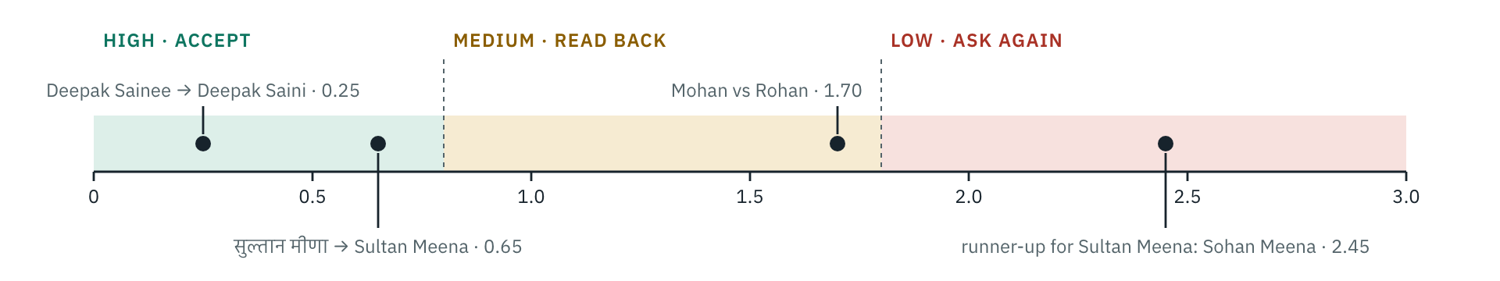
Name distance thresholds, drawn to scale. High also needs a lead of at least 1.0 over the runner-up, and medium a lead of 0.4. Places use slightly tighter bands (0.8 and 1.6).
WHERE THE MATCHER SITS

The model finds the words. Code decides the match.
The language model (Amazon Nova 2 Lite) never decides that a name or a date matched.
When a caller says “teis April unnees sau sattaasi”, the model's only job is to pass those exact words to a tool. The tool normalises them (1987-04-23), matches them against the records, scores the result and tells the agent what to do: accept, read the value back (“Maine suna 23 April 1987, sahi hai?”), or ask again. The same pattern covers dates, amounts, loan IDs, pincodes and districts, and spoken numbers in English, Hindi, Marathi and Tamil.
A name is a consistency check, not the security gate. Different people can sound almost the same: Anil Patel and Anil Patil are 0.35 apart. So a customer is verified in three layers:
1 · NARROW  An exact identifier  Date of birth, registered mobile or loan ID cuts the pool of candidates to one or a few records. | 2 · CHECK  The name, by sound  The spoken name must be within 2.0 of someone in that small pool. Other customers' names are never shown. | 3 · PROVE  A one-time password  For the registered mobile. In the demo it arrives as an SMS on the simulated phone. Only then do account tools appear for the model to use.

Places use the same matcher against all 745 Indian districts plus common city names. A pincode, when given, cross-checks the district. Bangalore matches Bengaluru Urban exactly, but Mangalore is only 0.45 away, so Vaani reads it back before acting.
EVALUATION

How it compares
982 test items. Names are matched against all 300 customers, places against 745 districts and their aliases. All three matchers get the same romanised input, so the comparison measures matching, not transliteration.
Test set | Items | Levenshtein | Metaphone | Vaani (sounds)
Hand-written names: STT spellings, surname first, native script | 62 | 96.8% | 96.8% | 100%
Hand-written places: Baadmer, Lakhnau, Koyambattur, old names | 50 | 92.0% | 74.0% | 100%
Customer names written in Devanagari or Tamil script | 254 | 97.6% | 97.6% | 100%
Rule-made spelling variants, names | 246 | 99.6% | 96.3% | 100%
Rule-made spelling variants, places | 170 | 97.6% | 90.0% | 100%

Top-1 accuracy: the right record ranked first.

Confidence is calibrated
Confidence | Names | Places | Correct
high · accept | 425 | 195 | 100%
medium · read back | 108 | 17 | 100%
low · ask again | 29 | 8 | 100%

Callers who are not customers
200 made-up full names built from the same name lists, none of them a customer. Anything except a confident match is the right outcome.
Outcome | Callers
asked again | 194
read back for confirmation | 5
wrongly high: Raman Patil → Raman Patel | 1

How to read these numbers
The rule-made variants use the same confusions the matcher was designed around, so that set flatters it. Two misses on the hand-written set were fixed after the first run, so it is not fully held out. All items are text, not recordings of real callers. The one wrong high match is why the name alone never verifies anyone.

SYSTEM ARCHITECTURE

How a call flows
A browser-based phone simulator calls the server over WebRTC. Speech goes in, the agent decides what to look up, the identification core checks what was heard, and the reply is spoken back.
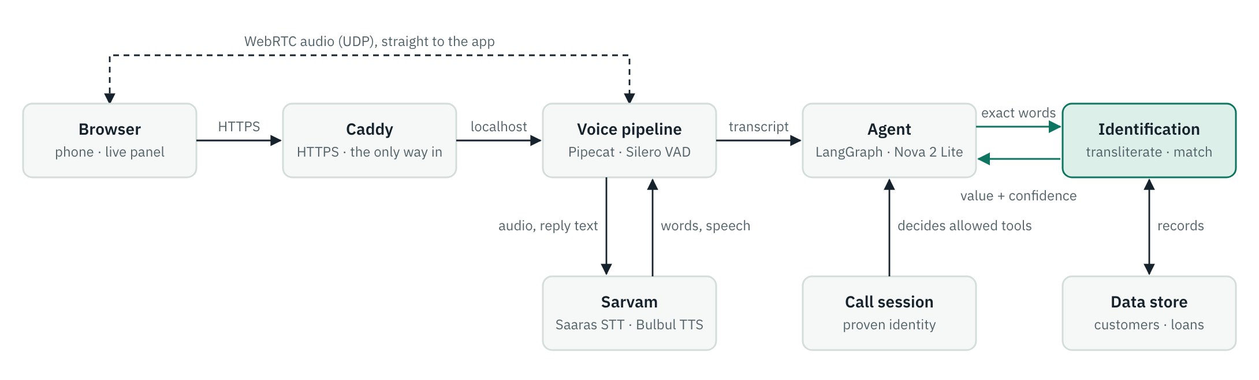
Requests and call setup pass through Caddy; the app itself listens only on localhost. Audio travels over WebRTC straight to the voice pipeline. The green path is the part this document is about: the agent hands over the caller's exact words, and code returns a checked value.
Part | Built with | Role
Speech to text, text to speech | Sarvam Saaras v4, Bulbul v3 | 10 Indian languages plus English, including code-mixed speech
Real-time voice | Pipecat over WebRTC, Silero VAD | Turn-taking, barge-in, a short filler while a lookup runs
Agent | LangGraph tool loop on Amazon Nova 2 Lite (Bedrock) | Understands the request and picks a tool; a gate refreshes which tools are allowed at every step
Identification core | Own Python code, identify/ | Transliteration, sound matching, spoken numbers and dates, IDs, confidence
Frontend | React and Vite | Phone simulator, 50 scenarios, and a live panel showing each value as it is heard, normalised, matched and scored
Hosting | Docker, Caddy | Automatic HTTPS; the app is never exposed directly

SECURITY

What a caller can and cannot make it do
Who may see what is decided in code. Nothing a caller says to the model can widen it.

Identity lives in the session
- Tools read who the caller is from the call session, never from the model's arguments.
- Before verification a customer can only verify, find a branch, report fraud or ask for a callback. Account tools appear only after the OTP.
- Staff log in with employee ID and PIN; their role decides their tools.
- A last check stops internal case notes from ever being spoken to a customer.

The server is closed by default
- The app listens only on localhost behind Caddy, and refuses to start in production otherwise.
- Nothing past the login screen works without the access code; wrong guesses are rate-limited per address.
- Each call has its own bearer token, kept out of URLs; the voice connection and event stream are bound to it.
- Strict content security policy and headers, request size limits, no stack traces in responses.
- The container runs read-only, as a non-root user, with every Linux capability dropped.

Costs and data are capped
- Limits on concurrent voice calls, calls per address per hour, a daily call budget, call length, silence, turns and agent steps per turn.
- Phone numbers, dates of birth, OTPs and PINs are masked in logs and in the audit trail.
- No AWS keys in the app's configuration: Bedrock access comes from the server's IAM role. The Sarvam key is the only secret in the server's environment file.
- All customer data is synthetic.
IN PRODUCTION

What changes for a real lender
The demo runs on one server with 300 synthetic customers. This is the plan for millions of customers and real phone lines.

Matching at scale
Customer verification already scales, because the exact identifier narrows the pool to a handful of records before any name is compared. Its cost stays flat as the customer base grows.
Staff name search across millions of records needs a two-stage search. Each record's sound sequence is computed once, when the record is written, and indexed by a coarse phonetic key that merges confusable sounds (d, ḍ, ṛ and r share one class). A search fetches the few hundred records that share the key, then ranks them with the full weighted distance. With about ten sounds per name, that distance is cheap.

Learning from read-backs
Every read-back produces a labelled pair: what speech recognition heard, and what the caller confirmed. Logged with consent, these pairs tune the confusion costs for each language and each speech model, and refit the thresholds on a held-out set.
The share of read-backs that callers reject is the live quality measure. If it rises after a speech model update, thresholds are too loose.

Real phone lines
WebRTC in the browser is replaced by a telephony provider over SIP. Phone audio is narrowband (8 kHz), which makes recognition worse, so thresholds are retuned on phone recordings and more values get read back. OTPs go out through a registered SMS provider, which in India means DLT template registration.

More than one server
Sessions and rate limits move from process memory to Redis, and records to a database, behind the same interfaces the code already uses. Application servers become stateless and sit behind a load balancer, with a TURN relay for callers on networks that block UDP.

More scripts
Transliteration covers Devanagari and Tamil today. Bengali, Telugu, Kannada, Malayalam and Gujarati each need their own script rules, written the same way and tested with every customer name in that script.

Data protection
Consent, purpose limits and retention periods under India's Digital Personal Data Protection Act. Masking in logs, an audit trail of every tool call and session-bound access already follow that model. In production the audit trail moves from a rotating log file to tamper-evident storage.
KNOWN GAPS

What is not proven yet
- The matcher is measured on text, not on recordings of real callers.
- Marathi number words need checking by a native speaker.
- Sound-alike names (Anil Patel, Anil Patil) cannot be told apart by sound alone. The design relies on the exact identifier and the OTP for that.
- One server process: sessions, rate limits and records created during calls live in memory until restart.
Matcher: identify/phonetic.py, identify/translit.py · Evaluation: eval/matchers.py

