Consumers of internet based businesses like online shopping portals, travel management sites, video streaming services, etc. switch their loyalty and look towards competitors' services. If they experience issues like loading time of more than 3-4 seconds for any page, frozen screens, frequent website down times, etc. You would have encountered lot of websites with such performance issues and didn't bother to visit them again. Such websites exist even today because their software development teams do not give as much importance to testing the performance of their website as they give to testing its functionalities.
Therfore, through this course will be able to determine the significance of performance testing and fundamental concepts applied while conducting performance tests on web applications.

By the end of this course, you will be able to:
- analyze application performance requirements by creating a workload model
- determine and state the activities involved in different stages of performance testing such as:
  - Requirements analysis
  - Test strategy
  - Test design and development
  - Test execution
  - Test result analysis
  - Post tuning testing and analysis
- examine and ascertain the need for different types of performance tests such as:
  - Load test
  - Stress test
  - Endurance test
  - Volume test
  - Availability test
  - Scalability test

Is Website Performance Important?

Would it be sufficient if performing functional testing on a web application and assuring that every field/element is working according to its purpose
This absolutely will not be sufficient.
According to 2009 Forrester survey report, internet users become impatient when a webpage takes more two seconds to load. Also, according to the same survey:
- 40 % of visitors don't visit a website again if it takes more than 3 seconds to load.
- 79% of online shoppers who are dissatisfied with website performance are less likely to buy from the same site again.
- 52% of online shoppers state that quick page loading is important to their site loyalty.
For internet enabled businesses such as online shopping portals or travel websites with sales of about $100,000 per day, an average of one second delay in loading pages could potentially cost them $2,500,000 worth sales every year.
This means that, before a software released on a website, testing its performance is as important as testing its functionality.

What is Performance?

While browsing an online shopping site to buy a product l, you would be satisfied with website's 'performance' if it:
- Does not stop responding to the clicks and keystrokes while trying to provide search strings, selecting a product, making a product etc.
- Does not display a 'Page cannot be displayed' error after clicking on the search button, checkout button, etc.
- Displays the search results, pictures of the product, payment confirmations, etc. without any irritating delays.
The below image is with generic sequence of events that happens during normal customer interaction with any online shopping portal. The performance of the application is considered good if the responses from the servers are as quick as shown below.
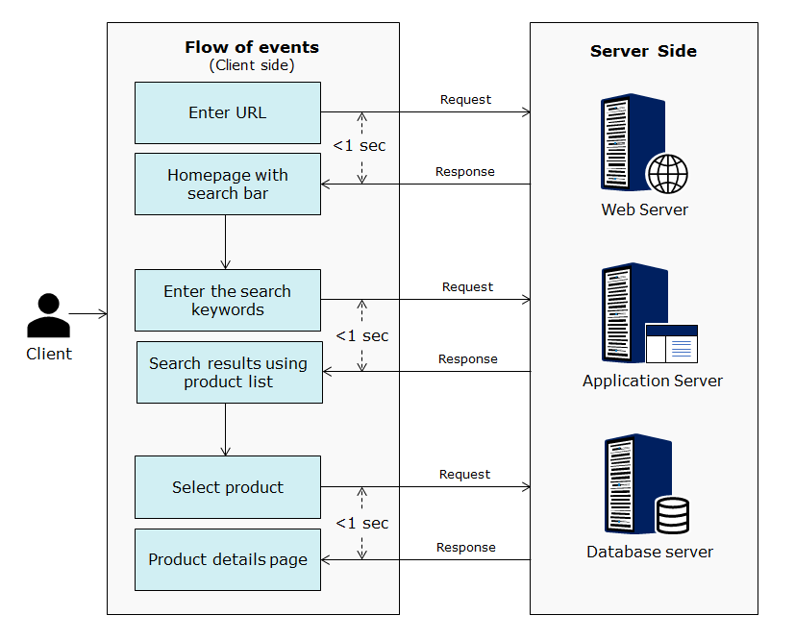
Measuring Performance

An application's performance may be subjective with user experience. However, as a performance tester, you should know how to state and measure it objectively. Some of the basic parameters that can be used to measure and state application performance are:
Response Time: Time taken by the server to process HTTP request.
Hit time: Time taken to complete a successful HTTP request. It is the sum of Connect, Send, Response and Process Times.
Transactions per Second (TPS) or Hits/second: The number of times the clients made an HTTP request divided by the elapsed time, in seconds.
Failed Transactions: The number of times the clients did not obtain the correct HTTP response
Successful Transactions: The number of times the Virtual Clients obtained the correct HTTP response.
Throughput: Work done per unit of time (Transactions/sec or Bytes/sec)
CPU Utilization: Percentage of time the CPU is busy.
Memory Utilization: Memory (RAM) used up by a process at client terminal or on web servers.
Load Size: Number of concurrent virtual users accessing the AUT (Application Under Test)
Think Time: The time taken by the user to think between 2 consecutive requests

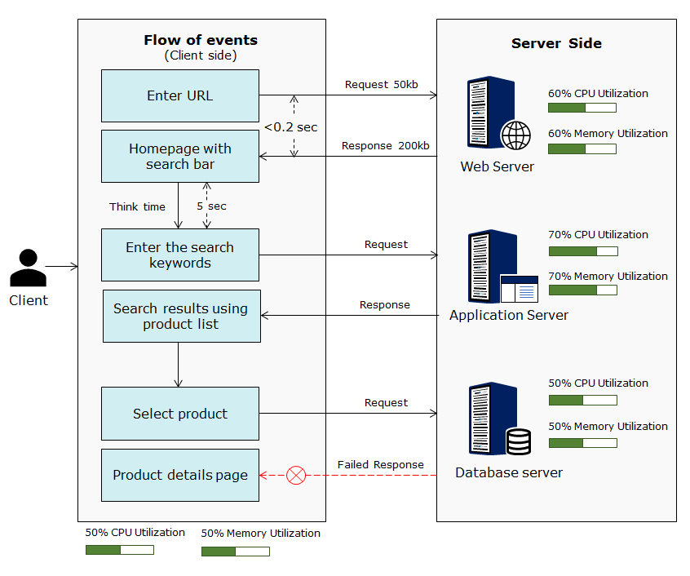
What Performance Measurements Specifies?

If there is high response times along with high CPU utilization and memory utilization on the web server when 50 concurrent users (load) are connected, then it indicates that the web server's hardware resources are insufficient to handle live website load of more than 50 concurrent users.
If the high response times is due along with high memory utilization on the database server indicates that the tables in the DB are not normalized..
The slowest performing constituent of any system (for e.g., application code in the application server, queries on database, services in web server, etc.) determines the overall performance of that system are called performance bottlenecks.
Therefore measuring performance parameters can:
- objectively state whether the application is ready for deployment based on real world conditions, (i.e. average load, peak load, network bandwidth) in which the application is going to work.​​​​​​​
- identify the bottlenecks which are degrading the performance of the application.
​​​​​​​
What is Performance Testing ?
Definition
Performance testing is a process concerned with determining and reporting the current performance of a software application when subjected to various user loads.
Objective
The objective of performance testing are to:
- either find the performance bottlenecks of a completely built system.
- or benchmark the performance requirements of individual modules or entire system.
- or Both
Inferences
After conducting performance tests on a system, the feedback on you will be able to tell whether the system meets the clients' expectations can be provided in terms of:
- Speed: Will the application respond fast enough to its users in the live environment?
- Scalability: Will the application have acceptable response times drop during projected peak loads? (e.g.: 100,000 concurrent users)​​​​​​​
- Stability: Will the application work without transactions failures, screen freezes or slow response times under regular loads? (e.g.: 1000 concurrent users)

When to Conduct Performance Tests ?
The below image is with performance testing activities that are aligned with the software development lifecycle.
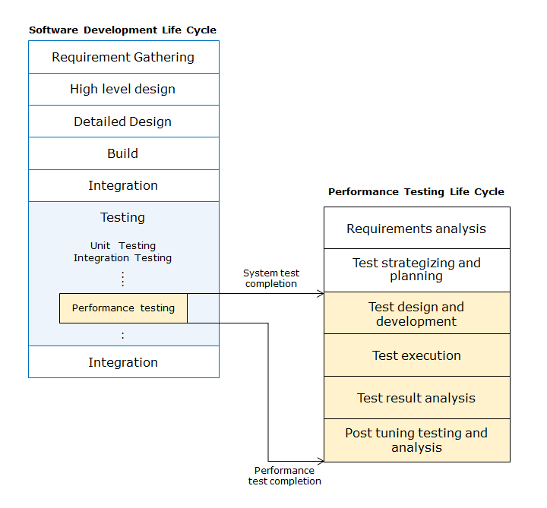
- Once performance requirements are finalized during requirements gathering phase of SDLC, the performance testing lifecycle can be kicked off.
- Performance test planning activities happen in parallel with development lifecycle.​​​​​​​
- A functionally stable version of application is a pre-requisite for performance test execution. Hence, it is preferable to execute performance tests after system testing completion

Q1 of 3
What is the first indication of a performance problem in an InfoKart online shopping website?
The network delay time is above 15ms.
The DNS is not resolving the machine name.
The Web server's available memory drops below 10 MB.
The end user experiences higher than expected response time

Q2 of 3
Which performance test objective is met when determining the cause of performance degradation?
Bottleneck identification
Product evaluation
Capacity planning
Reliability
Q3 of 3
Online shopping website is developed and needs to be tested before going online. When is the appropriate time for Performance testing in STLC?
Before functional testing
After functional testing
During functional testing
None of the given options

Proactive Performance Approach
Traditional performance test approaches are unable to validate applications due to complexities that are in these applications. Reactive performance test approaches are where applications are built, tested, and tuned later but result in increasing the cost associated with performance testing and lengthening the go-to-market time. Proactive performance test approach can solve these issues which is explained below:

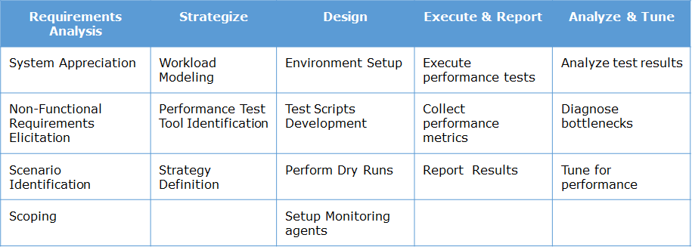

How is Performance Test Conducted?

Now let us understand the various activities involved in testing the performance of an application by considering an example of an e-commerce portal called ‘Infokart’.
Following are the modules of Infokart website and the activities involved in identifying bottlenecks and fine tuning it’s performance are:
- Login
- Search
- Shopping cart
- logout
To simplify the understanding of the sequence of tasks involved each of the following Performance Testing lifecycle phases are considered.

Different stages of Performance test​​​​​​​
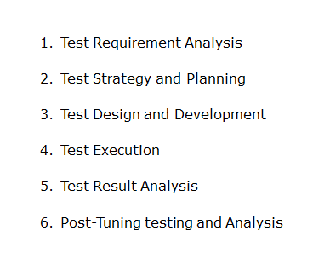
Requirements analysis
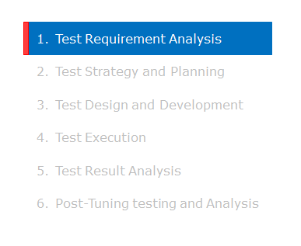

Objectives​​​​​​​
Determine the scope of performance testing.​​​​​​​
- Determine whether the performance requirements are complete, unambiguous, and testable. As per rule, the expected performance must be stated numerically in terms of response times and/or resource utilization
.Input
- Requirements, Design Architecture documents
- NFR gathering questionnaire
Roles
- Performance test manager and Performance test engineer
Activities
- Understand the scope of performance testing​​​​​​​
  - The entire application will not be tested for performance.The critical scenarios/functionalities from the application are tested.
  - The scope is to test Login, Search,Shopping cart and Logout.
- Gather performance test requirement/expectations
  - The expected response time each module is derived as:
    - Login = 1 second
    - Search =3 seconds
    - shopping cart =3 seconds
    - logout = 1 second
  - In any situation, the server processor utilization must not go above 80%.
- Understand the application by identifying the common usage patterns such as:
  - Sample usage pattern: Login search logout
  - Login logout
  - Login search shopping cart logout
- ​​​​​​​Prioritize test requirements based on criticality and time to market, and if in case​​​​​​​
  - the application is small, all modules can be tested
- Understand production infrastructure to help derive the performance test environment requirements.
- Understand implementation architecture to decide on tools usage.
- If needed, prepare performance requirements document with all the requirement and expectations.
Output
- Performance Test requirements approved and signed off by performance testing team.

Performance testing methodology

The below image represents the standard performance testing methodology practiced in the industry.
Some of the standardized set of activities performed in requirement analysis phase during any performance testing project.

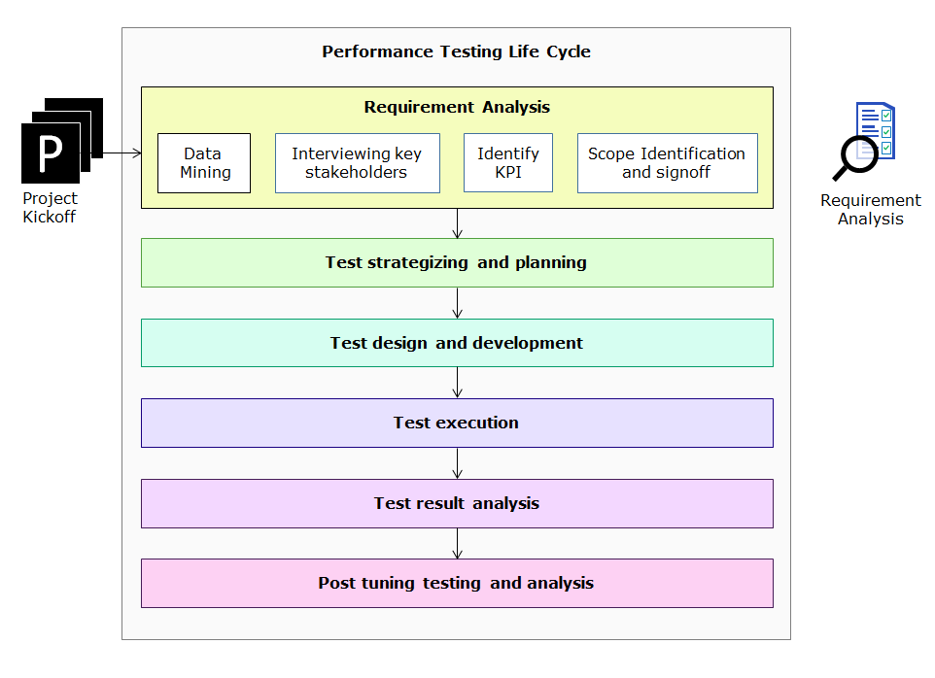

Test strategy and planning

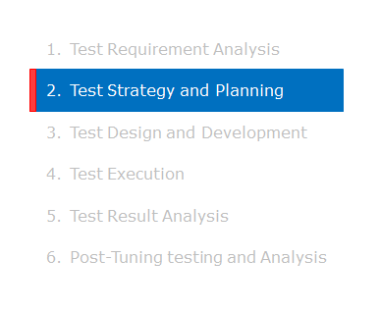
Objectives
- Define a strategy for performance test execution
Input
- Performance test requirements, Design & Architecture documents
- Test Requirements document
- Usage pattern, test, and production infrastructure
Roles
- Performance test manager and Performance test engineer
Activities
- Identify the required load in terms of number of virtual users by using workload models.
- Identify the types of performance tests to be conducted by considering the workload model and requirements.
- Identify testing tool and test infrastructure (controller, load generator and scripting machines) by considering
  - HP Performance center as the performance test creation and execution tool. It can generate a variety of loads.HP Sitescope as resource monitoring tool.
  - HP Diagnostics as application diagnostic tool.
- Identify stubs/simulators required. ( e.g. Payment gateway).
- Identify other group dependencies and their role like
  - application payment gateway is provided by 3rd party vendors.
- Identify tools & other infrastructure requirements, load generation, monitoring approach to:
  - Perform a POC and identify the suitable testing tool based on POC results. For this case, HP Performance center tool is considered for performance testing.
- Identify and prepare Test Data
  - In this application test data is needed for Login and shopping cart. Ensure that the respective tables have enough test data.
- Estimate effort for further stages and arrive at a schedule that:
  - Depends upon the scenarios and workload patterns.
  - is for script development, types of performance test execution, and bottleneck analysis.
- Identify the risks involved and prepare risk management strategies.
- Publish test strategy document based on the above analysis.
- Establish monitoring strategy for capturing performance statistics during test execution.
Output
- Approved Test strategy document
There are three categories in this phase such as:
- Workload model
- Transaction mix
- Types of performance test

Test strategy - Workload calculation

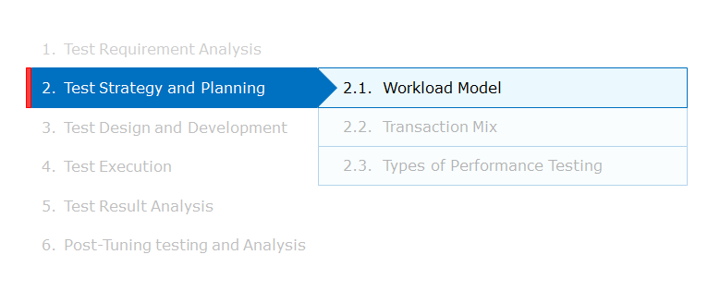

A workload model is designed to identify important test scenarios (Login, Fund transfer and logout) and load distribution across these scenarios. Performance test results can never be reliable unless its workload model is designed accurately.
Let us understand Below are two examples that explains about the workload model. with 2 examples given below
Example - 1
You want Tto run a steady state test that lasts for six hours. tThere is only one class of users and the total time for a tTransaction is 90 seconds (i.e. 1.5 minutes).
If you want To get a total of 10,000 tTransactions to run during this these six hours, how many virtual users are required? do you need?
- One virtual user can complete: 6*60/1.5= 240 tTransactions
- Total virtual users needed: 10000/240 = 41.7 virtual users
- With margin for error (5%): 42 * 1.05= 44 virtual users
Hence, 44 Virtual users load is executed to achieve 10000 transactions.
Example - 2
You want Tto run a steady state test that lasts for 15 minutes. There is only one class of users. The users execute:
- 1 registration transaction (60 seconds)
- 1 login transaction (20 seconds)
- 6 browse transactions (25 seconds each)
- 2 add to cart transactions (15 seconds each)
- 1 purchase transaction (30 seconds)
- 1 logout (10 seconds)
If you want To get a total of 300 transactions to run during this test, how many virtual users do you needare required?
- One Transaction takes: 60 + 20 + (6*25) + (2*15) + 30+10 = 300 seconds (5 min)
- One virtual User can run: 15 / 5 = 3 sets
- Total virtual users needed: 300 / 3 = 100 users​​​​​​​
- With margin for error: 100 * 1.05 = 105 users
Hence, 105 Virtual users load is executed to achieve 300 transactions.

Q1 of 3
You want to run a steady state test that lasts for eight hours. There is only one class of users and the total time for a Transaction is 90 seconds (1.5 minutes).
If you want a total of 12000 Transactions to run during this eight hours, how many virtual users do you need?
50
40
38
35
Q2 of 3
You want to run a steady state test that lasts for six hours. There is only one class of users and the total time for a Transaction is 120 seconds (2 minutes).
If you want a total of 5200 Transactions to run during this six hours, how many virtual users do you need?
52
38
28
30
Q3 of 3
You want to run a steady state test that lasts for ten hours. There is only one class of users and the total time for a Transaction is 60 seconds (1 minute).
If you want a total of 17500 Transactions to run during this ten hours, how many virtual users do you need?
30
35
32
25

Test strategy - Transaction mix

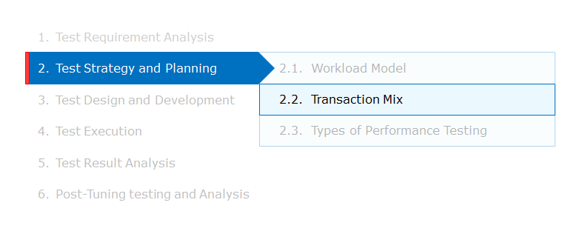
In the workload model, you understood how to calculate virtual user load for every usage pattern that needs to be tested. There were three usage patterns identified, and these usage patterns are captured in three different scripts. The table below has the transaction details and virtual user load for each scripts.
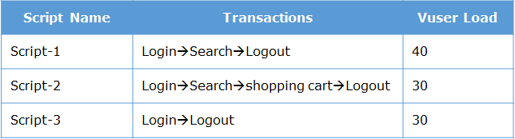

Below image shows three scripts that are run in a scenario with different virtual user load for each script.
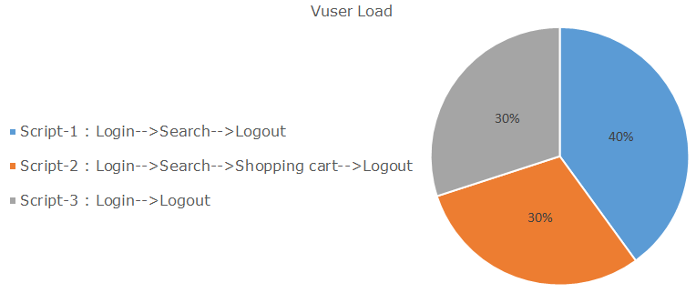
Types of Performance tests

Types of Performance tests

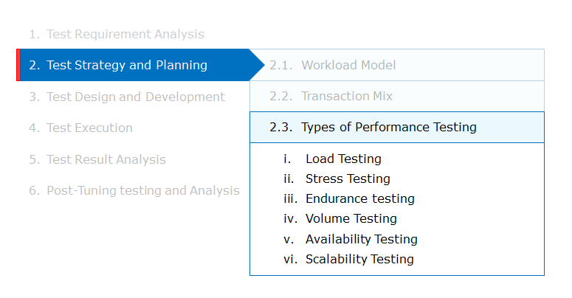

Load Testing
- Load testing simulates a real time user load on the application and testing it prior to production ensures stability of the application and any performance issues can be addressed in pre-production phase i.e. load testing is basically behaviour of the application at various user loads.
- In real time scenario all users do not log on to the system at the same time and their transaction behavior is also random.​​​​​​​
- User behavior includes variation of the order and duration in which they access the application. During load testing the system’s performance is measured against a set of users who transact in a random fashion.
- The workload is user oriented and should mimic the real-world scenario as far as possible.
Below is an example of load testing in ‘Infokart’ e-commerce portal:
Load test was conducted on script-1 (Login, search, and logout). This script was loaded with 150 users and the scenario was run for 2 to 3 hours to check if the application is giving the expected response time (1 second, 2 second and 1 second respectively) for all the 3 modules of script-1. After the load test gets over, the actual average response time was 2 second, 3 second and 1 second respectively.
Hence, this load test helped the performance tester to ascertain that only logout module can operate with optimum performance under a normal everyday load of 150 users. The Login and Search modules must be sent back to the developer to tune its performance.
​​​​​​​
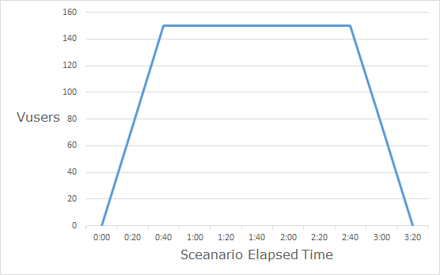

Stress testing

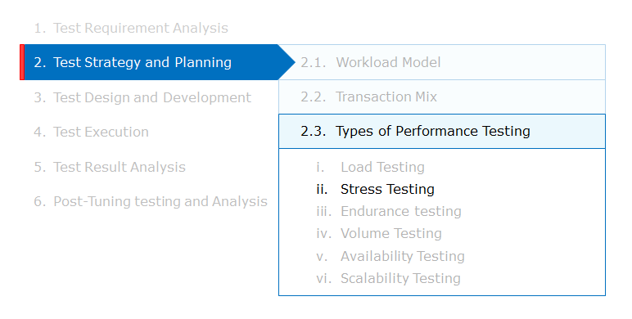

Stress Testing
- Stress Testing is done to determine the load at which the system breaks or fails (break point). During this process the response time is not of concern.
- Stress testing ensures the application which is tested for expected load can take on spikes in the load condition like increase in rate of transactions and study its impact on the system resources and helps tune and configure the system optimally.
- While doing stress testing, users are ramped up till a point so that the application reaches its saturation and it breaks down.​​​​​​
- Spike testing is the subset of stress testing, which determines the characteristics of a product under test. These tests are subjected to workload model and load volumes that repeatedly increases beyond anticipated production operations for short periods of time.
An example of stress testing in ‘Infokart’ e-commerce portal:
Stress test was conducted on script-1 (Login, search, and logout). This script was ramped up gradually from Zero Vusers to 650 Vusers. During this gradual ramp-up, the response time was monitored. The application was giving the expected response time (1second, 2second and 1 second respectively) for all the 3 modules of script-1 till 600 Vusers. Further when 50 more Vusers were ramped up, the response time increased drastically as application had a break point/saturation point and did not give the expected response time.
Hence, this stress test helped the performance tester to ascertain that the application can operate with acceptable response times for a maximum load of 600 Vusers.
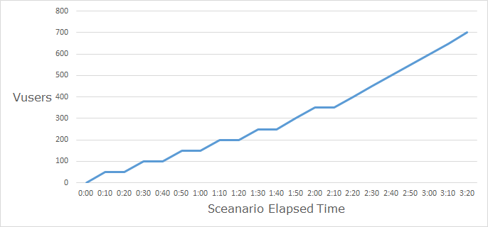

Endurance testing

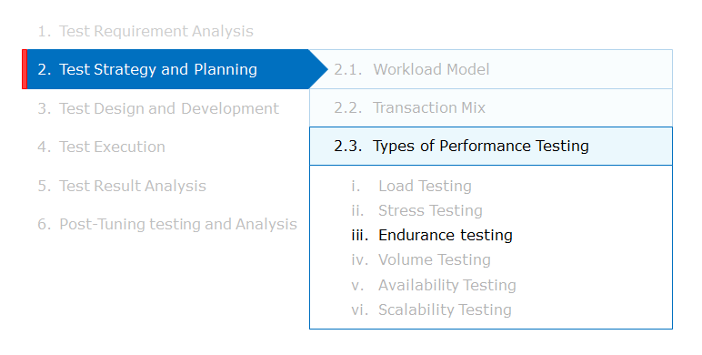

Endurance Testing
- This test is conducted to test the system’s ability to run over long periods. Depending on the system, these tests can run for 24 hours or more. These tests generally run loads that try to mimic the real traffic the application may encounter.​​​​​​​
- These tests are executed with expected user load sustained over longer period with normal ramp up and ramp down time. Endurance testing helps in determining memory leaks (if any) in the system.
An example of endurance testing in ‘Infokart’ e-commerce portal:
Endurance test was conducted on script-1 (Login, search, and logout). This script was loaded with 150 Vusers and the scenario was run for 24 hours. The CPU and RAM was monitored during the test duration. It was found that the memory utilization of the application was gradually increasing. Due to these memory leaks, after 20 hours of test there was insufficient RAM for the application to operate as per expected response times (2second, 3second and 1second respectively) for all the 3 modules of script - 1.
Hence, this endurance test helped the performance tester to ascertain that with the existing memory leaks, the application is not capable of operating with acceptable level of performance for more than 20 hours at a stretch. Therefore, the developer needs to fix the memory leaks before it is released to production.
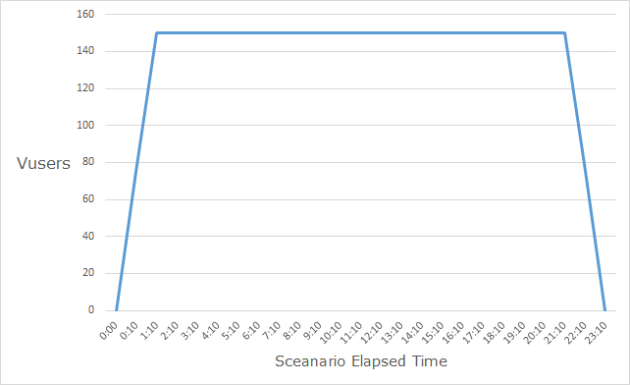

Differences between Load, Stress, & Endurance test

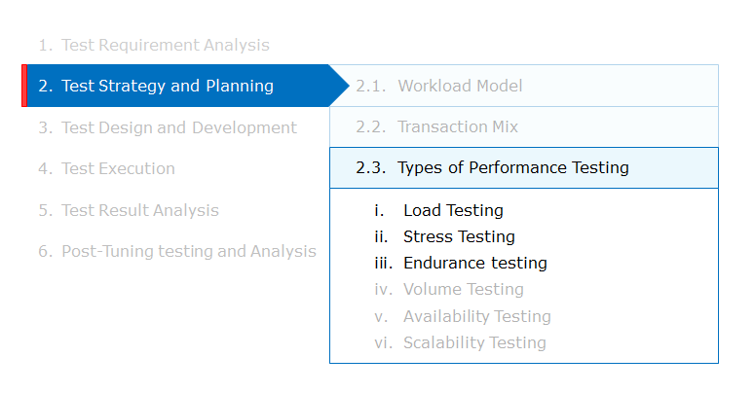
Now let us understand the difference between Load, Stress and Endurance test.
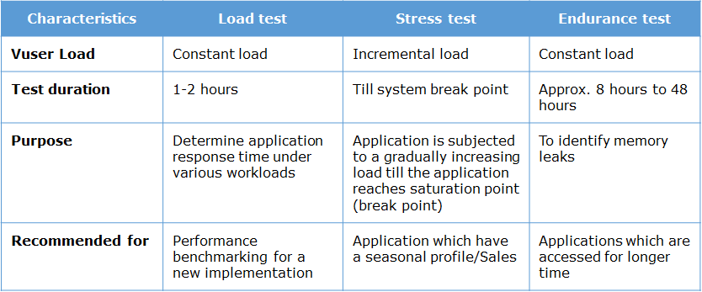

Volume testing

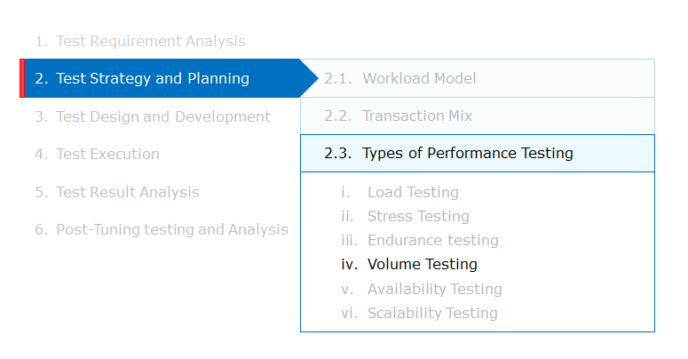

Volume Testing
- For heavy database transactions like the banking application where the data in the database increases with time, there would be definite impact on the application response time.
- Volume testing is a load testing where a large volume of data is populated on the database to study its impact on the application response time and database’s overall health.
An example of volume testing in ‘Infokart’ e-commerce portal:
Volume test was conducted on script-2 (Login, search, Shopping cart, and logout). This script was loaded with 150 Vusers and the scenario was run for 3 hours. The application database was monitored for the data volume to get added. The rate of increase of data volume was large that it slowed down internal query performance. This resulted in the application not giving the expected (3 seconds) response time for shopping cart module during the test.
Hence, this volume test helped the performance tester conclude that when a large volume of data is generated on the database, the database had a performance bottleneck

Availability testing

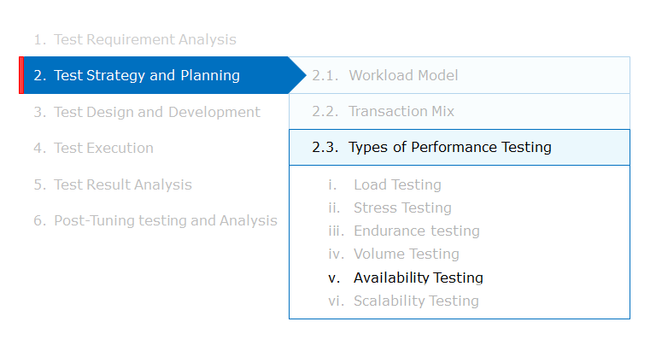

Availability Testing
- It means running an application for a planned period, collecting failure events and repair time.
- This helps ensure Service Level Agreement (SLA) by comparing the availability percentage to the original SLA.
An example of availability testing in ‘Infokart’ e-commerce portal:
Availability test was conducted on script-1 (Login, search, and logout). This script was loaded with 150 Vusers and the scenario was run for 10 hours to check if the application is available and giving the expected responses. The expected availability SLA was 95%. During the test execution, the application had an issue and the repair time was 1 hour. Hence, the application was available only for 9 hours and the availability was just 90%.
This availability test helps the performance tester ascertain that the application is not ready to be deployed in production yet as it cannot meet the availability SLA in its current state.
Scalability testing

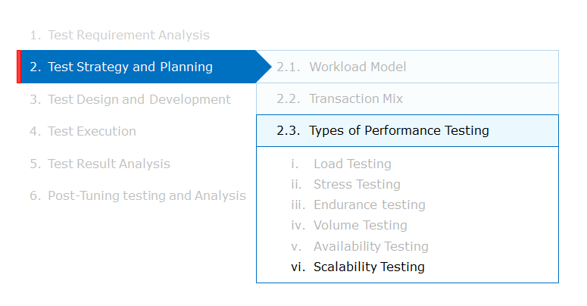

Scalability Testing
Scalability testing is done to determine the effectiveness of the system in scaling to accommodate the increasing load. Scalability is the ability of the system to gain in performance by increasing resources (i.e., by replacing a 4 CPU machine by 8 CPU machine), that can support a greater number of users.
The idea is to ascertain if the application is scalable and can leverage the hardware underneath it.
Hence, the following needs to be done:
- Test individual transactions in isolation and capture response time, throughputs, and validate the test results for each test run.
- From different load levels, it can be identified whether the transaction throughputs increases with increase in load, the device utilizations increases with increase in load, or if there are bottlenecks in the individual transaction which prevent a transaction from scaling.
- Once a particular transaction is displaying scalable characteristics, service demands for the same are stored for capacity sizing purpose.
An example of scalability testing in ‘Infokart’ e-commerce portal:
Scalability test was conducted once the requirement of 150 Vuser load was met. This test was conducted on script-1 (Login, search, and logout) with a total load of 200 Vusers and the scenario was run for 2 hours to check if the application is giving the same expected response time (1second, 2second and 1 second respectively). At the end of test, it was observed that the response times were not affected due to increased load.
Hence, this scalability test helped the performance tester conclude that the application doesn’t need any hardware upgrade or fine tuning for meeting nominal fluctuations to regular operating load.
Test strategy and planning in performance testing methodology

Here is how the tasks of in the test strategy and planning phase fits in the standard performance testing methodology.
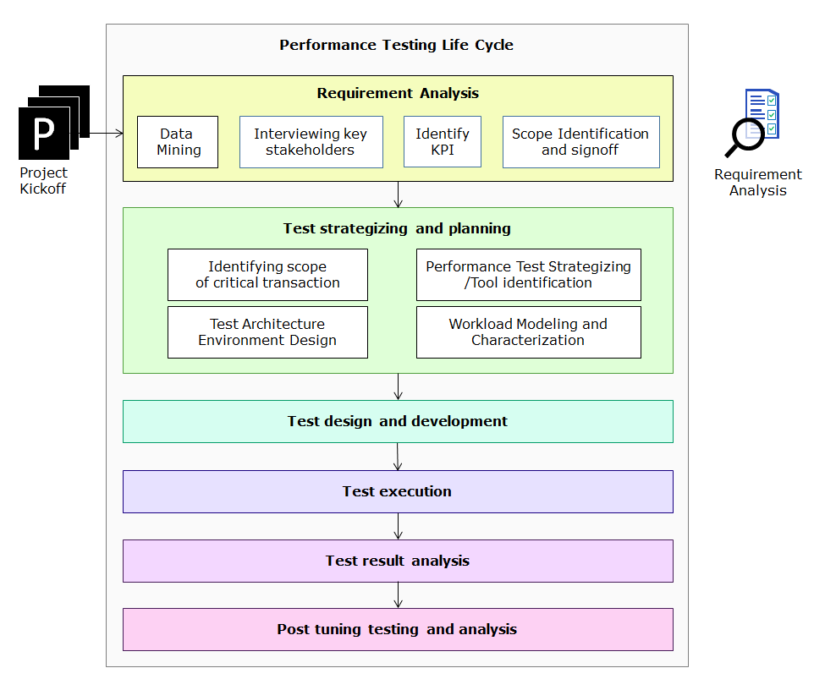
Performance test design and development
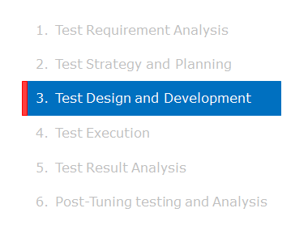
Objectives
- Design and develop the performance test suite
Input
- Performance test requirements, Design & Architecture documents
- Usage pattern, test, and production infrastructure
- Test strategy document
Roles
- Performance Test Specialist, Performance Test Engineer
Activities
- Workload Models must be reviewed and approved by the client.​​​​​​
- Payment gateway simulator must be integrated with shopping cart​​​​​​.
- Study the documented workflows for script generation​​​​​​.
- Design test scripts using performance testing tool to simulate online activity, batch, and interface traffic with all the performance features using the tool. (Verification point, think time, pacing, parametrization, and correlation)​​​​​​
- Design test plan to simulate business transactions and identify scope for parameterization​​​​​​​​​​​​​​​​​​​​​​​​​
  - Parameterization is done for Login, search, and shopping cart modules. The test data must ready for all these modules.​​​​​​​​​​​​​​​​​​​​
- Custom developed stubs and utilities as required for testing (for example, simulating a third- party system which is not connected in test environment)
  - ​​​​​​​Payment gateway simulator must be integrated with shopping cart
Output
- The following test scripts must be ready for test execution.​​​​​​
  - Script1: Login-->search-->logout
  - Script2: Login-->search-->shopping cart-->logout
  - Script3: Login-->logout
- Tested stubs/simulators
  - Payment gateway is integrated
- A ready-to-use performance test environment

Test design and development in performance testing methodology

Below image shows how the tasks in the test strategy and planning phase fits in the standard performance testing methodology.

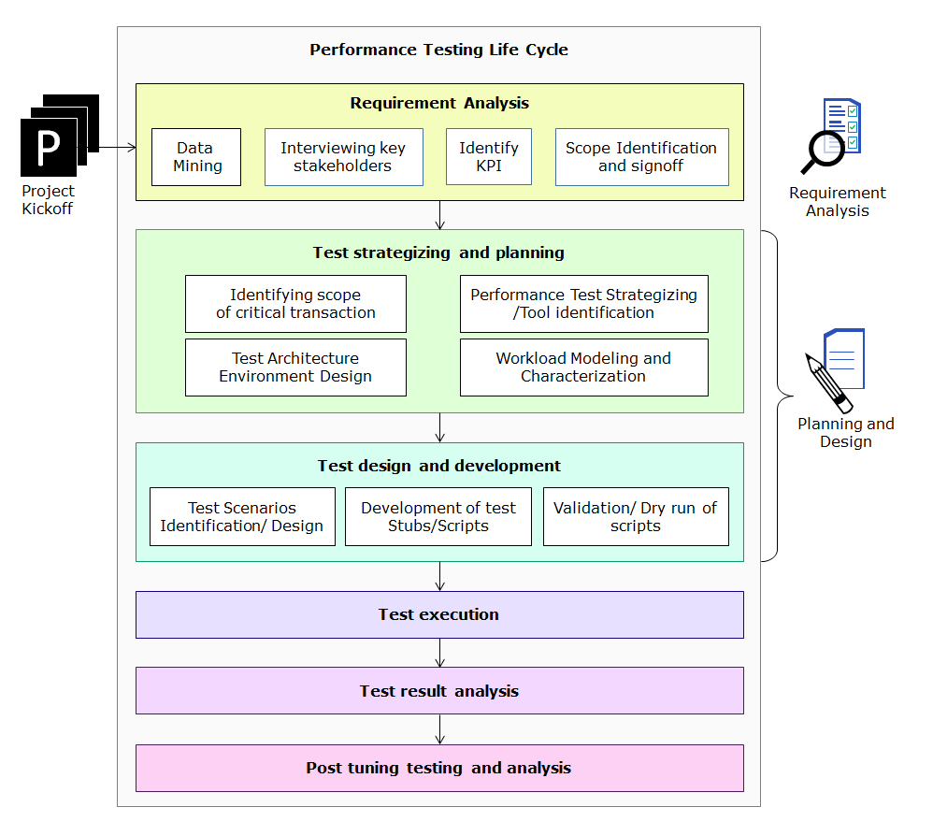

Test execution
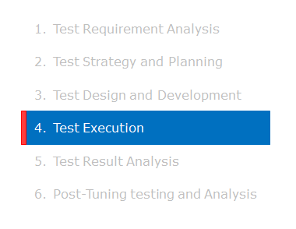

Objectives
- Perform identified type of performance tests and collect test results
Input
- Performance test strategy document
- Functionally stable application build
- Test cases and test scripts
- Sanity tested test environment
Roles
- Performance Test Specialist, Performance Test Engineer
Activities
- Configure performance monitoring tools’ access to various systems components (like network bandwidth, processors, memory, etc.) to capture performance parameters.
- Using the performance testing tools​​​​​​​​​​​​​​
  - Create the test scenarios depending on the workloads, test scripts, and test types. This involves activities like configuring the workload allocation, test duration, etc.​​​​​​
  - Generate the required load (VUsers)​​​​​​
  - Execute the identified types of performance tests like load, stress, endurance etc.​​​​​​​​​​​​
  - Keep monitoring and ensure required workload is being generated at various points as expected during the test.​​​​​​
  - Keep track of execution messages from the tool and take appropriate actions as and when required. For example, if there is a message saying that the application under test has gone offline, then stop the test execution and restart it after the application is up.
- Using performance monitoring tools, monitor, and capture performance statistics of various system components like servers, database etc.
- Report obvious functional defects when found
- At the end of execution, the tool will generate the execution results.
Output
- Test execution results show that all planned tests are captured in an output file.

Test execution in performance testing methodology

Below image shows how the tasks of the test execution phase fits in the standard performance testing methodology.​​​​​​​
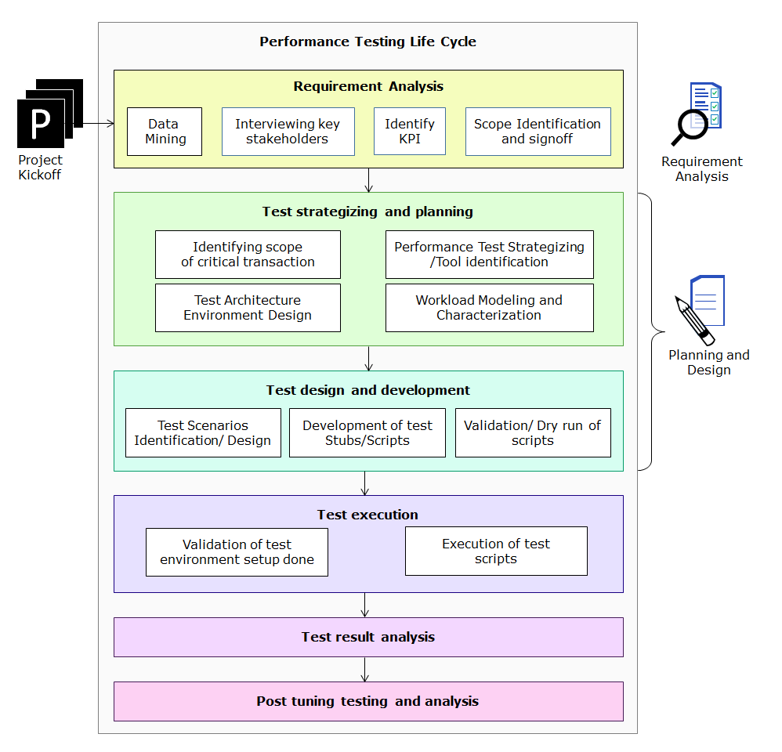

Test result analysis

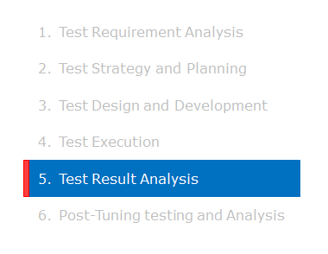
Objectives
- Identify performance issues and recommend tuning (if required,)
Input
- Requirement document.
- Performance test strategy document.
- Test results

Roles
- Performance Test Specialist
Activities
- Generate the various types of graphs required for analyzing the performance like response time graphs, virtual user graphs, throughput graphs, transaction summary graphs, hits per second graphs, etc.
- Create performance reports to be shared with all the stakeholders (clients, developers, operations team, DBAs, etc.).
- Analyze test results and identify performance issues and bottlenecks.
- Arrive at recommendations at various levels like application changes, DB changes, configuration, or architectural changes etc.
- Document identified performance issues and tuning recommendations.
- Escalate 3rd party issues (if any), for client management for them to communicate to the concerned party or relevant take business decisions.
- Review performance issues/recommendations with all the stakeholders.
Output
- All performance issues and tuning recommendations are documented for the concerned teams to address them.

Test result analysis in performance testing methodology

The image below shows, how tasks of the test result analysis phase fits in the standard performance testing methodology.
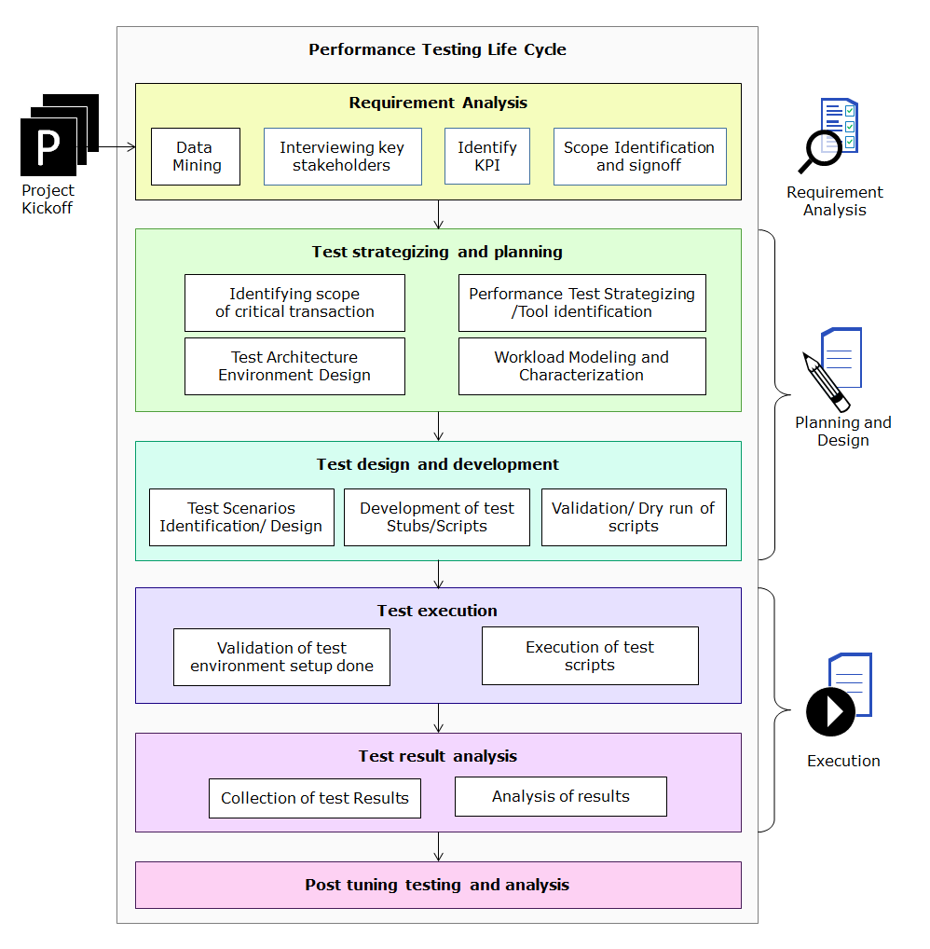

Post tuning testing and analysis

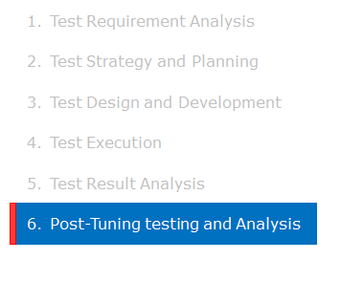
Objectives
- Verify if implemented tuning recommendations have improved the application performance and produced the expected results.
Input
- Tuned application
- Tuned test environment
Roles
- Performance Test Specialist, Performance Test Engineer and System Architects/Developers.
Activities
- Set-up the tests and retest the application
- Suggest alternate tuning recommendations, if expected performance is not achieved.
- Repeat this cycle till application/system performance reaches expected level
- Support in test environment rebuild in case of disasters
Output
- Application/system performing as per the expected performance levels.
- Overall Test summary report.

The overall performance testing methodology

In the image you can see how the tasks of the post tuning testing and analysis phase fits in the standard performance testing methodology.
It also summarizes how the information from the standard set of tasks performed in each phase of the performance testing life cycle flow to the tasks in the subsequent phase.
​​​​​​​
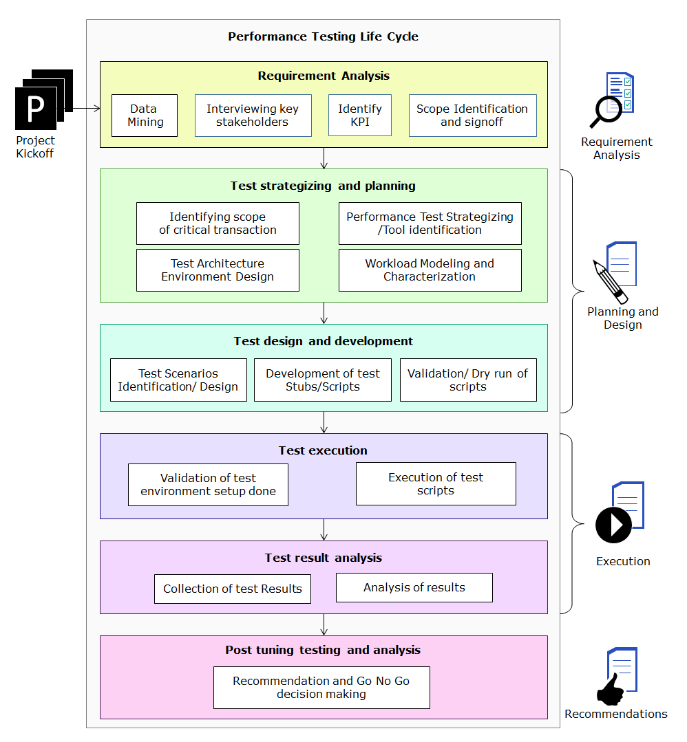

Challenges in Performance Testing

- Replicating the production environment is not always practically feasible. Unless the performance test environment is an exact replica of the production environment, there tends to be a certain degree of inaccuracy with respect to predictions on real world performance.
- Non-functional requirements like performance have a general tendency to contain ambiguity than functional requirements as they are more about user's subjective experience of the system.
- Unless historical usage data is present, arriving at accurate load data is not easy. Inaccurate loads used in performance test may give incorrect test results.
- Determining the right think times to be used in the script may not satisfy all possible real world scenarios since each individual user will interact with the application in their own comfortable pace.
- Monitoring of distributed applications at every server component is mandatory to analyze bottlenecks.
- Non-standard processes and methodologies applied for different applications might result in incorrect test results.

Test Data for Performance Testing

Performance test require two types of test data.
- Input data for the test scripts
  - Example: User-id and password for login. It can be obtained by modifying the scripts to accept parameters for input data, and “correlate” the different steps of the script using dynamic data.
- Pre-populated data to simulate a real-world environment.
  - Example: a user’s bank account pre-populated with 30 recent transactions

Significance of pre-populated data in performance tests:
An application can conceivably perform very well with a limited amount of data. However, presence of a large amount of data can impact performance, and in the worst case, it can uncover hidden functional bugs. Hence, pre-populated data is extremely important for an effective performance test.
The pre-populated test data can reside in:
- Database tables
- External resources like LDAP
- Physical files
- Any other sources
The test data can be pre-populated using SQL scripts, in-house utilities, shell scripts, etc. depending upon the type and nature of the data.
In some cases it is possible tto obtain an existing set of data that can be upgraded/added/modified to fit the needs.

General guidelines for workload modelling in absence of historical data

Scenario Selection
Average weightage can be used in selecting scenarios for an application with multiple modules where each module has different client owner in terms of questions asked on business criticality of their module/processes. That means each question in the questionnaire can be assigned a weightage and depending on client response, weightage can be assigned.
Coverage
Client must be clarified about business processes considered for performance tests as business users and development team often confuse performance testing with functional testing and expect 100% coverage. On the contrary, only 15% to 20% of total business processes are considered for performance testing for certain organizations. There will be only 20%-25% processes generating 80% of revenue. Hence, this pareto analysis is applied.
Concurrency
This is managed based on usage pattern, region and timings of any application. Below are examples to understand the concept of concurrency:
- If information is not available for total user base, domain of the application and location of user base must be considered. For e. g. Dell or Intel website for Asia Pacific region will have very high volume as India and China users will be accessing the website with an overlap of 6 hours. And, for a luxury car manufacture website such as BMW or Audi will have more volume for users who only view the product specifications etc.
- If it’s a financial application such as a bank website or BSE/NSE website, then user load at 9 AM to 10 AM will be the highest with a spike at 9 AM.
- Typically, users of in-house applications login in the morning continuously from 8 am to 10 AM, the user load then drops a little as they break for lunch, then between 1 to 3 we see peak user load and the users start logging out after 3 PM. So, this pattern should be followed while conducting endurance test and arriving at load test user/transactional load.
Project volume
For a legacy application, 10% yearly increase in user and transactional load can be considered once the app goes live.
SLA or KPI
If there is no clear SLA or KPI defined for response time, it is safe to assume that any user will lose interest in a website after 3 seconds and move on to competitor. For internal applications, SLA can be between 3 to 5 seconds.
Trade-offs
For any application type, day to day experience and general awareness becomes handy to make certain trade-offs:
- For an application that is going to be used by all field technicians, concurrency should not be considered 100% as the technicians are expected to work than check and update status throughout the day.
- Time sheet submission forms are usually accessed at the end of the week but not 24x7.
- For internal expense/claim submission and approval, throughout the day, no company can expect to have thousands of claim submission from employees.

Performance test vs Performance engineering
Below table is with the difference between Performance testing and Performance engineering

Performance testing and Performance engineering
Performance Testing | Performance Engineering
Evaluates the application | Eliminates issues in the application
Assesses the system | Addresses the issues in the system
Finds problematic areas in the SUT | Fixes problematic areas in the SUT

Compare performance testing with function testing

Below table is a comparison of performance testing with functional testing

Performance testing and Functional testing
Perfromance Testing | Functional Testing
Evaluates the system performance | Evaluates the application functionality
Assesses only performance critical scenarios | Assesses all possible functional scenarios
Conducted at multiple user load | Conducted at single user load
Requirements are provided in numbers | Requirements are hard-line specifications
Analytical and mathematical in nature, based on various therories | Either pass or fail is the test case's execution result
Classified as partly art and science | Quite evolved and best practices baseline for various methodologies

Key facts
Some of the key facts to remember in Performance testing are:
- Bottleneck need not occur only at high user load
- Software applications when subjected to performance check expose performance defects
- Defects could originate from any part of the application such as:
  - Application program
  - Database systems
  - Application server
  - Web server
  - Network
  - Operating system
- Any of the following can be causes for performance defects:

  - Poor programming practices – Programming logic, DB queries
  - Inappropriate system designs – Table/Index design, application design
  - Incorrect system configurations – App/Webserver configuration, OS parameter
- Performance issues cannot be always resolved by increasing hardware resources
- Number of concurrent users is not same as the number of application users

Performance Testing tool comparison

Below tables are analysis of the cost and features of leading performance testing tools in market.
