Why Python Libraries?

Let us consider the following scenario:
John is a software developer. His project requires developing an application that connects to various database servers like MySQL, Postgre, MongoDB etc. To implement this requirement from scratch, John needs to invest his time and effort to understand the underlying architectures of the respective databases. Instead, John can choose to use pre-defined libraries to perform the database operations which abstracts the complexities involved.
Use of libraries will help John in the following ways:
- Faster application development – Libraries promote code reusability and help the developers save time and focus on building the functional logic.
- Enhance code efficiency – Use of pre-tested libraries enhances the quality and stability of the application.
- Achieve code modularization – Libraries can be coupled or decoupled based on requirement.
Over the last two decades, python has emerged as a first-choice tool for tasks that involve scientific computing, including the analysis and visualization of large datasets. Python has gained popularity, particularly in the field of data science because of large and active ecosystem of third-party libraries.
Few of the popular libraries in data science include NumPy, Pandas, Matplotlib and Scikit-Learn.
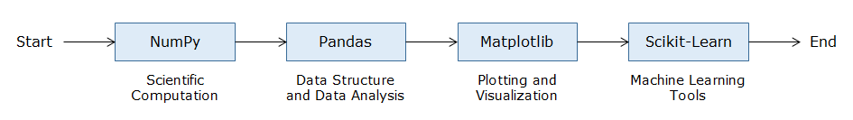

Business scenario

XYZ Custom Cars is an automobile restoration company based in New York, USA. This company is renowned for restoring vintage and muscle cars. Their team takes great pride in each of their projects, no matter how big or small. They offer paint jobs, frame build-ups, engine restoration, body work etc. They are also involved in buying and reselling of cars.


Every car owner that comes to XYZ Custom Cars gets a documentation drafted that consists important information about the car. This information is related to the car’s performance and manufacturing. The company maintains this database with proper diligence. Click here to download the XYZ Custom Cars data.
The data consists of features like acceleration, horsepower, region, model year, etc. And the board of directors think that these data can help generate insights about their projects. On the other hand, these insights would help restore similar cars with similar standards and procedures. Also, this would help them predict better reselling prices in future. Precisely, these insights would help generate greater revenue for the company through cost cutting and providing a data driven approach to their process.
For example, the company may be interested in setting up different workstations that cater to specific categories of cars as follows –
Category | Description | Features coming in play
Fuel efficient | Cars designed with low power and high fuel efficiency | High MPG, Low Horsepower, Low weight
Muscle Cars | Intermediate sized cars designed for high performance | High displacement, High horsepower, Moderate weight
SUV | Big sized cars designed for high performance, long distance trips and family comfort | High horsepower, High weight
Racecar | Cars specifically designed for race tracks | High horsepower, Low weight, High acceleration

This would allow the company to place specialized mechanics and equipment in specific workstations, thereby creating a hassle free and efficient work atmosphere. Another interesting thing would be predicting the fuel efficiency of cars after restoration based on the available data to minimize field testing.
The defined business scenarios will be used to understand the following Python libraries:
1. Numpy
- To get the mathematical and structural understanding of such data
- To build a base for Pandas, the data manipulation library
- To get familiar with terms like arrays, axis, vectorization etc.

2. Pandas
- To read the data
- To explore the data
- To do operations on the data
- To manipulate the data
- To draw simple visualizations for self-consumption
- To generate insights

3. Matplotlib
- To visualize the data
- To generate deep insights
- To present the data to the leadership
- To get a visual understanding of various features

4. Sci-kit learn
- To get data ready for model building
- To build predictive models
- To evaluate the models
- To infer the model results and present to the leadership

Introduction to Numpy

A python List can be used to store a group of elements together in a sequence. It can contain heterogeneous elements.
Following are some examples of List:
- item_list = ['Bread', 'Milk', 'Eggs', 'Butter', 'Cocoa']
- student_marks = [78, 47, 96, 55, 34]
- hetero_list = [ 1,2,3.0, ‘text’, True, 3+2j ]

To perform operations on the List elements, one needs to iterate through the List. For example, if five extra marks need to be awarded to all the entries in the student marks list. The following approach can be used to achieve the same:
- student_marks = [78, 47, 96, 55, 34]
- for i in range(len(student_marks)):
- student_marks[i]+=5
- print(student_marks)

It can be observed that, there is use of a loop. The code is lengthy and becomes computationally expensive with increase in the size of the List.
Data Science is a field that utilizes scientific methods and algorithms to generate insights from the data. These insights can then be made actionable and applied across a broad range of application domains. Data Science deals with large datatsets. Operating on such data with lists and loops is time consuming and computationally expensive.

Comparing Python List and Numpy performance.

Let us understand why Python Lists can become a bottleneck if they are used for large data.
Consider that 1 million numbers must be added from two different lists.
- %%time
- #Used to calculate total operation time
- list1 = list(range(1,1000000))

- list2 = list(range(2,1000001))

- list3 = []

- for i in range(len(list1)):
- list3.append(list1[i]+list2[i])

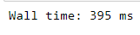
Note: Time taken will be different in different systems.
Let us understand, how Numpy can solve the same in minimal time.
Note: Ignore the syntax and focus on only the output.
- %%time
- #Used to calculate total operation time
- #Importing Numpy
- import numpy as np
- #Creating a numpy array of 1 million numbers
- a = np.arange(1,1000000)
- b = np.arange(2,1000001)
- c = a+b

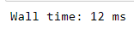
It can be observed that the same operation has been completed in 12 milliseconds when compared to 395 milliseconds taken by Python List. As the data size and the complexity of operations increases, the difference between the performance of Numpy and Python Lists broadens.
In Data Science, there are millions of records to be dealt with. The performance limitations faced by using Python List can be managed by usage of advanced Python libraries like Numpy.

Introduction to Numpy

Numeric-Python (Numpy), is a Python library that is used for numeric and scientific operations. It serves as a building block for many libraries available in Python.

Data structures in Numpy
The main data structure of NumPy is the ndarray or n-dimensional array.
The ndarray is a multidimensional container of elements of the same type as depicted below. It can easily deal with matrix and vector operations.
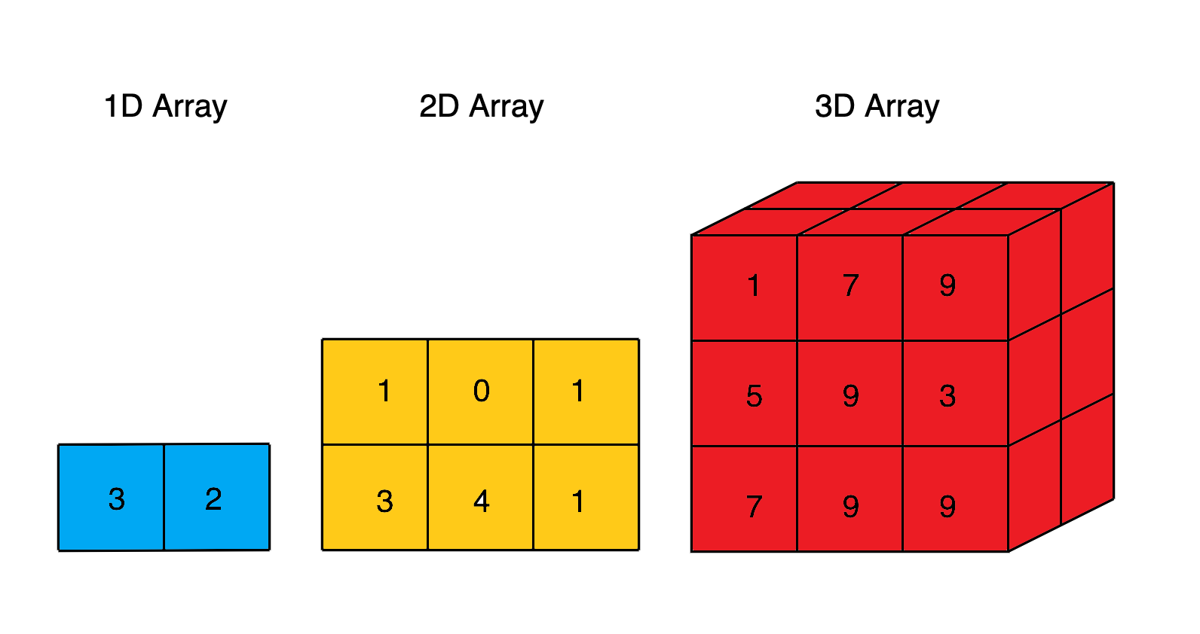
Following are the benefits of using Numpy:
- As the array size increases, Numpy can execute more parallel operations, thereby making computation faster. When the array size gets close to 5,000,000, NumPy gets around 120 times faster than Python List.
- NumPy has many optimized built-in mathematical functions. These functions helps in performing variety of complex mathematical computations faster and with very minimal code.
- Another great feature of NumPy is that it has multidimensional array data structures that can represent vectors and matrices. This can be useful as lot of machine learning algorithms rely on matrix operations.

Importing Numpy
Numpy library needs to be imported in the environment before it can be used as shown below. 'np' is the standard alias used for Numpy.
- import numpy as np

Numpy object creation
Numpy array can be created by using array() function. The array() function in Numpy returns an array object named ndarray.

Syntax: np.array(object, dtype)
object – A python object(for example, a list)
dtype – data type of object (for example, integer)
Example: Consider the following marks scored by students:
Student ID | Marks
1 | 78
2 | 92
3 | 36
4 | 64
5 | 89

These marks can be represented in a one-dimensional Numpy array as shown below:
- import numpy as np
- student_marks_arr = np.array([78, 92, 36, 64, 89])
- student_marks_arr

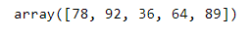
This is one way to create a simple one-dimensional array.
The following dataset has been provided by XYZ Custom Cars. This data comes in a csv file format.
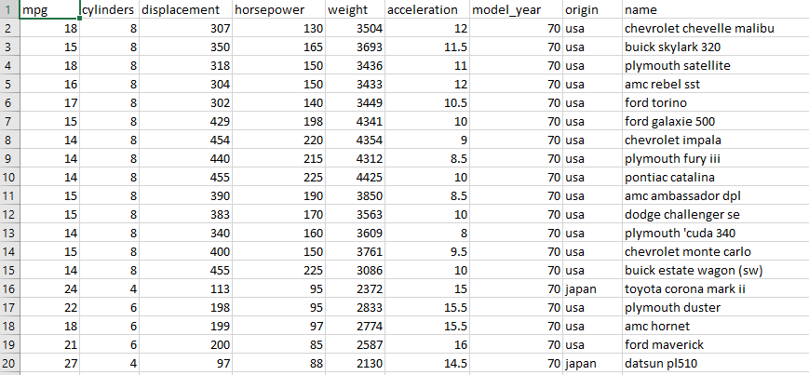
There are various columns in this dataset. Each column contains multiple values. These values can be represented as lists of items. Since each column contains homogenous values, Numpy arrays can be used to represent them.
Let us understand , how to represent the car ‘horsepower’ values in a Numpy array.
- #creating a list of 5 horsepower values
- horsepower = [130, 165, 150, 150, 140]
- #creating a numpy array from horsepower list
- horsepower_arr = np.array(horsepower)
- horsepower_arr

How can multiple columns be represented together?
This can be achieved by creating the Numpy array from List of Lists.
Let us understand , how to represent the car 'mpg', ‘horsepower’, and 'acceleration' values in a Numpy array.
- #creating a list of lists of 5 mpg, horsepower and acceleration values
- car_attributes = [[18, 15, 18, 16, 17],[130, 165, 150, 150, 140],[307, 350, 318, 304, 302]]
- #creating a numpy array from car_attributes list
- car_attributes_arr = np.array(car_attributes)
- car_attributes_arr

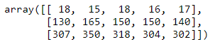
The example demonstrates that the Numpy array created using the List of Lists results in a two-dimensional array.

The numpy.ndarray.shape returns a tuple that describes the shape of the array.
For example:
- a one-dimensional array having 10 elements will have a shape as (10,)
- a two-dimensional array having 10 elements distributed evenly in two rows will have a shape as (2,5)
Let us comprehend, how to find out the shape of car attributes array.
- #creating a list of lists of mpg, horsepower and acceleration values
- car_attributes = [[18, 15, 18, 16, 17],[130, 165, 150, 150, 140],[307, 350, 318, 304, 302]]
- #creating a numpy array from attributes list
- car_attributes_arr = np.array(car_attributes)
- car_attributes_arr.shape

Here, 3 represents the number of rows and 5 represents the number of elements in each row.

'dtype' of ndarray

'dtype' refers to the data type of the data contained by the array. Numpy supports multiple datatypes like integer, float, string, boolean etc.
Below is an example of using dtype property to identify the data type of elements in an array.
- #creating a list of lists of 5 mpg, horsepower and acceleration values
- car_attributes = [[18, 15, 18, 16, 17],[130, 165, 150, 150, 140],[307, 350, 318, 304, 302]]
- #creating a numpy array from attributes list
- car_attributes_arr = np.array(car_attributes)
- car_attributes_arr.dtype

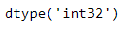

Changing dtype
Numpy dtype can be changed as per requirements. For example, an array of integers can be converted to float.
Below is an example of using dtype as an argument of np.array() function to convert the data type of elements from integer to float.
- #creating a list of lists of 5 mpg, horsepower and acceleration values
- car_attributes = [[18, 15, 18, 16, 17],[130, 165, 150, 150, 140],[307, 350, 318, 304, 302]]
- #converting dtype
- car_attributes_arr = np.array(car_attributes, dtype = 'float')
- print(car_attributes_arr)
- print(car_attributes_arr.dtype)
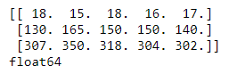

NumPy object creation
The calculations using NumPy are performed using nd-array object which can take any number of dimensions. Most commonly used NumPy nd-array is a matrix which takes 2 dimensions.

Array Creation
A NumPy nd-array inputs a basic Python list as an argument along with an explicit datatype (for typecasting) as shown below:

- arr = np.array([2,5,6,8], dtype = int)
- print(arr)
- # [2 5 6 8]
- print(type(arr))
- # class 'numpy.ndarray'
- print(np.result_type(arr))
- # int32

Here, we have used np.array() function which takes 2 arguments, the input list, and the corresponding data type (dtype). To check the data type of a particular NumPy object we have used np.result_type() command.
Most of the time, it is not an intuitive way to pass a list of predefined components. Therefore, NumPy offers some frequently used functions to create a NumPy object as shown below:

- ''' Creation of an array with step size 1.33 between 0 - 10 '''
- print(np.arange(0, 10, 1.33, dtype = np.float64))
- # [ 0. 1.33 2.66 3.99 5.32 6.65 7.98 9.31]

- # arange() gives uncertain number of values based on steps
- # Hence, we use linspace, which asks for total number of values

- ''' Creation of an array with total 5 values between 0 - 160 '''
- print(np.linspace(0, 160, 5, dtype = np.float64))
- # [ 0. 40. 80. 120. 160.]

Matrix Creation
Moving ahead, let's learn creation of matrix using NumPy. This task can be achieved in many ways as listed below:
- Method I: Use NumPy array to form a matrix
- Method II: Use NumPy's inbuilt matrix function
- Method III: Use miscellaneous functions such as ones(), zeroes(), etc.
Let's take some examples to study the creation of matrix through each of these methods:

- ''' Method I: Using array and reshape to convert array into matrix '''
- print(np.array([5,6,8,45,12,52]).reshape(2,3))
- # [[ 5 6 8]
- # [45 12 52]]

- ''' Method II: Using matrix function '''
- print(np.matrix([[1,2],
- [3,4]]))
- # [[1 2]
- # [3 4]]

- ''' Method III: Using misc. functions '''
- print(np.eye(3)) # Identity matrix
- # [[ 1. 0. 0.]
- # [ 0. 1. 0.]
- # [ 0. 0. 1.]]
- print( np.zeros( (4,3) ) )
- # [[ 0. 0. 0.]
- # [ 0. 0. 0.]
- # [ 0. 0. 0.]
- # [ 0. 0. 0.]]
- print(np.ones( (3,3), dtype = np.float64 ))
- # [[ 1. 1. 1.]
- # [ 1. 1. 1.]
- # [ 1. 1. 1.]]

Exercise

Problem Statement:
Given two NumPy arrays arr1 = [25, 56, 12, 85, 34, 75] and arr2 = [42, 3, 86, 32, 856, 46], solve the following:
- Create a new NumPy array Narr with the shape equal to arr1 filled with random values.
- Permanently change the dtype of arr1 to complex.
- Transform arrays arr1 and arr2 into two matrices (arr1_mat and arr2_mat) of shape (2,3) and arrive at the solution of the following equation:
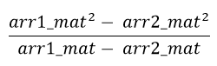

Hints/Answers:
- Hint: Use np.random.rand()
- Hint: Use astype(). Answer: [ 25.+0.j 56.+0.j 12.+0.j 85.+0.j 34.+0.j 75.+0.j]
- Hint: Use a² - b² property. Answer: [[ 67.+0.j 59.+0.j 98.+0.j] [ 117.+0.j 890.+0.j 121.+0.j]]

Accessing Numpy arrays
The elements in the ndarray are accessed using index within the square brackets [ ]. In Numpy, both positive and negative indices can be used to access elements in the ndarray. Positive indices start from the beginning of the array, while negative indices start from the end of the array. Array indexing starts from 0 in positive indexing and from -1 in negative indexing.
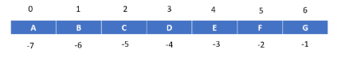
Below are some examples of accessing data from numpy arrays:

1. Accessing element from 1D array.
- #creating an array of cars
- cars = np.array(['chevrolet chevelle malibu', 'buick skylark 320', 'plymouth satellite', 'amc rebel sst', 'ford torino'])
- #accessing the second car from the array
- cars[1]

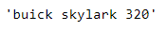

Accessing elements from a 2D array

- #Creating a 2D array consisting car names and horsepower
- car_names = ['chevrolet chevelle malibu', 'buick skylark 320', 'plymouth satellite', 'amc rebel sst', 'ford torino']
- horsepower = [130, 165, 150, 150, 140]
- car_hp_arr = np.array([car_names, horsepower])
- car_hp_arr

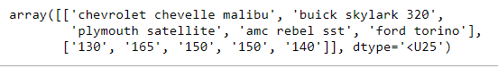

- #Creating a 2D array consisting car names and horsepower
- car_names = ['chevrolet chevelle malibu', 'buick skylark 320', 'plymouth satellite', 'amc rebel sst', 'ford torino']
- horsepower = [130, 165, 150, 150, 140]
- car_hp_arr = np.array([car_names, horsepower])
- #Accessing car names
- car_hp_arr[0]

- #Creating a 2D array consisting car names and horsepower
- car_names = ['chevrolet chevelle malibu', 'buick skylark 320', 'plymouth satellite', 'amc rebel sst', 'ford torino']
- horsepower = [130, 165, 150, 150, 140]
- car_hp_arr = np.array([car_names, horsepower])
- #Accessing horsepower
- car_hp_arr[1]

- #Creating a 2D array consisting car names and horsepower
- car_names = ['chevrolet chevelle malibu', 'buick skylark 320', 'plymouth satellite', 'amc rebel sst', 'ford torino']
- horsepower = [130, 165, 150, 150, 140]
- car_hp_arr = np.array([car_names, horsepower])
- #Accessing second car - 0 represents 1st row and 1 represents 2nd element of the row
- car_hp_arr[0,1]


- #Creating a 2D array consisting car names and horsepower
- car_names = ['chevrolet chevelle malibu', 'buick skylark 320', 'plymouth satellite', 'amc rebel sst', 'ford torino']
- horsepower = [130, 165, 150, 150, 140]
- car_hp_arr = np.array([car_names, horsepower])
- #Accessing name of last car using negative indexing
- car_hp_arr[0,-1]

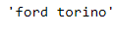

Slicing

Slicing is a way to access and obtain subsets of ndarray in Numpy.
Syntax: array_name[start : end] – index starts at ‘start’ and ends at ‘end - 1’.

1.Slicing from 1D array

- #creating an array of cars
- cars = np.array(['chevrolet chevelle malibu', 'buick skylark 320', 'plymouth satellite', 'amc rebel sst', 'ford torino'])
- #accessing a subset of cars from the array
- cars[1:4]

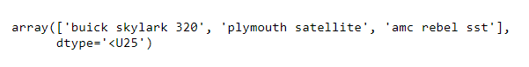

2. Slicing from a 2D array
- #Creating a 2D array consisting car names, horsepower and acceleration
- car_names = ['chevrolet chevelle malibu', 'buick skylark 320', 'plymouth satellite', 'amc rebel sst', 'ford torino']
- horsepower = [130, 165, 150, 150, 140]
- acceleration = [18, 15, 18, 16, 17]
- car_hp_acc_arr = np.array([car_names, horsepower, acceleration])
- car_hp_acc_arr

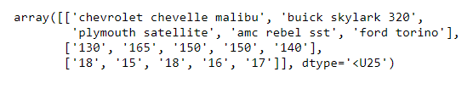

- #Creating a 2D array consisting car names, horsepower and acceleration
- car_names = ['chevrolet chevelle malibu', 'buick skylark 320', 'plymouth satellite', 'amc rebel sst', 'ford torino']
- horsepower = [130, 165, 150, 150, 140]
- acceleration = [18, 15, 18, 16, 17]
- car_hp_acc_arr = np.array([car_names, horsepower, acceleration])
- #Accessing name and horsepower
- car_hp_acc_arr[0:2]
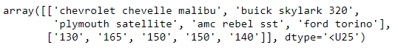

- #Creating a 2D array consisting car names, horsepower and acceleration
- car_names = ['chevrolet chevelle malibu', 'buick skylark 320', 'plymouth satellite', 'amc rebel sst', 'ford torino']
- horsepower = [130, 165, 150, 150, 140]
- acceleration = [18, 15, 18, 16, 17]
- car_hp_acc_arr = np.array([car_names, horsepower, acceleration])
- #Accessing name and horsepower of last two cars
- car_hp_acc_arr[0:2, 3:5]

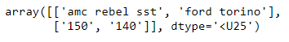

- #Creating a 2D array consisting car names, horsepower and acceleration
- car_names = ['chevrolet chevelle malibu', 'buick skylark 320', 'plymouth satellite', 'amc rebel sst', 'ford torino']
- horsepower = [130, 165, 150, 150, 140]
- acceleration = [18, 15, 18, 16, 17]
- car_hp_acc_arr = np.array([car_names, horsepower, acceleration])
- #Accessing name, horsepower and acceleration of first three cars
- car_hp_acc_arr[0:3, 0:3]
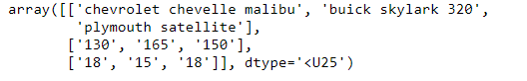

Mean and Median

Problem Statement:
The engineers at XYZ Custom Cars want to know about the mean and median of horsepower.

Solution:
The mean and median can be calculated with the help of following code:
- #creating a list of 5 horsepower values
- horsepower = [130, 165, 150, 150, 140]
- #creating a numpy array from horsepower list
- horsepower_arr = np.array(horsepower)
- #mean horsepower
- print("Mean horsepower = ",np.mean(horsepower_arr))

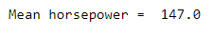
- #creating a list of 5 horsepower values
- horsepower = [130, 165, 150, 150, 140]
- #creating a numpy array from horsepower list
- horsepower_arr = np.array(horsepower)
- #median horsepower
- print("Median horsepower = ",np.median(horsepower_arr))

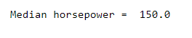

Min and max

Problem Statement:
The engineers at XYZ Custom Cars want to know about the minimum and maximum horsepower.

Solution:
The min and max can be calculated with the help of following code:

- #creating a list of 5 horsepower values
- horsepower = [130, 165, 150, 150, 140]
- #creating a numpy array from horsepower list
- horsepower_arr = np.array(horsepower)
- print("Minimum horsepower: ", np.min(horsepower_arr))
- print("Maximum horsepower: ", np.max(horsepower_arr))

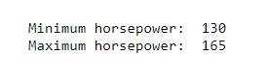

Finding the index of minimum and maximum values:
'argmin()' and 'argmax()' return the index of minimum and maximum values in an array respectively.
- #creating a list of 5 horsepower values
- horsepower = [130, 165, 150, 150, 140]
- #creating a numpy array from horsepower list
- horsepower_arr = np.array(horsepower)
- print("Index of Minimum horsepower: ", np.argmin(horsepower_arr))
- print("Index of Maximum horsepower: ", np.argmax(horsepower_arr))
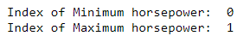

Querying/searching in an array

Problem Statement:
The engineers at XYZ Custom Cars want to know the horsepower of cars that are greater than or equal to 150.

Solution:
The 'where' function can be used for this requirement. Given a condition, 'where' function returns the indexes of the array where the condition satisfies. Using these indexes, the respective values from the array can be obtained.

- #creating a list of 5 horsepower values
- horsepower = [130, 165, 150, 150, 140]
- #creating a numpy array from horsepower list
- horsepower_arr = np.array(horsepower)
- x = np.where(horsepower_arr >= 150)
- print(x) # gives the indices
- # With the indices , we can find those values
- horsepower_arr[x]
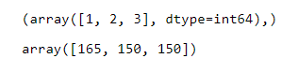

Filter data

Problem Statement:
The Engineers at XYZ Custom Cars want to create a separate array consisting of filtered values of horsepower greater than 135.

Solution:
Getting some elements out of an existing array based on certain conditions and creating a new array out of them is called filtering.
The following code can be used to accomplish this:
- #creating a list of 5 horsepower values
- horsepower = [130, 165, 150, 150, 140]
- #creating a numpy array from horsepower list
- horsepower_arr = np.array(horsepower)
- #creating filter array
- filter_arr = horsepower_arr > 135

- newarr = horsepower_arr[filter_arr]

- print(filter_arr)
- print(newarr)

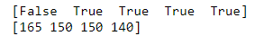

Sorting an array

Problem Statement:
The engineers at XYZ Custom Cars want the horsepower in sorted order.

Solution:
The numpy array can be sorted by passing the array to the function sort(array) or by array.sort.
So, what is the difference between these two functions though they are used for the same functionality?
- #creating a list of 5 horsepower values
- horsepower = [130, 165, 150, 150, 140]
- #creating a numpy array from horsepower list
- horsepower_arr = np.array(horsepower)
- #using sort(array)
- print('original array: ', horsepower_arr)
- print('Sorted array: ', np.sort(horsepower_arr))
- print('original array after sorting: ', horsepower_arr)

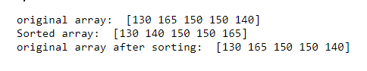
- #creating a list of 5 horsepower values
- horsepower = [130, 165, 150, 150, 140]
- #creating a numpy array from horsepower list
- horsepower_arr = np.array(horsepower)
- #using sort(array)
- print('original array: ', horsepower_arr)
- horsepower_arr.sort()
- print('original array after sorting: ', horsepower_arr)

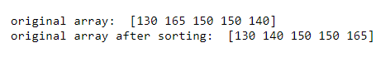
The difference is that the array.sort() function modifies the original array by default, whereas the sort(array) function does not.
Vectorized operations

The mathematical operations can be performed on Numpy arrays. Numpy makes use of optimized, pre-compiled code to perform mathematical operations on each array element. This eliminates the need of using loops, thereby enhancing the performance. This process is called vectorization.
Numpy provides various mathematical functions such as sum(), add(), sub(), log(), sin() etc. which uses vectorization.
Consider an example of marks scored by a student:
Subject | Marks
English | 78
Mathematics | 92
Physics | 36
Chemistry | 64
Biology | 89

Problem Statement:
Calculate the sum of all the marks.

Solution:
The sum() function can be used which internally uses vectorizaton .
- student_marks_arr = np.array([78, 92, 36, 64, 89])
- print(np.sum(student_marks_arr))

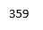

Problem Statement:
Award extra marks in subjects as follows:
English: +2
Mathematics: +2
Physics: +5
Chemistry: +10
Biology: +2

Solution:
Below is the solution to the problem:
- additional_marks = [2, 2, 5, 10, 1]
- student_marks_arr += additional_marks
- student_marks_arr
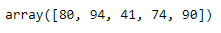
Also, the same operation can be performed as shown below:
- student_marks_arr = np.array([78, 92, 36, 64, 89])
- student_marks_arr = np.add(student_marks_arr, additional_marks)
- student_marks_arr

Both the above methods use vectorization internallly eliminating the need of loops.
Other arithmetic operations can also be performed in a similar manner.
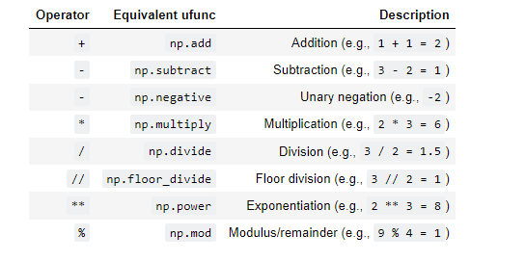
In addition to arithmetic operations, several other mathematical operations like exponents, logarithms and trigonometric functions are also available in Numpy. This makes Numpy a very useful tool for scientific computing.

Broadcasting

"Broadcasting" refers to the term on how Numpy handles arrays with different shapes during arithmetic operations. Array of smaller size is stretched or copied across the larger array.
For example, considering the following arithmetic operations across 2 arrays:
- import numpy as np
- # Array 1
- array1=np.array([5, 10, 15])
- # Array 2
- array2=np.array([5])
- array3= array1 * array2
- array3

In this example, the array2 is being stretched or copied to match array1 during the arithmetic operation resulting in new array array3 with the same shape as array1.
The following diagram explains broadcasting:
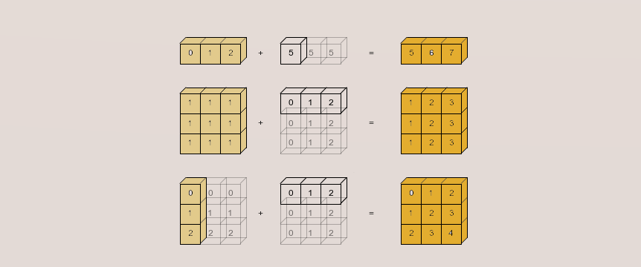

- In the first operation, the shape of first array is 1x3 and the shape of second array is 1x1. Hence, according to broadcasting rules, the second array gets stretched to match the shape of first array and the shape of the resulting array is 1x3.
- In the second operation, the shape of first array is 3x3 and the shape of second array is 1x3. Hence, according to broadcasting rules, the second array gets stretched to match the shape of first array and the shape of the resulting array is 3x3.
- In the third operation, the shape of first array is 3x1 and the shape of second array is 1x3. Hence, according to broadcasting rules, both first and second arrays get stretched and the shape of the resulting array is 3x3.

Broadcasting - demo

Consider the following table consisting marks scored by four student in two different subjects:
Students | Chemistry | Physics
Subodh | 67 | 45
Ram | 90 | 92
Abdul | 66 | 72
John | 32 | 40

The teacher of these students wants to represent their marks in an array. To do so, the marks can be stored using a 4x2 array as follows:
- #Students marks in 4 subjects
- students_marks = np.array([[67, 45],[90, 92],[66, 72],[32, 40]])
- students_marks

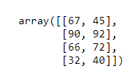

Problem Statement:
Now the teacher wants to award extra five marks in Chemistry and extra ten marks in Physics.

Solution:
- #Students marks in 4 subjects
- students_marks = np.array([[67, 45],[90, 92],[66, 72],[32, 40]])
- #Broadcasting
- students_marks += [5,10]
- students_marks

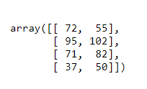
The student's marks array is a 2D array of shape 4x2. The marks to be added are in the form of a 1D array of size 1x2. According to the broadcasting rules, the marks to be added get stretched to match the shape of student marks array and the shape of the resulting array is 4x2.

Image as a Numpy matrix

Images are stored as arrays of hundreds, thousands or even millions of picture elements called as pixels. Therefore, images can also be treated as Numpy array, as they can be represented as matrix of pixels.
Certain basic operations and manipulations can be carried out on images using Numpy and scikit-image package. Scikit-image is an image processing package.
The package is imported as skimage.

Importing an image:
- #Importing path and skimage i/o library
- import os.path
- from skimage.io import imread
- from skimage import data_dir
- #reading the astronaut image
- img = imread(os.path.join(data_dir, 'astronaut.png'))

- #Using matplotlib.pyplot to visualize the image
- import matplotlib.pyplot as plt
- plt.imshow(img)



Indexing and selection

So far, you have become familiar with, how to retrieve the basic attributes of the image. Let us proceed to understand some examples on indexing and selection on images.

Cutting the rocket out of the image
- #Importing path and skimage i/o library
- import os.path
- from skimage.io import imread
- from skimage import data_dir
- #reading the astronaut image
- img = imread(os.path.join(data_dir, 'astronaut.png'))

- #Slicing out the rocket
- img_slice = img.copy()
- img_slice = img_slice[0:300,360:480]
- plt.figure()
- plt.imshow(img_slice)
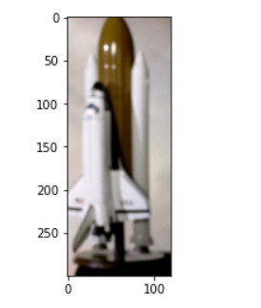

In this case, the image has been sliced corresponding to the rocket from the original image.

Assigning the values corresponding to the sliced image as 0:
- img[0:300,360:480,:] = 0
- plt.imshow(img)

