Defining an Interface
Interface keyword is used to declare an interface.
An interface should have properties and method declarations.
Properties or methods in an interface should not have any access modifiers.
Properties cannot be initialized in an interface.
Syntax :
- interface Interfacename {
- // declare properties;
- // method declarations;
- }
Example:
- //Declaring Product interface with productId and productName as properties. Function or Object which is going to use this interface should contain properties declared here.
- interface Product {
- productId: number;
- productName: string;
- }
- //In this function Product object is passed as parameter, if object passed does not have any of the properties declared in the Interface code throws error.
- function getProductDetails(productobj: Product): string {
- return `the product is ${productobj.productName}`
- }
- //Correct way of using the interface type
- let productobj1 = { productId: 1001, productName: 'Mobile' };
- console.log(getProductDetails(productobj1));
- //InCorrect way of using the interface type, as this declaration does not have productId property of Interface, code throws compilation error
- let productobj2 = { productCategory: 'Gadget', productName: 'Mobile' };
- getProductDetails(productobj2); //compilation error

Defining an Interface - Optional property

In a TypeScript interface, if certain properties need to be made optional, it can be done by adding the ‘?’ symbol after the property name.
Example:
- interface Product {
- productId?: number;
- productName: string;
- }
- function getProductDetails(productobj: Product): string {
- return "The product name is " + productobj.productName;
- }
- let prodObject = { productName: 'Mobile', productCategory: 'Gadget' };
- console.log(getProductDetails(prodObject));
In the above example
- Line no 2 makes the productId property optional by adding ? after property name.
- Line no 9 does not throw compilation error as productId property is optional.

Duck Typing

Duck-Typing is a rule for checking the type compatibility for more complex variable types.
TypeScript compiler uses the duck-typing method to compare one object with the other by comparing that both the objects have the same properties with the same data types.
TypeScript interface uses the same duck typing method to enforce type restriction. If an object that has been assigned as an interface contains more properties than the interface-mentioned properties, it will be accepted as an interface type and additional properties will be ignored for type checking.
Let us rewrite the previous example to a pass additional parameter.
- interface Product {
- productId: number;
- productName: string;
- }
- function getProductDetails(productobj: Product): string {
- return 'The product name is : ' + productobj.productName;
- }
- //Incorrect way of using the interface duck type
- let prodObject1 = { productName: 'Mobile', productCategory: 'Gadget' };
- console.log(getProductDetails(prodObject1));
- //Correct way of using the interface duck type by adding an additional property productCategory to demonstrate DuckTyping
- let prodObject2 = { productId: 1001, productName: 'Mobile', productCategory: 'Gadget' };
- console.log(getProductDetails(prodObject2));
- In the Line no.10 of the above code, it will throw error because of the duck typing.

Defining an Interface

- Interface keyword is used to declare an interface.
- An interface should have properties and method declarations.
- Properties or methods in an interface should not have any access modifiers.
- Properties cannot be initialized in a TypeScript interface.

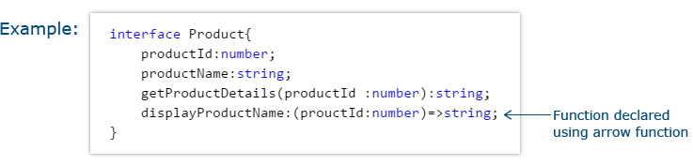

Defining an Interface – Optional Property

In a TypeScript interface, if certain properties need to be made optional, you can make them optional by adding ‘?’ after the property name.
Let us rewrite the duck typing example with the optional property.

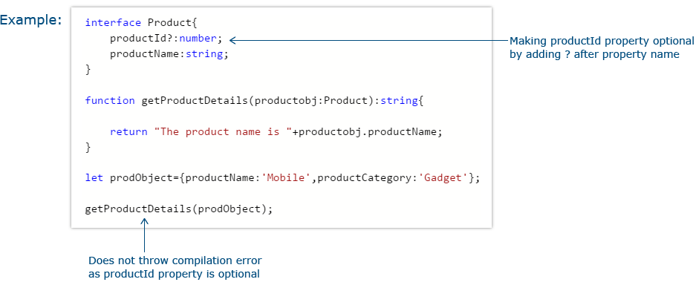

Extending Interfaces

An interface can be extended from an already existing one using the extends keyword.
In the code below, extend the productList interface from both the Category interface and Product interface.
Example:
- interface Category {
- categoryName: string;
- }
- interface Product {
- productName: string;
- productId: number;
- }
- interface productList extends Category, Product {
- list: Array<string>;
- }
- let productDetails: productList = {
- categoryName: 'Gadget',
- productName: 'Mobile',
- productId: 1234,
- list: ['Samsung', 'Motorola', 'LG']
- }
In the above example
- Line no 8 extends productList interface from two other interfaces Category and Product.
- Line no 11- creating object literal productDetails of productList interface type would throw compilation error if the properties declared in super interfaces are not defined.

Class Types

The interface can be used to define class types to explicitly enforce that a class meets a particular contract. Use the ‘implements’ keyword to implement interface inside a class.
To enforce interface type on a class while instantiating an object of a class, declare it using the interface type.
Only those methods and properties that are declared within the interface, will be available with the instantiated object.
Example:
- interface Product {
- getProductDetails(productId: number): string;
- displayProductName: (productName: string) => string;
- }
- class Gadget implements Product {
- getProductDetails(productId: number): string {
- return "The product id is" + " " + productId;
- }
- displayProductName(productName: string): string {
- return "The product name is" + " " + productName;
- }
- }
- var myproduct: Product = new Gadget();
- console.log(myproduct.getProductDetails(9861));
- console.log(myproduct.displayProductName("Samsung galaxy s23"))
- ;
In the above example
- Line no 5 implements interface Product with class Gadget. One should define all the functions declared within the interface inside class, otherwise it will throw compilation error.
- Line no 13 enforces type on class while declaring class variable.

What is Mixin?

Mixin is a way to extend the functionality of a class by incorporating the properties and methods of other classes into it.
They provide a mechanism for code reuse and allows to combine the functionalities of different classes without the need for traditional inheritance.
There are three ways to implement Mixin:
- Interface Class Extension
- Declaration Merging
- By using the helper function provided by TypeScript
Let us discuss these methods in detail.

Interface Class Extension

In TypeScript, an interface can extend multiple classes. For a class to have the properties of multiple classes, then:
1. Create an interface that extends all the required classes.
- interface newClassName extends class1, class2 {}
2. Declare a class with same name as the interface declared above
- class newClassName{}
Example:
Consider a class and interface as shown below.
- class Phone {
- color: string;
- }

- class DisplayDevice {
- resolution: string;
- }

- interface SmartPhone extends Phone, DisplayDevice { }
- class SmartPhone { }

- let gadget = new SmartPhone();
- gadget.color = "Green";
- gadget.resolution = "21 inches";
Line no 1 declares a class Phone and Line no 5 declares another class with name DisplayDevice.
Line no 9 declares an interface with name SmartPhone, which extends the Phone class and displayDevice class.
Line no 10 declares another class with the same name of the interface SmartPhone. The result is that, the SmartPhone class will have all the properties of the SmartPhone interface. In short, the SmartPhone class is merged with the SmartPhone interface. As Interfaces don’t have the implementations, only the interface members(and not its implementation) can be extended using this method.

Declaration Merging
Declaration merging is the TypeScript feature which combines multiple interface declarations with the same name into a single interface. For example, consider the interface declaration shown below:
- interface Phone {
- brand: string,
- warranty: number
- }
Now consider the declaration of another interface with same name but different properties:
- interface Phone {
- screenSize: string;
- }
Because of declaration merging, the interface Phone will now have the properties such as brand, warranty and screenSize.
Again, while creating an object of type Phone, it should have all the three properties mentioned. An example is given below.
- let phone1: Phone = {
- brand: 'ABC',
- warranty: 3,
- screenSize: '10inches'
- }

Helper function provided by TypeScript
TypeScript provides a helper function that can be used for merging multiple classes.
Consider the two classes Phone and DisplayDevice as shown below.
- class Phone {
- name: string;
- sayImAPhone() {
- console.log("I am a phone");
- }
- }
- class DisplayDevice {
- resolution: number;
- sayImADisplayDevice() {
- console.log("I am an DisplayDevice ");
- }
- }
Let us create a new class SmartPhone, which extends the classes Phone and DisplayDevice using the helper function applyMixins() as given below.
- function applyMixins(derivedCtor: any, constructors: any[]) {
- constructors.forEach((baseCtor) => {
- Object.getOwnPropertyNames(baseCtor.prototype).forEach((name) => {
- Object.defineProperty(
- derivedCtor.prototype,
- name,
- Object.getOwnPropertyDescriptor(baseCtor.prototype, name) ||
- Object.create(null)
- );
- });
- });
- }
The applyMixins() function accepts two parameters:
- Parameter1 is the new class that is to be created
- Parameter2 is an array of classes, from which the new class is to be created.
In above example, Parameter1 will be the class SmartPhone and Parameter2 will be [Phone, DisplayDevice]. The code snippet below shows extending SmartPhone class from Phone and DisplayDevice classes.
- class Phone {
- name: string;
- sayImAPhone() {
- console.log("I am a phone");
- }
- }

- class DisplayDevice {
- resolution: number;
- sayImADisplayDevice() {
- console.log("I am an DisplayDevice ");
- }
- }

- class SmartPhone {
- ProdId: string;
- }

- interface SmartPhone extends Phone, DisplayDevice { }

- function applyMixins(derivedCtor: any, constructors: any[]) {
- constructors.forEach((baseCtor) => {
- Object.getOwnPropertyNames(baseCtor.prototype).forEach((name) => {
- Object.defineProperty(
- derivedCtor.prototype,
- name,
- Object.getOwnPropertyDescriptor(baseCtor.prototype, name) ||
- Object.create(null)
- );
- });
- });
- }

- applyMixins(SmartPhone, [Phone, DisplayDevice]);

- let smPhone1: SmartPhone = new SmartPhone;
- smPhone1.sayImAPhone();
- smPhone1.sayImADisplayDevice();
The advantage of using the helper function is that the implementation of the base classes can also be extended.

