Identifiers – Why and What
To model the real-world entities,they have to be named to use it in the JavaScript program.
Identifiers are those names that help in naming the elements in JavaScript.
Example:
- firstName;
- placeOfVisit;
Identifiers should follow below rules:
- The first character of an identifier should be letters of the alphabet or an underscore (_) or dollar sign ($).
- Subsequent characters can be letters of alphabets or digits or underscores (_) or a dollar sign ($).
- Identifiers are case-sensitive. Hence, firstName and FirstName are not the same.
Reserved keywords are part of programming language syntax and cannot be used as identifiers.
Types of Identifiers - let, const, var

The identifiers in JavaScript can be categorized into three as shown below. They can be declared into specific type based on:
- The data which an identifier will hold and
- The scope of the identifier
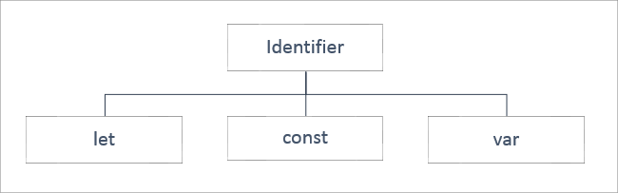

let

An identifier declared using ‘let’ keyword has a block scope i.e., it is available only within the block in which it is defined.
The value assigned to the identifier can be done either at the time of declaration or later in the code and can also be altered further.
All the identifiers known so far vary in their scope and with respect to the data it holds.
Example:
- let name="William";
- console.log("Welcome to JS course, Mr."+name);

- let name = "Goth"; /* This will throw an error because the identifier 'name' has been already declared and we are redeclaring the variable, which is not allowed using the 'let' keyword. */
- console.log("Welcome to JS course, Mr."+name);

Note: As a best practice, use the let keyword for identifier declarations that will change their value over time or when the variable need not be accessed outside the code block. For example, in loops, looping variables can be declared using let as they are never used outside the block.
Const
The identifier to hold data that does not vary is called 'Constant' and to declare a constant, 'const' keyword is used, followed by an identifier. The value is initialized during the declaration itself and cannot be altered later.
The identifiers declared using 'const' keyword have block scope i.e., they exist only in the block of code within which they are defined.
Example:
- const pi = 3.14;
- console.log("The value of Pi is: "+pi);

- pi = 3.141592; /* This will throw an error because the assignment to a const needs to be done at the time of declaration and it cannot be re-initialized. */
- console.log("The value of Pi is: "+pi);

Note: As a best practice, the const declaration can be used for string type identifiers or simple number, functions or classes which does not need to be changed or value

var
For example, if A4 size paper is referred, then the dimension of the paper remains the same, but its colour can vary.
The identifiers declared to hold data that vary are called 'Variables' and to declare a variable, the 'var' keyword is optionally used.
The value for the same can be initialized optionally. Once the value is initialized, it can be modified any number of times later in the program.
Talking about the scope of the identifier declared using ‘var’ keyword, it takes the Function scope i.e., it is globally available to the Function within which it has been declared and it is possible to declare the identifier name a second time in the same function.
Example:
- var name = "William";
- console.log("Welcome to JS course, Mr." + name);
- var name = "Goth"; /* Here, even though we have redeclared the same identifier, it will not throw any error.*/
- console.log("Welcome to JS course, Mr." + name);

Note: As a best practice, use the 'var' keyword for variable declarations for function scope or global scope in the program.
let vs. const vs. var

Below table shows the difference between let, const and var.
Keyword | Scope | Declaration | Assignment
let | Block | Redeclaration not allowed | Re-assigning allowed
const | Block | Redeclaration not allowed | Re-assigning not allowed
var | Function | Redeclaration allowed | Re-assigning allowed

Working with Data Types
To be able to proceed with the manipulation of the data assigned to the variables, it is mandatory for a programming language to know the type of value or the type of data that the variable holds.
That is because the operations or manipulations that must be applied on a variable will be specific to the type of data that a variable will hold.
For example, the result of add operation on two variables will vary based on the fact whether the value of both the variables is numeric or textual.
To handle such situation, data types are used.
Data type mentions the type of value assigned to a variable.
In JavaScript, the type is not defined during variable declaration. Instead, it is determined at run-time based on the value it is initialized with.
Hence, JavaScript language is a loosely typed or dynamically typed language.
Example:
- let age = 24; //number
- let name = “Tom” //string
- let qualified = true; //boolean

Also, there can be same variable of different types in JavaScript code based on the value that is assigned to it.
For example, if let age = 24, the variable 'age' is of type number. But if, let age = "Twenty-Four", variable 'age' is of type string.
Types of data types
JavaScript defines the following data types:
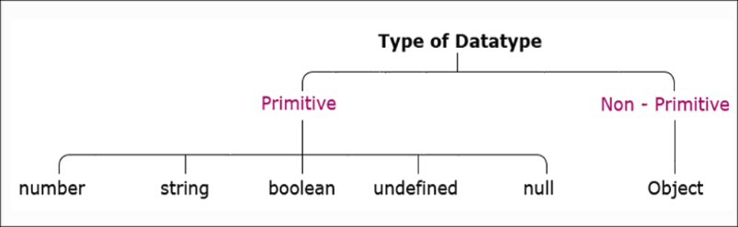
Primitive data type - Number

The data is said to be primitive if it contains an individual value.
Let us explore each of the primitive data types individually.
Number
To store a variable that holds a numeric value, the primitive data type number is used. In almost all the programming languages a number data type gets classified as shown below:
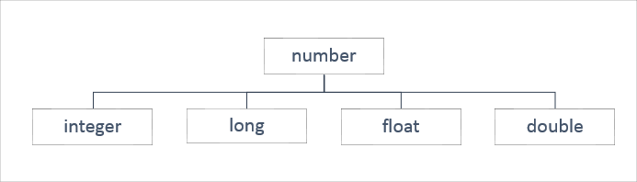
But in JavaScript. the data type number is assigned to the values of type integer, long, float, and double. For example, the variable with number data type can hold values such as 300, 20.50, 10001, and 13456.89.
Constant of type number can be declared like this:
Example:
- const pi = 3.14; // its value is 3.14
- const smallestNaturalNumber = 0; // its value is 0

In JavaScript, any other value that does not belong to the above-mentioned types is not considered as a legal number. Such values are represented as NaN (Not-a-Number).
Example:
- let result = 0/0; // its value is NaN
- let result = "Ten" * 5; //its value is NaN

String
When a variable is used to store textual value, a primitive data type string is used. Thus, the string represents textual values. String values are written in quotes, either single or double.
Example:
- let personName= “Rexha”; //OR
- let personName = ‘Rexha’; // both will have its value as Rexha
You can use quotes inside a string but that shouldn't match the quotes surrounding the string. Strings containing single quotes must be enclosed within double quotes and vice versa.
Example:
- let ownership= "Rexha's"; //OR
- let ownership = 'Rexha"s';
This will be interpreted as Rexha's and Rexha"s respectively. Thus, use opposite quotes inside and outside of JavaScript single and double quotes.
But if you use the same quotes inside a string and to enclose the string:
Example:
- let ownership= "Rexha"s"; //OR
- let ownership = 'Rexha's';
It is a syntax error.
Thus, remember, strings containing single quotes must be enlosed within double quotes and strings containing double quotes must be enclosed within single quotes.
To access any character within the string, it is important to be aware of its position in the string.
The first character exists at index 0, next at index 1, and so on.
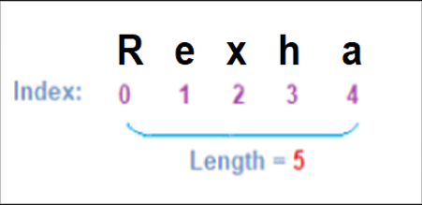
Literals
Literals can span multiple lines and interpolate expressions to include their results.
Example:
- let firstName="Kevin";
- let lastName="Patrick";
- console.log("Name: "+firstName+" "+lastName+"\n Email:"+firstName+"_"+lastName+"@abc.com");

- /*
- OUTPUT:
- Name: Kevin Patrick
- Email:Kevin_Patrick@abc.com
- */

Here, '+' is used for concatenation of identifiers and static content, and '\n' for a new line.

To get the same output, literals can be used as shown below:
- let firstName="Kevin";
- let lastName="Patrick";
- console.log(`Name:${firstName} ${lastName}
- Email: ${firstName}_${lastName}@abc.com`);

- /*
- OUTPUT:
- Name: Kevin Patrick
- Email:Kevin_Patrick@abc.com
- */

Using template literal, multiple lines can be written in the console.log() in one go.
So, the template literal notation enclosed in ``(backticks) makes it convenient to have multiline statements with expressions and the variables are accessed using ${} notation.
Boolean
When a variable is used to store a logical value that can always be true or false then, primitive data type Boolean is used. Thus, Boolean is a data type which represents only two values: true and false.
Values such as 100, -5, “Cat”, 10<20, 1, 10*20+30, etc. evaluates to true whereas 0, “”, NaN, undefined, null, etc. evaluates to false.

Undefined
When the variable is used to store "no value", primitive data type undefined is used.
Any variable that has not been assigned a value has the value undefined and such variable is of type undefined. The undefined value represents "no value".

Example 1:
- let custName; //here value and the data type are undefined
The JavaScript variable can be made empty by assigning the value undefined.
Example 2:
- let custName = "John"; //here value is John and the data type is String
- custName = undefined; //here value and the data type are undefined
null
The null value represents "no object".
Null data type is required as JavaScript variable intended to be assigned with the object at a later point in the program can be assigned null during the declaration.
Example 1:
- let item = null;
- // variable item is intended to be assigned with object later. Hence null is assigned during variable declaration.
If required, the JavaScript variable can also be checked if it is pointing to a valid object or null.
Example 2:
- document.write(item==null);

Note: 'document' is an object that represents the HTML document rendered on the browser window and write() method helps one to populate HTML expressions or JavaScript code directly to the document.

BigInt is a special numeric type that provides support for integers of random length.
A BigInt is generated by appending n to the end of an integer literal or by calling the function BigInt that generates BigInt from strings, numbers, etc.
Example:
- const bigintvar = 67423478234689887894747472389477823647n;

- OR

- const bigintvar = BigInt("67423478234689887894747472389477823647");

- const bigintFromNumber = BigInt(10); // same as 10n

common math operations can be done on BigInt as regular numbers. But BigInt and regular numbers cannot be mixed in the expression.
Example:
- alert(3n + 2n); // 5

- alert(7n / 2n); // 3

- alert(8n + 2); // Error: Cannot mix BigInt and other types
Here the division returns the result rounded towards zero, without the decimal part. Thus, all operations on BigInt return BigInt.
BigInt and regular numbers must be explicitly converted using either BigInt() or Number(), as shown below:
Example:
- let bigintvar = 6n;
- let numvar = 3;

- // number to bigint
- alert(bigintvar + BigInt(numvar)); // 9

- // bigint to number
- alert(Number(bigintvar ) + numvar); // 9

In the above example, if the bigintvar is too large that it won’t fit the number type, then extra bits will be cut off.
Talking about comparison and boolean operations on BigInt, it works fine.
Example:
- alert( 8n > 2n ); // true

- alert( 4n > 2 ); // true
Even though numbers and BigInts belong to different types, they can be equal ==, but not strictly equal ===.
Example:
- alert( 5 == 5n ); // true

- alert( 5 === 5n ); // false
When inside if or other boolean operations, BigInts behave like numbers.
Example:
- if (0n) {
- // never executes
- }
BigInt 0n is falsy, other values are considered to be truthy.
Boolean operators, such as ||, && and others also work perfectly with Bigints similar to numbers.
Example:
- alert( 1n || 2 );
- // 1, here 1n is considered truthy

- alert( 0n || 2 );
- // 2, here 0n is considered falsy
A "symbol" represents a unique identifier. You can make use of Symbol() to generate a value of this type.
Example:
- // empid is a new symbol
- let empid = Symbol();

Also, a description of the symbol generated can be provided which can be mostly used as a name during debugging.
Example:
- // empid is a symbol with the description "empno"
- let empid = Symbol("empno");
Even if various symbols are created with the same description, they are different values. Thus, symbols ensures uniqueness. So the description provided can be considered as just a label.
- let empid1 = Symbol("empno");
- let empid2 = Symbol("empno");

- alert(empid1== empid2); // false
Here both the symbols have the same description but are never considered equal.
Unlike other values, a symbol value doesn't follow auto-convert.
Example:
- let empid = Symbol("empno");
- alert(empid); // TypeError: Cannot convert a Symbol value to a string
This is a rule because strings and symbols are basically different and should not accidentally get converted to the other one.
But if it is a must to display the Symbol, then the following can be done:
Example:
- let empid = Symbol("empno");
- alert(empid.toString()); // Symbol(empno), now it works

- OR

- //use description
- let empid = Symbol("empno");
- alert(empid.description); // empno

Global symbols
So far you know that symbols remain unique even if they have the same name. But at times, there may be a situation where you may want the symbols with same name to be same entities.
In such a situation, symbols can be created in a global symbol registry and access them later and ensure that repeated accesses by the same name return exactly the same symbol. To read a symbol from the registry, use Symbol.for(key) which checks if there’s a symbol described as key, then returns it, otherwise creates a new symbol Symbol.for(key) and stores it in the registry by the given key.
Example:
- // read from the global registry
- let empid = Symbol.for("empno"); // if the symbol did not exist, it is created

- // read it again (maybe from another part of the code)
- let empidAgain= Symbol.for("empid");

- // the same symbol
- alert( empid === empidAgain ); // false
Thus, global symbols help in creating application-wide symbol which is accessible everywhere in the code.
Non-Primitive Data Types
The data type is said to be non-primitive if it is a collection of multiple values.
The variables in JavaScript may not always hold only individual values which are with one of the primitive data types.
There are times a group of values are stored inside a variable.
JavaScript gives non-primitive data types named Object and Array, to implement this.
Objects
Objects in JavaScript are a collection of properties and are represented in the form of [key-value pairs].
The 'key' of a property is a string or a symbol and should be a legal identifier.
The 'value' of a property can be any JavaScript value like Number, String, Boolean, or another object.
JavaScript provides the number of built-in objects as a part of the language and user-defined JavaScript objects can be created using object literals.
Syntax:
- {
- key1 : value1,
- key2 : value2,
- key3 : value3
- };
Example:
- let mySmartPhone = {
- name: "iPhone",
- brand: "Apple",
- platform: "iOS",
- price: 50000
- };

Array
The Array is a special data structure that is used to store an ordered collection, which cannot be achieved using the objects.
There are two ways of creating an array:
- let dummyArr = new Array();
- //OR
- let dummyArr = [];
Either array can be declared as empty and can be assigned with value later, or can have the value assigned during the declaration.
Example:
- digits =[1,2,3,"four"];
A single array can hold multiple values of different data types.
Working With Operators

Operators in a programming language are the symbols used to perform operations on the values.
Operands: Represents the data.
Operator: Performs certain operations on the operands.
- let sum = 5 + 10;
The statement formed using the operator and the operands are called Expression.
In the above example, 5+10 is an expression.
The values are termed as operands.
The symbol ‘+’ is the operator which indicates which operation needs to be performed.
Types of Operators
Operators are categorized into unary, binary, and ternary based on the number of operands on which they operate in an expression.
JavaScript supports the following types of operators:
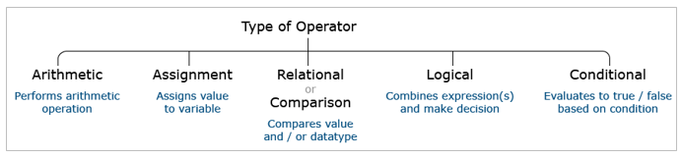
Arithmetic operators are used for performing arithmetic operations
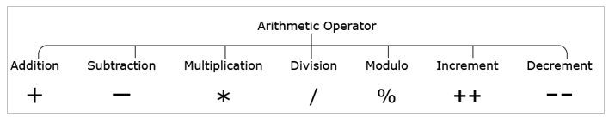
​
- let sum = 5 + 3; // sum=8
- let difference = 5 – 3; // difference=2
- let product = 5 * 3; // product=15
- let division = 5/3; // division=1
- let mod = 5%3; // mod=2
- let value = 5;
- value++; // increment by 1, value=6
- let value = 10;
- value--; // decrement by 1, value=9

Arithmetic operator '+' when used with string type results in the concatenation.
- let firstName = "James";
- let lastName = "Roche";
- let name = firstName + " " + lastName; // name = James Roche
Arithmetic operator ‘+’ when used with a string value and a numeric value, it results in a new string value.
- let strValue="James";
- let numValue=10;
- let newStrValue= strValue + " " + numValue; // newStrValue= James 10

Assignment operators are used for assigning values to the variables.
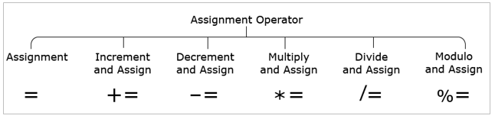

- let num = 30; // num=30
- let num += 10; // num=num+10 => num=40
- let num -= 10; // num=num-10 => num=20
- let num *= 30; // num=num*30 => num=900
- let num /= 10; // num=num/10 => num=3
- let num %= 10; // num=num%10 => num=0

Relational or Comparison Operators
Relational operators are used for comparing values and the result of comparison is always either true or false.
Relational operators shown below do implicit data type conversion of one of the operands before comparison.
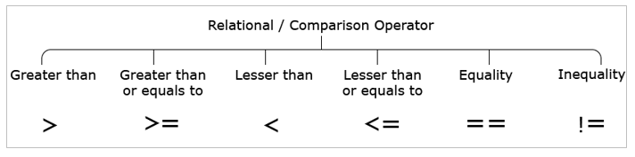
- 10 > 10; //false
- 10 >= 10; //true
- 10 < 10; //false
- 10 <= 10; //true
- 10 == 10; //true
- 10 != 10; //false

Relational or Comparison Operators
Relational operators shown below compares both the values and the value types without any implicit type conversion.
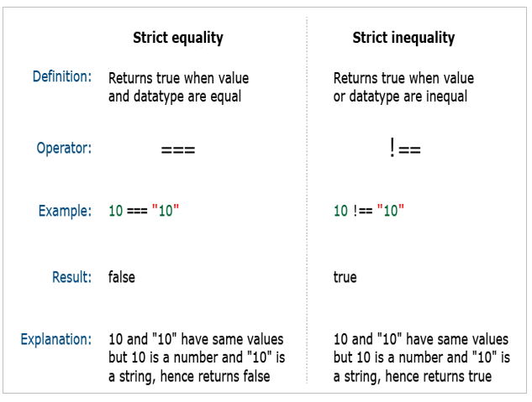
Strict equality (===) and strict inequality (!==) operators consider only values of the same type to be equal.
Hence, strict equality and strict inequality operators are highly recommended to determine whether two given values are equal or not.

Note: As a best practice, you should use === comparison operator when you want to compare value and type, and the rest of the places for value comparison == operator can be used.

Logical Operators
Logical operators allow a program to make a decision based on multiple conditions. Each operand is considered a condition that can be evaluated to true or false.
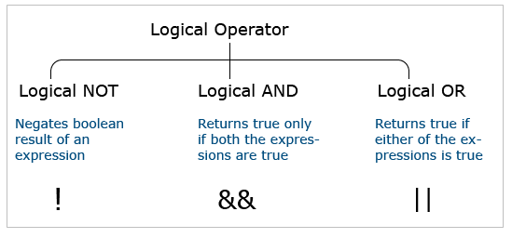
- !(10 > 20); //true
- (10 > 5) && (20 > 20); //false
- (10 > 5) || (20 > 20); //true

typeof Operator
"typeof" is an operator in JavaScript.
JavaScript is a loosely typed language i.e., the type of variable is decided at runtime based on the data assigned to it. This is also called dynamic data binding.
As programmers, if required, the typeof operator can be used to find the data type of a JavaScript variable.
The following are the ways in which it can be used and the corresponding results that it returns.
- typeof "JavaScript World" //string
- typeof 10.5 // number
- typeof 10 > 20 //boolean
- typeof undefined //undefined
- typeof null //Object
- typeof {itemPrice : 500} //Object

Types of Statements
In JavaScript, the statements can be classified into two types.
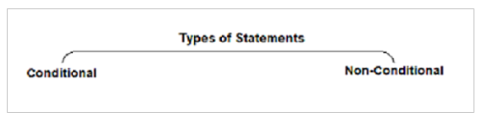
Conditional Statements:
Conditional statements help you to decide based on certain conditions.
These conditions are specified by a set of conditional statements having boolean expressions that are evaluated to a boolean value true or false.
Non-Conditional Statements:
Non-Conditional statements are those statements that do not need any condition to control the program execution flow.

Types of Non-Conditional Statements
Non-Conditional statements are those statements that do not need any condition to control the program execution flow.
In JavaScript, it can be broadly classified into three categories as follows:

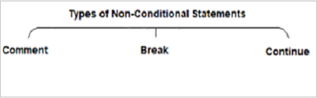
Comments
Comments in JavaScript can be used to prevent the execution of a certain lines of code and to add information in the code that explains the significance of the line of code being written.
JavaScript supports two kinds of comments.
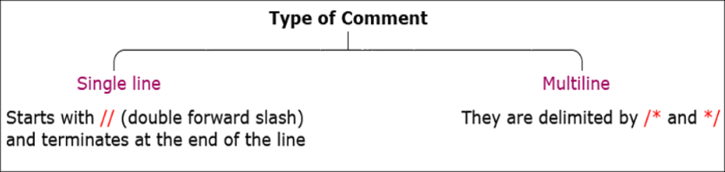

Example:
- // Formula to find the area of a circle given its radius
- var areaOfCircle = 2 * pi * radius;

- /*Formula to find the area of a circle based on
- given its radius value.
- */
- var areaOfCircle = 2 * pi * radius;

Note: As a best practice, it is recommended to use comments for documentation purposes and avoid using it for code commenting.
Break Statement
While iterating over the block of code getting executed within the loop, the loop may be required to be exited if certain condition is met.
The 'break' statement is used to terminate the loop and transfer control to the first statement following the loop.
Syntax:
- break;
Below example shows for loop with five iterations which increment variable "counter".
When loop counter = 3, loop terminates.
Also, shown below is the value of the counter and loopVar for every iteration of the loop.
- var counter = 0;
- for (var loop = 0; loop < 5; loop++) {
- if (loop == 3)
- break;
- counter++;
- }

loopVar | counter
0 | 1
1 | 2
2 | 3
3 | Loop terminated. counter = 3.
The 'if' statement used in the above example is a conditional / decision-making statement.
Continue Statement

There are times when during the iteration of the block of code within the loop, the block execution may be required to be skipped for a specific value and then continue to execute the block for all the other values. JavaScript gives a 'continue' statement to handle this.
Continue statement is used to terminate the current iteration of the loop and continue execution of the loop with the next iteration.
Syntax:
- continue;
Below example shows for loop with five iterations which increment variable "counter".
When loop counter = 3, the current iteration is skipped and moved to the next iteration.
Also, shown below is the value of the counter and the variable loop for every iteration of the loop.
- var counter = 0;
- for (var loop = 0; loop < 5; loop++) {
- if (loop == 3)
- continue;
- counter++;
- }

loopVar | counter
0 | 1
1 | 2
2 | 3
3 | Iteration terminated. Hence counter is not incremented.
4 | 4
The 'if' statement used in the example is a conditional / decision-making statement.
Types of Conditional Statements

Conditional statements help in performing different actions for different conditions.
It is also termed as decision-making statements.
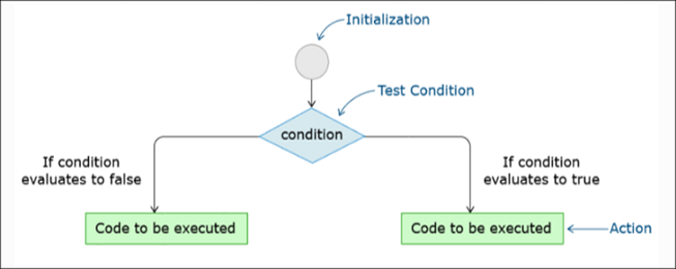
JavaScript supports two decision-making statements:
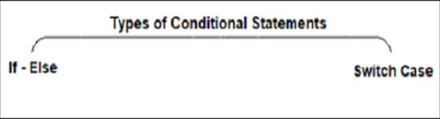

Ternary operator

It is a conditional operator that evaluates to one of the values based on whether the condition is true or false.
It happens to be the only operator in JavaScript that takes three operands. It is mostly used as a shortcut of 'if-else' condition.
Example:
- let workingHours = 9.20;
- let additionalHours;
- (workingHours > 9.15) ? additionalHours = "You have positive additional hours" : additionalHours = "You have negative additional hours";
- console.log(additionalHours);

If Statements
The 'if' statement evaluates the expression given in its parentheses giving a boolean value as the result.
You can have multiple 'if' statements for multiple choice of statements inside an 'if' statement.
There are different flavors of if-else statement:
- Simple 'if' statement
- if -else
- if–else–if ladder
Let us see each of them in detail.
if statement
The 'if' statement is used to execute a block of code if the given condition evaluates to true.
Syntax:
- if (condition) {
- // block of code that will be executed, if the condition is true
- }
Example:
- let num1 = 12;
- if (num1 % 2 == 0) {
- console.log("It is an even number!!");
- }
- // OUTPUT: It is an even number!! Because 12%2 evaluates to true

If-else

The 'else' statement is used to execute a block of code if the given condition evaluates to false.
Syntax:
- if (condition) {
- // block of code that will be executed, if the condition is true
- }
- else {
- // block of code that will be executed, if the condition is false
- }

Example:
- let num1 = 1;
- if (num1 % 2 == 0) {
- console.log("It is an even number!!");
- }
- else{
- console.log("It is an odd number!!");
- }
- //OUTPUT: It is an odd number!! Because in if 1%2 evaluates to false and moves to else condition

If-else-if Ladder

if...else ladder is used to check for a new condition when the first condition evaluates to false.
Syntax:
- if (condition1) {
- // block of code that will be executed if condition1 is true
- }
- else if (condition2) {
- // block of code that will be executed if the condition1 is false and condition2 is true
- }
- else {
- // block of code that will be executed if the condition1 is false and condition2 is false
- }
Example:
- let marks = 76;
- if (marks >= 75) {
- console.log("Very Good");
- }
- else if (marks < 85 && marks >= 50) {
- console.log("Good");
- }
- else {
- console.log("Needs Improvement");
- }
- // OUTPUT: Needs Improvement, Because the value of marks is 46 which doesn't satisfy the first two condition checks.

Switch Statement
The Switch statement is used to select and evaluate one of the many blocks of code.
Syntax:
- switch (expression) {
- case value1: code block;
- break;
- case value2: code block;
- break;
- case valueN: code block;
- break;
- default: code block;
- }
'break' statement is used to come out of the switch and continue execution of statement(s) the following switch.

Example:
For the given Employee performance rating (between 1 to 5), displays the appropriate performance badge.
- var perfRating = 5;

- switch (perfRating) {
- case 5:
- console.log("Very Poor");
- break;
- case 4:
- console.log("Needs Improvement");
- break;
- case 3:
- console.log("Met Expectations");
- break;
- case 2:
- console.log("Commendable");
- break;
- case 1:
- console.log("Outstanding");
- break;
- default:
- console.log("Sorry!! Invalid Rating.");
- }

OUTPUT: Very Poor

The break statements allow to get control out of the switch once we any match is found.

Example:
For the given Employee performance rating (between 1 to 5), displays the appropriate performance badge.
- var perfRating = 3;

- switch (perfRating) {
- case 5:
- console.log("Very Poor");
- break;
- case 4:
- console.log("Needs Improvement");
- break;
- case 3:
- console.log("Met Expectations");
- break;
- case 2:
- console.log("Commendable");
- break;
- case 1:
- console.log("Outstanding");
- break;
- default:
- console.log("Sorry!! Invalid Rating.");
- }

- /*
- OUTPUT:

- Met Expectation
- */

The reason for the above output is, first perfRating value is checked against case 5 and it does not match. Next, it is checked against case 4 and it also does not match. Next, when it is checked against case 3. it got a match hence “Met Expectation” is displayed, and the break statement moves the execution control out of the switch statement.

Consider the below code snippet without break statement:
- var perfRating = 5;

- switch (perfRating) {
- case 5:
- console.log("Very Poor");

- case 4:
- console.log("Needs Improvement");

- case 3:
- console.log("Met Expectations");

- case 2:
- console.log("Commendable");

- case 1:
- console.log("Outstanding");

- default:
- console.log("Sorry!! Invalid Rating.");
- }

- /*
- OUTPUT:
- Very Poor
- Needs Improvement
- Met Expectations
- Commendable
- Outstanding
- Sorry!! Invalid Rating.
- */

The reason for the above output is, initially perfRating is checked against case 5 and it got matched, hence 'Very Poor' is displayed. But as the break statement is missing, the remaining cases including default got executed.
A scenario in which the default statement gets executed.
- var perfRating = 15;

- switch (perfRating) {
- case 5:
- console.log("Very Poor");
- break;
- case 4:
- console.log("Needs Improvement");
- break;
- case 3:
- console.log("Met Expectations");
- break;
- case 2:
- console.log("Commendable");
- break;
- case 1:
- console.log("Outstanding");
- break;
- default:
- console.log("Sorry!! Invalid Rating.");
- }

- /*
- OUTPUT:
- Sorry!! Invalid Rating.
- */

The reason for the above output is, here perfRating = 15 does not match any case values. Hence, the default statement got executed.

