SQL DATA ANALYSIS PROJECT
USING SUPERSTORE SALES DATASET

- SALES PERFORMANCE ANALYSIS

1.TOTAL SALES

SELECT
FORMAT(SUM(SALES), 'N2') AS TOTAL_SALES
FROM ORDERS;
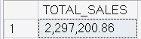

2.TOTAL PROFIT

SELECT
FORMAT(SUM(PROFIT), 'N2') AS TOTAL_PROFIT
FROM ORDERS;
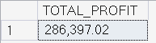

3.PROFIT MARGIN(%)

SELECT
ROUND(SUM(PROFIT)/SUM(SALES) * 100,2) AS PROFIT_MARGIN
FROM ORDERS;
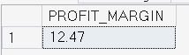

4.RETURN RATE

SELECT
100.0 * COUNT(R.ORDER_ID) / COUNT(O.ORDER_ID) AS RETURN_RATE
FROM ORDERS O
LEFT JOIN RETURNS R
ON O.ORDER_ID = R.ORDER_ID;
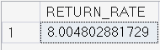

5.AVERAGE DISCOUNT

SELECT AVG(DISCOUNT) *100.0 AS AVERAGE_DISCOUNT
FROM ORDERS;
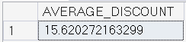

6.YEARLY SALES & PROFIT TREND

SELECT
YEAR(ORDER_DATE) AS YEAR,
FORMAT(ROUND(SUM(SALES), 2),'N2') AS TOTAL_SALES,
FORMAT(ROUND(SUM(PROFIT), 2),'N2') AS TOTAL_PROFIT
FROM ORDERS
GROUP BY YEAR(ORDER_DATE)
ORDER BY YEAR;
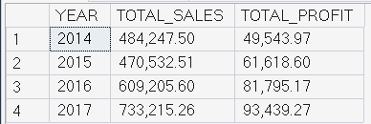

7.MONTHLY SALES & PROFIT TREND

SELECT
MONTH(ORDER_DATE) AS MONTH,
FORMAT(ROUND(SUM(SALES), 2),'N2') AS TOTAL_SALES,
FORMAT(ROUND(SUM(PROFIT), 2),'N2') AS TOTAL_PROFIT
FROM ORDERS
GROUP BY MONTH(ORDER_DATE)
ORDER BY MONTH;
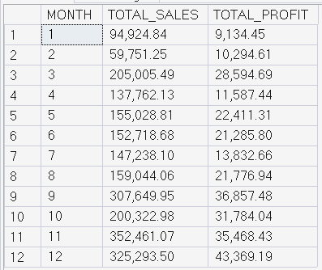

8.SALES BY CATEGORY & SUB-CATEGORY

SELECT
CATEGORY,
SUBCATEGORY,
ROUND(SUM(SALES), 2) AS TOTAL_SALES
FROM ORDERS
GROUP BY CATEGORY, SUBCATEGORY
ORDER BY TOTAL_SALES DESC;
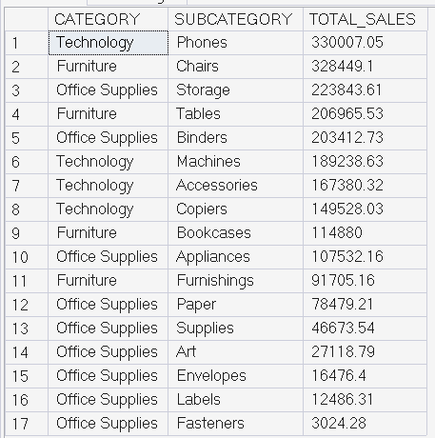
9.TOP 10 PRODUCTS BY SALES

SELECT TOP 10
PRODUCT_NAME,
ROUND(SUM(SALES), 2) AS TOTAL_SALES
FROM ORDERS
GROUP BY PRODUCT_NAME
ORDER BY TOTAL_SALES DESC;
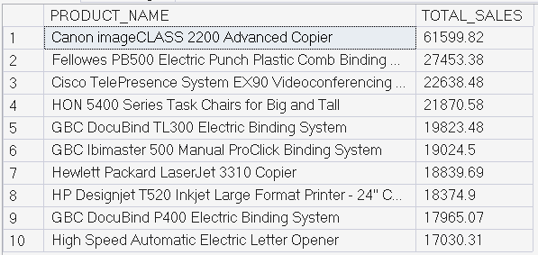

10.HIGH SALES BUT NEGATIVE PROFIT PRODUCTS

SELECT
PRODUCT_NAME,
ROUND(SUM(SALES), 2) AS TOTAL_SALES,
ROUND(SUM(PROFIT), 2) AS TOTAL_PROFIT
FROM ORDERS
GROUP BY PRODUCT_NAME
HAVING SUM(SALES) > 5000
AND SUM(PROFIT) < 0
ORDER BY TOTAL_SALES DESC;
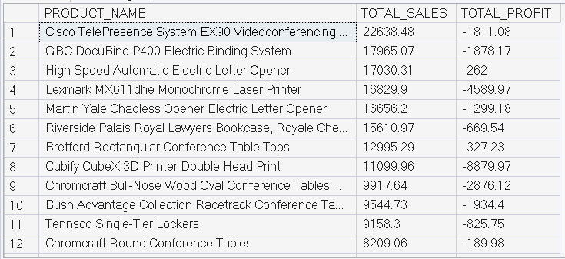

- REGIONAL & LOCATION ANALYSIS

1.SALES & PROFIT BY REGION

SELECT
REGION,
ROUND(SUM(SALES), 2) AS TOTAL_SALES,
ROUND(SUM(PROFIT), 2) AS TOTAL_PROFIT
FROM ORDERS
GROUP BY REGION
ORDER BY TOTAL_PROFIT DESC;
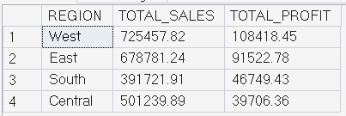

2.TOP 5 STATES BY PROFIT

SELECT TOP 5
STATE,
ROUND(SUM(PROFIT), 2) AS TOTAL_PROFIT
FROM ORDERS
GROUP BY STATE
ORDER BY TOTAL_PROFIT DESC;
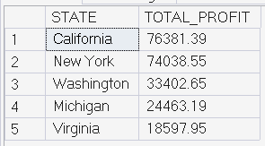

3.BOTTOM 5 STATES (LOSS MAKING)

SELECT TOP 5
STATE,
ROUND(SUM(PROFIT), 2) AS TOTAL_PROFIT
FROM ORDERS
GROUP BY STATE
ORDER BY TOTAL_PROFIT ASC;
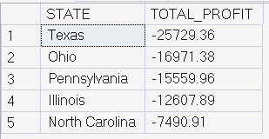

4.REGIONS WITH HIGH DISCOUNTS BUT LOW PROFIT

SELECT
REGION,
ROUND(AVG(DISCOUNT), 2) AS AVG_DISCOUNT,
ROUND(SUM(PROFIT), 2) AS TOTAL_PROFIT
FROM ORDERS
GROUP BY REGION
ORDER BY AVG_DISCOUNT DESC;
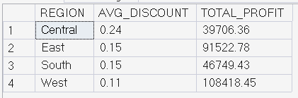

C.CUSTOMER ANALYSIS

1.AVERAGE ORDER VALUE (AOV)

SELECT
ROUND(SUM(SALES) / COUNT(DISTINCT ORDER_ID), 2) AS AVG_ORDER_VALUE
FROM ORDERS;
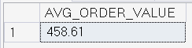
2.SALES & PROFIT BY SEGMENT

SELECT
SEGMENT,
ROUND(SUM(SALES), 2) AS TOTAL_SALES,
ROUND(SUM(PROFIT), 2) AS TOTAL_PROFIT
FROM ORDERS
GROUP BY SEGMENT
ORDER BY TOTAL_PROFIT DESC;
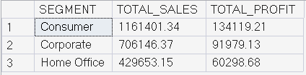

3.TOP 10 CUSTOMERS BY PROFIT

SELECT TOP 10
CUSTOMER_NAME,
ROUND(SUM(PROFIT), 2) AS TOTAL_PROFIT
FROM ORDERS
GROUP BY CUSTOMER_NAME
ORDER BY TOTAL_PROFIT DESC;
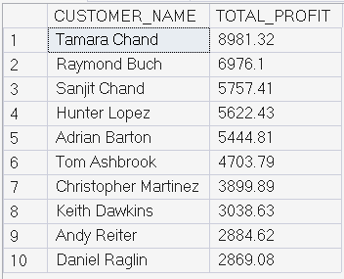

4.CUSTOMERS WITH HIGH SALES BUT LOSS

SELECT
CUSTOMER_NAME,
ROUND(SUM(SALES), 2) AS TOTAL_SALES,
ROUND(SUM(PROFIT), 2) AS TOTAL_PROFIT
FROM ORDERS
GROUP BY CUSTOMER_NAME
HAVING SUM(SALES) > 3000
AND SUM(PROFIT) < 0;
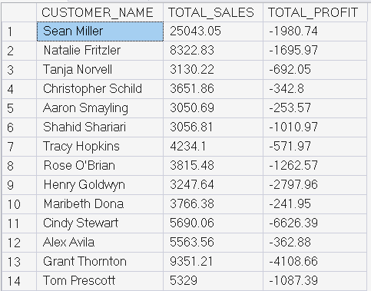

D.PRODUCT & CATEGORY PROFITABILITY

1.LOSS MAKING SUB CATEGORIES

SELECT
SUBCATEGORY,
ROUND(SUM(PROFIT), 2) AS TOTAL_PROFIT
FROM ORDERS
GROUP BY SUBCATEGORY
HAVING SUM(PROFIT) < 0
ORDER BY TOTAL_PROFIT;
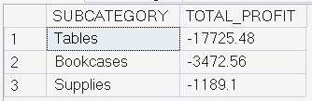

2.HIGH DISCOUNT – LOW PROFIT PRODUCTS

SELECT
PRODUCT_NAME,
ROUND(AVG(DISCOUNT), 2) AS AVG_DISCOUNT,
ROUND(SUM(PROFIT), 2) AS TOTAL_PROFIT
FROM ORDERS
GROUP BY PRODUCT_NAME
HAVING AVG(DISCOUNT) > 0.3
AND SUM(PROFIT) < 0;
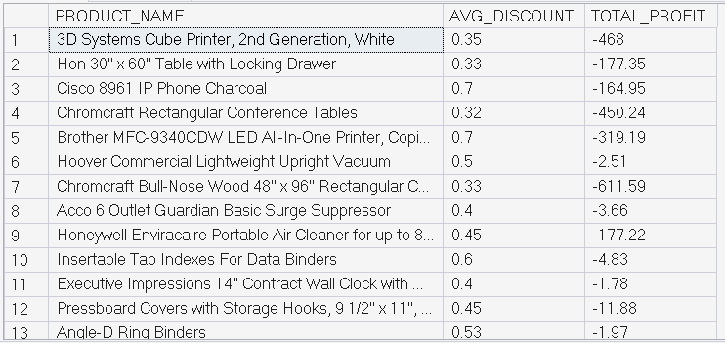

3.QUANTITY VS PROFIT

SELECT
QUANTITY,
ROUND(SUM(PROFIT), 2) AS TOTAL_PROFIT
FROM ORDERS
GROUP BY QUANTITY
ORDER BY QUANTITY;
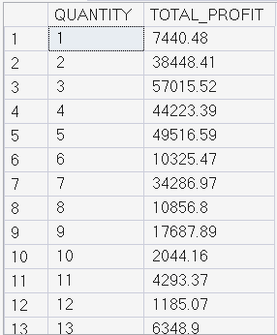

4.PROFIT MARGIN BY DISCOUNT

SELECT
DISCOUNT,
ROUND((SUM(PROFIT) / SUM(SALES)) * 100, 2) AS PROFIT_MARGIN_PCT
FROM ORDERS
GROUP BY DISCOUNT
ORDER BY DISCOUNT;
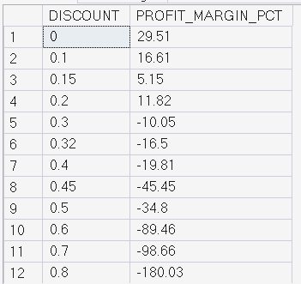

E.ORDER & SHIPPING DATE ANALYSIS

1.AVERAGE SHIPPING TIME

SELECT
ROUND(AVG(DATEDIFF(DAY, ORDER_DATE, SHIP_DATE)), 2) AS AVG_SHIPPING_DAYS
FROM ORDERS;
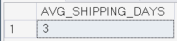

2.ORDERS BY SHIPPING MODE

SELECT
SHIP_MODE,
COUNT(DISTINCT ORDER_ID) AS TOTAL_ORDERS
FROM ORDERS
GROUP BY SHIP_MODE;
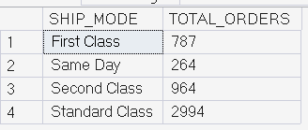

3.PROFIT BY SHIPPING MODE

SELECT
SHIP_MODE,
ROUND(SUM(PROFIT), 2) AS TOTAL_PROFIT
FROM ORDERS
GROUP BY SHIP_MODE
ORDER BY TOTAL_PROFIT DESC;
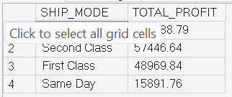

F.WINDOW FUNCTIONS

1.RANK PRODUCTS BY PROFIT WITHIN CATEGORY

SELECT
CATEGORY,
PRODUCT_NAME,
ROUND(SUM(PROFIT), 2) AS TOTAL_PROFIT,
RANK() OVER (PARTITION BY CATEGORY ORDER BY SUM(PROFIT) DESC) AS RANK_IN_CATEGORY
FROM ORDERS
GROUP BY CATEGORY, PRODUCT_NAME;
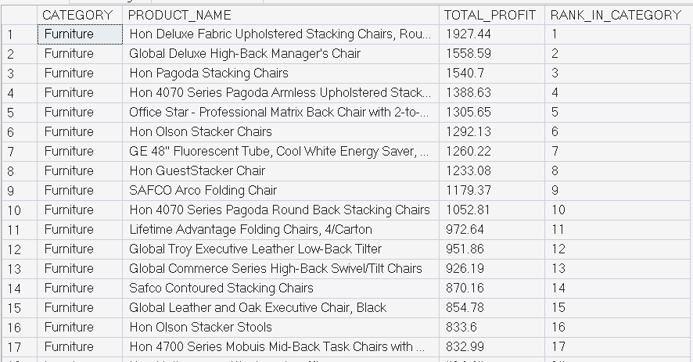

2.MONTH-OVER-MONTH SALES GROWTH

WITH MONTHLY_SALES AS (
SELECT
YEAR(ORDER_DATE) AS ORDER_YEAR,
MONTH(ORDER_DATE) AS ORDER_MONTH,
SUM(SALES) AS TOTAL_SALES
FROM ORDERS
GROUP BY
YEAR(ORDER_DATE),
MONTH(ORDER_DATE)
)
SELECT
ORDER_YEAR,
ORDER_MONTH,
TOTAL_SALES,
TOTAL_SALES
- LAG(TOTAL_SALES) OVER (
ORDER BY ORDER_YEAR, ORDER_MONTH
) AS MOM_GROWTH
FROM MONTHLY_SALES
ORDER BY
ORDER_YEAR,
ORDER_MONTH;
