A PROJECT REPORT ON

PRIDECTING OF LOAN ELIGIBILITY USING RANDOM FOREST CLASSIFIER

Submitted in partial fulfilment of the requirements for the degree in

BACHELOR OF TECHNOLOGY
IN
INFORMATION TECHNOLOGY
BY

CHAVALI VASUDHA (22NN1A1268)
MADDUKURI POOJA NAGA SAI LAKSHMI (22NN1A1285)
PENTEREDDY DIVYA (22NN1A1296)
BOYAPATI TRIVENI (22NN1A1265)



CONTENTS

CERTIFICATE
ACKNOWLEDGEMENTS
ABSTRACT 4
List of figures 5

Chapter 1: INTRODUCTION
1.1Introduction 6-7

Chapter 2:LITERATURE SURVEY 8-12
2.1 Literature survey 8
Chapter 3: Personal loan and
Business loan 13-20
3.1 Personal loan 13-14
3.2 Business Loan 14-15
3.3 Benefits of Personal loan 15-16
3.4 Benefits of Business loan 17-20

Chapter 4: Software Environment 21-28
4.1 Introduction to Python 21
4.2 Why Choose Python 22-23
4.3 Steps to Install Python 24-26
4.4 Modules 26
4.4.1 Random Forest 26
4.4.2 Linear Regression 27
4.4.3 Numpy 27-28
4.4.4. Logistic Regression 28

Chapter 5: APP DESIGNER 29-32
5.1 About HTTP Proxy 29-30
5.2 HTTP Proxy in Windows Version 30-31
5.3 Socket Programming in Python 31
5.4 Steps to Improvement HTTP Proxy 31-32

Chapter 6: WORKING OF HTTP PROXXY IN 33-38
ANDROID PHONE
6.1 HTTP Proxy Working 33
6.2 Algorithm For HTTP Proxy 33
6.3 Flowchart 34
6.4 EXISTING METHOD 35-36
6.5 PROPOSED SOLUTION 37-38
Chapter 7: PYTHON CODE 39-43
7.1 source code 39-40
7.2 Predict and main code 40-42
7.3 Init 43

Chapter 8: RESULTS AND DISCUSSION 44-46
8.1 Final result 44-46

Chapter 9: Conclusion 47

References 48-49

ABSTRACT

When one or more people, organizations, or other entities lend money to other people, organizations, or entities, it is known as a loan. The recipient (that is the borrower) takes on a debt for which he or she is normally accountable for interest payments until the loan is repaid. The major goal of this proposed model is to ensure that an individual, institution, or organization seeking for a loan is properly verified before granting them the loan they require. Before authorizing a loan for any individual or business several factors must be considered. That including gender, education, and the number of dependents. The goal of proposed model is to automate the method, which will save time and energy while improving the efficiency of the process. This particular process input is having two different kind of data set. First one is train data set and second set is test data set. The first date set that is train data set is generally used to train and assess the machine learning model accuracy. The loan eligibility predictions are generated using the test data set. To forecast loan eligibility and train this random forest, machine learning method called Random Forest. The proposed random forest model is providing higher accuracy level. This model is providing 28 % higher accuracy level compare to regular prediction.

LIST OF FIGURES

Figure 3.1 LOAN 20

Figure 3.2 PERSONAL LOAN 20

Figure 3.3 BUSINESS LOAN 20

Figure 6.3 FLOW CHART 34

Figure 8.1 IDLE PYTHON 44

Figure 8.2 ACTIVATING SERVER 44

Figure 8.3 WEB PAGE 45

Figure 8.4 OUTPUT 45

Figure 8.5 OUTPUT 46

Figure 8.6 LOAN ELIGIBLE 46

CHAPTER 1

INTRODUCTION

1.1 INTRODUCTION

People prefer to apply for loans on the internet because data is growing daily due to digitization in the financial sector. Artificial intelligence (AI) is gaining popularity as a common tool for data analysis. Individuals from diverse businesses are using AI calculations to solve problems based on their sector knowledge. Banks are having a difficult time getting loans approved. Every day, bank staff are faced with a large number of applications to manage, and the odds of making a mistake are significant. Almost every bank's fundamental operation is the distribution of loans. The profit earned from the loans distributed by the bank’s accounts.

So, one mistake can make a massive loss to a bank (Gupta et al 2020). The primary goal in the banking sector is to place their funds in safe hands. Many banks and financial institutions now grant loans after a lengthy process of verification and validation, but there is no guarantee that the chosen applicant is the most deserving of all applicants. We can forecast whether a given applicant is safe or not using our method, and the entire feature validation process is automated using machine learning techniques. Loan Prediction is extremely beneficial to both bank employees and applicants (Kumar et al. 2016). The purpose of this paper is to provide a quick, straightforward, and efficient method of selecting qualified applicants. It may provide the bank with unique benefits.

The Loan Prediction System can calculate the weight of each characteristic involved in loan processing automatically, and the same features are processed according to their associated weight on new test data. The applicant can be given a deadline to determine whether or not his or her loan will be approved. The Loan Prediction System allows you to jump to a specific application and review it on a priority basis [2]. This approach allows you to jump on specific applications that deserve to be accepted first. Gender. Married, Dependents, Education, Self-Employed, Applicant Income, Co applicant Income, Loan Amount, Loan Amount Term, Credit History, Property Area, and Loan Status are some of the features used in the forecast. There are six subsections in this research report. We've looked at the literature survey in the next part. A brief overview of our dataset follows that. A machine learning approach is suggested in the next section. The algorithms that were employed to create the model were then presented.

Loan approval constitutes a critical operation for financial institutions, entailing a comprehensive evaluation of various factors, including income, social status, and citizenship, to determine loan eligibility. Ensuring timely loan repayment is paramount for the successful operation of banks, necessitating a precise assessment of borrowers' repayment capacity . Several studies have explored machine learning for enhanced loan approval prediction. Utilized Random Forest classifiers and found them to outperform traditional Decision Trees. Introduced a stacking-based model that significantly improved joint loan approval. Developed an ensemble model, boosting prediction accuracy from 80% to 94%. Applied advanced machine learning techniques, particularly Random Forest, for nonperforming loan prediction with a focus on emerging markets. Existing research in this domain has proposed various models, yet a comprehensive analysis encompassing both machine learning and deep learning approaches has been lacking. Moreover, most existing solutions have not demonstrated the level of accuracy required for practical implementation in real-life scenario.
After that, there will be a quick discussion of the findings and analysis, in the conclusion.

The primary objective of this project is to provide a comprehensive overview
of the bank loan eligibility using machine learning, highlighting the
strengths and limitations of different approaches

CHAPTER 2

LITERATURE SURVEY

1.Title : Predict Loan Approval in Banking System Machine Learning Approach for Cooperative Banks Loan Approval.
Author: Amruta S. Aphale, Dr. Sandeep R. Shinde.
Year : 2020
In today’s world, taking loans from financial institutions has become a very common phenomenon. Everyday a large number of people make application for loans, for a variety of purposes. But all these applicants are not reliable and everyone cannot be approved. Every year, we read about a number of cases where people do not repay bulk of the loan amount to the banks due to which they suffers huge losses. The risk associated with making a decision on loan approval is immense.

So the idea of this project is to gather loan data from multiple data sources and use various machine learning algorithms on this data to extract important information. This model can be used by the organizations in making the right decision to approve or reject the loan request of the customers. In this paper, we examine a real bank credit data and conduct several machine learning algorithms on the data for that determine credit worthiness of customers in order to formulate bank risk automated system.
2.Title : Loan Approval Prediction Using Machine Learning
Author: Yash Divate , Prashant Rana, Pratik Chavan 6
Year : 2021
With the upgrade in the financial area loads of individuals are applying for bank advances however the bank has its restricted resources which it needs to allow to restricted individuals just, so discovering to whom the credit can be conceded which will be a more secure choice for the bank is a commonplace interaction. So in this task we attempt to decrease this danger factor behind choosing the protected individual in order to save bunches of bank endeavors and resources.

This is finished by mining the Data of the past records of individuals to whom the advance was conceded previously and based on these records/encounters the machine was prepared utilizing the AI model which give the most precise outcome. The principle objective of this paper is to anticipate whether relegating the advance to specific individual will be protected or not. This paper is separated into four areas (i)Data Collection (ii) Comparison of AI models on gathered information (iii) Training of framework on most encouraging model (iv) Testing.

3.Title : Modern Approach for Loan Sanctioning in Banks Using Machine Learning
Author: Golak Bihari Rath, Debasish Das, Biswa Ranjan Acharya
Year : 2021
Loan analysis is a process adopted by banks used to check the credibility of loan applicants who can pay back the sanction loan amount within regulations and loan amount term mentioned by the bank. Most banks use their common recommended procedure of credit scoring and background check techniques to analyze the loan application and to make decisions on loan approval. This is overall a risk-oriented and a time-consuming process. In some cases, people suffer through financial problems while some intentionally try to fraud. As a result, such delay and default in payment by the loan applicants can lead to loss of capital of the banks. Hence to overcome this, banks need to adopt a better procedure to find the trustworthy applicants for granting loan from the list of all applicants applied for the loan, who can pay can their loan amount in stipulated time. In the modern day age and advance of technology, we adopt a machine learning approach to reduce the risk factor and human errors in the loan sanction process and determine where an applicant is eligible for loan approval or not.

Here, we examine various features such as applicant income, credit history, education from past records of loan applicants irrespective of their loan sanction, and the best features are determined and selected which have a direct impact on the outcome for loan approval.

4.Title : A benchmark of machine learning approaches for credit score prediction.
Author: Vincenzo Moscato, Antonio Picariello, Giancarlo Sperlí
Year : 2021
Credit risk assessment plays a key role for correctly supporting financial institutes in defining their bank policies and commercial strategies. Over the last decade, the emerging of social lending platforms has disrupted traditional services for credit risk assessment. Through these platforms, lenders and borrowers can easily interact among them without any involvement of financial institutes. In particular, they support borrowers in the fundraising process, enabling the participation of any number and size of lenders.

However, the lack of lenders’ experience and missing or uncertain information about 4 borrower’s credit history can increase risks in social lending platforms, requiring an accurate credit risk scoring. To overcome such issues, the credit risk assessment problem of financial operations is usually modeled as a binary problem on the basis of debt’s repayment and proper machine learning techniques can be consequently exploited. In this paper, we propose a benchmarking study of some of the most used credit risk scoring models to predict if a loan will be repaid in a P2P platform.

We deal with a class imbalance problem and leverage several classifiers among the most used in the literature, which are based on different sampling techniques. A real social lending platform (Lending Club) data-set, composed by 877,956 samples, has been used to perform the experimental analysis considering different evaluation metrics (i.e. AUC, Sensitivity, Specificity), also comparing the obtained outcomes with respect to the state-of-the-art approaches. Finally, the three best approaches have also been evaluated in terms of their explainability by means of different explainable Artificial Intelligence (XAI) tools.

5.Title : An Approach for Prediction of Loan approval using Machine Learning Algorithm.
Author: Mohammad Ahmad Sheikh, Amit Kumar Goel, Tapas Kumar
Year : 2020
In our banking system, banks have many products to sell but main source of income of any banks is on its credit line. So they can earn from interest of those loans which they credits. A bank’s profit or a loss depends to a large extent on loans i.e. whether the customers are paying back the loan or defaulting. By predicting the loan defaulters, the bank can reduce its Non Performing Assets. This makes the study of this phenomenon very important. Previous research in this era has shown that there are so many methods to study the problem of controlling loan default. But as the right predictions are very important for the maximization of profits, it is essential to study the nature of the different methods and their comparison.
A very important approach in predictive analytics is used to study the problem of predicting loan defaulters: The Logistic regression model. The data is collected from the Kaggle for studying and prediction. Logistic Regression models have been performed and the different measures of performances are computed. The models are compared on the basis of the performance measures such as sensitivity and 5 specificity.

The final results have shown that the model produce different result. Model is marginally better because it includes variables (personal attributes of customer like age, purpose, credit history, credit amount, credit duration, etc.) other than checking account information (which shows wealth of a customer) that should be taken into account to calculate the probability of default on loan correctly.

Therefore, by using a logistic regression approach, the right customers to be targeted for granting loan can be easily detected by evaluating their likelihood of default on loan. The model concludes that a bank should not only target the rich customers for granting loan but it should assess the other attributes of a customer as well which play a very important part in credit granting decisions and predicting the loan defaulters.

CHAPTER 3

Personal loans and Business loans

3.1 Personal loans:
A personal loan is a loan in which a lending institution, like a bank, lends money to an individual. In return, you agree to repay this amount over a set time, often with interest and additional charges. Personal Loans are versatile and can be used for various personal financial needs.
When considering Personal Loans, it is essential to understand that several types are available, each designed for different purposes. Here are some common types of personal loans, explained in simple terms:
- Unsecured Personal Loans
Personal Loans of this type are the most frequent. You borrow a certain amount of money without collateral. Your credit score usually determines interest rates, and you repay the loan every month.
- Home Improvement Loans
These Personal loans are for home renovation or repair projects. The loan amount depends on the scope of your project and your creditworthiness.
- Medical Loans
Medical expenses can be high, so medical Personal loans are designed to cover these costs. They may offer flexible repayment terms.
A Personal Loan is a financial arrangement between you and the lending institutions. When you require funds for personal or financial needs, you typically approach a commercial lender or a trusted source. The lender then provides a specified amount based on agreed-upon terms, which include interest rates, fees, and the repayment plan.
For instance, interest may be paid in monthly increments, known as amortization, or in the case of an interest-only loan, only the interest is paid until the principal balance is cleared at the end. All these terms are explicitly outlined in loan documents and contracts before any funds are disbursed.
In many cases, lenders may request collateral to safeguard their investment if you default, ensuring they have an asset to recover their funds if necessary. Ultimately, both parties must agree on these terms before finalising the Personal Loan Agreement.

3.2 Business loans:
The definition of a business loan is a financial instrument that can be used
to cover both unexpected and anticipated expenses.
A business loan is a loan is borrowed money that businesses use to cover
costs they can't afford on their own in the short term. Loans are not provided
without charge. As the cost of borrowing the money, lenders charge interest
on loans. Knowing whether the interest is fixed or variable is crucial. A fixed
interest rate is one that doesn't change over the course of the loan or its
payback period.

Owners of businesses have the option of borrowing money from a financial institution. Financial organizations, including banks or credit unions, provide lines of credit to companies that are just getting started or need money for upgrades or new projects. Business owners must submit an application to be considered for a loan.

There are numerous financing options available to businesses. The most common kind of financing is traditional bank loans, although getting one from a bank is not always simple. Because of the economic downturns, banks tighten their lending standards, making it harder for enterprises to obtain commercial loans for financial support. When things are good, they provide better terms and simpler access.

Together with commercial lending options, sole proprietorships and other enterprises with just one owner (or a married couple) may also apply for home equity lines of credit. Businesses like PayPal and other financial applications provide interest-bearing loans with higher interest rates but perhaps easier qualification than a bank.

Investment associations or individual investors look for businesses in need of funding. Venture capitalists and angel investors are the two primary categories of investors. The average investment range for venture capitalists is between $500,000 and $10 million. Angel investors contribute lesser but nonetheless significant sums. In return for a portion of the company, investors provide money to enterprises. Investors prefer a cut of the earnings overpaying interest on the money they gave the company.

Business entrepreneurs can employ "bootstrapping," which is when a business owner uses personal funds to finance her business operations if they have savings accounts or retirement accounts. For the majority of young entrepreneurs, personal resources serve as their main source of capital.

They offer several benefits, including convenience, security, and the ability to loan eligibility. loan also come with features such as rewards programs, cashback, and travel benefits. Loans can make purchases online, in-store, or over the phone, and they receive a monthly statement detailing their transactions and the amount owed.

3.3 Benefits of Personal loan

Some of the benefits of a Personal Loan are as follows:

- Flexible use of Funds
Personal Loans offer versatility for various financial needs, like debt consolidation, medical expenses, or home improvements.

- No Collateral Needed
Personal Loans typically do not require assets like your home or car as collateral, reducing the risk of asset loss.

- Predictable Monthly Payments
These loans come with fixed interest rates and monthly payments, making budgeting more manageable.

- Quick and Easy Application
Applying for Personal Loans is often simple and can be done online, with a streamlined approval process for quick access to funds.

- Credit Score Improvement
Responsible Personal Loan management can enhance your credit score, potentially leading to better loan terms and lower interest rates.

Personal loan required documents
1. Salary Slips and Form 16
You must submit salary slips detailing monthly earnings and Form 16 outlining income and tax deductions. These are essential for income verification.
2. Bank Statements
These statements help reflect spending patterns and savings over the past few months.
3. Latest Income-Tax Returns
To establish financial credibility, provide a consolidated income summary, deductions, and tax payments.
4. Age Proof
You can provide proof of age through your birth certificate, passport, Aadhaar card, voter ID, or PAN card.
5. Address Proof
You must provide the address form through documents like an Aadhaar card, passport, electricity/telephone bill, or ration card.
6. Photo Identification Proof
To verify your identity, you must submit an Aadhaar card, voter ID, PAN card, passport, or driver's license.

3.4 Benefits of business loan
- Financial Flexibility
An online business loan provides essential working capital, ensuring flexibility in managing day-to-day expenses, seizing opportunities, and navigating cash flow fluctuations.
- Business Expansion
Loans enable businesses to expand operations, open new branches, diversify product lines, or enter new markets, contributing to increased revenue and market presence.
- Technology and Equipment Investment
Funds from loans can be invested in cutting-edge technology and equipment, enhancing efficiency, productivity, and competitiveness.
- Building Credit
Responsible repayment builds a positive credit history, improving the business's creditworthiness and facilitating access to larger loans with favorable terms in the future.
- Tax Benefits
The interest paid on an online business loan is often tax-deductible, reducing the overall tax burden and making borrowing more financially viable for the business.
- Improved Vendor Relationships
Timely payments to suppliers strengthen relationships, often leading to better terms, discounts, and enhanced reliability in the supply chain.
- Emergency Funds During Downturns
Instant business loan provide a safety net during economic downturns, allowing companies to cover operational costs, salaries, and other crucial expenses, ensuring business continuity.
- Marketing and Promotions
A business Loan in India can be used for marketing campaigns, promotions, and advertising, boosting brand visibility and attracting more customers, thereby increasing sales and revenue.
- Talent Acquisition and Training
Funds from an online business loan can be invested in hiring skilled professionals and providing training, ensuring a competent workforce that contributes to business growth.

Loan Eligibility Criteria

- Credit Score
A good personal and business credit score demonstrates your creditworthiness and financial responsibility. Lenders usually prefer a score of 650 or above.

- Business Age
Lenders often require a minimum business age, typically at least 1-2 years, to ensure the stability of your business operations. Make sure you have your business loan documents ready when you’re applying for it.

- Annual Revenue
Your business's annual revenue or turnover is a crucial factor. Lenders want a steady income to ensure you can repay the loan. There might be a minimum revenue threshold.

- Cash Flow
Positive cash flow indicates that your business generates enough money to cover expenses and repay debts, making your loan application more favorable.

- Debt-to-Income Ratio
Loan lenders first assess the business debt-to-income ratio by comparing monthly debt payments to the gross monthly income. A lower ratio signifies your capability to manage additional debt.

- Collateral
Lenders may require collateral, such as property or equipment, which they can claim if you default on the loan. Having valuable collateral can increase your chances of approval.

- Business Plan
A well-thought-out business plan demonstrates your vision, strategy, and financial projections. It helps lenders assess your business's potential for success.

- Industry Type
Some industries are considered riskier than others. Businesses in stable or growing industries might find it easier to secure a loan than those in volatile sectors.

- Legal and Regulatory Compliance
Ensuring that your business complies with all legal and regulatory requirements is essential. Lenders will verify your licenses, permits, and registrations.

- Outstanding Debt
Lenders assess your existing debts. If your business already has substantial outstanding debts, it might affect your loan business loan eligibility.

- Purpose of the Loan
Clearly stating the purpose of the loan, whether it's for expansion, working capital, or equipment purchase, helps lenders understand how the funds will be utilized.

- Personal Background
Lenders might consider your background, including your education, work experience, and criminal history, to evaluate your ability to run a successful business.

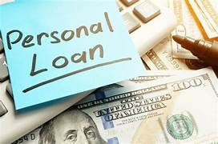


FIGURE3.1 FIGURE3.2



FIGURE 3.3

CHAPTER 4

SOFTWARE ENVIRONMENT

4.1 INTRODUCTION TO PYTHON
Python is a high-level, interpreted scripting language developed in the late 1980s by Guido van Rossum at the National Research Institute for Mathematics and Computer Science in the Netherlands. The initial version was published at the alt. Sources newsgroup in 1991, and version 1.0 was released in 1994. Python 2.0 was released in 2000, and the 2.x versions were the prevalent releases until December 2008. At that time, the development team made the decision to release version 3.0, which contained a few relatively small but significant changes that were not backward compatible with the 2.x versions. Python 2 and 3 are very similar, and some features of Python 3 have been back ported to Python 2. But in general, they remain not quite compatible.
Both Python 2 and 3 have continued to be maintained and developed, with periodic release updates for both. As of this writing, the most recent versions available are 2.7.15 and 3.6.5. However, an official End of Life date of January 1, 2020 has been established for Python 2, after which time it will no longer be maintained. If you are a newcomer to Python, it is recommended that you focus on Python 3, as this tutorial will do. Python is still maintained by a core development team at the Institute, and Guido is still in charge, having been given the title of BDFL (Benevolent Dictator For Life) by the Python community. The name Python, by the way, derives not from the snake, but from the British comedy troupe Monty Python’s Flying Circus, of which Guido was, and presumably still is, a fan. It is
common to find references to Monty Python sketches and movies scattered throughout the Python documentation.

4.2 WHY CHOOSE PYTHON
For some applications that are particularly computationally intensive like graphics processing or intense number, this can be limiting.
In practice, however, for most programs, the difference execution speed is measured in milliseconds, or seconds at most, and not appreciably noticeable to a human user. The expediency of coding in an interpreted language is typically worth it for most applications.
Python is Free
The Python interpreter is developed under an OSI-approved opensource license making it free to install use and distribute even for commercial purposes.
A version of the interpreter is available for virtually any platform there is, including all flavors of Unix, Windows, macOS, smart phones and tablets, and probably anything else you ever heard. A version even exists for the half dozen people remaining who use OS/2.
Python is Portable
Because Python code is interpreted and not compiled into native machine instructions, code written for one platform will work on any other platform that has the Python interpreter installed. (This is true of any interpreted language, not just Python.)
Python is Simple
Python-3 has 33 keywords, and Python-2 has 31. By contrast, C++ has 62, Java has 53, and Visual Basic has more than 120, though these latter examples probably vary Somewhat by implementation or dialect.
Python code has a simple and clean structure that is easy to learn and easy to read. In fact, as you will see the language definition enforces code structure that is easy to read.
But It’s Not That Simple for all its syntactical simplicity, Python supports most constructs that would be expected in a very high-level language, including complex dynamic data types, structured and functional programming, and object-oriented programming.
Additionally, a very extensive library of classes and functions is available that provides capability well beyond what is built into the language, such as database manipulation.
Python accomplishes what many programming languages don’t: the language itself is simply designed, but it is very versatile in terms of what you can accomplish with it.

Conclusion

This section gave an overview of the Python programming language, including:
A brief history of the development of Python Some reasons why you might select Python as your language of choice.
Python is a great option, whether you are a beginning programmer looking to learn the basics, an experienced programmer designing a large application, or anywhere in between. The basics of Python are easily grasped, and yet its capabilities are vast. Proceed to the next section to learn how to acquire and install Python on your computer.
Python is an open-source programming language that was made to be easy-to-read and powerful. A Dutch programmer named Guido van Rossum made Python in 1991. He named it after the television show Monty Python's Flying Circus.

Python is an interpreted language. Interpreted languages do not need to be compiled to run. A program called an interpreter runs Python code on almost any kind of computer. This means that a programmer can change the code and quickly see the results. This also means Python is slower than a compiled language like C, because it is not running machine code directly.
Python is a good programming language for beginners. It is a high-level language, which means a programmer can focus on what to do instead of how to do it. Writing programs in Python takes less time than in some other languages.
Python drew inspiration from other programming languages like C, C++, Java, Perl, and Lisp.

Python has a very easy-to-read syntax. Some of Python's syntax comes from C, because that is the language that Python was written in. But Python uses whitespace to delimit code: spaces or tabs are used to organize code into groups. This is different from C. In C, there is a semicolon at the end of each line and curly braces ({}) are used to group code. Using whitespace to delimit code makes Python a very easy-to-read language.

Python use [change / change source]
Python is used by hundreds of thousands of programmers and is used in many places. Sometimes only Python code is used for a program, but most of the time it is used to do simple jobs while another programming language is used to do more complicated tasks.
Its standard library is made up of many functions that come with Python when it is installed. On the Internet there are many other libraries available that make it possible for the Python language to do more things. These libraries make it a powerful language; it can do many different things.
Some things that Python is often used for are:

- Web development
- Scientific programming
- Desktop GUIs
- Network programming
- Game programming

4.3 STEPS TO INSTALL PYTHON
Step 1: Search python.org
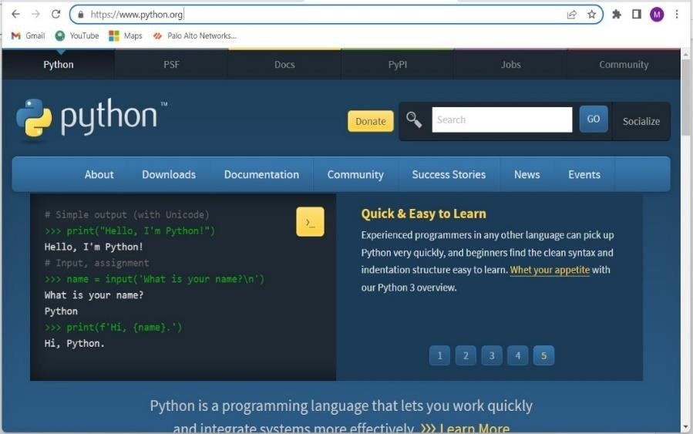

Step 2: Go to downloads and select windows
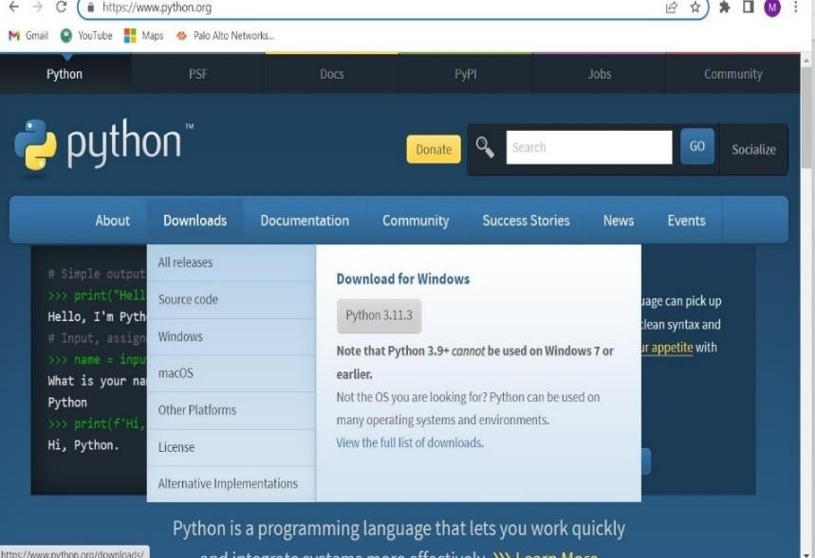

Step 3: Download Windows installer(64-bit)
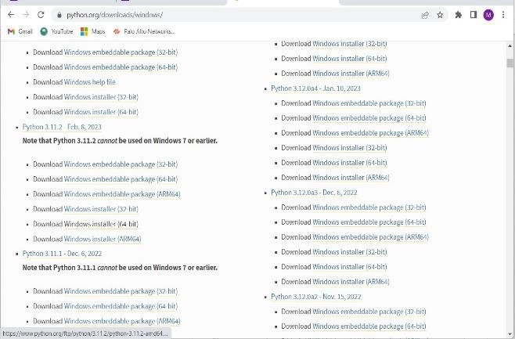

Step 4: Now select python.exe to path and install the IDLE

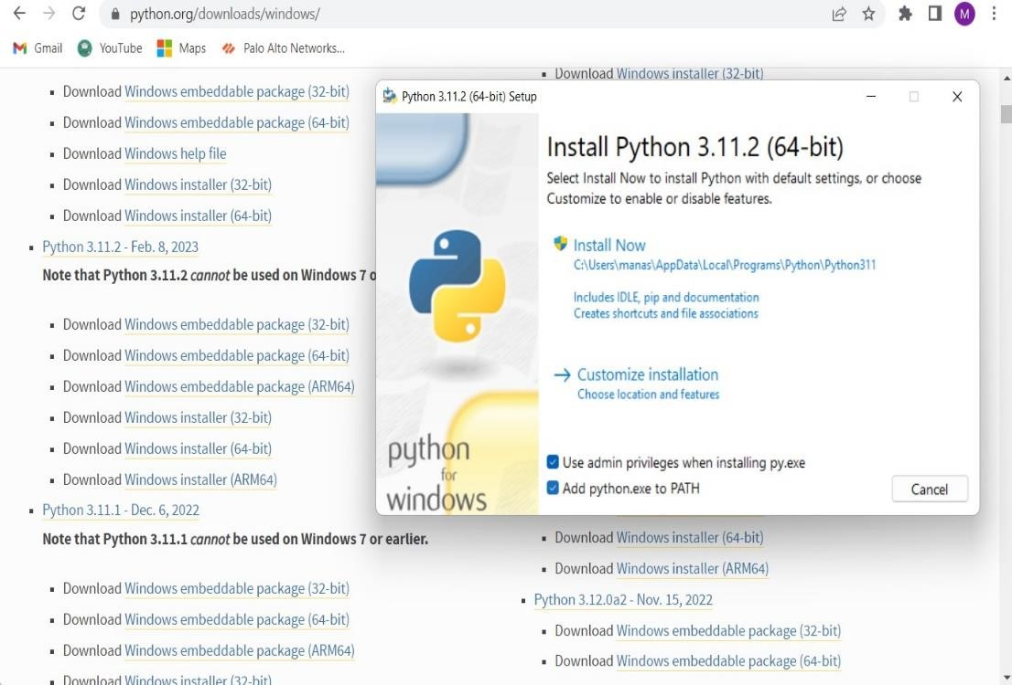

Modules:
4.4.1 Random forest:
Random Forest is a powerful ensemble learning method in machine learning that combines the predictions of multiple decision trees to improve accuracy and reduce overfitting. Each tree in the forest is trained on a random subset of features and a bootstrap sample of the data. This randomness helps to decorrelate the trees, making the model robust and less prone to variance. Random Forests are effective for handling large datasets with high dimensionality, providing feature importance scores for understanding which features contribute most to predictions. They find applications across various fields, including finance, medicine, and ecology, where accurate predictive models are crucial. Implemented in popular libraries like scikit-learn and R, Random Forests are relatively easy to use and tune, making them a preferred choice for many machine learning tasks.

4.4.2 Linear Regression:

Linear regression is a type of supervised machine learning algorithm, algorithm that computes the linear relationship between the dependent variable and one or more independent features by fitting a linear equation to observed data.
When there is only one independent feature, it is known as simple linear regression, and when there are more than one feature, it is known as multiple linear regression

The interpretability of linear regression is a notable strength. The model’s equation provides clear coefficients that elucidate the impact of each independent variable on the dependent variable, facilitating a deeper understanding of the underlying dynamics. Its simplicity is a virtue, as linear regression is transparent, easy to implement, and serves as a foundational concept for more complex algorithms.

Linear regression is not merely a predictive tool; it forms the basis for various advanced models. Techniques like regularization and support vector machines draw inspiration from linear regression, expanding its utility. Additionally, linear regression is a cornerstone in assumption testing, enabling researchers to validate key assumptions about the data.

4.4.3. Numpy
NumPy is a Python library used for working with arrays. It also has functions for working in domain of linear algebra, Fourier transform, and matrices.
NumPy was created in 2005 by Travis Oliphant. It is an opensource project and you can use it freely. NumPy stands for Numerical Python.
Numpy is a general-purpose array-processing package. It provides a high-performance multidimensional array object, and tools for working with these arrays. It is the fundament package for scientific computing with Python.
Besides its obvious scientific uses, Numpy can also be used as an efficient multi- dimensional container of generic data.

4.4.4 Logistic Regression
Logistic regression is a supervised machine learning algorithm used for classification tasks where the goal is to predict the probability that an instance belongs to a given class or not. Logistic regression is a statistical algorithm which analyze the relationship between two data factors. The article explores the fundamentals of logistic regression, it’s types and implementations.
Logistic regression is used for binary classification where we use sigmoid function, that takes input as independent variables and produces a probability value between 0 and 1.
For example, we have two classes Class 0 and Class 1 if the value of the logistic function for an input is greater than 0.5 (threshold value) then it belongs to Class 1 otherwise it belongs to Class 0. It’s referred to as regression because it is the extension of linear regression but is mainly used for classification problems.

CHAPTER 5

APP DESIGNING

5.1 WHAT IS HTTP PROXY

What is http proxy: the http proxy works with web browsers http clients and servers that supports http. The http proxy caches pages or store them for faster retrieval and are used occasionally to increase metadata services available on website following the script is crossplatform. Since the modules imported are cross-platform available in both windows and python and Linux. python import the socket module, import the size module then import everything from thread module. We ask the user for a listening port using the raw input function after we assign the input to the listening port variable keyboard interrupt this handles keyboard interrupts should the user want to close the script for whatever purpose when a connection arrives from the client accept it receive the client data which will be from browser request and start a thread the thread interns calls another function con string and past three arguments.

When a user interrupts the program the server connection stream closes prints the custom message and exits the proxy script what this function calls string basically does is to retrieve the host address port in the received client data call another function proxy server and pass five arguments to it.

Roxie's server function creates a new socket connects to the web server and sends the client request receives the reply forwards it back to the client without modifying it

Prints a custom success message and closes the streams use the script set your browser proxy to 127 point to point out point the desired port make sure your script is running on that port. This script can be hosted online maybe on a vps to serve as a proxy and receive requests from clients we can also make logs from script right after sending the reply back to the client.

5.2 HTTP PROXY IN WINDOWS VERSION

In any Windows version, you can find the proxy settings via the Control Panel on your computer.
- Click on Start and open the Control Panel. Then click on Internet Options.
- In the Internet Options, go to Connections > LAN settings.
- Here you have all the settings that are related to setting up a proxy in Windows.
In any Windows version, you can find the proxy settings via the Control Panel on your computer.
The HTTP-proxy is a high-performance content filter. It examines Web traffic to identify suspicious content that can be a virus or other type of intrusion. It can also protect your HTTP server from attacks. WatchGuard recommends you use HTTP Proxy policies for any HTTP traffic between your network and external hosts.
Proxy servers receive requests intended for other servers and then act to fulfill, forward, redirect, or reject the requests. Exactly which service is carried out for a particular request is based on a number of factors which include: the proxy server's capabilities, what is requested, information contained in the request, where the request came from, the intended destination, and in some cases, who sent the request.
The two most attractive reasons to use a proxy server are its ability to enhance network security and lessen network traffic. A proxy server enhances network security by providing controls for receiving and forwarding (or rejecting) requests between isolated networks, for example, forwarding requests across a firewall. A proxy server lessens network traffic by rejecting unwanted requests, forwarding requests to balance and optimize server workload, and fulfilling requests by serving data from cache rather than unnecessarily contacting the true destination server.

5.3 SOCKET PROGRAMMING IN PYTHON
Socket programming in python is very user friendly as compared to c.The programmer need not worry about minute details regarding sockets. In python, the user has more chance of focusing on the application layer rather than the network layer. In this tutorial we would be developing a simple multi-threaded proxy server capable of handling HTTP traffic. It would be mostly based on the basic socket programming ideas. If you are not sure about the basics then i would recommend that you brush them up before going through this tutorial.

5.4 STEPS TO IMPLEMENT HTTP PROXY
To begin with, we would achieve the process in 3 easy steps
1.Creating an incoming socket We create a socket server Socket in the _init_ method of the Server Class. This creates a socket for the incoming connections. We then bind the socket and then wait for the clients to connect.

2.Accept client and process This is the easiest yet the most important of all the steps. We wait for the client’s connection request and once a successful connection is made, we dispatch the request in a separate thread, making ourselves available for the next request. This allows us to handle multiple requests simultaneously which boosts the performance of the server multifold times.

3.Redirecting the traffic The main feature of a proxy server is to act as an intermediate between source and destination. Here, we would be fetching data from source and then pass it to the client.

4.Then, we find the destination address of the request. Address is a tuple of (destination_ip_address, destination_port_no). We will be receiving data from this address.

5.Now, we setup a new connection to the destination server (or remote server), and then send a copy of the original request to the server. The server will then respond with a response. All the response messages use the generic message format of RFC 822.

6.We then redirect the server’s response to the client. conn is the original connection to the client. The response may be bigger than MAX_REQUEST_LEN that we are receiving in one call, so, a null response marks the end of the response.

7.We then close the server connections appropriately and do the error handling to make sure the server works as expected.

CHAPTER 6

WORKING OF HTTP PROXY IN ANDROID PHONE

6.1 HTTP PROXY WORKING

An HTTP proxy act as a high performance content filter received by an HTTP server.The HTTP Proxy protocol routes client requests from web browsers to the internet and supports rapid data caching.
The HTTP proxy also examines the source of the web traffic before sending it to an internal web client. Doing so ensures that potentially harmful content is far less likely to enter your network, and buffer overflow attacks can be avoided.
You can customize the HTTP proxy server’s ruleset to suit your business requirements. Depending on the configuration, companies can set up the ruleset for different purposes, which will soon be discussed.

6.2 ALGORITHM FOR HTTP PROXY

- First open the file of skin disease detection
- Then select "APP FILE" for activating the server.
- After activating the server we should run the server.
- We should select show more options and continue with idle.
- And then open the main code and copy the IP address.
- After copying the IP address paste that in the chrome.
- Paste IP address whether in mobile or system.
- Once the web is opened upload the image which you want to detect.
- And click on upload then the results will be shown below the image.

33

6.3 FLOW CHART
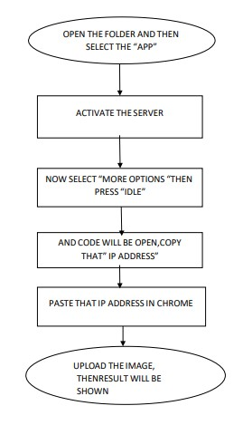

Figure 6.3 Flowchart

6.4 EXISTING METHODS

Here are some existing methods and technologies commonly used in loan eligibility projects:

1. Credit Scoring:
- Method: Utilizing credit scoring models such as FICO score, Vantage Score, or custom scoring algorithms.
- Technologies: Integration with credit bureaus' APIs (Equifax, Experian, TransUnion), use of statistical models and machine learning algorithms for credit risk assessment.

2. Document Verification:
- Method: Automated document verification using optical character recognition (OCR) and document analysis.
- Technologies: OCR libraries (Tesseract, Amazon Textract), document verification services (Thomson Reuters World-Check, Onfido).

3. Income Verification:
- Method: Verifying applicant income through bank statements, pay stubs, or tax returns.
- Technologies: Bank statement analysis APIs (Plaid, Yodlee), integration with payroll systems.

4. Identity Verification:
- Method: Verifying applicant identity using government-issued IDs and biometric verification.
- Technologies: Biometric verification services (Jumio, IDnow), identity verification APIs (Trulioo, Veriff).

5. Loan Eligibility Rules Engine:
- Method: Defining rules based on factors like credit score, income, debt-to-income ratio, and employment status.
- Technologies: Business rules management systems (Drools, IBM Operational Decision Manager), decision tables, custom rule engines.

6. Integration with Banking Systems:
- Method: Facilitating loan disbursement and repayment through integration with banking APIs.
- Technologies: Payment gateway APIs (Stripe, PayPal), banking APIs (Plaid, Dwolla).

7. Compliance and Regulatory Checks:
- Method: Ensuring compliance with regulations such as GDPR, CCPA, KYC, AML, etc.
- Technologies: Compliance management platforms (Compliance.ai, Onfido KYC), regulatory reporting tools.

8. Machine Learning for Risk Assessment:
- Method: Predictive modeling to assess loan default risk based on historical data.
- Technologies: Machine learning frameworks (Scikit-learn, TensorFlow), predictive analytics platforms (DataRobot, H2O.ai).

9. Fraud Detection:
- Method: Detecting fraudulent loan applications using anomaly detection and pattern recognition.
- Technologies: Fraud detection services (iovation, ThreatMetrix), behavioral analytics.

10. Customer Relationship Management (CRM):
- Method: Managing interactions with applicants throughout the loan application process.
- Technologies: CRM systems (Salesforce, HubSpot), communication APIs (Twilio, SendGrid).

These methods and technologies are widely used in various combinations depending on the specific requirements and scale of the loan eligibility project. Integrating these components effectively ensures efficient processing, accurate decision-making, and compliance with regulatory standards.

6.5 PROPOSED SOLUTION :

As the machine learning has been widely used in all sectors of E-commerce, it also plays a crucial role in loan eligibility by saving the time taken to identify the non eligibility persons and eliminate them.
In this project, we have used four ML algorithms: Logistic Regression, Random Forest Classifier, Naïve Bayes and Support Vector Machine. Out of which, the accuracy for Random Forest Classifier has been greater. Hence, we have used Random Forest Classifier to try and solve the Loan eligibility. We propose an effective solution for bank loan eligibility utilizing the Random Forest classifier algorithm. The aim is to accurately identify eligibility from legitimate ones.

Algorithm Choice
The Random Forest classifier was chosen due to its robustness, accuracy, and ability to handle large datasets with numerous features. As an ensemble learning method, it builds multiple decision trees during training and merges them to produce more reliable and accurate predictions. This technique mitigates overfitting, which is a common issue in single decision trees, and enhances the overall performance of the model.
Data Preprocessing
To ensure the model's effectiveness, extensive data preprocessing steps were undertaken:
- Data Cleaning: Removal of duplicates and handling of missing values to ensure data integrity.
- Feature Engineering: Creation of new features from existing ones to capture more intricate patterns in the data.
- Normalization: Standardization of features to ensure that all variables contribute equally to the model's performance.
Model Training and Evaluation

The dataset was split into training and testing sets to evaluate the model's performance. The Random Forest classifier was trained on the training set using a range of hyperparameters, optimized through techniques such as Grid Search and Cross-Validation to identify the best model configuration.

Key performance metrics were used to evaluate the model, including:

- Accuracy: The proportion of correctly identified eligibility.
- Precision: The ratio of true loan eligibility cases to the total cases predicted .
- F1 Score: The harmonic mean of precision and recall, providing a balance between the two.

The proposed Random Forest classifier demonstrated high accuracy and robustness in detecting fraudulent transactions. It outperformed traditional methods, showcasing its ability to capture complex patterns and providing a reliable solution for real-time loan eligibility.

Implementation
For practical implementation, the model can be integrated into the eligibility of bank loans. This integration would involve real-time analysis , flagging suspicious activities, and triggering further investigation or automated interventions to prevent fraud.

CHAPTER 7

PYTHON CODE

7.1 SOURCE CODE

import pandas as pd
import numpy as np
import joblib
from sklearn.feature_extraction.text import TfidfVectorizer
from sklearn.ensemble import RandomForestClassifier
from sklearn.model_selection import train_test_split
from sklearn.metrics import accuracy_score

# Load the data
data = pd.read_csv('loan.csv')

# Factorize categorical columns
data['Gender'], _ = pd.factorize(data['Gender'])
data['Married'], _ = pd.factorize(data['Married'])
data['Dependents'], _ = pd.factorize(data['Dependents'])
data['Education'], _ = pd.factorize(data['Education'])
data['Self_Employed'], _ = pd.factorize(data['Self_Employed'])
data['Property_Area'], _ = pd.factorize(data['Property_Area'])
data['Loan_Status'], _ = pd.factorize(data['Loan_Status'])

# Prepare features and target
X = data[['Gender', 'Married', 'Dependents', 'Education', 'Self_Employed', 'ApplicantIncome', 'CoapplicantIncome', 'LoanAmount', 'Loan_Amount_Term', 'Credit_History', 'Property_Area']]
y = data['Loan_Status']

# Split the data
X_train, X_test, y_train, y_test = train_test_split(X, y, test_size=0.2, random_state=42)

# Train the model
rf_classifier = RandomForestClassifier()
rf_classifier.fit(X_train, y_train)

# Evaluate the model
predictions = rf_classifier.predict(X_test)
accuracy = accuracy_score(y_test, predictions)
print("Accuracy using Random Forest Classifier:", accuracy)

# Save the model
joblib.dump(rf_classifier, "mymodel_rfc.h5")

7.2 PREDICT AND MAIN CODE:
From flask import Flask, render_template, request
import pandas as pd
from sklearn.feature_extraction.text import TfidfVectorizer
from sklearn.ensemble import RandomForestRegressor
import joblib

app = Flask(_name_)

# Load and preprocess the data
data = pd.read_csv('loan.csv')

# Factorize categorical columns
data['Gender'], _ = pd.factorize(data['Gender'])
data['Married'], _ = pd.factorize(data['Married'])
data['Dependents'], _ = pd.factorize(data['Dependents'])
data['Education'], _ = pd.factorize(data['Education'])
data['Self_Employed'], _ = pd.factorize(data['Self_Employed'])
data['Property_Area'], _ = pd.factorize(data['Property_Area'])
data['Loan_Status'], _ = pd.factorize(data['Loan_Status'])

# Fit the TF-IDF vectorizer on Loan_ID and the RandomForest model
tfidf = TfidfVectorizer(max_features=5000)
X = tfidf.fit_transform(data['Loan_ID'])
y = data['Loan_Status']

model = RandomForestRegressor()
model.fit(X, y)

# Save the trained model and TF-IDF vectorizer
joblib.dump(tfidf, 'tfidf_vectorizer.pkl')
joblib.dump(model, 'model.pkl')

@app.route('/')
def index():
return render_template('index.html')

@app.route('/predict', methods=['POST'])
def predict():
Loan = request.form['loan_id']

# Load the TF-IDF vectorizer and the model
tfidf = joblib.load('tfidf_vectorizer.pkl')
model = joblib.load('model.pkl')

Loan_tfidf = tfidf.transform([Loan])
prediction = model.predict(Loan_tfidf)

if prediction[0] > 0:
result = "You are not eligible for a loan"
else:
result = "You are eligible for a loan"

return render_template('result.html', loan_id=Loan, result=result)

if _name_ == '_main_':
app.run(debug=True)

7.3 INIT:

from flask import Flask, render_template, request
import pandas as pd
from sklearn.feature_extraction.text import TfidfVectorizer
from sklearn.ensemble import RandomForestRegressor
import joblib

app = Flask(_name_)

CHAPTER-8 FINAL RESULT

8.1 OUTPUT
IDLE PYTHON

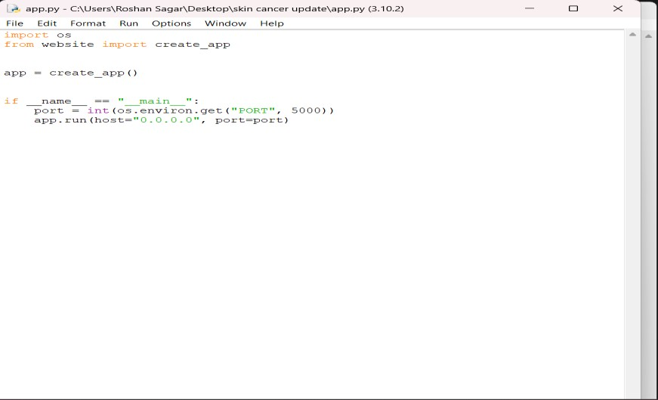

Figure 8.1 After opening the “APP FILE” the server will be activated.


ACTIVATING SERVER
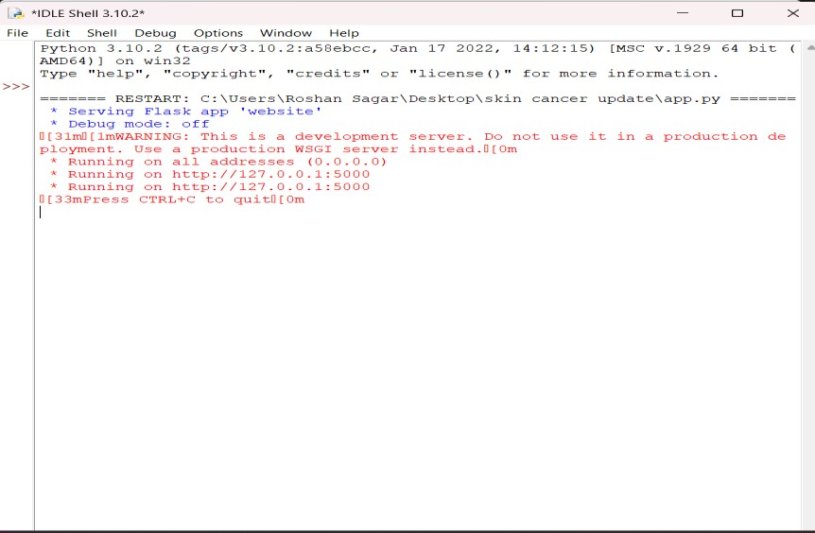

Figure 8.2 Open the main code and copy the IP address.

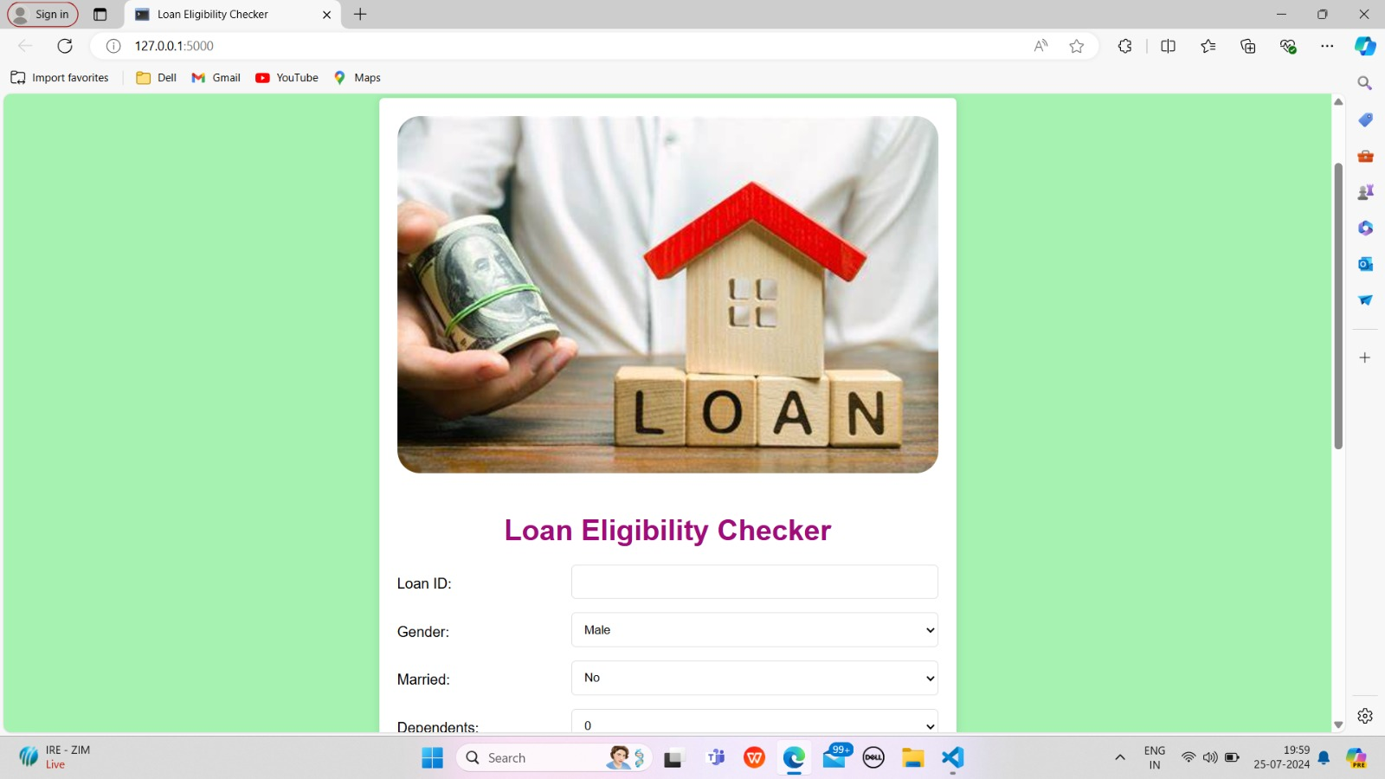
Figure 8.3 After copying the IP address paste that in the chrome

• OUTPUT:
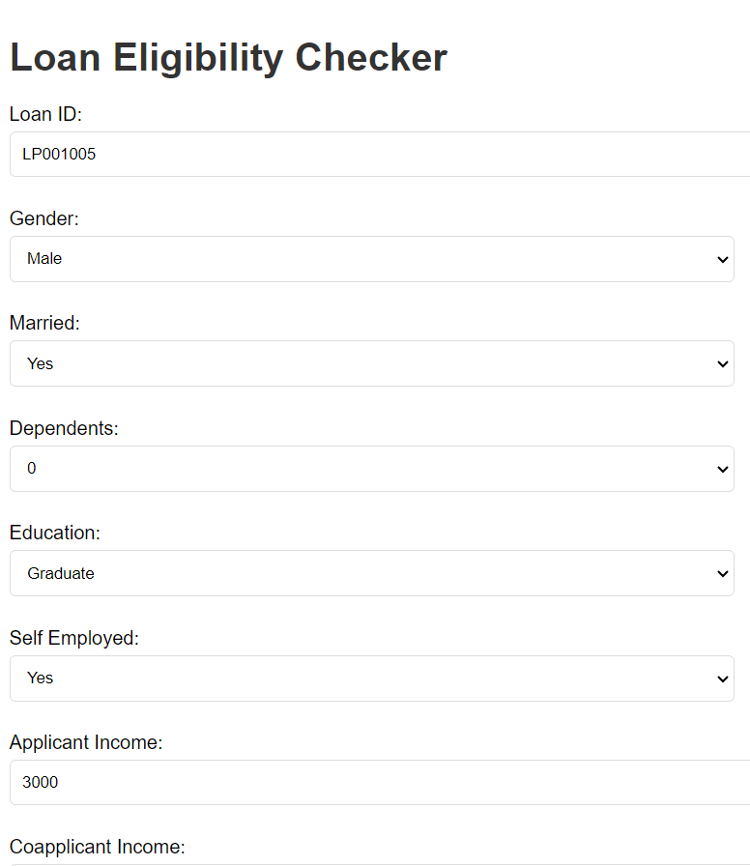

FIGURE 8.4
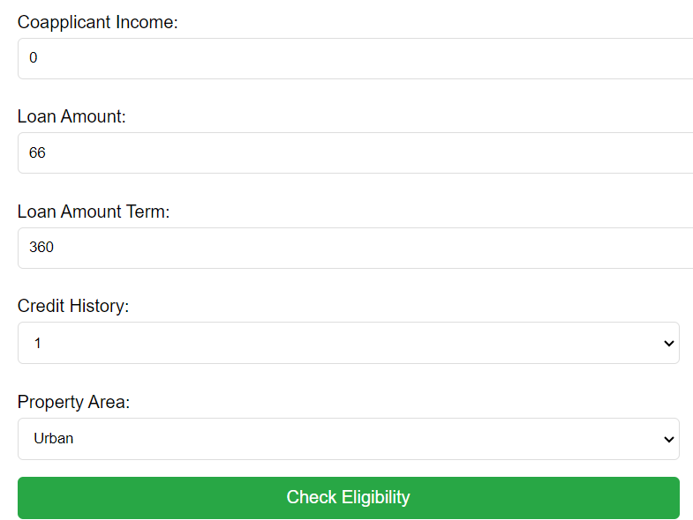
FIGURE 8.5
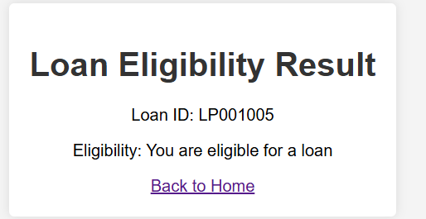
FIGURE 8.6

CHAPTER- 9

CONCLUSION AND FUTURE SCOPE

Today's fast-growing IT sector requires the development of new technology and the updating of existing technology that allows us to eliminate human interference and boost job productivity. This model is used for the banking system or anyone who wants to apply for a loan. Based on the examination of the data, it is apparent that it reduces all frauds committed during the loan approval process. Time is valuable to everyone, and by doing so, not only the bank, but also the applicant's waiting time will be reduced. Cleaning and processing of data, imputation of missing values, experimental analysis of data set, model construction, and testing on test data are all steps in the prediction process.

The best-case accuracy attained on the original data set is 0.9189 on Data set. After analyzing the data, the following conclusions were drawn: those applicants with the lowest credit scores will be denied a loan since they have a higher risk of defaulting on the loan. Most of the time, applicants with a high income and requests for a smaller loan are more likely to be approved, which makes sense because they are more likely to repay their debts. Other factors, such as gender and marital status, do not appear to be considered by the corporation.

This prediction module can be enhanced and integrated in the future. The system is prepared on the previous training data but in the future, it is possible to make changes to software, which can accept new testing data and should also take part in training data and predict accordingly.

REFERENCES

  - Al Mamun, M., Farjana, A., &Mamun, M. (2022): Predicting Bank Loan Eligibility Using Machine Learning

  - Models and Comparison Analysis. 7th North American International Conference on Industrial Engineering and Operations Management, Orlando, Florida, USA, June 12-14

  - Awodele, O., Alimi, S., Ogunyolu, O., Solanke, O., Iyawe, S., &Adegbie, F. (2022, November).

  - Deep Neural Network And Support Vector Machine for Credit Risk Prediction. In 2022 5th Information Technology for Education and Development (ITED) (pp. 1-8). IEEE.

  - Bansal, M., Goyal, A., &Choudhary, A. (2022). A comparative analysis of Knearest neighbor, genetic, support vector machine, decision tree, and long short term memory algorithms in machine learning. Decision Analytics Journal, 3, 100071.

  - Gupta, A., Pant, V., Kumar, S., & Bansal, P. K. (2020, December). Bank Loan Prediction System using Machine Learning. In 2020 9th International Conference System Modeling and Advancement in Research Trends (SMART) (pp. 423-426). IEEE. https://jupyter.org/ [Last accessed on 15-06-2023] https://docs.anaconda.com/free/navigator/index.html [Last accessed on 10-05- 2023]

  - Identification. In 2022 International Conference on Machine Learning, Computer Systems and Security (MLCSS) (pp. 17-21). IEEE.

  - Ndayisenga, T. (2021). Bank loan approval prediction using machine learning techniques (Doctoral dissertation).

  - Park, M. S., Son, H., Hyun, C., & Hwang, H. J. (2021). Explainability of machine learning models for bankruptcy prediction. IEEE Access, 9, 124887-124899.

